Quiz 2: CSE101 – Introduction to Computers

Name: _______________________ ID No: ____________________________

1. After the execution of the following code, what does lenlist contain? (1 pt)

bf = ['spam'+'3', 'eggs'*2, 'toast']

lenlist = [len(bf), len(bf[0]), len(bf[1]), len(bf[2])]

1. [3, 5, 8, 5]
2. [4, 5, 8, 5]
3. [3, 4, 4,5]
4. [3, 5, 4, 5]
5. The code (1 pt)

mylist = list(range(0,10,2))

Will produce the following value in mylist:

1. [0,1,2,3,4,5,6,7,8,9,10]
2. [0,0,2,2,4,4,6,6,8,8,10,10]
3. [0,2,4,6,8]
4. [0,0,1,1,2,2,3,3,4,4,5,5,6,6,7,7,8,8,9,9]
5. (Matching) Match the terms with the best definition (3 pts)

index

ceil

range

list

None

iteration

An ordered collection of objects (list)

A number that specifies a location in a list; if a list has n

Items, these numbers range from 0 to n – 1 (index)

A technique for solving a problem by repeating a set of steps (iteration)

A built-in function in Python used to generate a sequence of

values in order between a low and high value (range)

A function from Python’s math library that “rounds up” to

the nearest integer (ceil)

A special object that means “no object”, used as a placeholder

in lists or for variables that will be given a value later (None)

1. Python allows the use of indices on strings in the same way it allows indices to be used on lists. [ true / false] (1 pt)
2. Examine the following code: (1 pt)

temperatures = [18, 20, 19, 21, 20]

tindex = temperatures.index(20)

The value of tindex will be:

* 1. 4
  2. 5
  3. 1
  4. 2

1. Examine the following code: (2 pts)

def checkchars(aWord):

firsthalf = 'abcdefghijklm'

foo = ''

for letter in aWord.lower():

if letter in firsthalf:

foo += letter

else:

foo += ' '

return foo

theWord = 'blaisepascal'

print(checkchars(theWord))

This code will print following characters:

* 1. bl ise p s l
  2. blai e a cal
  3. b a e a c l
  4. bla se a cal

1. What type of object cannot be contained in a list? (1 pt)
   1. String.
   2. Integer.
   3. List.
   4. None of above.
2. Which of the following is not right? (1 pt)
   1. A for-loop can be used to iterate over the elements of a list.
   2. To convert a string into uppercase, iterate through this string and change the lowercase characters to uppercase.
   3. A for-loop can be used to iterate over the characters of a string.
   4. A character in a string can be accessed with an index.
3. How many times is the sixth line "minimum = list[i]" executed?  (2 pts)

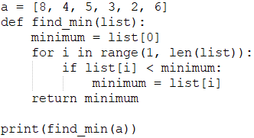

* 1. 6
  2. 5
  3. 4
  4. 3

1. Let classmates = ['Mike', 'Joseph'] and friends = ['Joseph' , 'Duke']. (2 pts)

What will be the output of the following code?

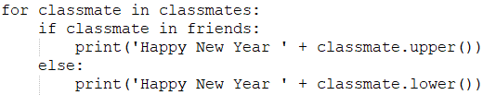

* 1. Happy New Year mike

Happy New Year JOSEPH

* 1. Happy New Year MIKE

Happy New Year joseph

* 1. Happy New Year Duke

Happy New Year JOSEPH

* 1. Happy New Year mike

Happy New Year DUKE

1. What is the output of print(partial_list(a, 4))?  (2 pts)

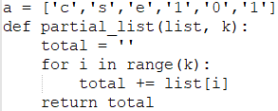

* 1. error
  2. cse1
  3. cse10
  4. cse101

1. Suppose you have a list majors = ['CSE']. What is the value of majors after executing the code majors += ['CSE', 'AMS']? (1 pt)
   1. ['CSE']
   2. ['CSE', 'AMS']
   3. ['CSE', 'CSE', 'AMS']
   4. Error
2. Which of the following statements is correct?  (1 pt)
   1. There exists a composite number that can be a prime number.
   2. 1 is a prime number.
   3. The Sieve of Eratosthenes is an algorithm to find prime numbers.
   4. The Sieve of Eratosthenes is so simple that humans can get the list of prime numbers between 2 and 10000 easily and quickly.
3. What is the output of the following program? (2 pt)

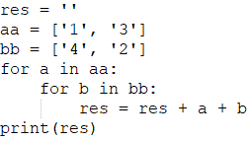

* 1. 41432123
  2. 14341232
  3. 41214323
  4. 14123432

1. Which of the following can generate a list of even numbers less than or equal to 10 in the decreasing order? (1 pt)
   1. list(range(-1, 10, -2))
   2. list(range(10, -1, -2))
   3. list(range(-1, 10, 2))
   4. list(range(10,-1, 2))
2. What is the output of the following program? (2 pts)

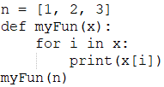

|  |  |  |  |  |  |  |  |
| --- | --- | --- | --- | --- | --- | --- | --- |
| a. | https://lh3.googleusercontent.com/mBQP1DxeNDjd0wilNwJXXenNzMj1clqNU0I2prtTsQ6xrmbapQkPZpy5LSbaMXwP_X24iXUJJA=w13 | b. | https://lh3.googleusercontent.com/2fsPCmO54mU_IFmCWSUuICVtRyrHprnx23M9_KbNaKHWIjtCVKXGumJiVAvNbZJjPU5d2lD9Eg=w21 | c. | https://lh6.googleusercontent.com/tjbdR1ovkhXuKTG9zOWpZZ3ukxOROnIzsmgCUE7kFW7GorF6seZEMbJk0lRSyREKwyYbZC9gDQ=w117 | d. | https://lh4.googleusercontent.com/skN6xodoApsZ6qpdgYp9czRYqkN4R4J3N8dSrgI7WRCGg15VqBLiDPf8x2v_PgbD8aRHNKv2fg=w117 |

1. Which statement about the debugger is not correct?  (1 pt)
   1. It is a powerful tool featured by PyCharm and it can help trace the execution of a program.
   2. You can set breakpoints by clicking the mouse to the right of the line where the computer should pause execution.
   3. After a "Debugger" panel opens, there is a sub-panel named "Variables" that will show the values of variables as the program runs.
   4. PyCharm highlights in blue that line it will execute next.