Quiz 5: CSE101 – Introduction to Computers

Name: ________________________________ ID No: ____________________________

1. Match the following pairs of concept and corresponding definitions. (3 pts)

|  |  |
| --- | --- |
| Class | A python class method that initializes (gives starting values to) instance variables |
| Object | A python class method that defines a string representation of an object that is suitable for printing on the screen |
| Constructor | Values that pertain to a particular class but are not instance variables |
| Class variables | Extensible program-code-template for creating objects, providing initial values for state and implementations of behavior using functions |
| __init__ | Represents an entity in the real world with its identity and behavior |
| __repr__ | Special method of a class or structure in object-oriented programming that initializes an object of that type |

1. Which of the following statements is true about Huffman coding? (1 pt)
2. Huffman coding may become lossy in some cases
3. Huffman Codes may not be optimal lossless codes in some cases
4. **Huffman coding is a lossless compression technique**
5. All of the above
6. What is the output of the following code? (1 pt)

class test:

def __init__(self,a="Hello World"):

self.a=a

def display(self):

print(self.a)

obj=test()

obj.display()

1. The program has an error because constructor can’t have default arguments
2. Nothing is displayed
3. **“Hello World” is displayed**
4. The program has an error display function doesn’t have parameters
5. What is the output of the following code? (1 pt)

class test:

def __init__(self,a):

self.a=a

def display(self):

print(self.a)

obj=test()

obj.display()

1. Runs normally, doesn’t display anything
2. Displays 0, which is the automatic default value
3. **Error as one argument is required while creating the object**
4. Error as display function requires additional argument
5. What is the output of the following code? (1 pt)

class Foo:

def printLine(self, line='Python'):

print(line)

o1 = Foo()

o1.printLine('Java')

1. Python
2. **Java**
3. Python

Java

1. line
2. What is the output of the following code? (1 pt)

class test:

def __init__(self):

self.variable = 'Old'

self.Change(self.variable)

def Change(self, var):

var = 'New'

obj=test()

print(obj.variable)

1. Error because function Change can’t be called in the __init__ function
2. ‘New’ is printed
3. **‘Old’ is printed**
4. Nothing is printed
5. Given the following Huffman tree, how many bits are required to encode message ‘go go gophers’? Considering that without encoding, it takes 1 byte to represent each character, what is the compression ratio achieved by Huffman coding for the message ‘go go gophers’? (Answer using the steps below)

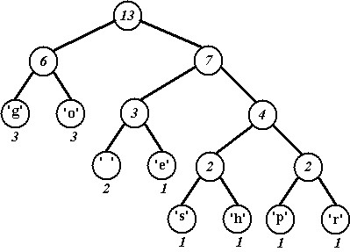

* 1. Generate Huffman codes from the tree shown above. (2 pts)

|  |  |  |  |
| --- | --- | --- | --- |
| Character | Frequency | Code | Code length |
| g | **3** | **00** | **2 bits** |
| o | **3** | **01** | **2** |
| ‘ ‘ | **2** | **100** | **3** |
| e | **1** | **101** | **3** |
| s | **1** | **1100** | **4** |
| h | **1** | **1101** | **4** |
| p | **1** | **1110** | **4** |
| r | **1** | **1111** | **4** |

* 1. Write down encoded message and calculate total number of bits required to represent message ‘go go gophers’. (2 pts)

00 01 100 00 01 100 00 01 1110 1101 101 1111 1100

* 1. Considering that without encoding, it takes 1 byte to represent each character, what is the compression ratio achieved by Huffman coding for the message ‘go go gophers’? Compression ratio is the ratio of the number of bits required to represent the encoded message and the number of bits required to represent the message without encoding. (2 pts)

**With encoding: 37 bits**

**Without encoding: 13 * 8 = 104 bits**

**Compression ratio: 37/104 = 0.3557**

1. How many bits may be required for encoding the message ‘mississipi’ using Huffman coding? (Answer using the steps below)
   1. Following is the frequency table for characters in the message ‘mississippi’.

|  |  |
| --- | --- |
| Character | Frequency |
| m | 1/11 = 0.09 |
| P | 2/11 = 0.18 |
| S | 4/11 = 0.36 |
| I | 4/11 = 0.36 |

* 1. Completely build the Huffman tree using the frequency table above. (3 pts)

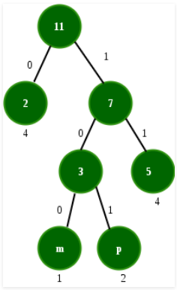

* 1. Generate Huffman codes from the tree built in the above step. (1 pt)

|  |  |  |  |
| --- | --- | --- | --- |
| Character | Frequency | Code | Code length |
| m | 0.09 | **100** | **3** |
| P | 0.18 | **101** | **3** |
| S | 0.36 | **11** | **2** |
| I | 0.36 | **0** | **1** |

* 1. Write down encoded message and calculate the total number of bits required to represent the message ‘mississippi’. (1 pt)

**100 0 11 11 0 11 11 0 101 101 0**

**Total number of bits**

**= freq(m) * codelength(m) + freq(p) * code_length(p) + freq(s) * code_length(s) + freq(i) * code length(i)**

**= 1*3 + 2*3 + 4*2 + 4*1 = 21**

1. Convert 10010111 from base 2 to base 16 (1 pt)
2. 0xA9
3. **0x97**
4. 0x227
5. 0x
6. Convert 100101110 from base 2 to base 8 (1 pt)
   1. 1132
   2. 567
   3. **456**
   4. 12E
7. Convert 229 from base 10 to base 2 (1 pt)
   1. **11100101**
   2. 11001001
   3. 11110100
   4. 10110101
8. Convert 39 from base 16 to base 10 (1 pt)
   1. 47
   2. 68
   3. 52
   4. **57**
9. Consider the following code and answer the output of questions below: (2 pts)

def bmi(height, weight, units = 'metric’):

if units == 'metric’:

return weight / height**2

elif units == 'standard’:

return (weight * 703) / (height ** 2)

else:

return None

1. print(bmi(100, 100, ‘standard’)) _____**7.03**____
2. print(bmi(100, 100)) _____**0.01**____