1. FTP Stands for --------
   1. Field Transfer Protocol
   2. File Transfer Protocol
   3. Fix Transfer Protocol
   4. Flexible Transfer Protocol
2. Which tag is used to create a list that displays items with bullets?
   1. <OL>
   2. <UL>
   3. <list>
   4. <DL>
3. For largest level of heading which tag is used?
   1. <h1>
   2. <h6>
   3. <heading>
   4. <head>
4. To group sentences in paragraph which tag is used?
   1. <para>
   2. <p>
   3. <b>
   4. <br>
5. The language used to develop web page is
   1. HTML
   2. HTTP
   3. Brower
   4. Protocol
6. Font tag has following attribute
   1. type
   2. face
   3. value
   4. caption
7. For handling user interaction side scripting is useful
   1. Server
   2. Client
   3. Server & Client
   4. None of these
8. In table row is created by
   1. <tr>
   2. <th>
   3. <ta>
   4. None of these
9. tag is used for document title
   1. <title>
   2. <head>
   3. <html>
   4. <body>
10. For inline images tag is used in an HTML document
    1. <input>
    2. <map>
    3. <img>
    4. None of these
11. are used to create imaginary sections of browser screen.
    1. form
    2. frame
    3. input
    4. select
12. is used to set background image at web page.
    1. <body background>
    2. <body bg ground>
    3. body back>
    4. None of these
13. ___is used to create a new paragraph
    1. <form>
    2. <img>
    3. <P>
    4. <marque>
14. _____is the text on clicking of which other web pages are opened
    1. Markup
    2. Hypertext
    3. Link
    4. None of these
15. ______ tag is used to format the text matter
16. <format>
17. <font >
18. <form>
19. <frame>
20. _______ tag is used to link a web page.
21. <a>
22. <b>
23. <td>
24. <tr>
25. tag is used to create a caption on top or below the table.
    1. <table>
    2. <caption>
    3. <align>
    4. <border>
26. Which tag is used to create a list that displays items with bullets? <ul>
27. Tag for largest level of heading? <h1>
28. The Language used to develop web page? <html>
29. How to make an email link? <a href="mailto:p.pawar@gmail.com">
30. how to open a link in new browser window? <a href="http://ppawar.github.io" target="_blank">
31. Which tag is used to insert line brake in HTML code? <br>
32. Which tag is used for smallest heading? <h6>
33. Which tag is used to make numbered list? <ol>
34. Which tag is used to create background image? <div style="background-image: url('img_girl.jpg');">
35. Which tag is used to list the items in the form of 1,2,3…? <ol>
36. What is Internet? Network of interconnected computers/devices
37. HTML Stands for? HyperText Markup Language
38. www Stands for what? World Wide Web
39. Which is the first tag of HTML program? <html>
40. Which tag is used to bold the text? <b>
41. Which tag is used to Italic the text? <i>
42. Which tag is used to Underline the text? <u>
43. Which tag is used to ~~Strikethrough~~ the text? <del>
44. Which tag is used to center the text? <center> CSS textalign:center
45. which tag is used to subscript the text? <sub>
46. which tag is used to superscript the text? <sup>
47. The <title> tag is present inside which tag? <head>
48. For inline image which tag is used in HTML document? <img>

**Descriptive questions**

1. What is the difference between IPv4 and IPv6?

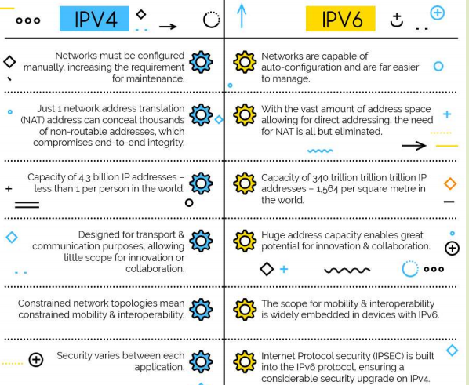

1. What are various services provided by Internet?

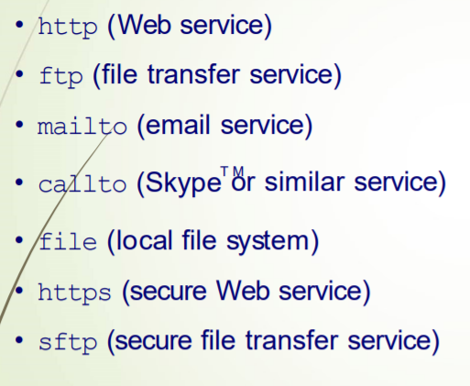

1. What is your advice for developing a stunning website?
   1. Choose a visually appealing color scheme suitable for the purpose of website.
   2. Make useful categories of information, so that useful information is quickly found.
   3. Design and navigation should be intuitive and user friendly.
   4. The website should be responsive and be able to function on multiple devices such as computer, laptop, mobiles and tablet PCs.
   5. The homepage should have proper banner, logo, tagline as well as space for hot/frequently access content, search bar etc.
2. How does HTTP protocol work?

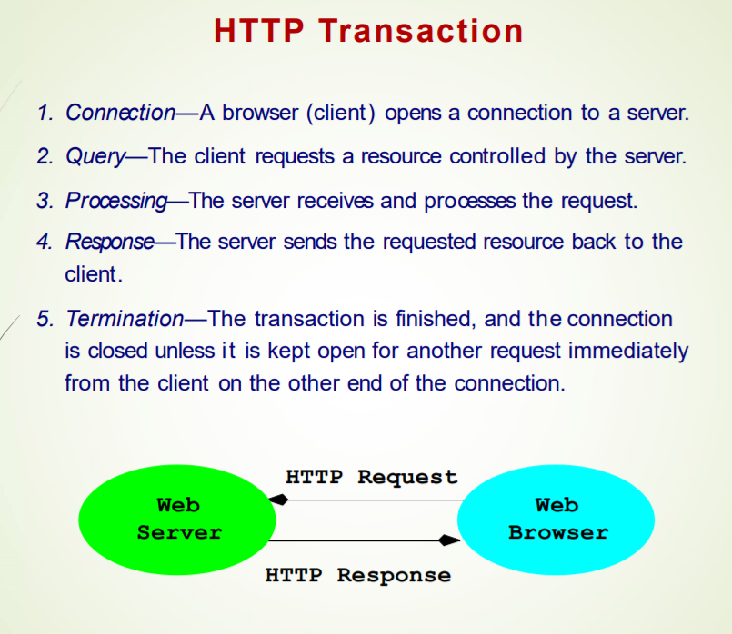

**Find the errors in code:**

**Example 1:**

<html xmlns="http://www.w3.org/1999/xhtml" lang="en" xml:lang="en">

<head>

<meta charset="utf-8"/>

<title>HTML5: Figure</title>

</head>

<body style="margin: 50px">

<figure style="text-align: center; font-style: italic">

<img src="dragonfly.jpg" alt="a blue-winged dragonfly" width="430" >

<figcaption>

<strong>Fig. 7 Dragonfly, an insect belonging to the order Odonata, the suborder Epiprocta or, in the strict sense, the infraorder Anisoptera. (Wikipedia)</strong>

</figcaption>

</figure>

</body></html>

**Example 2:**

<!DOCTYPE html>

<html xmlns="http://www.w3.org/1999/xhtml" lang="en" xml:lang="en">

<head>

<meta charset="utf-8"/>

<title>HTML5: image map</title>

</head><body style="margin: 50px">

<article><section>

<h2>The Planets</h2>

<figure>

<img src="planets.jpg" usemap="#planets" alt="Planets image map" />

<map name="planets" id="planets">

<area shape="circle" coords="40,176,7" href="http://en.wikipedia.org/wiki/Mercury_%28planet%29" alt="Mercury" title="Mercury"/>

<area shape="circle" coords="82,158,10" href="http://en.wikipedia.org/wiki/Venus_%28planet%29.html" alt="Venus" title="Venus"/>

<area shape="circle" coords="127,132,11" href="http://en.wikipedia.org/wiki/Earth_%28planet%29.html" alt="Earth" title="Earth">

<area shape="circle" coords="157,103,10" href="http://en.wikipedia.org/wiki/Mars_%28planet%29.html" alt="Mars" title="Mars"/>

<area shape="circle" coords="234,116,27" href="http://en.wikipedia.org/wiki/Jupiter_%28planet%29.html" alt="Jupiter" title="Jupiter"/>

</map>

</figure>

<p>Click on the Sun or a planet to see its description.</p>

<p>Click elsewhere in the picture to get a list of all the planets in the solar system.</p>

</section></article>

</body></html>

**Example 3:**

<!DOCTYPE html>

<html>

<head>

<meta charset="utf-8"/>

<title>Centering Different Elements</title></head>

<body style="margin: 50px"><section>

<link rel="stylesheet" type="text/css" href="[centerstyle.css](https://ppawar.github.io/Fall2019/CSE102-F19/programs/exc04/centerstyle.css)" title="center" />

<h2>Centering Different Elements</h2>

<p>Resize the window and see how each of these elements centers.

</p>

<h3> class="center">My Title</h3>

<p class="center">Topic of the Day</p>

<p style="text-align: center; font-weight: bold">Announcemenet</p>

<table>

<p class="center">

<img src="neptis.jpg" alt="Neptis Butterfly" />

</p>

</table>

</section>

</body>

</html>