Exercise 4 - CSE102

## Goals:

The goal of this exercise is to learn creating simple HTML based website that uses navigations, links, tables, images as well as a number of tags such as h1 – h6, p, br etc.

## Steps:

Refer to the Layout demo posted on the webpage: [https://ppawar.github.io/Fall2019/CSE102-F19/programs/exc02/Layout.html#](https://ppawar.github.io/Fall2019/CSE102-F19/programs/exc02/Layout.html). Use this as a base page to create a simple website for university.

* Create a HTML page named index.html which splits a single page into top banner, navigation banner and content area.
* The navigation banner on the left-hand side contains links to the following custom pages such as:
  + About.html
  + Department.html
  + Courses.html
  + Contact.html
  + Gallery.html
  + News.html

Feel free to experiment HTML tags you have learnt so far. Host the website on your infinity account and share link and screen shots of all pages.

## Some Examples:

About us:

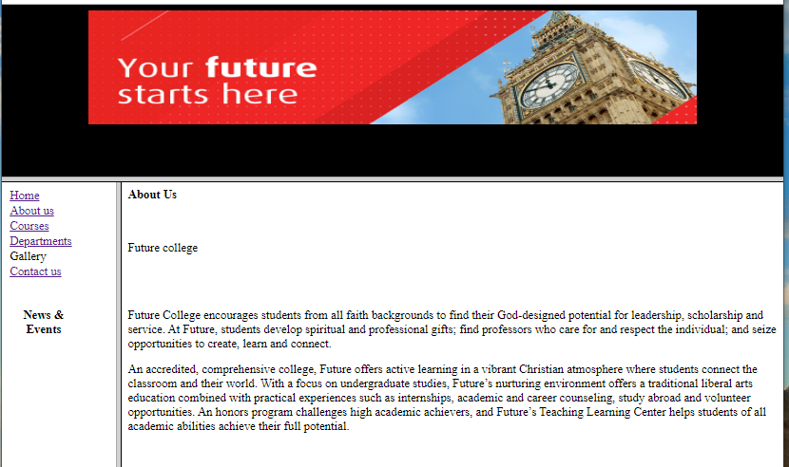

Courses:

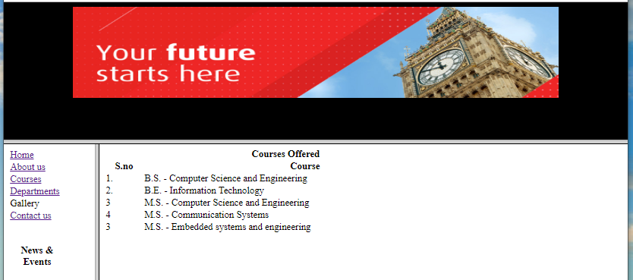

Departments:

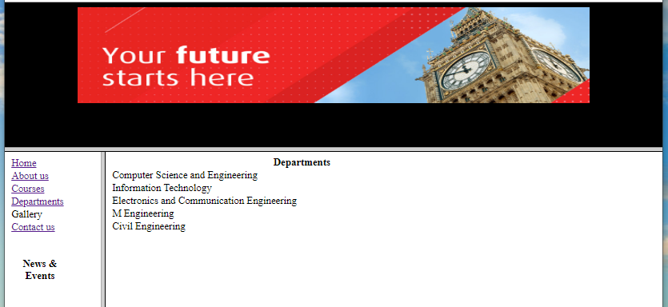

Contact us:

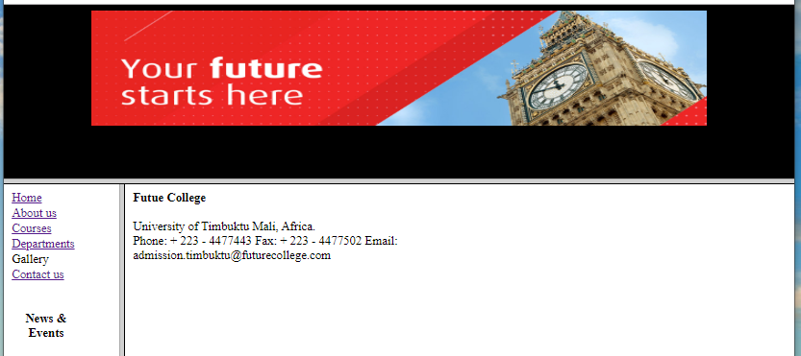

Index page:

