Detecting Information Omissions in AI Generated Research Summaries
  - Exercise and sleep in adults
Midterm preliminary evidence briefing
Pratiksha Pawar and project partner
EM 626 AI and Machine Learning for Systems
Professor Carlo Lipizzi
Presentation date 9 November 2026

Purpose and current conclusion
This checkpoint tests whether a small, reproducible pipeline can expose details that an AI summary leaves out of a research abstract. The pilot includes three real abstracts, one saved AI-generated summary per abstract and 30 selected information units. The provisional audit marks 20 units preserved and 10 omitted. These counts establish a working comparison, not predictive model performance or clinical trustworthiness.

Evidence available now
Item | Current status
Source material | Three public abstracts with citations and original licenses
Language components | Saved summaries and structured information-unit extraction
Graph evidence | Six graphs, GraphML files, graph statistics and degree distributions
Analysis | Coverage counts, worked examples and a validation log
Reproducibility | Python script, integrity tests, README and offline graph viewer
AI assistance disclosure: the ChatGPT coding assistant drafted summaries, code and provisional annotations in this session. Independent student review, a controlled generation experiment and GCN training remain pending. The exact backend model version was not exposed and has not been invented.

Research question and pilot method
Research question: Which predefined information units from an exercise-and-sleep research abstract remain in a short AI summary, and can source-graph structure later improve omission prediction over text features alone?

Boundaries and source selection
The pilot uses a purposive sample of three public abstracts about adult exercise interventions and sleep. The papers involve different populations and interventions. This is a feasibility demonstration, not a systematic review or a synthesis of clinical effectiveness. We audit only information reported in each abstract. Silence about adverse events does not establish that no adverse events occurred.
ID | Source | Study context
P01 | Baron 2023 | Aerobic exercise in women with insomnia
P02 | Gale 2024 | Evening activity breaks in healthy adults
P03 | Siu 2021 | Tai chi and exercise in older adults with insomnia

Pipeline at this checkpoint
We save cited abstract text and an AI-generated summary, then extract structured information units with exact text anchors. We check those anchors and align units between the source and summary. The graph builder constructs typed source and summary graphs and exports descriptive coverage statistics. The script replays saved outputs; it does not call a live LLM or perform learned omission detection.

Provisional labeling rule
A selected unit is preserved when the summary retains its full predefined meaning. It is omitted when that detail does not appear. For example, “sleep increased” can preserve the direction while omitting a separate unit that specifies minutes and a confidence interval. Partial or distorted statements require separate adjudication as the project expands. The 30 units were selected during development, so their omission rate is conditional on that selection.
Each record stores paper ID, concept type, source anchor, summary evidence, provisional status and rationale. Evidence-string checks prove text occurrence, not medical or semantic correctness. Two independent student reviewers should resolve ambiguity before calling these labels gold data.

First graphs and statistics
Each source graph contains one study node and ten selected information-unit nodes. Study-to-unit relations describe typed attributes. Intervention-to-outcome relations mean assessed_for and do not claim a causal mechanism. Summary graphs project the aligned preserved units into the same schema. They do not exhaustively represent every statement or summary-only concept.
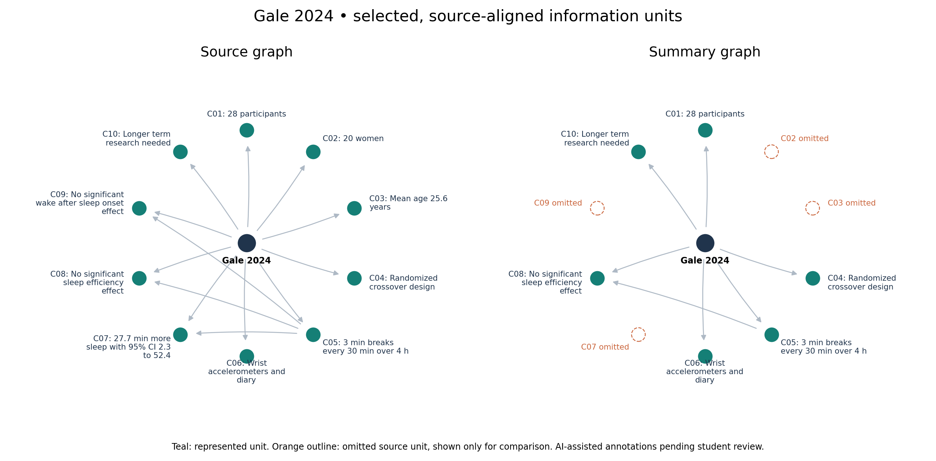
Figure 1. Gale 2024 source and summary comparison. Orange outlines identify omitted source units for comparison; those outlines are not nodes in the summary GraphML export. Source: doi:10.1136/bmjsem-2023-001774. Provisional AI-assisted alignment.
Paper | Source nodes / edges | Summary nodes / edges | Source mean degree
Baron 2023 | 11 / 13 | 8 / 8 | 2.36
Gale 2024 | 11 / 13 | 7 / 7 | 2.36
Siu 2021 | 11 / 12 | 8 / 8 | 2.18
Total degree means in-degree plus out-degree. The script exports the complete degree distribution and checks graph endpoints. Source graphs are small hub-and-spoke structures. Smaller summary graphs follow from the chosen projection and do not independently demonstrate that graph learning works.

Initial findings and preliminary conclusions
Paper | Selected units | Preserved | Omitted
Baron 2023 | 10 | 7 | 3
Gale 2024 | 10 | 6 | 4
Siu 2021 | 10 | 7 | 3
Total | 30 | 20 | 10
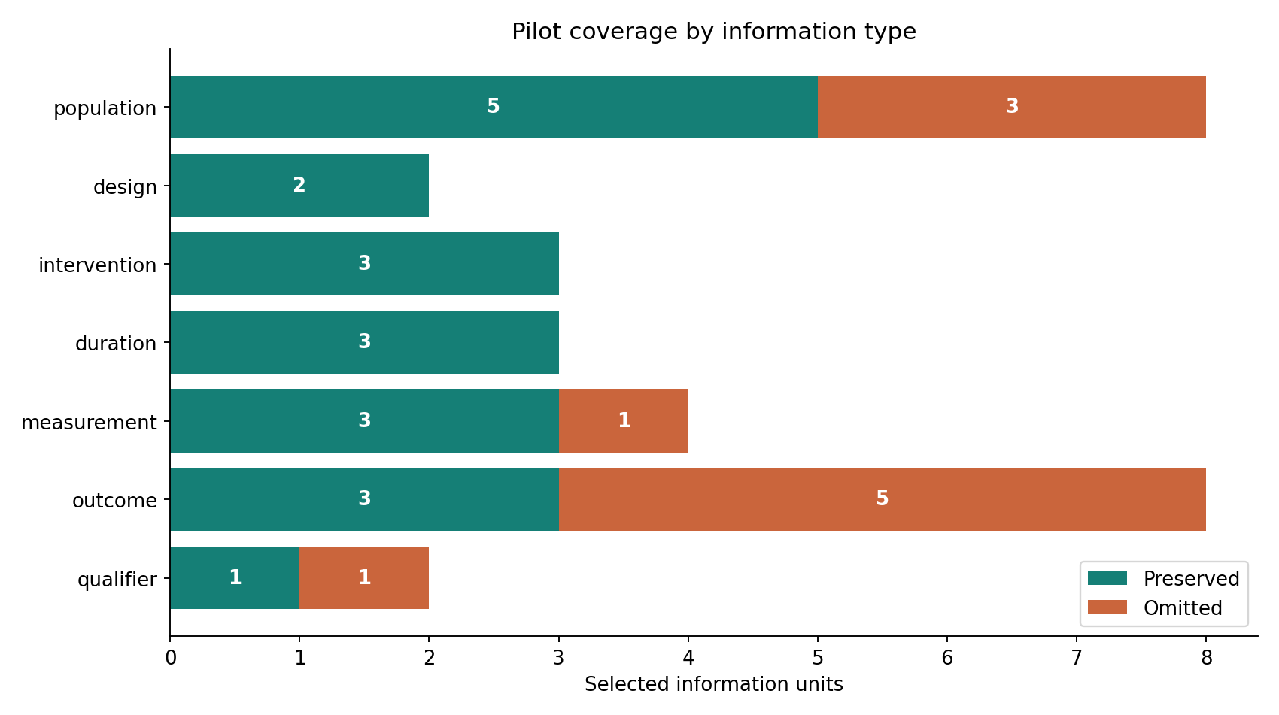
Figure 2. Descriptive coverage of the selected units. Counts describe the saved summaries and provisional annotation choices, not model accuracy or population-level omission rates.

Worked examples
Gale 2024: the summary retains the direction of the sleep-duration finding, but omits the unit specifying an additional 27.7 minutes asleep and its 95% confidence interval of 2.3 to 52.4 minutes. It also omits the mean age and women count while retaining the total sample size. These are missing details, not automatically evidence of demographic bias.
Siu 2021: the saved summary retains the 24-month follow-up and the absence of a significant objective difference between active groups. It omits the abstract’s qualification that absolute sleep improvements were modest. A reader therefore receives less detail about the size of the benefit.
Preliminary conclusion: the pipeline can make specific omissions traceable to source text. Whether those omissions materially change interpretation, and whether a GCN adds useful predictive value, remain open questions.

Graph learning plan and remaining work

Planned GCN task
A two-layer GCN will classify each source information-unit node as preserved or omitted. Candidate inputs are concept-type indicators, source-unit text embeddings and a representation of the summary text. We will exclude the study node from the classification loss. Reverse edges and self-loops may support message passing, with preprocessing documented. This architecture is proposed and has not been trained.

Labels and leakage prevention
Both students should annotate an overlapping subset independently, document disagreements and adjudicate ambiguous cases. Keep all concepts and summary variants from a paper in the same training, validation or test group. Do not give the model labels, summary graph membership, coverage, graph differences or alignment decisions. Those values directly reveal the task answer. The descriptive pilot uses them for analysis only.

Baselines and evaluation
Compare the GCN with a majority-class predictor and logistic regression or an MLP using the same non-graph features. Evaluate a separate direct text or semantic-matching baseline. Report omission-class precision, recall and F1, macro-F1 and confusion matrices over several seeds. Evaluate extraction quality separately. With only 15–30 papers, use paper-grouped evaluation and discuss instability rather than treating concept nodes as independent studies.

Next steps
Step | Expected evidence
1 Review the pilot | Student-reviewed records and resolved disagreements
2 Expand the corpus | 15–30 abstracts with recorded inclusion criteria
3 Freeze generation | Prompt, exact model metadata and saved outputs
4 Train and compare | GCN and non-graph results with leakage controls
5 Interpret and report | Error analysis, coverage patterns, grounded feedback and limitations
The handout recommends a Transformer-based comparison but requires only one baseline GNN as the minimum graph model. Broad bias analysis and an experimental coverage/trust index can follow once labels and definitions are defensible. A coverage index cannot certify clinical reliability.

Submission readiness and references

Before the presentation
Review every source and provisional label, add the partner’s name to the presentation and document, and rehearse the 13 slides for about 10 minutes. Submit the material in advance through the Canvas slot using its actual deadline. The professor permits PowerPoint or a document/PDF. The code folder is ready for an empty GitHub repository; no remote repository has been created or published.

Suggested team ownership
One partner can lead source selection, summary generation and extraction review. The other can lead graph construction, code integration and the GCN plan. Both should review labels, understand the complete pipeline and share interpretation and presentation. This is a proposed split, not a claim about work already performed.

Reproduction and demo
Install requirements.txt and run python src/run_pilot.py. Open results/interactive_graphs.html locally to inspect nodes. Use python -m unittest discover -s tests -v for the integrity tests. A standard-library-only run is available with --no-plots. Keep completed reviewer worksheets outside results/ because regenerated outputs overwrite that folder. README.md contains Windows PowerShell instructions.

References
Baron P, Hermand E, Bourlois V, et al. (2023). Effect of Aerobic Exercise Training on Sleep and Core Temperature in Middle-Aged Women with Chronic Insomnia: A Randomized Controlled Trial. https://doi.org/10.3390/ijerph20085452
Source: https://pmc.ncbi.nlm.nih.gov/articles/PMC10138891/
Original license: CC BY 4.0.
Gale JT, Haszard JJ, Wei DL, Taylor RW, Peddie MC. (2024). Evening regular activity breaks extend subsequent free-living sleep time in healthy adults: a randomised crossover trial. https://doi.org/10.1136/bmjsem-2023-001774
Source: https://pmc.ncbi.nlm.nih.gov/articles/PMC11256039/
Original license: CC BY-NC 4.0; noncommercial educational use.
Siu PM, Yu AP, Tam BT, et al. (2021). Effects of Tai Chi or Exercise on Sleep in Older Adults With Insomnia: A Randomized Clinical Trial. https://doi.org/10.1001/jamanetworkopen.2020.37199
Source: https://pmc.ncbi.nlm.nih.gov/articles/PMC7885034/
Original license: CC BY 4.0.
Kipf, T. N., and Welling, M. (2017). Semi-Supervised Classification with Graph Convolutional Networks. ICLR. https://arxiv.org/abs/1609.02907. Planned model reference.
Course requirements: Projects_Fall26_2.docx supplied by the instructor and the instructor’s email clarifications supplied in this conversation. This document is a midterm briefing, not the final approximately 10-page report.
Source text typography has been normalized. Original licenses and author rights remain in effect. The Gale article carries a noncommercial reuse restriction. No patient data is included. This academic prototype provides no medical advice.

