Final Year Project Report
Full Unit – Interim Report

Android Game Development

Patryk Pawlicki

A report submitted in part fulfilment of the degree of
BSc (Hons) in Computer Science
Supervisor: Peter Robinson

Department of Computer Science
Royal Holloway, University of London

Declaration
This report has been prepared on the basis of my own work. Where other published and unpublished source materials have been used, these have been acknowledged.

Word Count:

Student Name:

Date of Submission:

Signature:
Table of Contents
Abstract 4
Project Specification 5
Chapter 1: Game Design 6
Chapter 2: Android Life Cycle 7
Chapter 3: Worker Threads within a GUI 8
Chapter 4: Design Patterns 9
Chapter 5: Animation Techniques 10
Chapter 6: XML for GUIs 11
Bibliography 12

Abstract
The aim of my final year project is to develop a simple game for Android platform using the Android Software Development Kit which will cope with the variations of hardware configurations and be compatible with different devices and factors such as battery saving will be taken into consideration along with other constraints present when developing phone applications. Mobile applications as well as games are a very big market which is constantly growing with a massive potential for monetization, android as well as IOS are the leading systems for mobile games. It’s relatively easy to publish apps on the Android Market making Android App development accessible to anyone interested wishing to dedicate their time. There are a lot of resources available on the web with a big community of android developers. I have always been interested in game development, especially for Android systems. My motivation behind choosing this particular project was mainly due to the fact I would like to get involved with Android Game Development to potentially pursue my future career in app development after graduating from university.
I am an Android phone user myself, who has experience with apps and games available on the Android Market, therefore I understand the industry from the user side and have a bit of insight on what users want and expect from applications they download. Seeing as the market is very densely saturated with app developers, there are a lot of free applications available for download, therefore if an app or game does not satisfy the user they will simply uninstall and install another one. It’s very easy to download and install apps and users rarely get attached to using a single application.
I would like to try and get into the realm of Android app development myself and contribute to the community of developers and android game users, hopefully this project will be my gateway.

Project Specification
Your project specification goes here.

Game Design
e

Android Life Cycle

Activities in Android
In Android, the users navigate through different activity instances as the applications are being used, or navigated in and out of. All the transitions between applications or within a single application correspond to a change in an activity state of an application. This is done through the Activity class via a series of callback methods which are used for pausing, stopping, starting or resuming an activity.
It’s very important to consider what happens when an application is interrupted by things such as phone calls, alarms or even user input which will result in the application being paused or stopped. It’s important to define what happens in those instances so that the progress of our game is not lost and the user can switch between the applications fairly seamlessly without consuming system resources without using them.
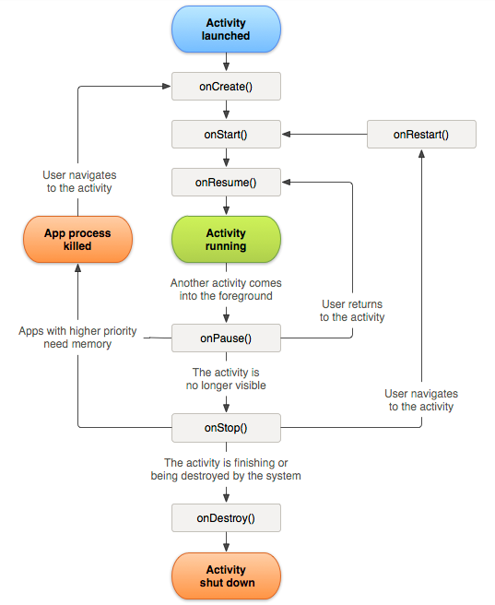
- Activity Life Cycle [1]

Callbacks
There are 6 main callbacks:
- onCreate()
- onStart()
- onResume()
- onPause()
- onStop()
- onDestroy()

OnCreate()
In this state the system will create and configure the backbone of the program required for the lifecycle of its operation, also things like layout for the main activity or the first UI would be configured here.
However onCreate is not a state that the application will stay on for long and after everything is set up, the activity will always move onto the onStart() state.

OnStart()
The started state is another quick state in which the activity doesn’t stay for long, its main purpose is to make the app interactive and make the activity available to the user. If the activity comes to the foreground it is then followed by onResume(), if it doesn’t it will be followed by the onStop() callback.

OnResume()
When applications are being actively used by the user and being interacted with, the activity will spend the most time in the Resumed state, until it gets disrupted by user input or other applications so that the focus is taken off it.
The resume state is at the top of the activity stack and has the least likelihood of being killed to free up memory. It has priority over other running applications and is currently in the spotlight.

OnPause()
onPause() state is called when the focus is taken off the application, it does exactly what it says, it pauses the application without killing it so that the system can come back to it later without losing any progress, the application is still running but is paused and in the background. This is an opposite state from resume. When in this state, there are two possibilities, either onResume() will be called and the application will carry on or onStop() will be called in order to stop it.

OnStop()
This callback is called when the activity has either finished running or when the UI is no longer visible to the user. After the call, the activity releases the resources it doesn’t need to free up memory, all the necessary CPU intensive operations can be performed on this callback, such as saving data to the database, etc. This callback is often followed by onRestart() or onDestroy() callback.

OnDestroy()
This is the final call of an activity, after it is invoked the activity gets destroyed and all the remaining resources gets released.

Activity State and ejection from memory
The system will kill processes in order to free up memory when needed to do so, the decision on what processes should be killed is dependent on the state of the activity within that process. This ensures that the system will not kill the application actively being used by the user but will rather prioritize processes which correspond to applications currently not in use.
Below we can see a table which talks about different activity states and the likelihood of the system killing them.
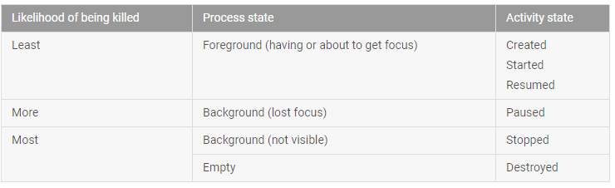
- Relationship between process lifecycle and activity state [2]

Worker Threads within a GUI
D

Design Patterns
F

Animation Techniques
F

XML for GUIs
G

Bibliography
- Figure 1 – Activity-lifecycle concepts, A simplified illustration of the activity lifecycle: https://developer.android.com/guide/components/images/activity_lifecycle.png
- Figure 2 – Activity state and ejection from memory, Table 1: https://developer.android.com/guide/components/activities/activity-lifecycle.html

