Final Year Project Report
Full Unit – Final Report

Android Game Development

Patryk Pawlicki

A report submitted in part fulfilment of the degree of
BSc (Hons) in Computer Science
Supervisor: Jasper Lyons

Department of Computer Science
Royal Holloway, University of London

Declaration
This report has been prepared on the basis of my own work. Where other published and unpublished source materials have been used, these have been acknowledged.

Word Count: 6912

Student Name: Patryk Pawlicki

Date of Submission: 01/12/2017

Signature: 
Table of Contents
Chapter 1: Project Diary 5
Chapter 2: Proof of concept programs 6
2.1 Hello World 6
2.2 Explosion Animation 7
2.3 XML based User Interface 10
Chapter 3: Design of a GUI based mobile game 12
3.1 Game Concept 12
3.2 Initial Game Design 13
3.3 Framework 14
Chapter 4: Android Life Cycle 15
4.1 Activities in Android 15
4.2 Callbacks 16
4.3 Activity State and ejection from memory 17
Chapter 5: Worker Threads within a GUI 18
5.1 UI Thread 18
5.2 What are worker threads 18
5.3 AsyncTask 18
5.4 Application Not Responding (ANR) 19
Chapter 6: Design Patterns 20
6.1 What are design patterns 20
6.2 Types of design patterns 20
Chapter 7: Animation Techniques 22
7.1 Animation Techniques used in the Android Framework 22
7.2 2D and 3D Graphics 24
Chapter 8: XML for GUIs 25
8.1 GUI design in Android 25
8.2 Using XML to set the layout: 25
8.3 View Group Layouts 25
8.4 ID 26
8.5 Attributes 26
Bibliography 27

Abstract
The aim of my final year project is to develop a simple game for Android platform using the Android Software Development Kit which will cope with the variations of hardware configurations and be compatible with different devices and factors such as battery saving will be taken into consideration along with other constraints present when developing phone applications. Mobile applications as well as games are a very big market which is constantly growing with a massive potential for monetization, android as well as IOS are the leading systems for mobile games. It’s relatively easy to publish apps on the Android Market making Android App development accessible to anyone interested wishing to dedicate their time. There are a lot of resources available on the web with a big community of android developers. I have always been interested in game development, especially for Android systems. My motivation behind choosing this particular project was mainly due to the fact I would like to get involved with Android Game Development to potentially pursue my future career in app development after graduating from university.
I am an Android phone user myself, who has experience with apps and games available on the Android Market, therefore I understand the industry from the user side and have a bit of insight on what users want and expect from applications they download. Seeing as the market is very densely saturated with app developers, there are a lot of free applications available for download, therefore if an app or game does not satisfy the user they will simply uninstall and install another one. It’s very easy to download and install apps and users rarely get attached to using a single application.
I would like to try and get into the realm of Android app development myself and contribute to the community of developers and android game users, hopefully this project will be my gateway.

A description of Android, its history and its internals

Brief history of Android

Early days of Android
Android started out in October 2003 in Palo Alto in California. The company has been co funded by Andy Rubin along with Nick Sears and Chris White which played the key role in the company. Android has started out as a company which primary focus was on developing operating systems for digital cameras. However the company shifted their focus on mobile phones as there was a bigger potential in that market and was aiming to rival with the market leaders at the time; Symbian as well as the Microsoft’s Windows Mobile.
Interestingly Andy Rubin spoke about his belief in developing smarter mobile devices around 2 months before Android as a company hit the market. In an interview with BusinessWeek he spoke about seeing a great potential in developing devices aware of user’s location and preferences and how this information could be useful to model consumer products. Rubin said: “If people are smart, that information starts getting aggregated into consumer products”[@@@].
Initially Android struggled to attract investors and was on the edge of bankruptcy, it has all changed when Google purchased the company in 2005, taking on Rubin as well as the other key employees to become part of Google. (https://web.archive.org/web/20110205190729/http://www.businessweek.com/technology/content/aug2005/tc20050817_0949_tc024.htm)
Rubin came from a background where he already had a good portfolio of experience working on operating systems and interfaces for hand-held mobile devices. He has previously worked for Apple Inc between 1992 and 1995, he worked on the development o Magic Cap operating system, MSN TV as well as Danger Inc, which he was a cofounder of, at the time of Android’s creation.

Android bought by Google
Around the time when Google purchased Android in 2005, Google has been purchasing many start-up companies, a lot of which never really made it to be part of Google’s arsenal of services. Initially the little known Android didn’t receive much sympathy and belief from the tech industry, even the chief executive of the company Eric Schmidt joked “One day Larry and Sergey bough Android, and I didn’t even notice”[@@@] https://www.nytimes.com/2015/05/28/technology/personaltech/a-murky-road-ahead-for-android-despite-market-dominance.html
which goes to show how little significance Android had to the tech giant Google when they initially took it on as part of their portfolio. Little did the industry know, Android would grow to become the most popular operating system in the world, currently one in two computers sold run on the Android OS.

Android OS and its internals
Android is an operating system designed for mobile devices such as smart phones, tablets, televisions as well as watches, with smart phones and tablets being the primary focus due to being the biggest market for Android.
Android is open source software with its Kernel based on one of Linux long term support branches, The source code is made available to the developers so that is can be further customised to accommodate different devices and device drivers, any modifications to the Android source code are however under the Android licence. Due to software being open source, the community has a chance of contributing to developing patches, updates and features quicker than the official developers, availability of the source code drives community driven projects and aids development.

Android Version Control
Android versions are named after desserts, starting from the release of version 1.5 Cupcake in April 2009. The previous API versions had no official codename. The code names for OS releases are in alphabetical order.
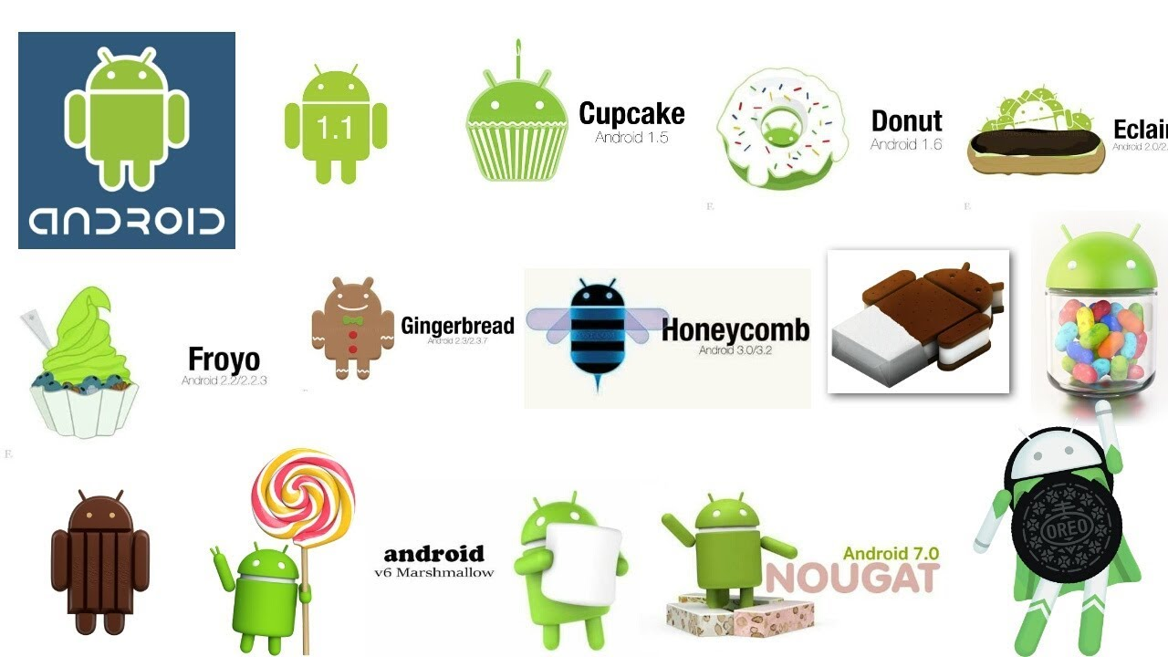
Src: https://i.ytimg.com/vi/pF_H4jbW41I/maxresdefault.jpg

Below we can see a table of all android versions with their corresponding release date, version and API level. I will also cover some of the most notable features and changes implemented at different version levels.
Version name: | Version number: | Release date: | API level:
 | 1.0 | September 2008 | 1
 | 1.1 | February 2009 | 2
Cupcake | 1.5 | April 2009 | 3
Donut | 1.6 | September 2009 | 4
Eclair | 2.0 - 2.1 | October 2009 | 5-7
Froyo | 2.2 – 2.2.3 | May 2010 | 8
Gingerbread | 2.3 – 2.3.7 | December 2010 | 9-10
Honeycomb | 3.0 – 3.2.6 | February 2011 | 11-13
Ice cream sandwich | 4.0 – 4.0.4 | October 2011 | 14-15
Jelly Bean | 4.1 – 4.3.1 | July 2012 | 16-18
Kitkat | 4.4 – 4.4.4 | October 2013 | 19-20
Lollipop | 5.0 – 5.1.1 | November 2014 | 21-22
Marshmallow | 6.0 – 6.0.1 | October 2015 | 23
Nougat | 7.0 – 7.1.2 | August 2016 | 24-25
Oreo | 8.0 – Present | August 2017 | 26-27

No codename – version 1.0
The first commercially available version of Android released on 23rd September 2008 came with a lot of features that we still have in Android to this day, they have been updated multiple times since then however they have been the ground to the OS as we know it today. It has been designed for the flagship phone at the time HTC Dream.
Most notably version 1 came equipped with an Android Market application which allows users to download applications straight onto their devices. It also came equipped with a web browser which supported the use of multiple tabs and zooming. Camera support, folder management, email server connectivity, YouTube, Google Maps as well as other obvious features such as Contacts, Calendar or text messaging application. It was a solid basis for a first commercial release back in 2008.

No codename – version 1.1
Version 1.1 brought minor changes, some of the most notable ones were the changes implemented to the Google Maps application which included business and reviews as well as the ability to save attachments in messages.

Cupcake – version 1.5
Cupcake was the first version which has been released with a code name after a dessert; this trend has since stuck for all the version releases. Cupcake has brought some influential changes which made Android a serious competitor to iOS based iPhone.
One of the main features which gave an edge for Android over iOS was the implementation of widgets, small applications which can be positioned on the home screen to provide limited functionality and quick access to some key features. Widgets provided android with another level of customisability which iPhones did not.
Cupcake was also a significant update due to the implementation of on screen keyboards with predictive typing, a rival to the autocorrect implemented by iOS. This was the turning point for android devices where physical keyboards would no longer be required.
Some of the other features worth mentioning involved animated screen transitions, auto screen rotation option as well as the copy and paste ability in the web browser.

Donut – version 1.6
Donut has brought some improvements to the OS which made multimedia applications more responsive and quicker to use, apps responsible for the camera, gallery and the cam recorder have been improved.
Google has also implemented the ability to search the web with voice entry on top of the traditional textual search engine; voice entry search has also been expanded to support bookmarks as well as contacts.
Donut has also been the first OS version which implemented the GestureBuilder development tool so that users can build their own gestures and assign custom functionality to them, a great tool for personalising Android devices to fit the user.

Eclair – version 2.0
Eclair arrived packed with features and changes to improve the speed and responsiveness of Android devices even further. The hardware has been optimized and the User Interface undergone a major revamp.
Eclair has brought support for more screen sizes and resolutions and optimised the UI to suit that, this was a major improvement to the OS, making it display better on a broader range of devices, expanding the Android circle of phones as well as tablets.
There have been several improvements to the camera features, features such as flash, digital zoom, colour effects and scene

Project Diary
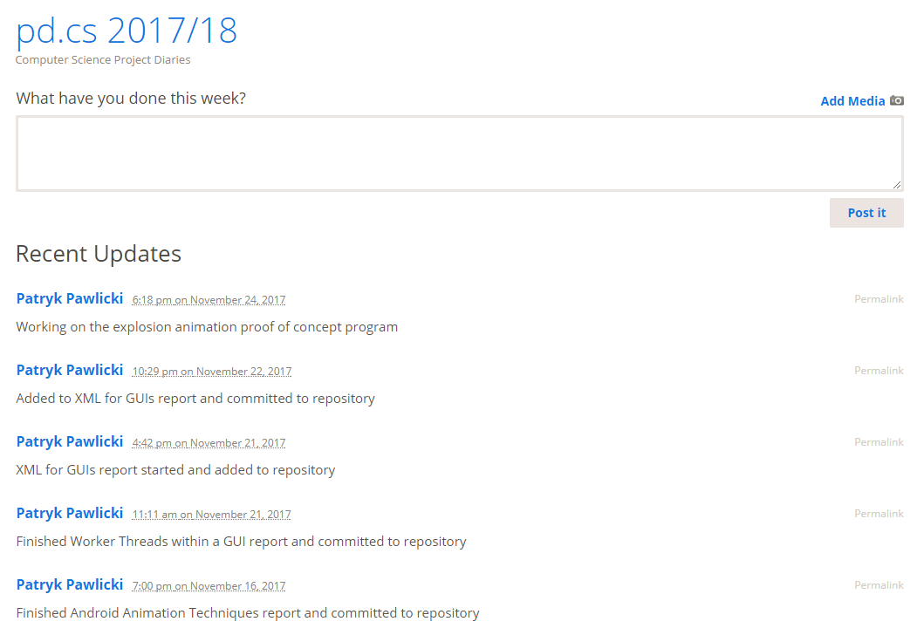
- Computer Science Project Diaries (https://pd.cs.rhul.ac.uk/2017-18/)
In order to log my progress on the project, I have been posting updates on the blog. These aid the development and clearly illustrate the progress at any given point of the project. The blog helps me to stay organised and make sure that all of the tasks I am currently working on, planning on working on, or the tasks I have finished are accordingly logged.
Figure 1 shows a screenshot of my diary and some of the recent updates I have made to log my progress. I will be using the diary throughout my project to stay organised and up to date with the previously written plan of action for the project.

Proof of concept programs

Hello World
My first proof of concept program is the classic “Hello World” program. The idea behind the program is very simple, it includes an empty interface with a button, which when pressed displays the “Hello World” message in the middle of the UI.
This functionality is achieved through the use of an onClick() method called “showHello” in order to alter the text of a blank text field. We can see that on Figure 2 below.
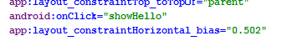
- showHello method linked in the button XML to be triggered on button click
In order to make the method work, I had to write relevant code which will change the text of the empty TextView object which has also been added to the View. We can see that in Figure 3.
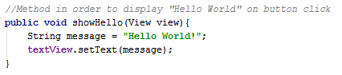
- showHello method defined in the java file
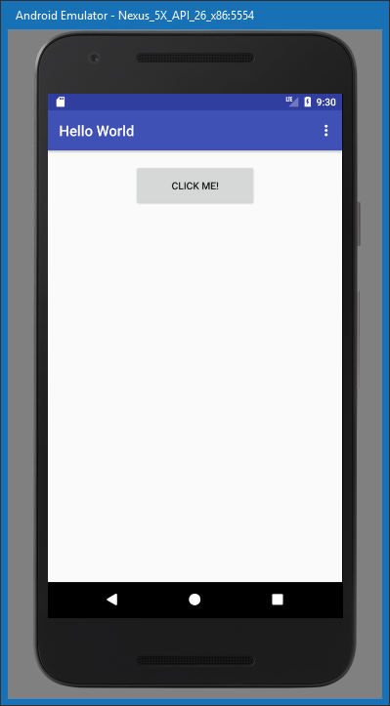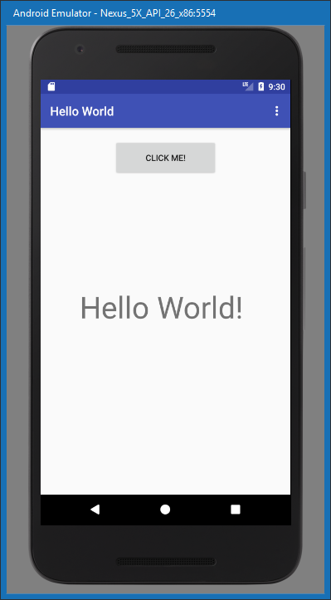
- Hello World application before button click (left) and after the button click (right)
The Hello World program is a very basic structure however it has helped me to understand how to use the GUI builder in order to add objects as well as change their state through the use of onClick methods. It was a necessary learning step to learn the basics about manipulating objects programmatically as well as creating basic user interfaces.

Explosion Animation
The explosion animation proof of concept program has been my introduction to implementing animation into the user interface. The animation technique I have decided to use for this purpose is by using drawable objects.
The first thing I had to do is to source my images for the explosion animation and split them up into individual frames so that when played back quickly in order, motion will be formed and the animation will be displayed smoothly.
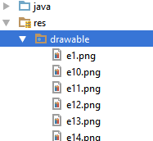
- Source folder with all the drawable frames of my animation
The first step is copying my images into the project resources under the drawable folder as displayed in Figure 5.
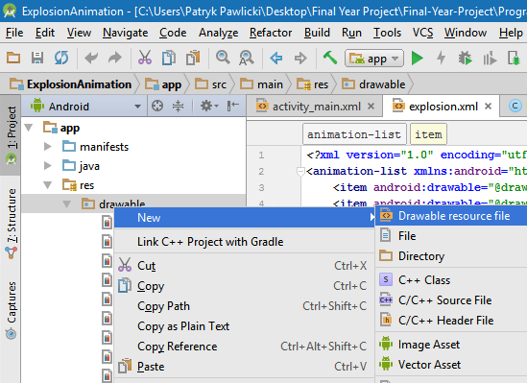
- Creating a new drawable resource file
The next step is creating a drawable resource file in order to define our drawable animation and all of its frames in order so that they can all be animated. We can see the process of me defining a new resource file in Figure 6.
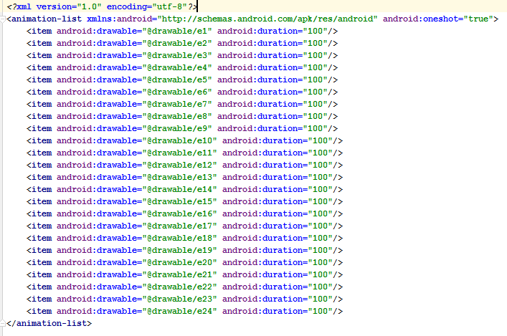
- Drawable resource file defining all of the frames as drawable items in order to compose an animation-list
The next step is to add all of the drawable animation frame images as items to the and set the duration so that the animation list can be composed. The second line also includes a definition “onceshot” which is set to true, this basically means the animation will display once and stop, instead of looping constantly.
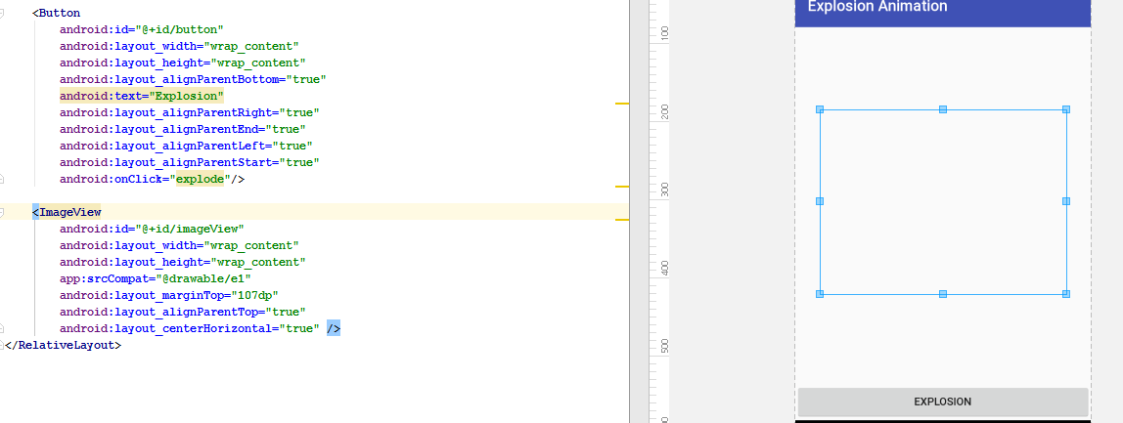
- GUI builder displaying my animation added as an ImageView as well as a button to trigger the “explode” animation
After we have our animation list composed we can add it to the UI y adding a ImageView object onto the canvas and referring to the first image of the animation in the XML properties.

Finally we are ready to edit our java file corresponding to this Activity. We have to define all of the new objects that have been added to the View, such as the button and the ImageView. After that we link our ImageView animation with the XML file which defines all of the frames which compose the animation list which I have described earlier and define the animation.
We can see that in Figure 9.
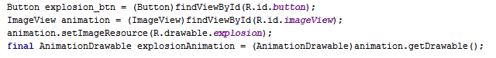
- Definition of all of the objects and animation
The last step is to add a button listener which will trigger the animation when the button is pressed.
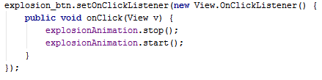
- Explosion button listener that triggers the animation
Figure 10 shows the structure of the listener method. An interesting thing worth mentioning is that the stop() method gets called before the start() method is called every time the button is click. This is in order so that if the animation is already running and the button is pressed, the application fill restart the animation. I have found that this is a necessary in order to make the animation run without any problems.
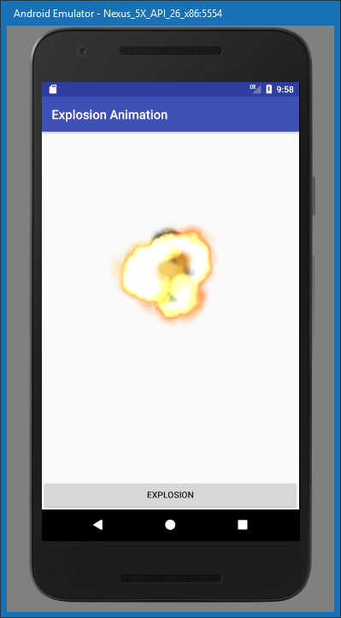
- Explosion animation at work
This proof of concept program has taught me the fundamentals of creating animation in the android framework. I have learnt how to use individual frames to compose an animation, how to control the playback speed and how to use button listeners in order to trigger events. I have previously used an onClick method in the XML code, this has been my first attempt at creating a button listener.

XML based User Interface
For my final proof of concept program I had to learn how to create multiple activities so that I can have more than user interface. I have also spent a significant amount of time using a graphical editing software in order to create the design for all of the objects required for a UI.
I wanted my UI to be aesthetically pleasing therefore I couldn’t use standard buttons which are provided by the Android SDK. I decided to design my own and use them to serve the purpose of a button.
I had to also learn how to navigate between activities when adequate buttons are pressed as well as how to close an application on button click.
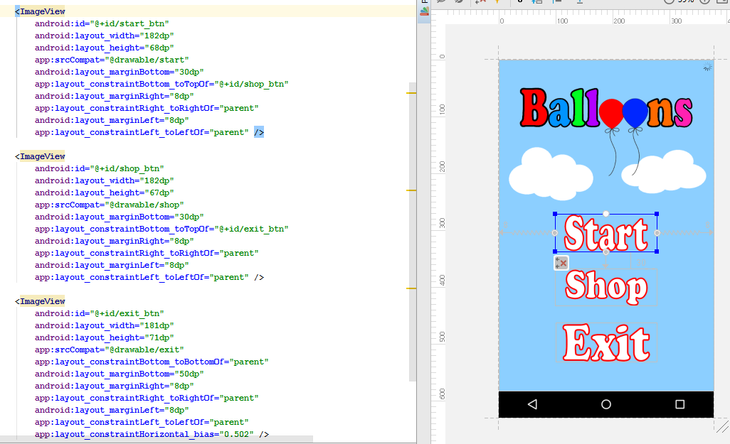
- Screenshot of the GUI builder and the corresponding XML file
Figure 12 shows how all of my custom made buttons are added to the UI as ImageView items, in order to make them functional I had to come up with button listeners for each one. I will now show an example of how I made my buttons navigate between different views as well as how the exit button works. The process of navigating between the user interfaces is the same for all of the buttons, therefore I will illustrate one.

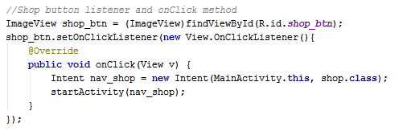
- Button listener for the “Shop” button
Figure 13 shows how I have used the “Intent” object in order to link my interfaces together. The intent basically defines the starting Activity (MainActivity.this) as well as the Activity we are navigating to (shop.class). This is all encapsulated in an inClick() event as standard.
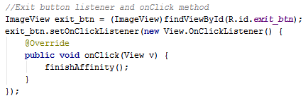
- Button listener for the “Exit” button
Figure 14 illustrates how the exit button works in order to close the application. This functionality is very easily achieved as it involves one method, however I am mentioning it as it is something now which I had to research in order to implement it with the use of finishAffinity() method.
Finally I wanted to cover how I managed to make the application display in full screen so that no name bar is included, this required some additional changes in the Android Manifest XML file. In order to make the views display in full screen, I had to change the theme of each one to “@style/AppTheme.NoActionBar”. This can be seen in Figure 15.
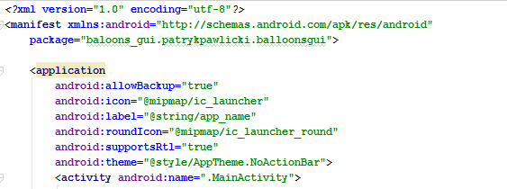
- AndroidManifest XML file defining the Activities within the application

Design of a GUI based mobile game

Game Concept
The concept I have came up for my GUI based mobile game is a game of balloons. The aim of the game is to pop helium filled balloons which are flying up from the bottom of the screen to the top. The game will progressively get harder, generating an increasing amount of balloons as well as increasing the speed of their movement. The game will end when the user has failed to catch a predefined number of balloons (based on difficulty).
The game will include special effects such as the ability to catch balloons which carry an additional balloon allowance, increasing the number of balloons a user can miss before losing a game, instant destruction of all balloons which are currently on the screen or coin rewards.
Coins are obtained through playing the game; the score achieved at the end of the game will be converted into coins which can be spent in the shop. The shop will allow the users to purchase upgrades which increase their balloon allowance or increase the multiplier which awards coins based on their score. After every round ends, the user will see a screen which will inform him on their score and display some statistics such as: time in game, balloons popped and coins earned.
A potential extension to my game would be implementing a High Score table which would store player’s scores securely off-phone in order to enable competition. Such high score table could contain different categories in which the players could compete on. These could include: most points scored in a round, most balloons popped (overall), longest survival time, etc.

Initial Game Design
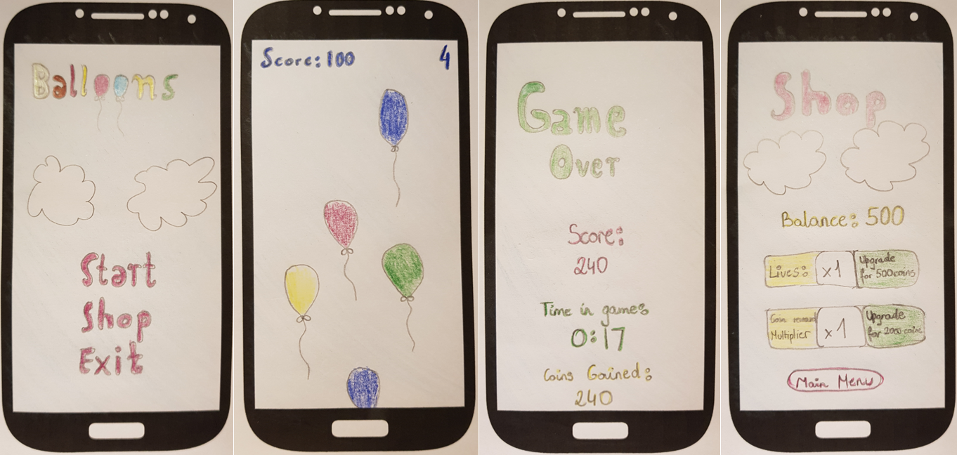
- Initial sketches of my game design
(from left to right: Main Menu, Gameplay, Shop UI, Game over UI)
Figure 16 illustrates some of my initial sketches I have done in order to come up with a design. I have then developed my design further and created it using graphical editing software called paint.net [1].
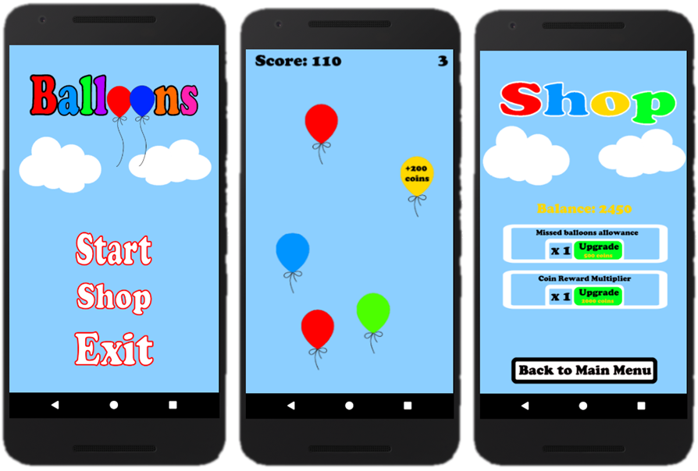
- Game Designs created with the use a graphical editing software
Figure 17 illustrated the designs I have came up with using graphical editing software. The design is likely to change during the development process. I have aimed to come up with a game design that will be colourful, readable and easy to navigate.

Framework

Android Studio
Android Studio is the official IDE (Integrated Development Environment) made for Android application development. “Android Studio is built on IntelliJ and is capable of advanced code completion, refactoring, and code analysis.”[2] IntelliJ[3] is one of the most popular IDE with growing popularity which provides a range of useful tools for software development.
The software also includes a range of other useful tools such a built in Emulator which allows us for rapid testing of our application as we develop, it allows us to test on different devices, screen sizes and preferences. This greatly aids development and software optimisation on order to make it run well on all sorts of android devices.
Development of the graphical UI in Android Studio is carried out through the use of a built in GUI builder which allows the user to add objects onto the View and easily manipulate them in order to achieve the desired structure. The XML code for the View is automatically generated. I cover this topic in more detail in Section 9.2.
Android Studio is the most popular choice amongst Android app developers therefore it was an obvious choice as it comes with a very broad support from the community, the SDK is very well documented and due to the large following, it’s very easy to find answers to common problems on various forums.

Version Control
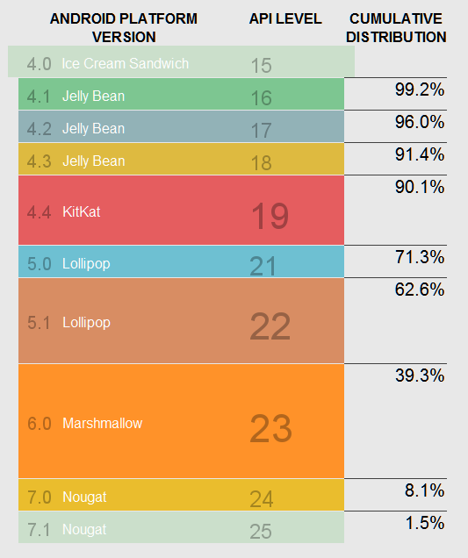
- Supported devices based on API level [4]
Figure 18 illustrates a table with all of the latest Android platform versions and their support amongst Android devices currently used on the market. Choosing the right API Level was an important decision I had to make prior to starting my app development.
When choosing the API, the goal is to achieve the right balance. I aimed to maximize the amount of devices my app can run on, without having to choose a version which is too outdated, meaning it might lack some of the new features and improvements implemented in the newer iterations.
I have decided to choose Android 4.4 Kitkat [5], due to it supporting over 90% of devices currently on the market whilst still offering some of the fresher features of the Android framework, most notably, the immersive full-screen mode [6] which has been added in this API version.

Android Life Cycle

Activities in Android
In Android, the users navigate through different activity instances as the applications are being used, or navigated in and out of. All the transitions between applications or within a single application correspond to a change in an activity state of an application. This is done through the Activity class via a series of callback methods which are used for pausing, stopping, starting or resuming an activity.
It’s very important to consider what happens when an application is interrupted by things such as phone calls, alarms or even user input which will result in the application being paused or stopped. It’s important to define what happens in those instances so that the progress of our game is not lost and the user can switch between the applications fairly seamlessly without consuming system resources without using them.
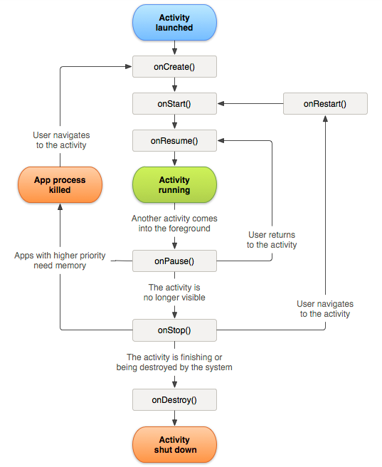
- Activity Life Cycle [7]

Callbacks
There are 6 main callbacks:
- onCreate()
- onStart()
- onResume()
- onPause()
- onStop()
- onDestroy()

OnCreate()
In this state the system will create and configure the backbone of the program required for the lifecycle of its operation, also things like layout for the main activity or the first UI would be configured here.
However onCreate is not a state that the application will stay on for long and after everything is set up, the activity will always move onto the onStart() state.

OnStart()
The started state is another quick state in which the activity doesn’t stay for long, its main purpose is to make the app interactive and make the activity available to the user. If the activity comes to the foreground it is then followed by onResume(), if it doesn’t it will be followed by the onStop() callback.

OnResume()
When applications are being actively used by the user and being interacted with, the activity will spend the most time in the Resumed state, until it gets disrupted by user input or other applications so that the focus is taken off it.
The resume state is at the top of the activity stack and has the least likelihood of being killed to free up memory. It has priority over other running applications and is currently in the spotlight.

OnPause()
onPause() state is called when the focus is taken off the application, it does exactly what it says, it pauses the application without killing it so that the system can come back to it later without losing any progress, the application is still running but is paused and in the background. This is an opposite state from resume. When in this state, there are two possibilities, either onResume() will be called and the application will carry on or onStop() will be called in order to stop it.

OnStop()
This callback is called when the activity has either finished running or when the UI is no longer visible to the user. After the call, the activity releases the resources it doesn’t need to free up memory, all the necessary CPU intensive operations can be performed on this callback, such as saving data to the database, etc. This callback is often followed by onRestart() or onDestroy() callback.

OnDestroy()
This is the final call of an activity, after it is invoked the activity gets destroyed and all the remaining resources gets released.

Activity State and ejection from memory
The system will kill processes in order to free up memory when needed to do so, the decision on what processes should be killed is dependent on the state of the activity within that process. This ensures that the system will not kill the application actively being used by the user but will rather prioritize processes which correspond to applications currently not in use.
Below we can see a table which talks about different activity states and the likelihood of the system killing them.
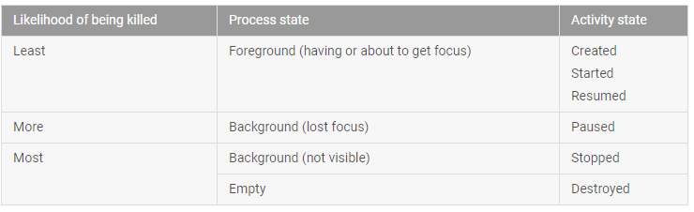
- Relationship between process lifecycle and activity state [8]

Worker Threads within a GUI

UI Thread
By default, the User Interface in the android framework is controlled by one thread, often referred to as the UI thread or the “main” thread of execution. It is responsible for everything the user sees on the screen while interacting with the application. This is not ideal as operations which take longer to compute will block the UI making our app unresponsive for the user and force them to wait until the operation finishes or even worst, trigger the Application Not Responding notification, which allows the user to close our application. We can avoid this with the user of worker threads.

What are worker threads
Worker threads have been introduced in order to take the load off the UI thread which is responsible for controlling the UI. Having all of our operations on the UI thread can have detrimental effects to the performance of our application. All the time intensive tasks such as querying the database, carrying out complex calculation or performing network functionality would mean that the GUI that the user is interacting with, would appear to be hanging as it becomes unresponsive to input until the operation finishes.
With game development it is essential to carry out all of the work and calculations in a worker thread, whilst the UI thread should focus on the graphical aspect of our application such as drawing animations and responding to user input.
Worker threads are basically threads which work in the background of our application, they are referred to as “worker” as they carry out work which the user can’t see and they are not allowed to interact with the UI directly, only objects which are part of the UI have access to the thread, an example of this would be the View objects.
In order to allow the background threads to communicate with the UI thread, the Android framework provides us with a few useful tools in order to allow communication between the worker threads as well as the UI thread. The most common one is to use a Handler. Handlers are responsible for thread management and allow messages to be exchanged between the worker thread as well as the UI thread.

AsyncTask
A common alternative to using Handlers is the use of AsyncTask subclass which provides us with a set of useful methods which make it even easier for background threads to communicate with the UI thread and exchange messages.
The process of passing on a message from the worker thread onto the UI thread is as simple as using a few methods which I will briefly cover below:

doInBackground():
This is where all of the work in our worker thread is carried out, all of the complex calculations, database queries and other time intensive operations would go here. Whenever we would want to communicate with the UI thread and update it with the progress from our operation, we call the publishProgress() method from within this method which invokes the onProgressUpdate(), this is where we specify the reaction to our method call, this could be as simple as updating the progress bar.

onPostExectute():
This method would be called after all of our time intensive background work has been finished, inside of this method we would specify the action carried out after that has taken place. It could be some meaningful change in UI or as simple as displaying a little message.
For example, if we used the above described structure to represent a user downloading an application of the web, all the intensive processing would go iniside of the doInBackground() method, which would allow the user to still interact with the UI. Once in a while the publishProgress() method would be called to update the UI on the progress of that activity, could be as simple as updating the progress bar. Finally the onPostExecute() the UI could display a little window notifying the user that the file has finished downloading.

Application Not Responding (ANR)
Android has a system guard implemented against unresponsive applications which hang for extensive amounts of time, making the user wait. In the event of an application being insufficiently responsive for a period of time by displaying a dialog that says the app has stopped working,
Figure 21 illustrates such dialog box. [9]
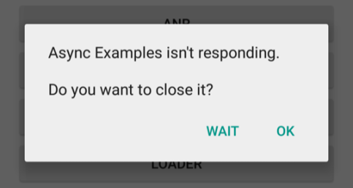
- Application Not Responding Dialog Box [10]
Generally the ANR dialog box will appear after the application has been unresponsive to user input for about 5 seconds; it will then throw up the dialog box asking the user whether they want to close the application as it is not responding.
In order to avoid the ANR dialog boxes from appearing on our application it is vital to make sure that the operations do not block the UI thread which would result in the GUI being unresponsive.
The use of worker threads allows us to minimize the risk of our application being sluggish or unresponsive and having to deal with the dreaded ANR dialog box. On top of using worker threads alongside our UI thread it is important to make sure that the workload that is carried out directly in our UI thread takes as little processing time as possible.

Design Patterns

What are design patterns
Design patterns aim to create reusable solutions to common software development problems. They can “even improve the documentation and maintenance of existing systems by furnishing an explicit specification of class and object interactions and their underlying intent.” [11]
Design patterns add clarity to the code and make it much easier to maintain, edit and test. Design patterns are solutions which are widely recognised by the industry therefore the intent of our implementation is much easier to understand as it can be explicitly specified in the documentation.
There are 3 main types of design patterns: Creational, Structural and Behavioural. I will cover some of the design patterns that can be used in the Android framework and can potentially aid the development of my game.

Types of design patterns

Creational
Builder:
The builder pattern is a commonly used in order to create multiple complex objects out of basic objects collectively. It makes it much easier to create them in mass amounts, the implementation makes sure our code is much cleaner and reduces the repetition. It allows us to use the same objects for various representations, or representations of other complex objects, which might consist of different basic objects.
Dependency Injection:
Dependency injection is a pattern where the dependency is not given to an object on creation; it is rather “injected” into it externally. In simple terms, this basically means that we are passing instance variables to our objects externally after they are created rather than on creation. There are multiple ways we can inject dependencies into our objects, two most basic methods to “inject” dependencies are through the constructors or setters. [12]
Dependency injection is especially useful when testing, it allows us to isolate classes in order so that a stub object can be passed and appropriate functionality can be easily tested.
Singleton:
This design pattern is used where only a single instance of a class is needed to be globally accessed. The class, with the way it’s written, implements a static method which returns an instance of the class, which can be initialized only once in the entire program, the constructor cannot be invoked. This is useful for modelling real life objects which can only exist as a single instance, singleton allows the instance to be accesses from anywhere within the program, it has a global access. [13]

Structural
Adapter:
The purpose of the adapter design pattern is to create a bridge between two classes which are not compatible and make it possible for them to work. The way that this is achieved is by converting our current class into an interface which we want the user to see. It’s very useful when working with classes that are not compatible but provide essential functionality for us, we can “adapt” them through a use of specifically written methods so that they convert their interface into one more suitable to achieve our goal.
Facade:
The goal behind the facade design pattern is to hide the underlying complexity of the system from the user. It’s about building an interface which will contain what the user needs without the unnecessary complexity behind it. We can think of it just like the literal real world use of facade, it’s a cover up, a fancy clean interface to hide all the nasty inner workings of a program.

Behavioural
Command:
“Command decouples the object that invokes the operation from the one that knows how to perform it. “Error: Reference source not found The invoker received a command hidden in an object and then passes it to the appropriate object which handles a given request. This pattern is useful when wanting to issue a command without knowing the receiver; the pattern handles our request and forwards the command to an appropriate object so that it can be dealt with.
Observer:
The observer pattern is used in order to be able to monitor changes in other objects. Whenever a change is detected, an observable object will notify all of its observers and the changes could be acted upon through the use of various methods. The observer pattern aims to decouple objects so that they are easy to change and maintain.

Animation Techniques

Animation Techniques used in the Android Framework
In the Android framework there are several animation techniques which can be used for both 2D as well as 3D graphics. The choice on which technique to use greatly depends on what we are trying to achieve since all of them have their pros and cons.
There are three main systems used in Android to create animation:
- Property Animation
- View Animation
- Drawable Animation
Along with the animation techniques there are frameworks which allow us to create 2D and 3D graphics in order to be used for our animations. The most common method is using Canvas and Drawables, which is powerful enough for most animation needs; there is also an alternative of using the OPEN GL ES framework which allows us to create more sophisticated and powerful graphics.

Property Animation
Property Animation focuses on the object properties in order to animate it. That can involve changing its X and Y coordinates in order to move it around the screen, altering its size properties to scale or rotate 2D or even 3D object by choosing a pivot point. We can also change alpha transparency of objects, which is useful to fade objects in and out of the view.
All of this is performed based on the duration of the animation; we can choose what kind of movement we want, over a specific timeframe. Longer duration or smaller change in properties will result in a slower animation, where as shorter animation duration or bigger change in properties over a timeframe will result in a quicker animation.
The animation interpolation can be linear meaning the movement will be the same within the duration of an animation (for example; change X coordinate from 0 to 50 over 50ms, 10ms being in increase of X coordinate by 10) resulting in a smooth consistent animation, or non-linear meaning the animation will change speed as the change in properties will not be constant within a time frame. We can even make the animation stop and resume after a given timeframe. All of this is possible due to the use of the “TimeInterpolators” provided by android or the use of Key frames which we can create and set up ourselves. Keyframes are a tool commonly used in filmmaking and animation, Keyframe is also a class used by Value Animator.
Property animation can be declared in both XML as well as programmatically. The main advantage of doing it in XML is the fact that we can reuse the code for more than one object or more than one activity, synchronising the animation sequence is also easier using XML.

View Animation
View animation, also referred to as “Tween Animation” is an older animation system implemented in the Android API. Just like property animation it allows us to animate view objects by moving them around, scaling, rotating and even changing the alpha transparency settings. The main disadvantage of using View Animation is the fact that it only allows us to work with view objects, whereas property animation allows us to work with any object.
Just like property animation we have the option to animate objects using XML or programmatically, with XML being the preferred option due to the ability to reuse code for more than one object; it is also a much cleaner, more readable implementation.
The speed of an animation is defined by assigning an Interpolar, the same technique which I have covered in the Property Animation.
The main problem with view animation compared to property animation is the fact that if we wanted to animate a button to move across the screen, visually it would do exactly what we ask it to do, but the physical button which we can click that provides functionality would stay in the original button location. Therefore if we wanted to animate a button using a view animation, it would no longer work when clicked and in order to move the functionality of the button to make it clickable again we would have to code that separately.
View animation is a very basic technique and it doesn’t require much code to write, it’s a good option when working with basic animation in views, where it’s flaws or inability to animate objects outside of view are not a problem.

Drawable Animation
Drawable animation is a technique where all of the images are loaded in and then played in sequence in order to create movement. It is done via the AnimationDrawable class.
Drawable animation is a very common technique for animation; it allows the use of spritesheets. Spritesheet is a series of images which are all in a slightly different positions, so when played back quickly in series, they appear to be moving, it’s just like having individual frames of a movie which are played back quickly to create movement. Spritesheets have been in most classic games and are still used today in modern games, for example a very successful game “Cut the rope” is also based on drawable animation using spritesheets.
Drawable Animation offers a lot of flexibility, the smoothness of animation can be chosen by deciding how many images we would like to use for our movement, the more we use, the smoother the animation and it will allow us to play it back slower without being able to notice the transition, however it will mean we will have to implement more individual images. It’s a bit like frame rate, the more we have the smoother it is, however it will also require more computational power in order to be played back.

2D and 3D Graphics
The android framework provides a variety of drawing APIs for 2D graphics which allow a user to generate and animate custom graphics for their application needs. There are two main ways of how graphics is done on the android frameworks, drawing graphics using the View object in the layout section or drawing graphics onto the Canvas object. Android framework also has a Drawable library which provides us with a range of tools for drawing shapes and graphics.

Canvas and Drawable
Canvas and Drawables are the most sensible option for creating custom 2D graphics for an android game, it’s perfect for rapidly changing animation unlike drawing straight on top of View. Graphics can be either drawn using the tools provided by the Drawable library or imported from our project resources, therefore techniques such as the use of sprites can be utilised.
The supported file types are PNG, JPG or GIF, however PNG is the proffered file type for the drawable library. When images are imported from project resource files, the images are automatically optimized using a lossless compression in order to reduce their size.
Drawable class has a useful subclass called ShapeDrawable which is a handy tool to create two dimensional graphics of primitive shapes. We can define and customise the size, position as well as colour properties and get our shape drawn onto the View.
An alternative to this is using vector drawables which are defined by a set of points, lines or curves which are also an option in the Drawable library.

OpenGL ES
OpenGL ES is a library in the Android framework which allows creating sophisticated 2D and 3D graphics which can be used for animation. The objects are formed through the use of matrices with a set of coordinates in order to define a shape. OpenGL has a very powerful toolset however it is very complex and requires a lot of coding in order to come up with 3D graphics of high quality, for my game I will most likely be focusing on the use of Canvas as well as drawables.

XML for GUIs

GUI design in Android
In the android framework there are two ways of defining the layout for Graphical User Interfaces, we can either programmatically manipulate the properties of objects or use XML in order to format out GUI according to our preferences. In this section, the focus will be on XML and how GUI builder is used in order to generate it.

Using XML to set the layout:
The main advantage of choosing to use XML over formatting the GUI programmatically is that we still have the ability to modify the layout and state of objects at run time, yet we separate the main code from the UI layout.
Declaring the UI in XML also means that the code can be reused or with slight changes multiple views can be created in order to suit different devices or screen resolutions in order to achieve the best possible optimization. XML driven UI’s are also much easier to edit and format as they allow the user to visualize the structure and make necessary changes using a graphical interface which generates the appropriate cod. It also provides the ability to replicate properties of a single object so that other objects so that consistency can be easily achieved amongst them when designing the UI.
The XML code is generated through the use of the inbuilt GUI builder which allows the user to drag and drop objects onto the View in order to create a GUI. Objects can easily be positioned and moved around whilst setting up various preferences is only click away and can be set up very easily. The XML code is automatically generated for the user so that no coding is required in order to set up the GUI. Therefore it’s very easy to create, modify and reuse the View specification which has been constructed using the UI builder to generate XML code.

View Group Layouts
The android framework comes with a series of layouts and views which are prewritten, they come as a subclass of ViewGroup, and some of the main ones include:
Linear Layout:
This layout organises the children elements in vertical rows
Relative Layout:
This layout organises the children elements in relative position to other elements or in relation to the container that it resides in
Absolute Layout:
This layout organises the children in exact positions on the view, the positions are defined by X and Y coordinates of the object
List View:
This view groups the children and allows them to be viewed in the scrollable list
Grid View:
This view groups the children and allows them to be displayed in a scrollable grid

ID
Each object can be uniquely identified with by an ID which can be assigned to it. IDs are strings, but when the program gets compiled they get changed into integers.
The ID can be used in order to refer to individual objects in order to manipulate them programmatically after we create an instance of them. We refer to object through the use of findViewById() method.
In order to declare a new ID we have to use a “+” sign, which basically means it will be added to the resources directory, “R.java” by default. After that they can just be referenced without the “+” sign.
Declaring and adding a new object in XML:
android:id="@+id/my_button"
Creating an instance:
Button myButton = (Button) findViewById(R.id.my_button);

Attributes
Attributes are used to define properties of different objects; they are different for various objects. For instance, we can create a button object, in order to define its properties we use attributes such as “text”, ”layout_width” or “layout_height”.
“id” is an attribute that is available to all kinds of objects.
Before we refer to an attribute we use the “android:” tag to refer to the library.
An example of an object reference with attributes:
<Button
android:id="@+id/button_id"
android:layout_height="wrap_content"
android:layout_width="wrap_content"
android:text="@string/self_destruct"
/>

Special considerations for mobile applications

Threads

Workers

Devices

Hardware

Screen size

Battery Consumption

Interesting programming techniques and data structures used in the project

Bibliography
- Paint.net software: https://www.getpaint.net/index.html
- Android Studio: https://developer.android.com/studio/index.html
- IntelliJ: https://www.jetbrains.com/idea/
- Sourced from Android Studio – Android Platform/API Version Distribution
- Android 4.4 API: https://developer.android.com/about/versions/android-4.4.html
- Immersive full-screen mode: https://developer.android.com/reference/android/view/View.html#SYSTEM_UI_FLAG_IMMERSIVE
- Figure 1 – Activity-lifecycle concepts, A simplified illustration of the activity lifecycle: https://developer.android.com/guide/components/images/activity_lifecycle.png
- Figure 2 – Activity state and ejection from memory, Table 1: https://developer.android.com/guide/components/activities/activity-lifecycle.html
- Keeping your app responsive: https://developer.android.com/training/articles/perf-anr.html
- Figure 3 – Keeping your app responsive, Figure 1 – An ANR dialog displayed to the user: https://developer.android.com/training/articles/perf-anr.html
- Gamme. E, Helm. R, Johnson. R, Vlissides. J (1994) Page 11 Design Patterns – Elements of Reusable Object-Oriented Software
- James Shore, Dependency Injection Demystified: http://www.jamesshore.com/Blog/Dependency-Injection-Demystified.html
- D.A. Cohen, CS2800 Software Engineering, Week 7:
GUI Design and Design Patterns
- Source Making – Command Design Pattern; https://sourcemaking.com/design_patterns/command

