

EHRServer v0.5 guide

Introduction

EHRServer is a generic, minimal, open source, standard-based, service-oriented, openEHR clinical data storage. It provides an administration Web GUI and a REST API for committing and querying openEHR clinical documents and data values.

EHRServer was designed and developed by Eng. Pablo Pazos Gutiérrez at CaboLabs Healthcare Informatics.

I’m interested… Can I try openEHR?

Yes. You have two options:

- Test it on our staging server online
- Install it and test it in your machine

How to use EHRServer from our staging server (TL;DR guide)

You are busy, we know it. This is the shortest explanation of what you can do by using the EHRServer Web GUI:

1) You need an account

Open the Web App: https://cabolabs-ehrserver.rhcloud.com/ehr

Go to “Create an Account”. You will receive an email with an organization number and a link to reset your password. After this you are all set to use EHRServer.

2) Login and create some patients

When you created your account, you also created an organization. The organization can be a clinic, hospital, etc. You need to create some patients, and those patients will be associated to your organization.

Login into the EHRServer, using your username, password and organization number.

Go to People > New Person, fill the form and click on Create.

Go to People, and on the patient’s row, click on Create EHR. Now your patient has an empty EHR.

So far so good, now you need to add some data to your patient’s EHR.

3) Commit data to an EHR

The easiest way of committing data to an EHR in EHRServer, is to use our testing app: EHRCommitter.

Go to: http://committer-ehrserver.rhcloud.com/committer

Login using your EHRServer credentials: username, password and organization number.

Select a clinical document from the list.

Select a patient from the list (your patient should be there!).

Fill the form or keep it as it is (with autogenerated testing data), and click on Save. This will send the data to EHRServer (invokes the commit service from the REST API). You can send as many documents you want.

4) I want to query data!

Yes, once you get your data in, you don’t want it to be stuck in the EHR. You want to query data and use it in different ways.

You can query for clinical documents or for data values.

Go to Queries > New Query.

Assign a name and select a type: “composition” means you want to query documents, “datavalue” means you want to query data.

4.1) Querying documents

1) Assign a name and select type “composition”.

2) Select a concept to define the criteria e.g. “Blood Pressure”

3) Select a data point to define the criteria e.g. Diastolic

4) Define the criteria e.g. magnitude > 90 and units = mm[Hg]

You can define as more conditions as part of your query criteria. We also defined a condition over Systolic to have magnitude > 140 and units = mm[Hg]

5) Select the criteria logic “and” or “or”, this will define how to interpret all your conditions. We selected “or”.

6) Our final criteria match all the clinical documents that have a record of high blood pressure. You can create other queries to match documents based on your requirements.

7) Click on “Create” to save your query.
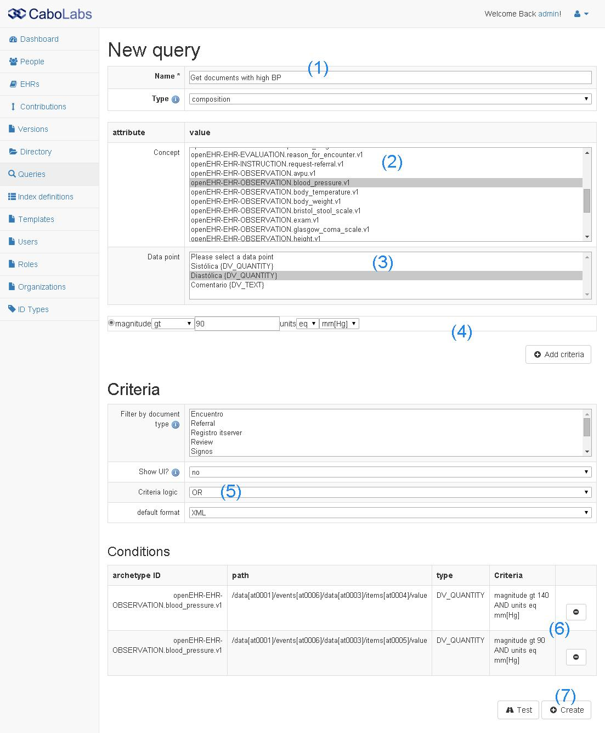

From the query creation screen you can also test your query to see if it was correctly defined and you get the data you expect. Click on “Test” and 1) Select an EHR of a patient (if no EHR is selected, the query will be executed over all the available EHRs, 2) then click on “Execute” and 3) Review the results (results are indexes, i.e. pointers to clinical docs, if you want the data, select “Retrieve data”).

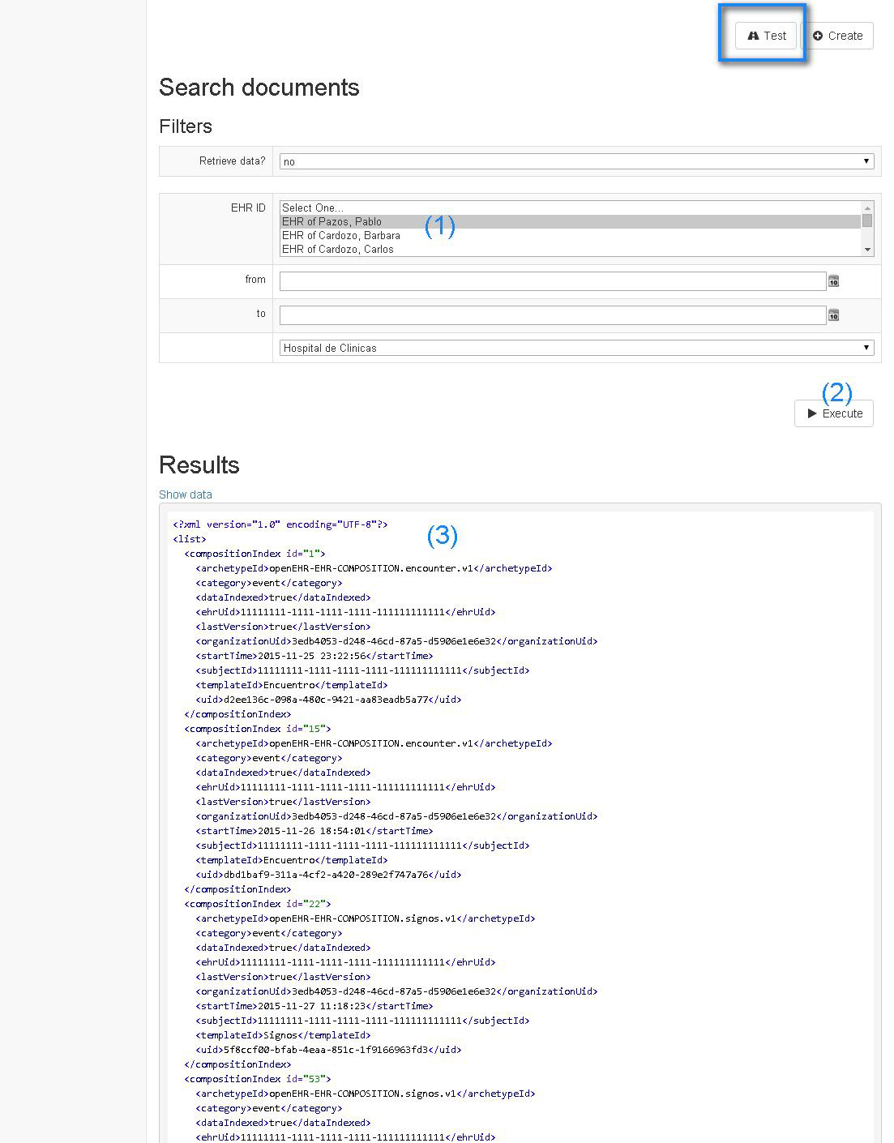

4.2) Querying data

Querying data is pretty easy, just select Concept and Data points and click on “Add projection”, that means that you want that data in the results. In the sample below we have selected Systolic and Diastolic Blood Pressure, Body Temperature, Body Weight, Respiration Rate, and Heart Rate (Pulse), so this is a pretty complete vital sign query.

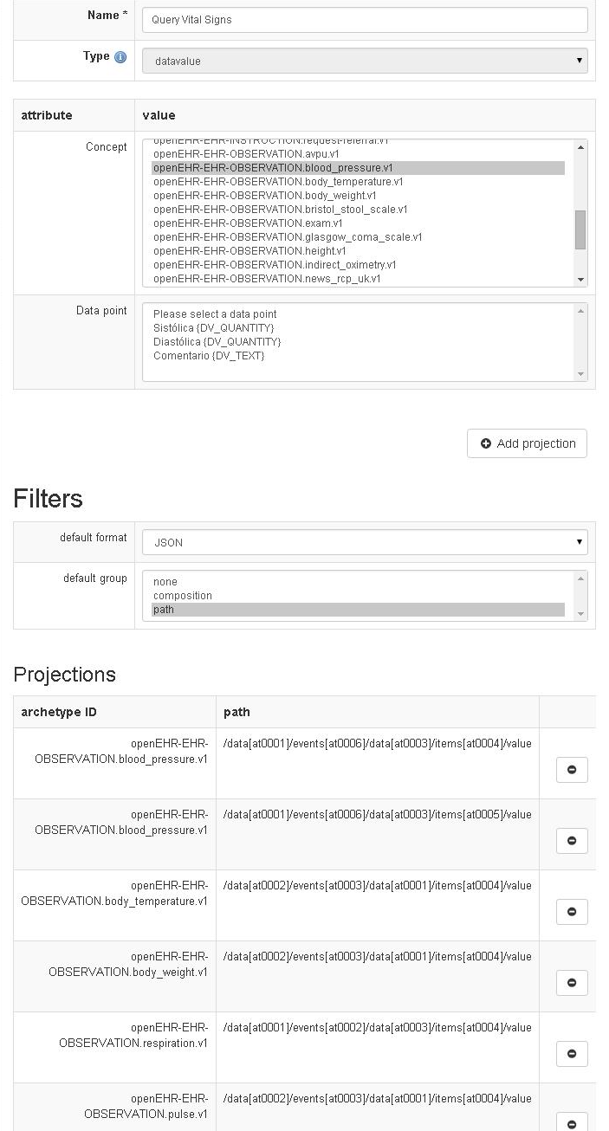
There are some output options like the output format (JSON or XML) and the default group (no grouping, group by composition or group by path).

Group by composition: data will be grouped by the clinical doc that contains the data.
Group by path: data will be grouped by the type of data, e.g. all Heart Rates will be contained on the same series (easy to chart). You can also test this query, and the process is the same as the composition query test.

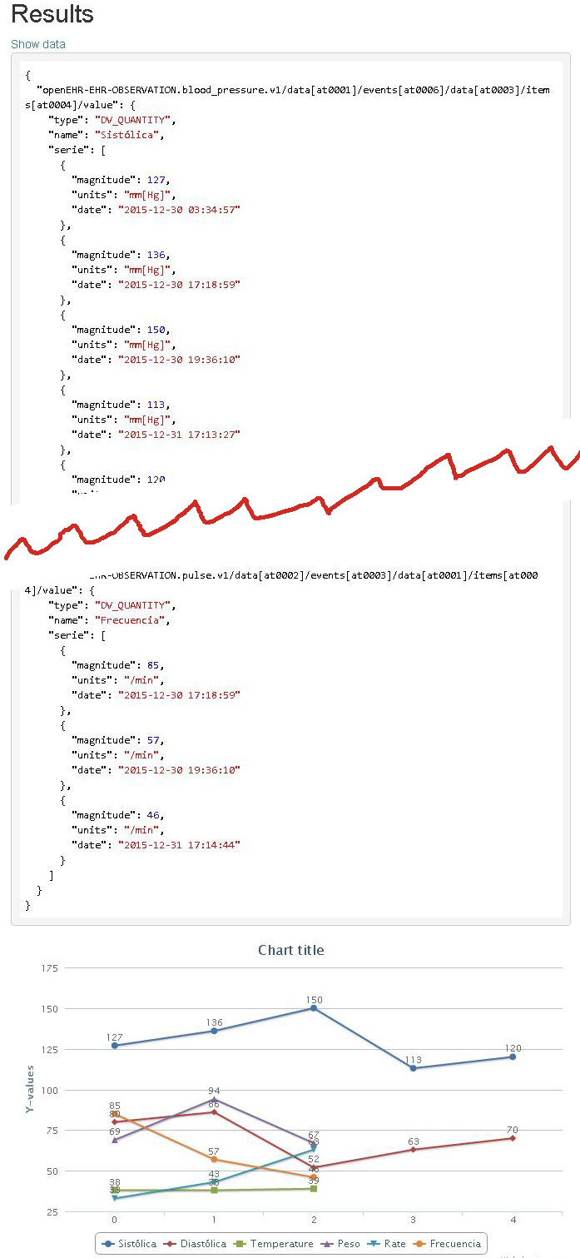
If you selected JSON as the result format, grouped the results by path, and the result includes numeric data, EHRServer will generate a small chart to show you the results in a graphical way (easy to verify that the results are the expected).

Installing EHRServer locally

Prerequisites:

1) Download and Install MySQL Server
https://dev.mysql.com/downloads/mysql/

2) Download and Install Grails 2.5.3
http://www.grails.org/download.html

3) Download EHRServer

You can download latest development version of EHRServer from here:
https://github.com/ppazos/cabolabs-ehrserver/archive/master.zip

You can download the latest release from here:
https://github.com/ppazos/cabolabs-ehrserver/releases

4) Configure the database

Edit the DaraSource, under the “development” environment, see:
https://github.com/ppazos/cabolabs-ehrserver/blob/master/grails-app/conf/DataSource.groovy

5) Run the EHRServer

Execute this command line from the project folder:

ehrserver/ grails -Dserver.port=8090 run-app

This will run the server locally, on the port 8090, so you will be able to access it through:
http://localhost:8090/ehr

Use admin / admin to login, and you are ready to go.

EHRServer Management

Supporting more clinical documents

TODO: OPT

http://www.openehr.org/downloads/modellingtools

Before committing any data, you need an Operational Template (OPT) that specifies the structure, semantics, constraints and terminology of your clinical documents. You can find OPT samples in our GitHub repo.

There are two ways of adding an OPT into EHRServer:

- Copy the OPT file into the “ehrserver/opts” folder. When EHRServer is started, it will automatically load all the OPTs from that folder.
- Upload the OPT file using the Administration User Interface. Just go to Templates > Upload Templates.

OPTs should comply with this XSD to be accepted by EHRServer:

https://github.com/ppazos/cabolabs-ehrserver/blob/master/xsd/OperationalTemplate.xsd

EHRServer REST API

TODO: endpoints, params, results

Commit Service

Before committing any data, you have to create a patient and his/her EHR. All committed clinical documents should be associated with an EHR.

That can be done using the Administration User Interface:

People > New Person (create the person with the patient role), then Create EHR for the new Person.

To commit data to EHRServer, use the commit REST service:

_baseurl_/rest/commit(String ehrId, Array xmlVersions, String auditSystemId, String auditCommitter)

Where:
- _baseurl_ is where EHRServer is running, e.g. http://localhost:8090/ehr/rest/commit
- ehrId is the UID of the EHR where the clinical documents are committed to
- xmlVersions is a set of clinical documents (called COMPOSITIONS in openEHR) in XML format, that are contained in a VERSION object that contains version control and audit information.
- auditSystemId is the UID of the API client
- auditCommitter is the name of the person responsible of the commit (we will add an id parameter to identify that person)

The XML VERSIONs should comply with this XSD:
https://github.com/ppazos/cabolabs-ehrserver/blob/master/xsd/Version.xsd

Sample VERSIONs in XML can be found here
https://github.com/ppazos/cabolabs-emrapp/tree/master/committed

To test the commit service without writing your own client, you can use one of these apps:

- https://github.com/ppazos/cabolabs-emrapp
- https://github.com/ppazos/EHRCommitter

Also check the unit test code:

- https://github.com/ppazos/cabolabs-ehrserver/blob/master/test/unit/ehr/RestControllerTests.groovy

https://www.linkedin.com/in/pablopazosgutierrez
https://github.com/ppazos/cabolabs-ehrserver/tree/master/opts
http://cabolabs-ehrserver.rhcloud.com/ehr-0.1/

