Introduction

EHRServer is a generic, minimal, open source, openEHR clinical data storage with a REST interface for committing and querying data. It also has a web UI for management and visual query creation.

EHRServer on GitHub: https://github.com/ppazos/cabolabs-ehrserver

Using EHRServer

Before committing any data, you need an archetype that will specify the structure, meaning and constraints of your data (see sample archetype). Only flat COMPOSITION archetypes are allowed right now, but this constraint will be removed.

Put your ADL files in this path: “ehr\archetypes\composition”.

Commit

Also, before committing any data, you have to create a patient and his/her EHR. This can be done using the EHRServer UI.

To commit data to EHRServer, use the commit REST service:

_base_/rest/commit(String ehrId, Collection versions)

Where _base_ is where EHRServer is running, e.g. http://localhost:8090/ehr/rest/commit

See “sample composition” as an example of what can be sent on versions parameter.

Querying

Using the Web UI, you can create a query. You can query for COMPOSITIONs using criteria over data (e.g. retrieve all the compositions with systolic BP > 100), or query for data (e.g. retrieve systolic BP, diastolic BP and body temperature).

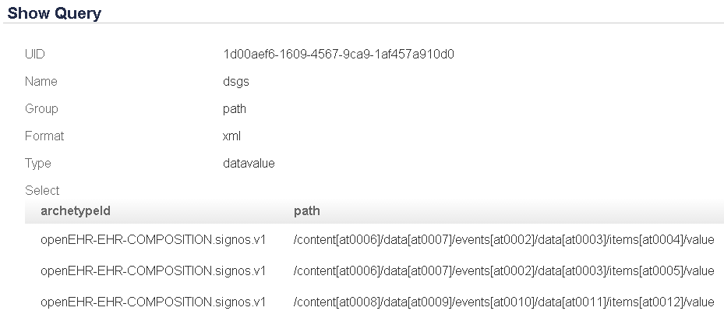
Fig. 1: Query for data, grouped by path, format as XML by default.

The examples below are shown after committing two records to the EHRServer, for the same EHR. Each query is executed in the context of one EHR. In the future, we’ll remove this constraint to run queries over different EHRs.

You can test your query using the EHRServer Web UI. If your query retrieves data and you selected JSON as an output format, the Web UI will show you a chart of your data.

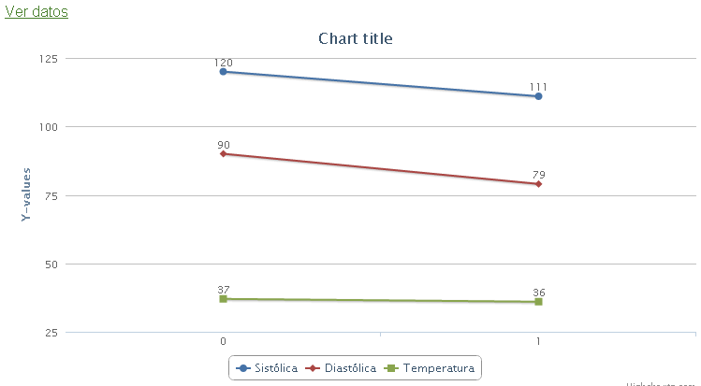
Fig. 2: Automatic data charting for JSON data results

And you can display the returned data:

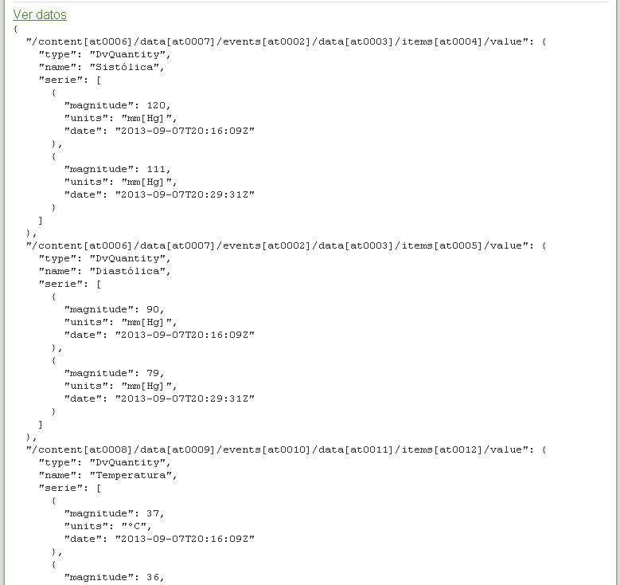
Fig. 3: data retrieved for query

Of course, queries can be executed using a REST service:

_base_/rest/query(String queryUid, String ehrId, String format)

This is a real query execution for the previously defined query, with two COMPOSITIONS committed for the same EHR:

http://localhost:8090/ehr/rest/query?queryUid=1d00aef6-1609-4567-9ca9-1af457a910d0&ehrId=0963c0bf-e8dd-43ee-80d5-57ecf8742413

Result:

<map>
<entry key="/content[at0006]/data[at0007]/events[at0002]/data[at0003]/items[at0004]/value">
<entry key="type">DvQuantity</entry>
<entry key="name">Sistólica</entry>
<entry key="serie">
<map>
<entry key="magnitude">120.0</entry>
<entry key="units">mm[Hg]</entry>
<entry key="date">2013-09-07 17:16:09.843 UYT</entry>
</map>
<map>
<entry key="magnitude">111.0</entry>
<entry key="units">mm[Hg]</entry>
<entry key="date">2013-09-07 17:29:31.984 UYT</entry>
</map>
</entry>
</entry>
<entry key="/content[at0006]/data[at0007]/events[at0002]/data[at0003]/items[at0005]/value">
<entry key="type">DvQuantity</entry>
<entry key="name">Diastólica</entry>
<entry key="serie">
<map>
<entry key="magnitude">90.0</entry>
<entry key="units">mm[Hg]</entry>
<entry key="date">2013-09-07 17:16:09.843 UYT</entry>
</map>
<map>
<entry key="magnitude">79.0</entry>
<entry key="units">mm[Hg]</entry>
<entry key="date">2013-09-07 17:29:31.984 UYT</entry>
</map>
</entry>
</entry>
<entry key="/content[at0008]/data[at0009]/events[at0010]/data[at0011]/items[at0012]/value">
<entry key="type">DvQuantity</entry>
<entry key="name">Temperatura</entry>
<entry key="serie">
<map>
<entry key="magnitude">37.0</entry>
<entry key="units">ºC</entry>
<entry key="date">2013-09-07 17:16:09.843 UYT</entry>
</map>
<map>
<entry key="magnitude">36.0</entry>
<entry key="units">ºC</entry>
<entry key="date">2013-09-07 17:29:31.984 UYT</entry>
</map>
</entry>
</entry>
</map>

Now specifying format=json

http://localhost:8090/ehr/rest/query?queryUid=1d00aef6-1609-4567-9ca9-1af457a910d0&ehrId=0963c0bf-e8dd-43ee-80d5-57ecf8742413&format=json

Result:

{
"/content[at0006]/data[at0007]/events[at0002]/data[at0003]/items[at0004]/value": {
"type": "DvQuantity",
"name": "Sistólica",
"serie": [
{
"magnitude": 120,
"units": "mm[Hg]",
"date": "2013-09-07T20:16:09Z"
},
{
"magnitude": 111,
"units": "mm[Hg]",
"date": "2013-09-07T20:29:31Z"
}
]
},
"/content[at0006]/data[at0007]/events[at0002]/data[at0003]/items[at0005]/value": {
"type": "DvQuantity",
"name": "Diastólica",
"serie": [
{
"magnitude": 90,
"units": "mm[Hg]",
"date": "2013-09-07T20:16:09Z"
},
{
"magnitude": 79,
"units": "mm[Hg]",
"date": "2013-09-07T20:29:31Z"
}
]
},
"/content[at0008]/data[at0009]/events[at0010]/data[at0011]/items[at0012]/value": {
"type": "DvQuantity",
"name": "Temperatura",
"serie": [
{
"magnitude": 37,
"units": "ºC",
"date": "2013-09-07T20:16:09Z"
},
{
"magnitude": 36,
"units": "ºC",
"date": "2013-09-07T20:29:31Z"
}
]
}
}

Query types and grouping

There are two kinds of queries: composition and datavalue.

- Composition: the result of the query will be a set of compositions, and the criteria of the query is defined over datavalues and date range.
- Datavalue: the result of the query will be a set of datavalues that can be grouped in different ways. The criteria is defined only by date range.

There are 3 ways of grouping datavalues:

- Ungrouped: just a set of datavalues without any grouping.
- Composition: group datavalues that belongs to the same composition. This is also called “row grouper”.
- Path: group datavalues with the same path. This is also called “column grouped”.

Grouping by composition simplifies displaying data as tables, and path grouper simplifies charting. The mix of REST querying services and grouping, make the creation of clinical dashboards a trivial task.

Sample archetype

archetype (adl_version=1.4)
openEHR-EHR-COMPOSITION.signos.v1

concept
[at0000] -- Signos
language
original_language = <[ISO_639-1::es]>
description
original_author = <
["name"] = <"">
>
details = <
["es"] = <
language = <[ISO_639-1::es]>
purpose = <"Signos">
use = <"">
misuse = <"">
copyright = <"">
>
>
lifecycle_state = <"0">
other_contributors = <>
other_details = <
["MD5-CAM-1.0.1"] = <"CA0D9C5FC48EAAEBF0DDCCC29CE382D6">
>

definition
COMPOSITION[at0000] matches { -- Signos
category matches {
DV_CODED_TEXT matches {
defining_code matches {[openehr::433]}
}
}
context matches {
EVENT_CONTEXT matches {
other_context matches {
ITEM_TREE[at0001] matches {*}
}
}
}
content cardinality matches {0..*; unordered} matches {

OBSERVATION[at0006] matches { -- Presión Arterial
data matches {
HISTORY[at0007] matches { -- Event Series
events cardinality matches {1..*; unordered} matches {
EVENT[at0002] occurrences matches {0..1} matches { -- Cualquier evento
data matches {
ITEM_TREE[at0003] matches { -- Arbol
items cardinality matches {0..*; unordered} matches {
ELEMENT[at0004] occurrences matches {0..1} matches { -- Sistólica
value matches {
C_DV_QUANTITY <
property = <[openehr::125]>
list = <
["1"] = <
units = <"mm[Hg]">
magnitude = <|0.0..400.0|>
>
>
>
}
}
ELEMENT[at0005] occurrences matches {0..1} matches { -- Diastólica
value matches {
C_DV_QUANTITY <
property = <[openehr::125]>
list = <
["1"] = <
units = <"mm[Hg]">
magnitude = <|0.0..400.0|>
>
>
>
}
}
}
}
}
}
}
}
}
}

OBSERVATION[at0008] matches { -- Temperatura corporal
data matches {
HISTORY[at0009] matches { -- Event Series
events cardinality matches {1..*; unordered} matches {
EVENT[at0010] occurrences matches {0..1} matches { -- Cualquier evento
data matches {
ITEM_TREE[at0011] matches { -- Arbol
items cardinality matches {0..*; unordered} matches {
ELEMENT[at0012] occurrences matches {0..1} matches { -- Temperatura
value matches {
C_DV_QUANTITY <
property = <[openehr::127]>
list = <
["1"] = <
units = <"ºC">
magnitude = <|0.0..50.0|>
>
["2"] = <
units = <"ºF">
magnitude = <|32.0..122.0|>
>
>
>
}
}
}
}
}
}
}
}
}
}

OBSERVATION[at0013] matches { -- Frecuencia cardiaca
data matches {
HISTORY[at0014] matches { -- Event Series
events cardinality matches {1..*; unordered} matches {
EVENT[at0015] occurrences matches {0..1} matches { -- Cualquier evento
data matches {
ITEM_TREE[at0016] matches { -- Arbol
items cardinality matches {0..*; unordered} matches {
ELEMENT[at0017] occurrences matches {0..1} matches { -- Frecuencia Cardiaca
value matches {
C_DV_QUANTITY <
property = <[openehr::382]>
list = <
["1"] = <
units = <"/min">
>
>
>
}
}
}
}
}
}
}
}
}
}
OBSERVATION[at0018] matches { -- Frecuencia respiratoria
data matches {
HISTORY[at0019] matches { -- Event Series
events cardinality matches {1..*; unordered} matches {
EVENT[at0020] occurrences matches {0..1} matches { -- Cualquier evento
data matches {
ITEM_TREE[at0021] matches { -- Arbol
items cardinality matches {0..*; unordered} matches {
ELEMENT[at0022] occurrences matches {0..1} matches { -- Frecuencia Respiratoria
value matches {
C_DV_QUANTITY <
property = <[openehr::382]>
list = <
["1"] = <
units = <"/min">
>
>
>
}
}
}
}
}
}
}
}
}
} -- frec resp
OBSERVATION[at0023] matches { -- Peso corporal
data matches {
HISTORY[at0024] matches { -- Event Series
events cardinality matches {1..*; unordered} matches {
EVENT[at0025] occurrences matches {0..1} matches { -- Cualquier evento
data matches {
ITEM_TREE[at0026] matches { -- Arbol
items cardinality matches {0..*; unordered} matches {
ELEMENT[at0027] occurrences matches {0..1} matches { -- Peso
value matches {
C_DV_QUANTITY <
property = <[openehr::124]>
list = <
["1"] = <
units = <"kg">
magnitude = <|0.0..400.0|>
>
>
>
}
}
}
}
}
}
}
}
}
} -- peso

OBSERVATION[at0028] matches { -- Estatura
data matches {
HISTORY[at0029] matches { -- Event Series
events cardinality matches {1..*; unordered} matches {
EVENT[at0030] occurrences matches {0..1} matches { -- Cualquier evento
data matches {
ITEM_TREE[at0031] matches { -- Arbol
items cardinality matches {0..*; unordered} matches {
ELEMENT[at0032] occurrences matches {0..1} matches { -- Estatura
value matches {
C_DV_QUANTITY <
property = <[openehr::122]>
list = <
["1"] = <
units = <"cm">
magnitude = <|0.0..250.0|>
>
>
>
}
}
}
}
}
}
}
}
}
} -- estatura / talla
}
}

ontology
term_definitions = <
["es"] = <
items = <
["at0000"] = <
text = <"Signos">
description = <"Registro de signos">
>
["at0001"] = <
text = <"Arbol">
description = <"@ internal @">
>

-- presion arterial
["at0006"] = <
text = <"Presión Arterial">
description = <"unknown">
>
["at0007"] = <
text = <"Event Series">
description = <"@ internal @">
>
["at0002"] = <
text = <"Cualquier evento">
description = <"*">
>
["at0003"] = <
text = <"Arbol">
description = <"@ internal @">
>
["at0004"] = <
text = <"Sistólica">
description = <"*">
>
["at0005"] = <
text = <"Diastólica">
description = <"*">
>
-- presion arterial

-- temperatura
["at0008"] = <
text = <"Temperatura corporal">
description = <"unknown">
>
["at0009"] = <
text = <"Event Series">
description = <"@ internal @">
>
["at0010"] = <
text = <"Cualquier evento">
description = <"*">
>
["at0011"] = <
text = <"Arbol">
description = <"@ internal @">
>
["at0012"] = <
text = <"Temperatura">
description = <"*">
>
-- temperatura

-- frec cardiaca
["at0013"] = <
text = <"Frecuencia cardiaca">
description = <"unknown">
>
["at0014"] = <
text = <"Event Series">
description = <"@ internal @">
>
["at0015"] = <
text = <"Cualquier evento">
description = <"*">
>
["at0016"] = <
text = <"Arbol">
description = <"@ internal @">
>
["at0017"] = <
text = <"Frecuencia Cardiaca">
description = <"*">
>
-- frec cardiaca

-- frec resp
["at0018"] = <
text = <"Frecuencia respiratoria">
description = <"unknown">
>
["at0019"] = <
text = <"Event Series">
description = <"@ internal @">
>
["at0020"] = <
text = <"Cualquier evento">
description = <"*">
>
["at0021"] = <
text = <"Arbol">
description = <"@ internal @">
>
["at0022"] = <
text = <"Frecuencia Respiratoria">
description = <"*">
>
-- frec resp

-- peso
["at0023"] = <
text = <"Peso corporal">
description = <"unknown">
>
["at0024"] = <
text = <"Event Series">
description = <"@ internal @">
>
["at0025"] = <
text = <"Cualquier evento">
description = <"*">
>
["at0026"] = <
text = <"Arbol">
description = <"@ internal @">
>
["at0027"] = <
text = <"Peso">
description = <"*">
>
-- peso

-- estatura / talla
["at0028"] = <
text = <"Estatura">
description = <"unknown">
>
["at0029"] = <
text = <"Event Series">
description = <"@ internal @">
>
["at0030"] = <
text = <"Cualquier evento">
description = <"*">
>
["at0031"] = <
text = <"Arbol">
description = <"@ internal @">
>
["at0032"] = <
text = <"Estatura">
description = <"*">
>
-- estatura / talla
>
>
>

Sample composition

<version xmlns='http://schemas.openehr.org/v1' xmlns:xsi='http://www.w3.org/2001/XMLSchema-instance'>
<commit_audit>
<change_type>
<value>creation</value>
<defining_code>
<terminology_id>
<value>openehr</value>
</terminology_id>
<code_string>249</code_string>
</defining_code>
</change_type>
<committer>
<name>Dr. Pablo Pazos</name>
</committer>
</commit_audit>
<data xsi:type='COMPOSITION' archetype_node_id='openEHR-EHR-COMPOSITION.signos.v1'>
<name>
<value>Signos</value>
</name>
<language>
<terminology_id>
<value>ISO_639-1</value>
</terminology_id>
<code_string>es</code_string>
</language>
<territory>
<terminology_id>
<value>ISO_3166-1</value>
</terminology_id>
<code_string>UY</code_string>
</territory>
<category>
<value>event</value>
<defining_code>
<terminology_id>
<value>openehr</value>
</terminology_id>
<code_string>443</code_string>
</defining_code>
</category>
<composer xsi:type='PARTY_IDENTIFIED'>
<name>Dr. Pablo Pazos</name>
</composer>
<context>
<start_time>
<value>20130907T172931,0984-0300</value>
</start_time>
<setting>
<value>Hospital Montevideo</value>
<defining_code>
<terminology_id>
<value>openehr</value>
</terminology_id>
<code_string>229</code_string>
</defining_code>
</setting>
</context>
<content xsi:type='OBSERVATION' archetype_node_id='at0006'>
<name>
<value>Presión Arterial</value>
</name>
<data xsi:type='HISTORY' archetype_node_id='at0007'>
<name>
<value>Event Series</value>
</name>
<events xsi:type='EVENT' archetype_node_id='at0002'>
<name>
<value>Cualquier evento</value>
</name>
<data xsi:type='ITEM_TREE' archetype_node_id='at0003'>
<name>
<value>Arbol</value>
</name>
<items xsi:type='ELEMENT' archetype_node_id='at0005'>
<name>
<value>Diastólica</value>
</name>
<value xsi:type='DV_QUANTITY'>
<magnitude>79.0</magnitude>
<units>mm[Hg]</units>
</value>
</items>
<items xsi:type='ELEMENT' archetype_node_id='at0004'>
<name>
<value>Sistólica</value>
</name>
<value xsi:type='DV_QUANTITY'>
<magnitude>111.0</magnitude>
<units>mm[Hg]</units>
</value>
</items>
</data>
</events>
</data>
</content>
<content xsi:type='OBSERVATION' archetype_node_id='at0008'>
<name>
<value>Temperatura corporal</value>
</name>
<data xsi:type='HISTORY' archetype_node_id='at0009'>
<name>
<value>Event Series</value>
</name>
<events xsi:type='EVENT' archetype_node_id='at0010'>
<name>
<value>Cualquier evento</value>
</name>
<data xsi:type='ITEM_TREE' archetype_node_id='at0011'>
<name>
<value>Arbol</value>
</name>
<items xsi:type='ELEMENT' archetype_node_id='at0012'>
<name>
<value>Temperatura</value>
</name>
<value xsi:type='DV_QUANTITY'>
<magnitude>36.0</magnitude>
<units>ºC</units>
</value>
</items>
</data>
</events>
</data>
</content>
<content xsi:type='OBSERVATION' archetype_node_id='at0013'>
<name>
<value>Frecuencia cardiaca</value>
</name>
<data xsi:type='HISTORY' archetype_node_id='at0014'>
<name>
<value>Event Series</value>
</name>
<events xsi:type='EVENT' archetype_node_id='at0015'>
<name>
<value>Cualquier evento</value>
</name>
<data xsi:type='ITEM_TREE' archetype_node_id='at0016'>
<name>
<value>Arbol</value>
</name>
<items xsi:type='ELEMENT' archetype_node_id='at0017'>
<name>
<value>Frecuencia Cardiaca</value>
</name>
<value xsi:type='DV_QUANTITY'>
<magnitude>78.0</magnitude>
<units>/min</units>
</value>
</items>
</data>
</events>
</data>
</content>
<content xsi:type='OBSERVATION' archetype_node_id='at0018'>
<name>
<value>Frecuencia respiratoria</value>
</name>
<data xsi:type='HISTORY' archetype_node_id='at0019'>
<name>
<value>Event Series</value>
</name>
<events xsi:type='EVENT' archetype_node_id='at0020'>
<name>
<value>Cualquier evento</value>
</name>
<data xsi:type='ITEM_TREE' archetype_node_id='at0021'>
<name>
<value>Arbol</value>
</name>
<items xsi:type='ELEMENT' archetype_node_id='at0022'>
<name>
<value>Frecuencia Respiratoria</value>
</name>
<value xsi:type='DV_QUANTITY'>
<magnitude>83.0</magnitude>
<units>/min</units>
</value>
</items>
</data>
</events>
</data>
</content>
<content xsi:type='OBSERVATION' archetype_node_id='at0023'>
<name>
<value>Peso corporal</value>
</name>
<data xsi:type='HISTORY' archetype_node_id='at0024'>
<name>
<value>Event Series</value>
</name>
<events xsi:type='EVENT' archetype_node_id='at0025'>
<name>
<value>Cualquier evento</value>
</name>
<data xsi:type='ITEM_TREE' archetype_node_id='at0026'>
<name>
<value>Arbol</value>
</name>
<items xsi:type='ELEMENT' archetype_node_id='at0027'>
<name>
<value>Peso</value>
</name>
<value xsi:type='DV_QUANTITY'>
<magnitude>79.0</magnitude>
<units>kg</units>
</value>
</items>
</data>
</events>
</data>
</content>
<content xsi:type='OBSERVATION' archetype_node_id='at0028'>
<name>
<value>Estatura</value>
</name>
<data xsi:type='HISTORY' archetype_node_id='at0029'>
<name>
<value>Event Series</value>
</name>
<events xsi:type='EVENT' archetype_node_id='at0030'>
<name>
<value>Cualquier evento</value>
</name>
<data xsi:type='ITEM_TREE' archetype_node_id='at0031'>
<name>
<value>Arbol</value>
</name>
<items xsi:type='ELEMENT' archetype_node_id='at0032'>
<name>
<value>Estatura</value>
</name>
<value xsi:type='DV_QUANTITY'>
<magnitude>180.0</magnitude>
<units>cm</units>
</value>
</items>
</data>
</events>
</data>
</content>
</data>
<lifecycle_state>
<value>completed</value>
<defining_code>
<terminology_id>
<value>openehr</value>
</terminology_id>
<code_string>532</code_string>
</defining_code>
</lifecycle_state>
</version>

