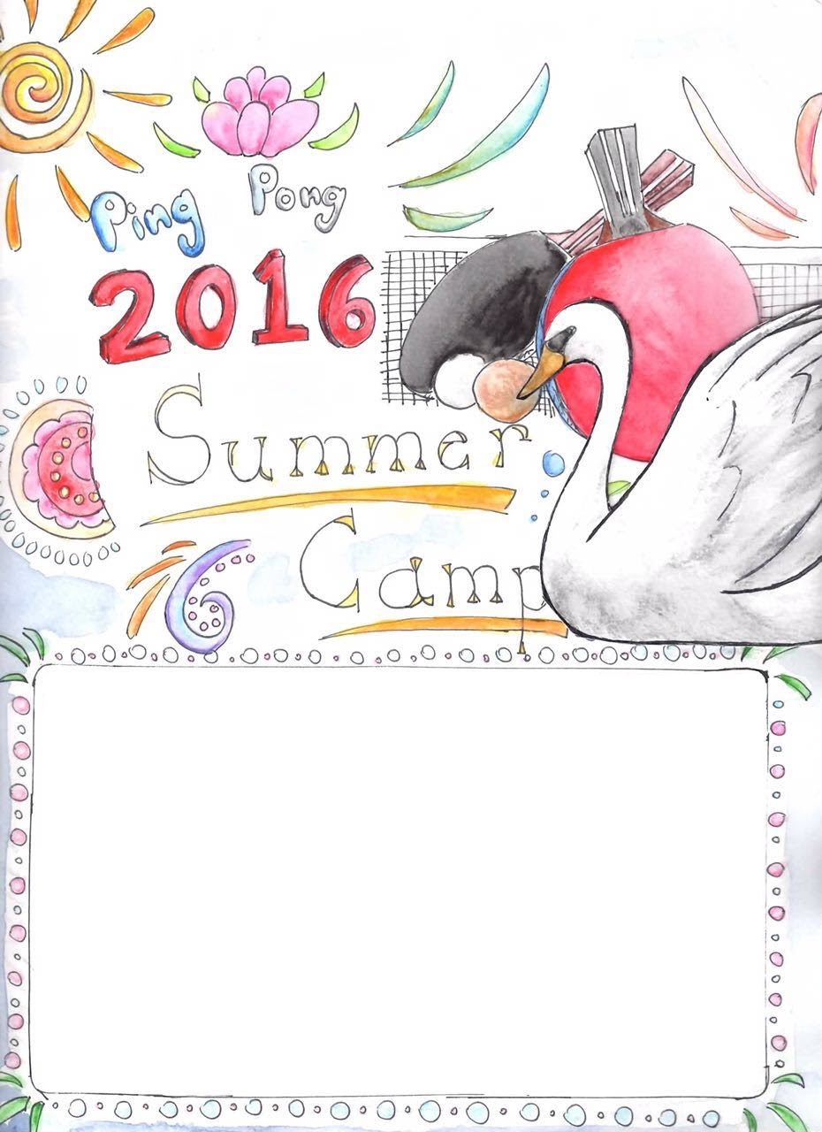

Professional Coaches

Formal Ping Pong Training

Best Location

Best Facility

Free 1 Day Trial Available

Call 408-915-7464, 389-8760 for detail

6/13

|

8/26

**Mon-Fri**

9am

|

630pm

[Date and Time]

[Street Address]