Computer Vision (2016/2017)
Lecture 05
André Saraiva (60623), Pedro Conde (64346)

Resumo – Neste trabalho desenvolveram-se vários programas de processamento e análise de imagem, utilizando C++ em conjunto com as librarias de funções do OpenCV.

Abstract – A program for image processing and analysis was developed in this work, using C++ and the function libraries provided by OpenCV.

I. Introduction
The following program, which will be explained in detail further down, was developed:
- CameraCalib

II. CameraCalib
This program starts off by asking the user which type of calibration is wanted. If it’s internal then we proceed to choose the calibration method, which will load several pictures taken by a specific camera or using video feed.
When we are on calibration mode we first load several pictures, we then look for the chess board and its corners and then save the intrinsic and distortion matrices in a xml file using FileStorage. In a different case where we were using a circle shape instead of a squares we would’ve needed to know for example the distance between the center of the circles to the neighbour circles, this way would be possible to keep track how the parameters change by knowing the actual dimensions of the calibration example.
Secondly using the line method we projected 3 lines which start on the corner of the square at position (0, 0).
As for the next part, we also calibrated the camera using the video capture from the camera. We are getting frames every 5ms and drawing the chess board corners for each frame, then we also project the same lines from the previous example using line method and finally save the calibration parameters to a xml file.
The last part was the external calibration, which unfortunately is not fully working right now, but so far we have implemented the solvePnP method and we are working on making sure that the rotation vector and the translation vector are used to project the image without distortion.

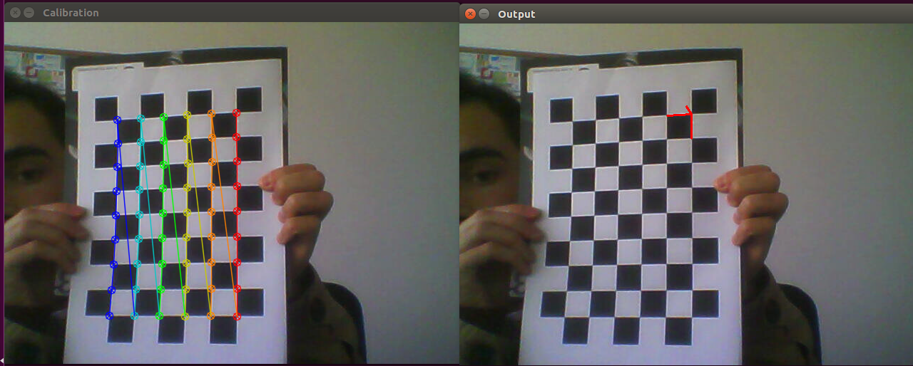
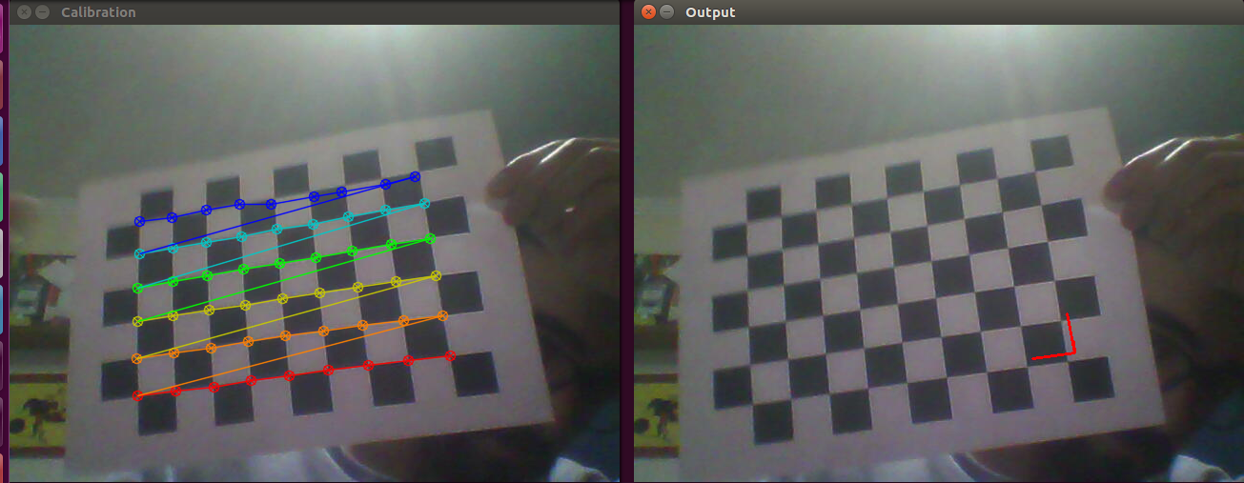
Fig. 1, 2– Output of CameraCalib. Picture load calibration, Video feed calibration, respectively.

