Computer Vision (2016/2017)
Lecture 11
André Saraiva (60623), Pedro Conde (64346)

Resumo – Neste trabalho desenvolveram-se vários programas de processamento e análise de imagem, utilizando C++ em conjunto com as librarias de funções do OpenCV e PCL.

Abstract – Different programs for image processing and analysis were developed in this work, using C++ and the function libraries provided by OpenCV and PCL.

I. Introduction
The following programs, which will be explained in detail further down, were developed:
- Hough
- FeatDetect

II. Hough
In this example we implemented a program that reads images from our digital camera and displays the edges of the acquired images. We can also change the threshold of the line detection. It’s noticeable that with a lower threshold more lines are detected.

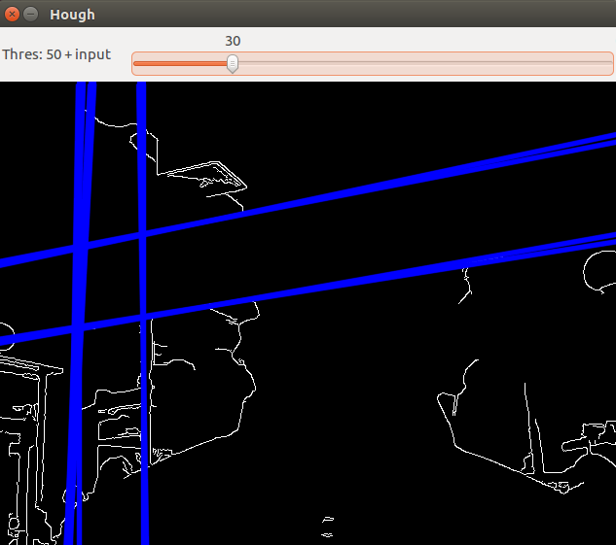
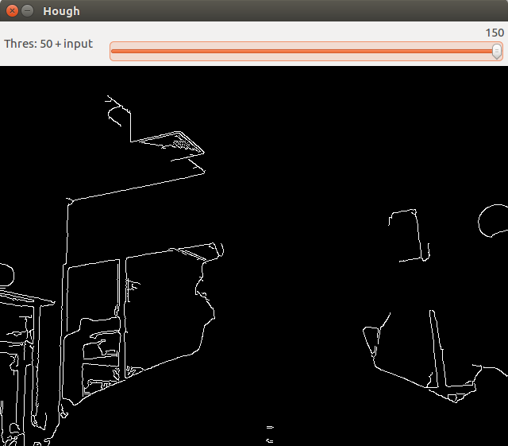
Fig. 1, 2 – Output of Hough function. Input threshold of 30 and 150 respectively.

III. FeatDetect

