Computer Vision (2016/2017)
Lecture 09
André Saraiva (60623), Pedro Conde (64346)

Resumo – Neste trabalho desenvolveram-se vários programas de processamento e análise de imagem, utilizando C++ em conjunto com as librarias de funções do OpenCV e PCL.

Abstract – Different programs for image processing and analysis were developed in this work, using C++ and the function libraries provided by OpenCV and PCL.

I. Introduction
The following programs, which will be explained in detail further down, were developed:
- OpticalFlow
- BackgForegSep
- ObjTracking

II. OpticalFlow
In this example we implemented the Lucas-Kanade optical flow algorithm to detect moving objects in a static scene.
In each for cycle we begin by tracking the strong corners of the video using the goodFeaturesToTrack, then we calculate the optical flow using the calcOpticalFlowPyrLK and draw the motions lines to display on top of the video. As we can see from the pictures below, when nothing is moving we don’t have optical flow vectors. As soon as something moves, optical flow vectors are drawn.

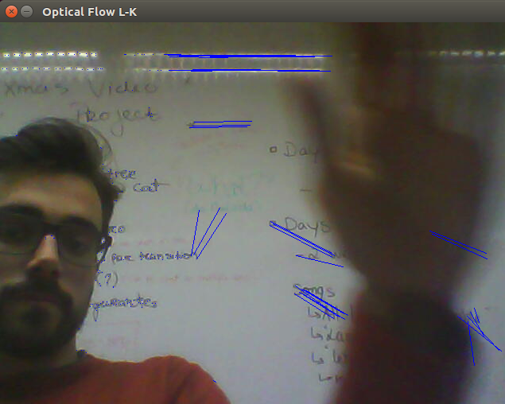
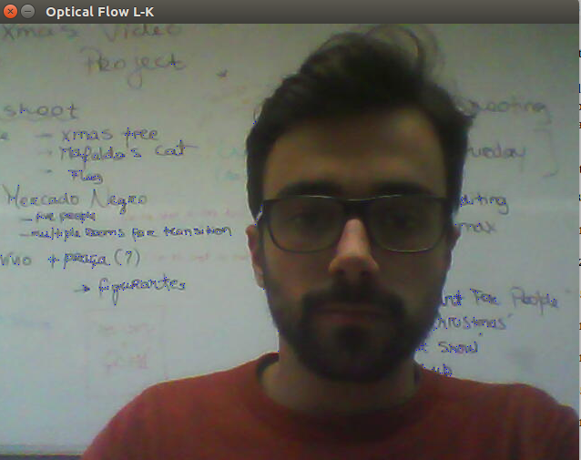

Fig. 1, 2 – Output of OpticalFlow. Standing still and motion figures, respectively.

III. BackgForegSep
This program uses either the camera feed or a an input video file to create the background-foreground separation.
This example basically consists of two main steps, the background initialization and the background update. In the first step, an initial model of the background is computed, while in the second step that model is updated in order to adapt to possible changes in the scene. In this case we are using the BackgroundSubtractor class with the MOG2 approach, which provides better adaptibility to varying scenes due to ilumination changes, etc. In the pictures below we can observe that when there’s no motion, the objects aren’t detected on the subtracted video feed. On the other hand, when we have movement, the objects appear in white.
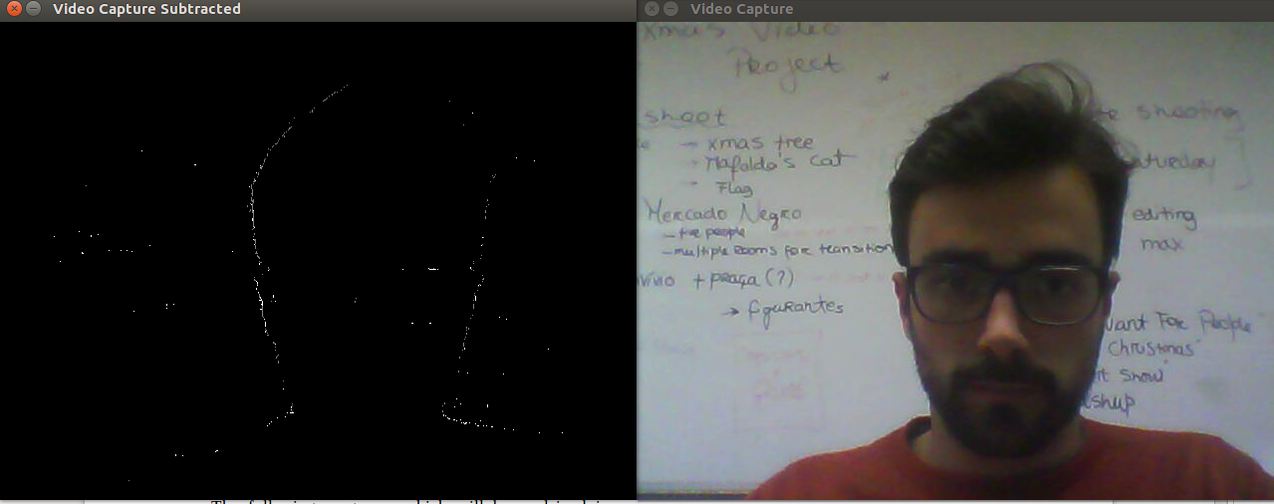
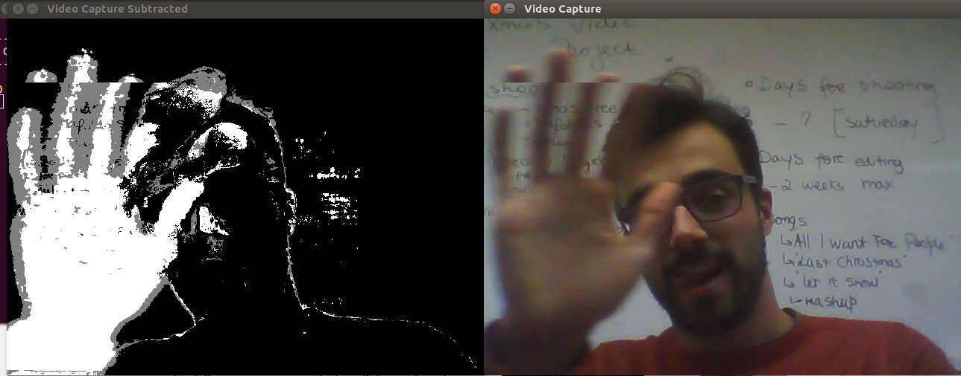
Fig. 3, 4, 5, 6– Output of BackgForegSep. Standing still video feed and moving video feed, respectively.
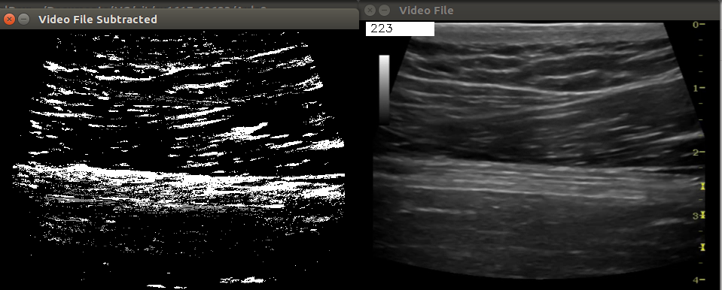
Fig. 7, 8– Output of BackgForegSep. Neuromuscular ultrasound video file.

IV. ObjTracking
In this example we implemented an object tracking system based on the Meanshift and Camshift algorithms. The meanshift is used when considering a set of points in a given window which finds nodes in a set of data samples representing an underlying probability density function. To use it we need to setup the target, find its histogram so we can backproject the target on each frame for calculation of meanshift. With camshift we can adapt the window size and rotation of the target. We can check the results on the pictures below. A good precision is achieved by calculatin a 2D histogram, using two channels of the video frames. A mask for the backproject is also used to further improve the tracking precision.
This object tracking algorythm uses color as main tracking argument, so grayscale objects will be hard to properly detect. The background subtraction technique could be used to track moving objects and wouldn’t be limited by color channels, although the moment an object completely stopped, the algorythm would be unable to tell its position.

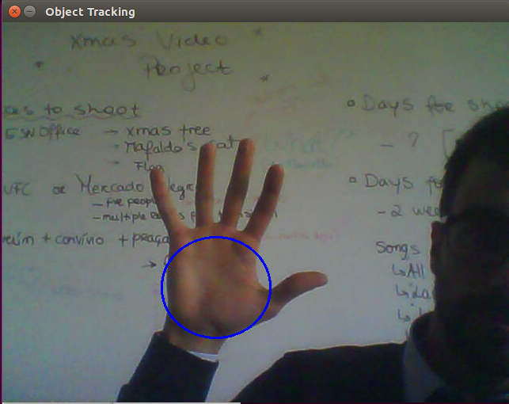
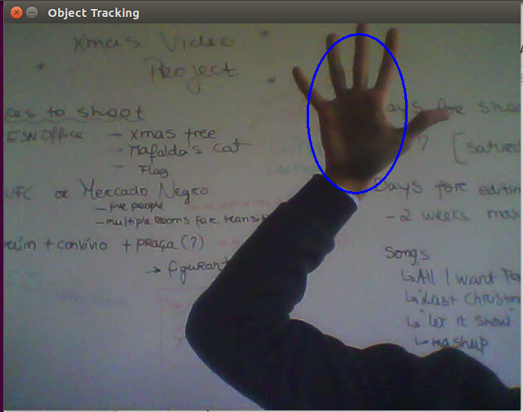
Fig. 9, 10– Output of ObjTracking. Tracking region with camera feed.

