Computer Vision (2016/2017)
Lecture 07 & 08
André Saraiva (60623), Pedro Conde (64346)

Resumo – Neste trabalho desenvolveram-se vários programas de processamento e análise de imagem, utilizando C++ em conjunto com as librarias de funções do OpenCV.

Abstract – Different programs for image processing and analysis were developed in this work, using C++ and the function libraries provided by OpenCV.

I. Introduction
The following programs, which will be explained in detail further down, were developed:
- Reconstruct
- ViewCloud
- ICPAlign
- ViewOpenNI

II. Reconstruct
In this example we used the code from the Reconstructc.cpp from last lecture and used the StereoBM class and the function that implements a block matching technique to make the disparity map of the given set of pictures. The results are as followed:

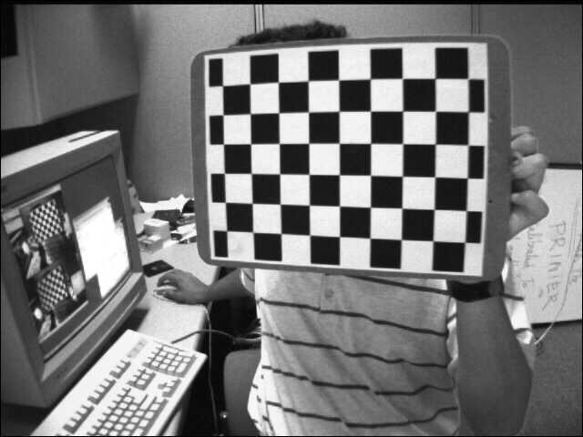
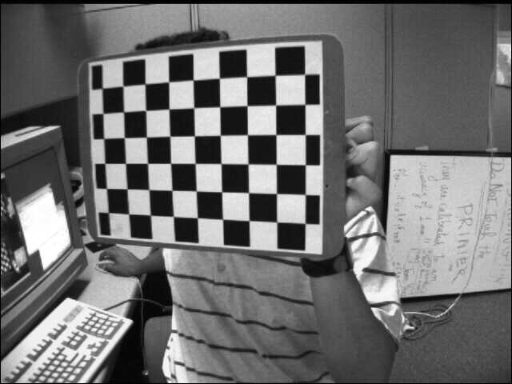
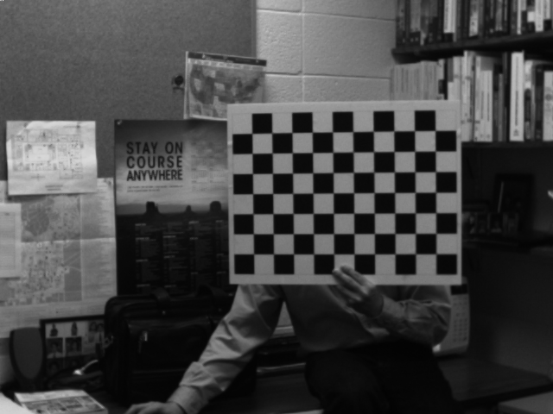
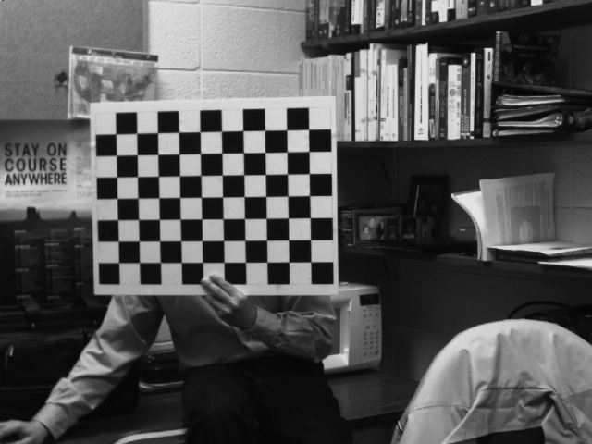
Fig. 1, 2, 3, 4– 1st pair of the 1st set of pictures on the top, left and right pictures respectively. 1st pair of the second set of pictures on the bottom, left and right pictures respectively.

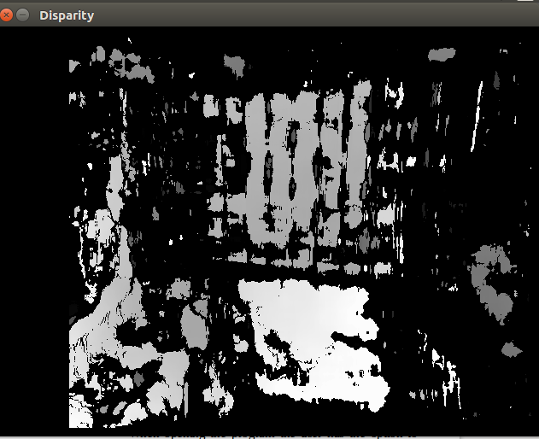
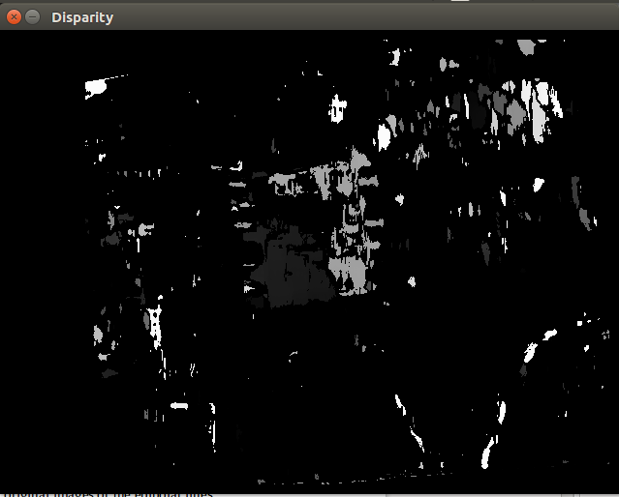
Fig. 5, 6– Output figures of Reconstruct program. 1st pair of the 1st set of pictures on the left. Array Min value: -16; Max value: 1264. 1st pair of the 2nd set of pictures on the right. Array Min value: -16; Max value: 1264.

From Figure 5 and 6 it’s possible to notice that some black areas are not reconstructed because the algorithm isn’t able to reconstruct the disparity map from the stereo pictures. It’s also noticeable that the picture on the left has a clearer disparity map than the right one, probably because of the better contrast between objects on the left picture.
Saved 3D points (part of it):
2.32613010e+01 5.55885544e+01 -2.12841232e+02 2.30359726e+01
5.55885544e+01 -2.12841232e+02 2.28106441e+01 5.55885544e+01
-2.12841232e+02 2.25853157e+01 5.55885544e+01 -2.12841232e+02
2.23599873e+01 5.55885544e+01 -2.12841232e+02 2.21346588e+01
5.55885544e+01 -2.12841232e+02 2.19093304e+01 5.55885544e+01
-2.12841232e+02 2.16840019e+01 5.55885544e+01 -2.12841232e+02
2.14586735e+01 5.55885544e+01 -2.12841232e+02 2.12333431e+01
5.55885544e+01 -2.12841232e+02 2.10080147e+01 5.55885544e+01

III. ViewCloud
This program uses the read 3D points of the file saved in the previous section and displays the results of the 3D reconstruction.

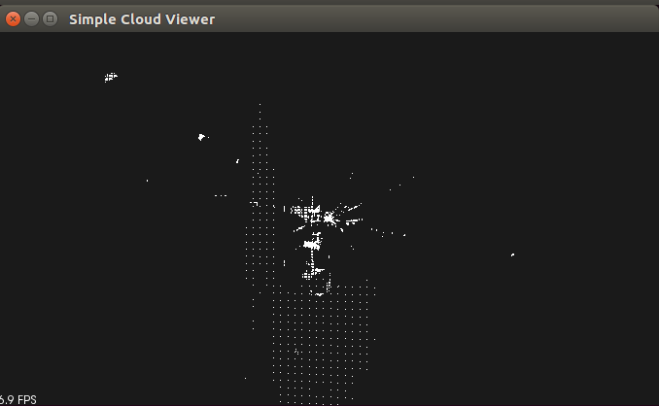
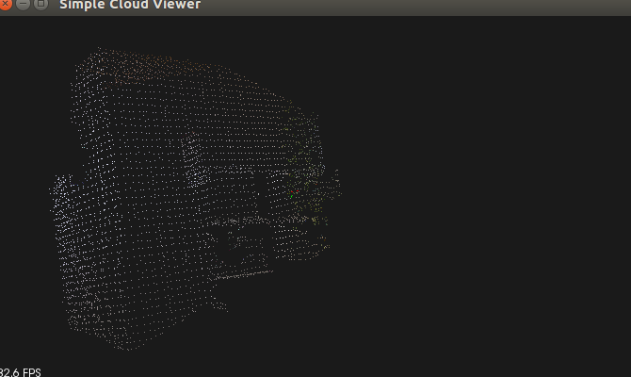
Fig. 7, 8– Output of ViewCloud. Coordinate points read from XML file of the previous exercise and 3D reconstruction on the left. Kinect point cloud file read and 3D reconstruction on the right.
It’s noticiable that Figure 7 doesn’t have a clear point cloud reconstruction because the 3D coordinates saved don’t represent a perfect reconstruction of the picture. On the other hand, we have a very clear 3D reconstruction from the two kinect images office1.pcd and office2.pcd, mainly because of the VoxelGrid filter that was used on the pictures previously to downsample the cloud of points.

IV. ICPAlign
In this example we are supposed to implement the Iterative Closest Point function to align the given down sampled cloud of points. This algorithm minimizes the differences between two clouds of points and shows the cloud reconstruction results. You can see in both Figures 9 and 10 that we have the reference cloud with black and white coordinates and the red aligned cloud for displaying purposes. When using the standard values for the IterativeClosestPoint the result is a cloud point less accurate in between the two original cloud points. The results are really similar nevertheless.

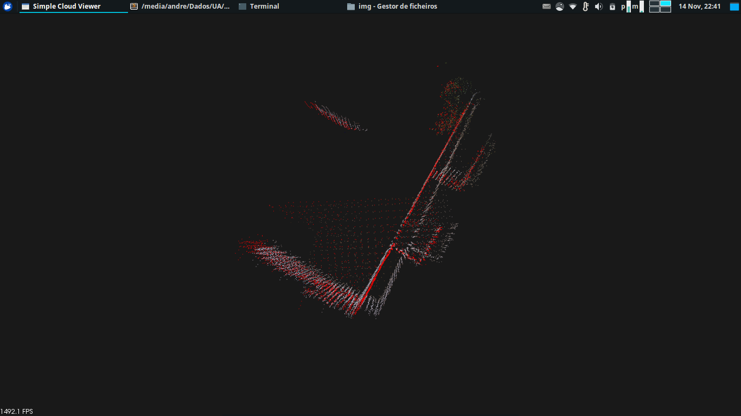

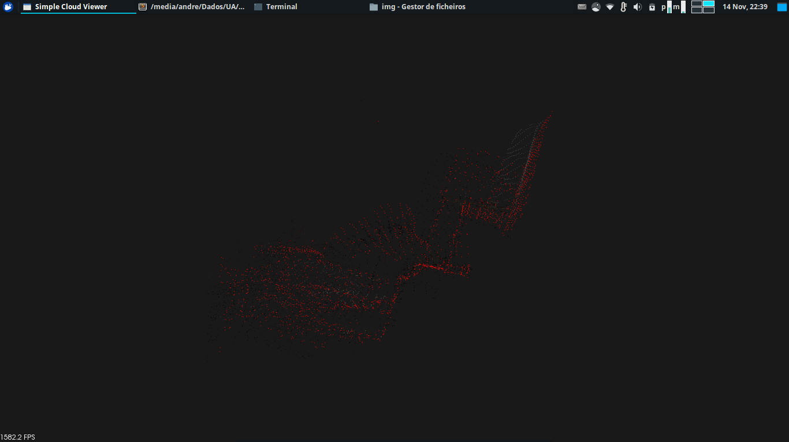

Fig. 9, 10– Output of ICPAlign. Given cloud points on top and user cloud points on the bottom.

V. ViewOpenNI
This program serves the purpose of displaying a point cloud feed from a Kinect device. It's possible to rotate and zoom the point cloud in real time, while it's being continuously updated. It's also possible to save a point cloud from the feed, which is stored as "kinect1.pcd" for the original point cloud and "filt_kinect1.pcd" for the same point cloud, but filtered, using the VoxelGrid algorithm. We can see the results in the pictures below.

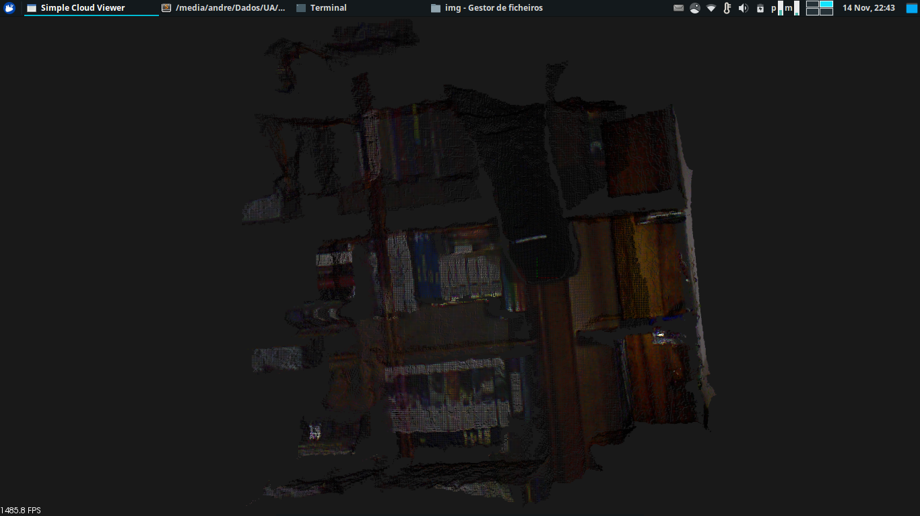

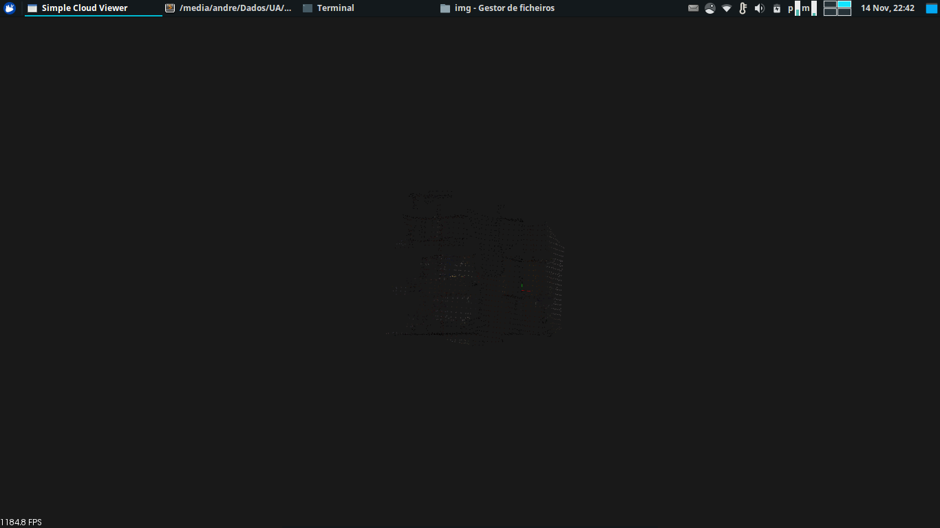

Fig. 11, 12 – Output of ViewOpenNI. Unfiltered cloud point picture above. Filtered cloud point picture below.

Appendix
Cam1 Calibration Parameters

<?xml version="1.0"?>
<opencv_storage>
<camMatrix1 type_id="opencv-matrix">
<rows>3</rows>
<cols>3</cols>
<dt>d</dt>
<data>
5.3236470236227001e+02 0. 3.3521917641721899e+02 0.
5.3234649612096655e+02 2.4113780466256102e+02 0. 0. 1.</data></camMatrix1>
<camMatrix2 type_id="opencv-matrix">
<rows>3</rows>
<cols>3</cols>
<dt>d</dt>
<data>
5.3236470236227001e+02 0. 3.3448425093245680e+02 0.
5.3234649612096655e+02 2.4197234569068686e+02 0. 0. 1.</data></camMatrix2>
<distCoeffs1 type_id="opencv-matrix">
<rows>1</rows>
<cols>5</cols>
<dt>d</dt>
<data>
-2.8401934415755636e-01 4.2884236035894335e-02
1.6539113654932037e-03 -7.9514236483524685e-04
1.2098146842779503e-01</data></distCoeffs1>
<distCoeffs2 type_id="opencv-matrix">
<rows>1</rows>
<cols>5</cols>
<dt>d</dt>
<data>
-2.9548950088987946e-01 1.3253907248971036e-01
-6.5056874774755671e-04 -7.3281523906068471e-04
-4.5364426755060409e-02</data></distCoeffs2>
<rotation type_id="opencv-matrix">
<rows>3</rows>
<cols>3</cols>
<dt>d</dt>
<data>
9.9972060471393698e-01 4.9879774037794389e-03
-2.3104817502410741e-02 -4.5315273245529622e-03
9.9979436356653062e-01 1.9766027438583921e-02 2.3198658808369719e-02
-1.9655804791852412e-02 9.9953762889021713e-01</data></rotation>
<translation type_id="opencv-matrix">
<rows>3</rows>
<cols>1</cols>
<dt>d</dt>
<data>
-3.3262735715943954e+00 4.3268863398628662e-02
-1.1378083658441802e-01</data></translation>
<essential type_id="opencv-matrix">
<rows>3</rows>
<cols>3</cols>
<dt>d</dt>
<data>
4.8817862901795732e-04 1.1290695476645687e-01 4.5497852264152636e-02
-3.6583961064316300e-02 -6.5948120249423356e-02
3.3273644842562105e+00 -2.8183674703543403e-02
-3.3258053926733089e+00 -6.4747495492009310e-02</data></essential>
<fundamental type_id="opencv-matrix">
<rows>3</rows>
<cols>3</cols>
<dt>d</dt>
<data>
-2.3521203052346058e-08 -5.4402181422312196e-06
1.5269998442909321e-04 1.7627322347719684e-06 3.1777000005977932e-06
-8.6707504074213210e-02 3.0425068681326874e-04
8.6361098280497969e-02 1.</data></fundamental>
</opencv_storage>

Cam2 Calibration Parameters

<?xml version="1.0"?>
<opencv_storage>
<camMatrix1 type_id="opencv-matrix">
<rows>3</rows>
<cols>3</cols>
<dt>d</dt>
<data>
1.0963386870625295e+03 0. 3.2243788169343611e+02 0.
1.0952758826758286e+03 2.2845119190724509e+02 0. 0. 1.</data></camMatrix1>
<camMatrix2 type_id="opencv-matrix">
<rows>3</rows>
<cols>3</cols>
<dt>d</dt>
<data>
1.0963386870625295e+03 0. 3.2875726717607773e+02 0.
1.0952758826758286e+03 2.4063959679722262e+02 0. 0. 1.</data></camMatrix2>
<distCoeffs1 type_id="opencv-matrix">
<rows>1</rows>
<cols>5</cols>
<dt>d</dt>
<data>
-3.0014515983062334e-01 3.8616017834627643e+00
-1.0325948352462632e-02 3.0705074227067087e-03
-1.9250972517687359e+01</data></distCoeffs1>
<distCoeffs2 type_id="opencv-matrix">
<rows>1</rows>
<cols>5</cols>
<dt>d</dt>
<data>
-1.0340935520082104e+00 5.9853082936907454e+00
-2.1748097884892743e-02 -2.1474094564523788e-03
-5.9744719880767843e+00</data></distCoeffs2>
<rotation type_id="opencv-matrix">
<rows>3</rows>
<cols>3</cols>
<dt>d</dt>
<data>
9.9956847094780388e-01 -7.0124606908322160e-03
-2.8525379614108563e-02 6.9982856274247753e-03
9.9997533364937319e-01 -5.9673369425258891e-04
2.8528860568667078e-02 3.9684743215685493e-04 9.9959289044428945e-01</data></rotation>
<translation type_id="opencv-matrix">
<rows>3</rows>
<cols>1</cols>
<dt>d</dt>
<data>
-5.9393184115383786e+00 -8.3602280562545939e-01
-1.4484191430704987e+00</data></translation>
<essential type_id="opencv-matrix">
<rows>3</rows>
<cols>3</cols>
<dt>d</dt>
<data>
-1.3714327182477412e-02 1.4480516423524241e+00
-8.3654677325856797e-01 -1.2783521212948112e+00
1.2513985565011690e-02 5.9782171641550610e+00 7.9409699082036511e-01
-5.9450344872890426e+00 -2.0303676479458608e-02</data></essential>
<fundamental type_id="opencv-matrix">
<rows>3</rows>
<cols>3</cols>
<dt>d</dt>
<data>
1.6508992095975432e-07 -1.7448227637200417e-05
1.4973140883082433e-02 1.5403441535147516e-05
-1.5093297501503585e-07 -8.3906092112097652e-02
-1.4241026327181969e-02 8.4308119518896843e-02 1.</data></fundamental>
</opencv_storage>

