Muscle Movement Quantification
André Saraiva (60623) Pedro Conde (64346)

Resumo – Neste trabalho desenvolveu-se um programa de processamento de imagem ecográfica, utilizando C++ em conjunto com as librarias de funções do OpenCV, com o intuito de quantificar o movimento de músculos em ecografias.

Abstract – This project consists of a muscle movement quantification program developed using C++ and the functions libraries provided by OpenCV.

I. Introduction
With the increased use of medical images and videos usage, it’s becoming essential to find tools to aid doctors and specialists on their job.
The aim of this project is to create three different approaches of analysis of ecographies and to track and quantitize muscle movement.
This report presents three different analysis methods for muscle movement quantization. A description of each analysis method will be followed by a comparison between the three.

II. Implementation
The code flow works based on user input. As we can see from Fig.1, the program starts by asking the video and the method of analysis.
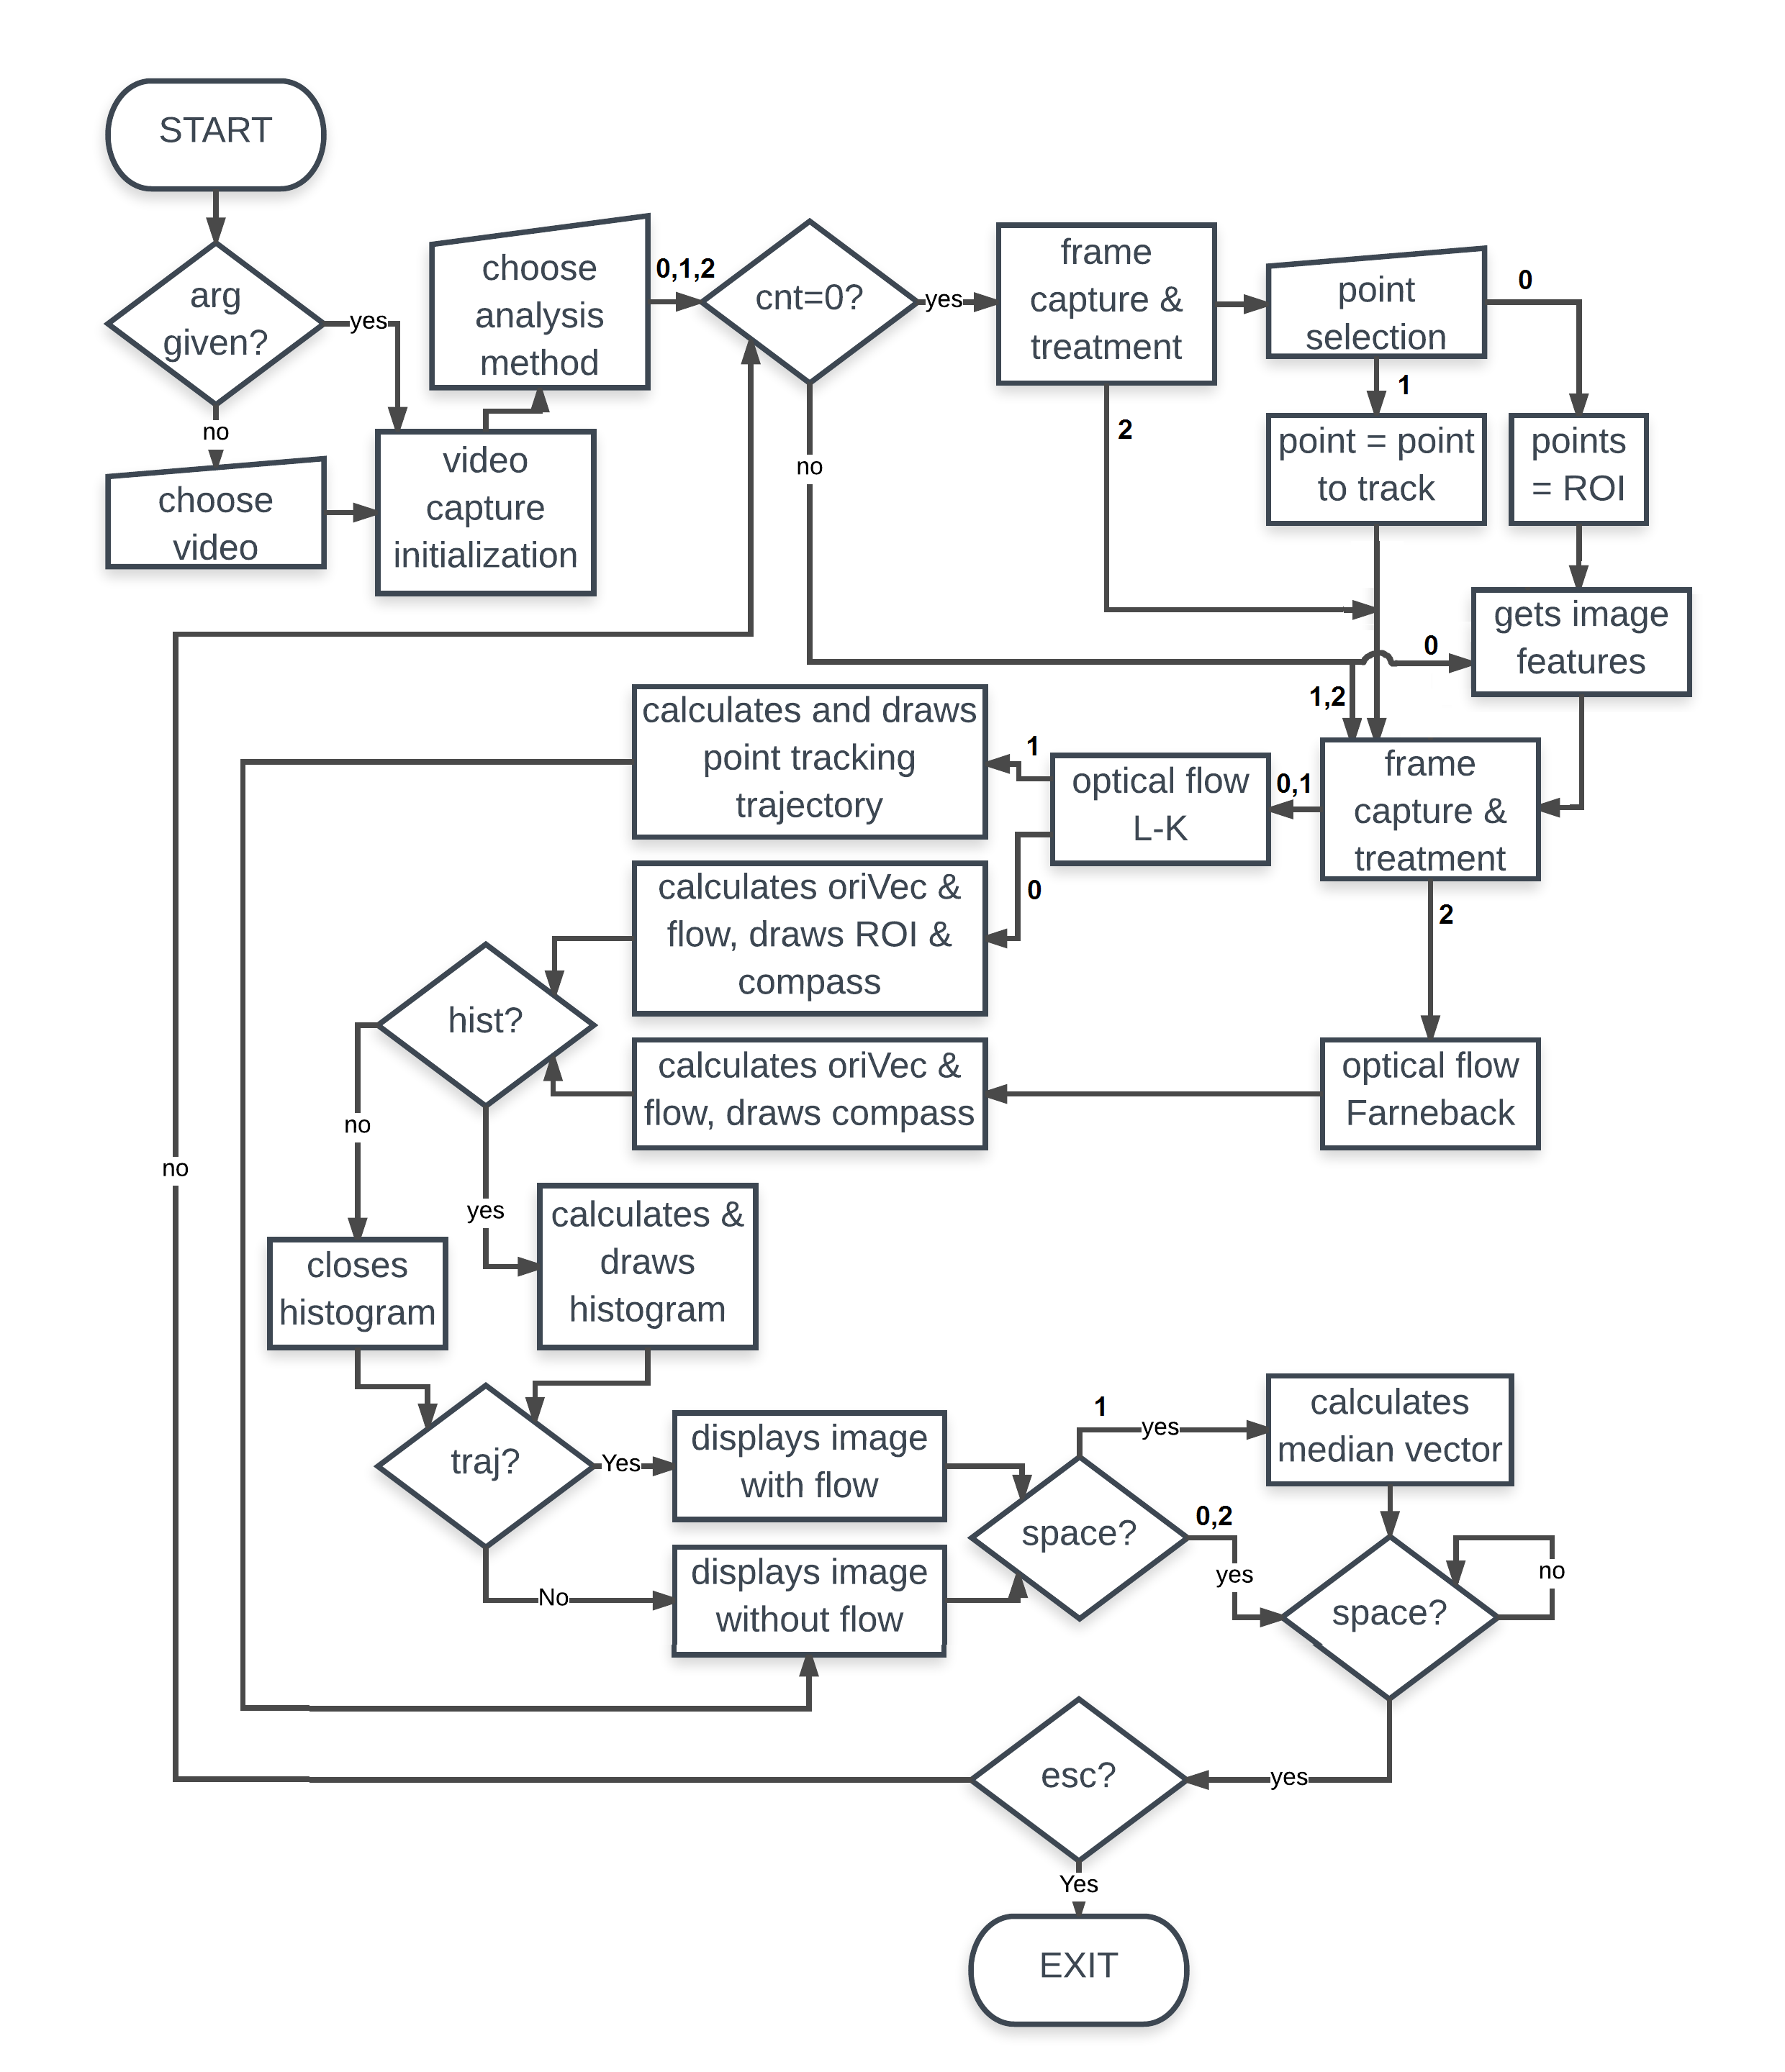

Fig. 1 - Simplified code flow chart. Lozenges – conditions; Squares – executions; Crooked squares – user options.A. If the first method, Region of Interest (Lukas-Kanade) is selected, then the following will happen:
- The first frame is captured and treated (resized and converted to grayscale);
- The user selects the points of the region of interest;
- The good image features are obtained (determines strong corners on an image);
- The optical flow is calculated using the Lukas-Kanade method;
- The vectors’ orientation and flow is calculated and the ROI and compass are drawn.
- The user gets to choose either if he wants the histogram and the trajectory of the vectors displayed or not, pressing H and S, respectively;
- The user can also press SPACE at any time to pause the video and press ESC to exit the program;
- Repeat from the third topic until there’s no more remaining frames;
- Program exits.

B. If the second method, Point Tracking (Lukas-Kanade), is selected, then the following will happen:
- The first frame is captured and treated (resized and converted to grayscale);
- The user selects the point to track;
- The good image features are obtained (determines strong corners on an image);
- The optical flow is calculated using the Lukas-Kanade method;
- The tracked point trajectory is calculated and drawn;
- The user can also press SPACE at any time to pause the video and press ESC to exit the program;
- The next frame is captured and treated (resized and converted to grayscale). Repeat from forth topic until there’s no more remaining frames;
- Program exits.

C. If the third method, Optical Flow (using Farneback), is selected, then the following will happen:
- The first frame is captured and treated (resized and converted to grayscale);
- The good image features are obtained (determines strong corners on an image);
- The optical flow is calculated using the Farneback method;
- The orientation vector and flow are calculated and the compass drawn;
- The user gets to choose either if he wants the histogram and the trajectory of the vectors displayed or not, pressing H and S, respectively;
- The user can also press SPACE at any time to pause the video and press ESC to exit the program;
- The next frame is captured and treated (resized and converted to grayscale). Repeat from the fourth topic until there’s no more remaining frames;
- Program exits.

III. Region of Interest (Lukas-Kanade)
The first analysis consists of a selection of region of interest based on the Lukas-Kanade method. In the Fig.1 we can see the capture of the first frame and the selection of the region of interest.
The results are displayed on the Fig.2 and Fig.3. On the corner of both figures we have a direction compass to represent each directions’ colour. In the Fig.2 there’s the calculated optical flow inside the region of interest previously selected and the corresponding orientation histogram on the right. Each colour corresponds to a certain direction. On Fig.3 we have the average direction vector of all the direction vectors inside the ROI. This vector is multiplied by a factor scale just so it can be better seen.
This implementation is faster compared to the Fanerback method, because it’s calculating the good features to track for each frame instead of selecting a grid and calculate for a bigger grid. The good features to track are also being calculated every frame to guarantee that the points of interest don’t get lost, even if momentanely (for example a single frame).

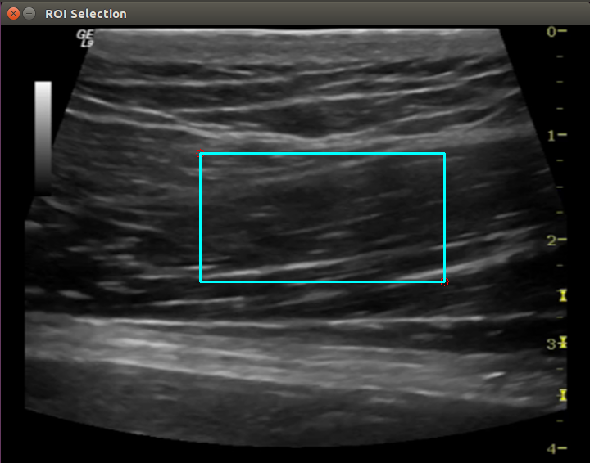
Fig. 1 - First frame captured. Region of Interest selection.

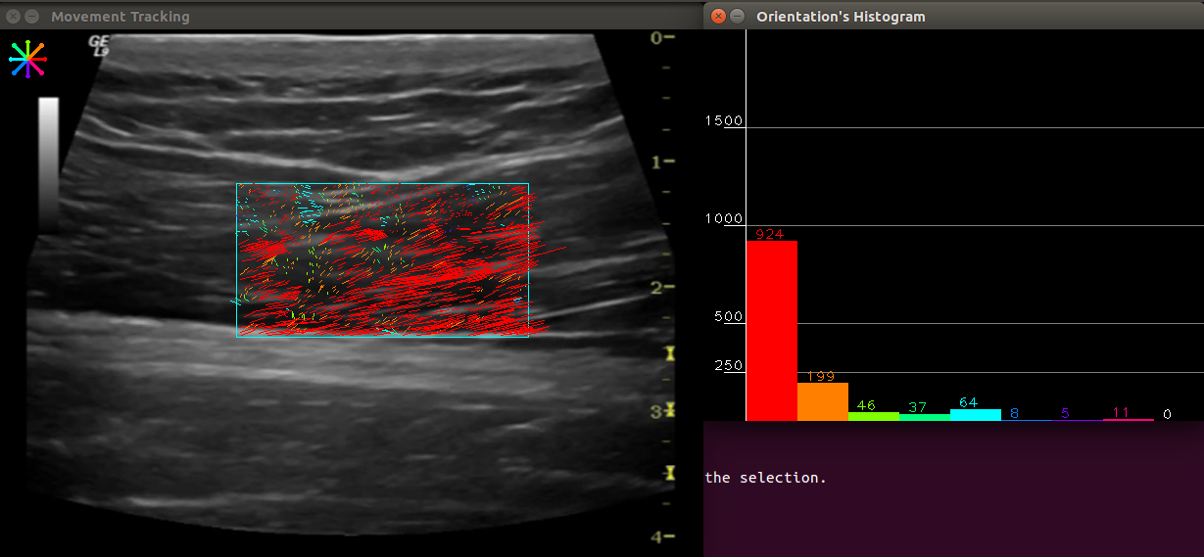
Fig. 2 - Movement Tracking. Optical flow on the left and histogram with movement quantization on the right.
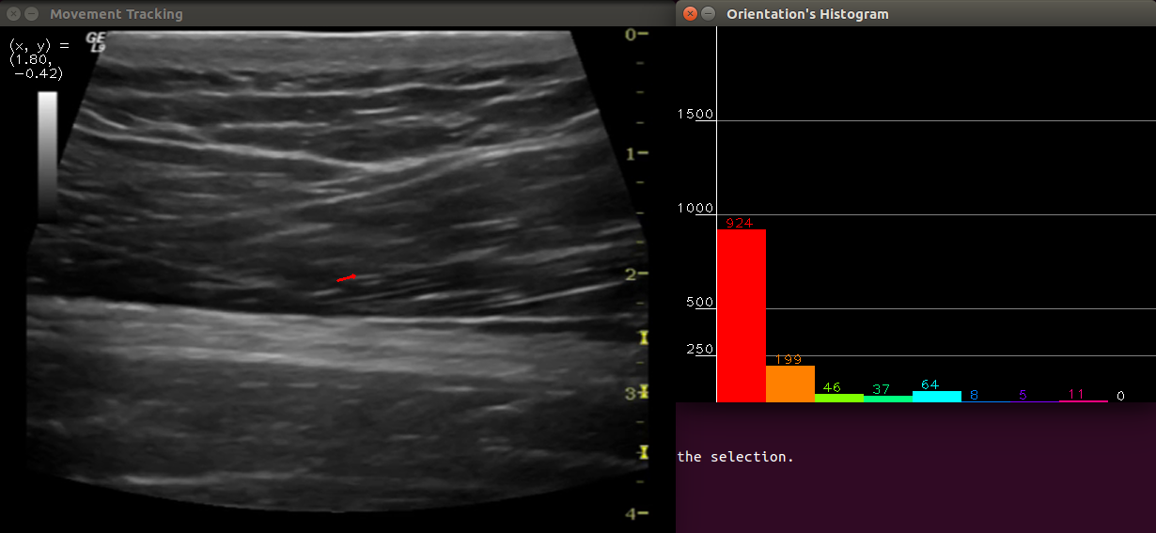
Fig. 3 - Movement Tracking. Average of all direction vectors displayed in red on the left. Histogram with movement quantization on the right.

IV. Point Tracking (Lukas-Kanade)
The second analysis consists of a point tracking system also based on the Lukas-Kanade method.
The results are shown in Fig.4 where the user previously selected a point to track and by the end of the program it’s possible to see the resulted motion of the same point.
This implementation is faster compared to the other two and works very well in real-time analysis, because it’s calculating optical flow using Lukas-Kanade method without the need of the good features extraction.
Also, the dot product was used to calculate the vectors’ direction between points. One point corresponding to the point of arrival and the other to a point over the horizontal line. In this calculation the acos isn’t able to find values in the third and forth quadrant, which meant that it was needed to calculate in advance the vectors’ arrival points positions in the first and second quadrant or the third and forth quadrant.

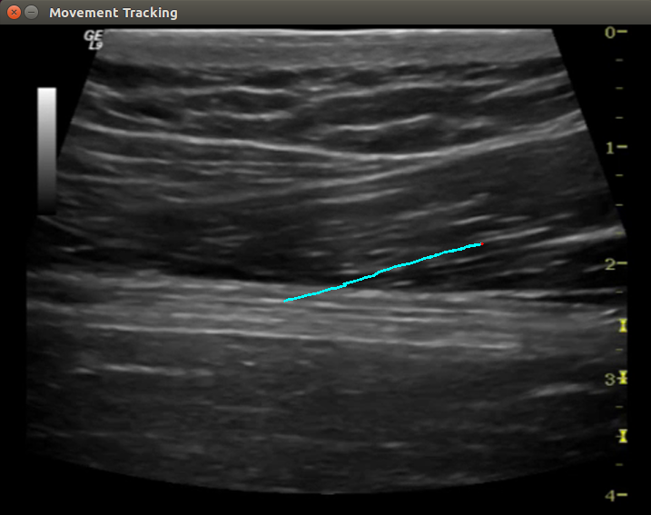
Fig. 4 - Movement Tracking. Resulted line drawn of point tracking.

V. Optical Flow (Farneback)
The third analysis consists of an optical flow motion display based on the Farneback method.
The user has the option to either select the sparse grid (Fig.5) or the dense grid (Fig.6) of the optical flow, which translates into less or more optical flow vectors displayed, respectively. The sparse uses 15 pixels of distance between each vector while the dense uses a denser grid to analyse.
Also, since this method creates a grid over the whole video, it was needed to remove points that were moving very little or not moving at all, such as points beyond the ecography scan, this resulted in no white points over the grid (points that didn’t move) thus the zero elements in the last white histogram bar.

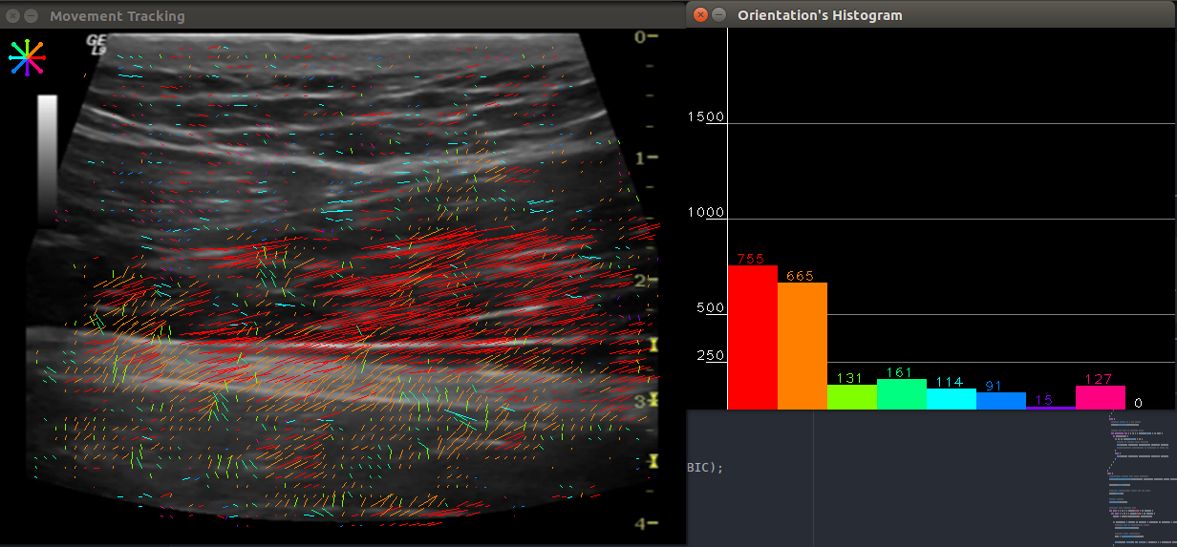
Fig. 5 - Movement Tracking. Sparse optical flow grid (Farneback) on the left. Movement quantization histogram on the right.

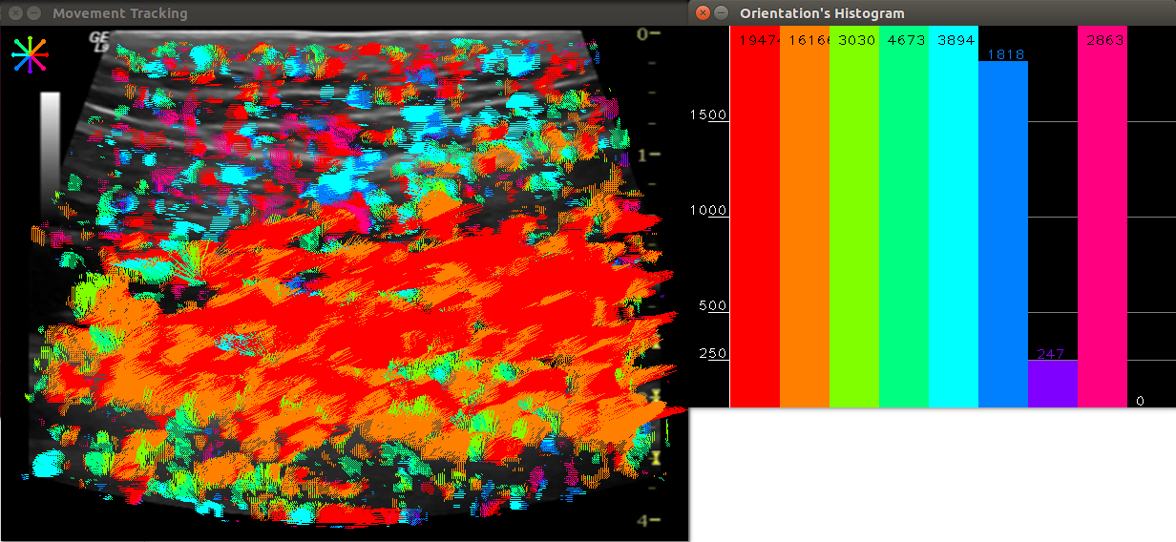
Fig. 6 - Movement Tracking. Dense optical flow grid (Farneback) on the left. Movement quantization histogram on the right.

