Computer Vision (2016/2017)
Lecture 03
André Saraiva (60623), Pedro Conde (64346)

Resumo – Neste trabalho desenvolveram-se vários programas de processamento e análise de imagem, utilizando C++ em conjunto com as librarias de funções do OpenCV.

Abstract – Several programs for image processing and analysis were developed in this work, using C++ and the function libraries provided by OpenCV.

I. Introduction
The following programs, which will be explained in detail further down, were developed:
- VideoCapture;
- SkinDetect;
- ImageFilter;
- GetHist;
- HistogramComp.

II. VideoCapture
This program stores captured frames by the computer webcam, which are then treated, with several thresholding methods, and finally sequentially displayed, creating a binary video feed of the images captured.
This thresholding is performed by the function adaptiveThreshold which reads a grayscale image (obtained by using cvtColor on the original images) and, depending on its arguments, outputs the resulting treated image. The arguments include the thresholding method (median or Gaussian) and the size of the filter block size. With these thresholding methods, a local binarization is achieved, that divides the image in regions and analyses them separately.
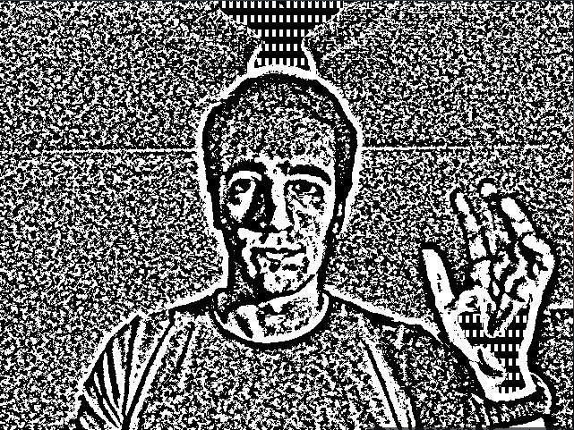
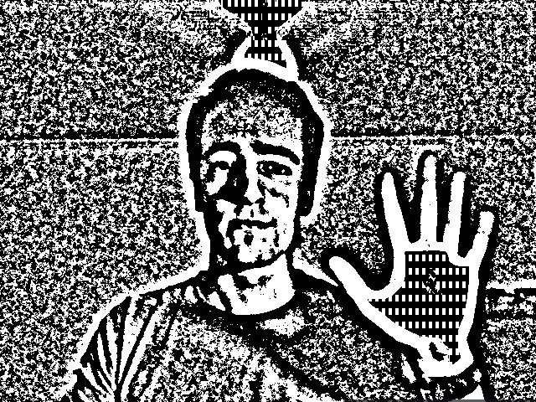
Fig. 1, 2 – Output of adaptive thresholding. Gaussian and Median methods respectively (both using block size = 21).

Later, this program was changed, enabling it to binarize an image not only by adaptive thresholding, but also by simple thresholding, using threshold. This function binarizes an image using a thresholding value: everything above that value is given the value one (true, white), while everything below is given the value zero (black). This makes global thresholding possible. A further improvement to the program was made by introducing Otsu binarization. This method is global and calculates the optimal threshold level, using the threshold function.
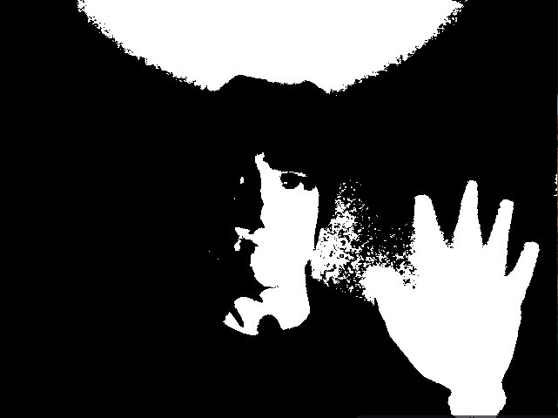
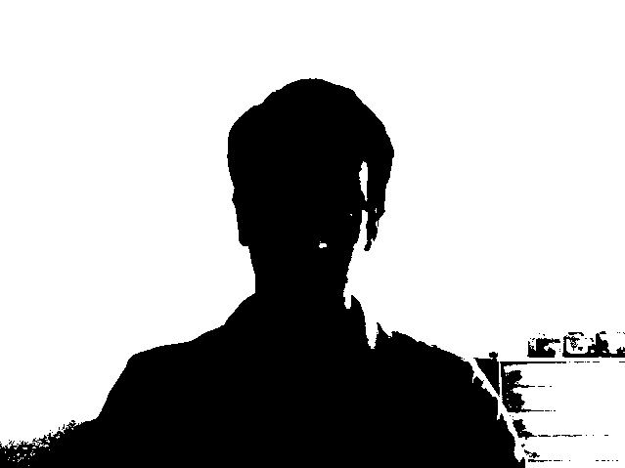
Fig. 3, 4 – Global thresholding methods. Fixed level (level = 127) and Otsu binarization, respectively.

III. SkinDetect
This program uses different colorspaces to analyse an image, in order to extract the pixels that fall within certain color or brightness bounds. In this case, the objective is the detection of skin, or more specifically, pixels that have color values close to the human skin.
This is achieved by converting an original image (BGR colorspace) into different colorspaces (in this case, HSV and YCrCb colorspaces were used), using the cvtColor function. After the convertion, pixels were detected using inRange, by giving it ranges of values (minimum and maximum values) for each channel the picture has. If this ranges encompass the general ranges where skin color falls on, skin will thus be detected. This implementation has several problems: it’s very brightness sensitive (better under bright light conditions) and detects objects that aren’t skin but have colors close to it (wood, for example).
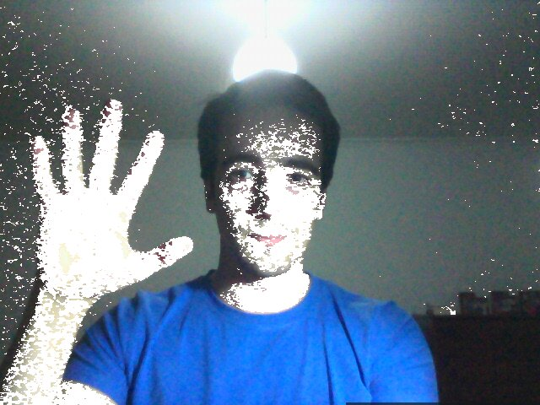
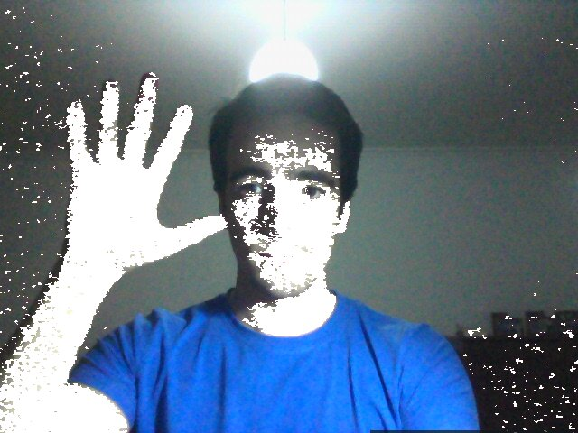
Fig. 5, 6 – Skin detection using HSV and YCrCb colorspaces (respectively). Detected pixels are displayed white.

IV. ImageFilter
The objective of this program is the filtering of images, using various methods. This was achieved by using the blur, medianBlur and gaussianBlur functions. This functions apply blurring filters, with the first being a simple blur and the second and third using the methods indicated by their names. The size of the blurring element is user defined.
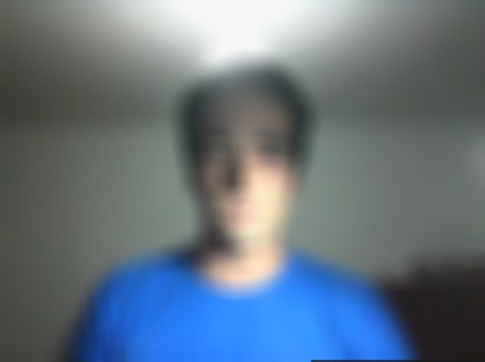
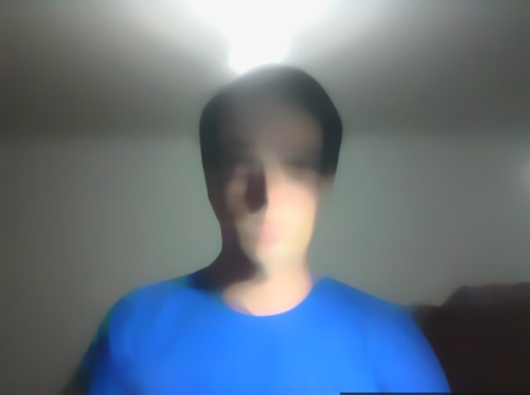
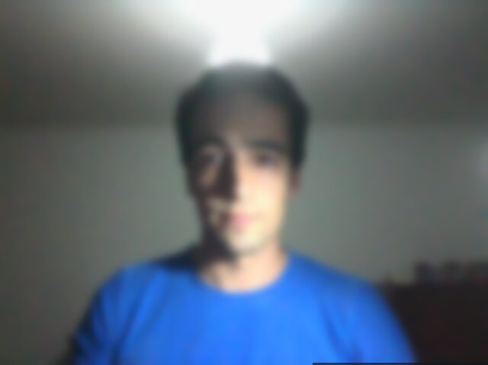
Fig. 7, 8, 9 – Simple, median and Gaussian blurring filters respectively (blozk size = 31).

IV. GetHist
By using this program it’s possible to calculate and display the histogram of a given image. It can either display the histograms for each image channel (BGR, if that is the case) or display the one related to the grayscale version of the same image.
This is achieved by using the functions calcHist, normalize, and line. The first calculates the values of the histogram, given a bin size (number of values to calculate) and range (range of values for each the image channel is analysed [255 values]). The second merely normalizes the size of the histogram to fit in the window size, while the third is used to draw the histogram values in the window, thus forming a curve. This is made by drawing a colored bar between each value and its next neighbour. This is done two times at slightly different heights of the window, with the second drawing in black, effectively creating a line and not a colored area. This procedure must be made for each channel.
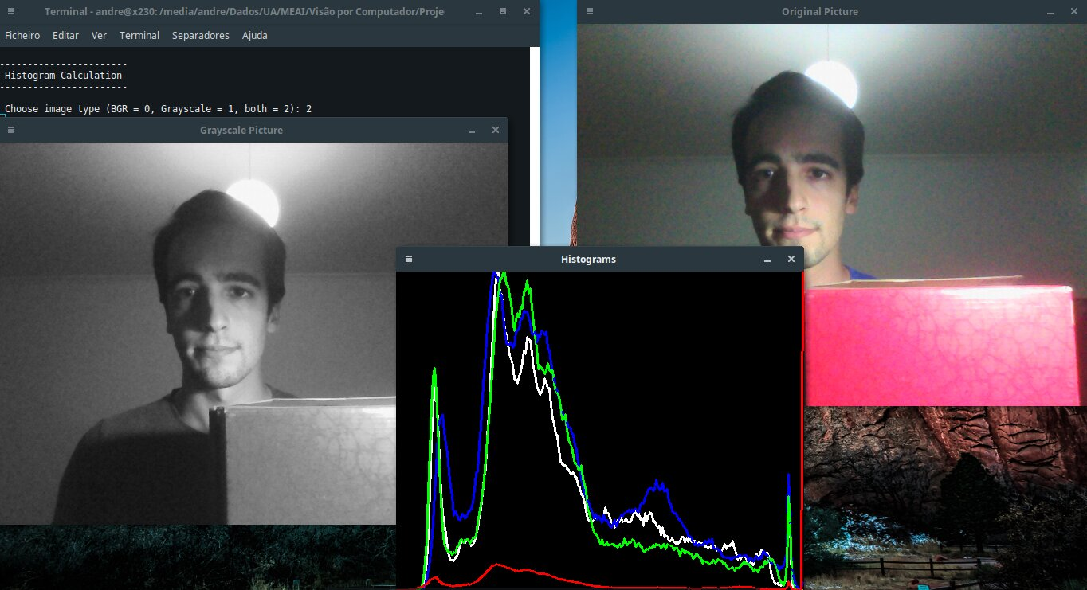
Fig. 10 – Original image, grayscale image and resulting histograms (grayscale histogram represented as white).

IV. HistogramComp
The objective of this program is to compare the histogram of two different specific pictures. First we read each picture using imread. Secondly we separate the images in 3 channels (B, G and R). We then compute the histograms, draw them on the screen and print on the terminal the results of different methods of pictures’ comparison.
On the first comparation we use different pictures to observe their histograms and test results that we can see on the table below. For the Correlation and intersection methods, the higher the metric, the more accurate the match. For the other two metrics, the less the result, the better the match.
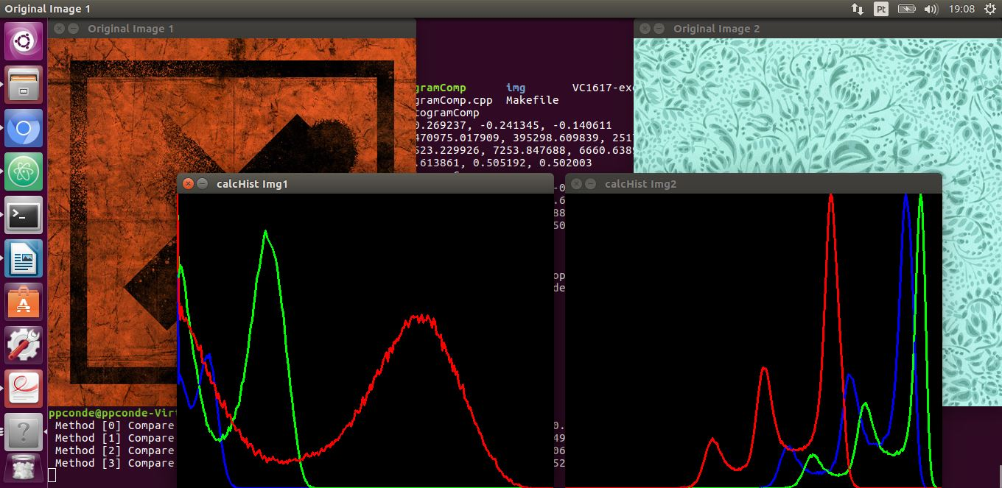
Fig. 11 - Original images and resulting histogram

 | B | G | R
Correlation | -0,177899 | -0,260063 | 0,454996
Chi-square | 4665,0492 | 15518,311 | 16797,0438
Intersection | 0,000 | 0,000 | 8606,56070
Bhattacharyya | 1,000 | 1,000 | 0,520924

Comparing to the results of similar pictures we can see that the Correlation method is not working as expected, but the Intersection method still just high metrics as it was expected. Chi-square is also not working as expected but the Bhattacharyya‘s method is. These can probably be explained thanks to the different lightning on both photos which influence the BGR colour channels. We get different histograms which results as inconsistent.
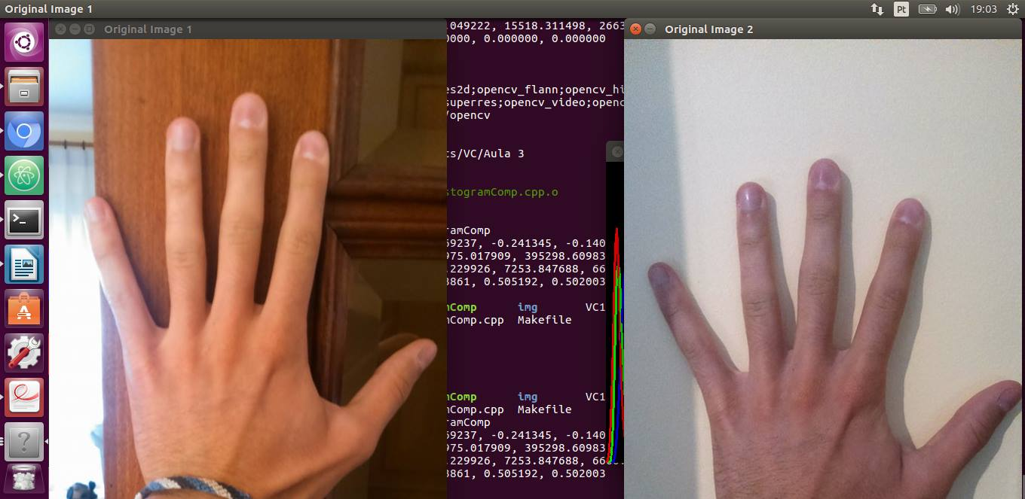
Fig. 22 - Original similar pictures

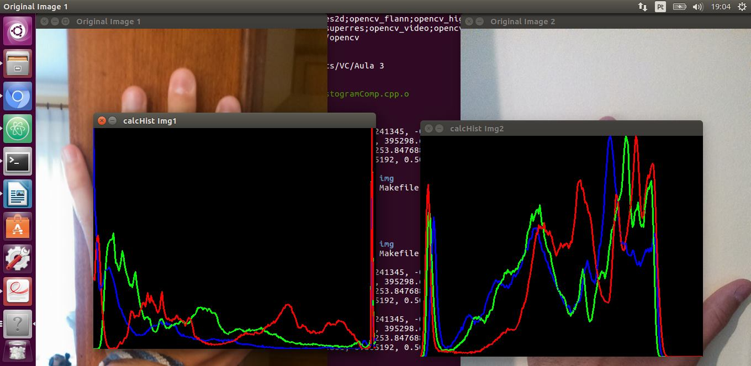
Fig. 13 - Original images and resulting histogram

 | B | G | R
Correlation | -0,269237 | -0,241345 | -0,140611
Chi-square | 247075,0179 | 395298,6098 | 251776,4753
Intersection | 4523,229926 | 7253,847688 | 6668,638920
Bhattacharyya | 0,613861 | 0,585192 | 0,582003

References
[1] Histogram Comparison - http://docs.opencv.org/2.4/doc/tutorials/imgproc/histograms/histogram_comparison/histogram_comparison.html
[2] Miscellaneous Image Transformations – adaptiveThreshold- http://docs.opencv.org/2.4/modules/imgproc/doc/miscellaneous_transformations.html

[3] Basic Thresholding Operations - http://docs.opencv.org/2.4/doc/tutorials/imgproc/threshold/threshold.html
[4] How to use the OTSU Threshold in opencv?- http://stackoverflow.com/questions/17141535/how-to-use-the-otsu-threshold-in-opencv
[5] Image Thresholding - http://docs.opencv.org/trunk/d7/d4d/tutorial_py_thresholding.html
[6] Histogram Calculation - http://docs.opencv.org/2.4/doc/tutorials/imgproc/histograms/histogram_calculation/histogram_calculation.html

