Computer Vision (2016/2017)
Lecture 04
André Saraiva (60623), Pedro Conde (64346)

Resumo – Neste trabalho desenvolveram-se vários programas de processamento e análise de imagem, utilizando C++ em conjunto com as librarias de funções do OpenCV.

Abstract – Several programs for image processing and analysis were developed in this work, using C++ and the function libraries provided by OpenCV.

I. Introduction
The following programs, which will be explained in detail further down, were developed:
- GradCalc;
- Canny;
- CornerDetect;
- HoughCircle;
- HoughLine.

II. GradCalc
This program takes a video feed as input, applies a convolution filter capable of “detecting” corners, and displays the output. These filters are user selected and use the first or second derivative to calculate where in the images provided an abrupt change in pixels’ value (gradient) takes place, emphasizing it. These changes may be considered “edges” and these methods may be used in edge detection.
The first filter used is the Sobel operator, by means of the Sobel function. It is possible to define the kernel size.
The second filter is the Scharr operator, which is actually a derivative of Sobel. This operator uses a different convolution matrix to compensate for Sobel’s shortcomings.
The third and final filter uses Laplacian filtering. This is the only second derivative based filtering (with the other two being first derivative).
Both Sobel and Scharr are somewhat useful for edge detection, but generally have noise. The Laplacian is the best of the three, but the edge detected is rather big, as along the gradient, many zeros of the second derivative may be found.
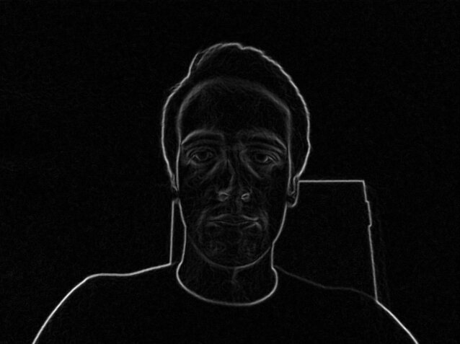
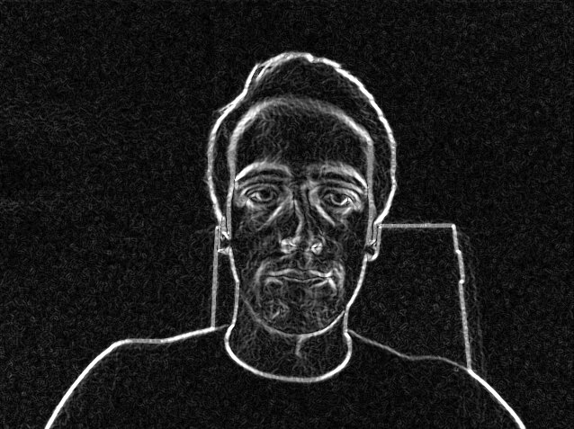
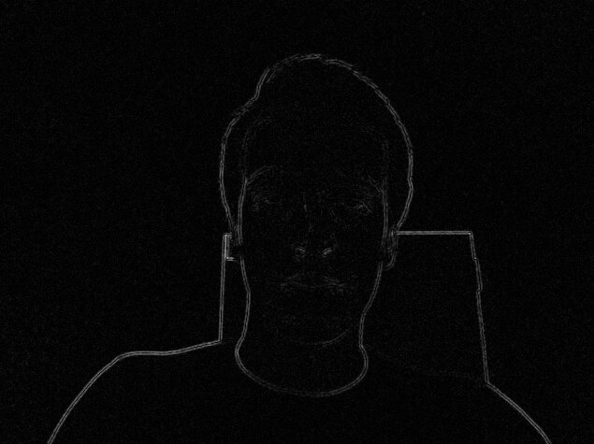
Fig. 1, 2, 3 – Output of GradCalc. Sobel (kernel size = 3), Scharr and Laplacian filtering (kernel size = 3), respectively.

III. Canny
This program uses the Canny method to detect edges in a images provided by a video feed. This is accomplished by using the Canny function. This function accepts values for a low threshold, a high threshold and the kernel size. The low threshold value may be changed on the fly, using a trackbar. The high threshold value is a ratio to the low threshold value that is also variable and defined by the user.
This method provides the best results for edge detection, comparing with the methods used in the previus program.
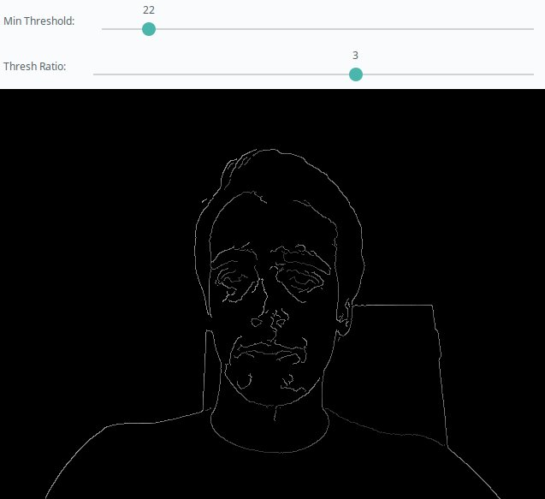
Fig. 4 – Edge detection with the Canny method (min threshold = 22, max threshold = 66).

IV. CornerDetect
The objective of this program is the detection of corners present in an image. This is made possible by using the Harris’ algorithm, provided by the cornerHarris function. This function takes a threshold value as argument. Later, the corners detected were identified in the output image with black circles.
This method is somewhat precise in detecting corners of a real world image. It isn’t more precise because the corners have gradients. Using a drawn picture, with well-defined corners, would make the corner detection very easy, using the Harris’ algorithm.
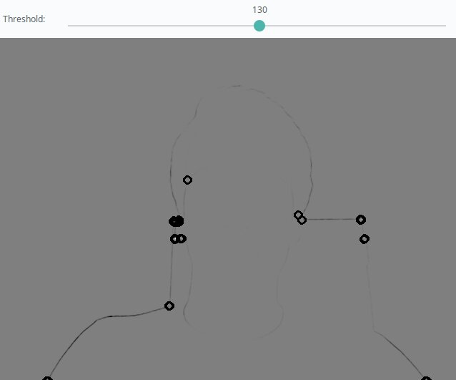
Fig. 5 – Corner detection using Harris’ algorithm (threshold value = 130). Corners are identified with black circles.

IV. HoughCircle
By using this program it’s possible to calculate and display the histogram of a given image. It can either display the histograms for each image channel (BGR, if that is the case) or display the one related to the grayscale version of the same image.
This is achieved by using the functions calcHist, normalize, and line. The first calculates the values of the histogram, given a bin size (number of values to calculate) and range (range of values for each the image channel is analysed [255 values]). The second merely normalizes the size of the histogram to fit in the window size, while the third is used to draw the histogram values in the window, thus forming a curve. This is made by drawing a colored bar between each value and its next neighbour. This is done two times at slightly different heights of the window, with the second drawing in black, effectively creating a line and not a colored area. This procedure must be made for each channel.
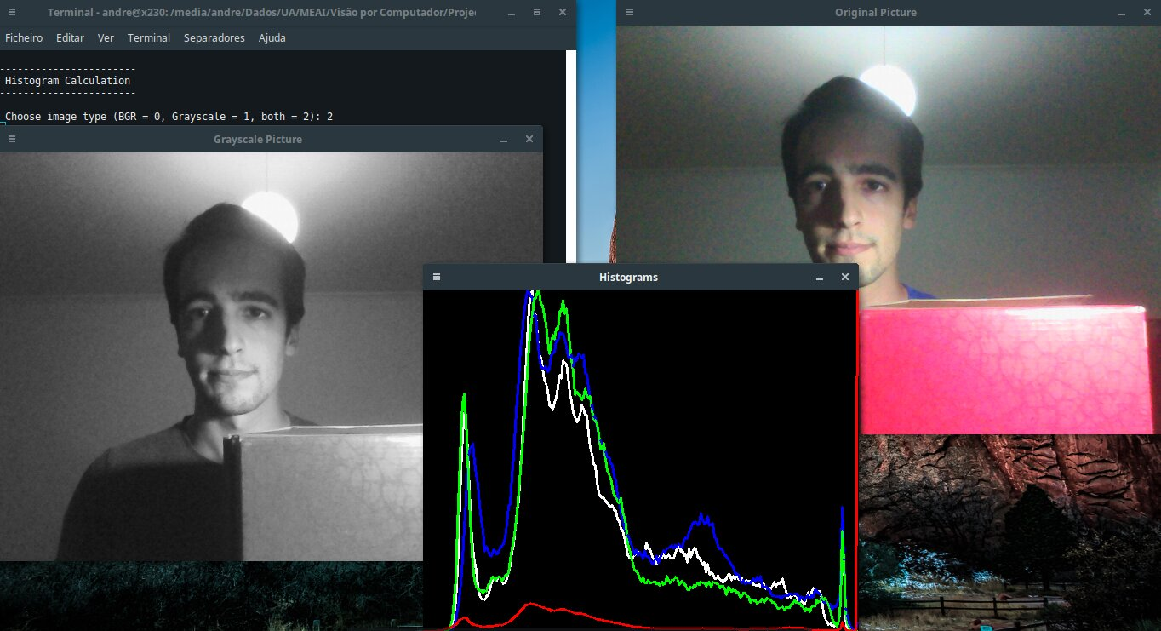
Fig. 10 – Original image, grayscale image and resulting histograms (grayscale histogram represented as white).

IV. HoughLine
The objective of this program is to compare the histogram of two different specific pictures. First we read each picture using imread. Secondly we separate the images in 3 channels (B, G and R). We then compute the histograms, draw them on the screen and print on the terminal the results of different methods of pictures’ comparison.
On the first comparation we use different pictures to observe their histograms and test results that we can see on the table below. For the Correlation and intersection methods, the higher the metric, the more accurate the match. For the other two metrics, the less the result, the better the match.
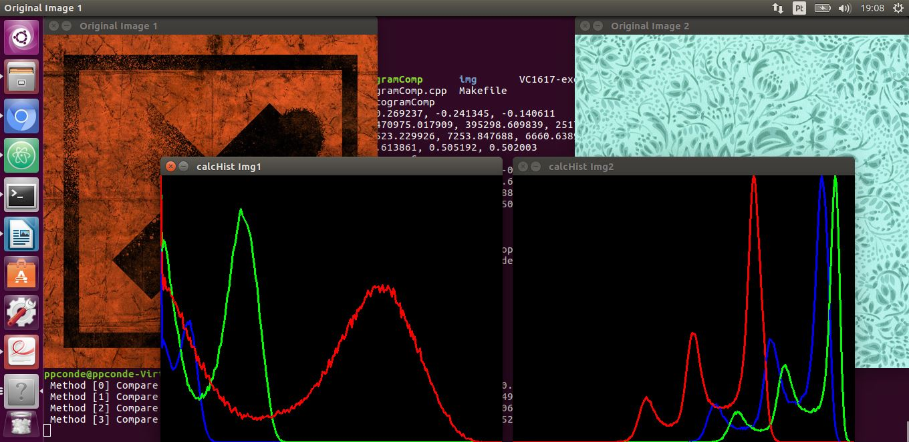
Fig. 11 - Original images and resulting histogram

 | B | G | R
Correlation | -0,177899 | -0,260063 | 0,454996
Chi-square | 4665,0492 | 15518,311 | 16797,0438
Intersection | 0,000 | 0,000 | 8606,56070
Bhattacharyya | 1,000 | 1,000 | 0,520924

Comparing to the results of similar pictures we can see that the Correlation method is not working as expected, but the Intersection method still just high metrics as it was expected. Chi-square is also not working as expected but the Bhattacharyya‘s method is. These can probably be explained thanks to the different lightning on both photos which influence the BGR colour channels. We get different histograms which results as inconsistent.
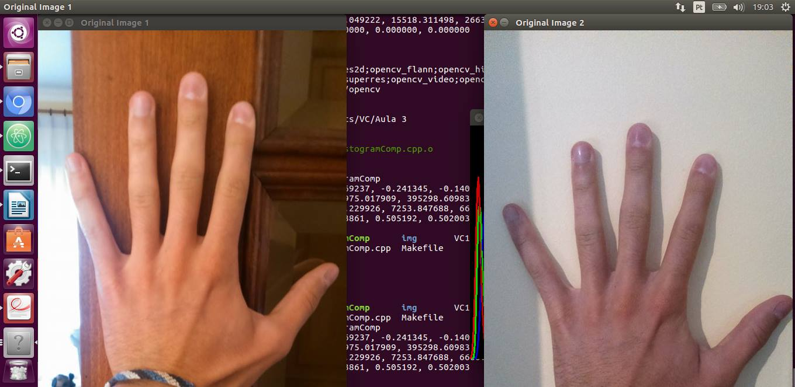
Fig. 22 - Original similar pictures

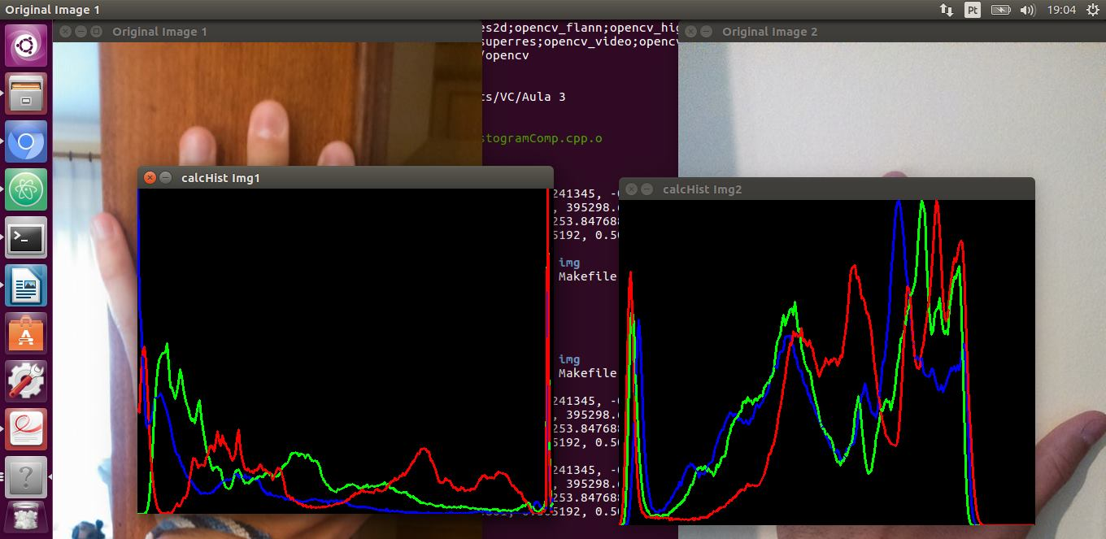
Fig. 13 - Original images and resulting histogram

 | B | G | R
Correlation | -0,269237 | -0,241345 | -0,140611
Chi-square | 247075,0179 | 395298,6098 | 251776,4753
Intersection | 4523,229926 | 7253,847688 | 6668,638920
Bhattacharyya | 0,613861 | 0,585192 | 0,582003

