Version Control With GIT
Practical 1:
To understand the concept of version control, its importance in managing projects changes and explore different version control system

Version control is a system that records changes to files over time so you call recall specific version later. It’s most commonly used in software development, but it’s also valuable for managing documents, designs, and any collaborative project.

Key Function:-
- Tracks every change made to a file
- Allows multiple people to work on the same project without conflict
- Enables reverting to previous version if needed
- Maintains a history of who changed what and when

Types of Version Control System:-
- Local Version Control System(Local VCS):-
A local Version Control System operates entirely on your personal machine without any connection to any remote repository. All changes and version history are stored in a local database on your computer.

- Centralized Version Control System:-
In Centralized Version Control System, all the files and their version history are stored in a single central server. This server acts as the main source for the entire project. Developers connect to this server to access or modify files but they do not maintain a full local copy of the project, instead they work with the most recent versions pulled from the server.

- Distributed Version Control Systems:-
Distributed Version Control Systems contains multiple repositories. Every user has their own repository and working copy. Just committing your changes will not give others access to your changes. This is because commit will reflect those changes in your local repository and you need to push them in order to make them visible on the central repository.

Practical 2
- Setup Git on Windows System and verify the installation
git –version

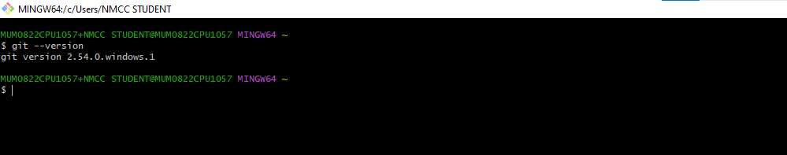

- Configure git with username, email and default Editor
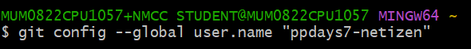
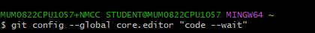
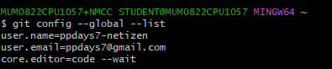
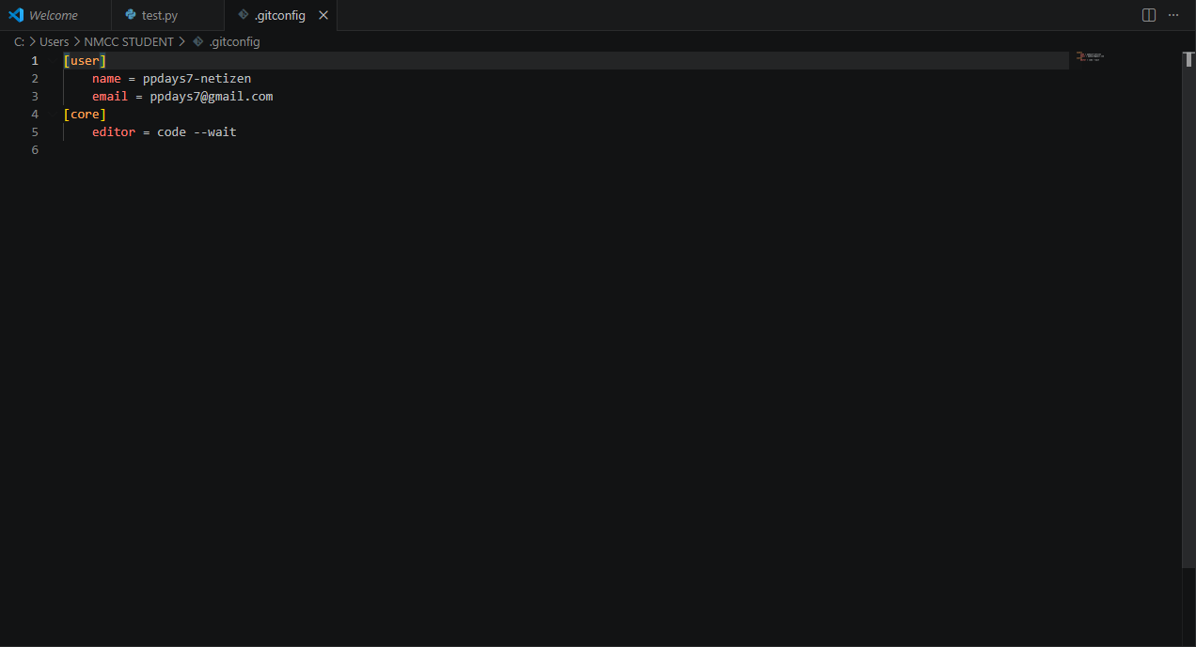
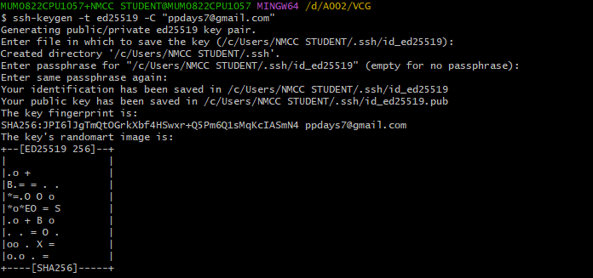

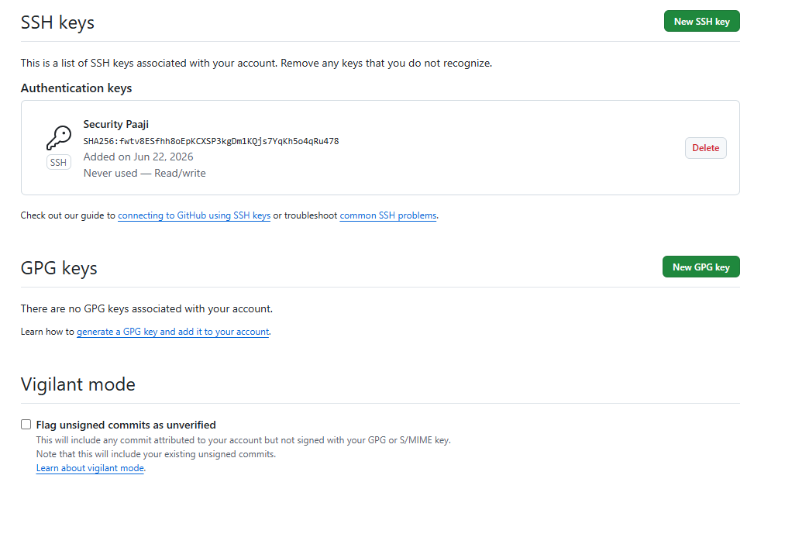

Practical 4:
To understand the concept of the git repository and learn to create and initialize a new local repository for tracking the project file.
- Create a new local repository using git init
