1.

(a)

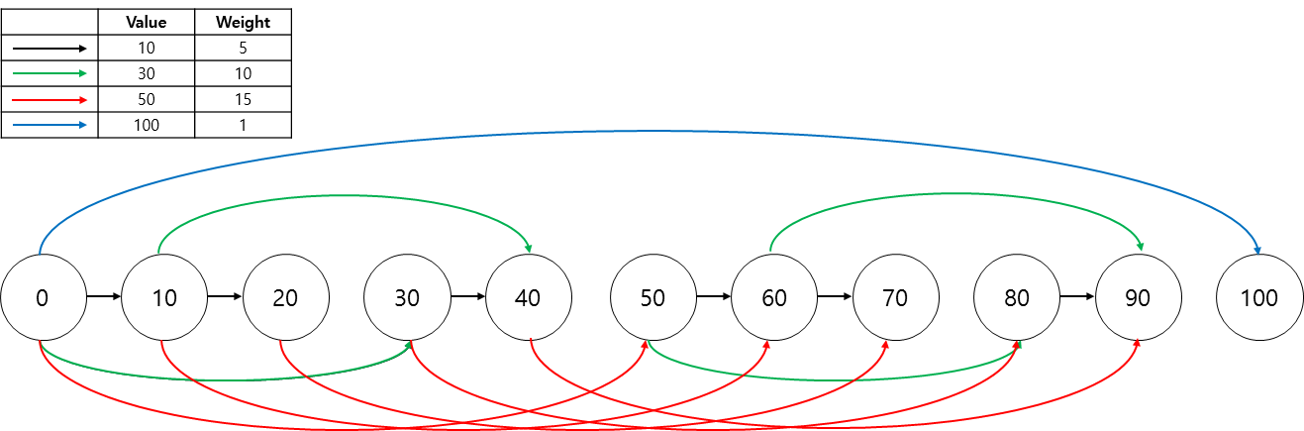

(b)

➀ Make an array , which has the value of . This means the cost of weight per a value.



➁ Let , such that the smallest value in the array which satisfies , and . Let this value as .



➂ Go to the next node . If there is no edge, call . Let's call this node .



➃ If , it terminates. If not, go to the step 2, do those again until becomes zero. For example, after iteration, if is not zero, go to the step 2. In step 2, we can get such that which satisfies step 2 conditions. After that, go to the step 3. If ≠, call . This will create path with smallest weight from 0 to .



(c)

Under the condition that all are positive, the graph is always a DAG. Currencies cannot have negative value so can't be negative. Since edges in the graph always go toward nondecreasing direction, there can't be a edge which goes backward(decreasing direction) and form this, there can't be a cycle.



2.

(a) /0/1/00/01/011/, 15times.

(b) Bob is true.

I used given example.

relative frequency of character : ~



and the number of transition is in below.

|  |  |
| --- | --- |
| Character | # of transition(~) |
| A | 1 |
| B | 2 |
| C | 2 |
| D | 3 |
| E | 3 |
| F | 4 |

So, running time can be represented by



Let's think about the point of and .



The grows bigger, the whole running time becomes smaller. The number of descendent's transition is always bigger than that of the parent. So coefficient of is smaller than the sum of the other coefficients, and sum of frequencies equal to 1, constantly. These characteristics hold in the subset of descendent(subtree).



Therefore, the larger ascendent's frequency is, the smaller whole running time will be.

(c)

0

0

1

1

/

/

/

/

/

3. Morse Code is not a prefix-free code.

SOS HELP → 000 111 000 0000 0 0100 0110 → 0001110000000001000110

I AM HIS DATE → 00 01 11 0000 00 000 100 01 1 0 → 0001110000000001000110

4.

(a)

➀ Unique MST

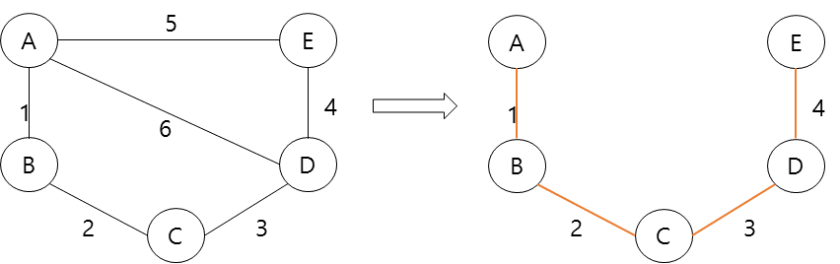

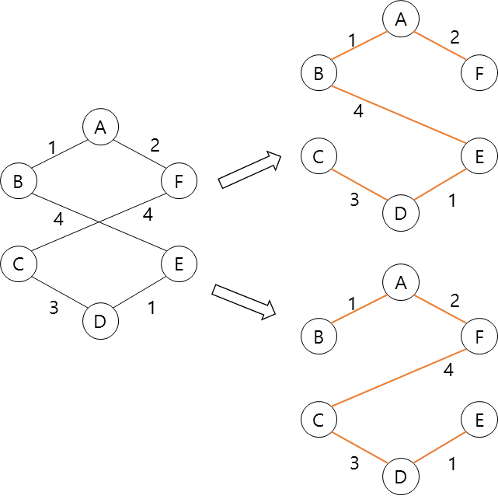➁ Exactly two MST

(b)

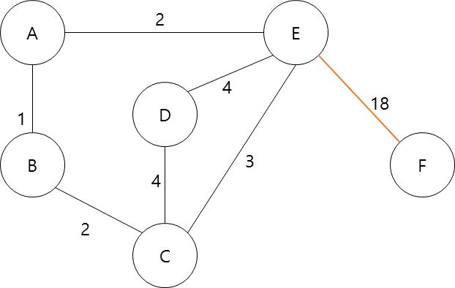Edge EF has maximum weight. It must be included in MST in order to contain node F.

(c) All edges in the graph have same weight.

