Assignment0

2013147513 Cho young jae

1. Install OpenGL
2. Move each files to appropriate directory

* glut.h -> C:\Program Files (x86)\Windows Kits\8.1\Include\um\gl
* glut.lib, glut32.lib -> C:\Program Files (x86)\Windows Kits\8.1\Lib\winv6.3\x86
* glut.dll, glut.32.dll -> c:\Windows\System32

1. Include glut32.lib, opengl32.lib, kernel32.lib

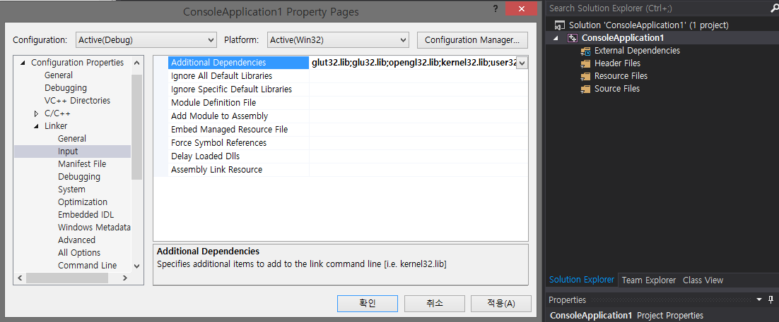

1. Run main
2. Result

