KNN calssifier

We can say that half of the information provided by the training set is contained in the nearest neighbor (asymptotically). Howerver, the KNN classifier breaks down for big dimention of datasets. We have 10 predictors but we will still try KNN classifier.
First we have to find the optimal number of neighbor ‘k’ that are going to be used in the final classifier.
So we compute the Error rate of the classfier for k from 1 to 15. This time the optimal k would have been 10. | But we repeated the process in order to have the mean of the optimal ks by using a loop.
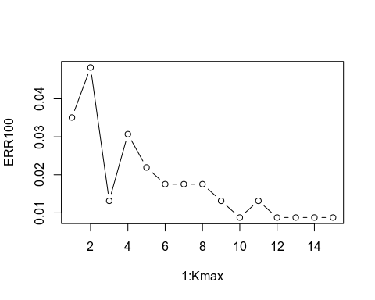 | 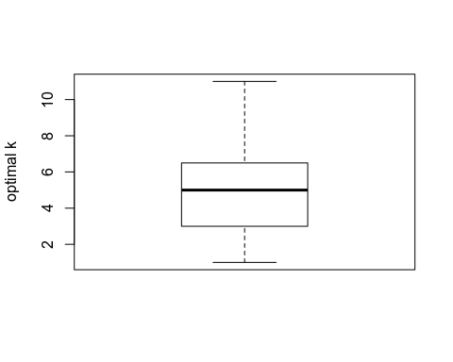

Cross Validation:

We have chosen the 5 fold cross validation method in order to estimate the error rate of each model without seeing the test set. The idea is to randomly divide the data into 5 equal-sized parts. We live out part k and we fit the model to the other parts combined and then obtain the prediction for the left -out kth part. We do this for k from 1 to 5 and we combine the results.

We can compare our different models that uses as trainning data only the rows that include no ‘Nas’ : | By using linear regression model to predict the ‘Nas’ of the training set, we were able to add 16 more rows, hoping to improve the quality of the classification:
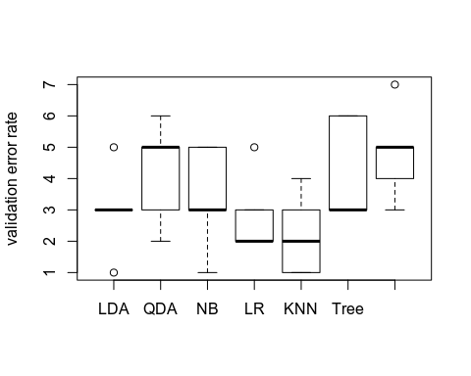 | 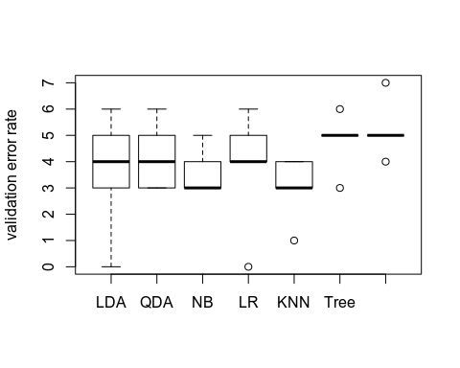

Even by repeating the process, we cannot say that by estimating the missing values with linear regression we improve significantly the quality of the classification. Unfortunately, we did not succeed to do the same comparison by replacing the missing values with the KNN regression.

Comparison with the ROC curve:

As we are in a problem of classification with two classes, we can choose a model also by dealing with the False positive and true negative error rates. Therefore it is interesting to prot the ROC curve.

MANON ROC CURVE IMAGE

and we can repeat the process using different random test sets among the dataset to compute the indicators.
We can compare the model’s test error rates | And we can also compute the Area Under the Curve of the ROC
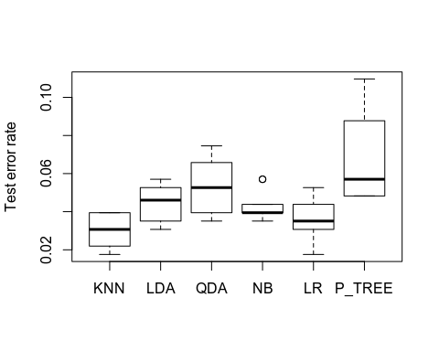 | 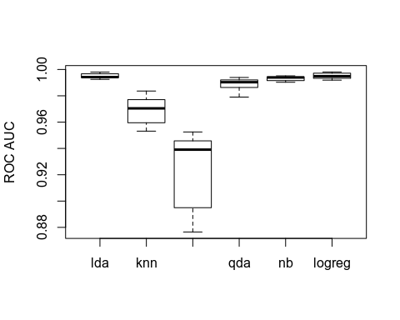
It is interesting to see that althrougth knn classifier offers better performances on test error rate compared to the logistic regression model, the LogReg model offers definitly better with the AUC.

