AboSettins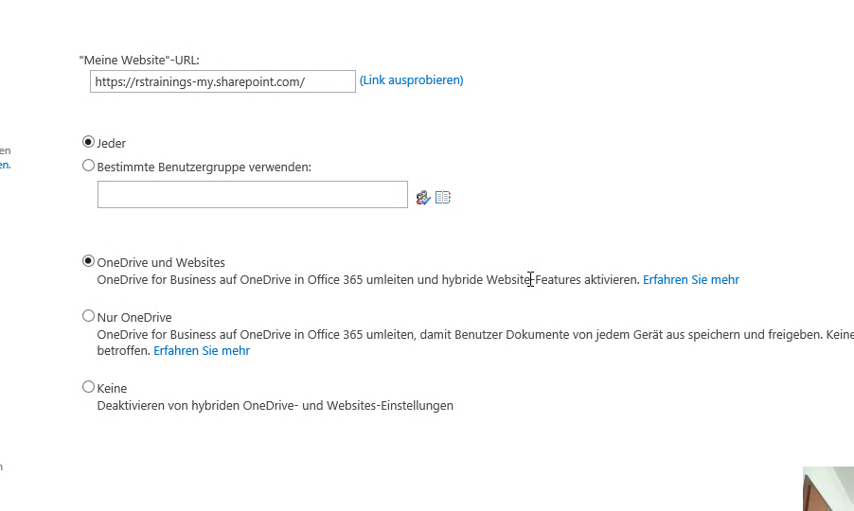

Settingssubscriptionservice

Online Hybrid Picker..

OneKlick Anwndung

FAZIT:

ONE Drive:

2 Lösungen

OveDrive Websites

