Vidzeme University of Applied Sciences
Faculty of Engineering

Web Technologies and Secure Websites

group 03

practical work #2

Valmiera, 2025

CONTENT
1 Content 4
2 HTML 4
2.1 Index.html 4
2.1.1 Index.html picture 5
2.2 About.html 5
2.2.1 About.html images 5
2.3 Services.html 6
2.4 Contact.html 7
2.5 Contacted.html 8
3 CSS 9
3.1 Styles.css important functionality 9
3.1.1 CSS images 9
List of used resources 11
APPENDIX 1 12

Document versions
Version | Status / Changes | Date | Author
1.0 | First version, added a folder for js, and implemented bootstrap, implemented the bootstrap nav bar on all pages, modified hero section and converted service pages list into a bootstrap card grid. | 28.03.2025 | Kristers Jirgensons
1.1 | Second version
1.2 | Third version,

Contacts and responsible (-s)
Name Surname | Department | Position | Contact information (e-mail)
Kristers Bizuns | Group #3 | Coordinator | Kristers.bizuns@va.lv
Kristers Jirgensons | Group #3 | Member | Kristers.jirgensons@va.lv
Jānis Petrovs | Group #3 | Member | Janis.petrovs@va.lv

Content

Our goal: To implement bootstrap and javascript in our previously created webpage.
In this practical work we used HTML to create the base of our websites 5 html files: index.html, services.html, about.html, contact.html and contacted.html. Each of these files represents a different aspect of our knowledge from the navigation bar being responsive to clicks and updating in each page, to the website being responsive to smaller screen sizes.

In this practical work we used Bootstrap and javascript to update our 5 html files, in 4 of the files we updated the navigation bar to use the bootstrap version of it, implementing a toggler button for mobile screens as well. We modified our hero section to use the bootstrap jumbotron and updated our services page to use the bootsrap card grid component. Later we decided to also implement this to our about page, since it would make it look better.

Implementation of bootstrap and JavaScript

We created a new folder which holds the javascript file “script.js”, and added the script and link for the bootstrap code to function properly in all of our html files, that require it.

Bootstrap navigation bar

The bootstrap navigation bar is much easier to use and easier to style, due to the fact that all of the available libraries are already online and guides on how to use them were provided in our lectures. This time we centered our navigation bar and made it so if the screen is smaller than 576 pixels it creates a toggler button, which on click shows all the options.

Bootstrap navigation bar and how it looks
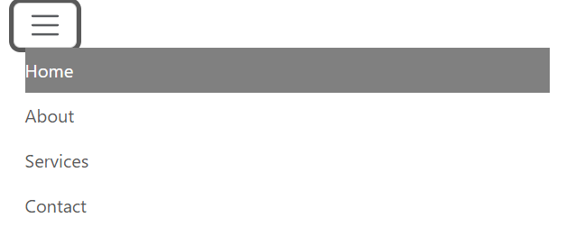

Updates to index.html hero section

The updates we made to the hero section are simple, we made it use the bootstrap jumbotron, and aligned the content to the center using the grid class.

Updated index.html

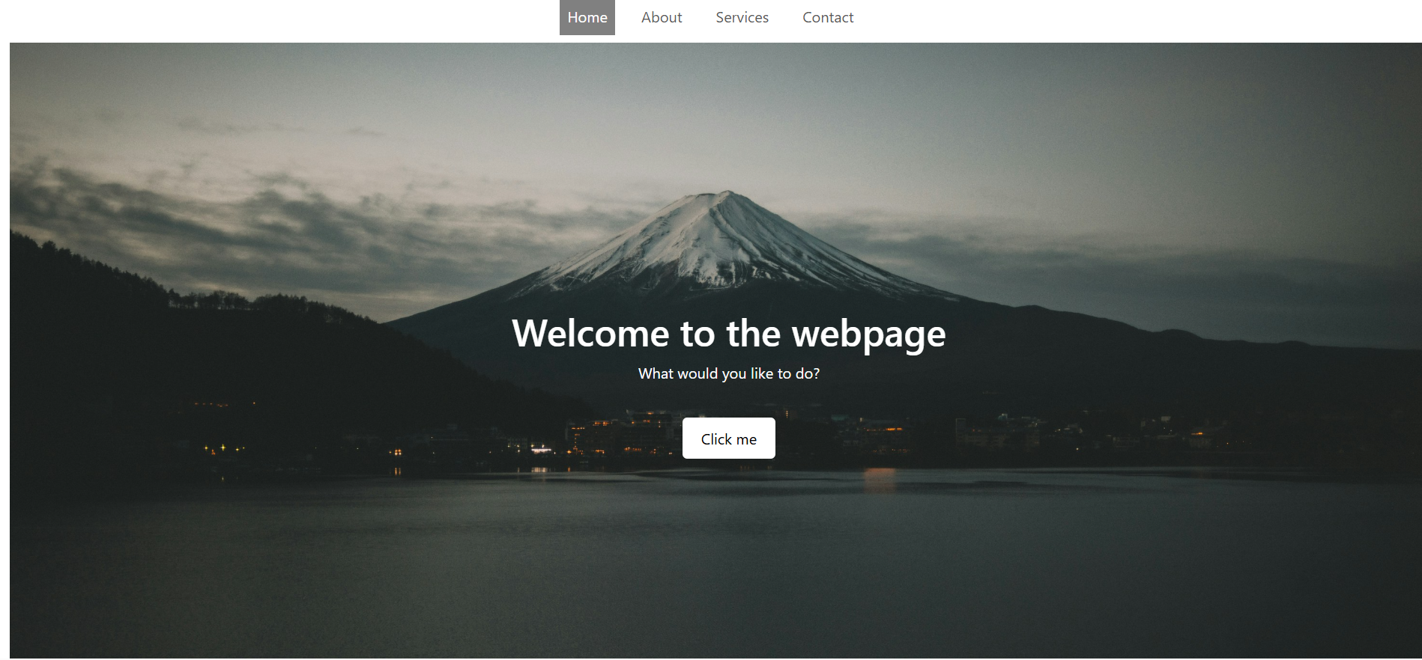

Services.html changes

Here we converted the list to a bootstrap card grid, and displayed the cards in a row instead of under each other, but if the site is viewed on a smaller screen they appear under each other

Services images
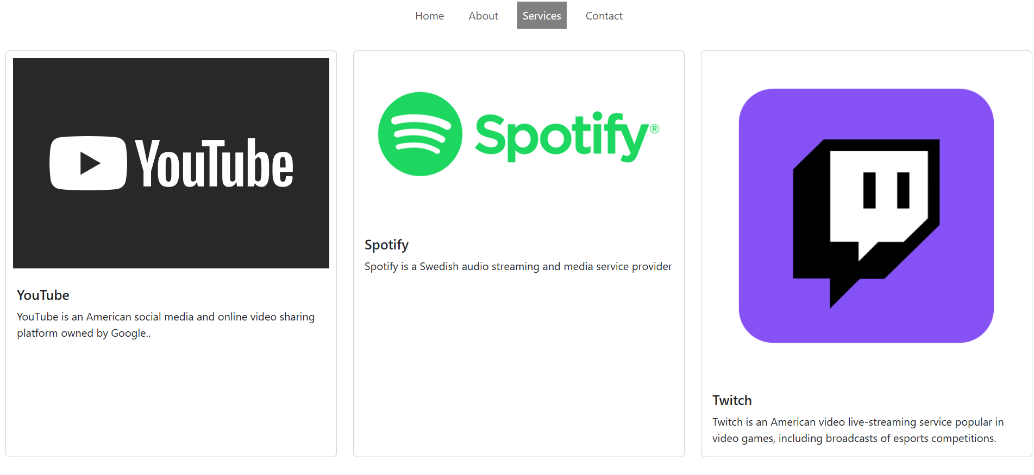
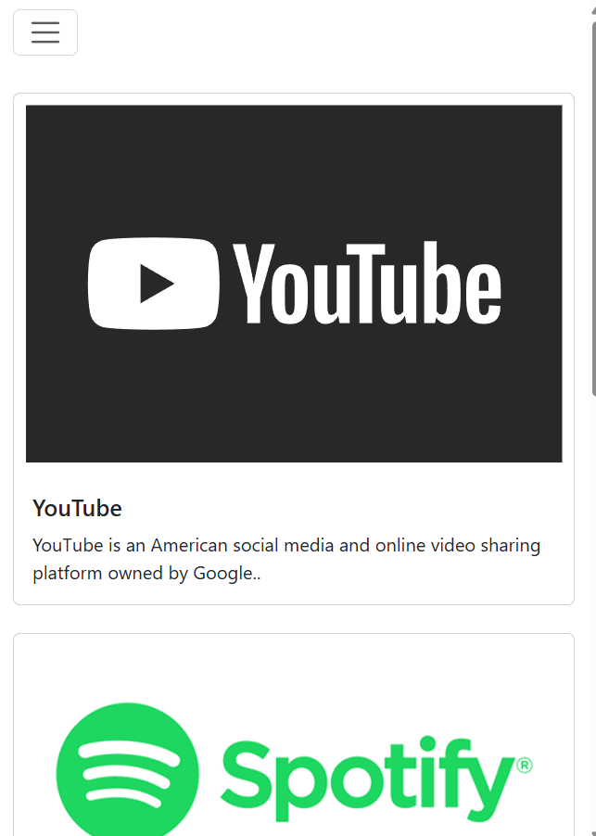

Changes to about.html

We implemented the same principle that we did to services cause it just looks better.

About.html change images
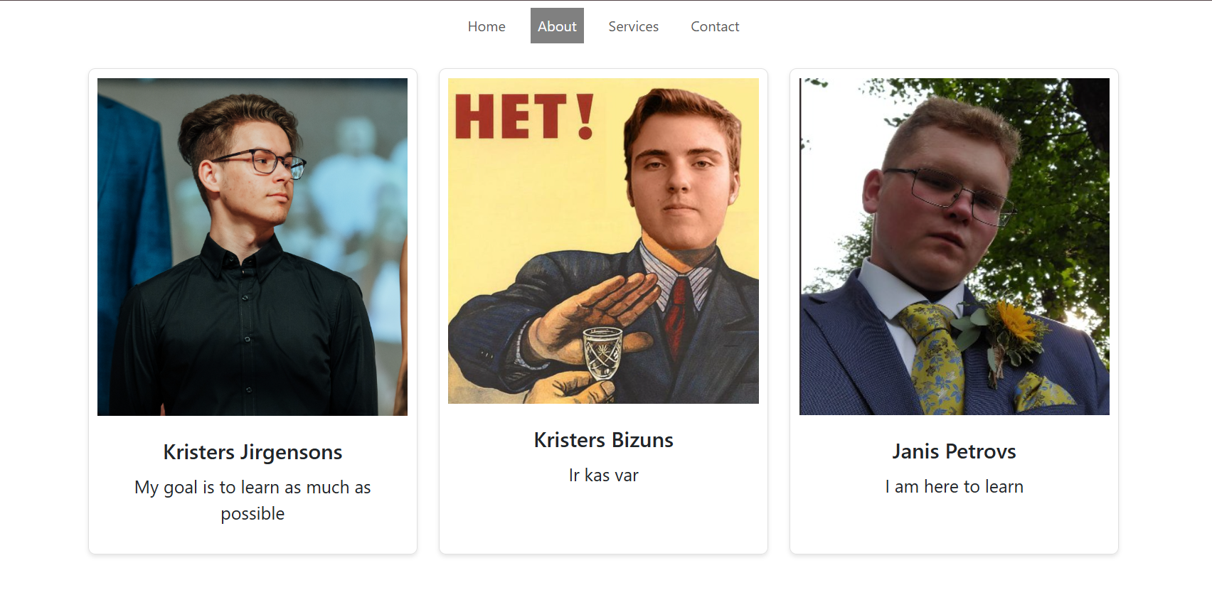

Contact.html changes

Javascript implementation

blablabla

List of used resources

https://www.w3schools.com/html/
https://www.w3schools.com/html/html_css.asp

APPENDIX 1

Index.html
<!DOCTYPE html>
<html>

<head>
<link rel='stylesheet' type='text/css' href='css/styles.css'>
<title>My web training page</title>
<meta name="viewport" content="width=device-width, initial-scale=1.0" charset="UTF-8" />
</head>

<body>

<div class="navigation">
<b><a class="active" href="index.html">Home</a>
<a href="about.html">About</a>
<a href="services.html">Services</a>
<a href="contact.html">Contact</a></b>
</div>

<div class="hero">
<h1>Welcome to the webpage</h1>
<p>What would you like to do?</p>
<a href="https://www.youtube.com/watch?v=dQw4w9WgXcQ">Click me</a>

</div>

<div class="HDP">
<h1 class="header1">Website</h1>
<p>This website is designed to qualify all the requirements
for the first practical work. The goal is to recieve the
maximum marks for this small project.</p><br>
<h3>Important features</h3>
<ul>
<li>The navigation bar
<ul>
<li>
Showing our skills that we have learnt throughout the lectures
</li>
</ul>
</li>

<li>Compatibility with smaller screens</li>
<ul>
<li>
Showing our competence with smaller screens and how it affects all the data shown
(i.e. the text becoming white because the background becomes black when screen shrinks)
</li>
</ul>
<li>Sleeping</li>
</ul>
</div>

<div>
<footer id="footer">
<p> Author: Kristers Jirgensons <br>
<a href="x">Placeholder1 for social media</a><br>
<a href="x">Placeholder2 for social media</a><br>
<a href="x">Placeholder3 for social media</a><br>
Copyright something
</p>
</footer>
</div>
</body>
</html>

About.html
<!DOCTYPE html>
<html>

<head>
<link rel='stylesheet' type='text/css' href='css/styles.css'>
<title>About</title>
<meta name="viewport" content="width=device-width, initial-scale=1.0" charset="UTF-8" />
</head>
<body>

<div class="navigation">
<b><a href="index.html">Home</a>
<a class="active" href="about.html">About</a>
<a href="services.html">Services</a>
<a href="contact.html">Contact</a></b>
</div>

<div class="container">
<div class="image">
<img src="images/kj.jpg" alt="KJ">
</div>
<div class="text">
<h1>Kristers Jirgensons</h1>
<p>My goal is to learn as much as possible</p>
</div>
</div>

<div class="container">
<div class="image">
<img src="images/kb.jpg" alt="KB">
</div>
<div class="text">
<h1>Kristers Bizuns</h1>
<p>Ir kas var</p>
</div>
</div>

<div class="container">
<div class="image">
<img src="images/jp.jpg" alt="JP">
</div>
<div class="text">
<h1>Janis Petrovs</h1>
<p>I am here to learn</p>
</div>
</div>

<div>
<h1 class="header1">Mission Statement</h1>
<p class="paragraph1">We as a team have decided that our goal in this course
will be learning as much as possible on our own through
the lecturers provided literature and presentations, without
the use of AI.
</p>

</div>

<div>
<h1 class="header1">Timeline</h1>
<ol class="lists">
<li> <b> Kristers Bizuns made his blueprint </b>
<ul class="ulists">
<li>
Me and Janis checked it out and it looked good
</li>
</ul>
</li>

<li><b>Kristers Jirgensons is making his blueprint </b>
<ul class="ulists">
<li> I am designing it to the fullest, doing my best to make the practical work look good</li>
</ul>
</li>

<li><b>Janis Petrovs Will make his blueprint </b> </li>
</ol>
</div>

</body>
</html>

Services.html
<!DOCTYPE html>
<html>

<head>
<link rel='stylesheet' type='text/css' href='css/styles.css'>
<title>About</title>
<meta name="viewport" content="width=device-width, initial-scale=1.0" charset="UTF-8" />
</head>
<body>
<div class="navigation">
<b><a href="index.html">Home</a>
<a href="about.html">About</a>
<a class="active" href="services.html">Services</a>
<a href="contact.html">Contact</a></b>
</div>

<section>
<ul>
<li>
<h2 class="header2">Youtube</h2>
<p class="paragraph2">YouTube is an American social media and online video
sharing platform owned by Google. YouTube was founded
on February 14, 2005, by Steve Chen, Chad Hurley, and
Jawed Karim, three former employees of PayPal.</p>
<img src="images/youtube.svg" alt="youtubelogo">
</li>
<li>
<h2 class="header2">Spotify</h2>
<p class="paragraph2">Spotify is a Swedish audio streaming and media service
provider founded on 23 April 2006 by Daniel Ek and Martin Lorentzon.
As of December 2024, it is one of the largest providers of music streaming
services, with over 675 million monthly active users comprising 263 million
paying subscribers.</p>
<img src="images/spotify.png" alt="spotifylogo">
</li>
</ul>
</section>
</body>
</html>

Contact.html
<!DOCTYPE html>
<html>

<head>
<link rel='stylesheet' type='text/css' href='css/styles.css'>
<title>About</title>
<meta name="viewport" content="width=device-width, initial-scale=1.0" charset="UTF-8" />
</head>
<body>
<div class="navigation">
<b><a href="index.html">Home</a>
<a href="about.html">About</a>
<a href="services.html">Services</a>
<a class="active" href="contact.html">Contact</a></b>
</div>

<div>
<h1 class="header1">Contact us!</h1>
<div class="contact">

<label id="labelid" for="email">Email</label><br>
<input id="textboxid" type="text"><br>
<label id="labelid" for="name">Full name</label><br>
<input id="textboxid" type="text"><br>
<label id="labelid" for="text">Reason you are contacting us </label><br>
<input id="textboxid" type="text"><br><br>

<button id="buttonid"><a href="contacted.html">Send</a></button>

</form>
</div>
</div>

<div>
<h1 class="header1">Our information</h1>
<p class="header3">Phone: +123456</p>
<p class="header3">Email: abc@gmail.com</p>

</div>
</body>
</html>

Contacted.html
<!DOCTYPE html>
<html>

<head>
<link rel='stylesheet' type='text/css' href='css/styles.css'>
<title>About</title>
<meta name="viewport" content="width=device-width, initial-scale=1.0" charset="UTF-8" />
</head>
<body>
<div class="centereddiv">
<h1 class="header1">You have succesfully contacted us</h1>
<button id="returnid"><a href="contact.html">Return</a></button>
</div>
</body>
</html>

Styles.css
@media only screen and (max-width: 600px) {
body {
background-color: black;

.navigation {
background-color: black;
}
.navigation a {
color: white;

}

.hero {
height: 300px;
font-size: 16px;
padding: 15px;
text-align:center;
align-content: center;
}

.HDP {
color: white;
}

.text {
color: white;
}

.paragraph1 {
color: white;

}

.header1 {
color: white;
}

.header2 {
color: white;
}

.paragraph2 {
color: white;
}

.header3 {
color: white;
}
.lists {
color: white;
}

#labelid {
color: white;
}

#footer {
color: white;
}
}
}

.navigation {
background-color: #ffffff;
overflow: hidden;
text-align: center;
font-family:'Segoe UI', Tahoma, Geneva, Verdana, sans-serif;

}

.navigation a {
float:left;
color: #000000;
text-align: center;
padding: 14px 18px;

text-decoration: none;
font-size: 17px;
}

.navigation a:hover {
background-color: #ddd;
color: black;
}

.navigation a.active {
background-color: gray;
color: white;
}

.hero {
background-image: url('../images/bg2.jpg');
background-size:100%;
background-repeat: no-repeat;
color: white;
padding: 250px;
font-family: sans-serif;
text-align: center;
font-size: 20px;
}

.hero a:hover {
background-color: #ddd;
color: black;
}

.HDP {
font-size: 16px;
font-family: 'Times New Roman', Times, serif;
text-align: justify;

}

.header1 {
text-align: center;
font-size: 36px;
}

.header2 {
text-align: left;
font-size: 24px;
}

.header3 {
text-align: center;
font-size: 24px;
}

.paragraph1 {
text-align: center;
font-size: 18px;
}

.paragraph2 {
text-align: left;
font-size: 14px;
}

.container {
display: grid;
align-items: center;
grid-template-columns: 1fr 1fr 1fr;
column-gap: 5px;
}

img {
padding: 10px;
width: 80%;
}

.text {
text-align: justify;
font-size: 20px;
}

.lists {
text-align: justify;
font-size: 18px;
}

.ulists {
text-align: justify;
font-size: 16px;
}

section {
display: block;
}

.contact {
text-align: center;
}

#textboxid
{
height: 25px;
font-size:14px;
}
#labelid {
font-size: 18px;
font-weight: bold;
}

#buttonid {
height: 25px;
font-size: 14px;
}

#returnid {
text-align: center;
height: 50px;
width: 100px;
font-size: 24px;
}

.centereddiv {
text-align: center;
margin: 20%;
font-size: 36px;
}

#footer {
background-color: black;
color: white;
text-align: center;
}

