Vidzeme University of Applied Sciences
Faculty of Engineering

Web Technologies and Secure Websites

group 03

Large Project Work
ProTuning - Chip tuning

Valmiera, 2025

TABLE OF CONTENTS
1 Content 4
2 Database Schema and table descriptions 4
2.1 Database setup 4
2.1.1 Tables 4
3 Features and functionalities 6
4 Code Demonstrations and Screenshots 6
4.1 User Registration register.php: 6
4.1.1 Register page 7
4.2 User login and logout, login.php / logout.php: 7
4.2.1 Login page 9
4.2.2 Logout showcase 10
4.3 Changing password 10
4.3.1 Change password page 12
4.4 CRUD operations 12
4.4.1 Admin page 14
4.5 Tuning operations 14
4.5.1 Tuning page 14
4.5.2 Tuning result 15
4.6 Dark mode / Light mode 15
4.6.1 Light-mode preview 17
4.7 Mobile support 17
4.7.1 Navigation bar and design on desktop 17
4.7.2 Navigation bar and design on mobile 18
4.8 Index.html 19
4.8.1 Home section 19
4.8.2 About section 19
4.8.3 Contact section 20
4.8.4 Tuning section 20
4.8.5 Login section 21
4.8.6 Register section 21
4.8.7 Change password section 22
List of used resources 23

Document versions
Version | Status / Changes | Date | Author
1.0 | First version, created documentation | 29.05.2025 | Kristers Jirgensons
1.1 | Updated document | 30.05.2025 | Kristers Bizuns
1.2 | Updated Document | 31.05. 2025 | Jānis Petrovs
1.3 | Finishing touches | 02.06.2025 | Kristers Jirgensons

Contacts and responsible (-s)
Name Surname | Department | Position | Contact information (e-mail)
Kristers Bizuns | Group #3 | Coordinator | Kristers.bizuns@va.lv
Kristers Jirgensons | Group #3 | Member | Kristers.jirgensons@va.lv
Jānis Petrovs | Group #3 | Member | Janis.petrovs@va.lv

Content

Our goal: To create a dynamic website that applies all of the skills learned in lectures and through self-study, inspired by our personal interests, experiences, and hobbies. This project fulfills the requirements for the Large Project Work, which builds upon our all of our previous work.
The purpose of the project is to provide a website for our chip tuning services as well as educate potential clients about vehicle performance optimization. Our goal is to deliver a professional online presence for our customers, enabling a smooth interaction between the customers and service team as well as lay the groundwork for future expansion.
Our target audience would be Car enthusiasts who are looking to enhance their vehicle’s performance, vehicle owners who are seeking better fuel efficiency or more horsepower and automotive professionals who may partner with us or refer their clients to us.

Database Schema and table descriptions

Database setup
The database_Setup.php script is responsible for the initial setup of the project's database environment. It ensures that the specified database is created if it does not already exist, selects it, and then proceeds to define and create the required tables.
First of all it connects to the MySQL server with the provided credentials using PDO
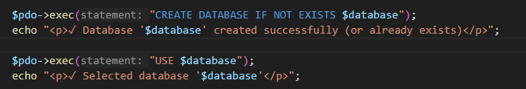
Here it creates the chiptuning_db database if it doesn’t already exist, then selects the database to run the subsequent SQL command
It then creates three tables, users, chip and contact_messages:
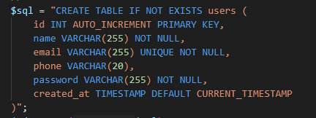
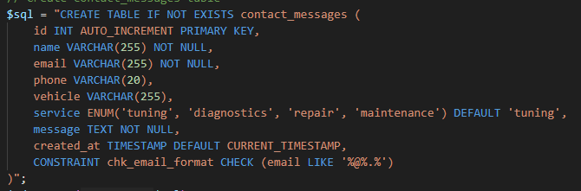
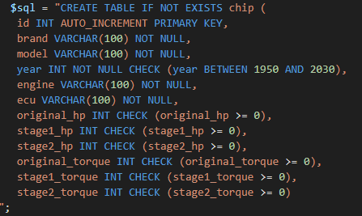

Tables
The database setup script creates three tables:
Users: Stores user credentials and roles.
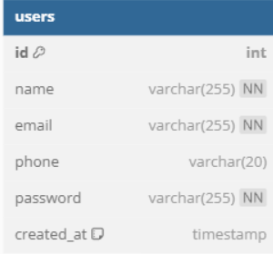

Chip: Stores information about the chip tuning records
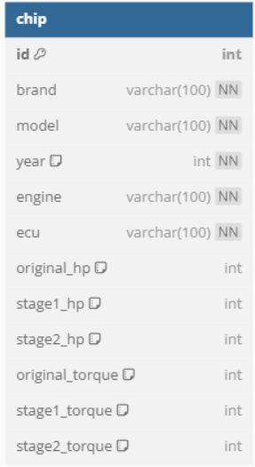
Contact_messages: Stores the messages that the users have contacted the staff with.
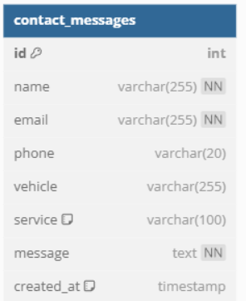

Features and functionalities
User authentication:
- Implemented in register.php, login.php, change_password.php, logout.php
- Sessions managed in check_session.php
Admin Panel:
- Admin.html provides an interface to manage chip data
Dynamic Content:
- fetch_chip.php fetches data via AJAX for real-time display.
- api.php used for back-end communication and CRUD.
Responsive Design:
- HTML5 and Bootstrap used in index.html and admin.html for layout and responsiveness.
- CSS files are linked to index.html and admin.html such as admin.css and styles.css.
- JavaScript files are also linked to index.html and admin.html such as admin_script.js, chipdatascript.js and main_script.js

Code Demonstrations and Screenshots

User Registration register.php:
This php file, gets the inputs from the user, such as:
- Name
- Email address
- Password
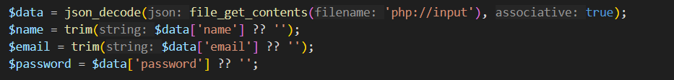
Also performing validation checks to make sure all the fields have been filled,
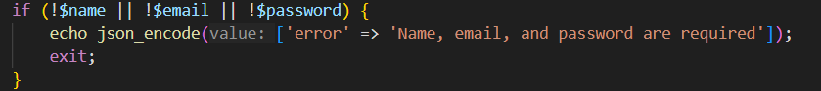
And in the end hashing the password

Register page
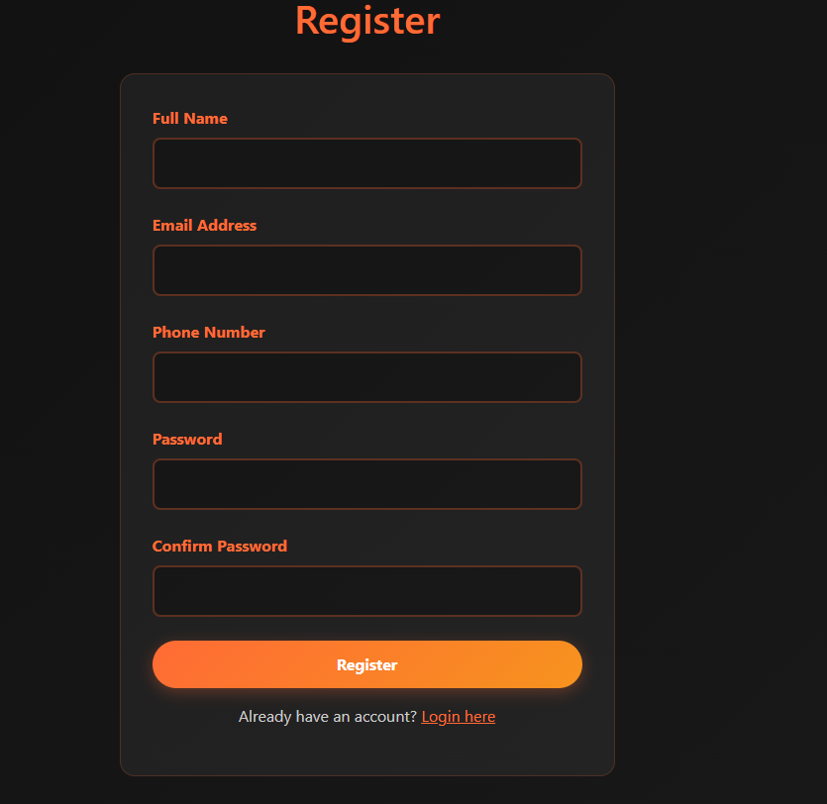

User login and logout, login.php / logout.php:
The login.php file gets an input from the user for:
- Email address
- Password
- Grabs the raw JSON payload sent in the POST request.
- Converts JSON into an associative array.
- Gets the email from the request, or uses an empty string if not provided.
- Gets the password.
Simple validation to check if the email and password have been provided:
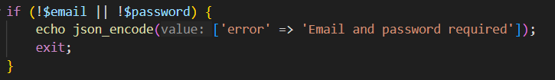
Check for if the user is in the database:
Verifying if the password has been entered correctly and sets the session:
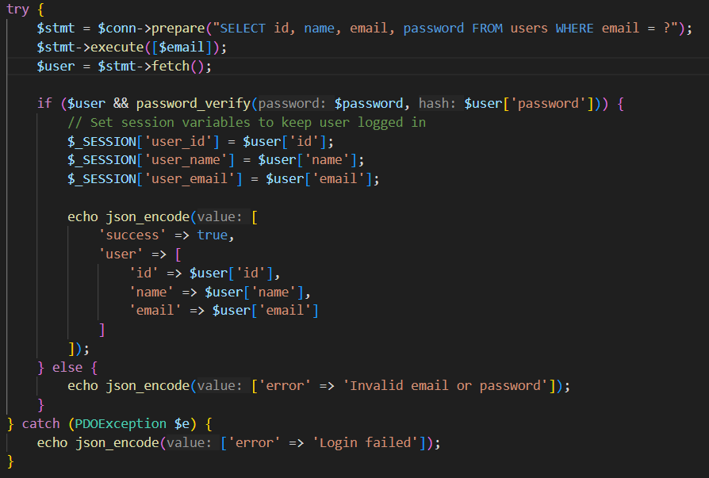
If the user exists and the password matches (using password_verify()):
- PHP session variables are set
- A success message with basic user info is returned.
If not, an error is returned.

Login page
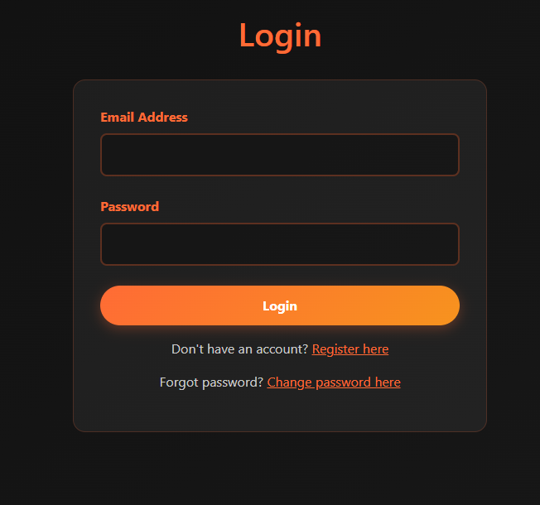
Logout.php
This php file just destroys the session and logs the user out of their account:
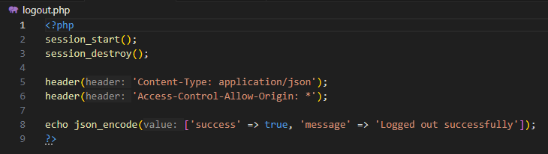

Logout showcase


Changing password
The changepassword.php file reads and parses the inputs, and retrieves all of the required fields:
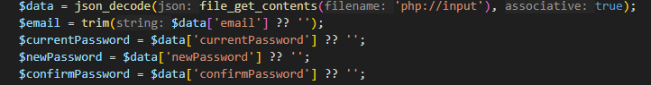
There is also simple input validation to check if the fields have been filled correctly,
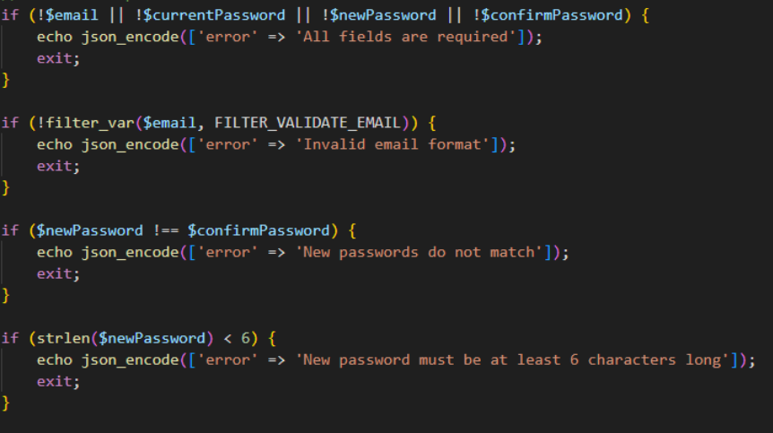
As well as a check if the user who’s password you are trying to change even exists,
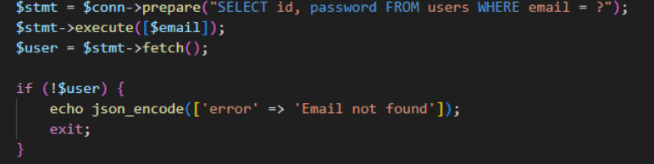
There is password verification to make sure you know the current password that you are trying to change:
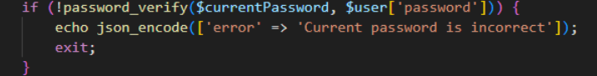
Which:
- Validates the current password using password_verify() function,
- If incorrect denies the request
The updated password gets hashed, and updated in the database, while also telling the user that the password was changed successfully
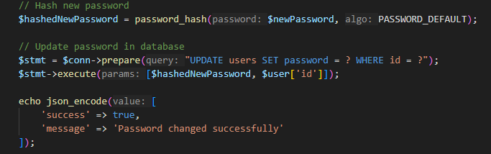

Change password page
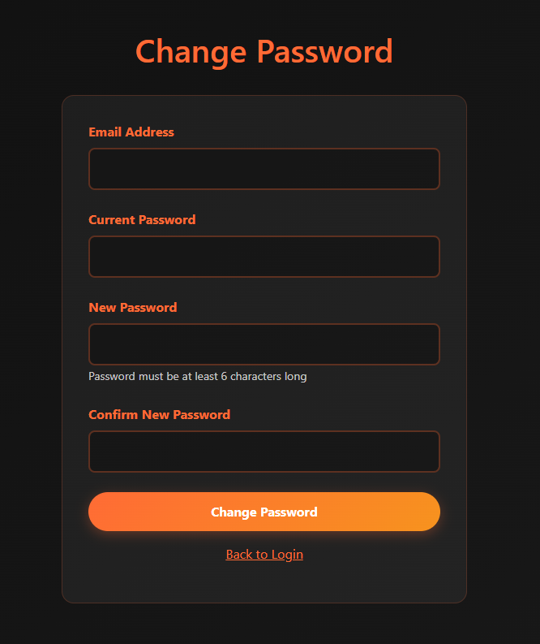

CRUD operations
CRUD operations happen in the admin.html page, through the api.php file,
First of all fetching all data from the table:
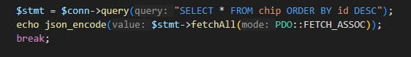
With the add new entry button there the admin user enters all the required data:
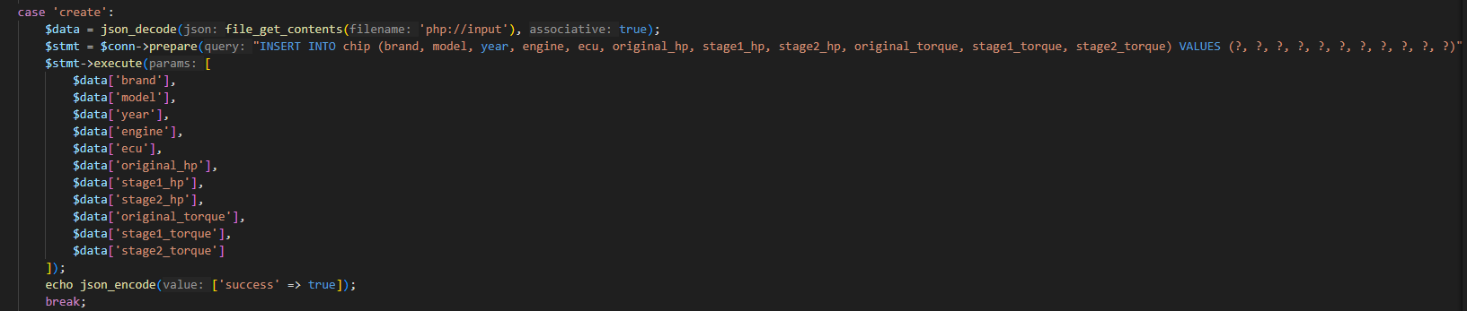
Where it:
- reads JSON input
- inserts a new chip tuning entry.
With the edit button the admin user can edit and update already existing data in the table:
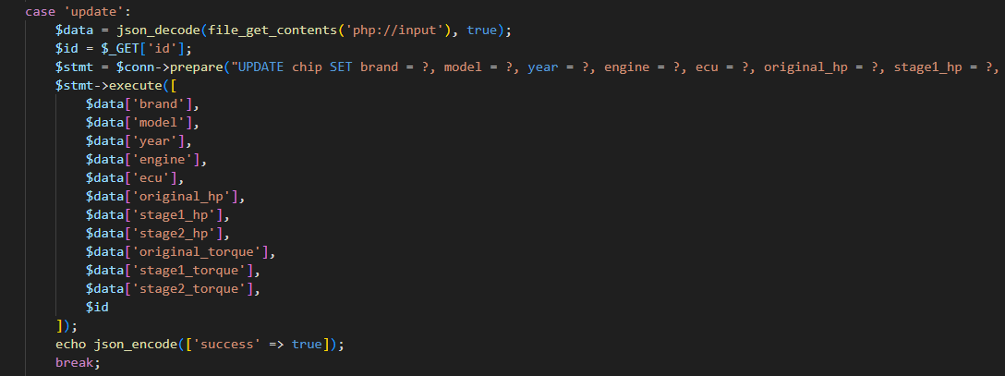
Where it:
- Reads JSON input and gets id from query string.
- Updates the matching row.
And with the delete button it deletes an entry:
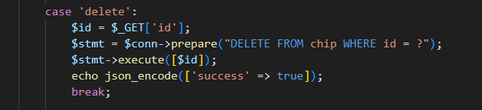
Which Deletes the entry with the provided id.

Admin page
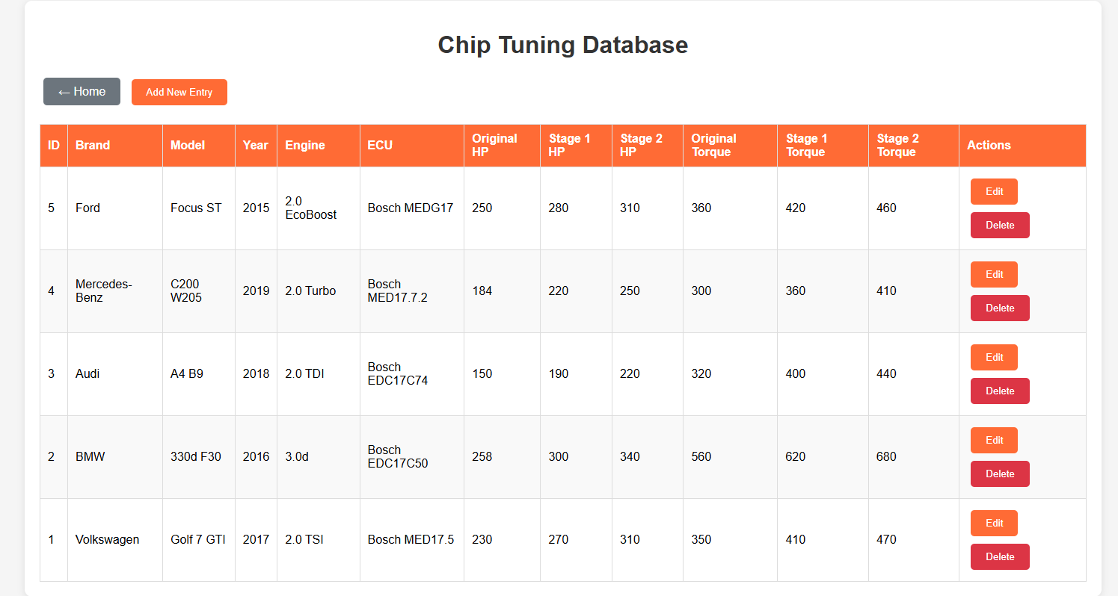

Tuning operations

Tuning page
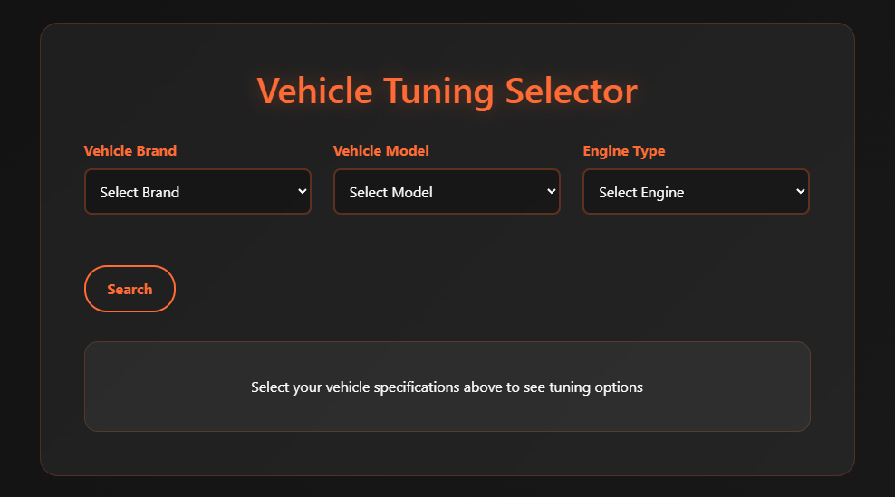
Where the user selects the vehicle brand, model and engine type, then through the JavaScript function searchTuning() it gives back what upgrade the selected vehicle would get in horsepower and torque.
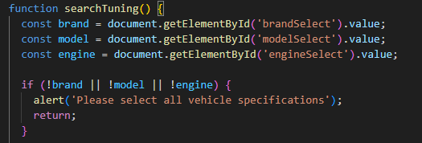

Tuning result
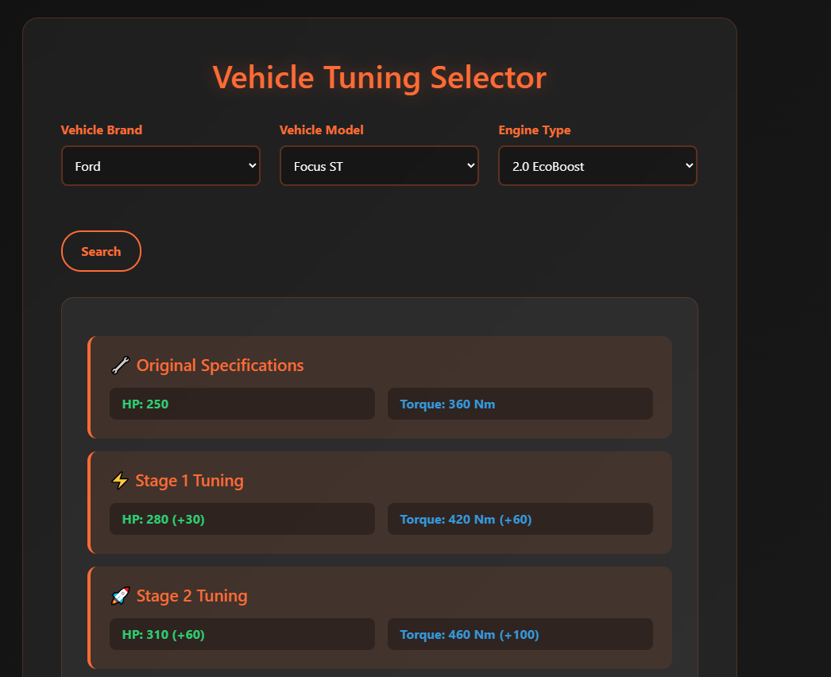

Dark mode / Light mode
The dark mode and light mode function initTheme(), works as such:
Looks for a DOM element with id="themeToggle" — this is the button that toggles the theme, then
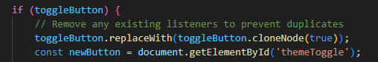
If the button exists:
- It replaces the original button with a clone of itself, to:
  - Remove all existing event listeners.
  - Avoid duplicate or stacked event triggers.
Then it reselects the new button (newButton) to attach a fresh event listener.
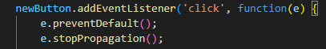
- Adds a click listener to the button.
- preventDefault() stops default behavior
- stopPropagation() prevents the click from bubbling up to parent elements.
- Changes the light-mode class on the <body> section
- Checks if light-mode is currently active.
- Saves 'light' or 'dark' to localStorage so it persists across page loads.
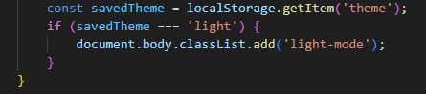
- On page load, checks if the user previously selected light mode.
- If yes, it applies light-mode to the <body> immediately.

Light-mode preview
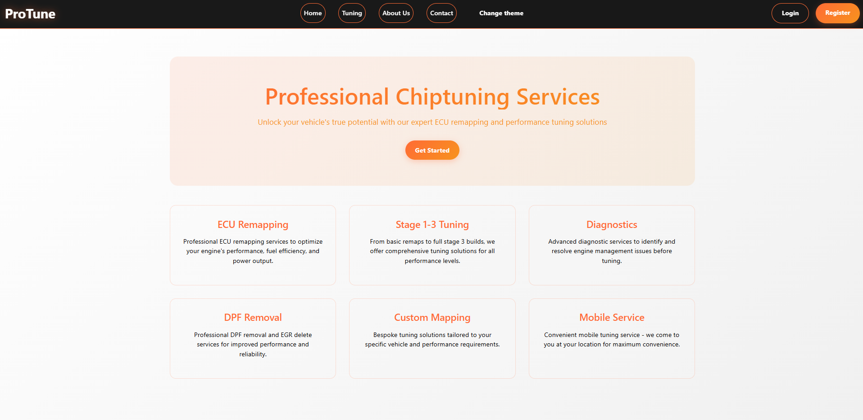

Mobile support
Through the use of bootstrap we have also made it so the webpage supports smaller screens, by changing the navigation bar and the objects in the page to fit properly.
Using bootstrap classes and data for design.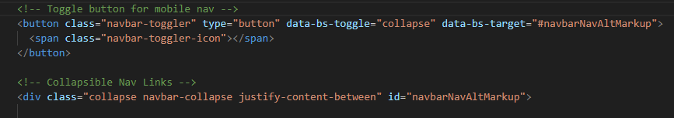

Navigation bar and design on desktop
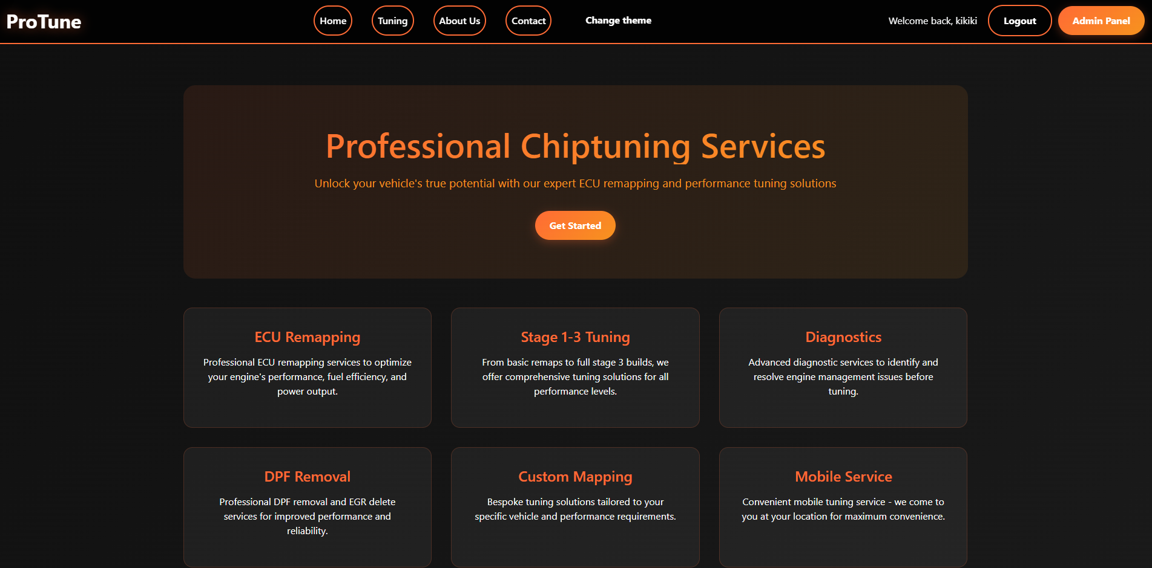

Navigation bar and design on mobile
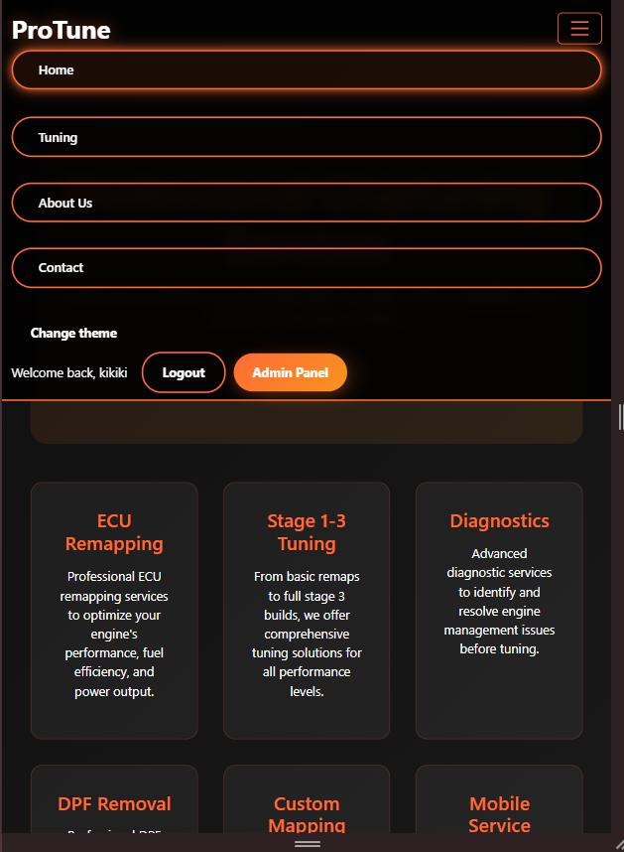

Index.html
The index.html file contains seven sections, Home, About, Contact, Tuning, Login, Register, Change Password, which are all made using HTML5, bootstrap and CSS.

Home section
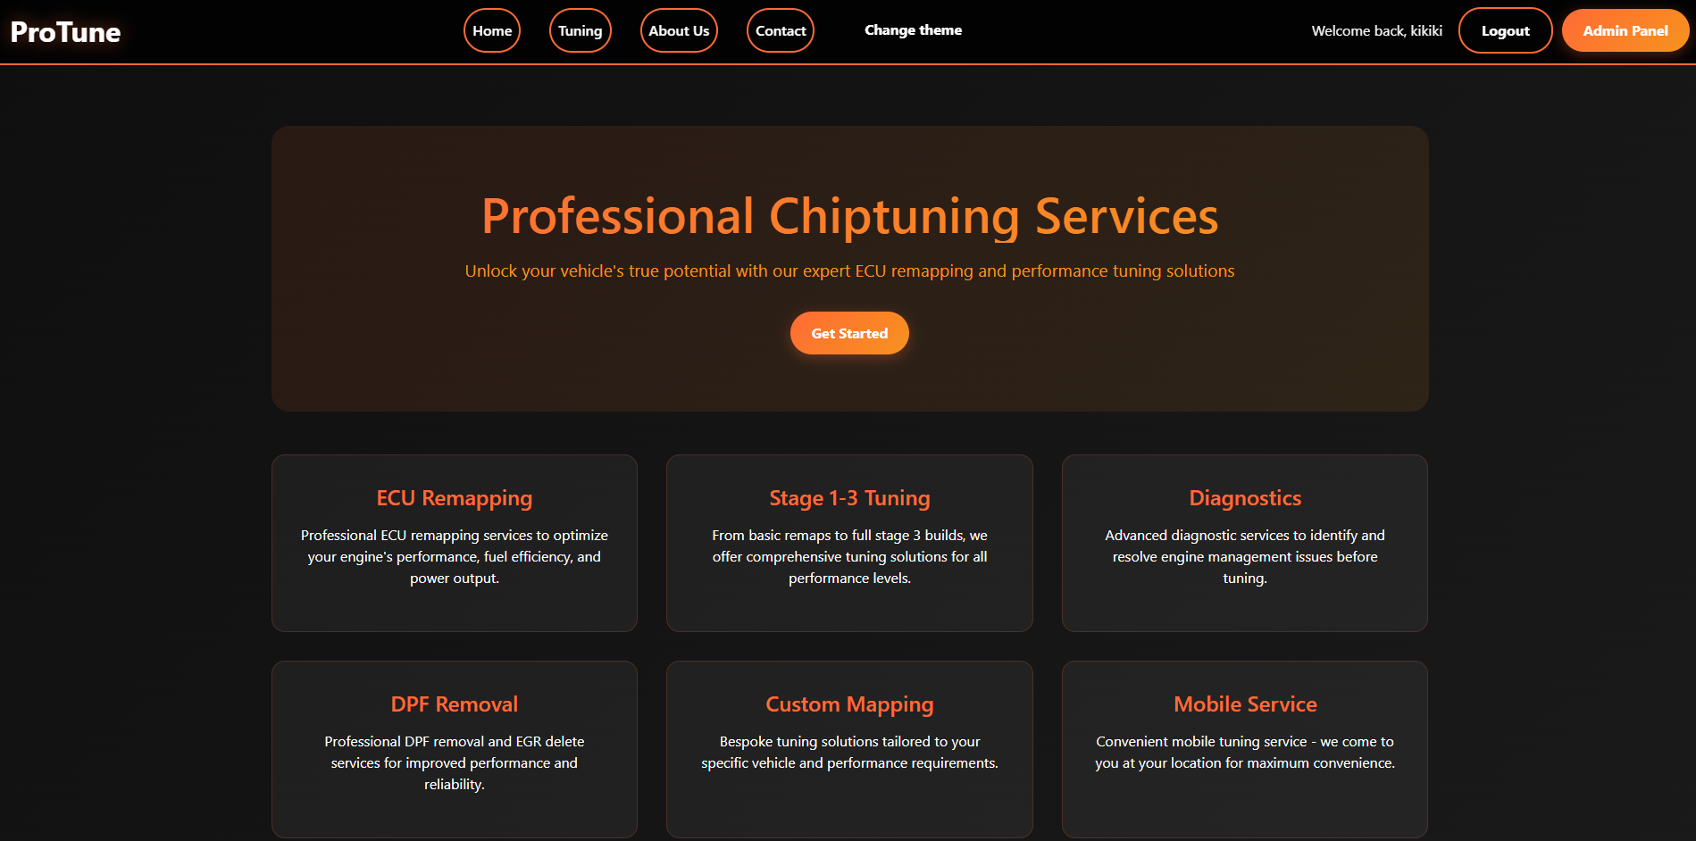

About section
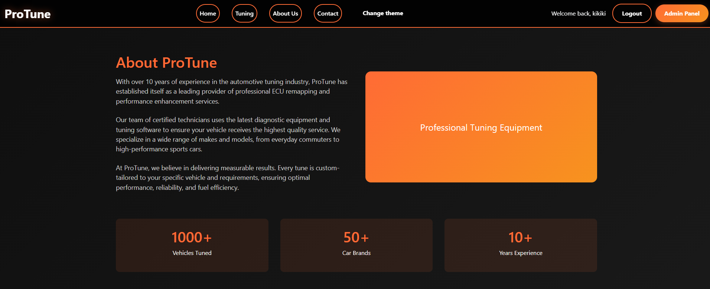

Contact section
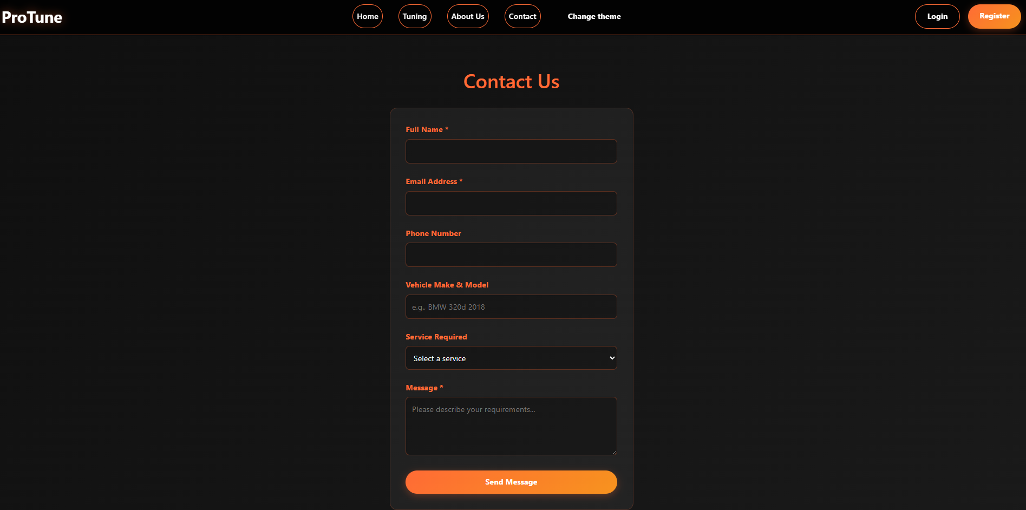

Tuning section
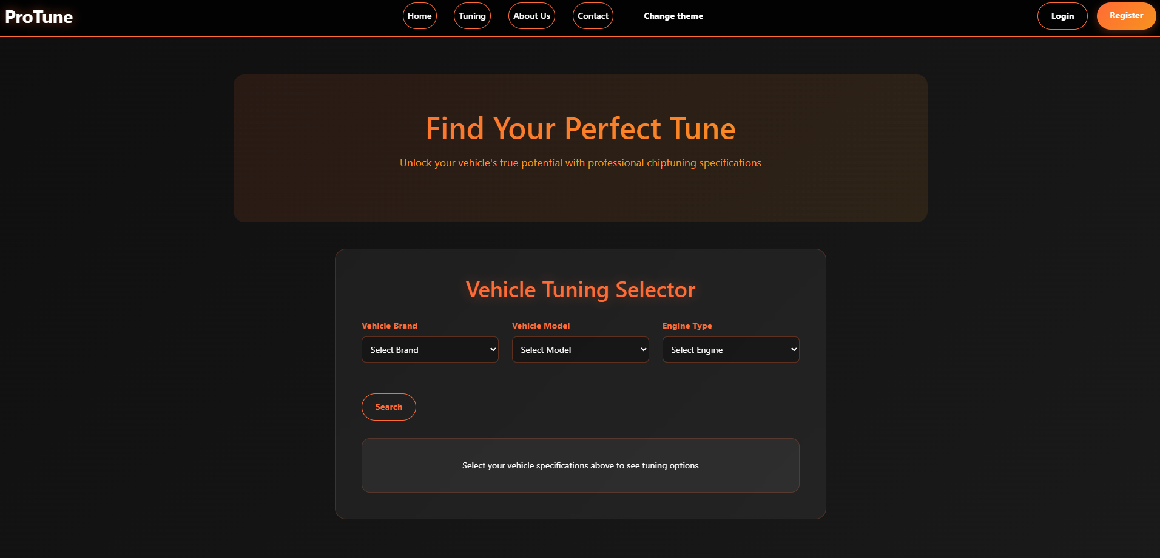

Login section
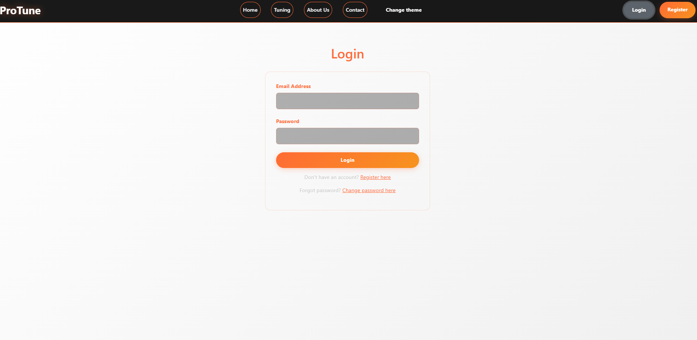

Register section
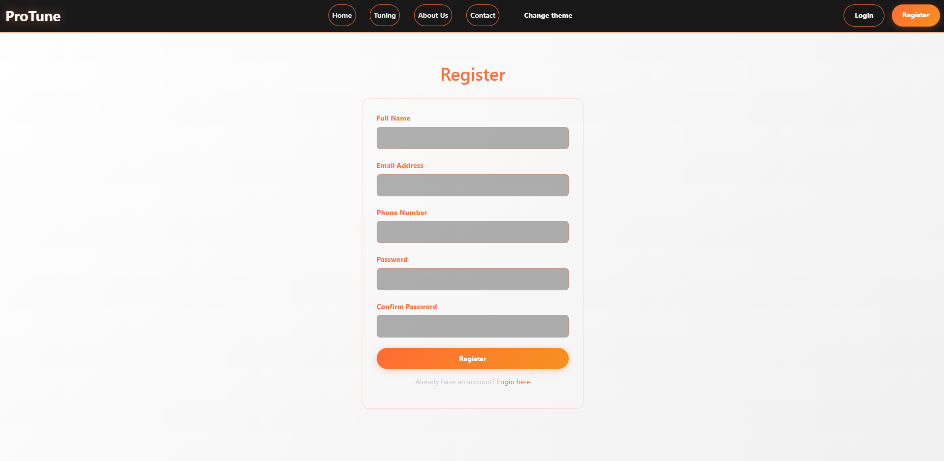

Change password section
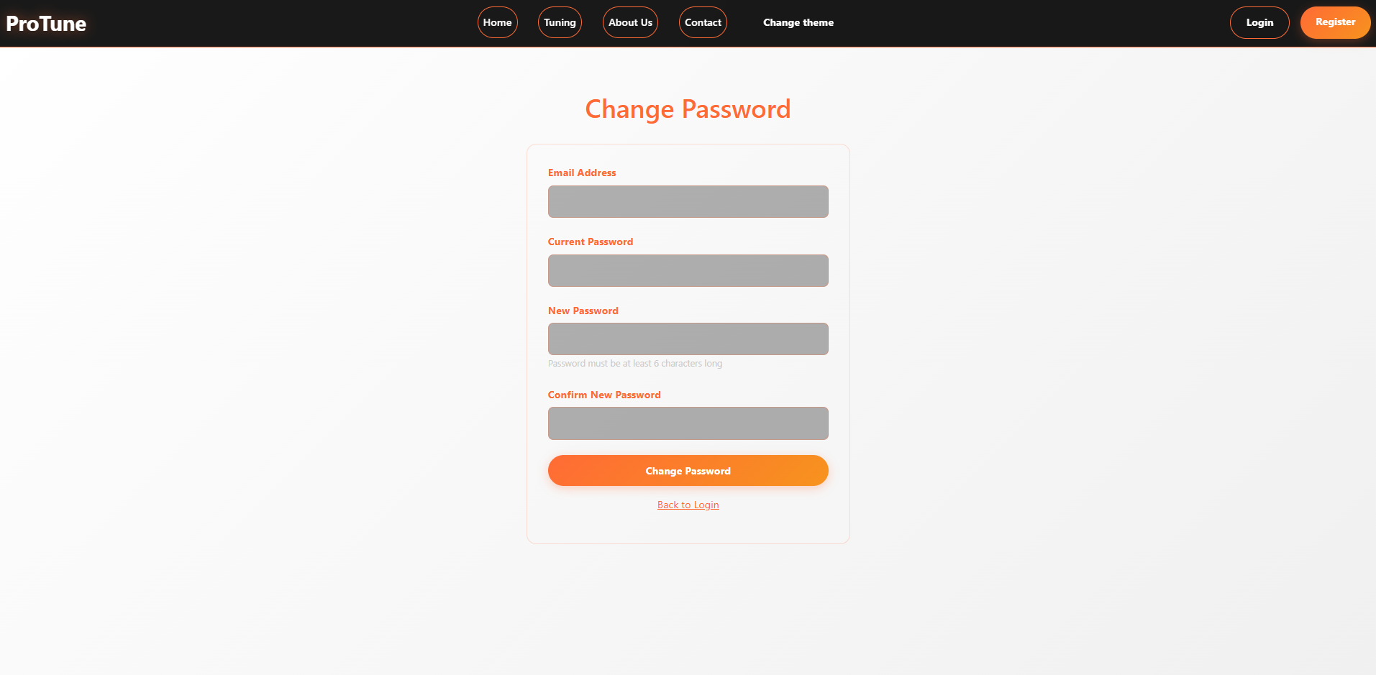

Admin panel
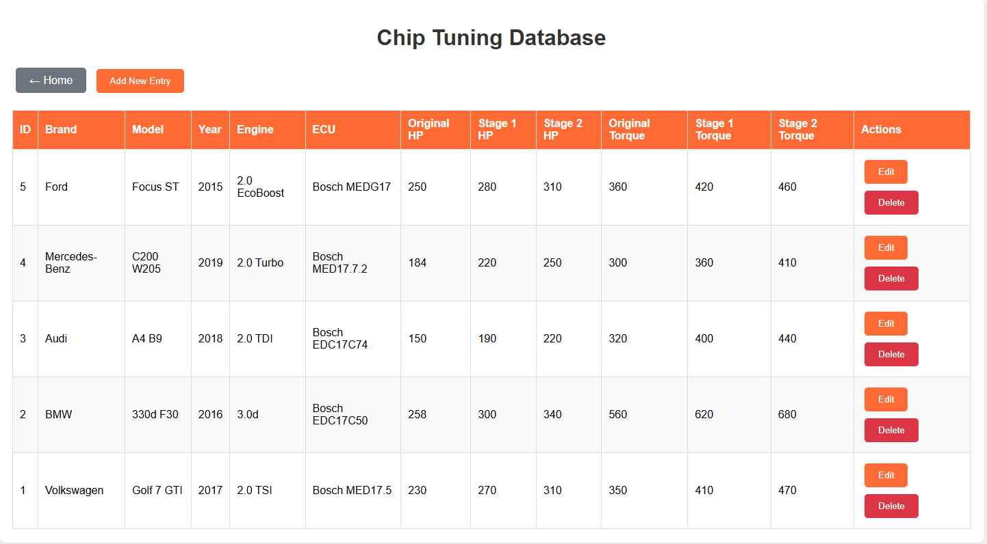

Code organization
The chiptuning project is a web-based application that combines PHP backend scripts with HTML frontends, styled using CSS and enhanced with JavaScript. The project is organized into three main areas:
- Root Directory: Contains core PHP and HTML files that handle user interaction and system logic.
- css/ Directory: Includes all stylesheets for layout and UI components.
- js/ Directory: Contains JavaScript files that manage client-side logic such as form validation, dynamic UI behavior, and AJAX functionality.
Key files and their purposes:
- index.html: Public homepage or landing interface.
- login.php, register.php, logout.php: Handle user authentication and session management.
- admin.php, change_password.php, check_session.php: Provide admin tools and user session utilities.
- api.php, fetch_chip.php: Handle API requests and data fetching operations.
- config.php, database_setup.php: Manage database connection and setup.
The naming conventions used in the project are mostly descriptive and consistent. For example:
- Files like fetch_chip.php and change_password.php clearly reflect their purpose.
- JavaScript files such as admin_script.js and chipdatascript.js suggest their scope and usage.
CSS and JS assets are logically grouped in css/ and js/ folders, respectively. This separation of concerns improves maintainability and scalability.

List of used resources

https://www.w3schools.com/php/
https://www.w3schools.com/js/
https://www.php.net/manual/en/function.password-hash.php
https://www.php.net/manual/en/function.password-verify.php
https://www.php.net/manual/en/book.session.php
https://getbootstrap.com/docs/5.3/forms/overview/
https://getbootstrap.com/docs/5.3/components/alerts/
https://developer.mozilla.org/en-US/docs/Glossary/Semantics
https://developer.mozilla.org/en-US/docs/Learn_web_development/Extensions/Forms

