Vidzeme University of Applied Sciences
Faculty of Engineering

Web Technologies and Secure Websites

group 03

practical work #3

Valmiera, 2025

CONTENT
1 Content 4
2 Setting up the database 4
2.1 Setup.php 4
2.2 DB.php 4
2.3 Database.php 4
2.4 Header 4
2.5 Footer 4
3 Base of the webpage 5
3.1 Register.php 5
3.1.1 Register.php image 5
3.2 Login.php 5
3.2.1 Login.php image 6
3.3 Logout.php 6
3.4 Service.php 6
3.4.1 Services.php 6
3.4.2 Add_service.php 6
3.4.3 Edit_service.php 6
3.4.4 Service Image 7
3.5 Dashboard.php 7
3.5.1 Dashboard.php image 7
3.6 Contact.php 7
3.6.1 Contact.php image 8
3.7 Index.php 8
3.7.1 Index.php image 8
List of used resources 9
APPENDIX 1 10

Document versions
Version | Status / Changes | Date | Author
1.0 | First version, created documentation | 03.05.2025 | Kristers Jirgensons
1.1 | Updated document | 05.05.2025 | Kristers Bizuns
1.2
1.3

Contacts and responsible (-s)
Name Surname | Department | Position | Contact information (e-mail)
Kristers Bizuns | Group #3 | Coordinator | Kristers.bizuns@va.lv
Kristers Jirgensons | Group #3 | Member | Kristers.jirgensons@va.lv
Jānis Petrovs | Group #3 | Member | Janis.petrovs@va.lv

Content

Our goal: To create a dynamic website that applies PHP and JavaScript skills learned in lectures and through self-study, inspired by our personal interests, experiences, and hobbies. This project fulfills Practical Assignment #3, which builds upon our previous work by introducing server-side scripting with PHP and MySQL database integration.
The website consists of 15 PHP files structured to provide comprehensive functionality. Nine core files (index.php, contact.php, services.php, register.php, logout.php, login.php, edit_service.php, dashboard.php, and add_service.php) form the website's foundation, delivering user authentication, service management, and public-facing content. Two class files (Database.php and Service.php) encapsulate object-oriented programming principles for database connectivity and service operations. Four supporting files (db.php, setup.php, header.php, and footer.php) handle database configuration, table structure creation, and consistent page layouts. Each component demonstrates our proficiency in web technologies while creating a cohesive, functional website.Setting up the database

Setup.php
The Setup.php script is responsible for the initial setup of the project's database environment. It ensures that the specified database is created if it does not already exist, selects it, and then proceeds to define and create the required tables.

DB.php
Db.php creates a direct connection to the project’s database using PHP Data Objects (PDO). It is in the includes/ directory. By centralizing the connection logic, any changes to the database credentials or configuration only need to be made in one place, reducing the risk of inconsistencies or hardcoded values across multiple files.

Database.php
Database.php defines an object-oriented PHP class that encapsulates all database-related logic using PDO. It serves as an abstraction layer over the raw connection, promoting clean architecture and reusable code.

Header
Header is included at the top of all pages and establishes the HTML structure, meta tags, and navigation menu for the WebDev Project. This approach maintains consistent presentation across all pages while enabling centralized updates to site-wide elements through a single file.

Footer
Footer is included at the bottom of all pages and contains the closing elements of each webpage including copyright information, secondary links, and JavaScript resources. This modular approach ensures uniform page endings throughout the site and simplifies maintenance by centralizing common closing elements.

Base of the webpage

Register.php
Register.php is responsible for handling the user registration process on the website. It presents a form where new users can input their personal details, such as name, email, and password, to create an account. When submitting the form, the script validates the inputs, interacts with the database to store the user's information securely, while Hashing passwords using password_hash() before storing them, and provides feedback to the user based on the success or failure of the operation.

Register.php image
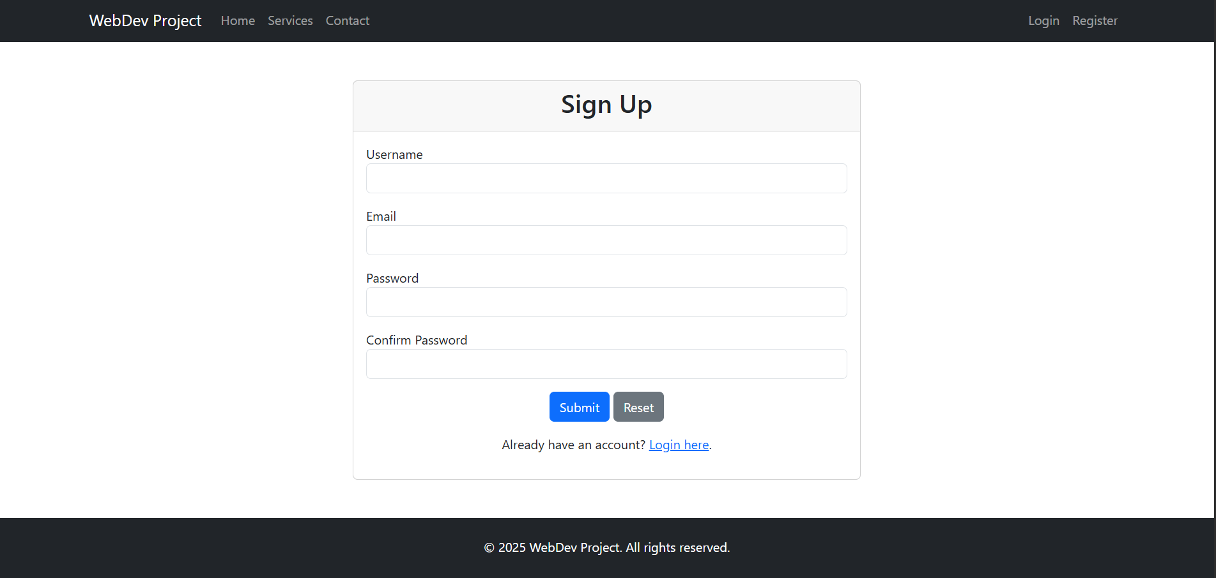

Login.php
The login.php file is made for the authentication of users, allowing registered users to access their accounts, while providing a clean login interface for the user. When clicking on the login button the script verifies the credentials by checking the stored values in the database then initiates a session if the login was successful.
If the login is successful it sets a cookie which stores the username for a set duration. Which makes it so on future visits upon logging in the cookie will be read and used to display a greeting “Welcome back, ‘Name of the user’ “ on the home page.

Login.php image
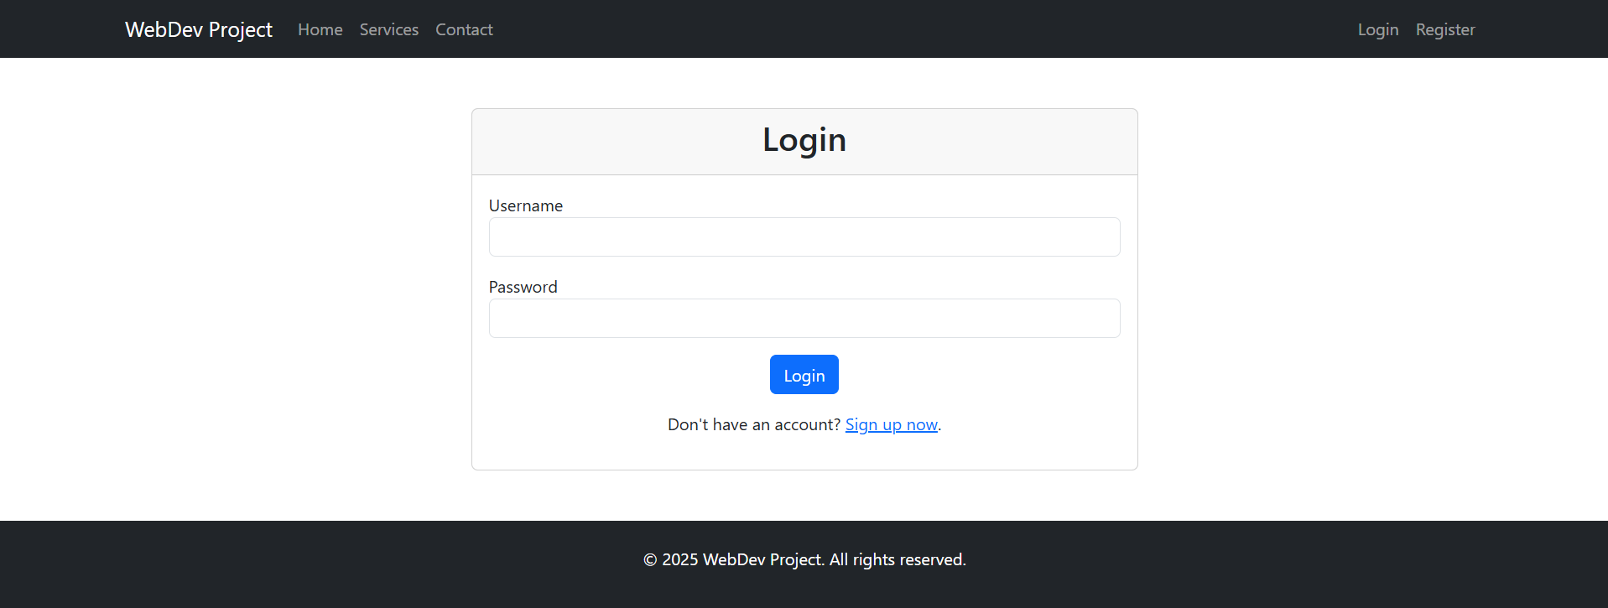

Logout.php
Logout.php securely logs out the user from the webpage, by clearing the session data and redirecting the user back to the login page.

Service.php
Service.php is located in the classes/ directory and defines the Service class, which encapsulates all logic related to managing service entries in the system. It handles interaction with the database using PDO.

Services.php
Services.php is responsible for displaying the services that are currently available in the system. It acts as the view that fetches data from the Service class, and displays them as bootstrap cards to the end user.

Add_service.php
Add.service.php handles the creation of new services and stores them into the database.

Edit_service.php
Edit_service.php allows an administrator to modify existing services, by fetching the service data based on an identifier, adding the current data into the form and allowing the user to update the details.

Service Image
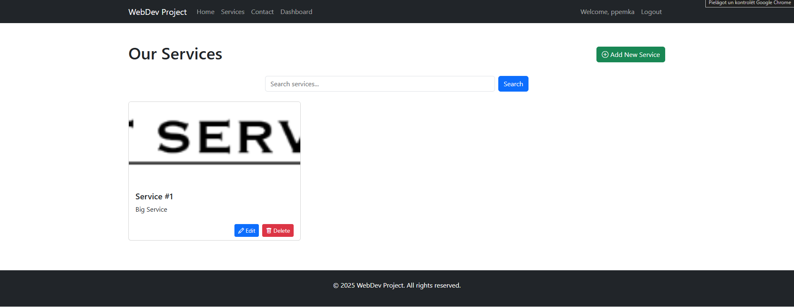

Dashboard.php
The dashboard.php file serves as the control panel for logged in users, by providing an overview of the applications metrics, and allowing them to manage users, services, appointments and messages.

Dashboard.php image
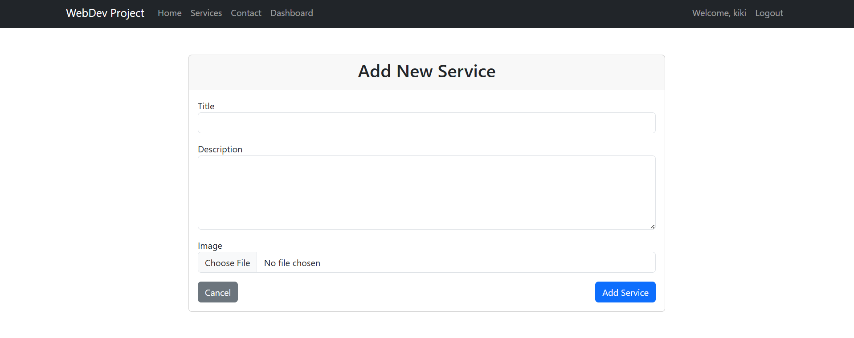

Contact.php
Contact.php handles the contact form submission, by performing user input validation, processing the data while also providing feedback to the user based on the outcome of the submission.

Contact.php image
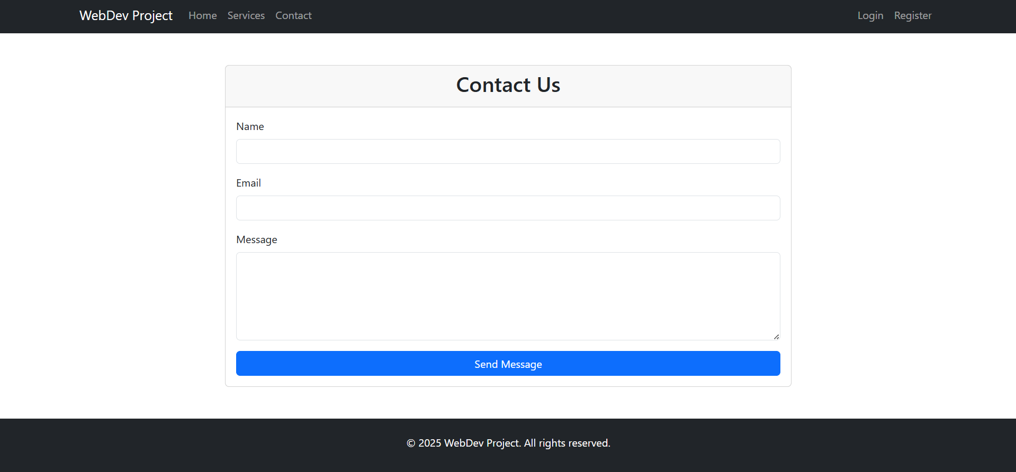

Index.php
Index.php serves as the home page of the website. It checks if the user is logged in or not. If the user is logged in it will display a welcome message, otherwise it will prompt the user to login or register.

Index.php image
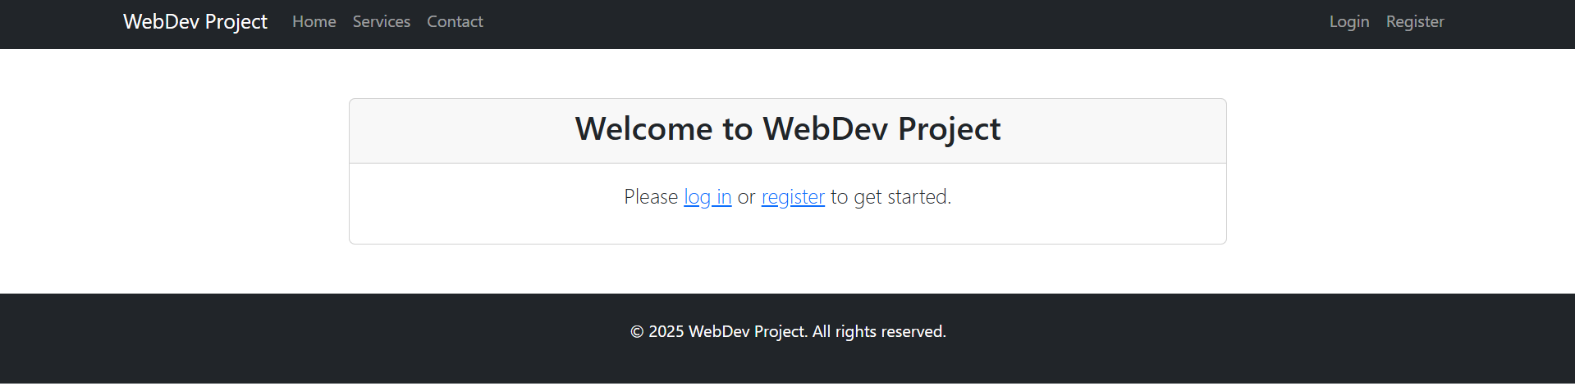

List of used resources

https://www.w3schools.com/php/
https://www.w3schools.com/js/

APPENDIX 1

