Vidzeme University of Applied Sciences
Faculty of Engineering

Web Technologies and Secure Websites

group 03

practical work #2

Valmiera, 2025

CONTENT
1 Content 4
2 HTML 4
2.1 Index.html 4
2.1.1 Index.html picture 5
2.2 About.html 5
2.2.1 About.html images 5
2.3 Services.html 6
2.4 Contact.html 7
2.5 Contacted.html 8
3 CSS 9
3.1 Styles.css important functionality 9
3.1.1 CSS images 9
List of used resources 11
APPENDIX 1 12

Document versions
Version | Status / Changes | Date | Author
1.0 | First version, added a folder for js, and implemented bootstrap, implemented the bootstrap nav bar on all pages, modified hero section and converted service pages list into a bootstrap card grid. | 28.03.2025 | Kristers Jirgensons
1.1 | Second version
1.2 | Third version,

Contacts and responsible (-s)
Name Surname | Department | Position | Contact information (e-mail)
Kristers Bizuns | Group #3 | Coordinator | Kristers.bizuns@va.lv
Kristers Jirgensons | Group #3 | Member | Kristers.jirgensons@va.lv
Jānis Petrovs | Group #3 | Member | Janis.petrovs@va.lv

Content

Our goal: To implement bootstrap and javascript in our previously created webpage.
In this practical work we used Bootstrap and javascript to update our 5 html files, in 4 of the files we updated the navigation bar to use the bootstrap version of it, implementing a toggler button for mobile screens as well. We modified our hero section to use the bootstrap jumbotron and updated our services page to use the bootsrap card grid component Later we decided to also implement this to our about page, since it would make it look better.

Implementation of bootstrap and JavaScript

We created a new folder which holds the javascript file “script.js”, and added the script and link for the bootstrap code to function properly in all of our html files, that require it.

Bootstrap navigation bar

The bootstrap navigation bar is much easier to use and easier to style, due to the fact that all of the available libraries are already online and guides on how to use them were provided in our lectures. This time we centered our navigation bar and made it so if the screen is smaller than 576 pixels it creates a toggler button, which on click shows all the options.

Bootstrap navigation bar and how it looks
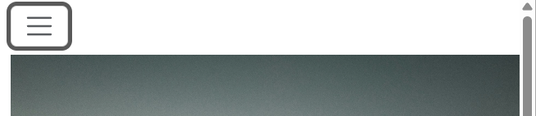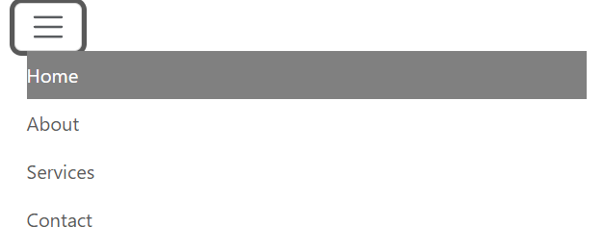

Updates to index.html hero section

The updates we made to the hero section are simple, we made it use the bootstrap jumbotron, and aligned the content to the center using the grid class.

Updated index.html

This index.html page serves as the homepage for the website. It introduces users to the site and provides an overview of its purpose. The page is designed with Bootstrap 5 for styling and responsiveness, ensuring a user-friendly experience across different devices.

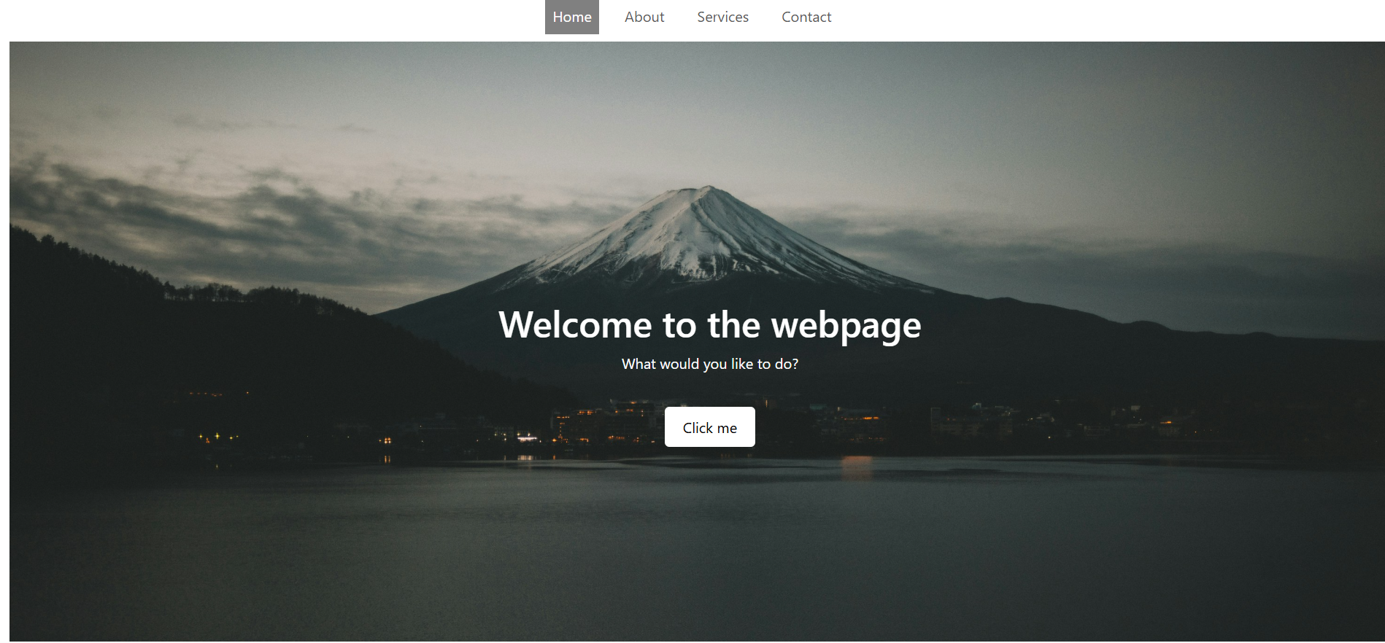

Services.html changes

Here we converted the list to a bootstrap card grid, and displayed the cards in a row instead of under each other, but if the site is viewed on a smaller screen they appear under each other

Services images
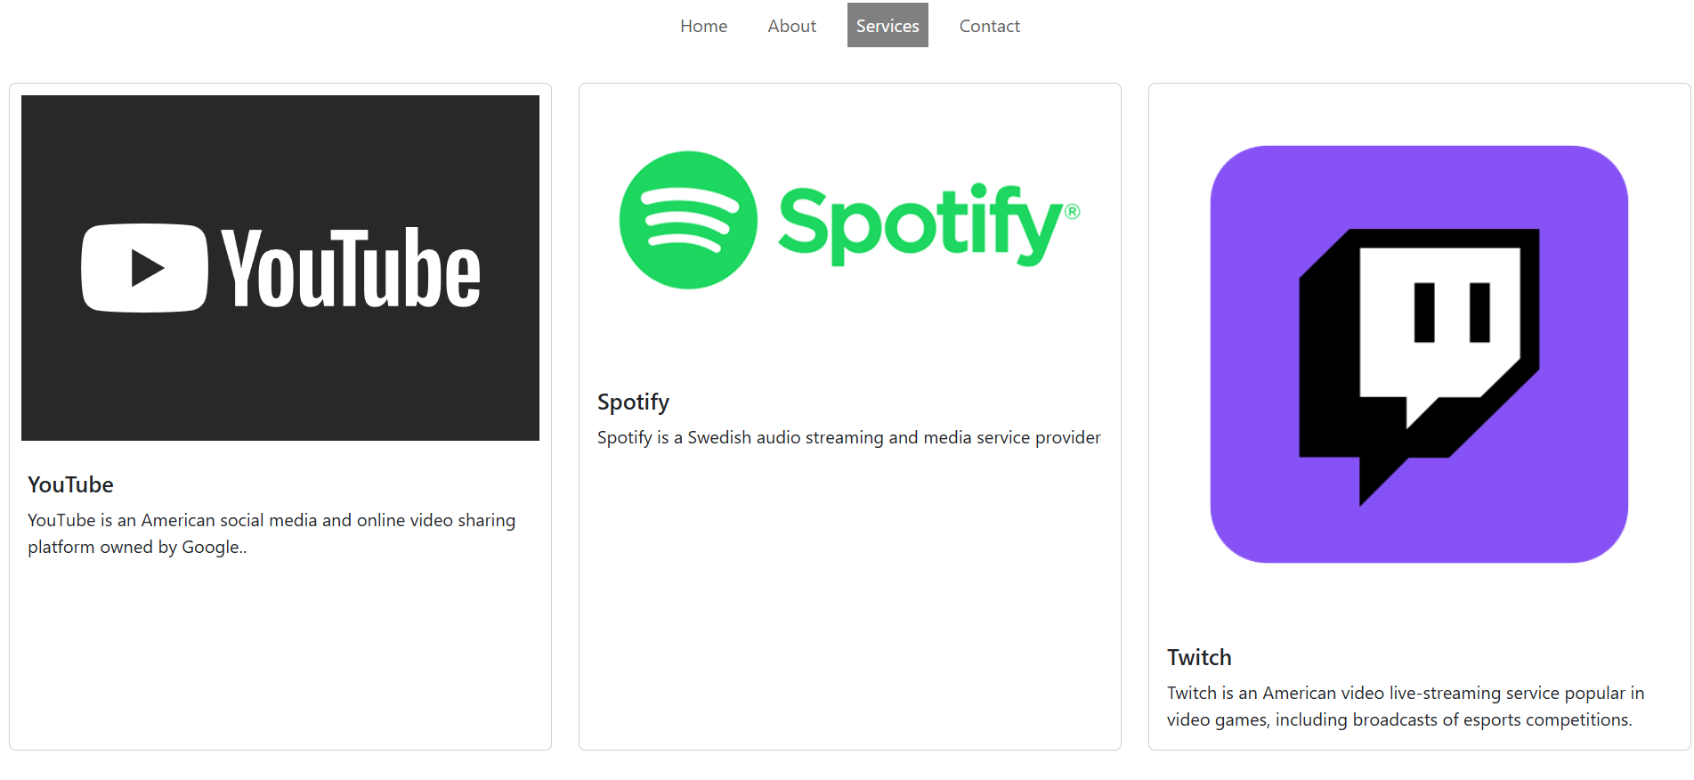
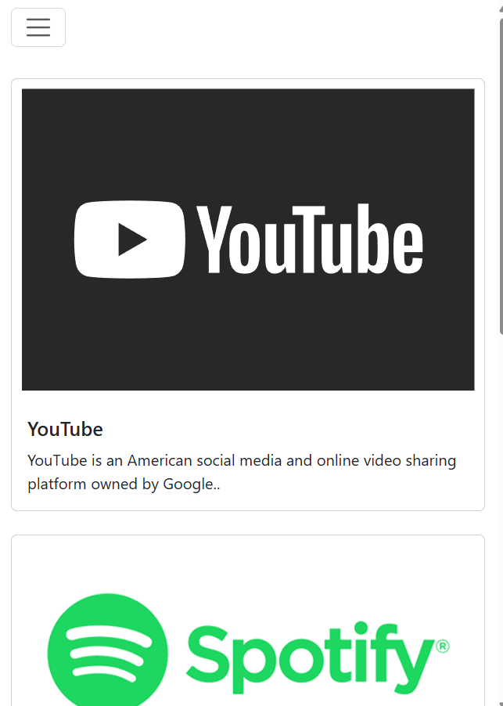

Changes to about.html

We implemented the same principle that we did to services cause it just looks better.

About.html change images
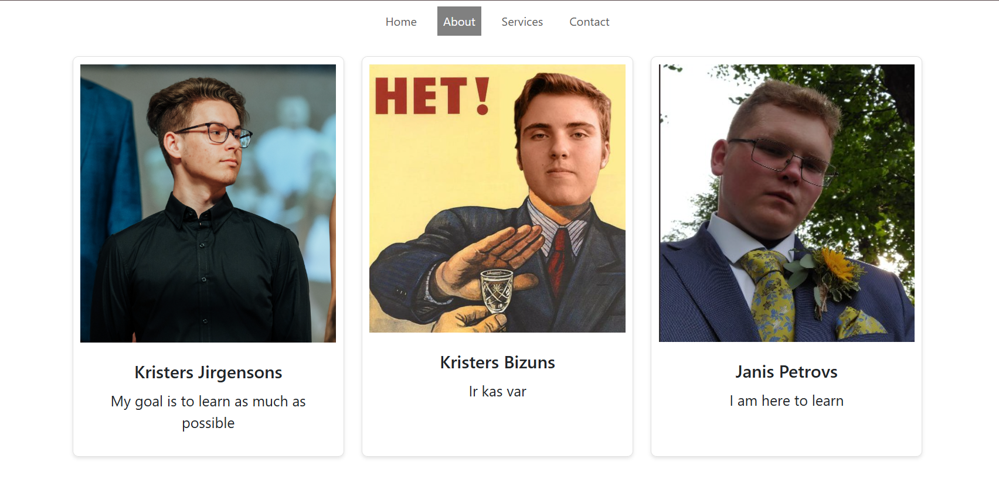

Contact.html changes

This page allows users to contact the website owners by submitting their details through a structured, well-styled form. The use of Bootstrap ensures a modern, professional look and mobile-friendly experience.

Javascript implementation

The Contact Page of the website provides users with a way to reach out for inquiries, feedback, or support. It includes a contact form, company contact details, and a navigation menu for easy access to other pages.
The Contact Page enhances communication between users and the website administrators by providing an intuitive, accessible, and validated form. The additional contact details ensure users have multiple ways to reach out, improving engagement and support efficiency

List of used resources

https://www.w3schools.com/html/
https://www.w3schools.com/html/html_css.asp

APPENDIX 1

Index.html
<!DOCTYPE html>
<html>

<head>
<link rel='stylesheet' type='text/css' href='css/styles.css'>
<title>My web training page</title>
<meta name="viewport" content="width=device-width, initial-scale=1.0" charset="UTF-8" />
<link rel="stylesheet" href="https://cdn.jsdelivr.net/npm/bootstrap@5.3.0/dist/css/bootstrap.min.css">
</head>

<body>

<nav class="navbar navbar-expand-lg navbar-light bg-white">
<div class="container-fluid">
<button class="navbar-toggler" type="button" data-bs-toggle="collapse" data-bs-target="#navbarNav">
<span class="navbar-toggler-icon"></span>
</button>
<div class="collapse navbar-collapse" id="navbarNav">
<ul class="navbar-nav">
<li class="nav-item">
<a class="nav-link active" href="index.html">Home</a>
</li>
<li class="nav-item">
<a class="nav-link" href="about.html">About</a>
</li>
<li class="nav-item">
<a class="nav-link" href="services.html">Services</a>
</li>
<li class="nav-item">
<a class="nav-link" href="contact.html">Contact</a>
</li>
</ul>
</div>
<!-- Theme Toggle Button -->
<button id="theme-toggle" class="btn btn-outline-dark">🌙 Dark Mode</button>
</div>
</nav>

<div class="container-fluid">
<div class="row justify-content">
<div class="col-md-8">
<div class="hero">
<div>
<h1>Welcome to the webpage</h1>
<p>What would you like to do?</p>
<a href="https://www.youtube.com/watch?v=dQw4w9WgXcQ">Click me</a>
</div>
</div>
</div>
</div>
</div>
<div class="HDP">
<h1 class="header1">Website</h1>
<p>This website is designed to qualify all the requirements
for the first practical work. The goal is to recieve the
maximum marks for this small project.</p><br>
<h3>Important features</h3>
<ul>
<li>The navigation bar
<ul>
<li>
Showing our skills that we have learnt throughout the lectures
</li>
</ul>
</li>

<li>Compatibility with smaller screens</li>
<ul>
<li>
Showing our competence with smaller screens and how it affects all the data shown
(i.e. the text becoming white because the background becomes black when screen shrinks)
</li>
</ul>
<li>Sleeping</li>
</ul>
</div>

<div>
<footer id="footer">
<p>
Author: Kristers Jirgensons <br>
<a href="x">Placeholder1 for social media</a><br>
<a href="x">Placeholder2 for social media</a><br>
<a href="x">Placeholder3 for social media</a><br>
Copyright <span id="currentYear"></span>
</p>
</footer>

</div>
<script src="js/script.js"></script>
<script src="https://cdn.jsdelivr.net/npm/bootstrap@5.3.0/dist/js/bootstrap.bundle.min.js"></script>
</body>
</html>

About.html
<!DOCTYPE html>
<html>

<head>
<link rel='stylesheet' type='text/css' href='css/styles.css'>
<title>About</title>
<meta name="viewport" content="width=device-width, initial-scale=1.0" charset="UTF-8" />
<link rel="stylesheet" href="https://cdn.jsdelivr.net/npm/bootstrap@5.3.0/dist/css/bootstrap.min.css">
</head>

<body>

<nav class="navbar navbar-expand-lg navbar-light bg-white">
<div class="container-fluid">
<button class="navbar-toggler" type="button" data-bs-toggle="collapse" data-bs-target="#navbarNav">
<span class="navbar-toggler-icon"></span>
</button>
<div class="collapse navbar-collapse" id="navbarNav">
<ul class="navbar-nav">
<li class="nav-item">
<a class="nav-link" href="index.html">Home</a>
</li>
<li class="nav-item">
<a class="nav-link active" href="about.html">About</a>
</li>
<li class="nav-item">
<a class="nav-link" href="services.html">Services</a>
</li>
<li class="nav-item">
<a class="nav-link" href="contact.html">Contact</a>
</li>
</ul>
</div>
<!-- Theme Toggle Button -->
<button id="theme-toggle" class="btn btn-outline-dark">🌙 Dark Mode</button>
</div>
</nav>

<div class="team-members-container">
<div class="row">
<!-- First member -->
<div class="col-12 col-md-4 mb-4">
<div class="member-container">
<div class="image">
<img src="images/kj.jpg" alt="KJ" class="img-fluid">
</div>
<div class="text">
<h1>Kristers Jirgensons</h1>
<p>My goal is to learn as much as possible</p>
</div>
</div>
</div>

<!-- Second member -->
<div class="col-12 col-md-4 mb-4">
<div class="member-container">
<div class="image">
<img src="images/kb.jpg" alt="KB" class="img-fluid">
</div>
<div class="text">
<h1>Kristers Bizuns</h1>
<p>Ir kas var</p>
</div>
</div>
</div>

<!-- Third member -->
<div class="col-12 col-md-4 mb-4">
<div class="member-container">
<div class="image">
<img src="images/jp.jpg" alt="JP" class="img-fluid">
</div>
<div class="text">
<h1>Janis Petrovs</h1>
<p>I am here to learn</p>
</div>
</div>
</div>
</div>
</div>

<div>
<h1 class="header1">Mission Statement</h1>
<p class="paragraph1">We as a team have decided that our goal in this course
will be learning as much as possible on our own through
the lecturers provided literature and presentations, without
the use of AI.
</p>

</div>

<div>
<h1 class="header1">Timeline</h1>
<ol class="lists">
<li> <b> Kristers Bizuns made his blueprint </b>
<ul class="ulists">
<li>
Me and Janis checked it out and it looked good
</li>
</ul>
</li>

<li><b>Kristers Jirgensons is making his blueprint </b>
<ul class="ulists">
<li> I am designing it to the fullest, doing my best to make the practical work look good</li>
</ul>
</li>

<li><b>Janis Petrovs Will make his blueprint </b> </li>
</ol>
</div>
<script src="js/script.js"></script>
<script src="https://cdn.jsdelivr.net/npm/bootstrap@5.3.0/dist/js/bootstrap.bundle.min.js"></script>
</body>
</html>

Services.html
<!DOCTYPE html>
<html>

<head>
<link rel='stylesheet' type='text/css' href='css/styles.css'>
<title>Services</title>
<meta name="viewport" content="width=device-width, initial-scale=1.0" charset="UTF-8" />
<link rel="stylesheet" href="https://cdn.jsdelivr.net/npm/bootstrap@5.3.0/dist/css/bootstrap.min.css">
</head>

<body>

<nav class="navbar navbar-expand-lg navbar-light bg-white">
<div class="container-fluid">
<button class="navbar-toggler" type="button" data-bs-toggle="collapse" data-bs-target="#navbarNav">
<span class="navbar-toggler-icon"></span>
</button>
<div class="collapse navbar-collapse" id="navbarNav">
<ul class="navbar-nav">
<li class="nav-item">
<a class="nav-link" href="index.html">Home</a>
</li>
<li class="nav-item">
<a class="nav-link" href="about.html">About</a>
</li>
<li class="nav-item">
<a class="nav-link active" href="services.html">Services</a>
</li>
<li class="nav-item">
<a class="nav-link" href="contact.html">Contact</a>
</li>
</ul>
</div>
<!-- Theme Toggle Button -->
<button id="theme-toggle" class="btn btn-outline-dark">🌙 Dark Mode</button>
</div>
</nav>

<div class="container-fluid mt-4">
<!-- Filter Dropdown -->
<div class="mb-4">
<label for="serviceFilter" class="form-label">Filter Services</label>
<select id="serviceFilter" class="form-select">
<option value="">All</option>
<option value="video">Video Services</option>
<option value="audio">Audio Services</option>
</select>
</div>

<!-- Service Cards -->
<div class="row" id="serviceList">
<div class="col-12 col-md-4 mb-4" data-category="video">
<div class="card h-100">
<img src="images/youtube.svg" class="card-img-top" alt="YouTube Logo">
<div class="card-body">
<h5 class="card-title">YouTube</h5>
<p class="card-text">YouTube is an American social media and online video sharing platform owned by Google.</p>
</div>
</div>
</div>

<div class="col-12 col-md-4 mb-4" data-category="audio">
<div class="card h-100">
<img src="images/spotify.png" class="card-img-top" alt="Spotify Logo">
<div class="card-body">
<h5 class="card-title">Spotify</h5>
<p class="card-text">Spotify is a Swedish audio streaming and media service provider.</p>
</div>
</div>
</div>

<div class="col-12 col-md-4 mb-4" data-category="video">
<div class="card h-100">
<img src="images/twitch.png" class="card-img-top" alt="Twitch Logo">
<div class="card-body">
<h5 class="card-title">Twitch</h5>
<p class="card-text">Twitch is an American video live-streaming service popular in video games, including broadcasts of esports competitions.</p>
</div>
</div>
</div>
</div>
</div>

</body>
<script src="js/script.js"></script>
<script src="https://cdn.jsdelivr.net/npm/bootstrap@5.3.0/dist/js/bootstrap.bundle.min.js"></script>
</html>

Contact.html
<!DOCTYPE html>
<html lang="en">
<head>
<link rel="stylesheet" type="text/css" href="css/styles.css">
<title>Contact</title>
<meta name="viewport" content="width=device-width, initial-scale=1.0" charset="UTF-8" />
<link href="https://cdn.jsdelivr.net/npm/bootstrap@5.3.0/dist/css/bootstrap.min.css" rel="stylesheet">
</head>
<body>
<nav class="navbar navbar-expand-lg navbar-light bg-white">
<div class="container-fluid">
<button class="navbar-toggler" type="button" data-bs-toggle="collapse" data-bs-target="#navbarNav">
<span class="navbar-toggler-icon"></span>
</button>
<div class="collapse navbar-collapse" id="navbarNav">
<ul class="navbar-nav">
<li class="nav-item">
<a class="nav-link" href="index.html">Home</a>
</li>
<li class="nav-item">
<a class="nav-link" href="about.html">About</a>
</li>
<li class="nav-item">
<a class="nav-link" href="services.html">Services</a>
</li>
<li class="nav-item">
<a class="nav-link active" href="contact.html">Contact</a>
</li>
</ul>
</div>
<!-- Theme Toggle Button -->
<button id="theme-toggle" class="btn btn-outline-dark">🌙 Dark Mode</button>
</div>
</nav>

<div class="container d-flex flex-column align-items-center mt-5">
<h1 class="text-center">Contact Us!</h1>
<div class="col-md-6">
<!-- Validation Alert (Initially Hidden) -->
<div id="validationAlert" class="alert alert-danger d-none" role="alert">
Please fill in all fields correctly.
</div>

<form id="contactForm" action="contacted.html" method="post" class="p-4 border rounded shadow">
<div class="mb-3">
<label for="email" class="form-label">Email</label>
<input id="email" name="email" type="email" class="form-control" placeholder="Your Email" required>
</div>

<div class="mb-3">
<label for="name" class="form-label">Full Name</label>
<input id="name" name="name" type="text" class="form-control" placeholder="Your Full Name" required>
</div>

<div class="mb-3">
<label for="reason" class="form-label">Reason for Contact</label>
<input id="reason" name="reason" type="text" class="form-control" placeholder="Why are you contacting us?" required>
</div>

<button type="submit" class="btn btn-primary w-100">Send</button>
</form>
</div>
</div>

<div>
<h1 class="header1">Our Information</h1>
<p class="header3">Phone: +123456</p>
<p class="header3">Email: abc@gmail.com</p>
</div>

<script src="js/script.js"></script>
<script src="https://cdn.jsdelivr.net/npm/bootstrap@5.3.0/dist/js/bootstrap.bundle.min.js"></script>
</body>
</html>

Contacted.html
<!DOCTYPE html>
<html>

<head>
<title>Contacted</title>
<meta name="viewport" content="width=device-width, initial-scale=1.0" charset="UTF-8" />

<!-- Bootstrap CSS -->
<link href="https://cdn.jsdelivr.net/npm/bootstrap@5.3.0/dist/css/bootstrap.min.css" rel="stylesheet">
<link rel='stylesheet' type='text/css' href='css/styles.css'>
</head>

<body class="d-flex justify-content-center align-items-center vh-100">
<div class="text-center">
<h1 class="display-4">You have successfully contacted us</h1>
<a href="contact.html" class="btn btn-primary mt-3">Return</a>
</div>

<!-- Bootstrap JS -->
<script src="https://cdn.jsdelivr.net/npm/bootstrap@5.3.0/dist/js/bootstrap.bundle.min.js"></script>
<script src="/js/script.js"></script>
</body>

</html>

Styles.css
@media only screen and (max-width: 576px) {

.hero {
height: 300px;
font-size: 16px;
padding: 15px;
text-align:center;
align-content: center;
}

.text h1 {
font-size: 1.2rem;
}
}

.navbar-nav {
width: 100%;
justify-content: center;
}
.nav-item {
margin: 0 10px;
}
.nav-link {
font-size: 17px;
padding: 14px 18px;
color: black;
}
.nav-link:hover {
background-color: #ddd;
}
.nav-link.active {
background-color: gray !important;
color: white !important;
}

.hero {
background-image: url('../images/bg2.jpg');
background-size: cover;
background-position: center;
background-repeat: no-repeat;
width: 100vw;
height: 100vh;
display: flex;
align-items: center;
justify-content: center;
text-align: center;
color: white;
}
.hero a {
display: inline-block;
margin-top: 20px;
padding: 10px 20px;
background-color: white;
color: black;
text-decoration: none;
border-radius: 5px;
}
.hero a:hover {
background-color: #ddd;
}

.HDP {
font-size: 16px;
font-family: 'Times New Roman', Times, serif;
text-align: justify;

}

.header1 {
text-align: center;
font-size: 36px;
}

.header2 {
text-align: left;
font-size: 24px;
}

.header3 {
text-align: center;
font-size: 24px;
}

.paragraph1 {
text-align: center;
font-size: 18px;
}

.paragraph2 {
text-align: left;
font-size: 14px;
}

.container {
display: grid;
align-items: center;
grid-template-columns: 1fr 1fr 1fr;
column-gap: 5px;
}

img {
padding: 10px;
width: 80%;
}

.text {
text-align: justify;
font-size: 20px;
}

.lists {
text-align: justify;
font-size: 18px;
}

.ulists {
text-align: justify;
font-size: 16px;
}

section {
display: block;
}

.contact {
text-align: center;
}

#textboxid
{
height: 25px;
font-size:14px;
}
#labelid {
font-size: 18px;
font-weight: bold;
}

#buttonid {
height: 25px;
font-size: 14px;
}

#returnid {
text-align: center;
height: 50px;
width: 100px;
font-size: 24px;
}

.centereddiv {
text-align: center;
margin: 20%;
font-size: 36px;
}

#footer {
background-color: black;
color: white;
text-align: center;
}

.team-members-container {
max-width: 1200px;
margin: 0 auto;
padding: 20px;
}

.team-members-container {
max-width: 1200px;
margin: 0 auto;
padding: 20px;
}

.member-container {
border: 1px solid #e0e0e0;
border-radius: 8px;
overflow: hidden;
height: 100%;
box-shadow: 0 2px 5px rgba(0,0,0,0.1);
}

.image img {
width: 100%;
height: auto;
display: block;
}

.text {
padding: 15px;
text-align: center;
}

.text h1 {
font-size: 1.5rem;
margin-bottom: 10px;
}

/* task 3 */

.navbar.scrolled {
background-color: rgba(0, 0, 0, 0.8) !important; /* Change to desired color */
transition: background-color 0.3s ease-in-out;
}

/* Default Light Mode */
body {
background-color: white;
color: black;
}

/* Dark Mode Styles */
body.dark-mode {
background-color: #121212;
color: white;
}

.navbar.dark-mode {
background-color: #333 !important;
}

.btn.dark-mode {
border-color: white;
color: white;
}

Script.js

document.addEventListener("DOMContentLoaded", function () {
const navbar = document.querySelector(".navbar");

window.addEventListener("scroll", function () {
if (window.scrollY > 50) {
navbar.classList.add("scrolled");
} else {
navbar.classList.remove("scrolled");
}
});
});

document.addEventListener("DOMContentLoaded", function () {
const themeToggle = document.getElementById("theme-toggle");
const body = document.body;

// Check local storage for theme preference
if (localStorage.getItem("theme") === "dark") {
body.classList.add("dark-mode");
themeToggle.textContent = "☀️ Light Mode";
}

themeToggle.addEventListener("click", function () {
body.classList.toggle("dark-mode");
if (body.classList.contains("dark-mode")) {
localStorage.setItem("theme", "dark");
themeToggle.textContent = "☀️ Light Mode";
} else {
localStorage.setItem("theme", "light");
themeToggle.textContent = "🌙 Dark Mode";
}
});
});

document.addEventListener("DOMContentLoaded", function () {
const serviceFilter = document.getElementById("serviceFilter");
const serviceList = document.getElementById("serviceList");

serviceFilter.addEventListener("change", function () {
const filterValue = serviceFilter.value.toLowerCase();
const services = serviceList.querySelectorAll(".col-md-4");

services.forEach(function (service) {
const category = service.getAttribute("data-category").toLowerCase();
if (filterValue === "" || category.includes(filterValue)) {
service.style.display = "block"; // Show matching service
} else {
service.style.display = "none"; // Hide non-matching service
}
});
});
});

document.addEventListener("DOMContentLoaded", function () {
const form = document.getElementById("contactForm");
const validationAlert = document.getElementById("validationAlert");

form.addEventListener("submit", function (event) {
event.preventDefault();

validationAlert.classList.add("d-none");

// Get form field values
const email = document.getElementById("email").value;
const name = document.getElementById("name").value;
const reason = document.getElementById("reason").value;

const emailRegex = /^[^\s@]+@[^\s@]+\.[^\s@]+$/;

// Check for empty fields
if (!email || !name || !reason) {
validationAlert.textContent = "All fields are required.";
validationAlert.classList.remove("d-none");
return;
}

if (!emailRegex.test(email)) {
validationAlert.textContent = "Please enter a valid email address.";
validationAlert.classList.remove("d-none");
return;
}

if (reason.length < 10) {
validationAlert.textContent = "Reason for contact must be at least 10 characters long.";
validationAlert.classList.remove("d-none");
return;
}

validationAlert.classList.add("d-none");
alert("Form submitted successfully!");

form.reset();
});
});

document.addEventListener("DOMContentLoaded", function () {

const currentYear = new Date().getFullYear();
document.getElementById("currentYear").textContent = currentYear;

const footer = document.getElementById("footer");

footer.addEventListener("mouseover", function () {
footer.style.backgroundColor = "#121212";
});

footer.addEventListener("mouseout", function () {
footer.style.backgroundColor = "";
});
});

