Vidzeme University of Applied Sciences
Faculty of Engineering

Web Technologies and Secure Websites

group 03

practical work #1

Valmiera, 2025

CONTENT
1 Content 4
2 HTML 4
2.1 Index.html 4
2.1.1 Index.html picture 5
2.2 About.html 5
2.2.1 About.html images 5
2.3 Services.html 6
2.4 Contact.html 7
2.5 Contacted.html 8
3 CSS 9
3.1 Styles.css important functionality 9
3.1.1 CSS images 9
List of used resources 11
APPENDIX 1 12

Document versions
Version | Status / Changes | Date | Author
1.0 | First version, added information about our goal, index.html, about.html | 01.03.2025 | Kristers Jirgensons
1.1 | Second version, added information about services.html, contact.html and contacted.html | 02.03.2025 | Janis Petrovs
1.2 | Third version, added information about CSS part of our code | 03.03.2025 | Kristers Bizuns

Contacts and responsible (-s)
Name Surname | Department | Position | Contact information (e-mail)
Kristers Bizuns | Group #3 | Dictator1 | Kristers.bizuns@va.lv
Kristers Jirgensons | Group #3 | Dictator2 | Kristers.jirgensons@va.lv
Jānis Petrovs | Group #3 | Dictator3 | Janis.petrovs@va.lv

Content

Our goal: To create a website using the HTML and CSS skills we were taught and learnt on our own based on our interests, experiences or hobbies.
In this practical work we used HTML to create the base of our websites 5 html files: index.html, services.html, about.html, contact.html and contacted.html. Each of these files represents a different aspect of our knowledge from the navigation bar being responsive to clicks and updating in each page, to the website being responsive to smaller screen sizes.

HTML

Our program consists of 5 html files, which are linked to eachother

Index.html

Index.html is the homepage of our website. It consists of a hero section which has a heading, short description and a call to action button. In our case it is just an introduction to the website with the words “Welcome to the webpage”. The action button redirects the user to a youtube video which we chose, as well as we went as far as adding a nice looking background image to it. Under the hero there is a short featured section which introduces the user to the websites purpose and a three column section which highlights the websites important features. On the very bottom of the website there is a footer which includes the author of the website, some placeholder links for social media and a copyright.

Index.html picture
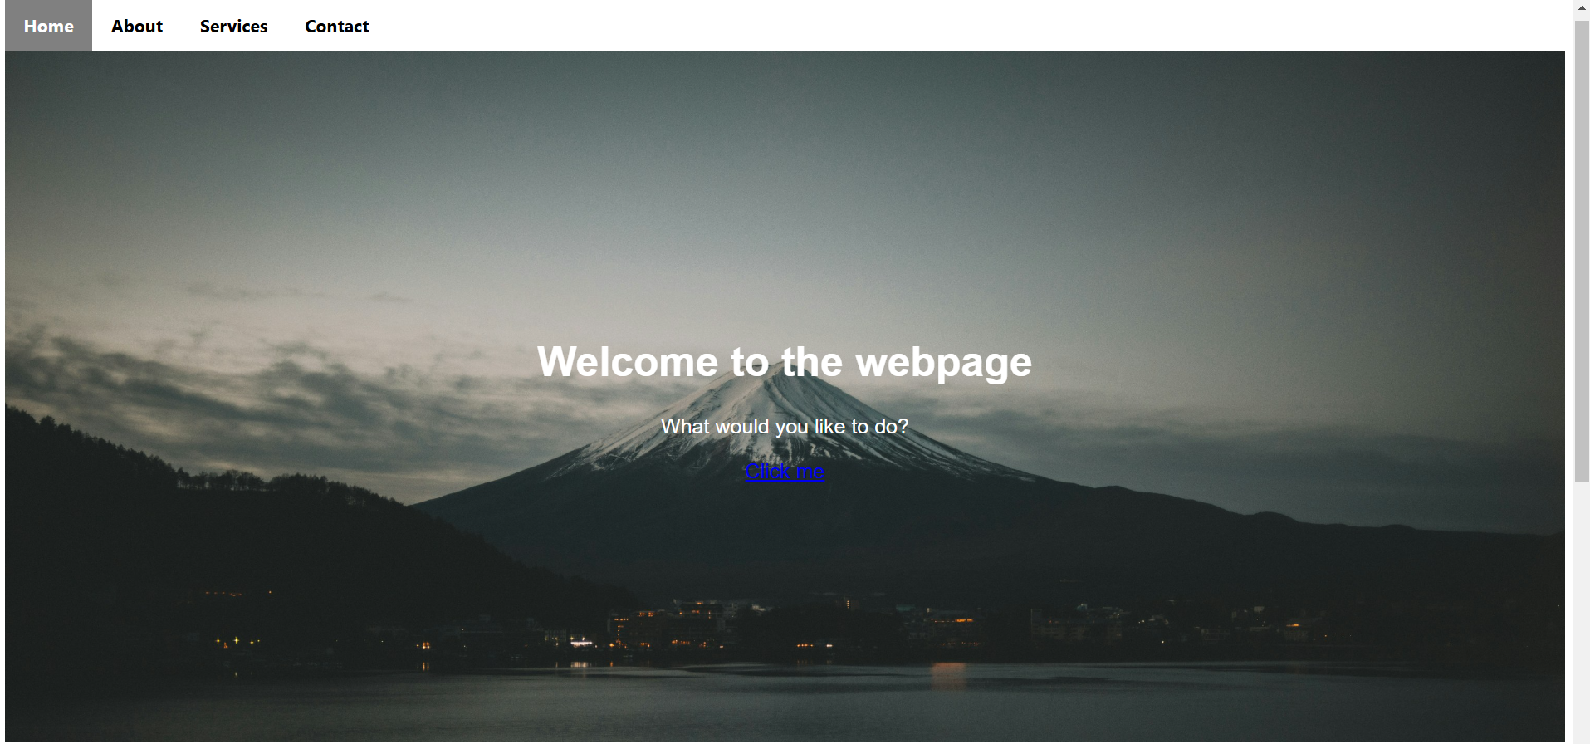
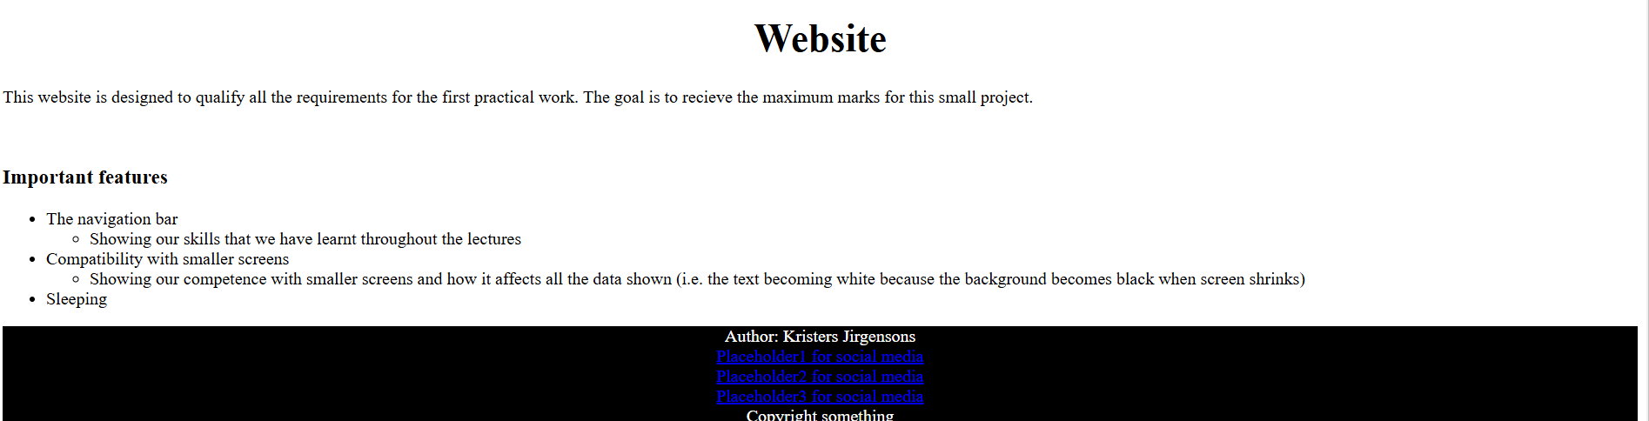

About.html

The about.html file consists of all three of our team members profile photos, names and a quote of ours. Down below is also a Mission statement and a timeline of our projects creation using lists.

About.html images
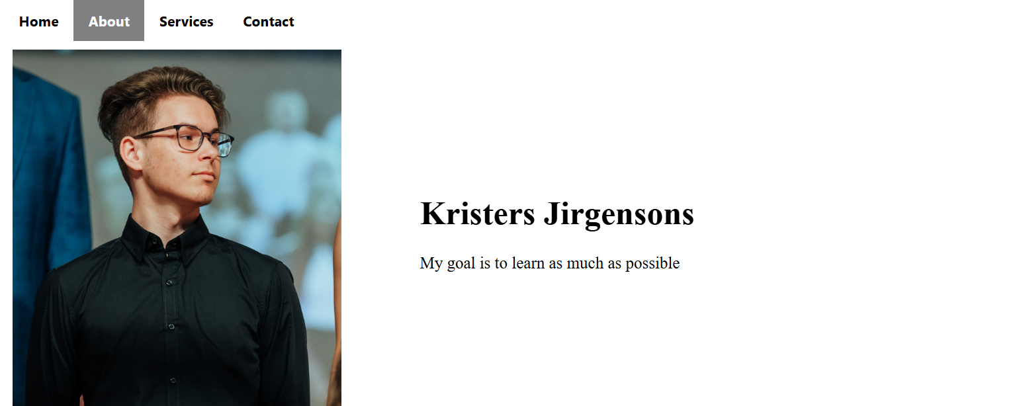
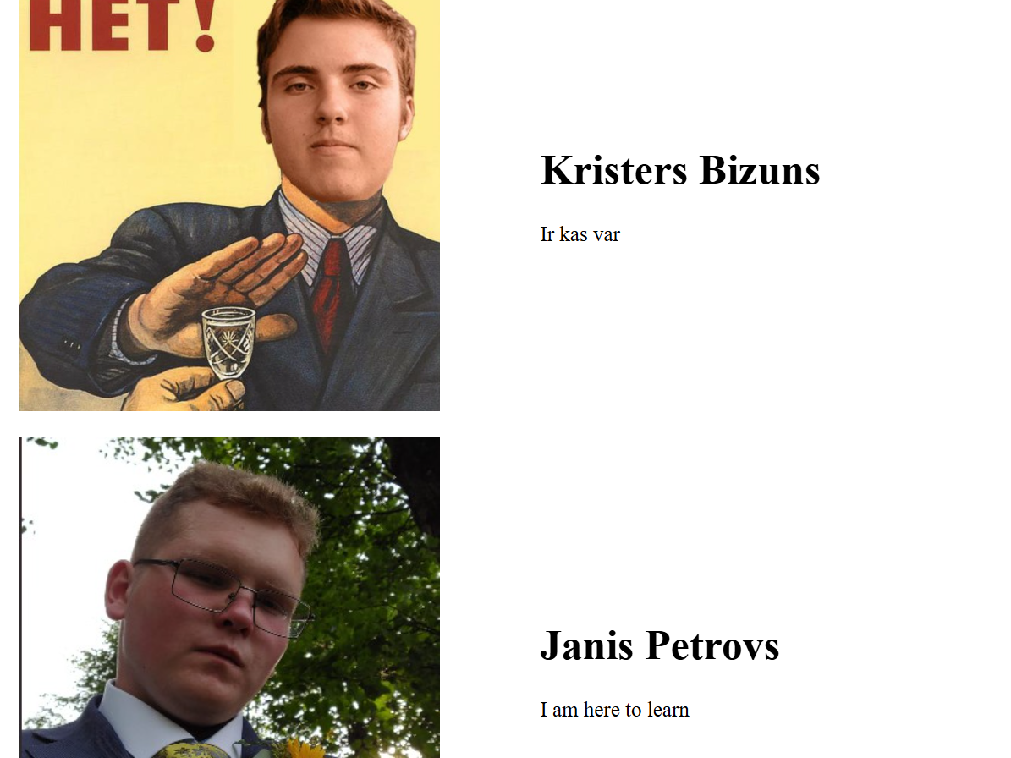
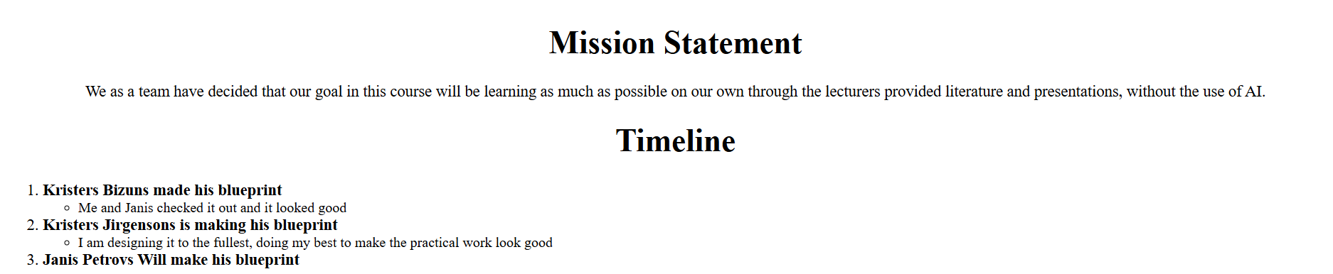

Services.html

The services provides two services which our team uses for the most part, an image of the service as well as a short history of it. This section focuses on the addition of images with css.

Services images

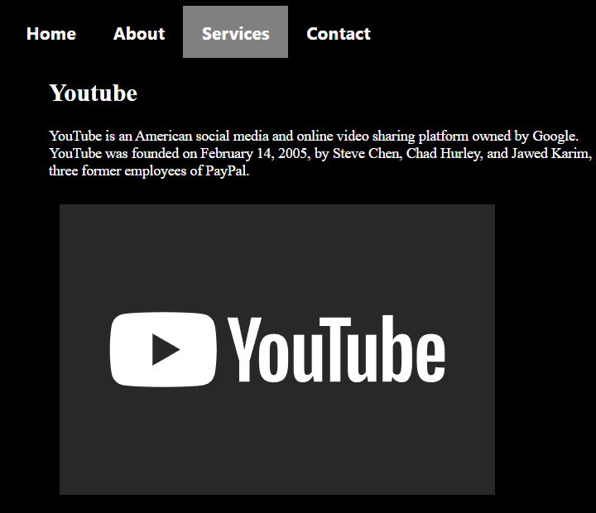

Contact.html

This is the contact section where visitors can contact the team by filling out a form. It requires entering an email address, full name, and reason for contact. Additionally, the team's contact information is provided - phone number and email address - to ensure easy communication.

Contact images
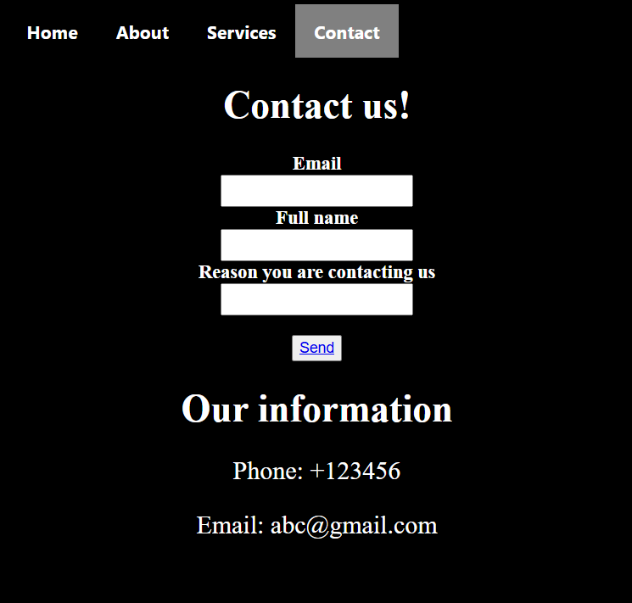

Contacted.html

This is a confirmation page that informs the user that the contact request was successfully sent. It includes a simple message and a "Return" button that allows you to return to the contact section.

Contacted images

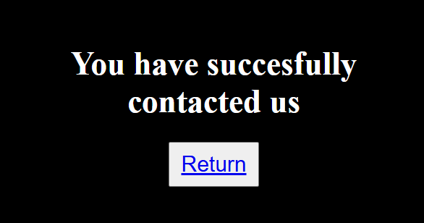

CSS

The CSS file is used to add depth to the webpage to make it look cleaner to the naked eye. Helping organise all the aspects from the HTML code, giving them color and making the website compatible with smaller screens.

Styles.css important functionality

This makes the website cleaner to look at. Giving all the text a font family, a font size, background colors as well as images. Not only that we added functionality for smaller screen sizes. Which in our case also works as a dark mode function making the background black and text white.

CSS images

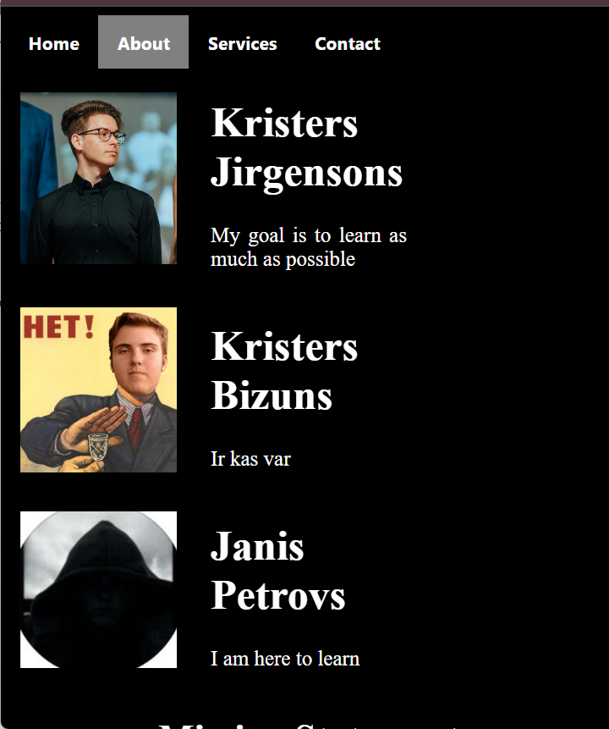
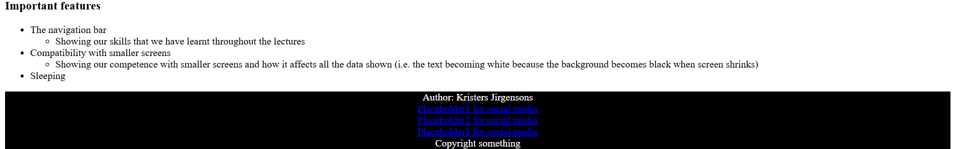

List of used resources

https://www.w3schools.com/html/
https://www.w3schools.com/html/html_css.asp

APPENDIX 1

Index.html
<!DOCTYPE html>
<html>

<head>
<link rel='stylesheet' type='text/css' href='css/styles.css'>
<title>My web training page</title>
<meta name="viewport" content="width=device-width, initial-scale=1.0" charset="UTF-8" />
</head>

<body>

<div class="navigation">
<b><a class="active" href="index.html">Home</a>
<a href="about.html">About</a>
<a href="services.html">Services</a>
<a href="contact.html">Contact</a></b>
</div>

<div class="hero">
<h1>Welcome to the webpage</h1>
<p>What would you like to do?</p>
<a href="https://www.youtube.com/watch?v=dQw4w9WgXcQ">Click me</a>

</div>

<div class="HDP">
<h1 class="header1">Website</h1>
<p>This website is designed to qualify all the requirements
for the first practical work. The goal is to recieve the
maximum marks for this small project.</p><br>
<h3>Important features</h3>
<ul>
<li>The navigation bar
<ul>
<li>
Showing our skills that we have learnt throughout the lectures
</li>
</ul>
</li>

<li>Compatibility with smaller screens</li>
<ul>
<li>
Showing our competence with smaller screens and how it affects all the data shown
(i.e. the text becoming white because the background becomes black when screen shrinks)
</li>
</ul>
<li>Sleeping</li>
</ul>
</div>

<div>
<footer id="footer">
<p> Author: Kristers Jirgensons <br>
<a href="x">Placeholder1 for social media</a><br>
<a href="x">Placeholder2 for social media</a><br>
<a href="x">Placeholder3 for social media</a><br>
Copyright something
</p>
</footer>
</div>
</body>
</html>

About.html
<!DOCTYPE html>
<html>

<head>
<link rel='stylesheet' type='text/css' href='css/styles.css'>
<title>About</title>
<meta name="viewport" content="width=device-width, initial-scale=1.0" charset="UTF-8" />
</head>
<body>

<div class="navigation">
<b><a href="index.html">Home</a>
<a class="active" href="about.html">About</a>
<a href="services.html">Services</a>
<a href="contact.html">Contact</a></b>
</div>

<div class="container">
<div class="image">
<img src="images/kj.jpg" alt="KJ">
</div>
<div class="text">
<h1>Kristers Jirgensons</h1>
<p>My goal is to learn as much as possible</p>
</div>
</div>

<div class="container">
<div class="image">
<img src="images/kb.jpg" alt="KB">
</div>
<div class="text">
<h1>Kristers Bizuns</h1>
<p>Ir kas var</p>
</div>
</div>

<div class="container">
<div class="image">
<img src="images/jp.jpg" alt="JP">
</div>
<div class="text">
<h1>Janis Petrovs</h1>
<p>I am here to learn</p>
</div>
</div>

<div>
<h1 class="header1">Mission Statement</h1>
<p class="paragraph1">We as a team have decided that our goal in this course
will be learning as much as possible on our own through
the lecturers provided literature and presentations, without
the use of AI.
</p>

</div>

<div>
<h1 class="header1">Timeline</h1>
<ol class="lists">
<li> <b> Kristers Bizuns made his blueprint </b>
<ul class="ulists">
<li>
Me and Janis checked it out and it looked good
</li>
</ul>
</li>

<li><b>Kristers Jirgensons is making his blueprint </b>
<ul class="ulists">
<li> I am designing it to the fullest, doing my best to make the practical work look good</li>
</ul>
</li>

<li><b>Janis Petrovs Will make his blueprint </b> </li>
</ol>
</div>

</body>
</html>

Services.html
<!DOCTYPE html>
<html>

<head>
<link rel='stylesheet' type='text/css' href='css/styles.css'>
<title>About</title>
<meta name="viewport" content="width=device-width, initial-scale=1.0" charset="UTF-8" />
</head>
<body>
<div class="navigation">
<b><a href="index.html">Home</a>
<a href="about.html">About</a>
<a class="active" href="services.html">Services</a>
<a href="contact.html">Contact</a></b>
</div>

<section>
<ul>
<li>
<h2 class="header2">Youtube</h2>
<p class="paragraph2">YouTube is an American social media and online video
sharing platform owned by Google. YouTube was founded
on February 14, 2005, by Steve Chen, Chad Hurley, and
Jawed Karim, three former employees of PayPal.</p>
<img src="images/youtube.svg" alt="youtubelogo">
</li>
<li>
<h2 class="header2">Spotify</h2>
<p class="paragraph2">Spotify is a Swedish audio streaming and media service
provider founded on 23 April 2006 by Daniel Ek and Martin Lorentzon.
As of December 2024, it is one of the largest providers of music streaming
services, with over 675 million monthly active users comprising 263 million
paying subscribers.</p>
<img src="images/spotify.png" alt="spotifylogo">
</li>
</ul>
</section>
</body>
</html>

Contact.html
<!DOCTYPE html>
<html>

<head>
<link rel='stylesheet' type='text/css' href='css/styles.css'>
<title>About</title>
<meta name="viewport" content="width=device-width, initial-scale=1.0" charset="UTF-8" />
</head>
<body>
<div class="navigation">
<b><a href="index.html">Home</a>
<a href="about.html">About</a>
<a href="services.html">Services</a>
<a class="active" href="contact.html">Contact</a></b>
</div>

<div>
<h1 class="header1">Contact us!</h1>
<div class="contact">

<label id="labelid" for="email">Email</label><br>
<input id="textboxid" type="text"><br>
<label id="labelid" for="name">Full name</label><br>
<input id="textboxid" type="text"><br>
<label id="labelid" for="text">Reason you are contacting us </label><br>
<input id="textboxid" type="text"><br><br>

<button id="buttonid"><a href="contacted.html">Send</a></button>

</form>
</div>
</div>

<div>
<h1 class="header1">Our information</h1>
<p class="header3">Phone: +123456</p>
<p class="header3">Email: abc@gmail.com</p>

</div>
</body>
</html>

Contacted.html
<!DOCTYPE html>
<html>

<head>
<link rel='stylesheet' type='text/css' href='css/styles.css'>
<title>About</title>
<meta name="viewport" content="width=device-width, initial-scale=1.0" charset="UTF-8" />
</head>
<body>
<div class="centereddiv">
<h1 class="header1">You have succesfully contacted us</h1>
<button id="returnid"><a href="contact.html">Return</a></button>
</div>
</body>
</html>

Styles.css
@media only screen and (max-width: 600px) {
body {
background-color: black;

.navigation {
background-color: black;
}
.navigation a {
color: white;

}

.hero {
height: 300px;
font-size: 16px;
padding: 15px;
text-align:center;
align-content: center;
}

.HDP {
color: white;
}

.text {
color: white;
}

.paragraph1 {
color: white;

}

.header1 {
color: white;
}

.header2 {
color: white;
}

.paragraph2 {
color: white;
}

.header3 {
color: white;
}
.lists {
color: white;
}

#labelid {
color: white;
}

#footer {
color: white;
}
}
}

.navigation {
background-color: #ffffff;
overflow: hidden;
text-align: center;
font-family:'Segoe UI', Tahoma, Geneva, Verdana, sans-serif;

}

.navigation a {
float:left;
color: #000000;
text-align: center;
padding: 14px 18px;

text-decoration: none;
font-size: 17px;
}

.navigation a:hover {
background-color: #ddd;
color: black;
}

.navigation a.active {
background-color: gray;
color: white;
}

.hero {
background-image: url('../images/bg2.jpg');
background-size:100%;
background-repeat: no-repeat;
color: white;
padding: 250px;
font-family: sans-serif;
text-align: center;
font-size: 20px;
}

.hero a:hover {
background-color: #ddd;
color: black;
}

.HDP {
font-size: 16px;
font-family: 'Times New Roman', Times, serif;
text-align: justify;

}

.header1 {
text-align: center;
font-size: 36px;
}

.header2 {
text-align: left;
font-size: 24px;
}

.header3 {
text-align: center;
font-size: 24px;
}

.paragraph1 {
text-align: center;
font-size: 18px;
}

.paragraph2 {
text-align: left;
font-size: 14px;
}

.container {
display: grid;
align-items: center;
grid-template-columns: 1fr 1fr 1fr;
column-gap: 5px;
}

img {
padding: 10px;
width: 80%;
}

.text {
text-align: justify;
font-size: 20px;
}

.lists {
text-align: justify;
font-size: 18px;
}

.ulists {
text-align: justify;
font-size: 16px;
}

section {
display: block;
}

.contact {
text-align: center;
}

#textboxid
{
height: 25px;
font-size:14px;
}
#labelid {
font-size: 18px;
font-weight: bold;
}

#buttonid {
height: 25px;
font-size: 14px;
}

#returnid {
text-align: center;
height: 50px;
width: 100px;
font-size: 24px;
}

.centereddiv {
text-align: center;
margin: 20%;
font-size: 36px;
}

#footer {
background-color: black;
color: white;
text-align: center;
}

