**3. Approach**

**3.1 System Overview**

Intellitune has a circuit with two essential paths: the feed line, and the control circuit. The power signal travels in from the transmitter, through the wideband current transformer, through the variable reactive components, and out to the antenna.

Simultaneously, when the power signal passes through the wideband current transformer, a voltage signal is derived and sent to the microcontroller. There, the microcontroller implements a search algorithm to determine how much additional capacitance and inductance that our variable components need to produce. Next, it utilizes the stepper motor drivers to rotate the variable components to the correct configuration for the matched impedance. It also stores this information for a quick return next time the same conditions are encountered. After that, the circuit is done making adjustments and the user is free to operate on that frequency.

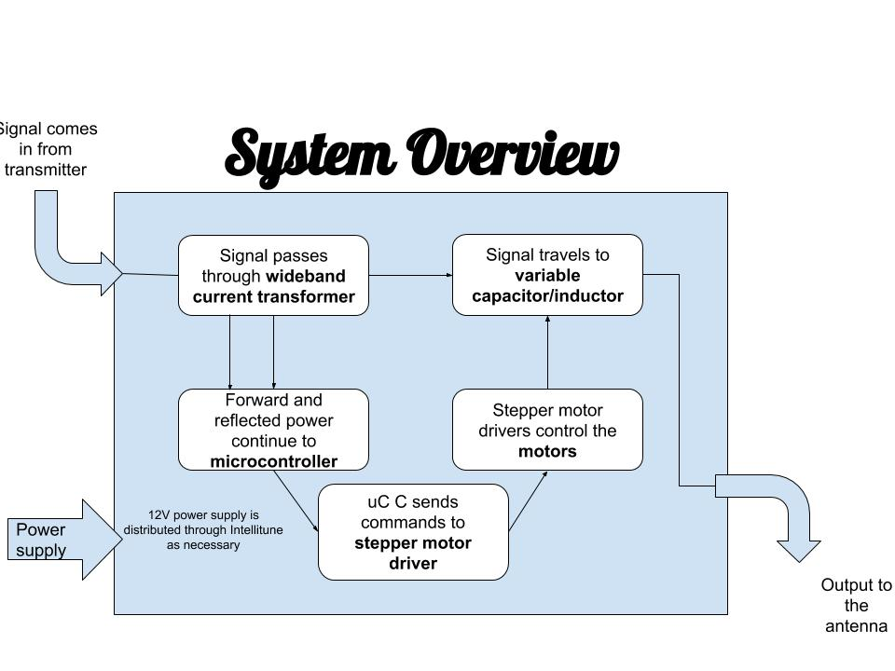

**Figure 3.1 - Intellitune System Design**

**3.2 Hardware**

In order for Intellitune to successfully tune the ham radio antenna, certain hardware must be present in the design. The essential hardware includes power supply, Voltage Standing Wave Ration (VSWR) meter/latch, microcontroller, launchpad development board, stepper motors/driver, variable inductor and capacitor, and enclosure. Their functions can be found below.

**3.2.1 Power Supply**

The intellitune requires a 12 VDC to operate, and since the tuner will always be stationary during use, the power can draw this from any wall outlet. Therefore, an 12 VDC AC adapter was selected for the power source.

|  |  |  |  |
| --- | --- | --- | --- |
| **AC Adapter** | **Voltage** | **Current** | **Price** |
| MFJ-1312DX | 12 VDC | 500 mA | $15.95 |
| SUPERNIGHT 12V Power Supply | 12 VDC | 2 A | $6.98 |
| BINZET AC to DC 12V 10A 120W Power Supply Adapter Converter Regulator | 12 VDC | 10 A | $17.58 |

Ultimately, the power supply chosen was the MFJ-1312DX because it met all of the power requirements for the project, and has been used for previous MFJ tuners with similar components, therefore proving to be reliable.

**3.2.2 Wideband Current Transformer**

Intellitune will accomplish VSWR measurement through the use of a wide band current transformer. This device appears similar to a step-up transformer schematically, but in operation, it is used to make a proportional measurement of the RF current in the feedline. In addition, a center tap on the current transformer allows two different measurements from which forward and reflected voltages can be derived. A sensor from Ameritron, a sister company to MFJ, will be used in our design since it is rated for the target 2500W.

**3.2.3 Microcontroller**

Intellitune requires a microcontroller as a link between the wideband current transformer and executing the automatic tuning. First, the microcontroller will read the input from the wideband current transformer, and then it calculate the amount of additional capacitance and inductance required to obtain an impedance match. Also, it will save this information for future reference so that it can return faster the next time the same conditions occur. Next, it will command the stepper motors to rotate to the appropriate position associated with the necessary impedance.

One requirement for our microcontroller is that it must have at least twelve general purpose input/output (GPIO) ports. Additionally, the clockspeed and the price must be weighed against each other in order to decide which microcontroller better suits the constraints of Intellitune.

|  |  |  |  |
| --- | --- | --- | --- |
| Microcontroller | GPIO Ports | Clockspeed | Price |
| Arduino Uno Rev3 | 14 | 16 MHz | $22.00 |
| Raspberry Pi 3 Model B+ | 40 | 1.4 GHz | $35.00 |
| Ti MSP430 LaunchPad | 40 | 24 MHz | $12.99 |

The arduino Uno was chosen as our microcontroller because it meets Intelline’s required specifications without exceeding them. This keeps the cost at a desirable level, while also featuring the technical requirements for the project.

**3.2.4 Stepper Motors/Couplings**

Variable capacitor and inductor both require rotation applied to their adjustment rod for tuning. The variable components are sensitive outputting a different value at every step. A motor presents the best efficiency/way to rotate. Specifically, stepper motors provide a more precise rotational option compared to a standard free-spinning motor. Stepper motors function by having a set degree of rotation for each step i.e. 1 degree will give you 1/360th of a complete rotation. To achieve a similar effect in a normal motor would require much more software design, also constant starting and stopping of standard motors has detrimental effects over the span of the products life.

The motors need to step both clockwise and counterclockwise. As explained above, they must be able to adjust low to high and vice versa, so the motor must also give the option of going two directions. All motors listed below meet the criteria of dual directionality. The variable components are designed to give no anti-rotation after they reach their position, which requires no need for a motor with high holding force. However, with everyday use such as moving to desired setup, some holding torque is required. Although not listed, every motor has holding torque that will allow it to hold in everyday situations(>1Ncm).

**Table 4.1 Stepper Motor Comparison**

|  |  |  |  |  |
| --- | --- | --- | --- | --- |
| **Motor** | **23HS41-1804S**  **[1]** | **17HS13-0404S-PG27 Nema 17 [2]** | **(3)11HS20-0674S-PG100**  **Nema 11 [3]** | **(4)17HS19-1684S-PG5 [4]** |
| **Maximum Torque** | 240 Ncm | 300 Ncm | 400 Ncm | 200 Ncm |
| **Voltage** | 4.95 V | 12 V | 6.2 V | 2.3 V |
| **Current rating** | 1.8 A | 0.4 A | bipolar | 2.8 |
| **Step angle** | 1.8 degrees | .067 degrees | .018 | 1.8 |
| **Price** | $25.91 | $26.87 | $34.72 | $55.59 |

Stepper motors in table 4.1 meet minimum requirement listed above. Exact torque requirements were never obtained due to the variable components small adjustment rods. By trial with a stepper motor with a similar torque rating, 17HS13-0404S-PG27 (PG27) was chosen to be most suitable for the variable capacitor. The variable capacitor requires only one complete rotation to cycle through all of its components, so then something with a lower step angle would give more options.

One complete rotation = 360 degree

Step angle of motor = 0.067 degree

Total values = 360/0.067 =5373.13 = 5373 unique values of capacitance

The variable inductor has a comparable torque, but requires 31 rotations. Something close to 31x larger step angle is required. Therefore, 23HS41-1804S was the best option with a 1.8 step angle and comparable torque it will cycle through the 31 rotations in 1/26th (1.8/.067) the time. Not only was 23HS41-1804S more cost effective than 17HS19-1684S-PG5, but it also has lower amp rating allowing for more compatibility with drivers.

Thirty-one complete rotations = 360 * 31 = 11,160

Step angle of motor = 1.8 degree

Total values = 360/1.8 =6200 = 6200 unique values of capacitance

The stepper motor must also connect to the variable components. A coupling is needed that adjusts on both ends since the stepper motor shaft and adjuster shaft on the variable components do not have the same diameter or shape. Additionally a flex spiral cut feature in the coupling would help compensate for binding effect caused by different shaft size.

**Coupling comparison Table 4.2**

|  |  |  |  |
| --- | --- | --- | --- |
| **Size** | **5mm to 8mm [5]** | **5mm to 10mm [6]** | **3mm to 5mm [7]** |
| **Feature** | Flex | Flex | Flex |
| **Price** | (2) $6.20 | (1) $4.95 | (1) $8.88 |

**Note: All couplings are made of aluminum**

The diameter of the stepper motor shaft 1, motor shaft 2, variable inductor shaft, and variable capacitor shaft is 5mm, 8mm, 5mm, and 7mm respectfully. The couplings are adjustable via set screw design, and they all have flex. 5mm to 8mm is adequate for all shaft diameters, and also ships in 2’s.

**3.2.5 Variable Inductor and Capacitor**

One essential component in this design is the variable inductor and capacitor; their variability is what sets Intellitune apart from existing automatic tuning units. The key concept of these components is that their levels of capacitance and inductance can be easily and continuously adjusted with only the turn of a knob [8]. For the Intellitune project, the range of capacitance and inductance needed must satisfy tuning for a 1.8-30MHz range. When selecting a variable capacitor and inductor, it is important that they meet the range requirements, and that they are also compatible with our stepper motors that will be used to rotate and adjust them.

The added inductance will be created completely by the rolling variable inductor, however for the added capacitance, the variable capacitor will work in conjunction with 500 pf capacitors that will be switched in using relays. The 500 pf capacitors are needed because if the load impedance is greater than 50 ohms, the variable capacitor alone should satisfy the impedance required, however if the load impedance is less than 50 ohms, much more capacitance is required. Therefor, the 500 pf capacitors are switched in and used to help achieve the high level of capacitance that is required.

The market for variable capacitors and inductors to fit the range of Intellitune are typically made to order, therefore unavailable for comparison. Ultimately, the variable capacitor and inductor that we went with were manufactured in house MFJ parts. Their range of capacitance and inductance is certainly enough to cover the 1.8-30 MHz tuning range.One advantage of these components is that they have been used in previous tuner models without issue, which proves they are reliable and can handle the task. However, they are relatively large, and will be one of the largest pieces of hardware in the Intellitune. Overall, the MFJ manufactured capacitor and inductor should be an appropriate fit for Intellitune.

**3.2.6 Housing/Enclosure:**

To protect the components and the operator, Intellitune will require housing/enclosure. With a 2.5 kW load, if the unit is not enclosed it has the potential to harm the user via electrocution through contact. The enclosure will also protect the components from the surrounding environment such as dust buildup and animal intrusion. Housing needs to have adequate mounting opportunities, for instance it needs to have predesignated mounting location for the circuit board and punch outs(see picture 6.1 ) for operational buttons and interface. Component attachment will require the material to be able to handle mounting components see picture 6.1.

**Picture 6.1**

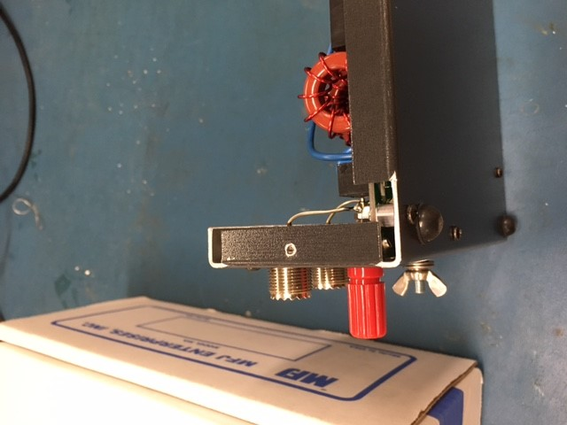

Aluminum and steel both hold up well if they are bolted into or welding onto compared to a synthetic alternatives.

**Table 6.1 Aluminum vs. Stainless Steel**

|  |  |  |
| --- | --- | --- |
| **Material** | **Stainless Steel** | **Aluminum** |
| **Manufacturing times [9][10]** | Varies but typically higher than aluminum | Varies but typically lower than aluminum |
| **Weight per cu./ft in pounds [11]** | 494.21 | 168.48 |
| **Price per lb.[12][13]** | $0.92 | $1.62 |

Aluminum will be the best option due to its lower manufacturing times, weight, and is readily available to manufacture in house with MFJ. MFJ typically opts for aluminum enclosures for the majority of its products, but will use steel if a larger component like a transformer is being supported. There have also been relationships built with suppliers that allows MFJ to get sheets of aluminum prefabricated with extra protective coatings before entering warehouse. Aluminum offers several advantages over both steel and stainless steel. Since aluminum is a much softer malleable metal, it allows manufacturing times to be much quicker **[**9][10]. Not only does it save time during production, but it also poses less strain on the equipment forming it. Standard steel would also require some type of coating like paint or varnish to help protect from the environment. Given the same environment aluminum and steel have similar lifetimes. Having a lower weight gives aluminum advantage over stainless steel in scenarios of handling and also leads to lower shipping cost. Steel is a stronger metal but for the purpose of protecting MFJ equipment, aluminum has proven satisfactory per customer feedback.

**3.3 Software**

**3.3.1 User Interface**

The Intellitune will feature a two-line, 16 character LCD display on the front panel as a user interface. This display will provide the user with the SWR reading, forward and reflected power, and frequency. A function will be written to display the values on the screen by the microcontroller, which receives # pins from the LCD.

**Table LCD Display Comparison**

|  |  |  |  |
| --- | --- | --- | --- |
| **LCD [14, 15, 16]** | **Characters** | **Interface** | **Price** |
| Adafruit 398 | 16x2 | GPIO | $12.95 |
| NHD-0216K3Z-NSW-BBW-V3 | 16x2 | I2C | $19.85 |
| Adafruit 198 | 20x4 | GPIO | $17.95 |

Adafruit 398 is the model of choice due to its price, interface, and customizable backlight. A display with two, 16 character rows is adequate enough for this LCD application. A GPIO interface will provide compatibility with the microcontroller to control the LCD. The backlight is powered by the DC voltage source and can operate from 3V or 5VDC.

**3.3.2. Impedance Match Code**

The Intellitune will perform a search algorithm to match the source and load impedance after reading in the reflected and transmitted power values. A conjugate match of the source impedance is found for the load to enable maximum power transmission. An SWR reading of 1.5:1 or lower is desirable using the algorithm. The algorithm will take the minimum and maximum settings of the variable components into account and calculate the necessary impedance match values. Starting from the last used impedance settings, a decision will be made by the algorithm which direction (increase/decrease) the impedance values should change via stepper motors. An SWR reading will be taken after each step up/down from the current capacitance/inductance values. This process will repeat while the reading is above 1.5, and after will fine tune at a smaller step size to achieve a best fit SWR for transmission.

**3.3.3 Driver Code**

Intellitune must be able to adjust the variable reactive components after it has calculated the necessary values. Therefore, our software must communicate to the stepper motor driver to control the motors. The driver requires three inputs: an enable, a direction, and a step size. In addition, the software must be able to track the position of the stepper motors and monitor the reactive component values.

**References**

[1] “Nema 23 Bipolar 1.8 degree 2.4Nm(340 oz.in) 1.8A 4.95V 57x57x104mm 4 wires”, stepperonline.com, 2018. [Online] Available: <https://www.omc-stepperonline.com/hybrid-stepper-motor/nema-23-bipolar-18deg-24nm-340ozin-18a-495v-57x57x104mm-4-wires-23hs41-1804s.html?mfp=149-step-angle%5B1.8%5D%2C145-holding-torque-ncm%5B190%2C220%2C240%2C250%2C280%2C283%2C300%2C310%2C340%2C400%2C450%2C707%2C850%2C1300%2C2200%2C3000%5D>.

[2] “Nema 17 Stepper Motor Bipolar L=33mm w/ Gear Ratio 27:1 Planetary Gearbox”, stepperonline.com, 2018. [Online] Available: <https://www.omc-stepperonline.com/nema-17-stepper-motor-bipolar-l33mm-w-gear-raio-271-planetary-gearbox-17hs13-0404s-pg27.html>.

[3] “Nema 11 Stepper Motor Bipolar L=51mm w/ Gear Ratio 100:1 Planetary Gearbox”, stepperonline.com, 2018. [Online] Available: <https://www.omc-stepperonline.com/geared-stepper-motor/nema-11-stepper-motor-bipolar-l51mm-w-gear-raio-1001-planetary-gearbox-11hs20-0674s-pg100.html>.

[4] “1460-1078-ND”, digikey.com, 2018. [Online] Available: <https://www.digikey.com/product-detail/en/trinamic-motion-control-gmbh/QSH5718-51-28-101/1460-1078-ND/4843429>.

[5] “[3D CAM] 2 PCS Flexible Couplings 5mm to 8mm NEMA 17 Shaft for RepRap 3D Printer or CNC Machine”, amazon.com, 2018. [Online] Available: <https://www.amazon.com/3D-CAM-Flexible-Couplings-Printer/dp/B010MZ8T2S>.

[6] “Aluminum Flex Shaft Coupler - 5mm to 10mm”, adafruit.com, 2018. [Online] Available: <https://www.adafruit.com/product/1177?gclid=EAIaIQobChMImvDt2Y_N3QIVmY-zCh1Q4AjKEAkYDSABEgKSofD_BwE>.

[7] “Flexible Parallel Aluminium Jaw Shaft CNC Coupling D19-L25-3x5MM”, vxb.com, 2018. [Online] Available: <https://www.vxb.com/Flexible-Parallel-CNC-Coupling-D19-L25-3X5M-p/D19-L25-3X5MM-COUPLING.htm?gclid=EAIaIQobChMImvDt2Y_N3QIVmY-zCh1Q4AjKEAkYDyABEgKJnvD_BwE>.

[8] M. S. Perdigão, M. Menke, A. R. Seidel, R. A. Pinto and J. M. Alonso, "A review on variable inductors and variable transformers: Applications to lighting drivers," *2014 IEEE Industry Application Society Annual Meeting*, Vancouver, BC, 2014, pp. 1-8.

doi: 10.1109/IAS.2014.6978431

[9] “Steel versus Aluminum Weight, Strength, Cost, Malleability Comparison”, wenxelmetalspinning.com, 2018. [Online] Available: <https://www.wenzelmetalspinning.com/steel-vs-aluminum.html>.

[10] “10 DIFFERENCES BETWEEN ALUMINUM AND STAINLESS STEEL”, metalsupermarkets.com, 2018. [Online] Available: <https://www.metalsupermarkets.com/10-differences-aluminum-stainless-steel/>.

[11] “Weights of Various Metals in Pounds Per *Cubic Foot”, coyotesteel.com, 2018. [Online] Available: http://www.coyotesteel.com/assets/img/PDFs/weightspercubicfoot.pdf.

[12] “Aluminum Prices and Aluminum Price Charts”, infomine.com, 2018. [Online] Available:

<http://www.infomine.com/investment/metal-prices/aluminum/>.

[13] “Stainless Steel”, agmetalminer.com, 2018. [Online] Available:<https://agmetalminer.com/metal-prices/stainless-steel/>.

[14] Adafruit Industries, New York City, NY, USA, “RGB backlight positive LCD 16x2 + extras - black on RGB,” Available: <https://www.adafruit.com/product/398> . Accessed: Sep. 25, 2018.

[15] Newhaven Display International, Inc., Elgin, IL, USA, “NHD-0216K3Z-NSW-BBW-V3,” Available: <http://www.newhavendisplay.com/nhd0216k3znswbbwv3-p-5739.html> . Accessed: Sep. 25, 2018.

[16] Adafruit Industries, New York City, NY, USA, “Standard LCD 20x4 + extras - white on blue,” Available: <https://www.adafruit.com/product/198> . Accessed: Sep. 25, 2018.