**3. Approach**

The Intellitune is an automatic antenna tuning unit (ATU) that enables ham radio operators to tune their antenna at the press of a button. An L matching network provides the required impedance range to support 1.5 MHz to 30 MHz operation, which encompasses all the high frequency (HF) band. Using an LCD and several pushbuttons, the operator may view tuning settings or touch up the tune. The summation of these features results in an ATU that meets the needs of both experienced and beginner ham operators alike.

**3.1 System Overview**

The Intellitune consists of two isolated circuits: the radio frequency (RF) circuit and the control circuit. Proper isolation between these circuits is necessary to prevent RF energy from entering the control circuit. Figure 3.1 depicts a high-level overview of the Intellitune and its subsystems.

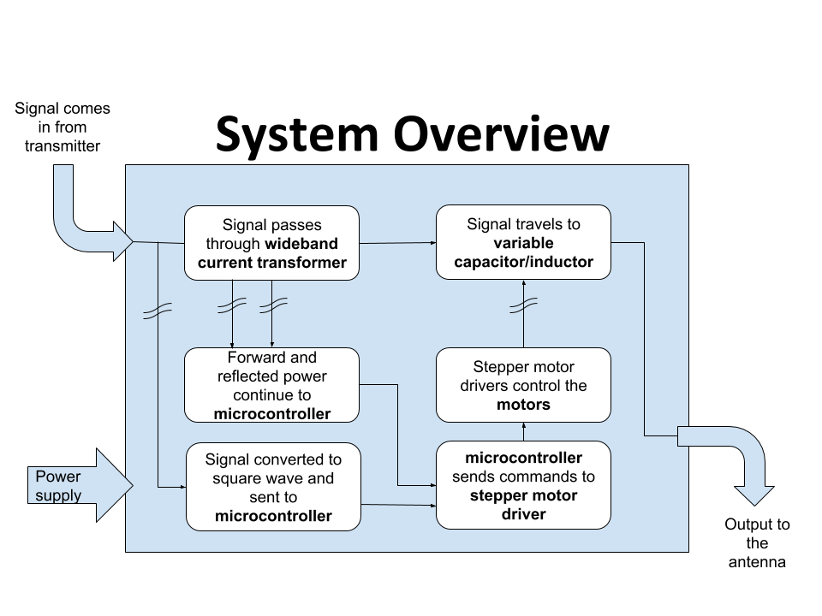

**Figure 3.1 - Intellitune System Design**

The RF signal enters the Intellitune, where it passes through a wideband current transformer. It then continues through the variable tuning components and out to the antenna. Separate ground paths between the RF circuit and control circuit will be maintained. A connection will be made between the two at a single point, at which a choke is placed to minimize the amount of RF energy flowing between the ground paths. The wideband current transformer and frequency counter are critical inputs to the control circuit. Two stepper motors are the driving force behind the Intellitune matching network and are controlled by the output of the tuning algorithm. A 16x2 LCD display shows useful information to the user, and six pushbuttons interface the user with the product.

**3.2 Hardware**

The Intellitune consists of many subsystems that integrate to perform the tuning process. The hardware includes a power supply, wideband current transformer, microcontroller, stepper motors and drivers, variable inductor and capacitor, enclosure, and LCD display. The microcontroller will tie all the subsystems together.

**3.2.1 Power Supply**

The Intellitune requires 12 VDC to operate the control circuit, and since the tuner will always be stationary during use, a wall-mounted supply is a sensible option. Therefore, a 12 VDC AC adapter was selected for the power source, as listed in Table 3.1.

**Table 3.1 - Power Supply Selection**

|  |  |  |  |
| --- | --- | --- | --- |
| **AC Adapter** | **Voltage** | **Current** | **Price** |
| MFJ-1312DX [1] | 12 VDC | 500 mA | $15.95 (Free) |
| SUPERNIGHT 12V Power Supply [2] | 12 VDC | 2 A | $6.98 |
| BINZET AC to DC 12V 10A 120W Power Supply Adapter Converter Regulator [3] | 12 VDC | 10 A | $17.58 |

|  |  |
| --- | --- |
| Selected Option | Not selected |

The power supply chosen was the MFJ-1312DX because it met all the power requirements for the project and was provided at no charge from MFJ.

**3.2.2 Wideband Current Transformer**

In electromagnetics, the standing wave ratio (SWR) relates the transmitted power to the reflected power in a transmission system. Figure 3.2 provides an example of a transmitted wave that has a reflected component.

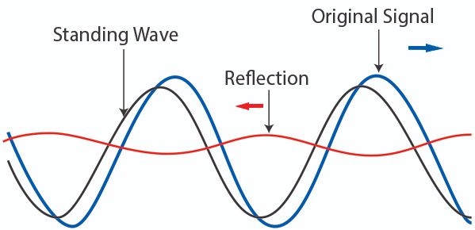[4]

**Figure 3.2 - Standing Wave example**

The blue wave in the above figure represents a transmitted signal traveling to the right on a transmission line. Suppose it encounters a load whose impedance does not match that of the transmission line. This will result in most of the wave being transmitted into the load, but a portion is reflected to the source, as represented by the red wave. The grey wave is a superposition, or combination, of the two waves, and it receives the name “standing wave” because it appears to oscillate in place through time unlike the original or reflected wave. The amount of power reflected is directly proportional to the mismatch in the load, and a reflection coefficient is used to relate the mismatch in impedance to the amount of reflected power:



ℾ: Reflection coefficient

Vref: Voltage of reflected wave

Vincident: Voltage of original wave

ZL: Impedance of load

ZS: Impedance of source

Voltage standing wave ratio (VSWR) is calculated from the reflection coefficient with the following formula:



VSWR: Voltage standing wave ratio

ℾ: Reflection coefficient

Vmax: Maximum voltage of the standing wave

Vmin: Minimum voltage of the standing wave

From the above formulas, it is evident that if the SWR of a signal is known, the amount of reflected power can be estimated. If an antenna tuner introduces more inductance or capacitance to the system, the SWR will change. In the Intellitune, the SWR will be measured with a wideband current transformer. Figure 3.3 shows a typical implementation of a wideband current transformer.

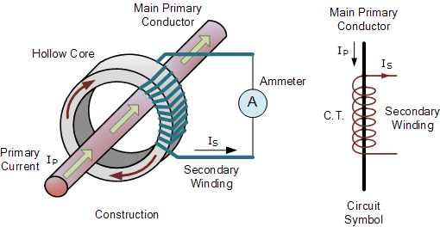[5]

**Figure 3.3 - Wideband Current Transformer**

The RF feedline passes through the center of a toroid, where a secondary winding is wrapped around the hollow core. This device appears similar to a step-up transformer schematically, but in operation, it is used to make a proportional measurement of the RF current in the feedline. In the Intellitune, a center tap on the current transformer allows two different measurements from which forward and reflected voltages can be derived. A sensor from Ameritron, a sister company to MFJ, will be used in the design since it is rated above the target 1500W.

**3.2.3 Microcontroller**

The Intellitune requires a microcontroller in the control circuit to calculate the tuning parameters and interface with peripherals. The most important requirement for the microcontroller is that it must have at least 36 general purpose input/output (GPIO) ports. Table 3.2 provides three of the microcontrollers that were considered for the Intellitune.

**Table 3.2 - Microcontroller Selection**

|  |  |  |  |
| --- | --- | --- | --- |
| **Microcontroller** | **GPIO Ports** | **Clockspeed** | **Price** |
| Arduino Uno Rev3 [6] | 14 | 16 MHz | $22.00 |
| Raspberry Pi 3 Model B+ [7] | 40 | 1.4 GHz | $35.00 |
| Ti MSP-EXP430FR2355 [8] | 40 | 24 MHz | $12.99 |

The Ti MSP-EXP430FR2355 Launchpad was the chosen microcontroller for several reasons. To begin, this microcontroller has many peripherals required for the design, specifically, external timer capability, four total timers, 40 pins broken out to headers, 12-bit ADC channels, and a serial peripheral interface (SPI) communication module. Prior experience developing with similar Ti products influenced the decision as well. Finally, this microcontroller was the least expensive compared to similar products.

**3.2.4 Stepper Motors and Couplings**

The variable capacitor and inductor each have a shaft that must be turned in order to change the component values. Stepper motors provide precise tuning compared to a standard DC motor or servo. By having a set degree of rotation for each step, i.e. one degree will give a 1/360th of a complete rotation, stepper motors can be as precise as the step angle allows. To achieve something similar to stepping in a standard DC motor, much more software development would be required. In addition, continual starting and stopping has detrimental effects on a DC motor’s lifetime, often resulting in premature failure. The motors need to step both clockwise and counterclockwise. Turning both ways is necessary because depending on the current position of the variable components, they may have to increase or decrease to a desired value. All motors listed in Table 3.3 have dual directionality. The variable components require no holding torque to maintain a constant position. However, with everyday use such as moving to desired setup, some holding torque is required. Although not listed, every motor has holding torque that will allow it to hold in everyday situations (>1Ncm).

**Table 3.3 - Stepper Motor Comparison**

|  |  |  |  |  |
| --- | --- | --- | --- | --- |
| **Motor** | 23HS41-1804S [9] | 17HS13-0404S-PG27 Nema 17 [10] | (3)11HS20-0674S-PG100  Nema 11 [11] | (4)17HS19-1684S-PG5 [12] |
| **Maximum Torque** | 240 Ncm | 300 Ncm | 400 Ncm | 200 Ncm |
| **Voltage** | 4.95 V | 12 V | 6.2 V | 2.3 V |
| **Current rating** | 1.8 A | 0.4 A | 0.067 A | 2.8 A |
| **Step angle** | 1.8 degrees | 0.067 degrees | 0.018 degrees | 1.8 degrees |
| **Price** | $25.91 | $26.87 | $34.72 | $55.59 |

Stepper motors in Table 3.3 meet the requirements listed above. The shafts on the variable components were so small that we were unable to find a torque wrench small enough to obtain a torque measurement. Therefore, a trial with a stepper motor that could turn the variable components was done, and the 17HS13-0404S-PG27 (PG27) was determined to have enough torque and deemed suitable for the variable capacitor.

The variable capacitor only requires one complete rotation to cycle through all of its values, so a lower step angle gives a smaller step between each value of capacitance. Therefore, the motor we chose for the capacitor has a 0.067 degree step angle. Since there are 360 degrees per revolution, this motor will be capable of providing 5373 unique values of capacitance.

The variable inductor has a comparable torque but requires 31 rotations to cycle through all values of inductance. The 23HS41-1804S was the best option because of its 1.8 degree step angle and comparable torque. The step angle results in 6200 unique values of inductance since 31 rotations are needed to cycle through the full range. Not only was 23HS41-1804S more cost effective than 17HS19-1684S-PG5, but it also has a lower current rating, allowing for more compatibility with drivers.

The stepper motor must also connect to the variable components. A coupling is needed that adjusts on both ends since the stepper motor shaft and adjuster shaft on the variable components do not have the same diameter or shape. Additionally, a flex spiral cut feature in the coupling limits binding caused by the difference in diameters. Table 3.4 displays couplings of various sizes that were considered.

**Table 3.4 - Coupling Comparison**

|  |  |  |  |
| --- | --- | --- | --- |
| **Size** | 5mm to 8mm [13] | 5mm to 10mm [14] | 3mm to 5mm [15] |
| **Feature** | Flex | Flex | Flex |
| **Price** | (2) $6.20 | (1) $4.95 | (1) $8.88 |

Note: All couplings are made of aluminum

The diameters of the stepper motor shaft 1, motor shaft 2, variable inductor shaft, and variable capacitor shaft are 5mm, 8mm, 5mm, and 7mm respectively. The couplings are adjustable via set screw design, and they all have rivets cut into them that allow more flexibility. 5mm to 8mm is adequate for all shaft diameters.

**3.2.5 Variable Inductor and Capacitor**

The essential components to the tuning process are the variable inductor and capacitor. Per the tuning constraint of the Intellitune, the additional capacitance and inductance must satisfy tuning for a 1.5 MHz to 30 MHz range. When selecting these components, it is important that they meet the range requirements, and that they are also compatible with our stepper motors that will be used to rotate and adjust them. Additionally, they must be able to withstand the rated power of 1.5 kW.

The additional inductance required to match the impedance will be introduced by only the rolling variable inductor. If the load impedance is greater than 50 ohms, the variable capacitor alone should satisfy the impedance required, however if the load impedance is less than 50 ohms, much more capacitance will be required. Therefore, the variable capacitor will work in conjunction with 470 pf capacitors that will be switched using relays.

The market for variable capacitors and inductors that fit the Intellitune’s tuning range are typically made to order, therefore unavailable for comparison. Ultimately, the variable capacitor and inductor that our group selected were in-house MFJ parts. One advantage of these components is that they have been used in previous tuner models without issues, which proves they are reliable and can handle the task. Additionally, the components are rated for 1.5 kW, as listed in the constraints, which is crucial since these components are directly in the RF path. While they are relatively large and will be one of the largest pieces of hardware, the MFJ manufactured capacitor and inductor are the best fit for the Intellitune.

**3.2.6 Drivers**

Stepper motor drivers are needed to operate the stepper motors. The microprocessor cannot drive the stepper motors alone. Because the two stepper motors operate at different voltages and current, two different drivers are needed to suit varying needs.

**Table 3.5 - Stepper Driver Comparison**

|  |  |  |  |  |
| --- | --- | --- | --- | --- |
| **Name** | Big Easy Driver [16] | EasyDriver [17] | Adafruit Motor Shield V2 [18] | 1460-1159 [19] |
| **Driving Voltage** | <30 V | 6 - 30 V | 4.5 - 13.5 V | 4.75-46 V |
| **Driving Current** | <2 A | <1 A | <1.2 A | <1.1 A |
| **Price** | $19.95 | $14.95 | $19.95 | $8.06 |

The Big Easy driver was chosen for the 23HS41 because it is suitable for both operational voltage and current. For the 17HS13, the EasyDriver was selected because it will function at the operational voltage and current. The Motor Shield was eliminated due to its dual functionality. It could drive two stepper motors at once but would have been unable to drive the 23HS41 due to its current draw. Because the 1460 has less compatibility with the motors and microprocessor, it is less practical.

**3.2.7 Enclosure**

To protect the components and the operator, Intellitune will require an enclosure. With a 1.5 kW load, if the unit is not enclosed it could harm the user via electrocution through contact. The enclosure will also protect the components from the surrounding environment such as dust buildup and animal intrusion. The housing needs to have adequate mounting capabilities. For instance, it needs to have predesignated mounting locations for the circuit board and punch outs (see Figure 3.4) for extruding components. Component attachment requires the material to be able to handle mounting components (as seen in Figure 3.4).

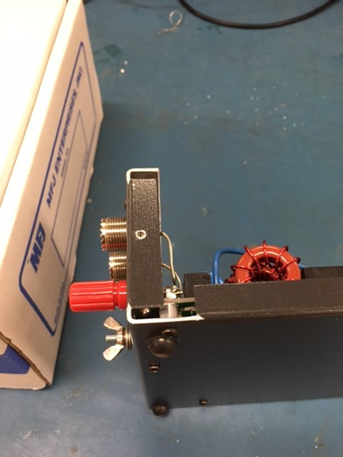

**Figure 3.4 - MFJ-998**

Aluminum and steel are both sturdy enough for mounting and anchoring. Table 3.6 elaborates on more qualities of each material.

**Table 3.6 - Aluminum vs. Stainless Steel**

|  |  |  |
| --- | --- | --- |
| **Material** | Stainless Steel | Aluminum |
| **Manufacturing times[20][21]** | Varies but typically higher than aluminum | Varies but typically lower than aluminum |
| **Weight per cu./ft in pounds[22]** | 494.21 | 168.48 |
| **Price per lb.[23][24]** | $0.92 | $1.62 |

Aluminum is the best option due to its low manufacturing times, weight, and availability. MFJ typically opts for aluminum enclosures for most of its products but will use steel if a larger component like a transformer is being supported. In addition, MFJ has built relationships with suppliers that allow them to get sheets of aluminum prefabricated with extra protective coatings. Aluminum offers several advantages over both steel and stainless steel. Since aluminum is a softer and malleable metal, it reduces manufacturing times compared to equivalent steel enclosures [20][21]. Not only does it save time during production, but it also poses less strain on the equipment forming it. Standard steel would also require some type of coating like paint or varnish to help protect from the environment. Given the same environment, aluminum and steel have similar lifetimes. Having a lower weight gives aluminum advantage over stainless steel in scenarios of handling and leads to lower shipping cost. Steel is a stronger metal but for protecting MFJ equipment, aluminum has proven satisfactory per customer feedback.

**3.2.8 LCD Display**

The Intellitune will feature a two-line, 16-character LCD display on the front panel that will show the SWR reading, forward and reflected power, and frequency. Table 3.7 compares three options the team considered.

**Table 3.7 - LCD Display Comparison**

|  |  |  |  |
| --- | --- | --- | --- |
| **LCD** | **Characters** | **Interface** | **Price** |
| Adafruit 181 [25] | 16x2 | GPIO | $9.95 |
| NHD-0216K3Z-NSW-BBW-V3 [26] | 16x2 | I2C | $19.85 |
| Adafruit 198 [27] | 20x4 | GPIO | $17.95 |

Although the Adafruit 181 is the least expensive of the selection pool, it still provides the necessary parallel operation mode for easy interfacing with the microcontroller. Additionally, the backlight brightness is controlled by a DC voltage input and can be varied easily with a potentiometer.

**3.3 Software**

The Intellitune software will be developed in the Ti Code Composer Studio (CCS) IDE. Personal experience determined that this environment was best suited for the selected microcontroller. With integrated device support and quick flashing capabilities, frequent testing of code will promote rapid development. The selected microcontroller features a JTAG interface, which communicates with the IDE in runtime. This allows register or variable values to be read and breakpoints to be placed at points of interest.

**3.3.1 Usage Cases**

In a “sunny-day” scenario (shown in Figure. 3.5), the Intellitune will tune the connected antenna at a low power until the SWR is below the user-defined limit, which ranges between 1.1:1 and 2:1. After the tuning process is complete, the user will be able to transmit at the rated power to their antenna. A notification on the LCD will alert the user when tuning is complete.

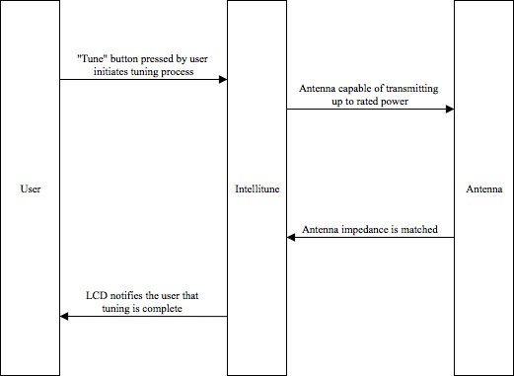

**Figure 3.5 - Sunny Day Scenario**

A “rainy-day” scenario (shown in Figure 3.6) for the Intellitune occurs when the SWR is above the limit of 2:1 and the user attempts to transmit at high power. At a high transmitting power, a mismatch above this limit indicates that a nominal amount of power is being reflected to the transmitter. The reflected power can result in substantial damage to the user’s equipment. A warning message will be sent to the user via the LCD and the tuner will cease operation.

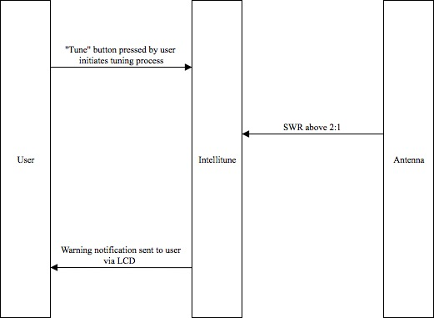

**Figure 3.6 - Rainy Day Case 1**

Figure 3.7 summarizes another “rainy-day” scenario where the transmitter does not supply enough power to tune the network; matching impedance requires a minimum of 10W in the Intellitune. Without meeting this power level, there is no way for the ATU to register the frequency to which the transmitter changed.

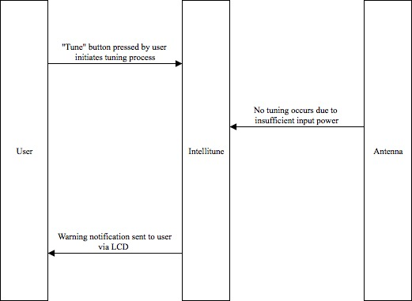

**Figure 3.7 - Rainy Day Case 2**

**3.3.2 Impedance Matching Algorithm**

The primary software component in the Intellitune is the tuning algorithm, which will tie in all the developed subsystems. Figure 3.8 shows a diagram of the tuning process.

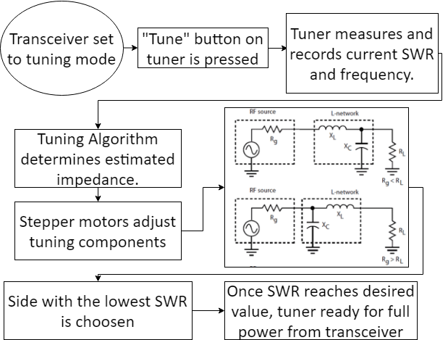

**Figure 3.8 - Tuning Process**

In the control circuit, a small portion of the transmitted RF signal is converted to a square wave and fed to the microcontroller to determine the frequency of the transmitted wave. As the RF signal passes through the wideband current transformer, forward and reflected power are derived as a pair of voltage signals and are routed to the microcontroller. With these inputs, the microcontroller executes the tuning algorithm which determines a conjugate match of the load impedance for the source to enable maximum power transmission. This conjugate impedance is introduced with the variable tuning components. The microcontroller commands the stepper motor drivers to rotate the variable components to the correct configuration for the matched impedance. If the capacitance calculated is greater than the total capacitance of the variable capacitor, additional capacitance is switched in with relays. A separate relay then switches the capacitor on either side of the inductor to determine which configuration presents the lowest SWR. Incremental adjustments are performed afterward until the user defined SWR is met, which must be below 2:1. This concludes the tuning process, and the user is free to operate at full transmission power for the tuned frequency.

**3.3.3 Variable Inductance and Capacitance**

The Intellitune’s software must accomplish two primary tasks relevant to the variable inductance and capacitance: it will interface with the stepper motor drivers to adjust the variable tuning components, and it will correlate an analog voltage input to a capacitance or inductance reading.

Three pin connections between the microcontroller and stepper driver are required for each motor and driver combo. The three signal inputs are a direction control, enable, and step. Each time a pulse is sent to the step input, the motor is incremented one step in the controlled direction. The software will increment or decrement the capacitance or inductance based upon the tuning algorithm output.

Since stepper motors have no internal tracking position, the Intellitune will utilize potentiometers connected to the shafts of the variable components to determine the current tuning values. Using a resistive divider network, the voltage will change as a function of the potentiometer’s position. This voltage is read as an analog input in the microcontroller with 12-bit resolution, which allows for 4096 unique values of inductance and capacitance to be correlated to the voltage. Single-turn potentiometers have been chosen to minimize cost, and a 40:1 gear will be placed on the inductor to limit the potentiometer rotation.

**3.3.4 User Interface**

The user interface will feature six push buttons for the following actions: power on/off, tune, capacitance up, capacitance down, inductance up, and inductance down. When powered off, the tuner will still allow power to be transmitted through the tuner, but the tuning components will not change values and the user interface will not be powered. This mode of operation is strongly discouraged for users because it will likely damage components in the control circuit. When powered on, the tune button can be pressed to begin the automatic tuning process. The up and down buttons for the variable components allow the user to adjust the component values manually if they feel a lower SWR is possible. The software will have hardware interrupts tied to the button inputs, so fast response to user changes can be achieved. In addition, SWR, frequency, forward power, and reflected power are the default settings displayed on the LCD, per MFJ standards. However, when either of the capacitance or inductance buttons are pressed, the LCD must display the current settings for the tuning components, so the user can observe how they are changing.

**3.3.5 Frequency Counter**

The frequency of the transmitted wave is another important parameter for the tuning algorithm. When considering common methods of frequency sampling, two were identified. One method commonly used for determining the frequency content of a sampled wave consists of sampling the desired signal at a frequency greater than the Nyquist Rate, defined as twice the bandwidth of the signal. Sampling at this rate allows for complete frequency decomposition using a Fourier Transform, but for the Intellitune, this rate would be at least 60 MHz, twice the highest expected frequency. Microcontrollers capable of sampling at this rate are much more expensive, and the additional frequency content is not used by the Intellitune. Since the frequency counter is only concerned with the signal’s center frequency, a simpler design is sufficient. Figure 3.9 displays the chosen method of deriving the frequency of the RF signal.

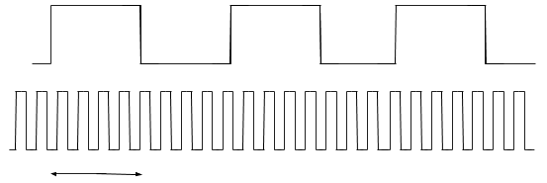



**Figure 3.9 - Frequency Counter timers**

The method pictured above uses two timers to determine the center frequency of the transmitted wave. A small portion of the RF signal is converted into a square wave as it enters the Intellitune and is then routed to the microcontroller. The square wave acts as the clock source for one timer, where it will increment a variable for each rising edge. This timer source is prescaled, or divided down, by a factor of 16 to decrease the total amount of pulses. An additional overflow register increments when the timer count exceeds its max value, which is 65,535 for the 16-bit timer variable. A separate timer will have a fixed known period of length one second in this implementation, which will allow precise measuring of the number of pulses in the interval. Using these two values, the number of pulses and the length of the gate interval, the frequency of the wave can be derived.

**References**

[1] “MFJ-1312DX”, mfj.com, 2018. [Online]. Available: <https://www.mfjenterprises.com/Product.php?productid=MFJ-1312DX>. Accessed: Oct. 18, 2018.

[2] ”Supernight 12V Power Supply”, amazon.com, 2018. [Online]. Available: <https://www.amazon.com/SUPERNIGHT-110-240V-Transformer-Adapter-5-5x2-1mm/dp/B00K6AHNWC>. Accessed: Oct. 18, 2018.

[3] ”Binzet AC to DC 12V 10A 120W Power Supply”, amazon.com, 2018. [Online]. Available: <https://www.amazon.com/BINZET-Adapter-Converter-Regulator-Flexible/dp/B00Z9X4GLW>. Accessed: Oct. 18, 2018.

[4] “Back to Basics in Microwave Systems: Return Loss and VSWR”, commonscope.com, 2018. [Online]. Available: <https://www.commscope.com/Blog/Back-to-Basics-in-Microwave-Systems-Return-Loss-and-VSWR/>. Accessed: Oct. 4, 2018.

[5] “Basics of Current Transformer,” engineeringtutorial.com, 2018. [Online]. Available: <https://engineeringtutorial.com/basics-of-current-transformer/>. Accessed: Oct. 4, 2018.

[6] “Arduino Uno Rev3”, arduino.cc, 2018. [Online]. Available: <https://store.arduino.cc/usa/arduino-uno-rev3>. Accessed: Sep. 23, 2018.

[7] “Raspberry Pi 3 Model B+”, raspberrypi.org, 2018. [Online]. Available: <https://www.raspberrypi.org/products/raspberry-pi-3-model-b-plus/>. Accessed: Sep. 23, 2018.

[8] “MSP430FR2355 LaunchPad Development Kit”, ti.com, 2018. [Online]. Available: <http://www.ti.com/tool/MSP-EXP430FR2355>. Accessed: Sep. 23, 2018.

[9] “Nema 23 Bipolar 1.8 degree 2.4Nm(340 oz.in) 1.8A 4.95V 57x57x104mm 4 wires”, stepperonline.com, 2018. [Online]. Available: <https://www.omc-stepperonline.com/hybrid-stepper-motor/nema-23-bipolar-18deg-24nm-340ozin-18a-495v-57x57x104mm-4-wires-23hs41-1804s.html?mfp=149-step-angle%5B1.8%5D%2C145-holding-torque-ncm%5B190%2C220%2C240%2C250%2C280%2C283%2C300%2C310%2C340%2C400%2C450%2C707%2C850%2C1300%2C2200%2C3000%5D>. Accessed: Sep. 21, 2018.

[10] “Nema 17 Stepper Motor Bipolar L=33mm w/ Gear Ratio 27:1 Planetary Gearbox”, stepperonline.com, 2018. [Online]. Available: <https://www.omc-stepperonline.com/nema-17-stepper-motor-bipolar-l33mm-w-gear-raio-271-planetary-gearbox-17hs13-0404s-pg27.html>. Accessed: Sep. 21, 2018.

[11] “Nema 11 Stepper Motor Bipolar L=51mm w/ Gear Ratio 100:1 Planetary Gearbox”, stepperonline.com, 2018. [Online]. Available: <https://www.omc-stepperonline.com/geared-stepper-motor/nema-11-stepper-motor-bipolar-l51mm-w-gear-raio-1001-planetary-gearbox-11hs20-0674s-pg100.html>. Accessed: Sep. 21, 2018.

[12] “1460-1078-ND”, digikey.com, 2018. [Online]. Available: <https://www.digikey.com/product-detail/en/trinamic-motion-control-gmbh/QSH5718-51-28-101/1460-1078-ND/4843429>. Accessed: Sep. 21, 2018.

[13] “[3D CAM] 2 PCS Flexible Couplings 5mm to 8mm NEMA 17 Shaft for RepRap 3D Printer or CNC Machine”, amazon.com, 2018. [Online]. Available: <https://www.amazon.com/3D-CAM-Flexible-Couplings-Printer/dp/B010MZ8T2S>. Accessed: Sep. 21, 2018.

[14] “Aluminum Flex Shaft Coupler - 5mm to 10mm”, adafruit.com, 2018. [Online]. Available: <https://www.adafruit.com/product/1177?gclid=EAIaIQobChMImvDt2Y_N3QIVmY-zCh1Q4AjKEAkYDSABEgKSofD_BwE>. Accessed: Sep. 21, 2018.

[15] “Flexible Parallel Aluminium Jaw Shaft CNC Coupling D19-L25-3x5MM”, vxb.com, 2018. [Online]. Available: <https://www.vxb.com/Flexible-Parallel-CNC-Coupling-D19-L25-3X5M-p/D19-L25-3X5MM-COUPLING.htm?gclid=EAIaIQobChMImvDt2Y_N3QIVmY-zCh1Q4AjKEAkYDyABEgKJnvD_BwE>. Accessed: Sep. 21, 2018.

[16] “Big Easy Driver”, sparkfun.com, 2018. [Online]. Available: <https://www.sparkfun.com/products/12859>. Accessed: Oct. 16, 2018.

[17] “EasyDriver - Stepper Motor Driver,” sparkfun.com, 2018. [Online]. Available: <https://www.sparkfun.com/products/12779>. Accessed: Oct. 6, 2018.

[18] “Adafruit Motor/Stepper/Servo Shield for Arduino v2 Kit - v2.3”, adafruit.com, 2018. [Online]. Available: <https://www.adafruit.com/product/1438>. Accessed: Oct. 5, 2018.

[19] “1460-1159-ND,” digikey.com, 2018. [Online]. Available: <https://www.digikey.com/product-detail/en/trinamic-motion-control-gmbh/TMC%2520SILENTSTEPSTICK/1460-1159-ND/5724190?WT.srch=1&gclid=EAIaIQobChMIk8-Ou5T63QIVCJyzCh0TjgHkEAYYASABEgKAzfD_BwE>. Accessed: Oct. 4, 2018.

[20] [Adam Hornbacher](https://plus.google.com/109972614238550156361?rel=author), “Steel versus Aluminum Weight, Strength, Cost, Malleability Comparison”, wenxelmetalspinning.com, 2018. [Online]. Available: <https://www.wenzelmetalspinning.com/steel-vs-aluminum.html>. Accessed: Sep. 21, 2018.

[21] Metal Supermarkets, “10 DIFFERENCES BETWEEN ALUMINUM AND STAINLESS STEEL”, metalsupermarkets.com, 2018. [Online]. Available: <https://www.metalsupermarkets.com/10-differences-aluminum-stainless-steel/>. Accessed: Sep. 21, 2018.

[22] “Weights of Various Metals in Pounds Per *Cubic Foot”, coyotesteel.com, 2018. [Online]. Available: <http://www.coyotesteel.com/assets/img/PDFs/weightspercubicfoot.pdf>. Accessed: Sep. 21, 2018.

[23] “Aluminum Prices and Aluminum Price Charts”, infomine.com, 2018. [Online]. Available:

<http://www.infomine.com/investment/metal-prices/aluminum/>. Accessed: Sep. 21, 2018.

[24] “Stainless Steel”, agmetalminer.com, 2018. [Online] Available:<https://agmetalminer.com/metal-prices/stainless-steel/>. Accessed: Sep. 21, 2018.

[25] “Standard LCD 16x2 + extras - white on blue”, adafruit.com. 2018. [Online]. Available: <https://www.adafruit.com/product/181>. Accessed: Sep. 25, 2018.

[26] “NHD-0216K3Z-NSW-BBW-V3”, newhaven.com, 2018. [Online]. Available: <http://www.newhavendisplay.com/nhd0216k3znswbbwv3-p-5739.html>. Accessed: Sep. 25, 2018.

[27] “Standard LCD 20x4 + extras - white on blue”, adafruit.com, 2018. [Online]. Available: <https://www.adafruit.com/product/198>. Accessed: Sep. 25, 2018.