**Executive Summary**

In amateur radio, an antenna tuning unit (ATU) is a critical component used for matching the connected antenna’s impedance to that of the transmitter. With a matched impedance network, the transmitter operates at maximum efficiency, which results in a better operating experience. Current ATU offerings are comprised of two main categories: manual tuners which utilize variable tuning components with gears attached for user adjustment and auto tuners composed of discrete components and relays to adjust impedance values. The Intellitune aims to bridge the gap between these offerings by automatically tuning with variable components. Figure 1 shows an overview of the Intellitune with its features, applications and specifications.

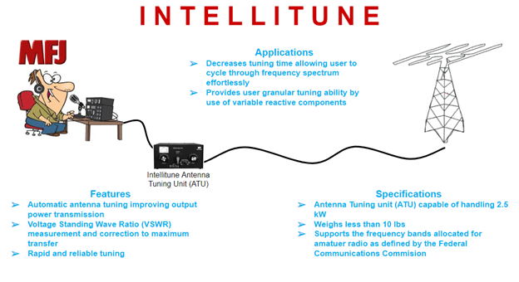

**Figure 1 - Intellitune Overview**

The Intellitune must meet certain design criteria to fulfill the needs of amateur radio operators. The operating frequency for the Intellitune is 1.5 MHz to 30 MHz, which essentially covers the most popular band among ham radio enthusiasts, the HF band. In addition, the 1.5kW power rating will enable operators to communicate across long distances without a repeater. In everyday use, the Intellitune must be safe to handle, with proper grounding channels connected to ensure no charge builds on the surface of the enclosure. Finally, the Intellitune must be no larger than a similar MFJ tuner, with dimensions 13” x 7” x 15.72” in order to fit in most amateur radio setups with ease.

To accomplish automated tuning, two subsystems were devised. The tuning network matches the load impedance to the transmitter, and the control circuit drives the matching network, adjusting the tuning components to the correct values for a given frequency. The RF signal enters the tuning network, where it is passed through the VSWR sensor and the matching network. After the tuning components, the RF signal exits the tuner where it connects to the antenna. On the control circuit, the primary inputs to the tuning algorithm are the VSWR sensor and the frequency counter. In addition, the control circuit will drive stepper motors to adjust the variable capacitor and inductor to match the network.

Most current auto tuners utilize a tuning network composed of purely discrete reactive components. This means that the auto tuner can find the lowest VSWR for a given frequency, but there will still be room for improvement since discrete steps between each setting are present. The Intellitune improves upon this design by introducing a variable capacitor and roller inductor to the tuning network, which allows continuous tuning through a range of values. This approach allows the user to reach the lowest VSWR for each frequency tuned.