# Personal Expense Tracker - Jupyter Notebook Project

## 1. Project Description

This project is a simple Personal Expense Tracker implemented using Python in a Jupyter Notebook. Users can enter their daily expenses, categorize them, and view summaries and visualizations. The data is saved locally as a CSV file for future reference.

## 2. Execution Steps

To run this project:

1. Install Jupyter using: pip install notebook

2. Save the notebook file as 'personal_expense_tracker.ipynb'.

3. Launch Jupyter by running: jupyter notebook

4. Open the notebook and run each cell using Shift + Enter.

5. Enter expense data when prompted. Leave the Date field blank to stop input.

6. View tabular and chart summaries of your expenses.

7. Expenses are saved to 'my_expenses.csv'.

## 3. Sample Output

Below is a sample preview of the expenses data entered:

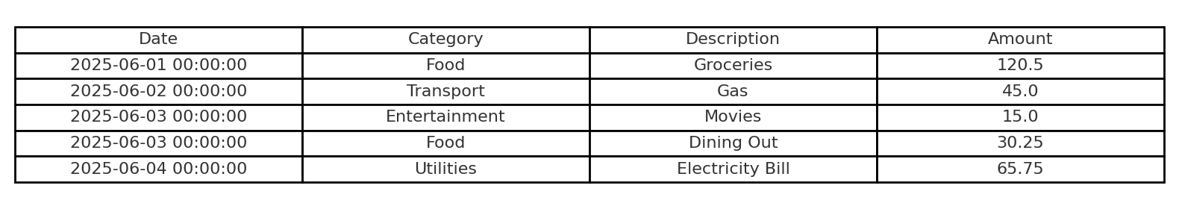

And here is a chart showing total expenses by category:

