Coding_Challenge4_Markdown

Pankaj Gaonkar

2025-02-27

# Coding Challenge 4 Answers

# Q1) Explain the following

1. YAML header YAMLS helps in writing the configuration of the files and is on the top of the markdown files.
2. Literate programming In literate programming along with our code we will have its explanations and provide the chunks of codes. Itexplains the codes in bettwe way.

# Q2)

# Below is the clickable link to manuscript where these data are published

[Noel et al., 2022. Endophytic fungi as promising biocontrol agent to protect wheat from Fusarium graminearum head blight. Plant Disease](https://doi.org/10.1094/PDIS-06-21-1253-RE)

## Load libraries  
library(tidyverse)

## ── Attaching core tidyverse packages ──────────────────────── tidyverse 2.0.0 ──  
## ✔ dplyr 1.1.4 ✔ readr 2.1.5  
## ✔ forcats 1.0.0 ✔ stringr 1.5.1  
## ✔ ggplot2 3.5.1 ✔ tibble 3.2.1  
## ✔ lubridate 1.9.3 ✔ tidyr 1.3.1  
## ✔ purrr 1.0.2   
## ── Conflicts ────────────────────────────────────────── tidyverse_conflicts() ──  
## ✖ dplyr::filter() masks stats::filter()  
## ✖ dplyr::lag() masks stats::lag()  
## ℹ Use the conflicted package (<http://conflicted.r-lib.org/>) to force all conflicts to become errors

library(ggpubr)  
library("knitr") # required for knitting  
  
  
## Reading data by reative path  
  
csv <- read.csv("MycotoxinData.csv", na.strings = "na")  
head (csv)

## Treatment Cultivar BioRep MassperSeed_mg DON X15ADON  
## 1 Fg Wheaton 2 10.291304 107.3 3.00  
## 2 Fg Wheaton 2 12.803226 32.6 0.85  
## 3 Fg Wheaton 2 2.846667 416.0 3.50  
## 4 Fg Wheaton 2 6.500000 211.9 3.10  
## 5 Fg Wheaton 2 10.179167 124.0 4.80  
## 6 Fg Wheaton 2 12.044444 73.1 3.30

## Codes needed for complete analysis  
  
#Plot1 Treatment on Y  
  
P1 <- ggplot(csv, aes(x = Treatment, y = DON, fill = Cultivar))+  
 theme_classic() + # removes the grids  
 geom_boxplot() +   
 xlab("") +  
 ylab("DON (ppm)") +  
 geom_point(alpha = 0.6, shape = 21, position = position_jitterdodge()) +  
 scale_fill_manual (values = c("#56B4E9", "#009E73")) +  
 facet_wrap(~ Cultivar)   
  
str(csv)

## 'data.frame': 375 obs. of 6 variables:  
## $ Treatment : chr "Fg" "Fg" "Fg" "Fg" ...  
## $ Cultivar : chr "Wheaton" "Wheaton" "Wheaton" "Wheaton" ...  
## $ BioRep : int 2 2 2 2 2 2 2 2 2 3 ...  
## $ MassperSeed_mg: num 10.29 12.8 2.85 6.5 10.18 ...  
## $ DON : num 107.3 32.6 416 211.9 124 ...  
## $ X15ADON : num 3 0.85 3.5 3.1 4.8 3.3 6.9 2.9 2.1 0.71 ...

csv$Treatment <- factor(csv$Treatment, levels = c("NTC", "Fg","Fg + 37", "Fg + 40", "Fg + 70"))  
  
  
#Plot2 X15ADON on Y  
  
P2 <- ggplot(csv, aes(x = Treatment, y = X15ADON, fill = Cultivar))+  
 theme_classic() + # removes the grids  
 geom_boxplot() +   
 xlab("") +  
 ylab("15ADON") +  
 geom_point(alpha = 0.6, shape = 21, position = position_jitterdodge()) +  
 scale_fill_manual (values = c("#56B4E9", "#009E73")) +  
 facet_wrap(~ Cultivar)   
  
  
#Plot3 MassperSeed_mg on Y  
  
P3 <- ggplot(csv, aes(x = Treatment, y = MassperSeed_mg, fill = Cultivar))+  
 theme_classic() + # removes the grids  
 geom_boxplot() +   
 xlab("") +  
 ylab("Seed Mass (mg)") +  
 geom_point(alpha = 0.6, shape = 21, position = position_jitterdodge()) +  
 scale_fill_manual (values = c("#56B4E9", "#009E73")) +  
 facet_wrap(~ Cultivar)

## Code from coding challenge 3, question 5 & sepreated code chunks for each plit

P1_stat <- P1 +   
 geom_pwc(aes(group = Treatment), method = "t_test", label = "p.adj.format")  
P1_stat

## Warning: Removed 8 rows containing non-finite outside the scale range  
## (`stat_boxplot()`).

## Warning: Removed 8 rows containing non-finite outside the scale range  
## (`stat_pwc()`).

## Warning: Removed 8 rows containing missing values or values outside the scale range  
## (`geom_point()`).

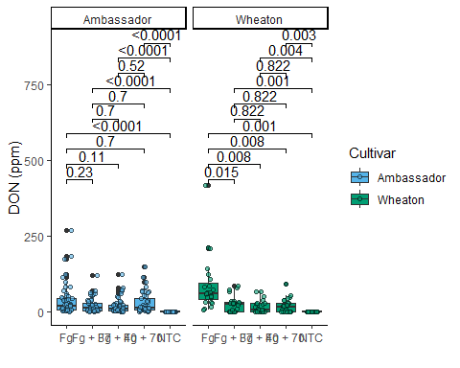

P2_stat <- P2 +   
 geom_pwc(aes(group = Treatment), method = "t_test", label = "p.adj.format")  
P2_stat

## Warning: Removed 10 rows containing non-finite outside the scale range  
## (`stat_boxplot()`).

## Warning: Removed 10 rows containing non-finite outside the scale range  
## (`stat_pwc()`).

## Warning: Removed 10 rows containing missing values or values outside the scale range  
## (`geom_point()`).

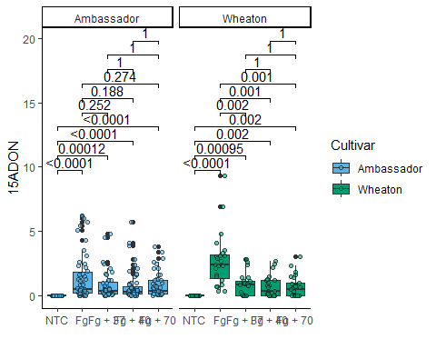

P3_stat <- P3 +   
 geom_pwc(aes(group = Treatment), method = "t_test", label = "p.adj.format")  
P3_stat

## Warning: Removed 2 rows containing non-finite outside the scale range  
## (`stat_boxplot()`).

## Warning: Removed 2 rows containing non-finite outside the scale range  
## (`stat_pwc()`).

## Warning: Removed 2 rows containing missing values or values outside the scale range  
## (`geom_point()`).

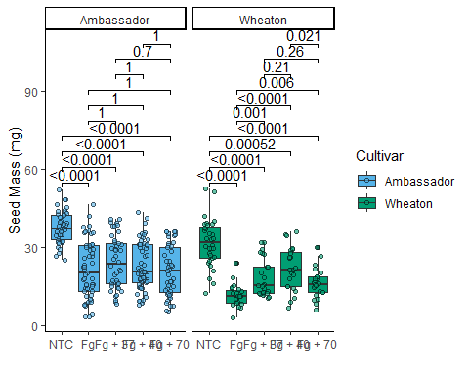

#combining  
Combined_plot_stat <- ggarrange(  
 P1_stat, ## add the plots onf interest subsequently  
 P2_stat,  
 P3_stat,  
 labels = "auto", # Automatically label the plots (A, B, C, etc.)  
 nrow = 1, # Arrange the plots in # rows  
 ncol = 3, # Arrange the plots in # column  
 common.legend = T  
)

## Warning: Removed 8 rows containing non-finite outside the scale range  
## (`stat_boxplot()`).

## Warning: Removed 8 rows containing non-finite outside the scale range  
## (`stat_pwc()`).

## Warning: Removed 8 rows containing missing values or values outside the scale range  
## (`geom_point()`).

## Warning: Removed 8 rows containing non-finite outside the scale range  
## (`stat_boxplot()`).

## Warning: Removed 8 rows containing non-finite outside the scale range  
## (`stat_pwc()`).

## Warning: Removed 8 rows containing missing values or values outside the scale range  
## (`geom_point()`).

## Warning: Removed 10 rows containing non-finite outside the scale range  
## (`stat_boxplot()`).

## Warning: Removed 10 rows containing non-finite outside the scale range  
## (`stat_pwc()`).

## Warning: Removed 10 rows containing missing values or values outside the scale range  
## (`geom_point()`).

## Warning: Removed 2 rows containing non-finite outside the scale range  
## (`stat_boxplot()`).

## Warning: Removed 2 rows containing non-finite outside the scale range  
## (`stat_pwc()`).

## Warning: Removed 2 rows containing missing values or values outside the scale range  
## (`geom_point()`).

# Q3.Knit your document together in the following formats:

pdf and .md file generated by knitting

# Q4. 2 pts. Push the .docx or .pdf and .md files to GitHub inside a directory called Coding Challenge 4.

bith files added to coding challenge 4 folder. [Link](https://github.com/ppg0001/PLPA_Assignment/tree/main/Coding_challenge_4)

# Q5. 6 pts. Now edit, commit, and push the README file for your repository and include the following elements.

A clickable link in your README to your GitHub flavored .md file [Readme.md Click me](https://github.com/ppg0001/PLPA_Assignment/blob/main/Coding_challenge_4/Coding_challenge_markdown.md)

A file tree of your GitHub repository.

├── Coding Pracitce Assignment2_Datavis1  
│ ├── Assignment_DataVis1.docx  
│ ├── Assingmner_DataVis2.pdf  
│ ├── Bull_richness.csv  
│ └── Coding_Assignment2_DataVis.R  
├── Coding Practice Assignment1_Intro  
│ ├── PLPA_assignment_R1.R  
│ └── TipsR.csv  
├── CodingChalleng3_AdvancedVis.R  
├── CodingChallenge2_IntroDataVis.R  
├── Coding_Challenge1_Assignment_.R  
├── Coding_challenge_4 #ASSIGNMENT4 Main FOLDER  
│ ├── Coding_challenge_markdown.md  
│ └── Coding_challenge_markdown.pdf  
├── Coding_challenge_markdown.html  
├── Coding_challenge_markdown.md  
├── Coding_challenge_markdown.pdf  
├── Coding_challenge_markdown.Rmd  
├── Coding_challenge_markdown_files  
│ └── figure-gfm  
│ ├── P1-1.png  
│ ├── P2-1.png  
│ └── P3-1.png  
├── Coding_practice_Rmarkdown.html  
├── Coding_practice_Rmarkdown.md  
├── Coding_practice_Rmarkdown.Rmd  
├── Coding_practice_Rmarkdown.tex  
├── Coding_practice_Rmarkdown_files  
│ └── figure-gfm  
│ └── include the figures-1.png  
├── Dummy_markdown_repo_edit_PG.Rmd  
├── MycotoxinData.csv  
├── PLPA_Assignment.Rproj  
├── README.html  
├── README.md  
└── shrek.jpg

# Q6. 1 pt. Please provide me a clickable link to your GitHub

[Git Hub Link](https://github.com/ppg0001/PLPA_Assignment/tree/main)