Supplementary

# Exhaustive Search for Significance

We can visualize many different combinations of plots, so I wrote a script to perform linear regression between two numerical variables with/without categories. The data columns are specified below:

Categories: Calibration Technique, Algorithm, Dataset, Testing Subject Characteristics, Study Characteristics, Sensor Data

Numerical Variables: Number of Test Subjects, Power, SBP Distribution STD, DBP Distribution STD, SBP Error STD, DBP Error STD, SBP ED, DBP ED

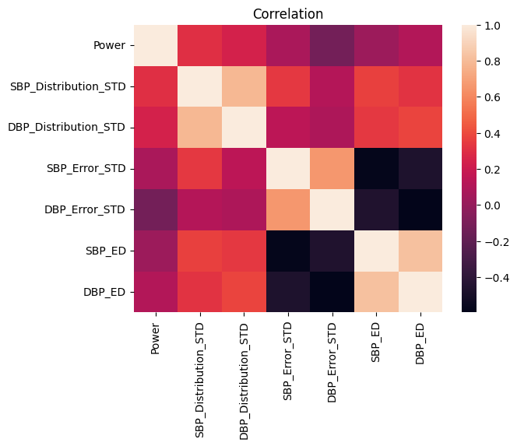

Fig. 1. Correlation between numerical columns

The p-values of the slopes were saved, so we can determine which plots are worthy of visualization. This data frame is saved in ‘regression_results.csv’ and ‘significant regression_results.csv’ (for all slopes with p-value < 0.05). In total, there are 18 significant regression results that had slopes with all p-values < 0.05. However, not all of the plots make sense, and some were already included in the main text. Example: SBP Distribution STD vs DBP Error. Furthermore, there was one plot that I originally included in the main text (SBP ED vs DBP ED). In this regression case, there was a significant relationship between SBP ED and DBP ED stratified by Testing Subject Characteristics (healthy, diseased, healthy+diseased). Although each category had a significant p-value, the differences in slopes were not significant as indicated by the confidence intervals.

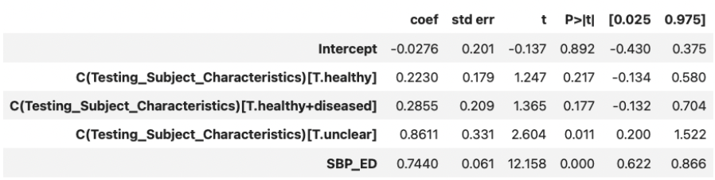

Fig. 2. Regression results for SBP_ED ~ DBP_ED + C(Testing_Subject_Characteristics)

# Supplementary Plots

Only plots made sense and had significant regression results.

**SBP/DBP Distribution STD vs Power:** Power can be considered as a surrogate for the number of testing subjects. These plots show that the more testing subjects, the larger the BP Distribution.

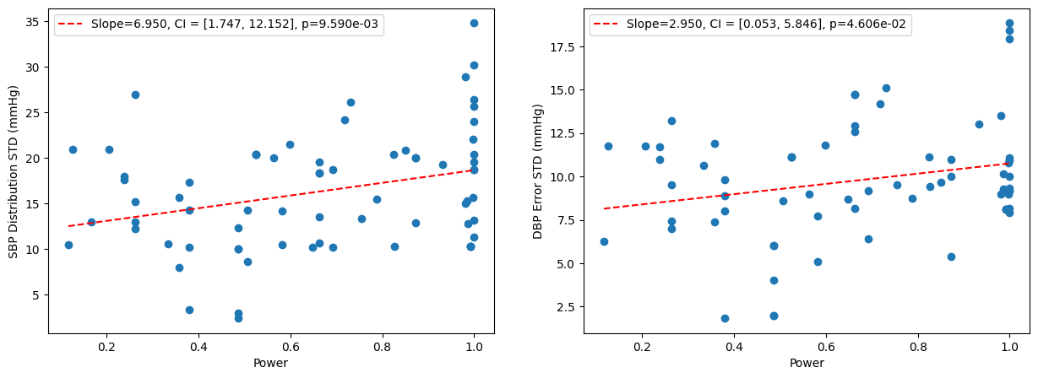

Fig. 3. SBP/DBP Distribution STD vs Power

**SBP Error STD vs DBP Error STD:** Indicates that SBP and DBP Error increase together. The magnitude of the slope may indicate that DBP error increases faster than SBP Error. But the slope is questionable due to outliers and confidence intervals for slope contains 1.

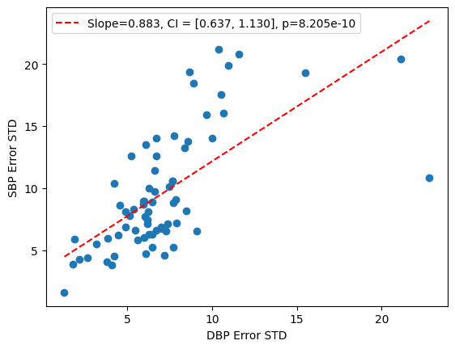

Fig. 4. SBP Error STD vs DBP Error STD

**Time between calibration and test vs SBP/DBP Distribution STD:** shows whether the change in BP distribution varies with time. Regression coefficients are not significant (p<0.05) possibly due to the lack of data but show “mostly” a positive relationship. How long is enough for sufficient ∆BP to meet the estimated minimum requirements in AAMI/ANSI/ISO is unknown because there is no data that records ∆BP larger than estimated from standards (17.36mmHg and 11.09mmHg for SBP and DBP).

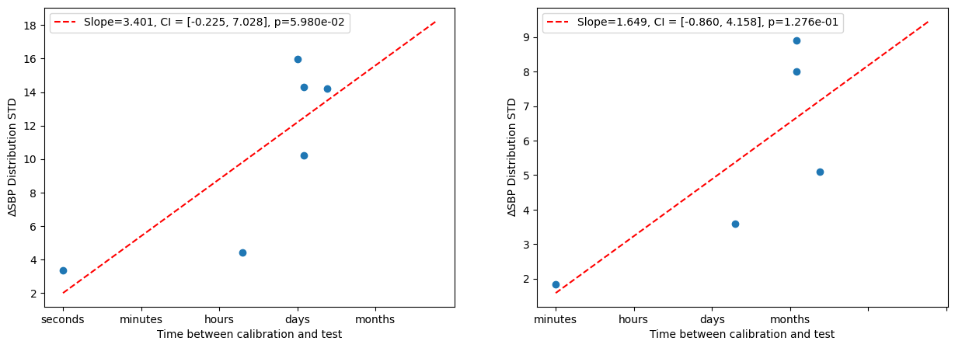

Fig. 5. Time between calibration and test vs SBP/DBP Distribution STD

# Other plots

Other plots are contained in the ‘other_plots’ folder. The regression statistics are in ‘regression_results.csv’.