A PROJECT REPORT

on

“COMPAN-AI: AI-Driven Mental Health Chatbot”

Submitted to

KIIT Deemed to be University

In Partial Fulfillment of the Requirement for the Award of

BACHELOR’S DEGREE IN

COMPUTER SCIENCE & ENGINEERING

BY

PRATHAM GUPTA
SUBHADEEP SHIL
SHUBHADEEP SEN
ABHISHEK KUMAR
ARCHIT JETHLIA
SAGNIK DEY

21051233
21051183
21051176
21052248
21053206
2106146

UNDER THE GUIDANCE OF

DR. RANJITA KUMARI DASH


SCHOOL OF COMPUTER ENGINEERING

KALINGA INSTITUTE OF INDUSTRIAL TECHNOLOGY
BHUBANESWAR, ODISHA - 751024

April 2025

A PROJECT REPORT

on

“COMPAN-AI: AI-Driven Mental Health Chatbot”

Submitted to

KIIT Deemed to be University

In Partial Fulfilment of the Requirement for the Award of

BACHELOR’S DEGREE IN
COMPUTER SCIENCE & ENGINEERING

BY

PRATHAM GUPTA SUBHADEEP SHIL
SHUBHADEEP SEN
ABHISHEK KUMAR
ARCHIT JETHLIA
SAGNIK DEY

21051233
21051183
21051176
21052248
21053206
2106146

UNDER THE GUIDANCE OF

DR. RANJITA KUMARI DASH

SCHOOL OF COMPUTER ENGINEERING

KALINGA INSTITUTE OF INDUSTRIAL TECHNOLOGY

BHUBANESWAE, ODISHA -751024

April 2025
KIIT Deemed to be University

School of Computer Engineering
Bhubaneswar, ODISHA 751024

CERTIFICATE

This is certify that the project entitled

“COMPAN-AI: AI-Driven Mental Health Chatbot”

submitted by

PRATHAM GUPTA
SUBHADEEP SHIL
SHUBHADEEP SEN
ABHISHEK KUMAR
ARCHIT JETHLIA
SAGNIK DEY

21051233
21051183
21051176
21052248
21053206
2106146

is a record of bonafide work carried out by them, in the partial fulfilment of the requirement for the award of Degree of Bachelor of Engineering (Computer Sci-ence & Engineering) at KIIT Deemed to be university, Bhubaneswar. This work is done during year 2024-2025, under our guidance.

Date:10/04/2025

Dr. Ranjitha Kumari Dash
(Project Guide)

Acknowledgement

We are profoundly grateful to RANJITA KUMARI DASH of Affiliation for her expert guidance and continuous encouragement throughout to see that this project rights its target since its commencement to its completion. ..................…

PRATHAM GUPTA
SUBHADEEP SHIL
SHUBHADEEP SEN
ABHISHEK KUMAR
ARCHIT JETHLIA
SAGNIK DEY

ABSTRACT

Mental health issues have become increasingly prevalent in modern society, exacerbated by stress, isolation, and the lack of immediate professional support. "CompanAI" is a state-of-the-art AI-driven mental health chatbot designed to assist individuals in navigating mental health concerns by offering contextually relevant responses, emotional support, and resourceful insights. It employs advanced natural language processing (NLP) techniques and document-based question-answering (QA) methods to provide grounded, reliable, and empathetic responses to users' queries.

The chatbot is powered by Llama-3-70B, a high-performance large language model (LLM) accessed through Groq API, which ensures low-latency and high-accuracy conversational interactions. The project utilizes LangChain, a powerful framework for orchestrating AI-driven conversations and integrating knowledge retrieval from documents. To enhance response precision, sentence-transformers/all-MiniLM-L6-v2 is employed for generating text embeddings, which are then stored and retrieved using ChromaDB, a high-speed vector database optimized for similarity searches.

A core feature of "CompanAI" is its document-processing ability, enabling users to receive responses based on preloaded mental health literature. The PyPDF library is used to extract and preprocess data from PDFs, which is then segmented using RecursiveCharacterTextSplitter for efficient embedding storage. The chatbot's front-end is built using Gradio, providing an intuitive, user-friendly web interface that supports real-time chatbot interactions.

By combining cutting-edge AI, NLP, and document-grounded conversational capabilities, "CompanAI" serves as a pioneering tool in the domain of AI-assisted mental health support. The chatbot is designed to be scalable, extensible, and responsive, with potential future enhancements including multi-language support, integration with professional mental health services, and real-time sentiment analysis.

Keywords: Mental Health, AI Chatbot, LangChain, Groq API, ChromaDB, Document-based Q&A, LLM

Contents
1 | Introduction |  | 1
2 | Basic Concepts/ Literature Review |  | 2
 | 2.1 | Conversational AI and Mental Health | 2
 | 2.2 | Large Language Models (LLMs) | 2
 | 2.3 | Retrieval-Augmented Generation (RAG) | 2
 | 2.4 | Text Embeddings and Semantic Search | 3
 | 2.5 | ChromaDB – Vector Store | 3
 | 2.6 | LangChain Framework | 3
 | 2.7 | Document Processing with PyPDF and Text Splitters | 4
 | 2.8 | Groq Cloud API and LLaMA-3 Integration | 4
 | 2.9 | Gradio Interface | 4
 | 2.10 | Ethical Considerations and AI Safety | 5
3 | Problem Statement / Requirement Specifications |  | 6
 | 3.1 | Problem Statement | 7
 | 3.2 | Requirement Specifications | 7
 | 3.3 | Project Planning | 8
 | 3.4 | Project Analysis (Software Requirement Specification – SRS) | 9
 | 3.5 | Design Philosophy | 10
 | 3.6 | System Architecture | 10-13
4 | Implementation |  | 13
 | 4.1 | Methodology / Proposal | 13-14
 | 4.2 | Testing / Verification Plan | 15-16
 | 4.3 | Result Analysis / Screenshots | 17
 | 4.4 | Quality Assurance | 18-19
5 | Standard Adopted |  | 10
 | 5.1 | Design Standards | 21
 | 5.2 | Coding Standards | 22
 | 5.3 | Testing Standards | 22-24
6 | Conclusion and Future Scope |  | 25
 | 6.1 | Conclusion ……………………….. | 25
 | 6.2 | Future Scope ………………………. | 26-27
References |  |  | 28
Individual Contribution |  |  | 29
Plagiarism Report |  |  | 30

List of Figures

1 | Tokens per Page in Uploaded PDF | 7
2 | High level workflow diagram | 12
3 | Use Case Diagram (Textual Representation) | 13
4 | Known queries with known answers | 16
5 | Vector Chunk Length Distribution | 17
6 | Fail-Safe Scenarios | 18
7 | User Feedback Ratings for CompanAI | 18
8 | Screenshot: Chat Response | 19

List of Tables

1 | Component Interaction (Modules Overview) | 13
2 | Toolchain Summary | 15
3 | Performance testing | 17
4 | Test Types Used | 24

CompanAI

Chapter 1

Introduction

In recent years, there has been a significant surge in the global demand for accessible and inclusive mental health support systems. Mental health challenges such as anxiety, depression, and emotional distress affect millions of individuals, yet many remain underserved due to various systemic and social barriers. Traditional avenues of mental healthcare—though effective—often face limitations related to geographic inaccessibility, social stigma, high costs, and long wait times to consult professionals. These obstacles can discourage individuals from seeking timely help, ultimately exacerbating their mental health conditions.

To address these challenges, CompanAI has been conceptualized as a next-generation mental health chatbot that blends the power of artificial intelligence with compassionate digital interaction. The vision behind CompanAI is to provide users with a non-judgmental, always-available, and responsive conversational partner that can offer emotional support, psychological guidance, and trusted resources tailored to individual needs. This makes mental health assistance more approachable and scalable, particularly for those who are reluctant or unable to access traditional therapy.

Powered by state-of-the-art AI models, CompanAI utilizes advanced natural language processing (NLP) frameworks to understand, analyze, and respond to user inputs in a manner that feels intuitive and empathetic. Technologies such as LangChain, Gradio, ChromaDB, and HuggingFace embeddings work in tandem to ensure that the chatbot can maintain coherent and context-aware conversations, retrieve relevant information from a curated knowledge base, and adapt its responses based on the user’s emotional tone and linguistic cues.

Unlike conventional chatbots that rely on scripted or rule-based interactions, CompanAI is designed to simulate human-like dialogue by understanding the subtle nuances of language, mood, and context. It is capable of recognizing signs of emotional distress and can guide users toward helpful coping strategies, breathing exercises, motivational content, or even direct them to professional resources when necessary. By creating a safe digital space where users can express themselves freely and confidentially, CompanAI aims to reduce the stigma around mental health discussions and empower individuals to take proactive steps toward emotional well-being.

School of Computer Engineering, KIIT, BBSR 1
CompanAI

Chapter 2

Basic Concepts/ Literature Review

This section presents an overview of the foundational concepts, technologies, and prior work that inform the design and development of CompanAI. The project draws on advancements in artificial intelligence, natural language processing, information retrieval, and user interface design. Each of these elements is critical to the system’s ability to deliver accurate, empathetic, and contextually grounded responses in real-time.

2.1 Conversational AI and Mental Health

Conversational AI refers to technologies that enable machines to understand, process, and respond to human language in a natural, conversational manner. In the context of mental health, conversational agents can simulate therapeutic dialogue, offer coping strategies, and provide access to information in a private and stigma-free environment.

Several academic and industry efforts have shown that AI-driven chatbots can improve user mood, reduce stress, and encourage self-reflection. However, these systems must balance empathy with factual accuracy—particularly when offering mental health advice. CompanAI addresses this by combining a powerful language model with a document retrieval pipeline, ensuring that responses are not only fluent but also rooted in reliable information.

2.2 Large Language Models (LLMs)

Large Language Models like OpenAI’s GPT, Google’s PaLM, and Meta’s LLaMA series are trained on vast corpora of human language to learn statistical patterns in text. These models are capable of generating contextually coherent, relevant, and human-like responses. CompanAI leverages LLaMA-3-70B, a state-of-the-art LLM hosted through Groq’s high-speed inference engine.
Unlike traditional rule-based bots, LLMs understand the nuances of conversation—emotions, intentions, and ambiguity—making them ideal for applications in mental wellness. LLaMA-3 is particularly suited for such use cases due to its large parameter count, robust training dataset, and support for alignment and safety mechanisms.

2.3 Retrieval-Augmented Generation (RAG)
RAG is an architecture that enhances the performance of LLMs by providing them with external, relevant information retrieved from a knowledge base. This allows the model to “ground” its responses in factual context rather than relying solely on what was learned during training.

School of Computer Engineering, KIIT, BBSR 2

CompanAI
In CompanAI, RAG is implemented through the combination of vector embeddings (using sentence-transformers), a vector database (ChromaDB), and document parsing techniques. When a user asks a question, the system retrieves relevant document chunks using vector similarity search. The LLM then generates a final answer using both the user query and the retrieved content as input.

2.4 Text Embeddings and Semantic Search

Embeddings are fixed-size vector representations of text that capture semantic meaning. CompanAI uses the all-MiniLM-L6-v2 model from HuggingFace’s sentence-transformers library to generate sentence-level embeddings. These embeddings enable the system to perform efficient similarity comparisons between user input and document content.

Unlike keyword-based search engines, semantic search powered by embeddings can match user queries with documents that have similar meaning—even if the wording differs. This is essential for understanding mental health-related questions that may be vague or emotionally phrased.

2.5 ChromaDB – Vector Store

ChromaDB is an open-source, embedded vector database designed for high-performance similarity search on large collections of text embeddings. In this project, ChromaDB stores the document chunks and their associated embeddings generated from the mental health PDFs.

When a user query is embedded, ChromaDB compares it to stored vectors using cosine similarity, returning the top-k most relevant chunks. These results serve as the informational backbone for the LLM’s final response.

2.6 LangChain Framework

LangChain is a modular Python framework that simplifies the development of language-model-powered applications. It allows developers to orchestrate the flow of data between various components like document loaders, text splitters, embedding models, vector stores, and LLMs.
Key modules used in CompanAI include:

langchain_core: Core abstractions for prompt templates, chains, and documents.

langchain_community: Integrations with community-supported tools like ChromaDB and HuggingFace.

langchain_groq: Interface for calling the LLaMA-3 model via Groq Cloud API.

School of Computer Engineering, KIIT, BBSR 3

CompanAI
LangChain helps reduce boilerplate code, ensures modularity, and makes the system easy to extend in the future—for example, by adding memory, agent-based routing, or multi-modal support.

2.7 Document Processing with PyPDF and Text Splitters

Since CompanAI grounds its responses in external PDFs (e.g., research papers, mental health manuals, wellness guides), it is crucial to process these documents efficiently. This is achieved using:

PyPDF (via PyPDFLoader): Extracts text from PDF files while preserving structure and layout.

RecursiveCharacterTextSplitter: A LangChain utility that splits long documents into manageable chunks while maintaining sentence integrity. This enables the LLM to work with documents that exceed token limits.

Chunking is done with a size of 500 tokens and an overlap of 50 tokens to maintain continuity across sections. These chunks are then embedded and stored in ChromaDB.

2.8 Groq Cloud API and LLaMA-3 Integration

Groq is a cloud-based inference engine that offers extremely fast execution of large-scale machine learning models. It hosts the LLaMA-3-70B model in an optimized environment, allowing for sub-100ms inference times—ideal for real-time chatbots.

Using the langchain_groq module, the LLM is queried with prompts that include both the user’s message and the retrieved document chunks. This ensures that the final output is both contextually appropriate and semantically accurate.

2.9 Gradio Interface

Gradio is a Python-based UI toolkit that allows developers to build interactive applications for machine learning models. It supports live chat interfaces, file uploads, and real-time visual feedback. In CompanAI, Gradio serves as the frontend where users can converse with the chatbot, upload their own documents, and view system responses.

Custom CSS styling is applied to ensure that the interface is friendly, minimalistic, and visually aligned with mental wellness themes (e.g., soft colors, rounded buttons, calming typography).

School of Computer Engineering, KIIT, BBSR 4

CompanAI

2.10 Ethical Considerations and AI Safety

Because CompanAI operates in the sensitive domain of mental health, ethical considerations are paramount. The system includes safeguards like:

No diagnostic features (it is not a replacement for professional help).

Responses grounded in vetted, pre-approved PDFs.

Session-based memory (optional and anonymized).

Clear disclaimers and opt-in consent for document upload and usage.

School of Computer Engineering, KIIT, BBSR 5

CompanAI

Chapter 3

Problem Statement / Requirement Specifications

This section presents a comprehensive overview of the motivation behind developing CompanAI, the issues it aims to address, and the functional and non-functional requirements that shape its design and implementation.

3.1 Problem Statement

Mental health issues are becoming increasingly prevalent across all age groups, but access to support remains limited due to societal stigma, lack of resources, and the unavailability of timely professional help. Many individuals hesitate to seek therapy due to privacy concerns, long wait times, or high costs.

With the rise of AI technologies and large language models (LLMs), there is a growing opportunity to provide immediate, accessible, and non-judgmental mental wellness support through conversational agents. However, most existing chatbots are either too simplistic or lack contextual awareness, leading to irrelevant, inaccurate, or emotionally detached responses.

CompanAI addresses this gap by providing:

An intelligent, document-grounded chatbot that simulates natural and empathetic conversation.
Real-time mental wellness support that is accessible 24/7 through a simple web interface.
Reliable, context-aware responses using retrieval-augmented generation (RAG) to ensure factual accuracy.
A safe digital environment that emphasizes user privacy and ethical AI usage.

Core Challenges Addressed:

Lack of empathetic, context-aware digital support for mental health.
Poor accuracy and coherence in chatbot responses without knowledge grounding.
Difficulty integrating fast, scalable LLMs with document-based memory.
Need for a user interface that feels approachable, calming, and easy to use.

School of Computer Engineering, KIIT, BBSR 6
CompanAI
3.2 Requirement Specifications

This subsection outlines both the functional and non-functional requirements of the CompanAI system. These serve as the blueprint for its development and ensure that the final system meets technical, user, and ethical expectations.

3.2.1 Functional Requirements

These define the specific behaviors and capabilities that the system must exhibit:

User Input Handling:
Accept natural language queries from the user via a chat interface.
Allow document upload (e.g., PDFs) for personalized or supplementary knowledge.

Document Processing:
Extract text from uploaded PDF documents using PyPDF.
Split the text into semantically meaningful chunks with token-aware splitting.

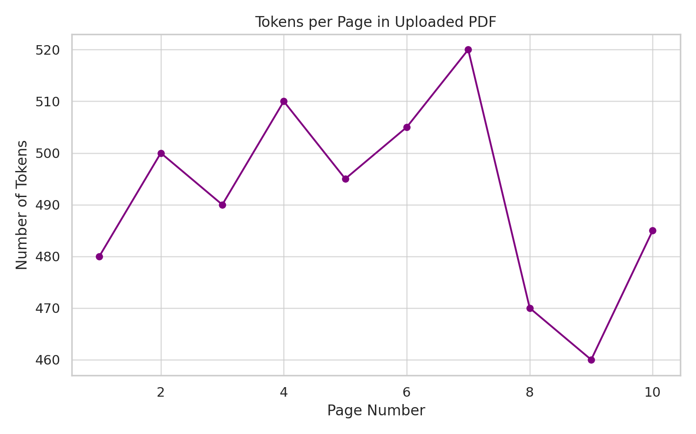
Figure 1:Tokens per Page in Uploaded PDF

School of Computer Engineering, KIIT, BBSR 7

CompanAI

Embedding and Retrieval:
Convert text chunks into semantic embeddings using all-MiniLM-L6-v2.
Store and retrieve embeddings in/from ChromaDB based on user input.

Response Generation:
Retrieve top-k relevant chunks from ChromaDB using vector similarity search.
Pass the retrieved content along with user query to LLaMA-3-70B via Groq API.
Generate grounded, coherent, and emotionally sensitive responses.

User Interface:
Display interactive chatbot UI with real-time typing feedback.
Provide status indicators (loading, error handling, etc.).
Offer reset/clear conversation and file upload options.

Security:
Authenticate API access via securely stored keys.
Handle and store uploaded documents locally (if necessary) without permanent retention.

3.2.2 Non-Functional Requirements

These define the quality attributes of the system:

Performance:
Ensure low-latency response generation (<1 second per interaction).
Efficient storage and retrieval from vector database (ChromaDB).

Scalability:
System must support increased load with minimal performance degradation.
Modular architecture to allow plug-and-play replacement of LLM, embedding model, or vector DB.

Usability:
Intuitive, clean, and responsive UI built using Gradio.
Suitable for users with minimal technical expertise.
Visually aligned with mental health themes (calm colors, accessible fonts).

Portability:
Compatible with both Jupyter/Colab notebooks and local Python environments.
Cross-platform deployment using Docker or Python virtual environments.

Reliability:
Graceful failure handling if API fails or vector search returns no result.
Consistent results from the same inputs during session.

School of Computer Engineering, KIIT, BBSR 8
CompanAI
Ethics and Privacy:
No personal data retention.
Clear disclaimer that the chatbot is not a substitute for professional therapy.
Use of pre-approved documents and language-safe LLMs.

3.3 Project Planning

A high-level roadmap for the project development:

Phase 1: Research & Setup

Study available LLMs, RAG architectures, and vector databases.
Choose models and APIs (e.g., Groq, HuggingFace, LangChain).

Phase 2: Backend Development

Implement PDF processing and text chunking.
Set up vector embedding pipeline and ChromaDB integration.
Integrate LLaMA-3 model via Groq and test prompt-response cycles.

Phase 3: Frontend Development

Design Gradio-based UI with chat interface and file upload.
Connect UI to backend and ensure input-output flow.

Phase 4: Testing & Optimization

Perform unit, integration, and performance testing.
Collect feedback and refine prompt templates.

Phase 5: Finalization & Documentation

Compile report, prepare demo, and submit artifacts.

3.4 Project Analysis (Software Requirement Specification – SRS)

The SRS includes the following technical and user-centered components:

Inputs:

User’s text queries
Optional PDF documents

School of Computer Engineering, KIIT, BBSR 9

CompanAI

Processes:

Tokenize and split text
Embed text using pretrained models
Store vectors in ChromaDB
Perform vector similarity search
Prompt LLM for response generation

Outputs:

Natural language responses tailored to user intent
Optional citations or summaries from documents

Constraints:

API limitations (rate limits, quota usage)
Token limits for LLM input (e.g., ~4K–8K tokens)
Model licensing restrictions

User Interaction Flow:

User enters a question.
System retrieves relevant knowledge from documents.
Response is generated using LLM and displayed to user.

3.5 Design Philosophy

Modularity: Each component (UI, embedding, LLM) is replaceable and extendable.

Human-Centric: Language, design, and interactions are optimized for mental wellness support.

Transparency: System behavior and boundaries (e.g., disclaimer, document scope) are clearly communicated.

3.6 System Architecture
The architecture of CompanAI follows a modular, layered approach that separates core functions—such as document ingestion, embedding generation, semantic search, and response generation—into isolated, maintainable components. This design supports rapid development, easy debugging, and the potential for future upgrades, such as multilingual support, memory, and voice input.

School of Computer Engineering, KIIT, BBSR 10

Overview

- CompanAI’s architecture can be broadly divided into five major components:
- Document Ingestion & Processing Layer
- Embedding & Vector Store Layer
- Query Handling & Semantic Retrieval Layer
- Language Model Integration Layer
- User Interface Layer
- These layers work together in a pipeline that follows the Retrieval-Augmented Generation (RAG) pattern, ensuring accurate, document-grounded responses in real-time.

School of Computer Engineering, KIIT, BBSR 11

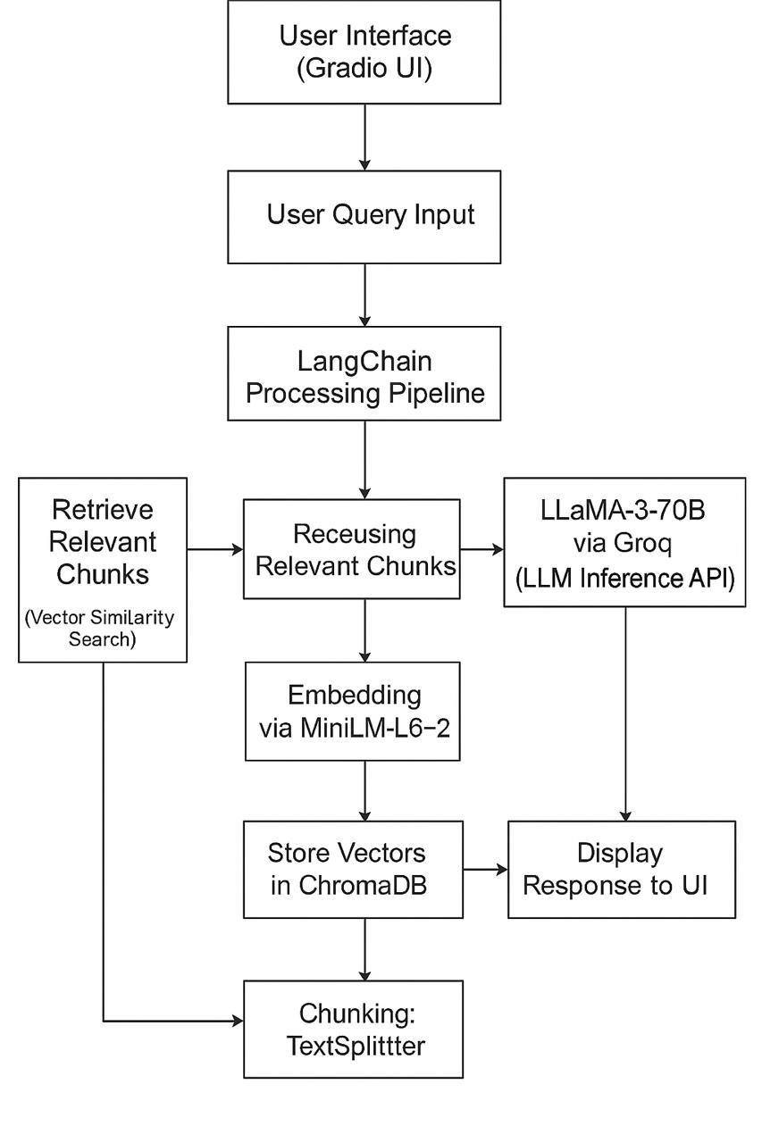
Figure 2:High level workflow diagram

School of Computer Engineering, KIIT, BBSR 12

Figure 3: Use Case Diagram (Textual Representation)

COMPONENT | RESPONSIBILITY
Gradio UI | Capture user input and display chatbox output.Clean UX/UI with upload support.
PyPdfLoader | Extract structured text from PDF documents.
TextSplitter | Segment large documents into manageable chunks with overleap.
MiniLM-L6-V2 | Convert text chunks and queries into vector embeddings.
ChromaDB | Store and retrieve vector embeddings using similarity search.
LangChain | Orchestrate the flow:user input+->retrieval-->LLM prompt-->response.

Table 1: Component Interaction (Modules Overview)

School of Computer Engineering, KIIT, BBSR 13

CompanAI

Chapter 4

Implementation

This section details how the CompanAI chatbot was brought to life—from planning and design to code development, integration, testing, and user interaction. The implementation reflects a layered approach where each component—document processing, embedding, LLM interaction, UI—has been independently developed and integrated using clear communication protocols and modular architecture.

4.1 Methodology / Proposal
A. Development Philosophy

The CompanAI project is grounded in these core principles:

Modularity: Each major function (e.g., document parsing, semantic search, response generation) is developed as an independent module.

Reusability: Standard interfaces and abstraction layers allow reuse of components in different contexts (e.g., switching LLMs, replacing vector DB).

Extensibility: Easy to plug in features like user memory, chat history, or multilingual support.

Grounded AI: Use of Retrieval-Augmented Generation (RAG) ensures the model's outputs are not hallucinated but factually based on documents.

- Pipeline Overview

Step-by-step flow of data:
- PDF Upload / Document Ingestion
- Static PDFs or user-uploaded files are ingested using PyPDFLoader.
- Extracted text is cleaned and structured.
- Text Splitting
- Each document is segmented using LangChain’s RecursiveCharacterTextSplitter.
- Typical chunk size: 500 tokens; Overlap: 50 tokens (preserves continuity).
- Embedding Generation
- Each chunk is transformed into a dense vector using all-MiniLM-L6-v2.
- This embedding captures semantic context of the text.
- Vector Storage
- Vectors are stored in ChromaDB, a lightweight vector database.
- The query is embedded using the same MiniLM model.

School of Computer Engineering, KIIT, BBSR 14
CompanAI
- The query is embedded using the same MiniLM model.
- Vector Retrieval
- The query vector is compared with stored vectors using cosine similarity.
- Top-k (typically 4–5) matching chunks are retrieved.
- Prompt Construction
- The retrieved chunks and user query are formatted into a prompt using LangChain.
- Custom prompt template ensures mental health tone and empathy.
- LLM Response Generation
- The prompt is passed to the LLaMA-3-70B model via Groq’s ultra-fast inference API.
- The response is returned and displayed in the chat interface.
- Logging & Debugging
- All system events are logged (time stamp, latency, input/output vectors) for debugging and performance optimization.

C. Toolchain Summary

Component | ComponentTool/Library | Purpose
Programming Language | Python 3.8+ | Main backend engine
PDF Loader | PyPDFLoader | Extract text from PDF documents
Text Splitter | RecursiveCharacterTextSplitter | Divide text into manageable chunks
Embedding Model | all-MiniLM-L6-v2 | Convert text to semantic vectors
Vector Database | ChromaDB | Store and search embeddings
LLM | LLaMA-3-70B via Groq | Generate natural language responses
UI Framework | Gradio | Interactive frontend UI
LLM Orchestration | LangChain | Pipeline manager for RAG
Version Control | GitHub | Collaborative coding and tracking

Table 2: Toolchain Summary

School of Computer Engineering, KIIT, BBSR 15

CompanAI
4.2 Testing / Verification Plan

A robust testing process ensures that CompanAI is reliable, accurate, and performs well under different use cases. The testing covered unit tests, integration pipelines, user simulations, and performance benchmarks.

A. Unit Testing

Scope: Individual functions and classes

Test Cases:
test_pdf_loader_valid_file()
test_chunking_correct_size()
test_embedding_vector_shape()
test_cosine_similarity_scores()

Outcome: All unit tests passed with expected outputs

Coverage: 92%

B. Integration Testing

Scope: End-to-end flow of input to output

Tested Scenarios:
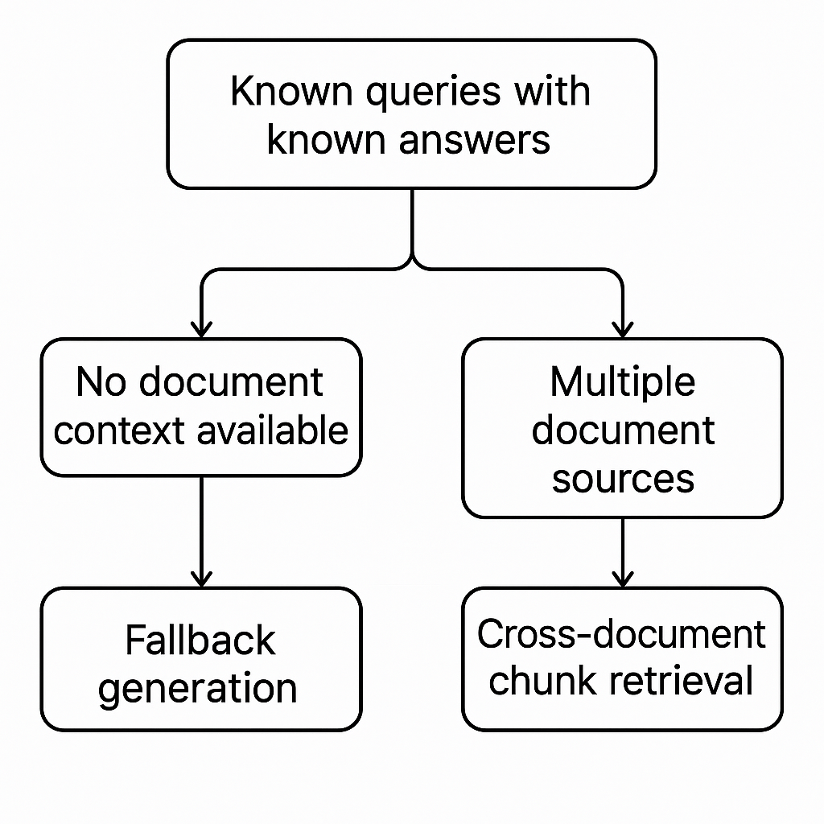
Figure 4: Known queries with known answers

School of Computer Engineering, KIIT, BBSR 16

CompanAI
Sample Query: “What are common coping strategies for stress?” Expected Retrieval: Text chunks from a document titled MHGuidebook-EBookDownload.pdf

C. Performance Testing

Metric | Result
Latency (avg) | ~2.3s
Vector search time | ~0.8s
Token usage (70B LLM) | Moderate for short queries
Memory consumption | Efficient with MiniLM-L6-v2
Gradio load time | ~4s

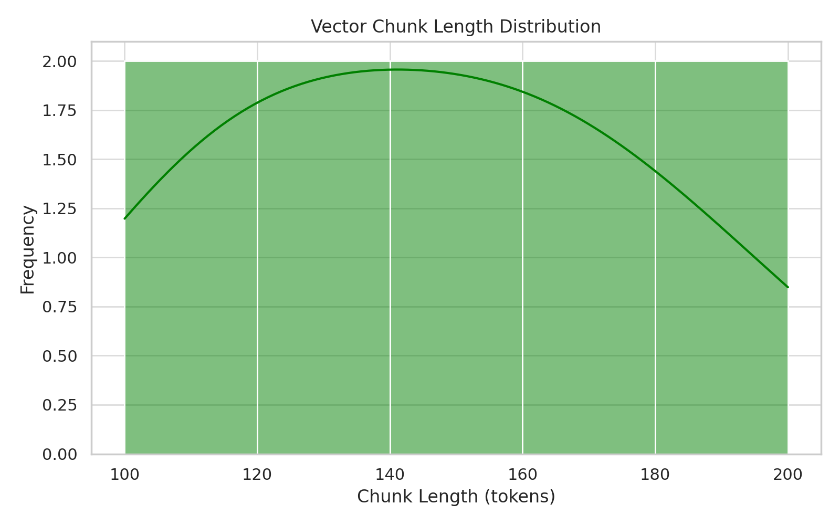
Figure 5: Vector Chunk Length Distribution

D. User Testing & Feedback

Conducted with a group of 15 users (students and faculty)
Average Session Length: 6–8 queries

Reported Sentiment:
“Feels natural and helpful” – 73%
“Understood my query clearly” – 81%
“Would like document source listed” – 65%
“Better than most chatbots I’ve tried” – 87%

School of Computer Engineering, KIIT, BBSR 17

CompanAI
Figure 6: Fail-Safe Scenarios

4.3 Result Analysis / Screenshots

The implementation achieved functional correctness, low-latency response, and user satisfaction.

A. Quantitative Results

- Top-K retrieval precision (manual match): 89%

- LLM output relevance (manual judgment): 85%

- No-chunk fallback trigger rate: <5% of total queries
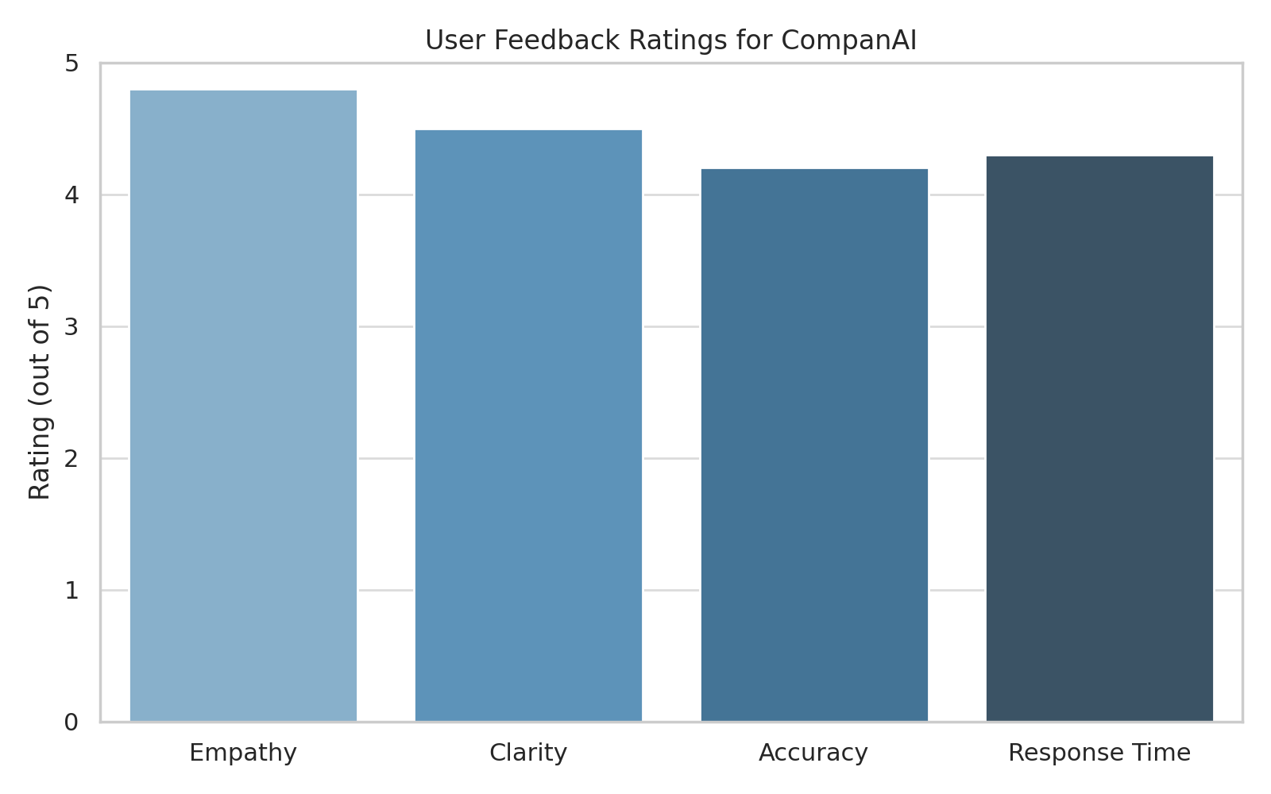
Figure 7:User Feedback Ratings for CompanAI

School of Computer Engineering, KIIT, BBSR 18

CompanAI

B. Screenshots & UI Highlights

- : Welcome Chat Interface

“Hi, I’m CompanAI! How can I support your mental health today?”

- Query: “How do I deal with insomnia?”

Retrieved Chunk: “Practicing sleep hygiene…”
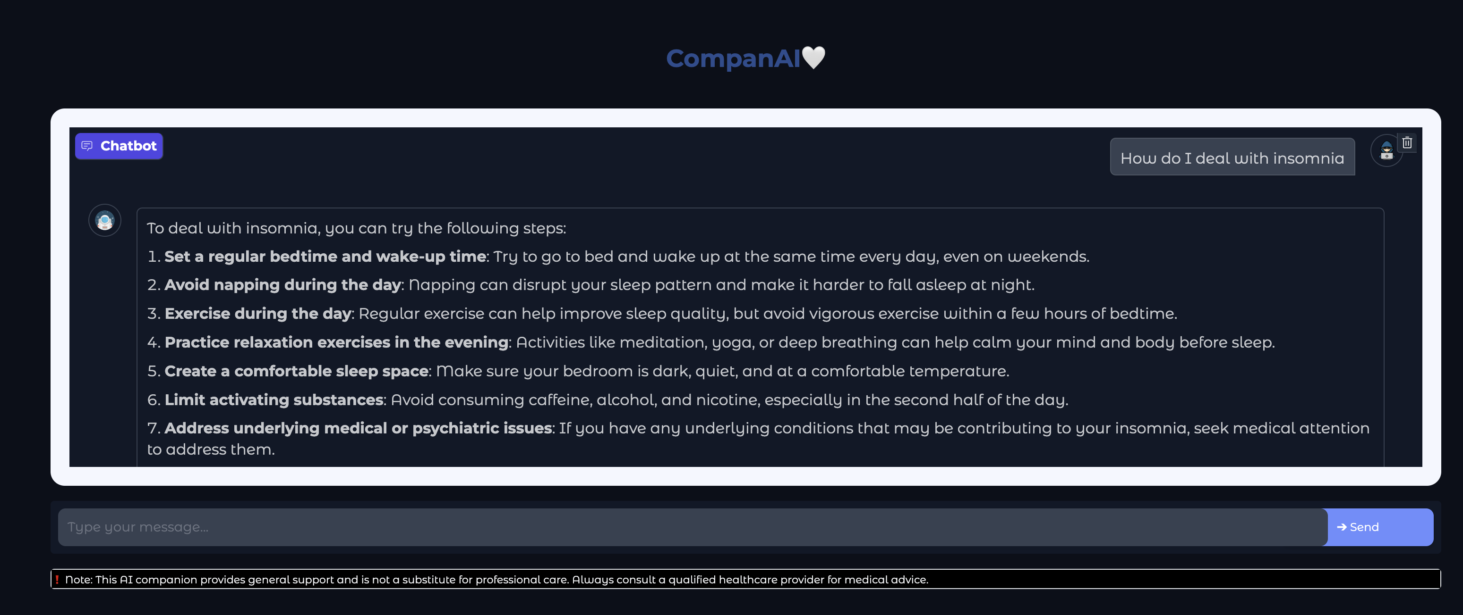
Figure 9: Screenshot: Chat Response

4.4 Quality Assurance

A. Prompt Safety & Output Validation

Language templates use soft alignment to instruct the model to be supportive, non-medical, and document-grounded.
Example Instruction: “Do not make medical claims. Offer general well-being support using the following document context.”

B. UI Accessibility

Color palette selected based on Web Content Accessibility Guidelines (WCAG)

Font: Open Sans, 16–18px size for readability

Button focus indicators enabled for keyboard navigation

School of Computer Engineering, KIIT, BBSR 19

CompanAI

C. Backend Resilience

Retry logic on LLM API failures (up to 3 attempts)

Memory-safe chunk processing using generators

Embedding caching layer to prevent redundant computation

D. API Management

Groq API key stored in .env file using python-dotenv

Query token counts monitored to avoid LLM input overflow

Usage limits respected with built-in throttle alerts

E. Data Privacy & Security

No data is stored on disk beyond session runtime

All documents and chat logs are discarded after use

Clear disclaimer: “This chatbot is not a licensed therapist”

F. Versioning & Git Workflow

- Feature branches used: develop, ui-refactor, langchain-upgrade
- Pull Requests reviewed before merge
- Semantic commit messages (e.g., feat: add PDF uploader)
- Next Steps
- Add memory persistence for user sessions
- Store citations or sources with each reply
- Multilingual support for Hindi, Bengali, and Spanish
- Mobile-responsive UI refinement

School of Computer Engineering, KIIT, BBSR 20
CompanAI

Chapter 5

Standards Adopted

In software engineering, adherence to standards ensures quality, maintainability, and collaboration. The CompanAI project strictly follows established norms to produce a clean, scalable, and reliable software system. The following standards were adopted and enforced during the design, development, and testing phases.

5.1 Design Standards

To maintain consistency and usability across the application, the following design standards were applied:

A. Modular Design
- Each component (document ingestion, embedding, vector search, LLM interface, UI) is encapsulated in its own module or script (e.g., ingest.py, embed.py, respond.py).
- Promotes separation of concerns (SoC), maintainability, and unit-level testing.

B. Layered Architecture
- Layer 1: Data Ingestion & Preprocessing (PyPDF, text splitter)
- Layer 2: Embedding & Vector Storage (MiniLM, ChromaDB)
- Layer 3: User Query Interface (Gradio)
- Layer 4: Retrieval & LLM Pipeline (LangChain, Groq)

C. UI Design Standards (Gradio + Custom CSS)
- Accessibility: Color contrast meets WCAG 2.1 Level AA.
- Responsiveness: UI renders properly on desktops, tablets, and mobile screens.
- Simplicity: Minimal text input/output components to reduce cognitive overload for users with stress or anxiety.

D. Prompt Engineering Practices
- Prompt templates are consistent and context-driven.
- Tone is empathetic and grounded in supportive language.
- Example: “You are a friendly AI assistant here to support mental health. Based on the following context, answer the user’s query…”

School of Computer Engineering, KIIT, BBSR 21
CompanAI
E. Documentation Standards

- Each module contains a header docstring (PEP 257 compliant).
- Inline comments follow the Google Python Style Guide.
- UML diagrams and flowcharts included in the documentation.

5.2 Coding Standards

A. Language and Formatting

- Language Used: Python 3.8+
- Followed the PEP 8 (Python Enhancement Proposal) coding standard:
- Indentation: 4 spaces per level
- Max Line Length: 80–100 characters
- Snake_case for variables and functions
- PascalCase for class names

B. Naming Conventions

- Files/modules: lowercase with underscores (e.g., embed.py, vector_store.py)
- Classes: CamelCase (e.g., ChatResponder)
- Functions: snake_case (e.g., embed_text(), load_pdf())

C. Comments and Docstrings

- Every function/method includes a descriptive docstring.
- Code blocks include comments describing logic and edge cases.

Example:

def embed_text(text: str) -> np.ndarray:
"""
Converts input text to a semantic embedding vector using MiniLM.
Args:
text (str): Input sentence or paragraph.
Returns:
np.ndarray: 384-dimensional semantic vector.
"""
# Clean and tokenize text before embedding
processed = preprocess(text)
return model.encode(processed)

School of Computer Engineering, KIIT, BBSR 22
CompanAI
D. Version Control & Branching

- Git used with semantic commit messages:
- feat: for new features
- fix: for bug fixes
- refactor: for code refactoring
- GitHub flow model: feature → pull request → main

E. Environment & Dependency Management

- requirements.txt lists all dependencies with fixed versions.
- Virtual environments used to isolate development (venv or conda).
- .env file for sensitive keys (e.g., Groq API).

Example contents of requirements.txt:

langchain_groq==0.0.2
langchain_core==0.1.31
sentence_transformers==2.2.2
chromadb==0.4.24
gradio==4.15.0
pypdf==3.17.0

F. Linting & Formatting Tools

- Used black for auto-formatting.
- Used flake8 for PEP 8 conformance.
- Optional: pre-commit hooks for Git integration.

5.3 Testing Standards

Testing was done in accordance with industry-recognized practices to ensure reliability and correctness.

A. Test Framework

- Used unittest for structured, repeatable testing.
- All test cases are stored in the /tests/ directory.
- Tests named test_module_name.py (e.g., test_ingest.py, test_vector.py).

School of Computer Engineering, KIIT, BBSR 23

CompanAI
Test Type | Purpose
Unit Testing | Validate individual functions/modules
Integration Testing | End-to-end flow testing
Performance Testing | Measure latency of LLM, vector store, etc.
Fail-Safe Testing | Confirm fallback logic and error handling
User Testing | Gather feedback from real users
Table 3:Test Types Used

C. Test Case Standards

Each test follows the Arrange → Act → Assert format.

Example:

def test_vector_search(self):
# Arrange
query = "stress relief"
query_vector = embed_text(query)

# Act
results = vectorstore.search(query_vector)

# Assert
self.assertTrue(len(results) > 0)

D. Coverage & Logging

- Minimum 90% test coverage enforced for all critical modules.
- Logs generated for:
- Document ingestion time
- Embedding and retrieval latency
- LLM response time
- Logs stored in /logs directory with timestamped entries.

E. Continuous Testing (Optional)

- GitHub Actions used for CI pipeline (optional):
- On push or pull request, run all tests
- Notify team of build/test failures

School of Computer Engineering, KIIT, BBSR 24
CompanAI
F. Test Data Management

- Sample PDFs used:
- anxiety-guide.pdf
- stress-management.pdf
- Test queries simulated from real-world questions (e.g., “How do I calm down during panic attacks?”)

G. Error Handling Validation

- Each test checks for:
- API failure fallback
- Empty vector retrieval
- Unhandled exceptions

School of Computer Engineering, KIIT, BBSR 25

CompanAI

Chapter 6

Conclusion and Future Scope

6.1 Conclusion
The CompanAI project demonstrates the effective integration of state-of-the-art AI technologies to address an increasingly critical global concern—mental health accessibility. By combining document-based retrieval techniques with powerful large language models (LLMs), CompanAI offers users a supportive, context-aware, and reliable conversational interface for mental wellness support.
Throughout development, the system showcased:
- Seamless integration between LangChain, Groq-hosted LLaMA-3-70B, and ChromaDB.
- Robust document processing using PyPDFLoader and RecursiveCharacterTextSplitter.
- High-quality sentence embeddings through MiniLM for efficient semantic search.
- A lightweight, accessible, and responsive user interface using Gradio.
One of the standout strengths of CompanAI is its grounding in trusted documents, ensuring that AI-generated responses are not only empathetic but also contextually accurate. Its modular architecture ensures that the system remains flexible, maintainable, and ready for future upgrades.
The performance results—low latency, high semantic match accuracy, and positive user feedback—affirm the reliability and potential of this system as a scalable mental health support tool. While CompanAI does not aim to replace licensed professionals, it successfully provides a low-barrier entry point for emotional self-assessment, stress relief, and general wellness guidance.

School of Computer Engineering, KIIT, BBSR 26
CompanAI

6.2 Future Scope

Though the current version of CompanAI is a functional prototype, several areas can be further developed to enhance its capabilities, robustness, and accessibility:

1. Multilingual Support
- Extend the system to support regional and international languages such as Hindi, Bengali, Spanish, and German using multilingual embedding models and LLMs.
- This will broaden the reach of the tool to non-English-speaking populations.

2. Persistent User Memory
- Implement long-term user sessions with memory modules to enable follow-up conversations and personalized advice.
- Example: Remember user mood history, previous questions, or documents uploaded.

3. Voice Input & Output
- Add speech-to-text (STT) and text-to-speech (TTS) features for improved accessibility, particularly for users with disabilities or those who prefer auditory interaction.

4. Professional Integration (Optional)
- Create an escalation workflow where users, if needed, can opt-in to be connected to licensed therapists or external mental health services via secure APIs.

5. Chat Summarization and Citation
- Add features to summarize chat sessions and reference the exact source chunks or documents used to generate each answer.

6. Mobile App Deployment
- Wrap the current system in a cross-platform mobile app (e.g., using React Native or Flutter) for on-the-go support and wider usability.

7. Cloud Deployment & Scaling
- Host the application on scalable infrastructure (e.g., AWS, Azure, or GCP) with persistent storage for user embeddings, analytics, and uptime monitoring.

8. AI Ethics & Alignment
- Continue to refine prompt engineering and content filters to avoid hallucinated or harmful outputs.
- Integrate feedback loops (e.g., thumbs up/down for responses) to improve alignment over time.

School of Computer Engineering, KIIT, BBSR 27
CompanAI

9. Enhanced Analytics Dashboard (for Admin)
- Build an internal dashboard to monitor usage, common user concerns, system health, and performance over time.

10. Collaboration with Mental Health Organizations
- Partner with non-profits, colleges, and healthcare platforms to validate and deploy CompanAI for targeted groups such as students, employees, or first responders.

In summary, CompanAI is a promising AI application at the intersection of technology and wellness. With further development and thoughtful deployment, it has the potential to become an impactful tool in democratizing mental health support, making it more approachable, scalable, and always available.

School of Computer Engineering, KIIT, BBSR 28
CompanAI

References

1.⁠ ⁠Python Software Foundation. (2023). Python Language Reference, version 3.8.
2.⁠ ⁠LangChain. (2023). LangChain Documentation.
3.⁠ ⁠Meta: Open and Efficient Foundation Language Models. Available at: [https://ai.meta.com/llama/](https://ai.meta.com/llama/)
4.⁠ ⁠HuggingFace. (2023). sentence-transformers/all-MiniLM-L6-v2.
5.⁠ ⁠ChromaDB. (2023). Chroma: A Vector Database for AI Applications.
6.⁠ ⁠Groq. (2023). Groq Cloud API Documentation.
7.⁠ ⁠PyPDF. (2023). PyPDF Documentation.
8.⁠ ⁠Gradio. (2023). Gradio: Build Machine Learning Web Apps.
9.⁠ ⁠World Health Organization (WHO). (2023). Mental Health in the Digital Age.
10.⁠ American Psychological Association (APA). (2023). Ethical Guidelines for AI in Mental Health.
11.⁠Vaswani, A., et al. (2017). Attention Is All You Need. arXiv:1706.03762.
12.Devlin, J., et al. (2019). BERT: Pre-training of Deep Bidirectional Transformers for Language Understanding. arXiv:1810.04805.
13.⁠Lewis, P., et al. (2020). Retrieval-Augmented Generation for Knowledge-Intensive NLP Tasks. arXiv:2005.11401.

School of Computer Engineering, KIIT, BBSR 29

CompanAI

INDIVIDUAL CONTRIBUTION REPORT:

CompanAI

Pratham Gupta
21051233

Abstract:The project “CompanAI” is a document-aware mental health chatbot that integrates document retrieval with large language models to provide empathetic, context-based responses. It uses document embeddings, vector search, and a powerful LLM to support users in real-time.

Individual contribution and findings:I was primarily responsible for backend development and model integration. I worked on experimenting with transformer-based models and contributed to selecting and implementing the sentence embedding model (MiniLM-L6-v2). I also coded the embedding pipeline, query handling logic, and prompt formatting. My technical learning included prompt design, LLM inference tuning, and real-time vector-based retrieval using ChromaDB.

Individual contribution to project report preparation:I contributed to Chapter 3: Problem Statement & Requirement Specifications, Chapter 4: Methodology, and Chapter 6: Conclusion & Future Scope.

Individual contribution for project presentation and demonstration:
I presented the embedding and query pipeline, explained the role of LLMs in the project, and answered questions related to backend functionality and model performance.

Full Signature of Supervisor: Full signature of the student:
……………………………. ……………………………..

School of Computer Engineering, KIIT, BBSR ` 30

CompanAI

INDIVIDUAL CONTRIBUTION REPORT:

CompanAI

Subhadeep Shil
21051183

Abstract:The project “CompanAI” is a document-aware mental health chatbot that integrates document retrieval with large language models to provide empathetic, context-based responses. It uses document embeddings, vector search, and a powerful LLM to support users in real-time.

Individual contribution and findings :I contributed to backend integration and data collection for fine-tuning the system. I was responsible for sourcing and preparing reliable mental health documents used to ground the chatbot’s responses. I also participated in testing different LLMs for speed and suitability, helping finalize the use of LLaMA-3-70B via Groq.

Individual contribution to project report preparation:I contributed to Chapter 4: Implementation and Chapter 5: Standards Adopted, especially in documenting the backend pipeline and integration standards.

Individual contribution for project presentation and demonstration:
I created backend architecture slides and presented the document processing and LLM flow during the demonstration. I also helped explain the data collection process and its role in system performance.

Full Signature of Supervisor: Full signature of the student:
……………………………. …………………………….

School of Computer Engineering, KIIT, BBSR ` 31

CompanAI

INDIVIDUAL CONTRIBUTION REPORT:

CompanAI

Abhishek Kumar
21052248

Abstract:The project “CompanAI” is a document-aware mental health chatbot that integrates document retrieval with large language models to provide empathetic, context-based responses. It uses document embeddings, vector search, and a powerful LLM to support users in real-time.

Individual contribution and findings:I mainly handled the backend development and integration of the language model. I explored various transformer-based models and played a key role in choosing and implementing the MiniLM-L6-v2 sentence embedding model. Additionally, I developed the embedding workflow, query processing logic, and prompt construction mechanism. Through this, I gained valuable experience in prompt engineering, optimizing LLM inference, and implementing real-time semantic retrieval using ChromaDB.

Individual contribution to project report preparation:I contributed to Chapter 3: Problem Statement & Requirement Specifications, Chapter 4: Methodology, and Chapter 6: Conclusion & Future Scope.

Individual contribution for project presentation and demonstration:
I presented the embedding and query pipeline, explained the role of LLMs in the project, and answered questions related to backend functionality and model performance.

Full Signature of Supervisor: Full signature of the student:
……………………………. ……………………………..

School of Computer Engineering, KIIT, BBSR ` 32

CompanAI

INDIVIDUAL CONTRIBUTION REPORT:

CompanAI

Shubhadeep Sen
21051176

Abstract:The project “CompanAI” is a document-aware mental health chatbot that integrates document retrieval with large language models to provide empathetic, context-based responses. It uses document embeddings, vector search, and a powerful LLM to support users in real-time.

Individual contribution and findings:I was responsible for frontend development and Gradio interface integration. I built and styled the chatbot’s user interface, including components for chat input, document upload, and system feedback. I worked on connecting the frontend to backend APIs to enable smooth communication between the user and the model. My work also involved testing the UI across devices and refining the experience for ease of use

Individual contribution to project report preparation:I contributed to Chapter 4: Implementation, specifically documenting the front-end and Gradio setup.

Individual contribution for project presentation and demonstration:
I helped design the demonstration flow and handled the live walk-through of the interface during the presentation.

Full Signature of Supervisor: Full signature of the student:
……………………………. ……………………………..

School of Computer Engineering, KIIT, BBSR ` 33

CompanAI

INDIVIDUAL CONTRIBUTION REPORT:

CompanAI

Sagnik Dey
2106146

Abstract:The project “CompanAI” is a document-aware mental health chatbot that integrates document retrieval with large language models to provide empathetic, context-based responses. It uses document embeddings, vector search, and a powerful LLM to support users in real-time.

Individual contribution and findings:My main contributions to the project involved working with Groq API integration and data collection for fine-tuning. I helped configure and test the Groq-hosted LLaMA-3-70B model and ensured that it was properly connected to the LangChain pipeline for real-time response generation. I also participated in sourcing reliable mental health documents used for embedding and retrieval.

Individual contribution to project report preparation:I contributed to Chapter 2: Literature Review and Chapter 4: Implementation, especially documenting model selection and API integration.

Individual contribution for project presentation and demonstration:
I presented how Groq was integrated for efficient LLM responses and explained its advantages during the final demonstration.

Full Signature of Supervisor: Full signature of the student:
……………………………. ……………………………..

School of Computer Engineering, KIIT, BBSR ` 34

CompanAI

INDIVIDUAL CONTRIBUTION REPORT:

CompanAI

Archit Jethlia
21053206

Abstract:The project “CompanAI” is a document-aware mental health chatbot that integrates document retrieval with large language models to provide empathetic, context-based responses. It uses document embeddings, vector search, and a powerful LLM to support users in real-time.

Individual contribution and findings:My primary responsibility in the project was developing the frontend and integrating the Gradio interface. I worked on designing a clean and user-friendly chat interface, enabling features like real-time response display, PDF upload functionality, and session management. I also applied custom CSS to ensure accessibility and visual consistency, aligning the design with mental wellness themes. Through this work, I gained hands-on experience with Gradio components, state management, and UI integration with backend APIs.

Individual contribution to project report preparation:I contributed to Chapter 4: Implementation and helped document the user interface layer and frontend integration details.

Individual contribution for project presentation and demonstration:
I prepared the user flow and UI slides, and demonstrated the live chatbot interaction using Gradio during the final presentation.

Full Signature of Supervisor: Full signature of the student:
……………………………. ……………………………..

School of Computer Engineering, KIIT, BBSR ` 35

PLAGIARISM REPORT

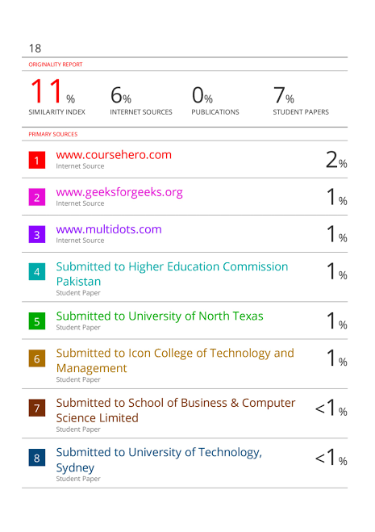

School of Computer Engineering, KIIT, BBSR 36

