Computer Vision 2017FALL HW#6 R05525130 曹珉齊

Python

Import numpy opencv(for reading and writing)

Binary image為之前作業2所生成的圖檔，檔名為lena_bin_128.png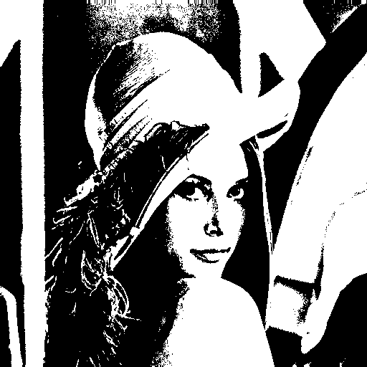

Step1: down sampling

i_ds = np.zeros((64,64), np.int)

for i in range(64):

for j in range(64):

i_ds[i,j] = img[8*i,8*j]

cv2.imwrite("lena_bin_128_64*64.png", i_ds)

依照spec建立一個64*64的0矩陣，再將原圖中每8*8的最左上角pixel記錄下來

Step2: padding

將64*64改為66*66最周圍加入值為0的pixel以方便之後運算

img_pad = np.zeros((img.shape[0]+2,img.shape[1]+2), np.int)

for i in range(img.shape[0]):

for j in range(img.shape[1]):

img_pad[i+1,j+1] = img[i,j]

Step3:依照講義所給的公式進行yokoi connectivity number

def h(b,c,d,e):

if b == c and (d != b or e != b):

return 'q'

elif b == c and (d == b and e == b):

return 'r'

else:

return 's'

a1 = h(img_pad[i,j], img_pad[i,j+1], img_pad[i-1,j+1], img_pad[i-1,j])

a2 = h(img_pad[i,j], img_pad[i-1,j], img_pad[i-1,j-1], img_pad[i,j-1])

a3 = h(img_pad[i,j], img_pad[i,j-1], img_pad[i+1,j-1], img_pad[i+1,j])

a4 = h(img_pad[i,j], img_pad[i+1,j], img_pad[i+1,j+1], img_pad[i,j+1])

yokoi_num[i-1,j-1] = f(a1,a2,a3,a4)

上面參照CH6 PPT PG.59

Step4: output

yokoi_num = yokoi(i_ds)

np.savetxt('lena_yokoi.txt', yokoi_num, '%d')

s = open('lena_yokoi.txt').read().replace('0', ' ')

open('lena_yokoi_final.txt','w+').write(s)

輸出後將isolated的pixel，也就是label為0的替換成空格以方便觀看。

