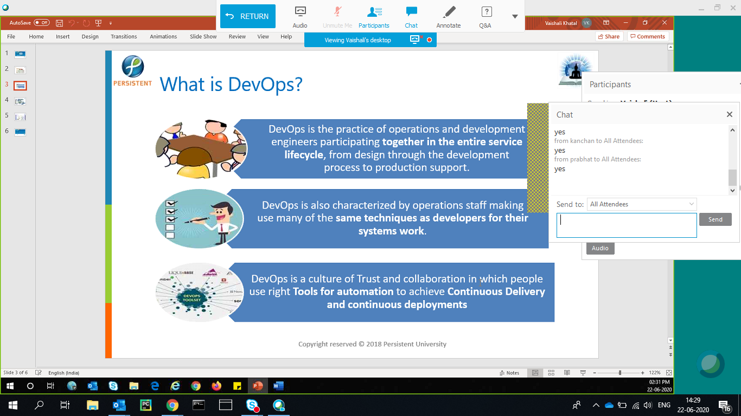

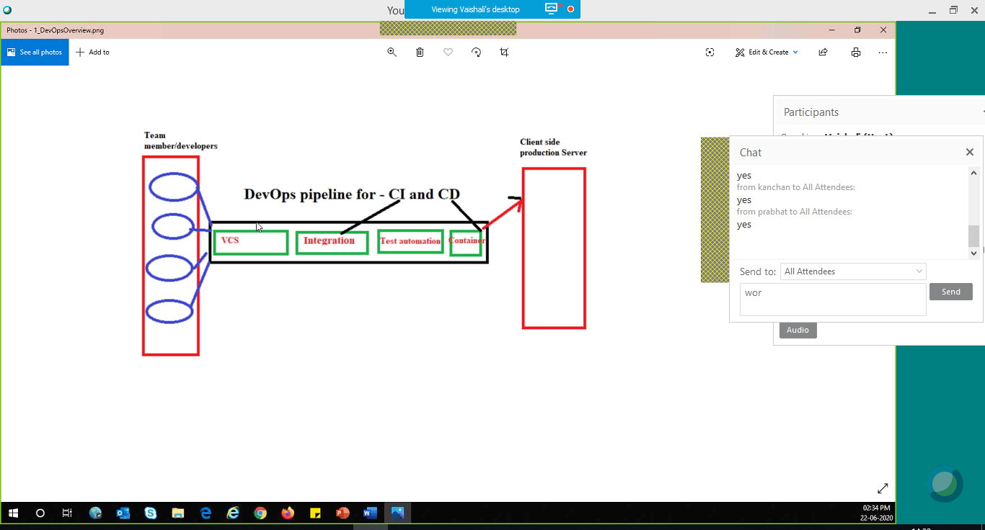

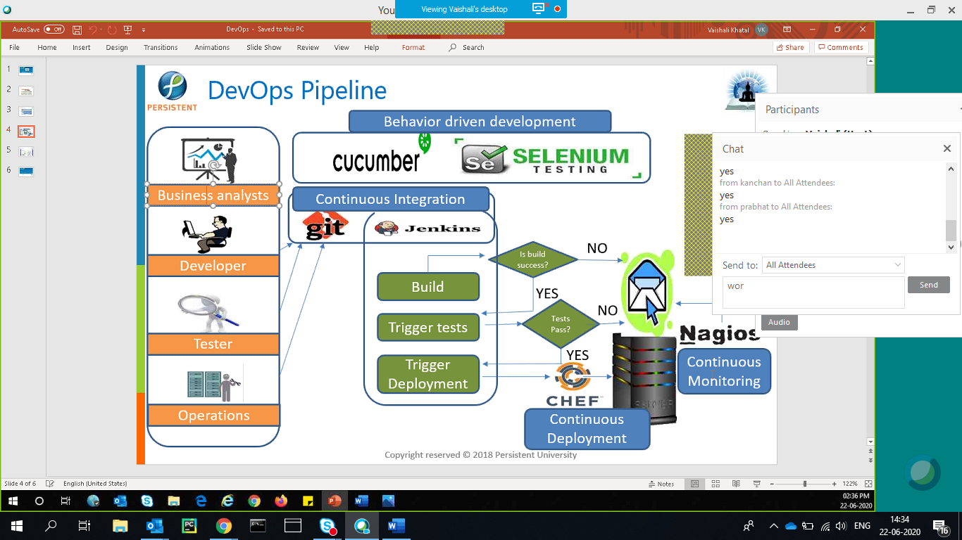\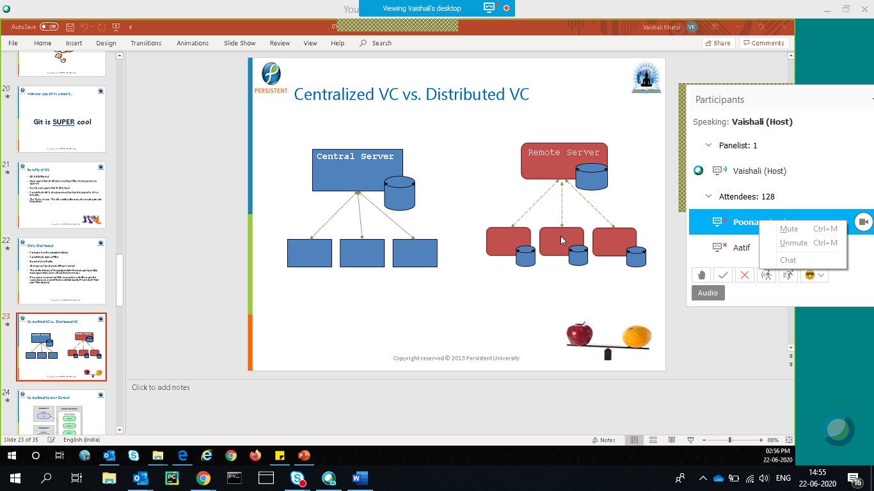

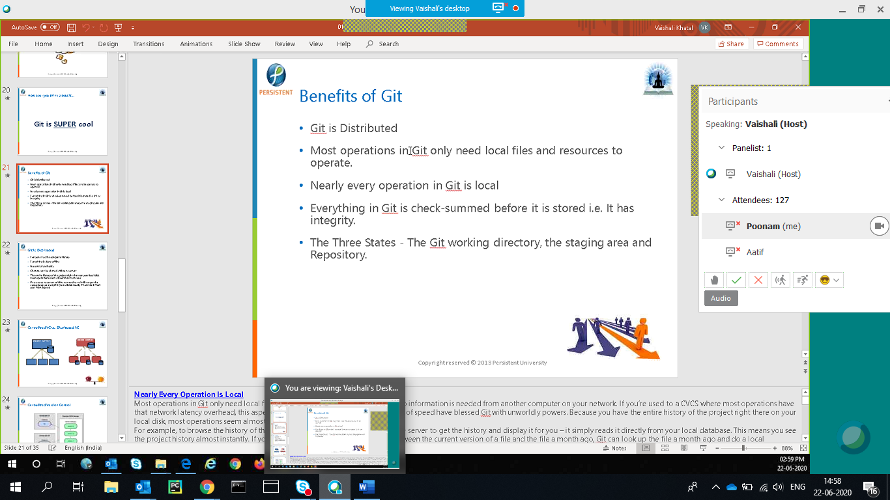

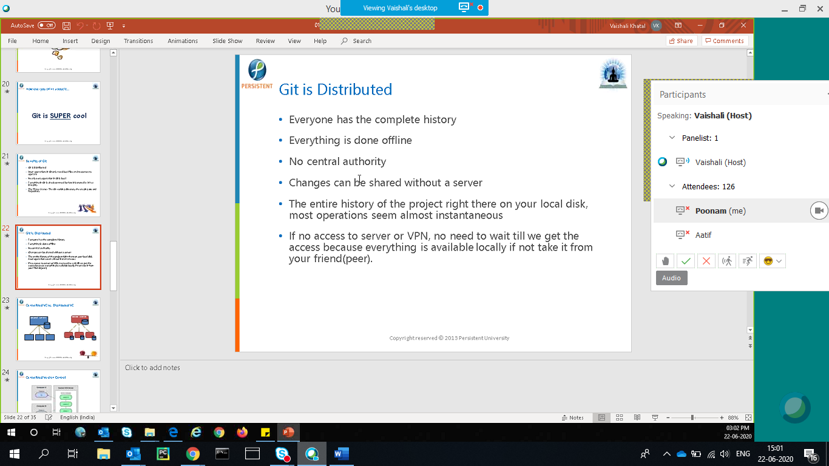

Git checkout – 1. used to just take a look at a file/project

2. to switch between diff versions/branches

3. undo unstaged or uncommitted changes – recommended to be used with local/private branch

git revert – safe undo committed changes, works only on commit level, worls with both public & private/local branch, history is maintained even for revert

On the top of the logs, revert will add additional log and retains the existing logs but the actual change is reverted

git reset – unsafe undo committed changes, works on commit as well as file level, recommended to be used on private only, logs also get deleted.- permanent delete – data as well as log related to that change

reset doesn’t work at the middle SHA key

git reset <SHA key – which is below the one I want to reset>

git reset head~<no of commits u wanna reset>

git diff – gives the diff between current file and last committed version for a file which is not stages yet

git checkout --<filename> the unstaged changes are rolled back and u get a clean git status after that

git revert <SHA key>