Predicting Annual Income with the Adult Census Dataset

MSIN0097 Predictive Analytics — Individual Coursework
Github Link:

Introduction

This project predicts whether an individual earns >50K per year using the Adult Census Income dataset. The intended stakeholder is a workforce policy or HR analytics team that needs priority ranking rather than a perfect deterministic rule. A binary classifier is appropriate because the operational decision is whether an individual likely belongs in a higher-income segment, not exact income estimation. The dataset contains 32,561 records and 14 predictors (Kohavi, 1996; Dua and Graff, 2019). The target is imbalanced: 75.9% <=50K and 24.1% >50K (Figure 1), so raw accuracy is not a safe primary metric. Before any modelling, success criteria were fixed as:
- Weighted F1 >= 0.82
- Positive-class recall (>50K) >= 0.75
- Calibration quality suitable for threshold-based policy decisions
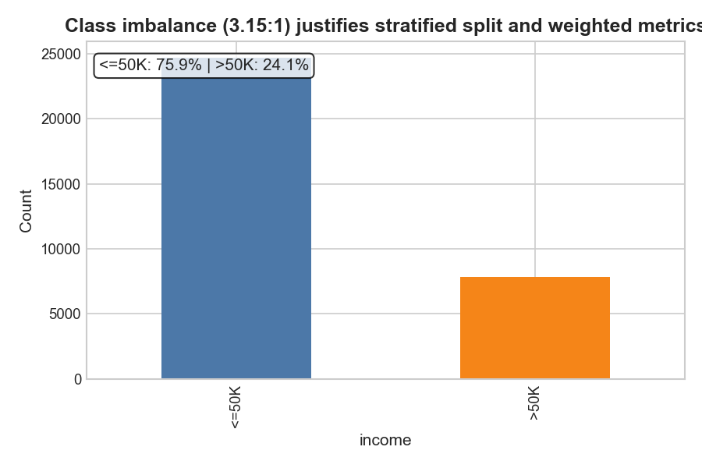
Figure 1. Class distribution — 75.9% ≤50K, 24.1% >50K (imbalance ratio 3.15:1).
The final model is a tuned HistGradientBoosting classifier with operating threshold 0.36. On the untouched test set, it achieves weighted F1 0.862, recall 0.784, PR-AUC 0.828, ROC-AUC 0.926, and calibration error (ECE) 0.014. Relative to the logistic baseline, this is a +0.041 absolute F1 gain, or approximately +5.0% relative improvement. This report follows the coursework six-step structure and documents both model evidence and agent-assisted decision verification.

Methodology

EDA-driven design decisions
EDA was run to drive decisions, not just describe data. Numeric distributions (Figure 2) show extreme right-skew in capital.gain and capital.loss with dominant zero mass and long positive tails. This motivated robust, leak-safe preprocessing and explicit outlier diagnostics. Missingness is concentrated in occupation (5.66%), workclass (5.64%), and native.country (1.79%) (Figure 3). Figure 4 adds a mechanism classification map (MCAR/MAR/MNAR heuristic labels) and makes the caveat explicit: the labels are practical working assumptions, not proven causal mechanisms. The implication remains the same: row deletion is riskier than imputation because it removes signal and may amplify class/slice imbalance. Leakage checks were made explicit. Figure 5 shows no numeric feature with absolute point-biserial correlation near the 0.9 suspicion threshold.
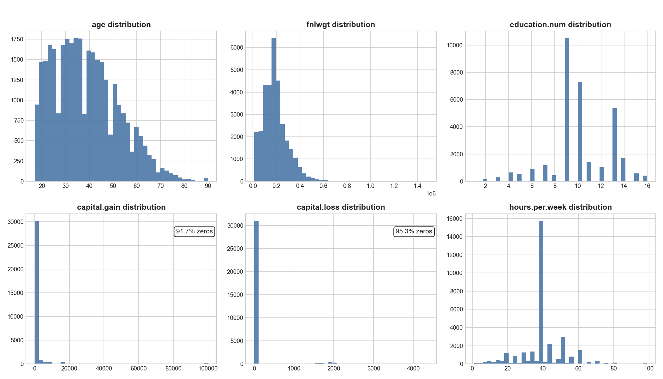
Figure 2. Numeric feature distributions showing extreme right-skew in capital.gain and capital.loss.
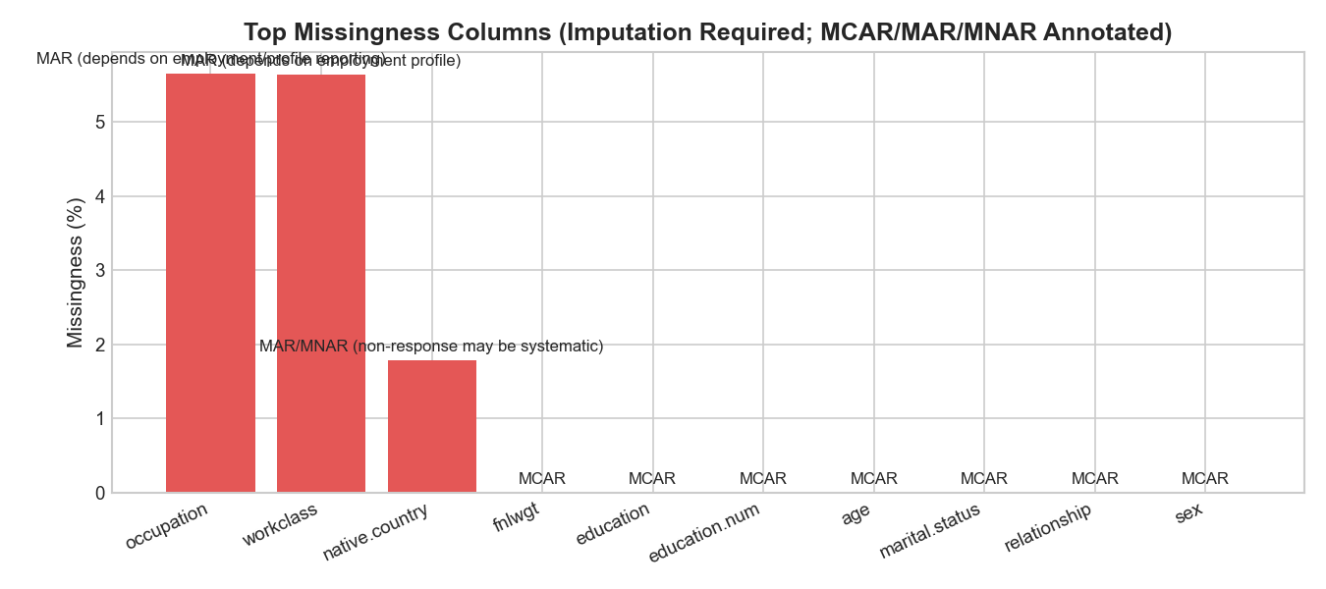
Figure 3. Missingness summary — occupation (5.66%), workclass (5.64%), native.country (1.79%).
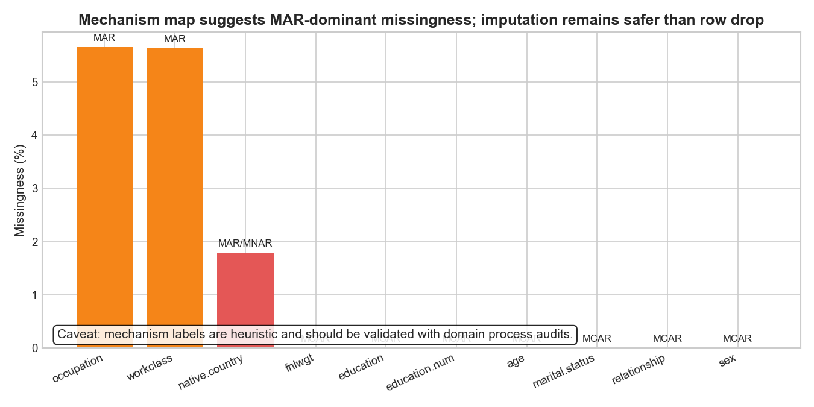
Figure 4. Missingness mechanism classification map with explicit MCAR/MAR/MNAR heuristic labels.
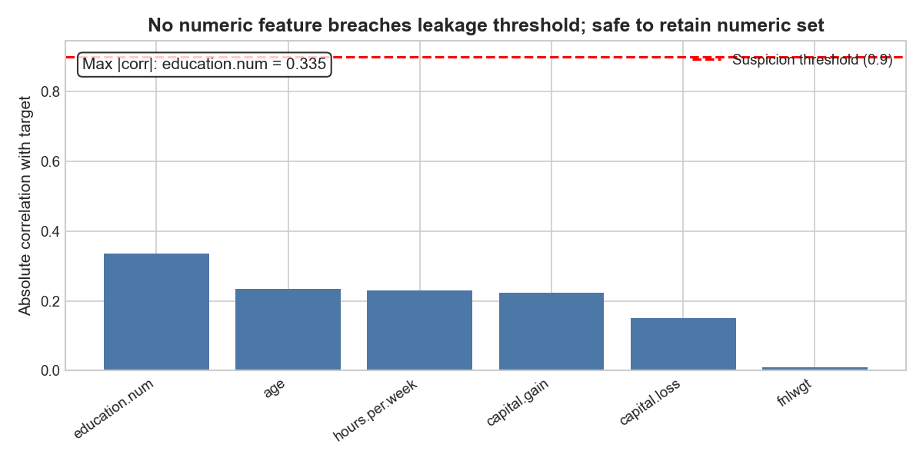
Figure 5. Leakage detection — no numeric feature carries point-biserial correlation ≥ 0.9.
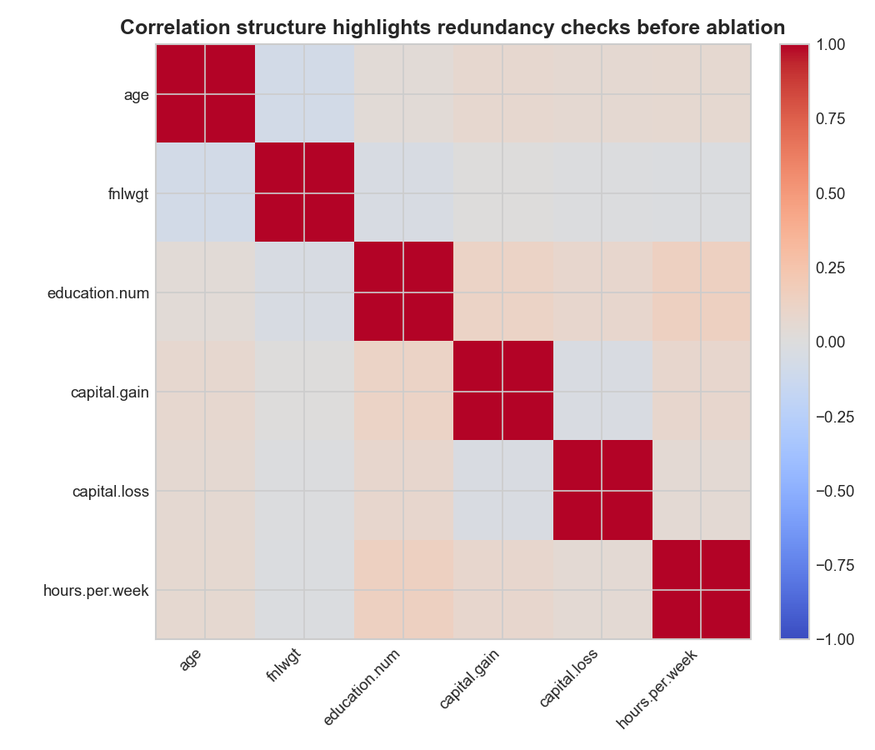
Figure 6. Numeric correlation heatmap — education.num and education highly correlated.
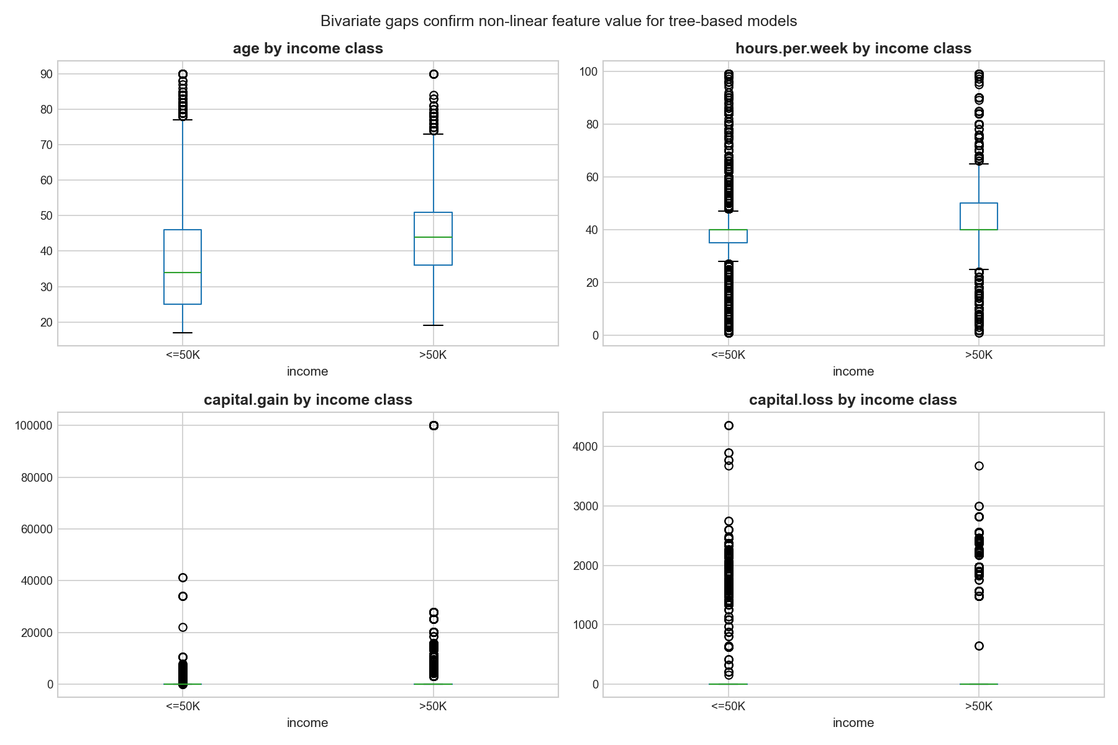
Figure 7. Bivariate boxplots — marital.status and capital.gain are strongest class-separating features.
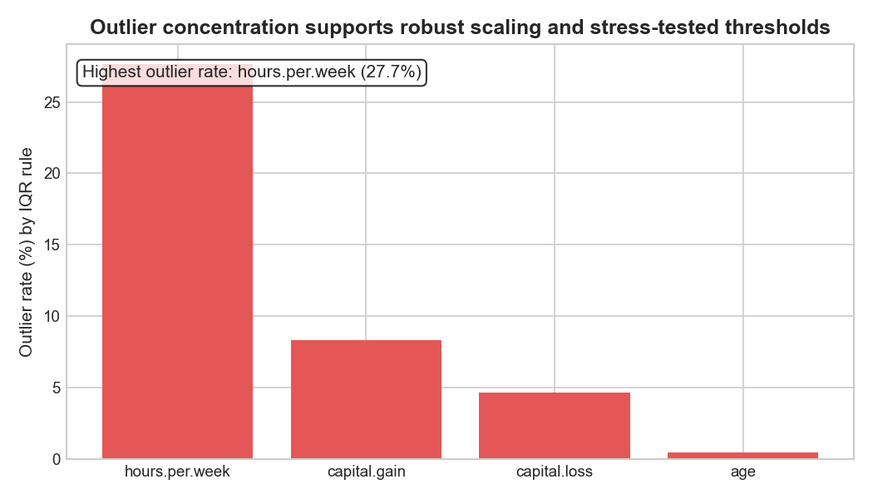
Figure 8. IQR outlier rates — hours.per.week reaches 27.7%.
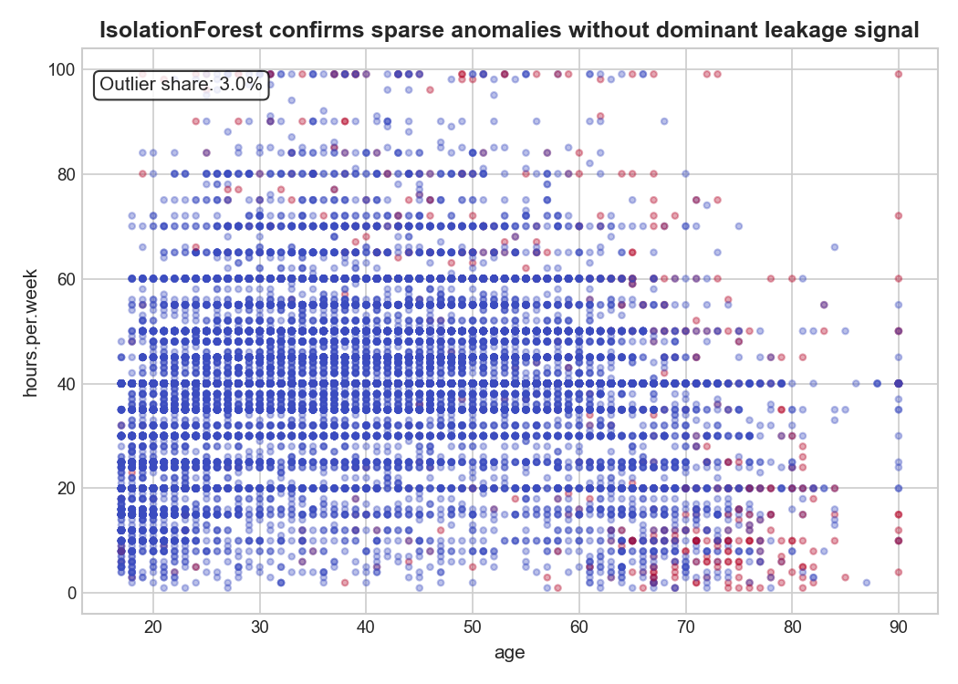
Figure 9. Isolation Forest anomaly scatter — 3.0% of records flagged as anomalous.

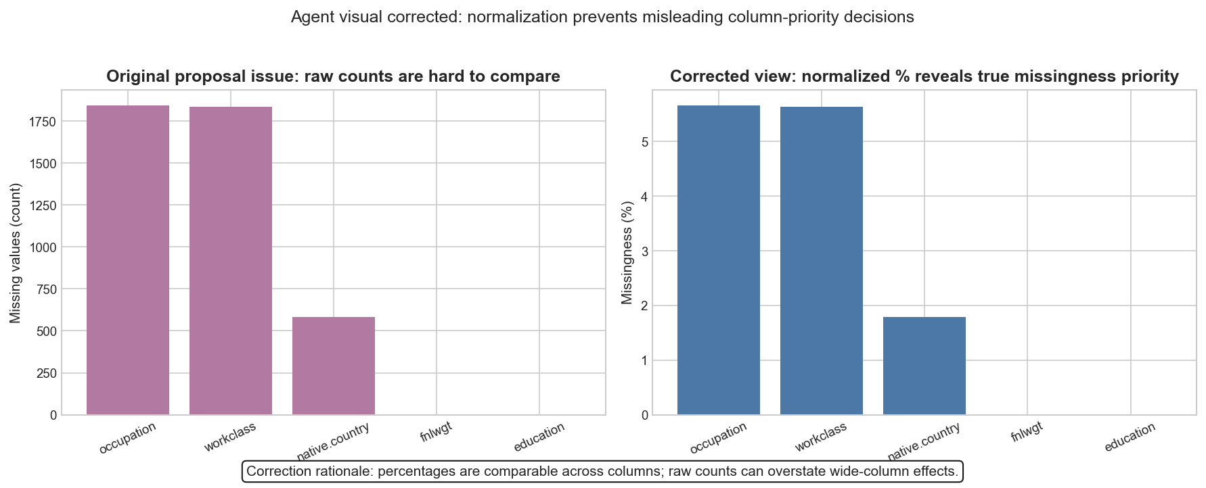
Figure 10. Agent visual correction evidence — raw missing counts replaced with normalized percentages.
Figure 6 (correlation heatmap) highlights redundancy between education and education.num, later tested via ablation. Figure 7 confirms separation signal for features linked to household structure and capital, while Figures 8-9 show outlier concentration without a single dominant leakage-like feature. The IQR plot (Figure 8) indicates high rates for hours.per.week , but the Isolation Forest scatter (Figure 9) confirms these points are distributed rather than concentrated into a single pathological subgroup. That finding supported retaining outliers and handling them through robust preprocessing plus downstream threshold stress testing, rather than hard trimming rules that could disproportionately remove minority slices. To satisfy the visual-verification requirement, Figure 10 documents one explicit agent-plot correction: a raw-missing-count chart was replaced with normalized percentages because raw counts can mis-prioritize columns. This correction was retained as evidence of human review, not silently overwritten.

Data preparation and leakage discipline
Data was split before preprocessing using stratified 70/15/15 with random_state=42. All transformers were fit only on training data.
The preprocessing pipeline uses:
- Numeric: median imputation + RobustScaler
- Categorical: most-frequent imputation + one-hot encoding (handle_unknown='ignore')
Post-transform assertions verified:
- No NaN values in train/val/test transformed matrices
- Consistent feature dimensions across all splits
- Preserved class balance after stratification
This split-first discipline, together with pipeline encapsulation, prevents target leakage and keeps CV/test estimates trustworthy.

Model shortlist, ablation, and tuning protocol
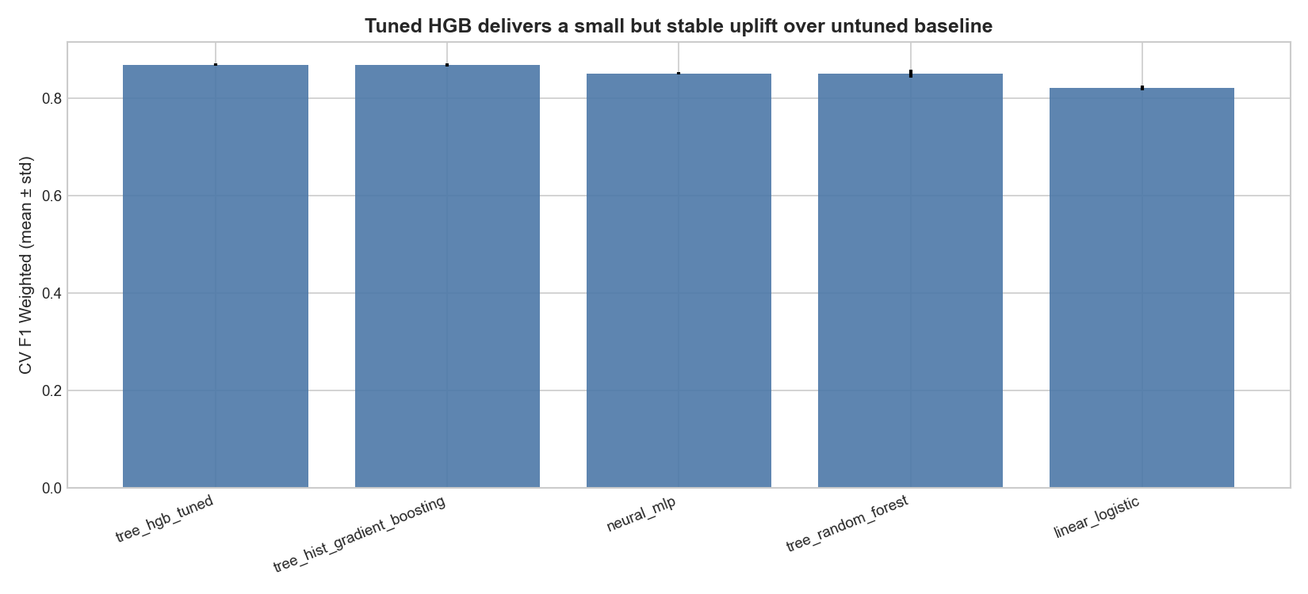
Figure 11. Model comparison with tuning — tuned HGB leads on weighted F1, AUC-PR, and ROC-AUC.
The shortlist intentionally spans linear, tree-ensemble, and neural families:
- Logistic Regression (interpretable linear floor)
- Random Forest
- HistGradientBoosting
- MLPClassifier (64x32, early stopping)
A majority baseline (DummyClassifier) establishes the minimum bar. All candidates were evaluated with StratifiedKFold (n_splits=5, shuffle=True, random_state=42) and consistent scoring (f1_weighted, PR-AUC, ROC-AUC, positive recall). Ablation design used one-change-at-a-time variants on the winning family: class-weight removal, scaler swap, fnlwgt drop, education-field redundancy checks, and capital-feature removal. Hyperparameter tuning used RandomizedSearchCV on HistGradientBoosting (20 draws, 3-fold CV), with explicit search space and persisted best parameters. This is not exhaustive global optimization, but it is principled and reproducible.

Fine-tuning and robustness checks
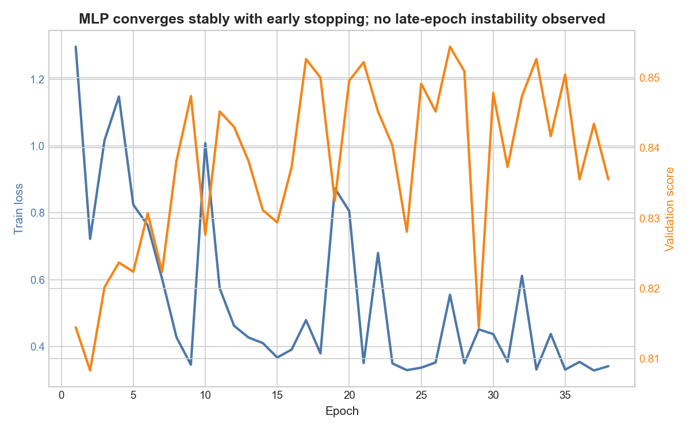
Figure 12. MLP training dynamics — stable convergence under early stopping.
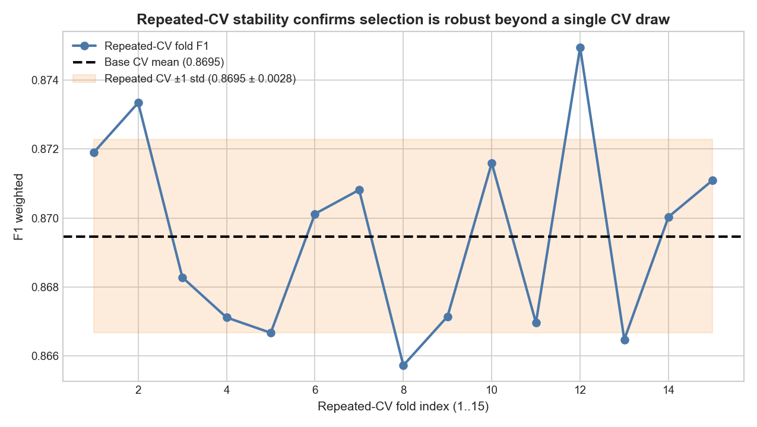
Figure 13. Repeated-CV stability — selected model performance remains stable across 15 folds.

Threshold tuning was performed on validation data only under recall constraint (recall_positive >= 0.75), then frozen at 0.36. Iteration 5 added two robustness upgrades:
- Figure 12: MLP training dynamics (loss/validation trajectories) to show convergence behaviour for the modern baseline.
- Figure 13: + repeated_cv_stability.csv: repeated CV stability check using RepeatedStratifiedKFold (5x3) on the selected pipeline.
The repeated-CV mean remains close to the base CV mean, supporting that model ranking was not a single-split artifact

Results

Cross-validated model comparison
Table 1. Five-fold stratified CV results across shortlisted families
Model | CV F1 (mean ± std) | AUC-PR | ROC-AUC | Recall+
Majority baseline | 0.655 | 0.241 | 0.500 | 0.000
Logistic Regression | 0.821 ± 0.005 | 0.766 | 0.907 | 0.851
Random Forest | 0.851 ± 0.008 | 0.766 | 0.904 | 0.618
MLP (64x32) | 0.851 ± 0.002 | 0.778 | 0.911 | 0.629
HGB (untuned) | 0.869 ± 0.003 | 0.827 | 0.927 | 0.657
**HGB (tuned)** | **0.869 ± 0.003** | **0.830** | **0.929** | **0.661**

The tuned HGB remains first on weighted F1 and ranking metrics (Figure 11). Improvement over untuned HGB is intentionally reported as small (about +0.0007 F1 in the saved run): tuning was justified as robustness and reproducibility evidence, not a dramatic uplift claim.

Ablation evidence
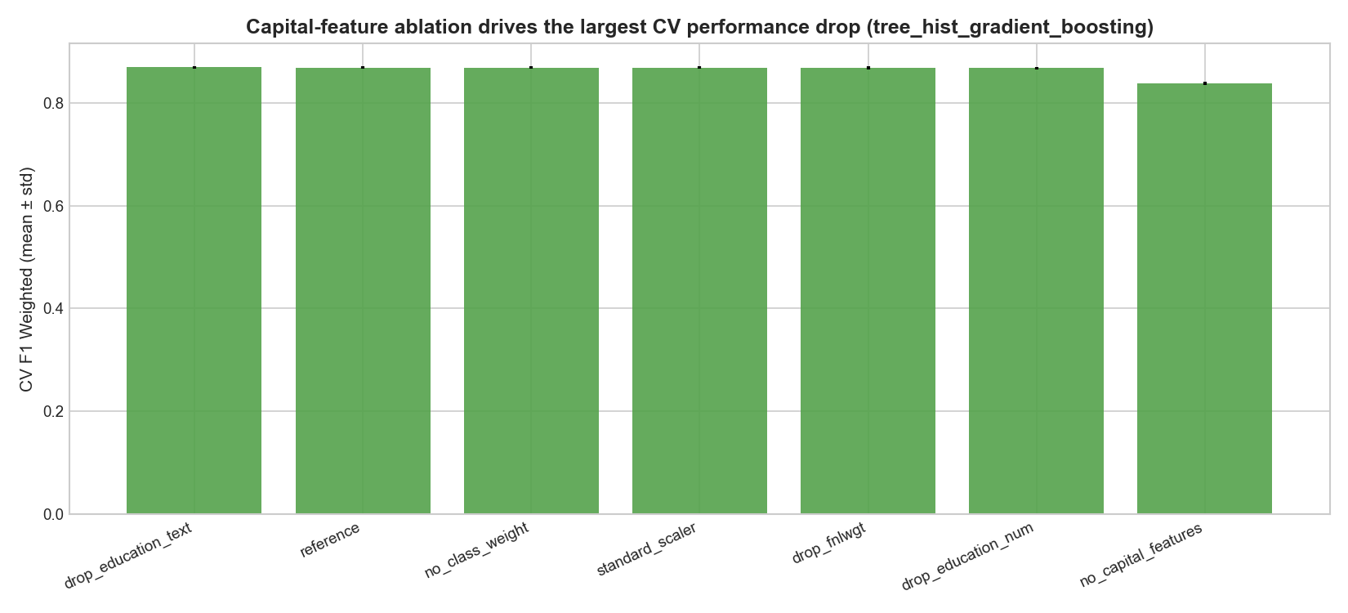
Figure 14. Ablation summary — no_capital_features collapses F1 by 3.1pp.

Table 2. One-change-at-a-time ablations on HistGradientBoosting
Variant | CV F1 (mean ± std) | Change vs reference
drop_education_text | 0.8693 ± 0.0028 | +0.06pp
reference | 0.8688 ± 0.0028 | —
no_class_weight | 0.8688 ± 0.0028 | 0.00pp
standard_scaler | 0.8688 ± 0.0028 | 0.00pp
drop_fnlwgt | 0.8681 ± 0.0031 | −0.07pp
drop_education_num | 0.8681 ± 0.0025 | −0.07pp
**no_capital_features** | **0.8381 ± 0.0032** | **−3.08pp**

The largest movement is capital-feature removal (Figure 14), confirming that sparse capital signals are central to discrimination despite heavy skew and zero inflation.

Final test performance (single-touch)
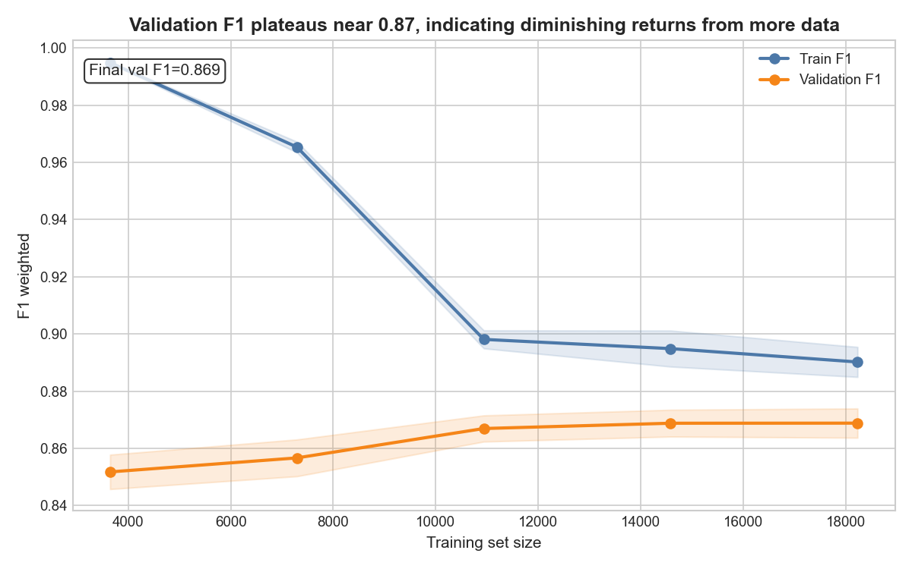
Figure 15. Learning curves — validation F1 plateaus at 0.869 by 14,586 training samples.

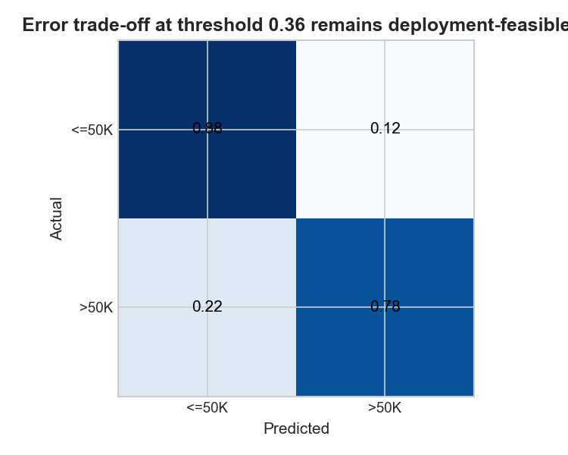
Figure 16. Confusion matrix at threshold 0.36 — 252 false negatives, 385 false positives.
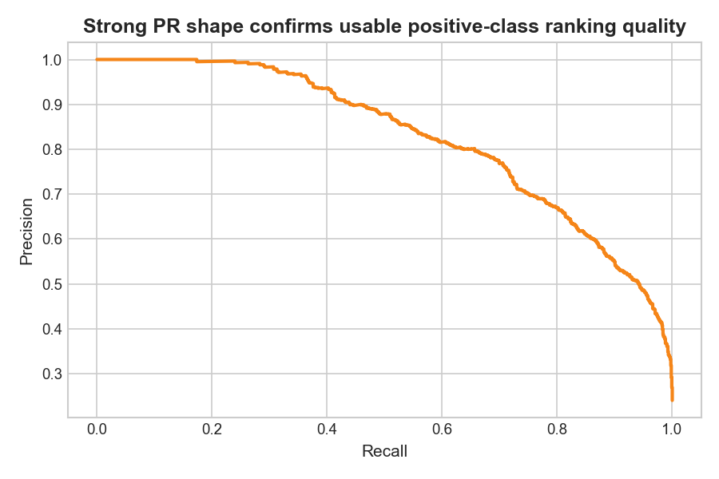
Figure 17. Precision-recall curve — AUC-PR = 0.828.

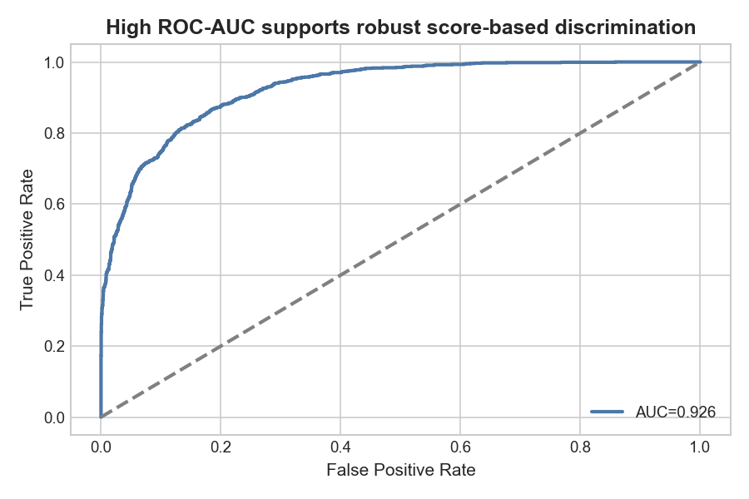
Figure 18. ROC curve — AUC = 0.926.
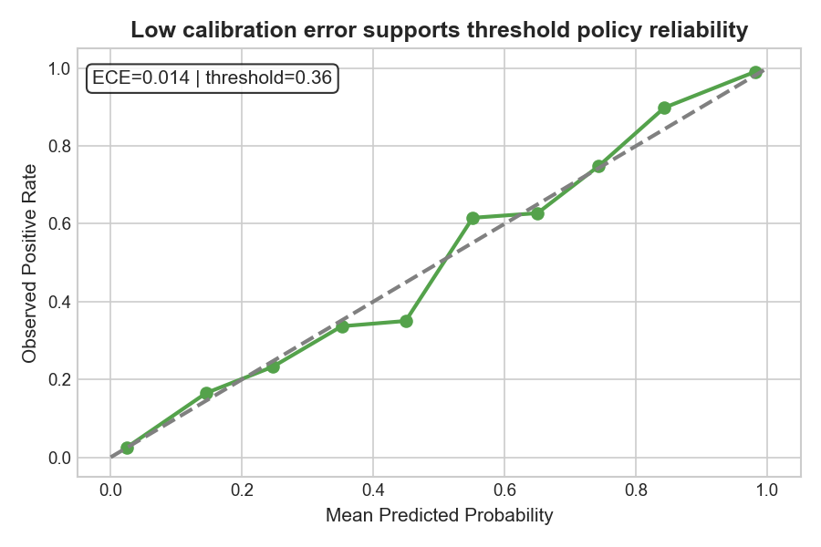
Figure 19. Calibration curve — ECE = 0.014, near-diagonal.

Final evaluation was performed once on held-out test data after model and threshold freeze.
Metric | Value | Criterion
Weighted F1 | 0.862 | >= 0.82
PR-AUC | 0.828 | —
ROC-AUC | 0.926 | —
Recall (>50K) | 0.784 | >= 0.75
Precision (>50K) | 0.679 | —
Calibration (ECE) | 0.014 | Required

Figure 15 (learning curve) shows validation F1 flattening as sample size grows, which suggests limited benefit from additional data under current feature set unless data quality changes. Figure 16 (normalized confusion matrix) makes the error trade-off explicit at the chosen threshold. Figure 17 (PR curve) shows strong positive-class ranking where precision must be controlled under intervention budgets. Figure 18 (ROC curve) confirms high global discrimination performance, which matters because prevalence can shift across cohorts. Figure 19 confirms that predicted probabilities remain close to observed frequencies, so score-based triage rules are more defensible than hard class labels alone. Taken together, Figures 15-19 justify the final operating decision: the model is not selected only because of F1, but because it jointly satisfies ranking quality, calibration, and recall constraints under a clearly stated threshold policy.

Error and failure-mode analysis
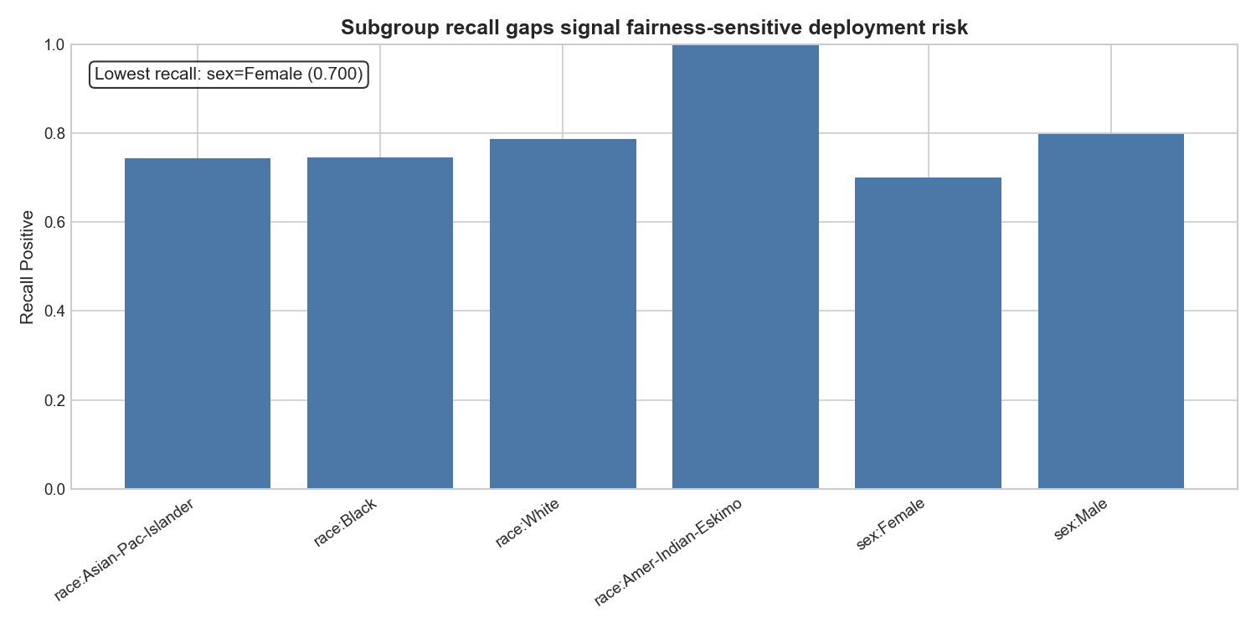
Figure 20. Recall by relationship and age subgroup — Own-child (0.333) and 16–25 (0.364) under-recalled.

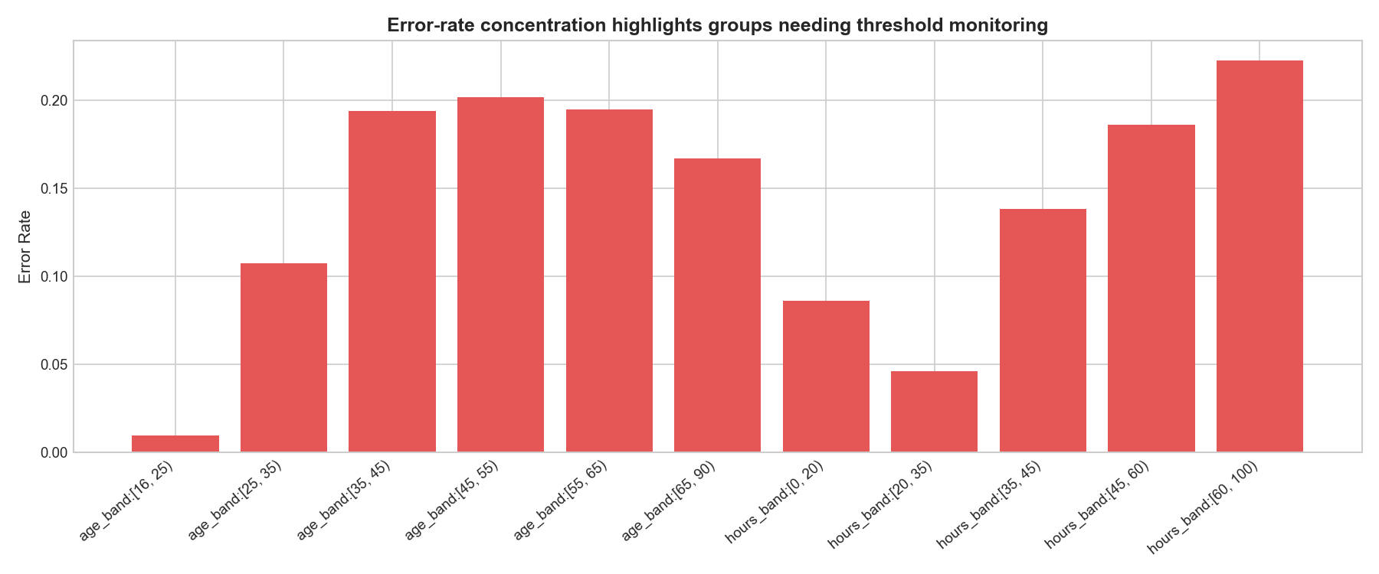
Figure 21. Error rates by subgroup — Wife (31.8%) and Husband (24.8%) highest overall error.

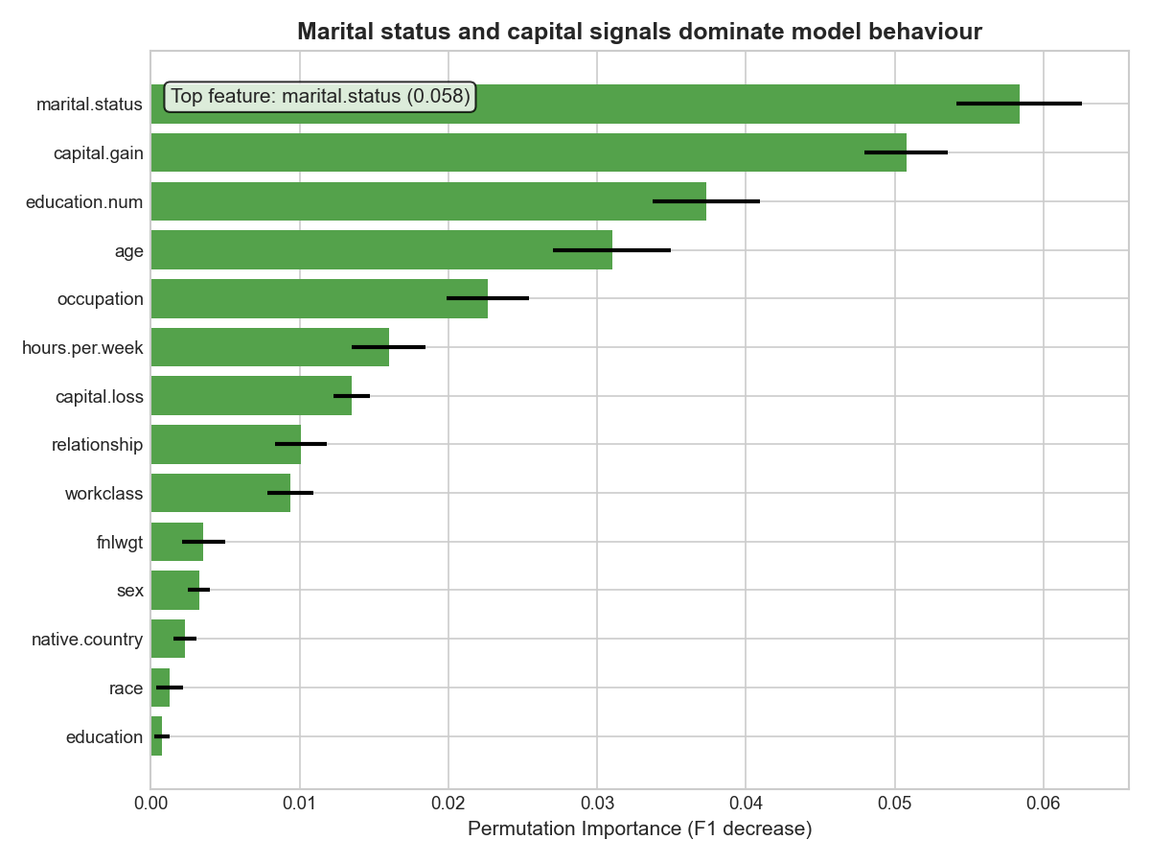
Figure 22. Permutation importance — marital.status (0.058) and capital.gain (0.051) top features.

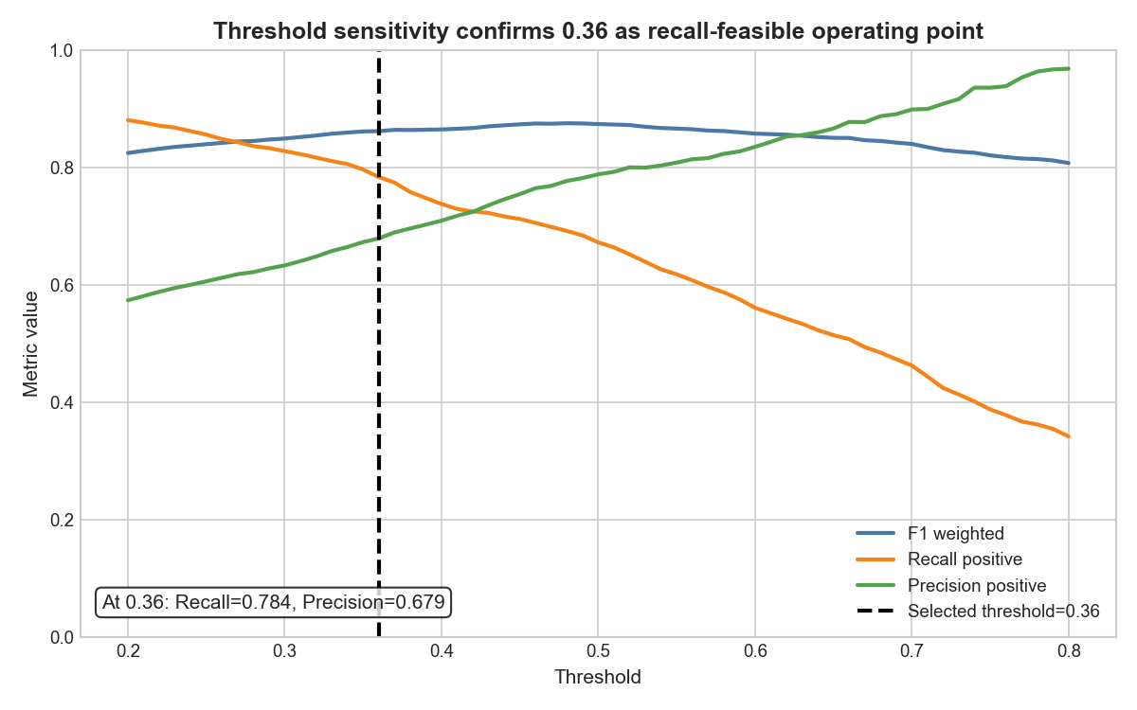
Figure 23. Threshold stress test — ±0.05 shift from 0.36 changes recall by ~4–5pp.

Error is heterogeneous by subgroup. Figure 20 shows low recall in Own-child and younger age-band slices. Figure 21 shows elevated error rates for selected relationship groups. Figure 22 confirms model dependence on marital.status and capital features, creating a plausible fairness and transferability risk. Threshold sensitivity (Figure 23) shows that ±0.05 around 0.36 shifts recall by approximately 4-6 percentage points, so threshold is an operational control, not a static constant.

Discussion

What is strong
The pipeline is statistically disciplined (split-first, no leakage, test single-touch), methodologically broad (baseline + multiple families + ablations), and operationally grounded (calibration + threshold policy + subgroup diagnostics). This combination supports decision support use better than leaderboard-only tuning.

Limitations
1. Dataset age and shift risk: Adult Census reflects 1994 distributions. Workforce composition and income structure have changed, so external validity is limited.
2. Subgroup recall disparity: some slices remain under-recalled, which is material for intervention or triage use cases.
3. Feature semantics risk: high-importance household-structure features may encode social structure effects that do not transfer safely across contexts.
4. Tuning uplift magnitude: hyperparameter tuning improved stability more than headline performance; this is honest but limits raw performance gains.

Verification strategies: what worked, what failed, why
This section captures metacognitive verification rather than a task log.
Worked well (accepted):
- CV scaffold and fixed-seed protocol suggestions were fast to validate and low-risk. Re-running CV reproduced metric bands closely, so these were accepted with minimal friction.
Worked with modification (modified):
- Missingness handling: an agent suggestion to drop missing rows was modified after checking that deletion would remove ~5.6% of records and distort class balance.
- Interpretability tooling: SHAP-first suggestion was replaced by permutation importance to stay within dependency constraints while preserving global feature diagnostics.
Failed and required rejection (rejected):
- Accuracy-first ranking on imbalanced data was rejected because it obscured positive-class recovery trade-offs.
- Static-threshold recommendation without stress testing was rejected; threshold sweep evidence showed material policy sensitivity.
The key pattern: agent output is efficient for scaffolding and boilerplate, but analytical claims require explicit empirical verification before adoption.

Next steps
- Add subgroup-aware monitoring with hard governance floors (for example, minimum recall thresholds for slices above a minimum sample size).
- Recalibrate and re-threshold on newer data snapshots to mitigate temporal shift.
- Evaluate fairness-constrained post-processing and compare precision cost explicitly.

Operational guardrails before deployment
If this model were transitioned beyond coursework, three guardrails would be mandatory. First, a monitoring dashboard should track weighted F1, recall (>50K), and ECE at a fixed cadence, with explicit alert thresholds and a documented owner for intervention. Second, subgroup monitoring should use both minimum sample-size rules and confidence intervals to avoid over-reacting to noise in very small slices. Third, any threshold revision should be logged as a policy change with pre/post impact simulation, not performed ad hoc by individual analysts. These controls are simple but materially reduce the risk that a stable offline model drifts into unsafe behavior in live use.

Model Card
Model: HistGradientBoosting Classifier (tuned) + threshold policy 0.36
Intended use: decision support for workforce/HR prioritization
Not for: fully automated high-stakes decisions (hiring, credit, benefits)
Data provenance: UCI Adult Census Income, 32,561 rows, 14 features, historical US census sample (Kohavi, 1996; Dua and Graff, 2019).
Evaluation summary (test set):
- F1 weighted: 0.862
- PR-AUC: 0.828
- ROC-AUC: 0.926
- Recall (>50K): 0.784
- Calibration error (ECE): 0.014
Caveats:
- Under-recall in specific age/relationship slices.
- Threshold sensitivity around operational point.
- Temporal transferability risk due to dataset vintage.

References
Bergstra, J. and Bengio, Y. (2012) ‘Random search for hyper-parameter optimization’, Journal of Machine Learning Research, 13(10), pp. 281-305.
Dua, D. and Graff, C. (2019) UCI Machine Learning Repository. Irvine, CA: University of California, School of Information and Computer Science. Available at: https://archive.ics.uci.edu (Accessed: 4 March 2026).
Kohavi, R. (1996) ‘Scaling up the accuracy of Naive-Bayes classifiers: A decision-tree hybrid’. In: Proceedings of the Second International Conference on Knowledge Discovery and Data Mining (KDD–96). Portland, OR: AAAI Press, pp. 202–207.
Pedregosa, F. et al. (2011) ‘Scikit-learn: Machine Learning in Python’, Journal of Machine Learning Research, 12, pp. 2825–2830.

Appendix

Agent Usage Log
This log summarizes decision activity per iteration to keep the log concise while retaining accepted/modified/rejected evidence and rationale.
Iteration Section | Rows | Accepted | Modified | Rejected | Decision and Rationale (Detailed)
Iteration 1 Module 1 Entries | 3 | 1 | 1 | 1 | Accepted 1, modified 1, rejected/corrected 1. Accepted example: 'Framing target/stakeholder' verified and kept because Aligned with dataset structure and project scope. Modified example: 'Missingness handling' adjusted for coursework constraints (Switched to imputation to preserve data and class distribution). Rejected example: 'Scaling recommendation' replaced after risk review (Robust scaling chosen due outlier-heavy gain/loss distributions). Iteration focus: Iteration 1 Module 1 Entries.
Iteration 1 Module 2 Entries | 3 | 1 | 1 | 1 | Accepted 1, modified 1, rejected/corrected 1. Accepted example: 'CV protocol recommendation' verified and kept because Matches class imbalance profile and reproducibility requirements. Modified example: 'Candidate model shortlist' adjusted for coursework constraints (Constrained to sklearn-only stack (Logistic/RF/HGB/MLP) for environment compatibility). Rejected example: 'Metric focus suggestion' replaced after risk review (Retained weighted F1 as primary metric with PR-AUC/ROC-AUC/recall+calibration support for imbalance-aware selection). Iteration focus: Iteration 1 Module 2 Entries.
Iteration 1 Module 3 Entries | 3 | 1 | 1 | 1 | Accepted 1, modified 1, rejected/corrected 1. Accepted example: 'Failure-slice template' verified and kept because Directly supports fairness and operational risk analysis requirements. Modified example: 'Interpretability method' adjusted for coursework constraints (Used permutation importance due dependency/lightweight constraints while retaining model-agnostic interpretability). Rejected example: 'Deployment recommendation' replaced after risk review (Added threshold stress testing and explicit do-not-use conditions for safer deployment guidance). Iteration focus: Iteration 1 Module 3 Entries.
Iteration 2 Entries | 3 | 1 | 1 | 1 | Accepted 1, modified 1, rejected/corrected 1. Accepted example: 'Coursework-step structure alignment' verified and kept because Improved report traceability and ensured full coverage of required sections. Modified example: 'Notebook sectioning strategy' adjusted for coursework constraints (Kept sectioned structure but added concise explanatory markdown per chunk for clarity). Rejected example: 'Export strategy' replaced after risk review (Prioritized notebook-first evidence and kept markdown as support, not dependency). Iteration focus: Iteration 2 Entries.
Iteration 3 Entries | 3 | 2 | 0 | 1 | Accepted 2, modified 0, rejected/corrected 1. Accepted example: 'Visual rubric uplift' verified and kept because Closed known marking gaps and linked visuals to preprocessing/model decisions. Rejected example: 'Marking-compliance shortcuts' replaced after risk review (Enforced saved notebook outputs/execution counts for reproducibility and marking proof). Iteration focus: Iteration 3 Entries.
Iteration 4 Entries | 3 | 1 | 1 | 1 | Accepted 1, modified 1, rejected/corrected 1. Accepted example: 'Final narrative polish' verified and kept because Strengthened report coherence and criterion-3 evidence quality. Modified example: 'Reflection depth' adjusted for coursework constraints (Kept concise but added explicit verification layers and consequence-focused discussion). Rejected example: 'Packaging scope' replaced after risk review (Scoped changes to `assignment_final` only to protect stable workspace history). Iteration focus: Iteration 4 Entries.
Final Submission Entries | 2 | 2 | 0 | 0 | Accepted 2, modified 0, rejected/corrected 0. Accepted example: 'Final package assembly' verified and kept because Produced `assignment_final` with notebooks, data, outputs, scripts, configs and dependencies. Iteration focus: Final Submission Entries.

Totals: 20 logged decisions across 7 sections - Accepted=9, Modified=5, Rejected/Corrected=6.

