# *ENSURING YOUR HEALTH WITH THE BEST THAT MONEY CAN BUY*

# EnSure.AI

# CONTENTS

1. Company Description
   1. Mission Statement
   2. Goals
2. Industry
   1. Industry Overview
   2. Industry Growth & Outlook
3. Solution at a glance
4. Detailed Solution
5. Threats & Opportunities
6. SWOT Analysis
7. Competition & Competitive Analysis
8. Target Customer
9. Business Plan & Financials

# COMPANY DESCRIPTION

## Mission Statement

Provide a holistic healthcare solution for every life that we touch.

## Goals

Short Term (0-18 months)

* Enable at least 1,00,000 people to have a seamless experience right from purchasing insurance to getting the reimbursement using the app
* Tie up with 5 insurance companies to enable cashless treatments and cashless limits of the policy holder
* Tie up with 3 hospital chains to get medical history of the policy holder

Long Term (18-36 months)

* Become the one stop app for all your medical and insurance needs
* Enable virtual consultations and tie up with at least 1,00,000 doctors nationwide
* Bring an additional 5,00,000 people under the net of insurance by using the app

# INDUSTRY

## Industry Overview

Ensure.AI (Ensuring your health with the best that money can buy) is a product in the customer centric healthcare solutions including insurance solutions that aims to simplify in getting the best medical resolution to your health related queries as well extended to your loved ones and support staff.

In the fiscal year of 2019, over 472 million people across India were covered under health insurance schemes. Of these, the highest number of people were insured under government-sponsored health insurance schemes, while individual insurance plans had the lowest number of people. Overall, the penetration of health insurance in India stood at just around 35 percent in financial year 2018. ([Reference)](https://www.statista.com/statistics/657244/number-of-people-with-health-insurance-india/#:~:text=Number%20of%20lives%20covered%20under%20health%20insurance%20in%20India%20FY%202014%2D2019&text=In%20the%20fiscal%20year%20of,covered%20under%20health%20insurance%20schemes.&text=Overall%2C%20the%20penetration%20of%20health,percent%20in%20financia)

So there is still huge scope in the industry and the Government of India has taken number of initiatives to boost the insurance industry. The Government's policy of insuring the uninsured has gradually pushed insurance penetration in the country and proliferation of insurance schemes.

Overall insurance penetration (premiums as per cent of GDP) in India reached 3.69 per cent in 2017 from 2.71 per cent in 2001.

## Industry Growth & Outlook

The overall insurance industry is expected to reach US$ 280 billion by 2020. Life insurance industry in the country is expected to increase by 14-15 per cent annually for the next three to five years. Demographic factors such as growing middle class, young insurable population and growing awareness of the need for protection and retirement planning will support the growth of Indian life insurance.

The health insurance industry in India is the fastest growing segment in the non-life insurance sector. The market witnessed a robust double digit growth of 24% in FY 17, with a market share of 24%, in the entire non-life insurance sector. It has been the fastest growing market segment, registering a CAGR of 23%, for the past 10 years. This phenomenal growth may be attributed to the liberalization of the economy and growing general awareness among the public on healthcare.

The health insurance industry is at an embryonic stage, with roughly 25% of the population under its coverage. There exists a huge potential for growth and penetration of health insurance to a larger population.

# SOLUTION AT A GLANCE

EnSure.AI is a holistic platform which prioritize the customer’s health needs to map to the best insurance/financial plan/health solutions available in the market and in turn it’s mission is to meet the health needs of every strata of society which in turn improves the health of the economy.

This platform is an ever evolving amalgamation of AI algorithms which sources information from users their health conditions/insurance plans/family health plans and makes the recommendations real-time for the all the economic decisions in any health-dire situation.

To start with we need to understand what the customer existing health needs and financial/insurance state. Depending on that recommendations would come up. Looking at the genuineness of the recommendations and data security that will be provided to users, further preferred and available insurance companies will partner up, their tie-ups with healthcare institutions and speciality hospitals will as well line up. All this information & its computations would require immense investment in terms of infrastructure & available cycles for regression hence Azure cloud is the choice here to build the solution. Our AI hybrid engine will be able to correlate the past & present health history of the customer with the insurance currently in place and will share the best solution to go forward with.

# 

# Source:- https://www.defteam.com/what-we-do/

# DETAILED SOLUTION

This smart & advanced AI will analyse the entire health profile of the customer in terms of the data that is available in his feed and his past transactions with hospitals/Insurance companies. Looking at his dependants expenditure in the past, it will present with best solutions which will be easy on the pocket & as well be proactive in terms of needed health check-ups and other measures to keep him fit. This product will significantly transform the industry in the next three years to empower citizens in making the choices and to enhance the customer experience with automated personalized services, faster claims handling and individual risk-based underwriting processes. If we look at the data, most of our data is unstructured and lies in the documents, chat logs, emails, and the textual data which is generated in our day-to-day interactions. [Natural language processing](https://bdtechtalks.com/2018/02/20/ai-machine-learning-nlg-nlp/), the science of helping our AI to understand and draw value from unstructured text, is the area which we will focus on and has tremendous potential in giving us insights & then driving the neural networks further going ahead to recommend the best solution to the customers. In line with computer vision to extract meaning and context from visual data will advance our recommendations by leaps and bounds to perform image recognition and classification tasks with stunning accuracy.

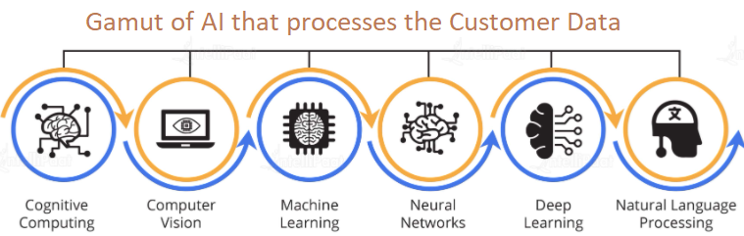

The benefits of adapting this platform:-

1. To create a chain of family members and extended family members/support staff & utilize the best available insurance plan to be healthy and have better run in life.
2. For this AI solution to work in tandem with healthcare solutions and insurance providers at the same platform to reduce the risk of fraud and being real-time.
3. To become the bridge in providing inclusive healthcare to everyone and cultivate a community among people so that nobody feels left alone.
4. Later with this wealth of knowledge about the existing healthcare & financial systems, this can lead to disruptive pathways and innovation to the firms who are interested to bridge the gaps.
5. Immense scope in increased integration for other financial solutions to customer to reduce stress.
6. Providing the best in class security for the incoming data from multiple sources and harness the knowledge out of it.

EnSure.AI will have essentially six key functional blocks to be executed on-demand in the cloud:-

1. Data Processing Section – This function will be at the end points of the incoming data sources from multiple streams. After taking the data ,this section will convert to the required dataset for processing to the sub functions. This dataset maybe structured or unstructured data coming from different sources and location & will be tagged accordingly for further processing
2. Data Analytics Section – We are looking for a series of NLP and CV algorithms to extract the required personalization’s for every profile & setting it up for following CNNs. It performs actions on the identified data set & designs a profile with the health priorities & financial condition of that individual. This step can present classifiers predictive capabilities on features like:-
3. Lifestyle
4. Health Risks
5. Previous Health conditions
6. Hereditary Health Conditions
7. Insurance availed
8. Hospitals and its services accepted in past
9. Hospitals and its services reviews and feedbacks coming from customer account.
10. Existing dependants
11. Existing Financial condition.
12. Data Insights Section – This section deals with the CNNs and recommendation systems that will divulge in the profile created for a customer in the previous step and work towards bringing good accuracy to make the systems efficient. Here there will be regressive training and testing of data for the model to curate the best recommendations for offering.
13. Feedback Section – This feature will record and notify the Analytics section as to how far the predictions have been accepted.

# AI Model Development

AI Model Lifecycle

1. Scope & deliverables
2. Solution & Product selection
3. Source Systems & Data Assets
4. Set-up, Configure & Build
5. Cut-over, Roll Out & Run
6. Monitor & Manage
7. Continuous Improvements

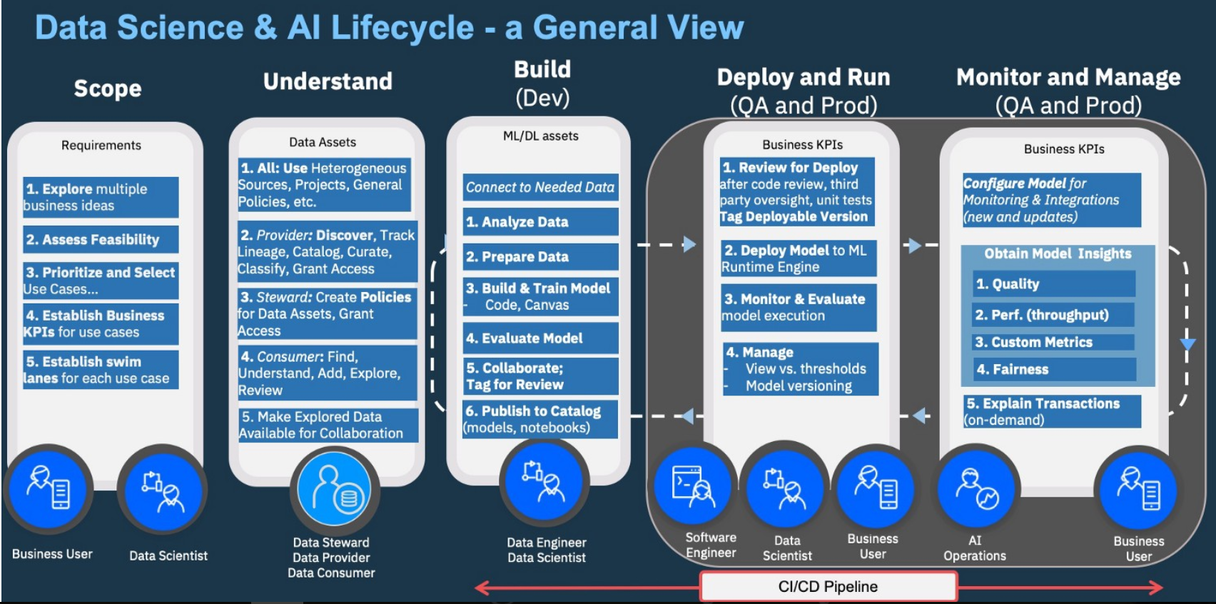

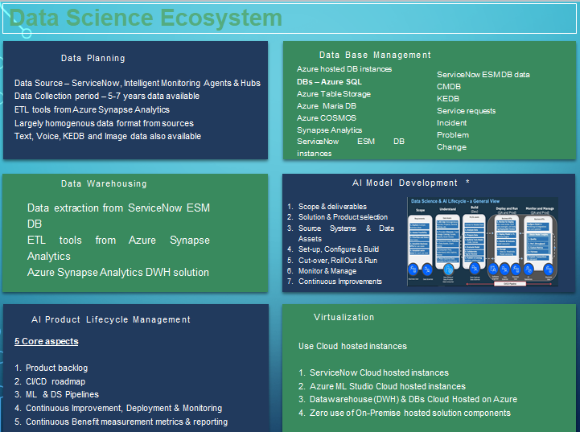

# Solution requirements & Talent skills

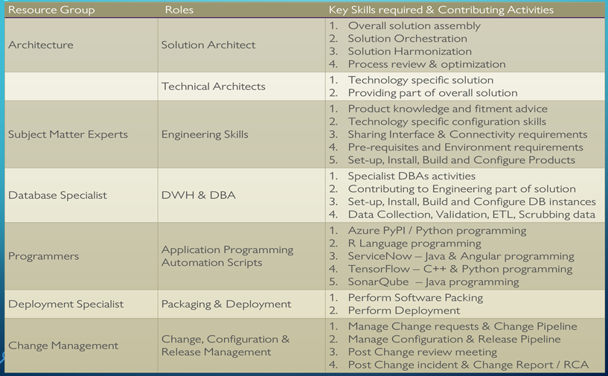

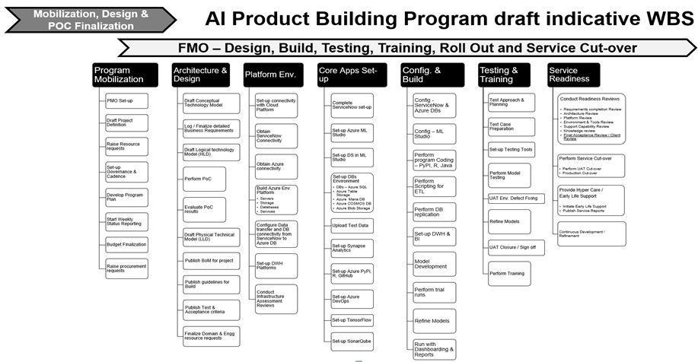

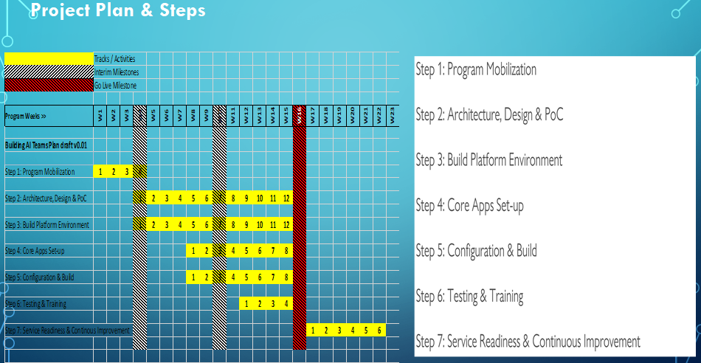

# THREATS & OPPORTUNITIES

AI is rapidly entering health care and serving major roles, from automating drudgery and routine tasks in medical practice to managing patients and medical resources. As developers create AI systems to take on these tasks, several risks and challenges emerge, the risk to patient privacy of data acquisition and AI inference, and more. Potential solutions are complex but involve investment in infrastructure for high-quality, representative data; collaborative oversight by both the Food and Drug Administration and other health-care actors; and changes to medical education that will prepare providers for shifting roles in an evolving system.

The biggest opportunity and benefit of this EnSure AI is managing medical resources & financial resources in one platform. With ease of doing business & creating confusion to the public, AI can be used to allocate resources and shape financial solution & grow business. For instance, Our AI systems might predict which hospitals provide the premium care depending on the location and insured amount/available funds for the customer & his circle of supporters and at the same time identify revenue-maximizing practices.

Next-gen healthcare finance tools: AI and blockchain will help hospitals adapt to value-based care. There are three major features healthcare industry needs to pay attention to in their planning for next-generation financial management tools: visualization, artificial intelligence and blockchain, all delivered via cloud services.

Points to look at:-

1. Regulatory Shackles: One of the key regulatory issues that are hampering the acceptance of AI in healthcare is the archaic regulatory infrastructure. Although the technological advancements in the field of healthcare have grown by leaps and bounds, the regulatory infrastructure has failed to keep up.
2. The Opacity Of Processes: While deep learning models and neural networks in AI have proven over time to be perfect than human decision-making, they are often not transparent in terms of revealing how they generated such conclusions. It then becomes a challenge for insurance companies to explain that to the regulators. It has been mentioned that the biggest challenge in using big data, artificial intelligence is that they operate outside the framework of traditional privacy principles. This could now act in a reverse way and expose banks/healthcare/insurance to risks without their knowledge. It could also possibly give rise to hidden biases in decision making since AI has access to data of all the customers.
3. Leakage And Misuse Of Data: Several experts in the U.S. and the U.K. opine that cyber, political and physical threats arise with the growth in the capabilities and reach of AI. Complete transparency while venturing into new AI projects also should be ensured so that banks/insurance companies don’t face reputation risks. Adequate investments should be done on the safe storage of data and prevent it from leakage. EnSure architecture will detect potential hazards in the implementation stage of the project and enable efficient identification—and then execution—of goals and priorities of the organization. Artificial intelligence will soon become the sole determinant of the competitive position of financial institutes and a key element enhancing their competitive advantage.

# SWOT ANALYSIS

|  |  |  |  |  |
| --- | --- | --- | --- | --- |
|  | **Strengths** | **Weaknesses** | **Opportunities** | **Threats** |
| **Product Offering** | Customer Centric; Next gen tools - AI ;Blockchain | To not be puppet/dominated by Healthcare/Insurance companies to compromise customer needs. | To give the best corroborative healthcare solutions that money can buy | Managing the Data Privacy Threats |
| **Brand / Marketing** | New strategies in Marketing to attract clients | People might opt for the tried and tested platforms | To publicize the new platform |  |
| **Staff/HR** | Data Engineers/Data Architects | AI/Blockchain experts |  |  |
| **Finance** |  | Angel funding for initial capital. | Excellent growth |  |
| **Operations / Management** |  | Private cloud based, needs explicit management | Build Strong expertise to create integrated platforms. | Needs to be open for maximum healthcare vendors and financial institutions |
| **Market** | Openness to try new solutions. | Clients who don’t want to share information | Expand into other verticals & geos | Existing Players in parts of our services like Practo, Pathlabs might be planning to launch similar app. |

Key strengths available to improve weaknesses/ combating threats

One of the strength is to invest in leading security solutions like Cognitive security with Watson - Cognitive computing, an advanced type of artificial intelligences, leverages various forms of AI, including machine-learning algorithms and deep-learning networks that get stronger and smarter over time. Watson™ for Cyber Security, IBM’s cognitive AI, learns with each interaction to connect the dots between threats and provide actionable insights. The result: We can respond to threats with greater confidence and speed.

* Immediate goals/next steps - Our immediate next steps are:
  1. Collect the various customer data from various backgrounds their preferences/health history.
  2. Estimate the scale , need to plan & security in place use that to populate the business case for the tools, infrastructure, security and skills requirements
  3. Analyze the data types and fine tune the architecture to include the best security required by data engineering, data analytics, NLP and other ML models.

## Long-term goals/next steps -On a longer term we need to do the following:

1. Identify pilot clients/Enterprises/Insurance companies to get the Beta deployments on a discounted model in return for testimonials and field testing.
2. Gain entry into the forums / bodies defining the standards for platforms security where data is coming in from multiple sources
3. Keep researching support for additional products to be better at performance & reliability.

# COMPETITION

## Competitive Analysis Worksheet

|  |  |  |  |  |  |
| --- | --- | --- | --- | --- | --- |
| **Factor** | **EnSure.AI** | **(IIT)-iMediX** | **Practo** | **Novartis** | **Importance to Customer** |
| **Products** | EnSure.AI App | W | S | S | 3 |
| **Brand Value** | W | S | S | S | 2 |
| **Price** | W | W | W | W | 3 |
| **Quality** | S | S | S | S | 1 |
| **Selection** | S | S | S | S | 1 |
| **Service** | S | S | S | S | 1 |
| **Reliability** | S | S | S | S | 1 |
| **Location** | W(India) | S(Global) | S(Global) | S(Global) | 3 |
| **Sales Method** | S | W | W | W | 4 |
| **Infra-Requirements** | S | W | W | W | 2 |

# TARGET CUSTOMER

We intend to target two groups of users here – the insured and the insurance companies.

1. Insured – Any Indian citizen, who is of eligible age to get insurance is the target market but we will specifically target the head of the family. (Our marketing efforts will be targeted towards appealing to the humane side of – have you ensured the safety of your family?) The ideal customer would be
   1. Age – 25 to 45 years of age
   2. Location – Tier 1 & Tier 2 cities
   3. Income Group – In the tax net and has a pan card
2. Insurance Companies – The medical insurance companies would be our target market as well and especially those that are facing a large number of claims and seeing a lot of false/fraudulent claims.

# BUSINESS PLAN

*(In progress)*

