**Credential Information**

For ease of exploring our NurseEllie application, we have set-up and prepared a Patient Account and a Health Professional Account with some test information.

For the Patient Account, please login with the following credentials:

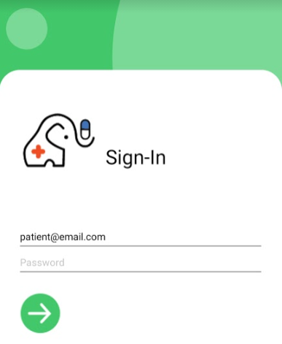

<-- password

<-- email address

testing123

For the Health Professional Account, please login with the following credentials:

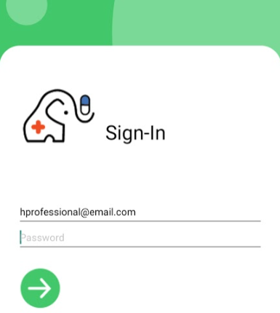

<-- password

<-- email address

testing123