**Database with Meaningful Test Data**

To view our database which contains our test data, please visit <https://console.firebase.google.com/> You will need the provided email and password to login and view our data. Should two-factor authentication be required, please contact Vivian Chiu at [vivian.chiu@live.com](mailto:vivian.chiu@live.com) or (905) 472-3221.

**Firebase**: [nurseellieapp@gmail.com](mailto:nurseellieapp@gmail.com)

**Firebase Password**: CPAF2020

Please see below for screen captures of examples of our database for Health Professionals and Patients.

**Database for Health Professional:**

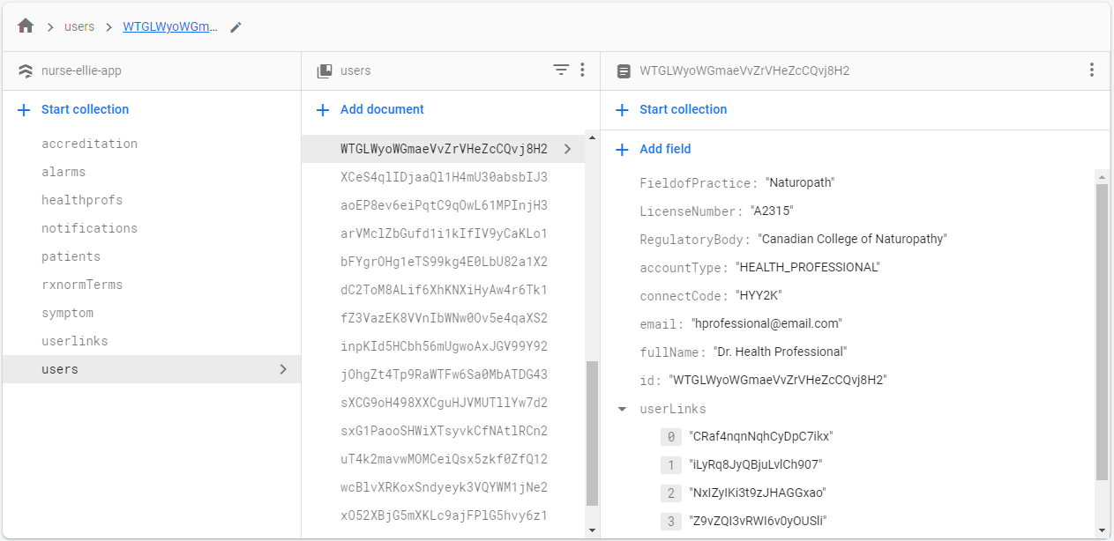

**Database for Patient:**

