一种矢量寻路的思路

先说说这种寻路和A*的对比：
矢量：处理大地图的时候效率提升非常明显。特别是处理比较空旷的大地图，效率甚至可以达到A*的100倍或更多。
A*：处理大地图有很多不必要的运算。
矢量：可以做到非常精确，1px或者小数点大小，而且矢量是缩放无关的。
A*：1X1的网格计算将会导致非常庞大的运算。使得实际几乎不可行。精确度低。
矢量：处理复杂地图是没有很好的一个评估筛选算法。而且没有完整的理论和实践检验。
A*：在网格数量不是很多的情况下无论多复杂的地图都能处理，而且经过实践检验了。
矢量：更智能的评估算法。好的算法和理论能使运算量大大减少。偏AI。
A*：比较一般的评估算法。依赖于数据结构和存储，偏数据结构和空间。
矢量：取决于顶点数量。不会呈指数级递增。
A*：取决于网格数量，而10*10和20*20的差距是4倍。
矢量：任意角度和坐标的评估算法，更为准确。
A*：评估算法只有固定的8个方向，而精确取决于网格坐标，有时候会导致结果不准确。这也是A*很多时候寻出来的路径不真实的原因。
A*和矢量都与地图复杂度有影响，但相对来说，A*的影响更小。A*对于地图大小和精确度更敏感。矢量恰恰相反，精确度和地图大小几乎没有影响。就是如果障碍物一样，那么无论地图多大和要求多精确计算量都是一样的，计算量只取决于地图矢量物体的复杂度和AI算法的好坏。
我是觉得矢量寻路是一个比A*更有前途的寻路。因为A*有几个缺点，不能无限精度的划分（因为每提高1倍，运算量和存储都提高4倍）。而且找到的路径很多时候看起来不太自然。当然现在而言，A*更实用。A*一定能找到路径。而且有各个语言版本的代码。
其实就是任意地图大小的顶点寻路，但这种算法如果好的话那速度比A*就不是快10倍，百倍这样了。A*网格打得很细而且地图大的话还是很费时的。
对于任意一个凸边多边形,最短路径一定是过这个多边形的一个或多个顶点。而且两点之间直线最短，用这个方法可以非常迅速的求出大地图的最短路径。
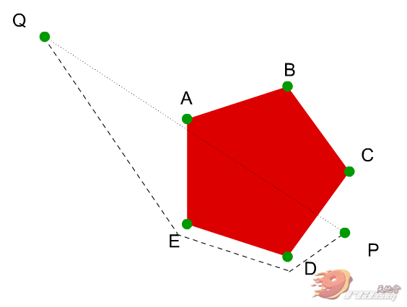
从P到q，肯定走P-D-E-Q或者P-C-B-Q
先连线看相交不，如果相交，找最近的顶点，然后再试，直到E点不相交，路径就找到了，两点之间，直线最短。
如果找到多条路径，然后对找到的路径比较，取最短的一条。
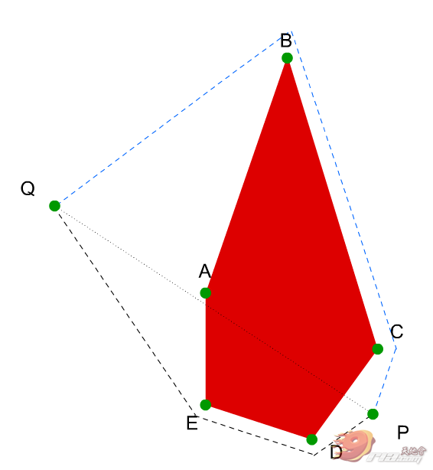
像这种情况，蓝色和黑色的路径最终去黑色的那条。
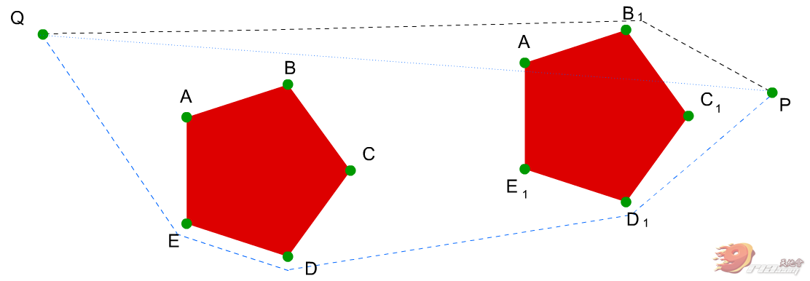
其实就是预先设定好各个转折点(顶点），然后使用相交查找法，依据的定理就是，两点之间，直线最短。这种适合在地图超大，然后又要求非常精细（比如1px的精度）的寻路时。
这样寻路可以做到非常精确(1px的精度，或者到小数点），不过如果地形过于复杂，也可能找不到路就是。
精确度比A*高，计算量和内存消耗的都比A*少。
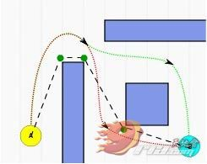
现在我估计能处理掉98%简单的情况和70%复杂的情况。不过还不完美。（还有很多问题和bug）
复杂版，有时候无解，可能是理论的问题，也可能是代码的问题：
DEMO 下载：
 矢量寻路Demo .rar (72.89 KB, 下载次数: 67)
（如果遇到复杂地形的解不出来的时候尝试下稍微更改起点终点连线的角度）
绿色为找到的最优路径，蓝色为寻路最后一步的其它参考评估路径。
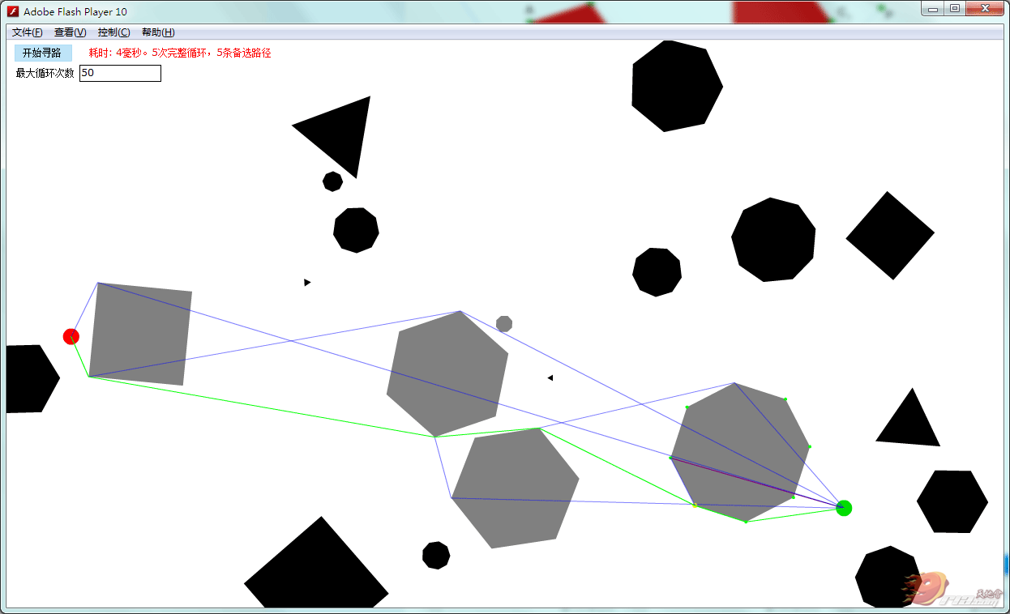
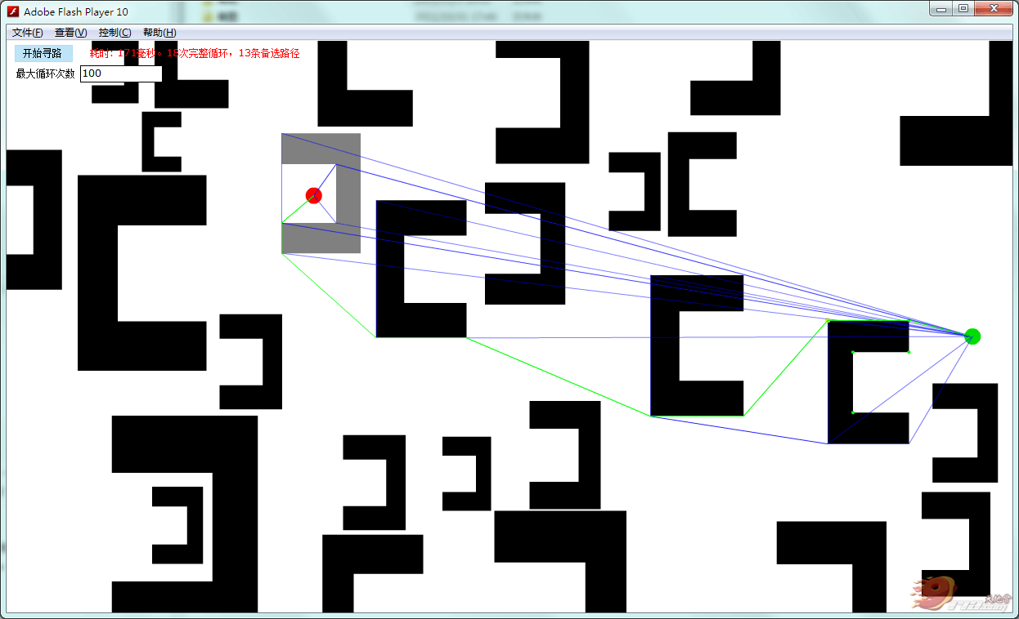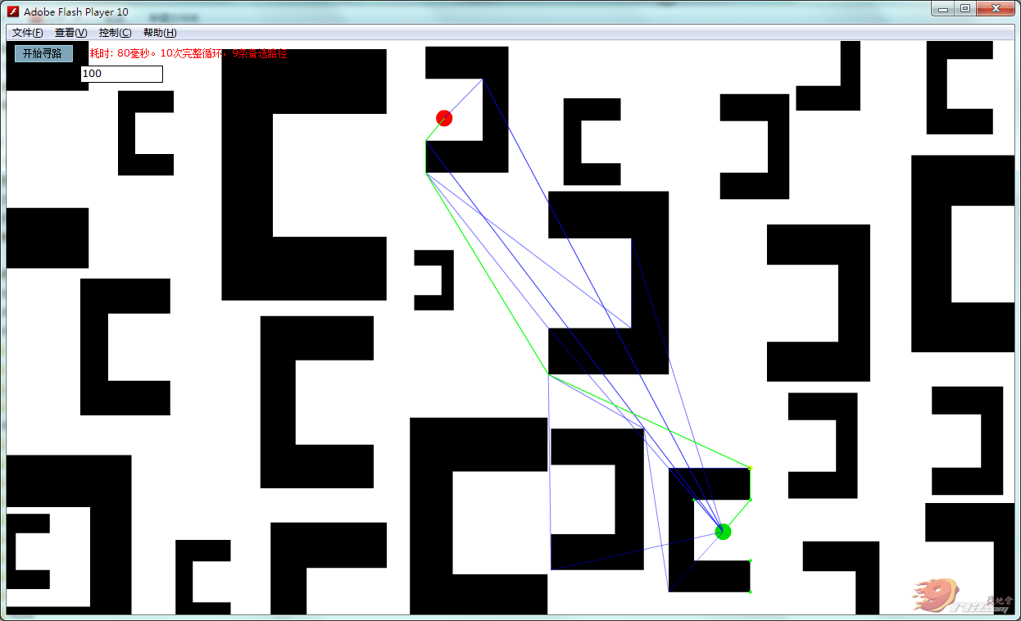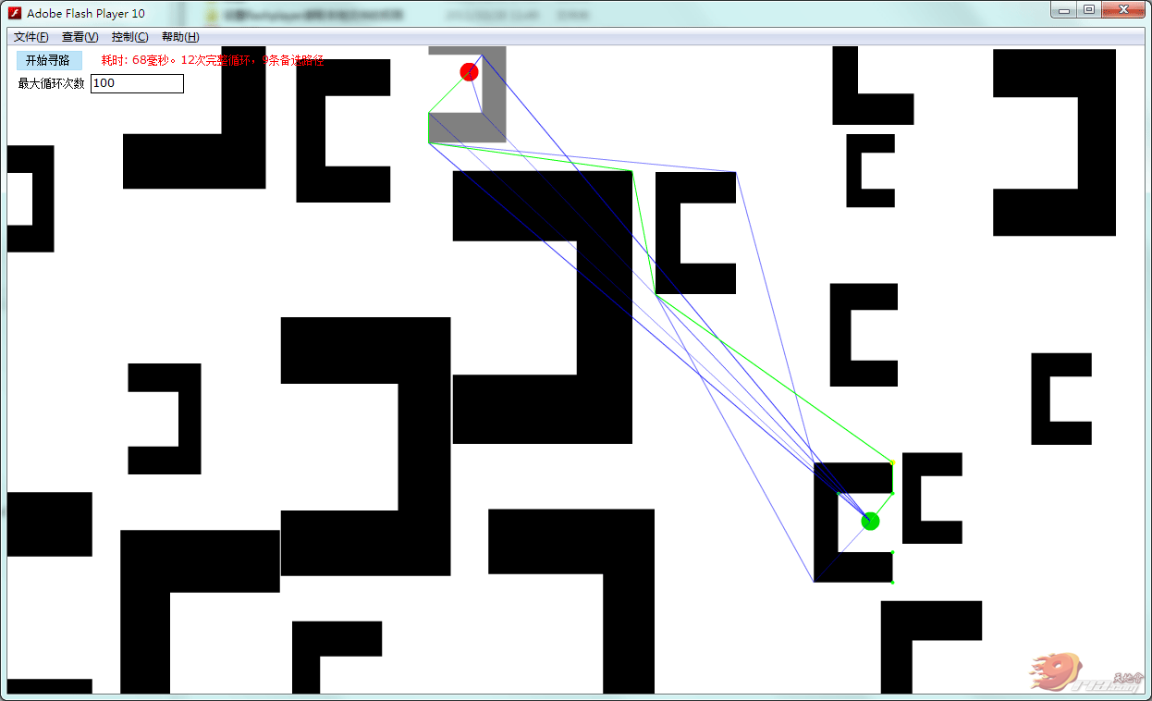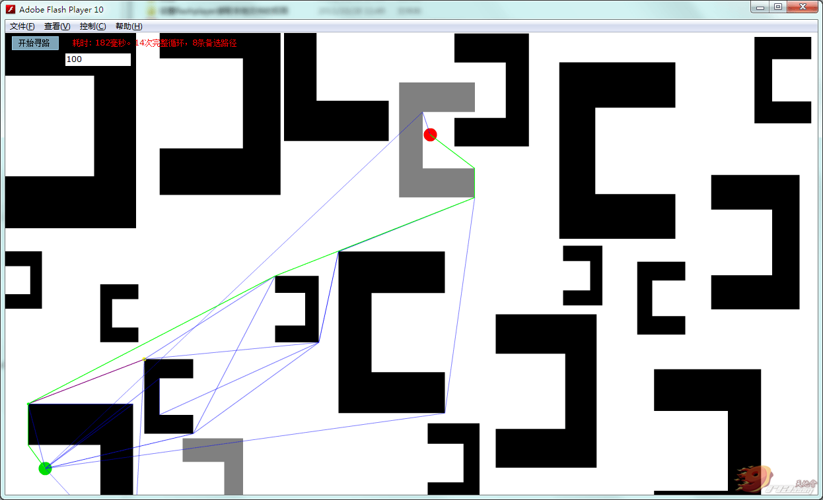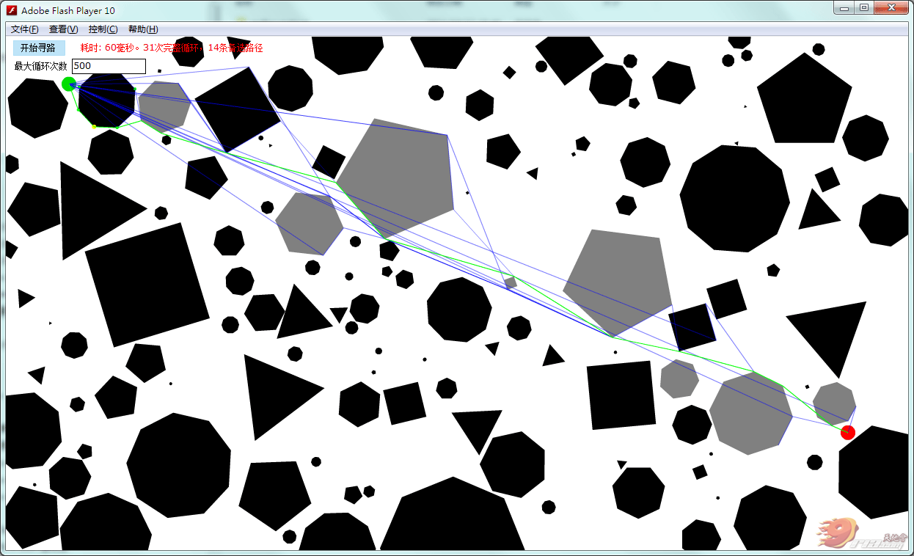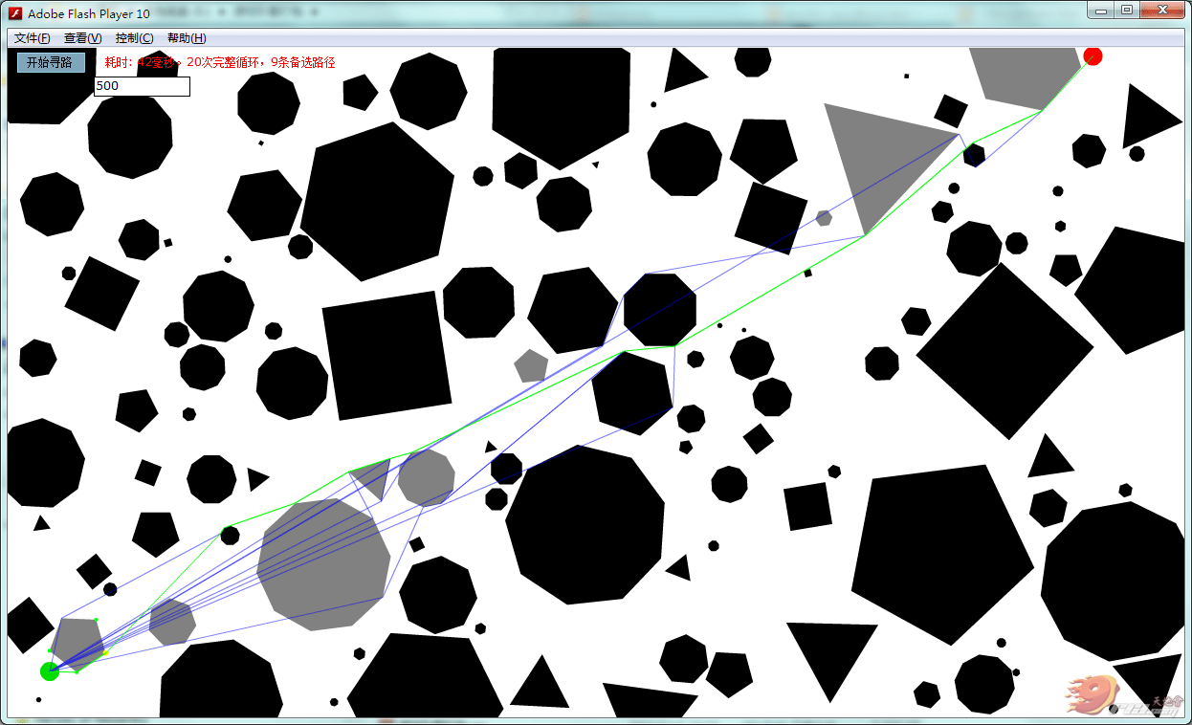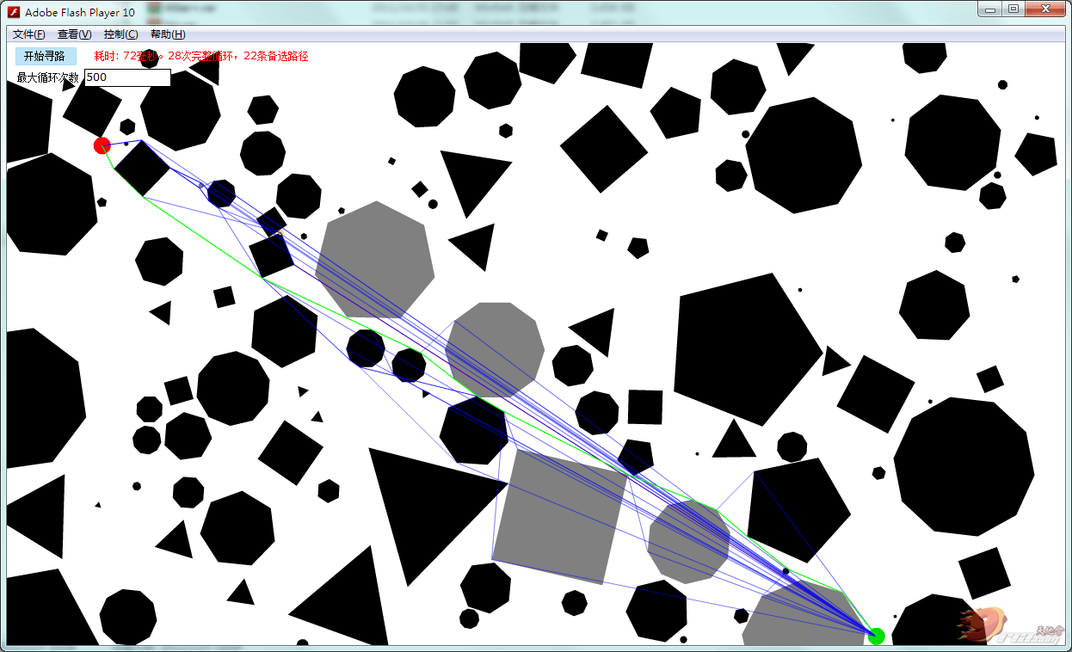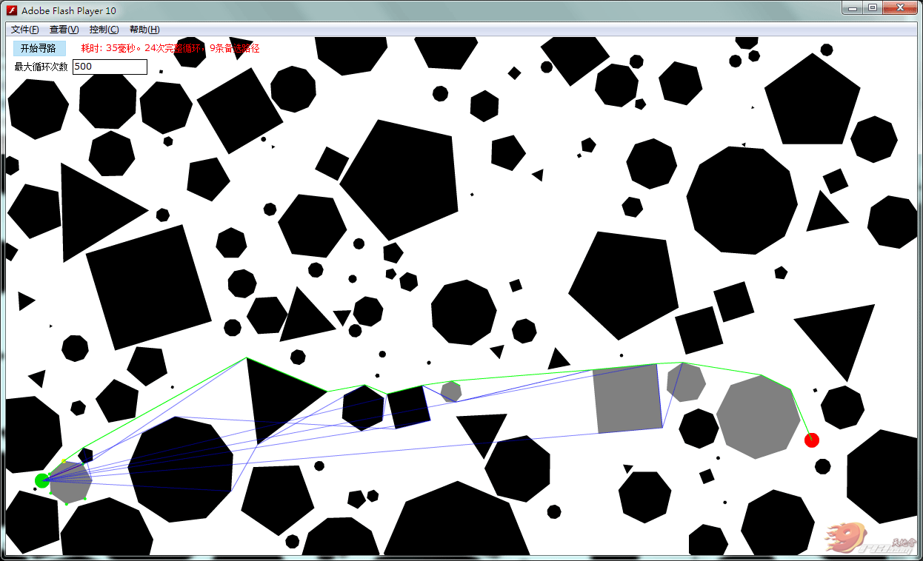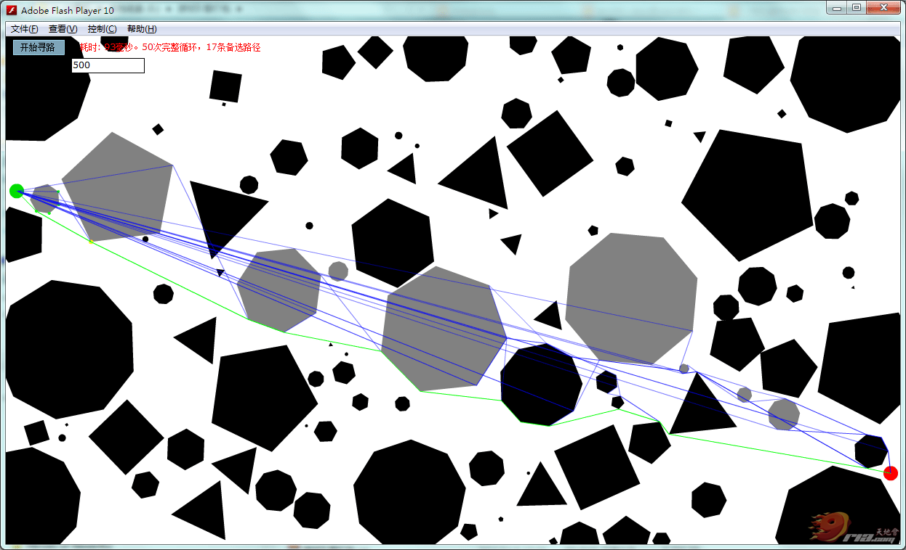
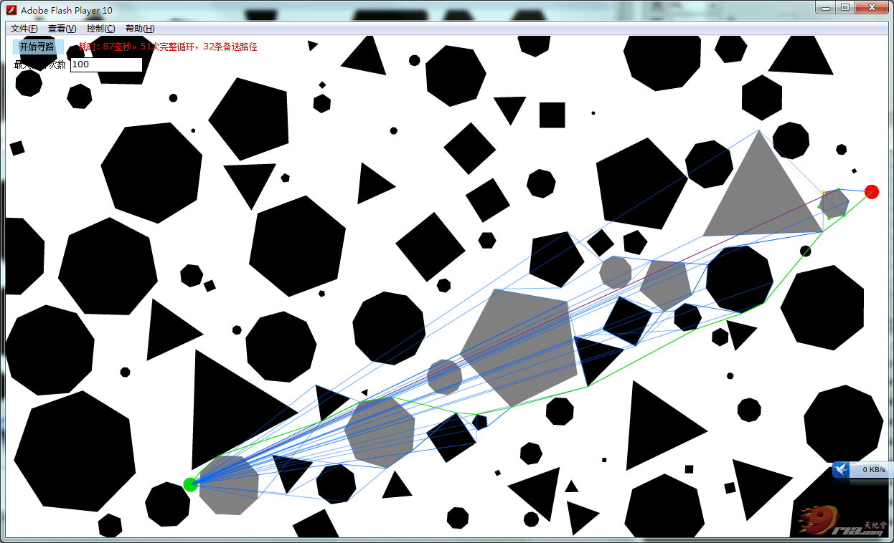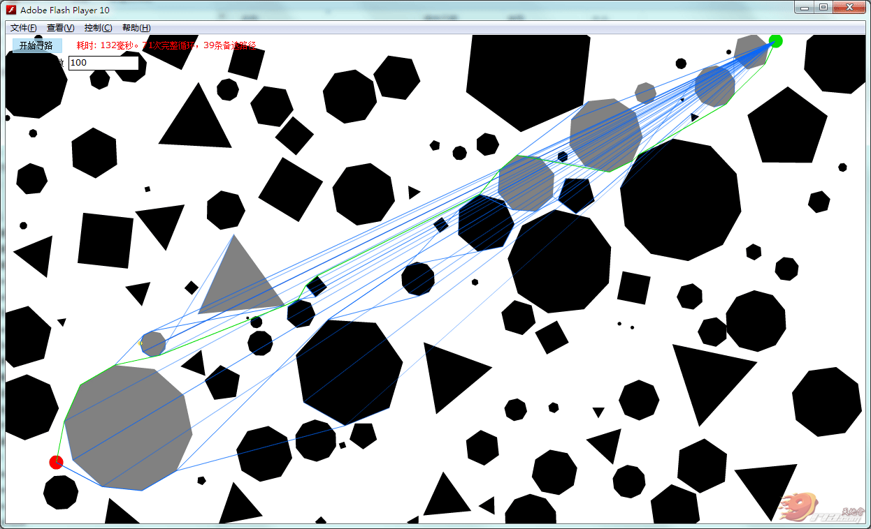
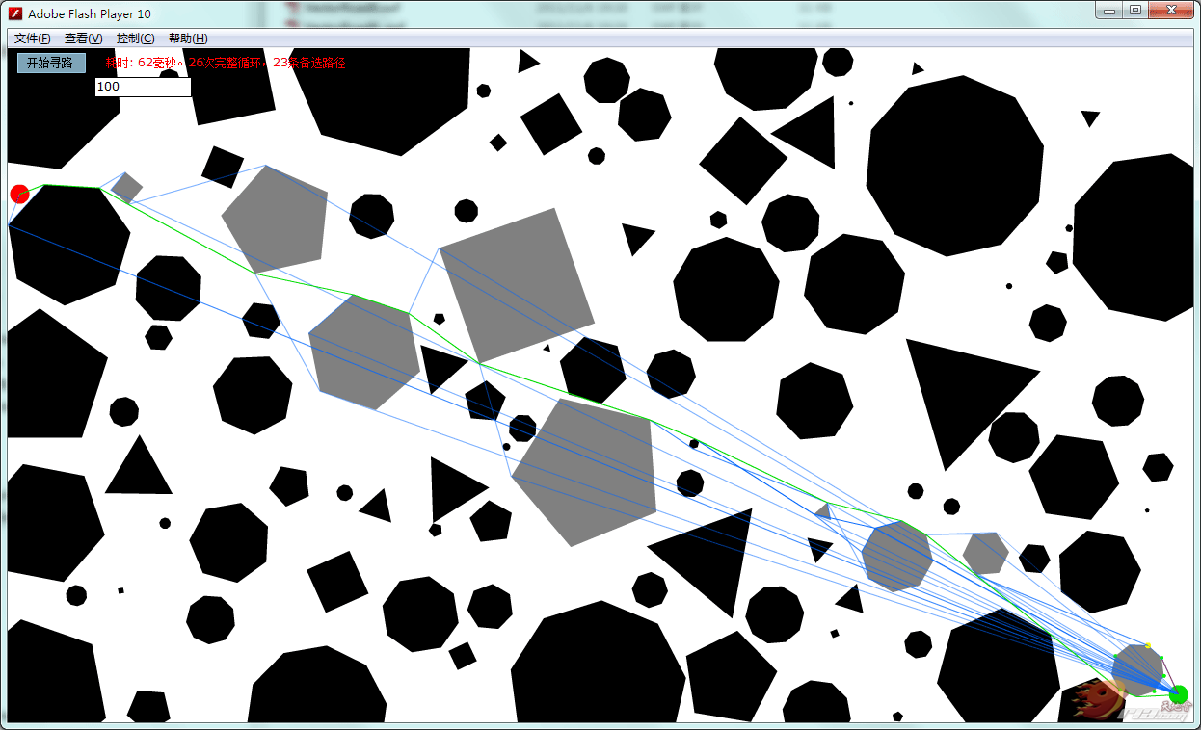
还有不少问题，AI和复杂图形的情况下还是有问题。有时候也找不到路。
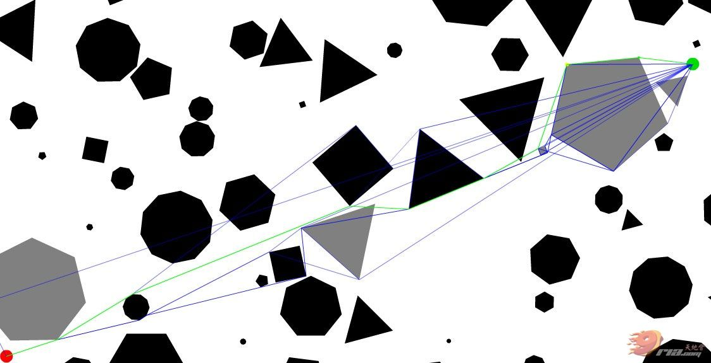
很接近，但某些情况下还是会解不出来。
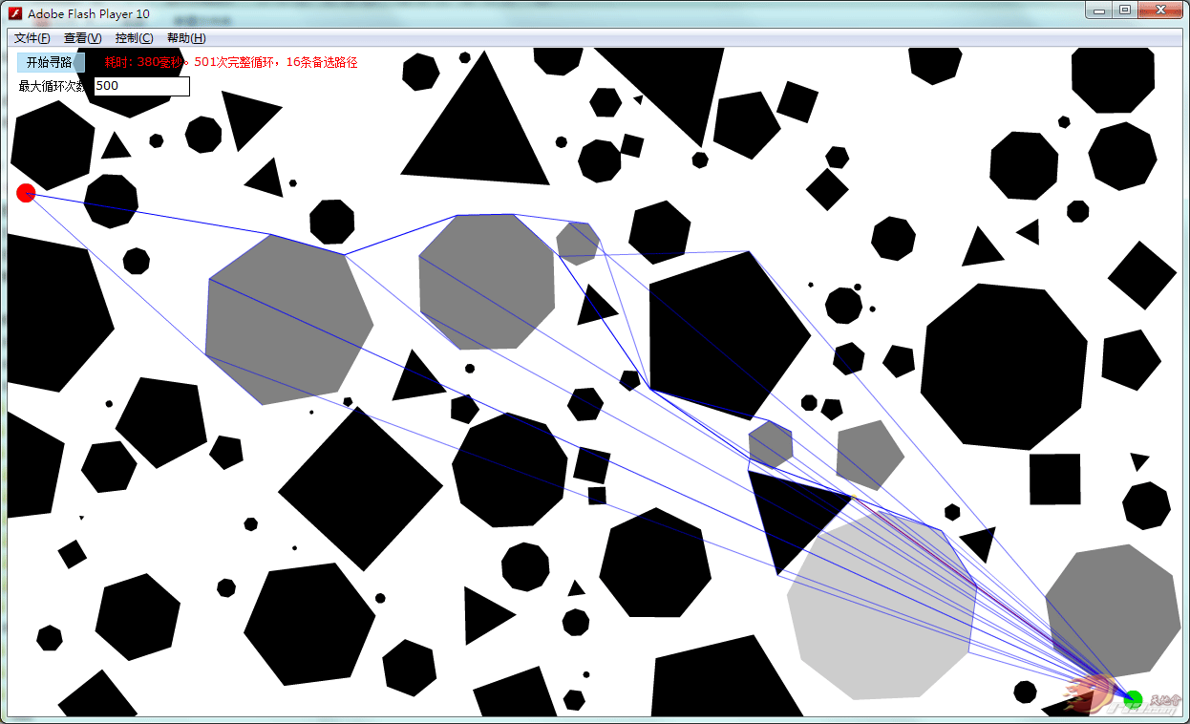
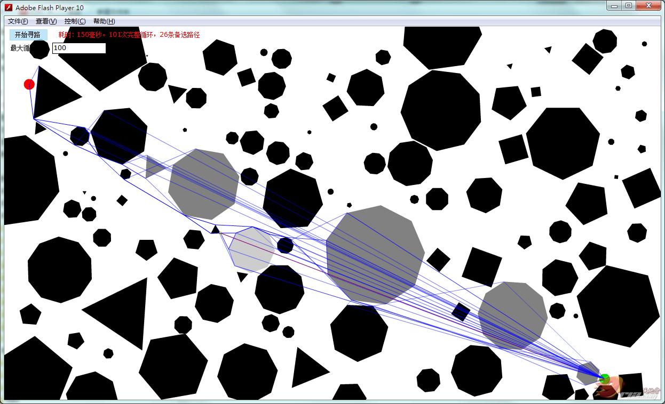

代码还没经过整理，将就看吧。
- package
- {
- import flash.display.Sprite;

- public class VectorsFind
- {
- private var all:Array;

- public function VectorsFind()
- {
- }
- public function initData():void{
- all = new Array();
- var sp:Sprite = Canvas.ins.allBlocks;
- var blockSh:BlockShape;
- var obj:Object = new Object();
- for(var i:int=0;i<sp.numChildren;i++){
- blockSh = sp.getChildAt(i) as BlockShape;
- obj.x = blockSh.x;
- obj.y = blockSh.y;
- obj.points = blockSh.getAllPoints();
- obj.worldPoints = blockSh.getWorldPoints();
- obj.radius = blockSh.radius;
- trace(obj.worldPoints);
- }
- }
- }
- }
复制代码
- package
- {
- import flash.display.Bitmap;
- import flash.display.BitmapData;
- import flash.display.Shape;
- import flash.geom.Matrix;
- import flash.geom.Point;

- public class BlockShape extends Shape
- {
- public static var maxX:Number = 1200;
- public static var maxY:Number = 700;
- public var radius:Number;

- private var pos:Number;
- private var bd:BitmapData;
- private var points:Array;
- private var worldPoints:Array;

- public function BlockShape()
- {
- points = new Array();
- worldPoints = new Array();
- }
- public function getAllPoints():Array{
- return points;
- }
- public function getWorldPoints():Array{
- return worldPoints;
- }
- public function buildRandom():void{
- this.x = int(Math.random()*maxX*100)/100;
- this.y = int(Math.random()*maxY*100)/100;
- var len:Number = 2+Math.random() * 100;
- radius = len;
- //this.graphics.beginFill(0,0.3);
- //this.graphics.drawCircle(0,0,len);
- this.graphics.beginFill(0,1);
- var sides:int=int(3+Math.random()*8);
- var startAt:Number = Math.random()*120;
- var px:Number = int(Math.cos(startAt*Math.PI/180)*len*100)/100;
- var py:Number = int(Math.sin(startAt*Math.PI/180)*len*100)/100;
- this.graphics.moveTo(px,py);
- points[0] = [px,py];
- worldPoints[0] = [px+this.x,py+this.y];
- for(var i:int=0;i<sides-1;i++){
- var add:Number = 360/sides;
- startAt+=add;
- px = int(Math.cos(startAt*Math.PI/180)*len*100)/100;
- py = int(Math.sin(startAt*Math.PI/180)*len*100)/100;
- points[i+1] = [px,py];
- worldPoints[i+1] = [px+this.x,py+this.y];
- this.graphics.lineTo(px,py);
- }
- this.graphics.endFill();

- bd = new BitmapData(len*2,len*2,true,0x00FFFFFF);
- bd.draw(this,new Matrix(1,0,0,1,len,len));
- //var bp:Bitmap = new Bitmap(bd);
- //VectorRoad.ins.addChild(bp);
- var isHit:Boolean = Canvas.ins.checkHit(bd,new Point(this.x-len,this.y-len));
- //trace(isHit);
- if(isHit == false){
- Canvas.ins.redraw();
- }else{
- Canvas.ins.allBlocks.removeChild(this);
- bd.dispose();
- }
- }
- public function checkHit(lineBD:BitmapData,linePoint:Point):Boolean{
- return bd.hitTest(new Point(this.x-radius,this.y-radius),1,lineBD,linePoint,1);
- }
- }
- }
复制代码
- package
- {
- import flash.display.Bitmap;
- import flash.display.BitmapData;
- import flash.display.Shape;
- import flash.display.Sprite;
- import flash.events.MouseEvent;
- import flash.geom.Matrix;
- import flash.geom.Point;
- import flash.geom.Rectangle;
- import flash.utils.getTimer;

- public class Canvas extends Sprite
- {
- public static var ins:Canvas;
- private var bd:BitmapData;
- public var allBlocks:Sprite;
- private var fromSP:Sprite;
- private var toSP:Sprite;
- private var veFind:VectorsFind;
- private var startX:Number;
- private var startY:Number;
- private var endX:Number;
- private var endY:Number;
- private var allPath:Array;
- private var line:Shape;
- private var lineBD:BitmapData;
- private var hits:Array;
- private var realHits:Array;
- private var nowFirstHit:BlockShape;
- private var nowCheckPoint:Point;
- private var pointView:Shape;
- private var nowPathIndex:int;
- private var allLineView:Shape;
- private var maxCount:int = 101;
- private var checkCount:int = 0;
- private var lastFirstHit:BlockShape;

- public function Canvas()
- {
- Canvas.ins = this;
- veFind = new VectorsFind();
- allBlocks = new Sprite();
- this.addChild(allBlocks);
- bd = new BitmapData(1230,700,true,0x00FFFFFF);

- fromSP = new Sprite();
- fromSP.graphics.beginFill(0xFF0000,1);
- fromSP.graphics.drawCircle(0,0,10);
- fromSP.x = Math.random()*1230;
- fromSP.y = Math.random()*700;
- fromSP.buttonMode = true;
- fromSP.useHandCursor = true;
- fromSP.addEventListener(MouseEvent.MOUSE_DOWN,startDragPoint);
- this.addChild(fromSP);

- toSP = new Sprite();
- toSP.graphics.beginFill(0x00DD00,1);
- toSP.graphics.drawCircle(0,0,10);
- toSP.x = Math.random()*1230;
- toSP.y = Math.random()*700;
- toSP.buttonMode = true;
- toSP.useHandCursor = true;
- toSP.addEventListener(MouseEvent.MOUSE_DOWN,startDragPoint);
- this.addChild(toSP);
- line = new Shape();
- this.addChild(line);
- pointView = new Shape();
- this.addChild(pointView);
- allLineView = new Shape();
- this.addChild(allLineView);
- }
- public function redraw():void{
- //trace(allBlocks.numChildren);
- bd.fillRect(new Rectangle(0,0,bd.width,bd.height),0x00FFFFFF);
- bd.draw(allBlocks);
- }
- public function checkHit(hitBD:BitmapData,point:Point):Boolean{
- var isHit:Boolean = bd.hitTest(new Point(0,0),1,hitBD,point,1);
- return isHit;
- }
- public function initData():void{
- trace(allBlocks.numChildren);
- veFind.initData();
- }
- public function find():void{
- var t:int = getTimer();
- var blockSh:BlockShape;
- checkCount = 0;
- for(var i:int=0;i<allBlocks.numChildren;i++){
- blockSh = BlockShape(allBlocks.getChildAt(i));
- blockSh.alpha = 1;
- }
- startX = fromSP.x;
- startY = fromSP.y;
- endX = toSP.x;
- endY = toSP.y;
- allPath = new Array();
- allPath[0] = new Object();
- allPath[0].paths = new Array();
- allPath[0].hasRun = 0;
- allPath[0].needRun = 0;
- allPath[0].distance = 0;
- allPath[0].assess = 1;
- allPath[0].paths[0] = [startX,startY];
- nowPathIndex = 0;
- checkHitLine(allPath[0].paths[0]);
- VectorRoad.info_txt.text = "耗时: "+(getTimer()-t)+"毫秒。"+checkCount+"次完整循环，"+(allPath.length-1)+"条备选路径";
- }
- private function checkLineHitOtherShapes(pointArr:Array,percent:Number=1):Array{
- hits = new Array();
- realHits = new Array();
- line.graphics.clear();
- line.graphics.lineStyle(1,0xFF0000,1);
- line.graphics.moveTo(endX-(endX-pointArr[0])*percent,endY-(endY-pointArr[1])*percent);
- line.graphics.lineTo(endX,endY);
- var blockSh:BlockShape;
- for(var i:int=0;i<allBlocks.numChildren;i++){
- blockSh = BlockShape(allBlocks.getChildAt(i));
- if(blockSh.hitTestObject(line) == true){
- hits.push(blockSh);
- blockSh.alpha = 0.5;
- }
- }
- if(lineBD != null)lineBD.dispose();
- var rect:Rectangle = line.getBounds(line);
- var lineBD:BitmapData = new BitmapData(rect.width,rect.height,true,0x00FFFFFF);
- lineBD.draw(line,new Matrix(1,0,0,1,-rect.x,-rect.y));

- for(i =0;i<hits.length;i++){
- //trace(i);
- if(BlockShape(hits[i]).checkHit(lineBD,new Point(rect.x,rect.y)) == false){
- BlockShape(hits[i]).alpha = 1;
- }else{

- realHits.push({target:hits[i],distance:0});
- }
- }
- //if(realHits.length==0) ;
- return realHits;
- }
- private function checkHitLine(pointArr:Array):void{
- nowCheckPoint = new Point(pointArr[0],pointArr[1]);
- checkLineHitOtherShapes(pointArr);
- var blockSh:BlockShape;
- var i:int;
- for(i =0;i<realHits.length;i++){
- blockSh = realHits[i].target;
- realHits[i].distance = Math.sqrt(Math.pow(blockSh.x-pointArr[0],2)+Math.pow(blockSh.y-pointArr[1],2));
- //trace(realHits[i].distance);
- }
- realHits.sortOn("distance",Array.NUMERIC);
- nowFirstHit = BlockShape(realHits[0].target);
- /**
- if(nowFirstHit == lastFirstHit){
- var ps:Array = nowFirstHit.getWorldPoints();
- var isRealHis:Boolean = checkPointIsHitItSelf(nowCheckPoint.x,nowCheckPoint.y,ps);
- if(isRealHis == true){
- trace("++++++++++上一个");
- realHits.splice(0,1);
- nowFirstHit = BlockShape(realHits[0].target);
- }
- trace("上一个");
- }
- **/
- nowFirstHit.alpha = 0.2;
- //trace(realHits);
- lastFirstHit = nowFirstHit;
- findPoints();
- }
- private function checkPointIsHitItSelf(pointX:Number,pointY:Number,points:Array):Boolean{
- var ps:Array = points;
- var isRealHis:Boolean = false;
- var x3:Number;
- var y3:Number;
- var x4:Number;
- var y4:Number;
- var i:int;
- for(i=0;i<ps.length;i++){
- x3 = ps[i][0];
- y3 = ps[i][1];
- if(i<ps.length-1){
- x4 = ps[i+1][0];
- y4 = ps[i+1][1];
- }else{
- x4 = ps[0][0];
- y4 = ps[0][1];
- }
- if(checkTwoLines(pointX,pointY,endX,endY,x3,y3,x4,y4) == true){
- isRealHis = true;
- }
- }
- return isRealHis;
- }
- private function checkTwoLines(x1:Number,y1:Number,x2:Number,y2:Number,x3:Number,y3:Number,x4:Number,y4:Number):Boolean{
- var line1:Array = [ { x:x1, y:y1 }, { x:x2, y:y2 }]
- var line2:Array = [ { x:x3, y:y3 }, { x:x4, y:y4 }]
- var myside:Number = tgFun(line1[0], line1[1], line2[0]) * tgFun(line1[0], line1[1], line2[1]);
- var myside2:Number = tgFun(line2[0], line2[1], line1[0]) * tgFun(line2[0], line2[1], line1[1]);
- if (myside<0 && myside2<0)
- {
- return true;

- }else
- {
- return false
- }
- }
- private function findPoints():void{
- pointView.graphics.clear();
- pointView.graphics.beginFill(0xFFFF00,1);

- pointView.graphics.drawCircle(nowCheckPoint.x,nowCheckPoint.y,3);
- pointView.graphics.beginFill(0x00FF00,1);

- var ps:Array = nowFirstHit.getWorldPoints();
- var ra:Number = Math.sqrt(Math.pow(nowCheckPoint.x-nowFirstHit.x,2)+Math.pow(nowCheckPoint.y-nowFirstHit.y,2));
- var dis:Number;
- //trace(ps.length);
- //trace(ps);
- var pssort:Array =new Array();
- for(var i:int=0;i<ps.length;i++){
- dis = Math.sqrt(Math.pow(nowCheckPoint.x-ps[i][0],2)+Math.pow(nowCheckPoint.y-ps[i][1],2));
- ps[i][2] = dis;
- pssort[i] = {distance:dis,index:i};
- }
- pssort.sortOn("distance",Array.NUMERIC);
- //trace(pssort[0].index);
- var lowIndex:int = pssort[0].index;
- var index:int = lowIndex;
- //pointView.graphics.drawCircle(ps[lowIndex][0],ps[lowIndex][1],3);
- var x1:Number;
- var y1:Number;
- var x2:Number;
- var y2:Number;
- var x3:Number;
- var y3:Number;
- var x4:Number;
- var y4:Number;
- var isRound:Boolean = false;
- x1 = nowCheckPoint.x;
- y1 = nowCheckPoint.y;
- var needCheckPoints:Array = new Array();

- while(isRound == false){
- index--;
- if(index<0) index=ps.length-1;
- if(index==lowIndex) {
- isRound=true;
- }
- x2 = ps[index][0];
- y2 = ps[index][1];
- var isNeed:Boolean = true;
- for(i=0;i<ps.length;i++){
- x3 = ps[i][0];
- y3 = ps[i][1];
- if(i<ps.length-1){
- x4 = ps[i+1][0];
- y4 = ps[i+1][1];
- }else{
- x4 = ps[0][0];
- y4 = ps[0][1];

- }
- var line1:Array = [ { x:endX+(x1-endX)*1, y:endY+(y1-endY)*1 }, { x:x2, y:y2 }]
- var line2:Array = [ { x:x3, y:y3 }, { x:x4, y:y4 }]
- var myside:Number = tgFun(line1[0], line1[1], line2[0]) * tgFun(line1[0], line1[1], line2[1]);
- var myside2:Number = tgFun(line2[0], line2[1], line1[0]) * tgFun(line2[0], line2[1], line1[1]);
- if (myside<0 && myside2<0)
- {
- //trace('相交');
- isNeed = false;
- break;
- }else
- {
- //trace('不相交');
- }

- for(var m:int=0;m<allPath.length;m++){
- var pathTmp:Array = allPath[m].paths;
- if(Math.abs(pathTmp[pathTmp.length-1][0]-x2)<1 && Math.abs(pathTmp[pathTmp.length-1][1]-y2)<1){
- isNeed = false;
- }
- }
- }
- if(isNeed == true){
- needCheckPoints.push([ps[index][0],ps[index][1],ps[index][2],index]);
- pointView.graphics.drawCircle(ps[index][0],ps[index][1],2);
- }

- if(Math.abs(nowCheckPoint.x-x2)<1 && Math.abs(nowCheckPoint.y-y2)<1){
- trace("+++++++++++++++++++++++++++++++++++++++++++");
- var lastCheckIndex:int = allPath[nowPathIndex].pointIndex;
- needCheckPoints = new Array();
- if(lastCheckIndex == ps.length-1){
- needCheckPoints.push([ps[0][0],ps[0][1],ps[0][2],0]);
- }else{
- needCheckPoints.push([ps[lastCheckIndex+1][0],ps[lastCheckIndex+1][1],ps[lastCheckIndex+1][2],lastCheckIndex+1]);
- }
- if(lastCheckIndex == 0){
- needCheckPoints.push([ps[ps.length-1][0],ps[ps.length-1][1],ps[ps.length-1][2],ps.length-1]);
- }else{
- needCheckPoints.push([ps[lastCheckIndex-1][0],ps[lastCheckIndex-1][1],ps[lastCheckIndex-1][2],lastCheckIndex-1]);
- }

- isRound=true;
- }
- }

- var endR:Number = Math.atan2(endY-nowCheckPoint.y,endX-nowCheckPoint.x);
- var needCheckPoints1:Array = new Array();
- var needCheckPoints2:Array = new Array();
- for(i=0;i<needCheckPoints.length;i++){
- needCheckPoints[i][4] = Math.atan2(needCheckPoints[i][1]-nowCheckPoint.y,needCheckPoints[i][0]-nowCheckPoint.x);
- //trace(needCheckPoints[i][4],endR);
- if(needCheckPoints[i][4]>endR){
- needCheckPoints1.push({distance:needCheckPoints[i][2],data:needCheckPoints[i]});
- }else{
- needCheckPoints2.push({distance:needCheckPoints[i][2],data:needCheckPoints[i]});

- }
- }
- trace(needCheckPoints1.length,":",needCheckPoints2.length);
- needCheckPoints1.sortOn("distance",Array.NUMERIC|Array.DESCENDING);
- needCheckPoints2.sortOn("distance",Array.NUMERIC|Array.DESCENDING);

- var newPath1:Object;
- newPath1 = new Object();
- var hitsArr:Array;
- newPath1.paths = new Array();
- if(needCheckPoints1.length>0){

- newPath1.hasRun = Math.sqrt(Math.pow(nowCheckPoint.x-needCheckPoints1[0].data[0],2)+Math.pow(nowCheckPoint.y-needCheckPoints1[0].data[1],2))+allPath[nowPathIndex].hasRun;
- newPath1.needRun = Math.sqrt(Math.pow(endX-needCheckPoints1[0].data[0],2)+Math.pow(endY-needCheckPoints1[0].data[1],2));
- newPath1.distance = 0;
- newPath1.assess = 1;
- newPath1.pointIndex = needCheckPoints1[0].data[3];
- hitsArr = checkLineHitOtherShapes([needCheckPoints1[0].data[0],needCheckPoints1[0].data[1]],1);
- trace(hitsArr);
- if(hitsArr.length==0){
- newPath1.assess = 0;
- }
- if(hitsArr.length ==1 && hitsArr[0].target == nowFirstHit){
- if(checkPointIsHitItSelf(needCheckPoints1[0].data[0],needCheckPoints1[0].data[1],ps) == false){
- newPath1.assess = 0;
- }
- trace("是自己",newPath1.assess);
- }
- trace("run",newPath1.assess,newPath1.hasRun+newPath1.needRun);
- newPath1.paths = new Array();
- allPath.push(newPath1);

- for(i=0;i<allPath[nowPathIndex].paths.length;i++){
- newPath1.paths.push([allPath[nowPathIndex].paths[i][0],allPath[nowPathIndex].paths[i][1]]);
- }
- newPath1.paths.push([needCheckPoints1[0].data[0],needCheckPoints1[0].data[1]]);
- }
- //
- var newPath2:Object;
- newPath2 = new Object();
- newPath2.paths = new Array();
- if(needCheckPoints2.length>0){
- newPath2.hasRun = Math.sqrt(Math.pow(nowCheckPoint.x-needCheckPoints2[0].data[0],2)+Math.pow(nowCheckPoint.y-needCheckPoints2[0].data[1],2))+allPath[nowPathIndex].hasRun;
- newPath2.needRun = Math.sqrt(Math.pow(endX-needCheckPoints2[0].data[0],2)+Math.pow(endY-needCheckPoints2[0].data[1],2));
- newPath2.distance = 0;
- newPath2.assess = 1;
- newPath2.pointIndex = needCheckPoints2[0].data[3];
- hitsArr = checkLineHitOtherShapes([needCheckPoints2[0].data[0],needCheckPoints2[0].data[1]],1);
- trace(hitsArr);
- if(hitsArr.length==0){
- newPath2.assess = 0;
- }
- if(hitsArr.length ==1 && hitsArr[0].target == nowFirstHit){
- if(checkPointIsHitItSelf(needCheckPoints2[0].data[0],needCheckPoints2[0].data[1],ps) == false){
- newPath2.assess = 0;
- }
- trace("是自己2",newPath2.assess);
- }
- trace("run",newPath2.assess,newPath2.hasRun+newPath2.needRun);
- newPath2.paths = new Array;
- allPath.push(newPath2);

- for(i=0;i<allPath[nowPathIndex].paths.length;i++){
- newPath2.paths.push([allPath[nowPathIndex].paths[i][0],allPath[nowPathIndex].paths[i][1]]);
- }
- newPath2.paths.push([needCheckPoints2[0].data[0],needCheckPoints2[0].data[1]]);
- }

- if(needCheckPoints1.length >0 || needCheckPoints2.length >0){
- allPath.splice(nowPathIndex,1);
- }
- trace(allPath.length);
- checkAllPath();
- }
- private function checkAllPath():void{
- checkCount++;
- trace("checkAllPath",checkCount,"共",allPath.length);
- if(checkCount>maxCount){
- return;
- }
- allLineView.graphics.clear();
- allLineView.graphics.lineStyle(1,0x0000FF,0.5);
- var path:Array;
- for(var i:int=0;i<allPath.length;i++){
- path = allPath[i].paths;
- allPath[i].distance = allPath[i].hasRun + allPath[i].needRun;
- allLineView.graphics.moveTo(path[0][0],path[0][1]);
- for(var j:int=1;j<path.length;j++){
- allLineView.graphics.lineTo(path[j][0],path[j][1]);
- }
- allLineView.graphics.lineTo(endX,endY);
- //allLineView.graphics.endFill();
- }
- allPath.sortOn("distance",Array.NUMERIC);
- trace(allPath[0].assess,"+++++");
- if(allPath[0].assess == 0){
- //已经找到最短路径
- path = allPath[0].paths;
- allLineView.graphics.lineStyle(1,0x00FF00,1);
- allLineView.graphics.moveTo(path[0][0],path[0][1]);
- for(j=1;j<path.length;j++){
- allLineView.graphics.lineTo(path[j][0],path[j][1]);
- }
- allLineView.graphics.lineTo(endX,endY);
- }else{
- nowPathIndex = 0;
- var len:int = allPath[0].paths.length;
- checkHitLine(allPath[0].paths[len-1]);
- }
- }
- //tg的差值；
- private function tgFun(p1:Object, p2:Object,p:Object):Number
- {
- var tg:Number = (p.x - p1.x) * (p2.y - p1.y) - (p2.x - p1.x) * (p.y - p1.y);
- return tg;
- }

- private function startDragPoint(event:MouseEvent):void{
- Sprite(event.currentTarget).startDrag();
- this.stage.addEventListener(MouseEvent.MOUSE_UP,stopDragPoint);
- }
- private function stopDragPoint(event:MouseEvent):void{
- fromSP.stopDrag();
- toSP.stopDrag();
- this.stage.removeEventListener(MouseEvent.MOUSE_UP,stopDragPoint);
- }
- }
- }
复制代码
- package
- {
- import flash.display.Sprite;
- import flash.events.MouseEvent;
- import flash.text.TextField;
- import flash.text.TextFormat;

- [SWF(width="1230",height="700",backgroundColor="#FFFFFF",frameRate = 30)]
- public class VectorRoad extends Sprite
- {
- private var canvas:Canvas;
- public static var ins:VectorRoad;
- public static var info_txt:TextField;
- private var btn:Sprite;

- public function VectorRoad()
- {
- VectorRoad.ins = this;
- canvas = new Canvas();
- this.addChild(canvas);
- btn = new Sprite();
- btn.graphics.beginFill(0xa9dbf6,0.75);
- btn.graphics.lineStyle(1,0xa9dbf6,0.9);
- btn.graphics.drawRect(0,0,70,20);
- btn.x = 10;
- btn.y = 5;
- btn.buttonMode = true;
- btn.useHandCursor = true;
- var txt:TextField = new TextField();
- txt.text = "开始寻路";
- txt.width = btn.width;
- txt.height = btn.height;
- txt.x = 8;
- txt.selectable = false;
- txt.mouseEnabled = false;
- btn.addChild(txt);
- this.addChild(btn);
- var bs:BlockShape;
- for(var i:int=0;i<30;i++){
- bs = new BlockShape();
- canvas.allBlocks.addChild(bs);
- bs.buildRandom();
- }
- canvas.initData();
- btn.addEventListener(MouseEvent.CLICK,startFind);
- info_txt = new TextField();
- info_txt.mouseEnabled = false;
- info_txt.y = 5;
- info_txt.x = 100;
- info_txt.width = 300;
- var tf:TextFormat = new TextFormat();
- tf.color = 0xFF0000;
- tf.font ="Verdana";
- info_txt.defaultTextFormat = tf;
- this.addChild(info_txt);
- }
- private function startFind(event:MouseEvent):void{
- canvas.find();
- }
- }
- }
复制代码

回复 2# lzl123
思路=代码，完整的思路如果有了，还怕没代码么。代码这么简单的事。我觉得讨论代码本身没什么意义，讨论思路和可能遇到的情况和解决办法更重要（伪代码），思路比代码更难啊。不过需要一个Demo测试各种情况倒是真。
完美真不好说，A*的特点是只要有路就一定找得到，这个倒不排除可能在极端情况下找不到路的可能。[

其实我想说的是能不能找到一种在各种复杂情况下的规律。这样可以使运算量达到最小。
所以需要归纳和几何求证才能找到规律。这并不是代码能解决的问题。先把方法总结出来，再code。穷举法确实不是个好办法。也或许可以想A*一样，把当前可能的路径都存起来，然后每一步比较最小代价那条路径（可能是最短路径）。
算法应该可以拆成两部分，一个是找到一条合乎AI(比如动物查找路径的方式，比如动物遇到障碍物的第一反应就是绕过障碍物，而一般选择视野范围内当前视野范围内能直线到达的顶点），这样可以用在动物AI寻路上。
一个是找到最短路径，然后就要求证出这条路径的规律，也就是说一个符合什么条件的顶点才一定是最短路径中的顶点.
至于死循环那个问题，肯定可以避免的。
按照你这话 就死循环了 首先p找到的是d，d跟p又最近那不就死循环了，P已经在路径中肯定是排除的，因为你从P到D，又从D到P，代价肯定比PD大，所以肯定排除的。就像ED，如果D已经在路径节点中，那么下个考虑的节点也肯定不是D。
就比如这个图，第一次连线检测碰撞物是右边的五边形，然后找出这个五边形的5个顶点，这个可视范围内能最快到的肯定是B1或者D1，因为P->C1-B1>P-B1，所以C1先放在排除的顶点里面，然后从B1和D1再开始。D1可能会有两条路径。P->D1->B-Q P->D1->D>->E->Q 但可以肯定的是，p->B1->Q肯定是代价最小的。就是在哪一步就排除另外两条路径，而能知道p->B1->Q就是最短路径，这个是可以借鉴A*排序的地方（当然这也肯定是启发式搜索，只不过比A*更进一步，更智能，A*等于是半穷举半启发的算法，Dijkstra的改进版，而且普遍A*的评估函数并不好）。我这边筛选的依据是，从P-B1-Q和P-D1-Q两条路径是相等的，但D1-Q这条路径和左边五边形相交了，所以从P->D1到Q所用的路径肯定代价大于p->B1->Q，因为只要从D1走，它肯定代价会超过D1-Q的直线距离。当然这里说的也只是一种情况，可能还会有更复杂的情况。
原则有几个：
1.两点之间，直线最短。
2.如果连接这条直线，中间碰到障碍物，那么绕过这个障碍物的代价是最小的（应该是，不是很好确定）。
3.绕过障碍物经过的点必定在这个这个障碍物的凸边顶点上，因为如果是凹边，那肯定是死胡同。
4.在顶点搜索筛选过程中尽量找出最短路径的顶点并排除其他不相关的顶点，以使运算量达到最小。(其实就是筛选和查找算法的好坏）
然后分为开放式寻路和封闭式寻路。
开放式：空旷的地图上出障碍物的任意地点都是可以走的。
封闭式，只能经过给点的路线和交叉点，可以在任意两个相连交叉点走动。比如汽车街道。

http://bbs.9ria.com/thread-102623-1-1.html

