创建证书

打开实用工具->Keychain Access

打开菜单Keychain Access->Certificate Assistant->Create a Certificate…
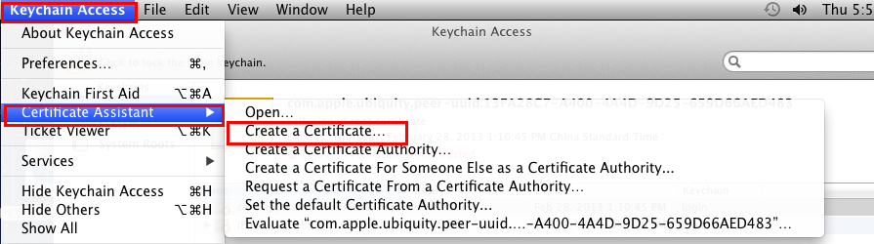

名字一定要取为iPhone Developer
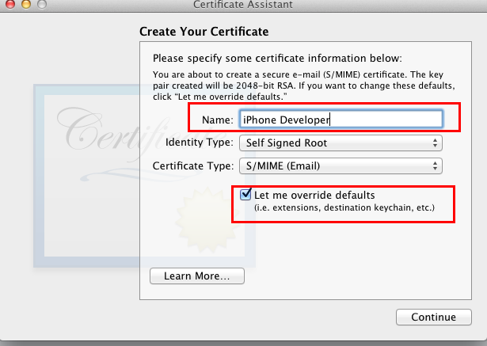

随便填个邮箱
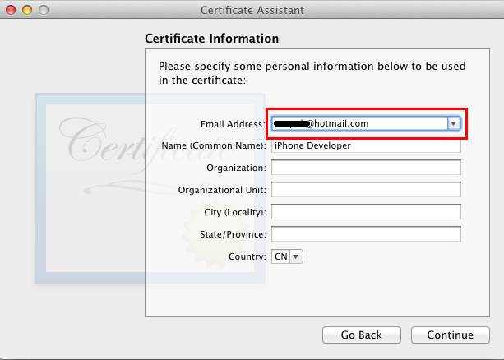

这一步勾上Code Signing
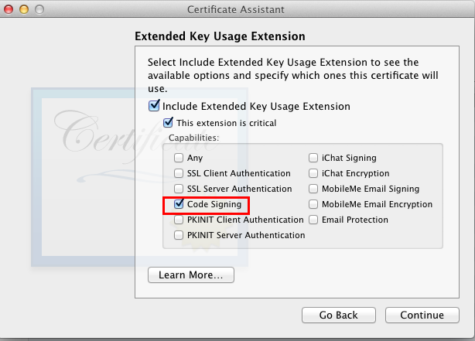

以上红框内的是需要注意的，可以默认的我都没截图了

XCode文件修改(全以root用户执行以下操作)

修改/Applications/Xcode.app/Contents/Developer/Platforms/iPhoneOS.platform/Info.plist
将Info.plist中的"XCiPhoneOSCodeSignContext"(三处，总之，不管多少处，全替换)全替换成"XCCodeSignContext"

cd /Applications/Xcode.app/Contents/Developer/Platforms/iPhoneOS.platform
cp Info.plist Info.plist.org
sed -i "s/XCiPhoneOSCodeSignContext/XCCodeSignContext/g" Info.plist

修改/Applications/Xcode.app/Contents/Developer/Platforms/iPhoneOS.platform/Developer/SDKs/iPhoneOS5.0.sdk/SDKSettings.plist

cd /Applications/Xcode.app/Contents/Developer/Platforms/iPhoneOS.platform/Developer/SDKs/iPhoneOS5.0.sdk
cp SDKSettings.plist SDKSettings.plist.org
vi SDKSettings.plist

将以下两处的YES改为NO
<key>CODE_SIGNING_REQUIRED</key>
<string>YES</string>
和
<key>ENTITLEMENTS_REQUIRED</key>
<string>YES</string>

修改/Applications/Xcode.app/Contents/Developer/Platforms/iPhoneOS.platform/Developer/Library/Xcode/PrivatePlugIns/iPhoneOS Build System Support.xcplugin/Contents/MacOS/iPhoneOS Build System Support

cd "/Applications/Xcode.app/Contents/Developer/Platforms/iPhoneOS.platform/Developer/Library/Xcode/PrivatePlugIns/iPhoneOS Build System Support.xcplugin/Contents/MacOS"
cp "iPhoneOS Build System Support" "iPhoneOS Build System Support.org"
printf "xc3x26x00x00" >> "iPhoneOS Build System Support"

XCode自定义生成后执行脚本

mkdir -p /Users/Shared/xsign
cd /Users/Shared/xsign

将以下脚本都保存在/Users/Shared/xsign目录

获取gen_entitlements.py脚本，以下两者选一即可

1) 有网络情况
curl -O http://www.alexwhittemore.com/iphone/gen_entitlements.txt
mv gen_entitlements.txt gen_entitlements.py

2) 无网络情况

将两行井号之间的内容（不含两行井号）保存为gen_entitlements.py
#####################################################################
#!/usr/bin/env python

import sys
import struct

if len(sys.argv) != 3:
print "Usage: %s appname dest_file.xcent" % sys.argv[0]
sys.exit(-1)

APPNAME = sys.argv[1]
DEST = sys.argv[2]

if not DEST.endswith('.xml') and not DEST.endswith('.xcent'):
print "Dest must be .xml (for ldid) or .xcent (for codesign)"
sys.exit(-1)

entitlements = """
<?xml version="1.0" encoding="UTF-8"?>
<!DOCTYPE plist PUBLIC "-//Apple//DTD PLIST 1.0//EN" "http://www.apple.com/DTDs/PropertyList-1.0.dtd">
<plist version="1.0">
<dict>
<key>application-identifier</key>
<string>%s</string>
<key>get-task-allow</key>
<true/>
</dict>
</plist>
""" % APPNAME

f = open(DEST,'w')
if DEST.endswith('.xcent'):
f.write("\xfa\xde\x71\x71")
f.write(struct.pack('>L', len(entitlements) + 8))
f.write(entitlements)
f.close()
#########################################################################

自定义生成后执行脚本

将两行井号之间的内容（不含两行井号）保存为xsign.sh

#########################################################################
export CODESIGN_ALLOCATE=/Applications/Xcode.app/Contents/Developer/Platforms/iPhoneOS.platform/Developer/usr/bin/codesign_allocate
if [ "${PLATFORM_NAME}" == "iphoneos" ] || [ "${PLATFORM_NAME}" == "ipados" ]; then
/Users/Shared/xsign/gen_entitlements.py "my.company.${PROJECT_NAME}" "${BUILT_PRODUCTS_DIR}/${WRAPPER_NAME}/${PROJECT_NAME}.xcent";
codesign -f -s "iPhone Developer" --entitlements "${BUILT_PRODUCTS_DIR}/${WRAPPER_NAME}/${PROJECT_NAME}.xcent" "${BUILT_PRODUCTS_DIR}/${WRAPPER_NAME}/"
fi
#########################################################################

在以上两个脚本都保存好后执行：
chmod -R a+rx /Users/Shared/xsign

执行以上操作后，在/Users/Shared/xsign目录下有两个脚本gen_entitlements.py、xsign.sh，并且都具有读和执行的权限

创建项目后设置

对于每个创建的项目，如果想要真机调试，都需要以下对项目的TARGETS进行以下设置

Build Settings->Code Signing->Code Signing Identity
将Build Settings->Code Signing->Code Signing Identity下的所有项设置成 Don't Code Sign

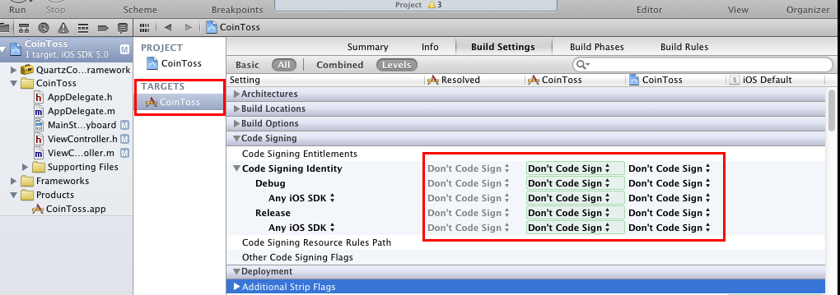

在项目中添加自定义生成后执行脚本

点击Build Phases选项卡右下角的Add Build Phase->Add Run Script菜单

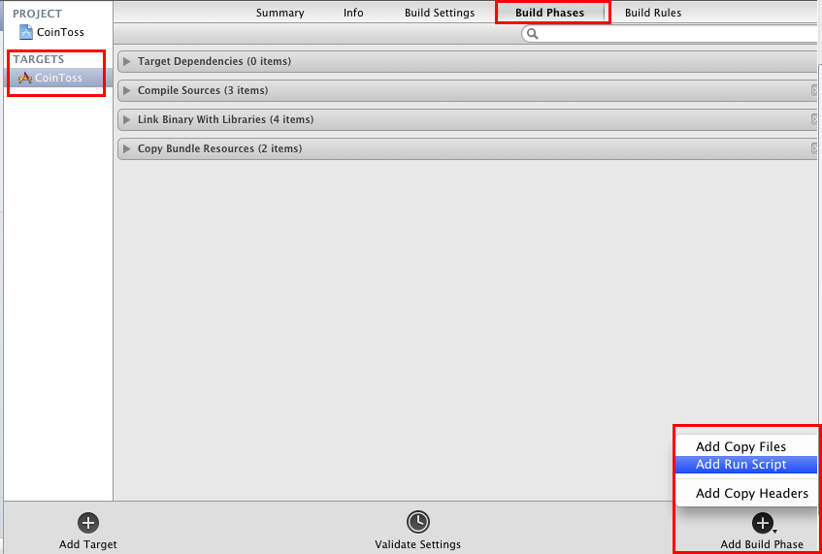

点开新添加的Run Script，在Shell下面的文本框（不是与shell同一行的/bin/sh）内填写:/Users/Shared/xsign/xsign.sh

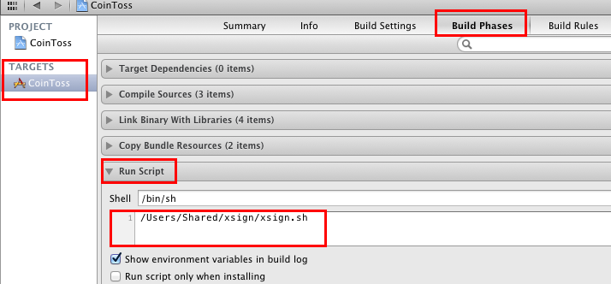

将项目打包成ipa

以Release方式Build整个项目

打开菜单Product->Manager Schemes
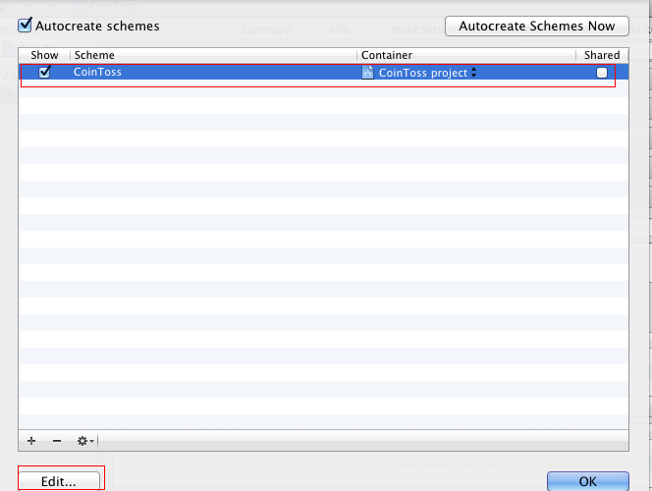

选择一个项目点Edit，将Build Configuration改为Release
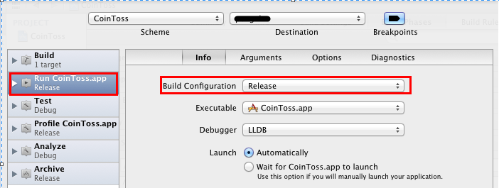

在Finder中打开Products下的XXXX.app
如图点Show in Finder
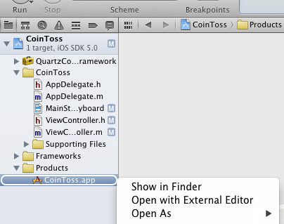

将以Finder中的以项目名命名的文件拖到iTunes中
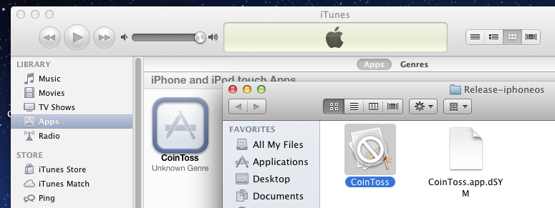

将iTunes中的应用拖到桌面上
