密级：

irrlicht

版本 | 作者 | 时间 | 操作
0.1 | 洪智标 | 2011-3-29 | 初稿

目录
1 引言 4
1.1 编写目的 4
1.2 项目背景 4
1.3 定义 4
1.4 参考资料 4
2 总体要求 4
2.1 总体功能要求 4
2.2 软件平台要求 4
3 软件开发 5
3.1 需求概述 5
3.2 概要设计 5
3.3 详细设计 5
3.4 编码实现 5
3.4.1 编码规范 5
3.4.2 XX模块 5
3.5 软件测试 5
3.6 软件的交付准备 6
3.7 软件的鉴定验收 6

引言

编写目的
阐明编写详细设计说明书的目的，指明读者对象。
本文档用于指导软件开发者为XXXX应用进行设计和开发的过程，通过规范软件项目承担单位的开发过程达到提高软件质量，降低维护成本的目的。

项目背景
应包括项目的来源和主管部门等。

定义
列出本文档中所用到的专门术语的定义和缩写词的愿意。

参考资料
● 列出有关资料的作者、标题、编号、发表日期、出版单位或资料来源
●项目经核准的计划任务书、合同或上级机关的批文；项目开发计划；需求规格说明书；概要设计说明书；测试计划（初稿）；用户操作手册
● 文档所引用的资料、软件开发的标准或规范。

什么是irrlicht
Irrlicht引擎是一个用C++书写的高性能实时的3D引擎，可以应用于C++程序或者.NET语言中。通过使用Direct3D（Windows平台），OpenGL 1.2或它自己的软件着色程序，可以实现该引擎的完全跨平台。尽管是开源的，该Irrlicht库提供了可以在商业级的3D引擎上具有的艺术特性，例如动态的阴影，粒子系统，角色动画，室内和室外技术以及碰撞检测等。
Irrlicht是一个德国神话故事中的一种动物的名字，它能够发光和飞翔，可以在大部分的沼泽地附近发现它。单词"Irrlicht"是两个德国单词（"irr"意思是疯狂的；而"Licht"意思是光）的组合。在英语中，它被译为"鬼火"。
Irrlicht十分幸运地为一个巨大的活跃的开发团队以大量的工程所支持。然而，因为Irrlicht主要由游戏名家Nikolaus Gebhardt所设计，所以该引擎在设计上十分连贯。你可以在网上到处发现有Irrlicht的增强程序，如可选用的地形生成器，入口生成器，输出器，world层生成器，相关教程和编辑器等。而且，它独立地创建了到Java，Perl，Ruby，BASIC，Python，LUA甚至更多种语言的绑定。而最为重要的是，它是完全自由的。

组成结构
Irrlicht引擎共分为五部分：

1）Core

该部分由一些容器类及数学库组成，如string、vector等。

对应的名字空间为：namespace irr::core

2）Scene

该部分主要负责三维场景的绘制及管理，包括场景节点，摄像机，粒子系统、mesh 资源，公告板，灯光，动画器，天空体，地形等。

Irrlicht的场景中的所有的东西都是场景节点，统一由场景管理器来管理。

对应的名字空间为：namespace irr::scene

3）Video

该部分主要负责图片纹理的载入及管理，包括纹理，材质，灯光，图片，顶点等渲 染属性的控制。

对应的名字空间为：namespace irr::video

4）GUI

该部分包括了一些二维GUI控件

对应的名字空间为：namespace irr::gui

5）FileSystem

该部分负责文件系统的读写。

对应的名字空间为：namespace irr::io

Irrlicht编程步骤
1、获取设备指针

在编写任何一个Irrlicht程序时，首选需要做的就是获取设备指针

IrrlichtDevice *device ：

video::E_DRIVER_TYPE driver_type = irr::video::EDT_OPENGL;

core::dimension2d<s32> screen_resolution = core::dimension2d<s32>(1280, 800);

u32 color_depth = 32;

bool is_full_screen = true;

IrrlichtDevice* device = irr::createDevice(driver_type, screen_resolution, color_depth, is_full_screen);

driver_type为驱动类型，可以选择OPENGL，DX8 或 DX9。其余几个参数分别为分辨率，颜色 深度，是否全屏。

获得 device 指针以后，就可以得到属于该 device 的四大块功能：

video::IVideoDriver* driver = device->getVideoDriver();

scene::ISceneManager* scene_mgr = device->getSceneManager();

gui::IGUIEnvironment* gui_env = device->getGUIEnvironment();

io::IFileSystem* file_system = device->getFileSystem();

2、创建3D场景

创建3D场景有三个步骤：

(1) 通过场景管理器scene_mgr添加3D物体：

// 为场景添加一个立方体，边长100

scene::ISceneNode* cube = scene_mgr->addCubeSceneNode(100.0f);

(2) 为3D物体贴上纹理：

// 载入纹理

video::ITexture* tex = driver->getTexture("box.jpg");

// 将纹理附加到立方体上

cube->setMaterialTexture(0, tex);

// 将纹理EMF_LIGHTING属性设为false

// 表示该纹理现实与光源无关，即为图片自身颜色

cube->setMaterialFlag(video::EMF_LIGHTING, false);

// 使纹理支持半透明，半透明效果与图片相同

cube->setMaterialType(video::EMT_TRANSPARENT_ALPHA_CHANNEL);

(3) 添加Camera，使物体可见：

// 添加一个相机，在(700,700,-700)位置，往(0,0,0)位置拍摄。

scene::ICameraSceneNode* camera = scene_mgr->addCameraSceneNode(0,

core::vector3df(700,700,-700), core::vector3df(0,0,0));

3、进入主循环

通过 driver 载入图片和 texture，通过 scene_mgr 为3d场景添加 irrlicht 内置支持的3D对象等工作后，即可进入主循环，主循环结束时，释放 device，程序结束。其中 beginScene 的参数 SColor(alpha, r, g, b) 为背景色：

1 while (device->run())

2 {

3 if (device->isWindowActive())

4 {

5 driver->beginScene(true, true, video::SColor(0, 0, 0, 0));

6 scene_mgr->drawAll();

7 gui_env->drawAll();

8 driver->endScene();

9 }

10 }

11 device->drop();

值得一提的是 drop() 函数。Irrlicht中大部分类都继承自一个 IReferenceCounted 的接口，类似智能指针。Irrlicht 中的惯例是不使用 delete 删除对象，而调用该接口的 drop() 函数。在添加对象的引用时，调用 grap() 函数。

四、Irrlicht引擎之场景中的对象结构

3D对象在场景中被组织成一个树形结构，在该树中，仅有一个根节点。当在程序的主循环中调用scene_mgr->drawAll()时，系统会从场景的树形结构的根节点开始递归绘制所有的节点对象。

每一个节点对象都维护了一个“动画效果”ISceneNodeAnimator列表：

core::list<ISceneNodeAnimator*> Animators;

在绘制每一个节点对象之前，都会将其所维护的所有动画效果应用到该节点上。

“动画效果”的原理是，当节点每次被绘制之前，均先根据其维护的动画对象Animators来计算出该节点的位置、大小、纹理。这样，当一个节点不断被绘制时，就产生了动画效果。

五、Irrlicht引擎之3D对象运动原理

所谓运动，实际上是计算机在不停地绘制场景，每绘制一次称之为一帧。 当各帧中物体的位置或外观有所变化，那么它就动起来了。 在irrlicht中，绘制一帧是在run循环中完成的：

1 while (device->run())

2 {

3 if (device->isWindowActive())

4 {

5 driver->beginScene(true, true, video::SColor(0, 0, 0, 0));

6 scene_mgr->drawAll(); // 绘制一帧

7 driver->endScene();

8 }

9 }

10 device->drop();

我们所要做的，就是在 drawAll() 函数中，更新物体的位置及大小等属性，那么场景就动起来了。

在Irrlicht中，所有与运动相关的一切，都与 scene::ISecenNodeAnimator 这个接口相关。凡是实现这个接口的类实例，都可以通过 addAnimator() 函数加入到 ISceneNode 所维护的animators列表中。

SceneManager 的drawAll() 函数在渲染(render)场景前，会调用其OnAnimate() 函数。这个函数是递归的，以保证加入场景中的每个 SceneNode 都会被调用。 在OnAnimate() 函数中， SceneNode 的每一个 ISecenNodeAnimator 的 animateNode() 函数都会被调用，以更新 SceneNode 的位置、大小或纹理等属性。

其具体的调用顺序如下：

1. SceneManager --> drawAll() 绘制一帧画面

2. ISceneNode --> OnAnimate() SceneNode运动

3. ISceneNodeAnimator --> animateNode(ISceneNode) 实现运动的具体函数

4. SceneManager --> render() 渲染

可见，只要实现 ISecenNodeAnimator 接口，并加入到 SceneNode 中，就能够让该SceneNode 运动起来。而至于具体如何运动，完全可由自己来定义。

六、Irrlicht引擎之消息传递原理

Irrlicht引擎中消息的传递是从device->run()开始的，首先由具体平台的操作系统接口将接收到的用户消息打包成Irrlicht的SEvent结构（这一步打包过程是在device->run()中完成的），再由postEventFromUser()将该消息依次传递给UserReceiver, GUI 和 3D Scene。

Irrlicht 中所有处理消息的类都必须实现 IEventReciever 接口。UserReceiver 就是在CreateDevice函数中指定的一个 IEventReceiver。 也就是说，消息处理的优先级为 UserReceiver > GUI > 3D Scene。

如果在程序中，没有指定UserReceiver和GUI，消息就会直接交给SceneManager。

SceneManager 的消息，也由 ISceneManager 的 postEventFromUser() 传递。 这个函数的实现如下：

1 bool CSceneManager::postEventFromUser(const SEvent& event)

2 {

3 bool ret = false;

4 ICameraSceneNode* cam = getActiveCamera();

5 if (cam)

6 ret = cam->OnEvent(event);

7

8 _IRR_IMPLEMENT_MANAGED_MARSHALLING_BUGFIX;

9 return ret;

10 }

也就是说，只有当前Active(有效)的 ICameraSceneNode 才会接收到消息。ICameraSceneNode 会检测ISceneNodeAnimator 的isEventReceiverEnabled(), 如果为真则调用其OnEvent 函数。

整理消息传递的机制如下：

1. IrrlichtDevice --> run() 搜集消息并打包

2. IrrlichtDevice --> postEventFromUser() 传递消息到userReceiver GUI 和 Scene

3. ISceneManager --> postEventFromUser() 传递消息到CameraNode

4. ICameraSceneNode --> onEvent() 调用 Animator 的onEvent

5. ISceneNodeAnimator --> onEvent() // if enabled 响应消息。

可见，实现 ISceneNodeAnimator 虽然可以 SceneNode 动起来，但只有在 ICameraSceneNode 上，才能够接收和处理消息。

摘自: http://blog.csdn.net/gogor/article/details/6623437

官网
http://irrlicht.sourceforge.net/

SDK目录结构
描述软件对运行环境、依赖组件及开发工具的要求

官方API文档
Irrlicht Engine 1.7 API documentation
http://irrlicht.sourceforge.net/docu/index.html

子库与版本对应表
Item | Status | Progress | Description | Since
CORE-Library
Container | 100% | Complete | Lists and array templates | 0.1
3D Library | 100% | Complete | Vectors, planes, matrices, bounding boxes, math | 0.1
Strings | 100% | Complete | String templates with unicode support | 0.1
IO-System
File read access abstraction | 100% | Complete | Plattform independent read access to files. | 0.1
File write access abstraction | 100% | Complete | Plattform independent write access to files. | 0.6
File list | 100% | Complete | Retrieving file lists and manipulating them | 0.6
Zip-file access | 100% | Complete | Read access to compressed .zip files. | 0.1
XML Parser | 100% | Complete | Integrated XML parser | 0.6
XML Writer | 100% | Complete | Utility to write XML files more easily | 0.6
GUI-Library
GUI-Environment | 100% | Complete | GUI-Environment with event system | 0.1
Fonts | 100% | Complete | 2D Font drawing environment | 0.1
Image Element | 100% | Complete | GUI-Element for viewing images | 0.1
Static Text Element | 100% | Complete | GUI-Element for viewing single line text | 0.1
List Box Element | 100% | Complete | ListBox GUI-Element | 0.1
Mesh Viewer Element | 100% | Complete | 2D GUI Element for viewing 3D Meshes | 0.1
Scrollbar Element | 100% | Complete | Scrollbar GUI-Element | 0.1
Button Element | 100% | Complete | Standard text button GUI-Element | 0.1
CheckBox Element | 100% | Complete | Standard check box GUI-Element | 0.1
FileOpen Dialog | 100% | Complete | Dialog for selecting files | 0.1
FadeInOut | 100% | Complete | Element for fading in or out the screen or parts of it | 0.4
Edit Box Element | 100% | Complete | A edit box for entering text | 0.5
Tab Control | 100% | Complete | Tab control | 0.5
Context Menu | 100% | Complete | Context and top window menus | 0.5
Message Boxes | 100% | Complete | Standard Message Boxes | 0.4.1
Skinnable Elements | 100% | Complete | Elements skinnable with bitmaps and textures | 0.11.0
Video-System
Null Device | 100% | Complete | Null device, does not draw anything | 0.1
Software 3D Video Device | 100% | Complete | Draws 3D meshes using only software | 0.1
Software 2D Video Device | 100% | Complete | Draws 2D elements using only software | 0.1
DirectX 8.1 3D Video Device | 100% | Complete | Draws 3D meshes using the D3D8.0 device | 0.1
DirectX 8.1 2D Video Device | 100% | Complete | Draws 2D elements using the D3D8.0 device | 0.1
DirectX 9.0 3D Video Device | 100% | Complete | Draws 3D meshes using the D3D9.0 device | 0.5
DirectX 9.0 2D Video Device | 100% | Complete | Draws 2D elements using the D3D9.0 device | 0.5
OpenGL 3D Video Device | 100% | Complete | Draws 3D meshes using OpenGL | 0.2
OpenGL 2D Video Device | 100% | Complete | Draws 2D elements using OpenGL | 0.2
Video Mode enumeration | 100% | Complete | Possibility to enumerate all video modes and current desktop mode. | 0.4
JPG Support | 100% | Complete | Loads JPG textures | 0.1
TGA Support | 100% | Complete | Loads TGA textures | 0.1
BMP Support | 100% | Complete | Loads BMP textures | 0.1
PCX Support | 100% | Complete | Loads PCX textures | 0.4.2
PNG Support | 100% | Complete | Loads PNG textures | 0.10
PSD Support | 100% | Complete | Loads PSD textures | 0.1
8-32 bit textures | 100% | Complete | Supports rendering all types of textures | 0.4.2
Lightmap Support | 100% | Complete | Draws lightmap geometry | 0.1
Bump map Support | 100% | Complete | Draws 3d geometry texured with bump/normal maps | 0.8
Parallax mapping support | 100% | Complete | Draws 3d geometry texured using Unreal 3 like parallax mapping | 0.10
Multitexturing | 100% | Complete | Possiblity to combine 2 or more textures | 0.4
Stencil Shadow Support | 100% | Complete | Draws stencil shadows | 0.2
Sphere Mapping | 100% | Complete | Draws sphere mapped geometry
Alpha blending Support | 100% | Complete | Draws transparent geometry | 0.1
Triangle fans | 100% | Complete | VideoDriver should be able to draw triangle fans | 0.5
Render to Texture Support | 100% | Complete | Renders to texture | 0.10
Fog support | 100% | Complete | Enables fog | 0.5
Dynamic light support | 100% | Complete | Calculates dynamic light when drawing meshes | 0.1
Pixel Shader support | 100% | Complete | Enables support for vertex shader / fragment programs in OpenGL and Direct3D | 0.7
Vertex Shader support | 100% | Complete | Enables support for vertex shader programs in OpenGL and Direct3D | 0.7
HLSL support | 100% | Complete | Enables creation of new materials written in HLSL | 0.8
GLSL support | 100% | Complete | Enables creation of new materials written in GLSL | 0.12.0
Scene Management
Scene Manager | 100% | Complete | Manages all scene nodes | 0.1
Scene serialization | 90% | Nearly finished | Reads and writes scenes from and to disk via XML | 1.1
Camera Scene Nodes | 100% | Complete | Camera support for scenes | 0.1
Billboard Support | 100% | Complete | Billboards | 0.2
OctTree Scene Node | 100% | Complete | Standard OctTree implementation | 0.1
Skybox Scene Node | 100% | Complete | Implements a sky box | 0.2
Water surface scene node | 100% | Complete | Scene node for drawing realistic water surfaces | 0.4
Particle System | 100% | Complete | Extensible scene node for particle systems | 0.4
Terrain Scene Node | 100% | Features missing | Scene node for rendering terrain | 0.4.2
OBJ File Support | 100% | Complete | Loading meshes from Maya .obj files | 0.1
OCT File Support | 100% | Complete | Loading .oct files | 0.9
CSM File Support | 100% | Complete | Loading Cartography shop 4 files | 0.9
LMTS File Support | 100% | Complete | Loading Pulsar LMTools files | 0.9
.X File Support | 100% | Complete | Implement .X file loading indepentend of which device is used. (.X-files must be loaded also with OpenGL and the Software Device.) | 0.5
MD2 File Support | 100% | Complete | Loading meshes from Quake2 .md2 files | 0.1
BSP File Support | 100% | Complete | Loading meshes from Quake3 .bsp files | 0.1
DMF File Support | 100% | Complete | Loading of DeleD meshes | 0.10
COLLADA Support | 60% | Incomplete | Loading of COLLADA files | 0.10
MS3D File Support | 100% | Complete | Loading an animating meshes from Milkshape | 0.3
3DS File Support | 100% | Complete | Loading meshes from 3DStudio .3ds files | 0.2
Picking | 100% | Complete | Picking scene nodes with the cursor or a 3d ray. | 0.2.5
Simple Collision Detection | 100% | Complete | Simple bounding box collision detection | 0.3
Real Collision Detection | 100% | Complete | Fast triangle based collision detection and response. | 0.4
Scene Node animators | 100% | Complete | Standard animators for scene nodes | 0.1
General Irrlicht Engine
Mac Support | 100% | Complete | The engine runs on Mac platforms | 0.14.0
Win64 Support | 50% | untested | The engine runs on Windows64 platforms | 0.12.0
Win32 Support | 100% | Complete | The engine runs on Windows32 platforms | 0.1
Linux 64 Support | 100% | Complete | The engine runs on Linux 64 platforms | 0.14.0
Linux Support | 100% | Complete | The engine runs on Linux | 0.3
Solaris Support | 50% | untested | The engine runs on Sun Solaris/SPARC | 1.2

引擎架构
所有Irr的引擎文件都在Irr命名空间下，Irr命名空间下又分五大模块：
Core：包含一些引擎核心类，包括各种数据结构和自定义的数据结构。
Gui：一些常用的图形用户接口，实现了各种常用控件。
Io：内部的一些输入输出，xml，zip，ini的文件的读取。
Scene：内部主要负责场景管理，包括场景节点，摄像机，粒子系统mesh，公告板，灯光，动画器，天空盒，地形等。
Video：负责对视频驱动的设置，2D，3D渲染都在这里实现，包括纹理，材质，灯光，图片，顶点等渲染属性的控制。
Irrlicht的场景中的所有的东西都是场景节点，统一由sceneManager来管理。
步骤：
1、创建设备。
2、获取场景管理器，视频设备、GUI环境指针，使用他们进行渲染控制。
3、在beginScene和endScene之间drawAll。
4、释放设备。

摄相机
Irrlicht的摄相机有三种： Maya/FPS/Scene

irr::IReferenceCounted
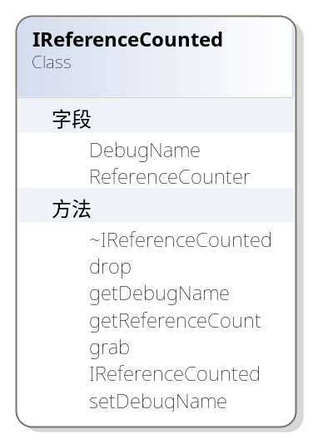
//! Base class of most objects of the Irrlicht Engine.
/** This class provides reference counting through the methods grab() and drop().
It also is able to store a debug string for every instance of an object.
Most objects of the Irrlicht Engine are derived from IReferenceCounted, and so they are reference counted.

When you create an object in the Irrlicht engine, calling a methodwhich starts with 'create', an object is created, and you get a pointerto the new object. If you no longer need the object, you haveto call drop(). This will destroy the object, if grab() was not called in another part of you program, because this part still needs the object.

Note, that you only need to call drop() to the object, if you created it,and the method had a 'create' in it.

A simple example:

If you want to create a texture, you may want to call an imaginable method IDriver::createTexture. You call
ITexture* texture = driver->createTexture(dimension2d<u32>(128, 128));
If you no longer need the texture, call texture->drop().

If you want to load a texture, you may want to call imaginable method IDriver::loadTexture. You do this like
ITexture* texture = driver->loadTexture("example.jpg");
You will not have to drop the pointer to the loaded texture, because the name of the method does not start with 'create'. The texture is stored somewhere by the driver.

在这个类中通过ReferenceCounter成员实现对外部引用的统计，ReferenceCounter是一个mutable变量。当调用drop()时，ReferenceCounter减1，如果此时统计为0则释放本对象并返回true，否则返回false。

irr::io::IAttributeExchangingObject
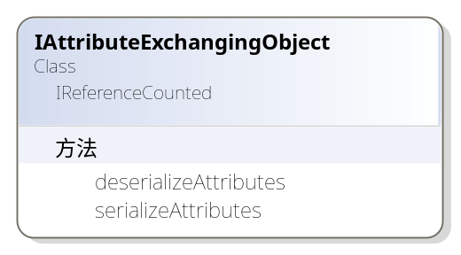
An object which is able to serialize and deserialize its attributes into an attributes object

irr::IEventReceiver
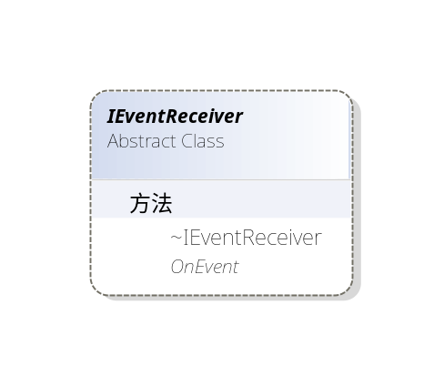
Interface of an object which can receive events.

Many of the engine's classes inherit IEventReceiver so they are able to process events. Events usually start at a postEventFromUser function and are passed down through a chain of event receivers until OnEvent returns true. See irr::EEVENT_TYPE for a description of where each type of event starts, and the path it takes through the system.

irr:scene::ISceneNodeAnimator
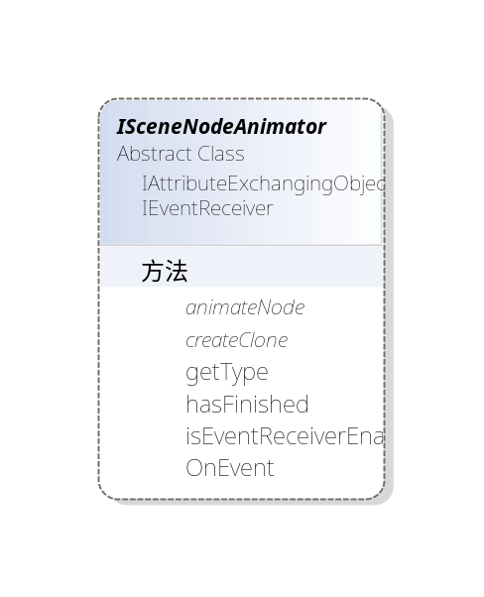
Animates a scene node. Can animate position, rotation, material, and so on.

A scene node animator is able to animate a scene node in a very simple way. It may change its position, rotation, scale and/or material. There are lots of animators to choose from. You can create scene node animators with the ISceneManager interface.

重要的方法有：

//! Animates a scene node.
/** \param node Node to animate.
\param timeMs Current time in milli seconds. */
virtual void animateNode(ISceneNode* node, u32 timeMs) =0;

动态节点.其实就是利用一个scene::ISceneNodeAnimator对象；将这个对象通过如下函数将其绑定在一块
ISceneNode->addAnimator(ISceneNodeAnimator* animator)。

场景管理器中有4种函数可以返回动态节点的。

ISceneNodeAnimator* createRotationAnimator(const core::vector3df& rotationPerSecond) = 0;

ISceneNodeAnimator* createFlyCircleAnimator(const core::vector3df& center, f32 radius, f32 speed= 0.001f, const core::vector3df& direction = core::vector3df ( 0.f, 1.f, 0.f ) ) = 0;

ISceneNodeAnimator* createFlyStraightAnimator(const core::vector3df& startPoint,const core::vector3df& endPoint, u32 timeForWay, bool loop=false) = 0;

ISceneNodeAnimator* createTextureAnimator(const core::array<video::ITexture*>& textures,
s32 timePerFrame, bool loop=true) = 0;

irr:scene::ISceneNodeAnimationCameraFPS
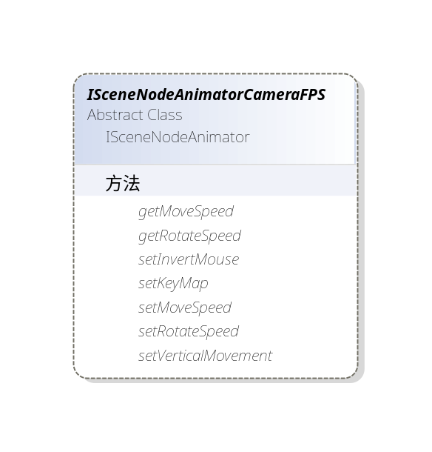
Special scene node animator for FPS cameras.

This scene node animator can be attached to a camera to make it act like a first person shooter.

其中速度以毫秒为单位，旋转采用角度单位

irr::scene:CCameraSceneNode
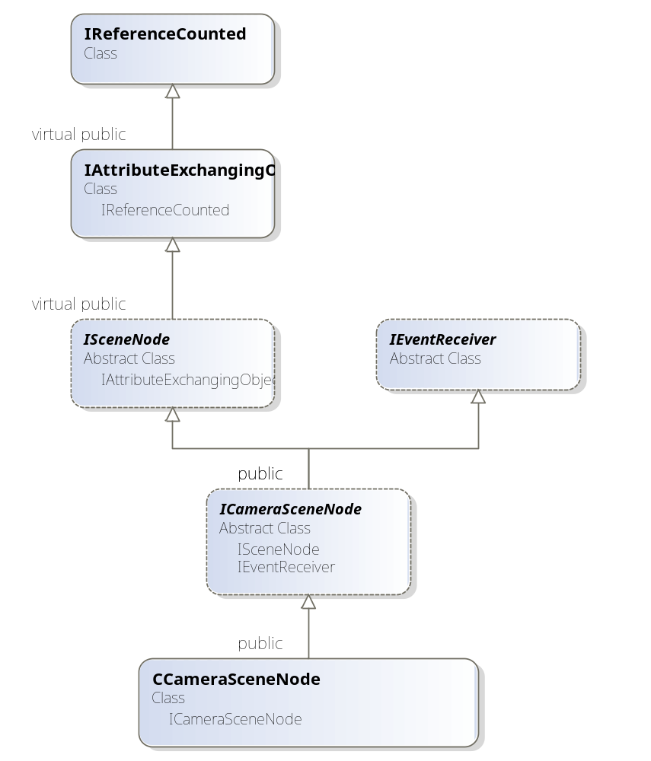
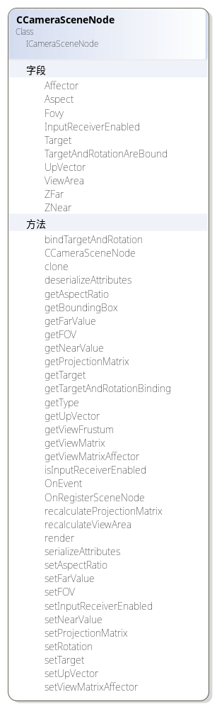

irr:scene::CSceneNodeAnimatorCameraFPS
类的层次关系如下：
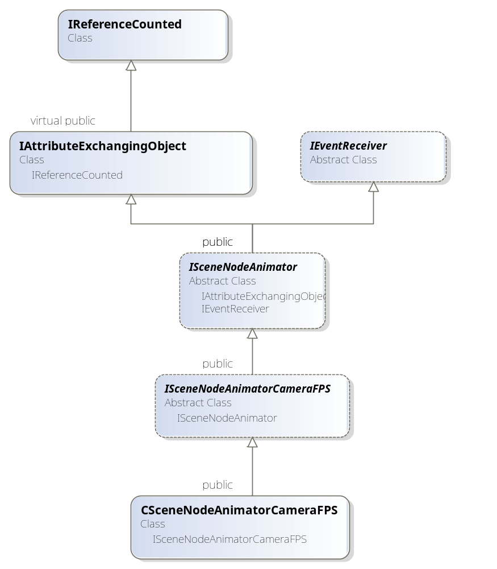
类成员如下：
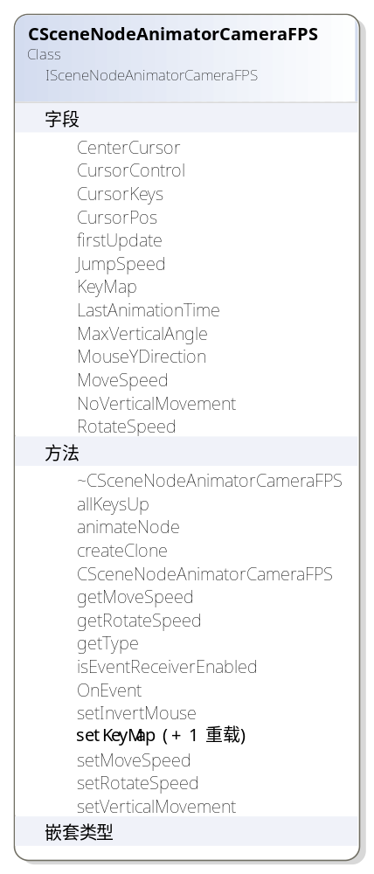
Special scene node animator for FPS cameras

irr::scene::CSceneNodeAnimatorCameraMaya
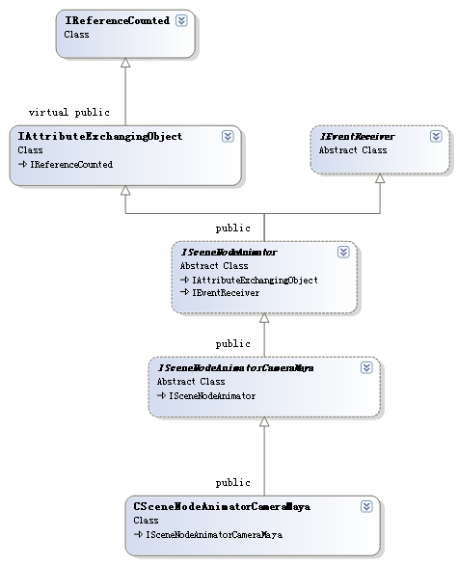
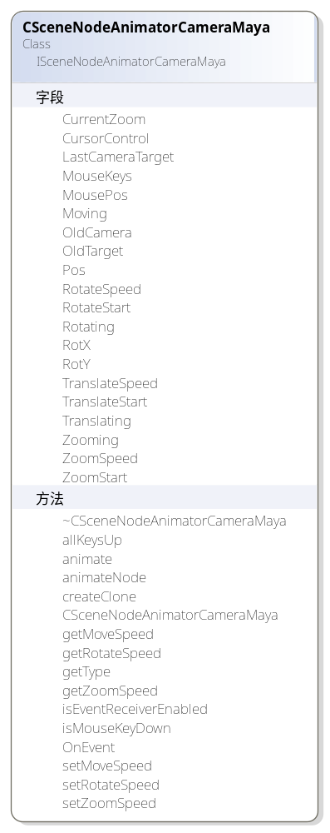
Special scene node animator for FPS cameras

This scene node animator can be attached to a camera to make it act like a 3d modelling tool camera

irr::scene::CSceneManager
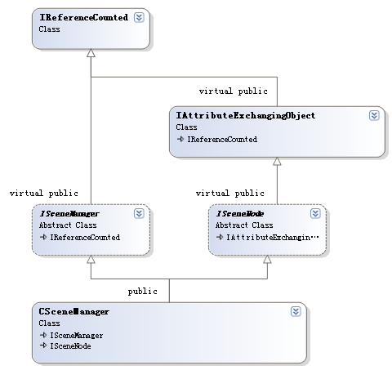
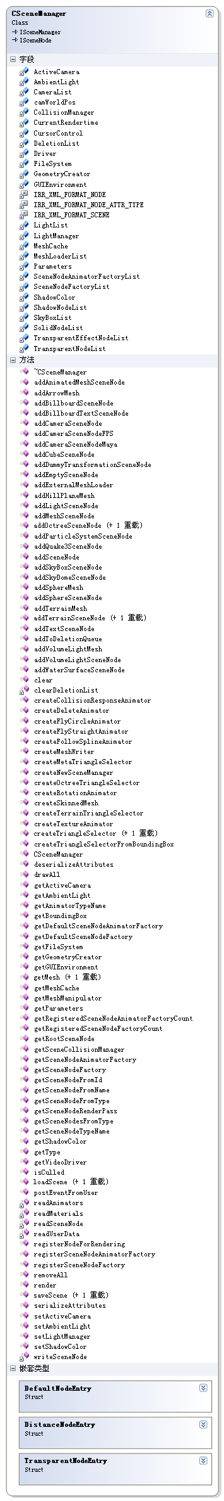
其中部分重要方法如下:

声明
virtual ICameraSceneNode* addCameraSceneNodeFPS(ISceneNode* parent = 0,
f32 rotateSpeed = 100.0f, f32 moveSpeed = .5f, s32 id=-1,
SKeyMap* keyMapArray=0, s32 keyMapSize=0,
bool noVerticalMovement=false, f32 jumpSpeed = 0.f,
bool invertMouseY=false, bool makeActive=true);
定义
ICameraSceneNode* CSceneManager::addCameraSceneNodeFPS(ISceneNode* parent,
f32 rotateSpeed, f32 moveSpeed, s32 id, SKeyMap* keyMapArray,
s32 keyMapSize, bool noVerticalMovement, f32 jumpSpeed,
bool invertMouseY, bool makeActive)
{
ICameraSceneNode* node = addCameraSceneNode(parent, core::vector3df(),
core::vector3df(0,0,100), id, makeActive);
if (node)
{
ISceneNodeAnimator* anm = new CSceneNodeAnimatorCameraFPS(CursorControl,
rotateSpeed, moveSpeed, jumpSpeed,
keyMapArray, keyMapSize, noVerticalMovement, invertMouseY);

// Bind the node's rotation to its target. This is consistent with 1.4.2 and below.
node->bindTargetAndRotation(true);
node->addAnimator(anm);
anm->drop();
}

return node;
}

声明
virtual ICameraSceneNode* addCameraSceneNodeMaya(ISceneNode* parent = 0,
f32 rotateSpeed = -1500.0f, f32 zoomSpeed = 200.0f,
f32 translationSpeed = 1500.0f, s32 id=-1,
bool makeActive=true);
定义
ICameraSceneNode* CSceneManager::addCameraSceneNodeMaya(ISceneNode* parent,
f32 rotateSpeed, f32 zoomSpeed, f32 translationSpeed, s32 id,
bool makeActive)
{
ICameraSceneNode* node = addCameraSceneNode(parent, core::vector3df(),
core::vector3df(0,0,100), id, makeActive);
if (node)
{
ISceneNodeAnimator* anm = new CSceneNodeAnimatorCameraMaya(CursorControl,
rotateSpeed, zoomSpeed, translationSpeed);

node->addAnimator(anm);
anm->drop();
}

return node;
}

关联
//! Adds a camera scene node to the tree and sets it as active camera.
//! \param position: Position of the space relative to its parent where the camera will be placed.
//! \param lookat: Position where the camera will look at. Also known as target.
//! \param parent: Parent scene node of the camera. Can be null. If the parent moves,
//! the camera will move too.
//! \return Returns pointer to interface to camera
ICameraSceneNode* CSceneManager::addCameraSceneNode(ISceneNode* parent,
const core::vector3df& position, const core::vector3df& lookat, s32 id,
bool makeActive)
{
if (!parent)
parent = this;

ICameraSceneNode* node = new CCameraSceneNode(parent, this, id, position, lookat);

if (makeActive)
setActiveCamera(node);
node->drop();

return node;
}

irr::gui:: ICursorControl
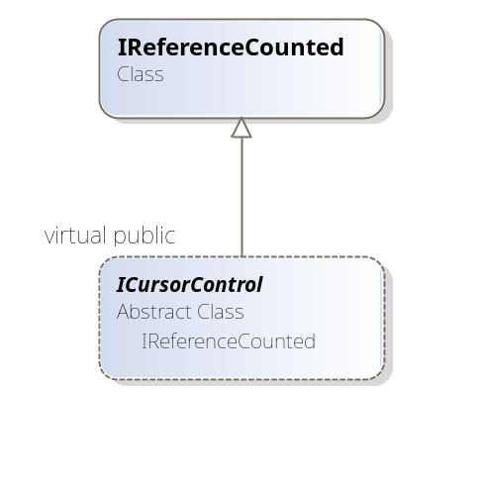
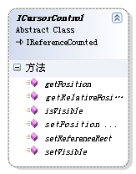
Interface to manipulate the mouse cursor.

重要的方法：

//! Sets the new position of the cursor.
/** The position must be
between (0.0f, 0.0f) and (1.0f, 1.0f), where (0.0f, 0.0f) is
the top left corner and (1.0f, 1.0f) is the bottom right corner of the
render window.
\param x New x-coord of the cursor.
\param y New x-coord of the cursor. */
virtual void setPosition(f32 x, f32 y) = 0;

//! Returns the current position of the mouse cursor.
/** \return Returns the current position of the cursor. The returned position
is a value between (0.0f, 0.0f) and (1.0f, 1.0f), where (0.0f, 0.0f) is
the top left corner and (1.0f, 1.0f) is the bottom right corner of the
render window. */
virtual core::position2d<f32> getRelativePosition() = 0;

irr::scene:: ISceneCollisionManager
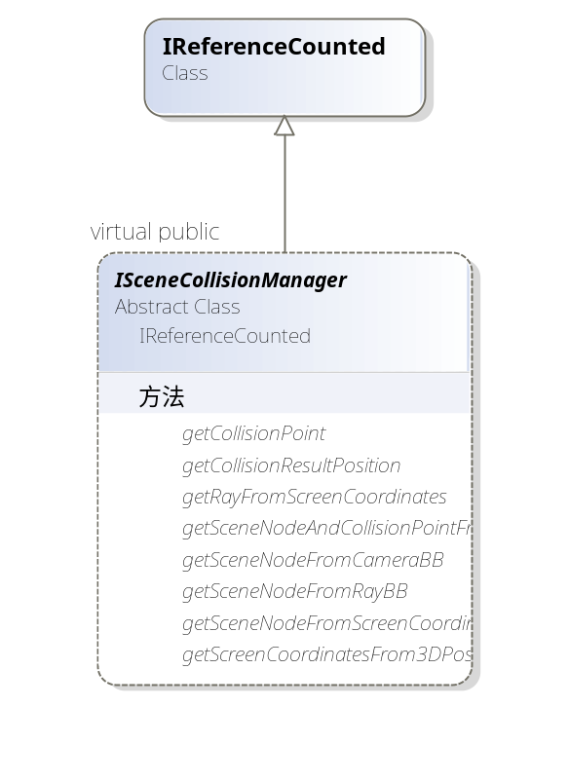
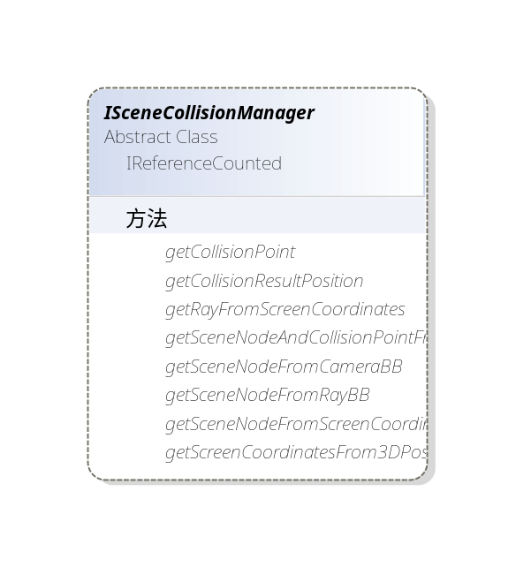
The Scene Collision Manager provides methods for performing collision tests and picking on scene nodes.

Maya摄相机
鼠标左键控制旋转，右键控制移动

GUI模块
关于irr的GUI部分的整理
http://blog.sina.com.cn/s/blog_6215fe350100fll9.html

射线拾取
3d position from mouse click
http://irrlicht.sourceforge.net/forum/viewtopic.php?p=42907

void clicked(int x,int y){
//Returns a 3d ray which would go through the 2d screen coodinates.
// pos,: core::position2d< s32 >,Screen coordinates in pixels.
//camera,: Camera from which the ray starts. If null, the active camera is used.
position2d<s32> pos;
pos.X=x;
pos.Y=y;
ray = collMan->getRayFromScreenCoordinates(pos, camera);
}

MFC与Irrlicht结合

在MFC中添加Irrlicht渲染区
MFC и Irrlicht
http://www.gamedev.ru/community/irrlicht/forum/?id=75642
irrlicht结合MFC MFC的dialog接收irrlicht消息
http://hi.baidu.com/crazyonline/blog/item/0a4a7289e08573ba0e244401.html

渲染到纹理
Irrlicht 1.4.2 examples 阅读笔记 12-16
http://hi.baidu.com/kamelzcs/blog/item/b8296be9f3f8c1c0d539c98f.html

事件响应

Android平台下的应用

教程

官网教程
http://irrlicht.sourceforge.net/tutorials.html

其他教程
Chapter 2: Learning the Basics
http://www.irrlicht3d.org/wiki/index.php?n=Main.IrrlichtManualChapter2

Downloaded Irrlicht for Android:
>>git clone git://gitorious.org/irrlichtandroid/irrlichtandroid.git

Irrlicht之01.HelloWorld
http://hi.baidu.com/geiseil/blog/item/7e82e71994b96e1a304e1592.html

开源应用实例
swdgame-freekick-simulator
http://code.google.com/p/swdgame-freekick-simulator/source/checkout

project-lon
http://code.google.com/p/project-lon/

教程移植记录
网上有部分移植教程，参考：
http://gitorious.org/irrlichtandroid/

HelloWorld
目标
了解如何启用Irrlicht引擎，以及VideoDriver、GUIEnvironment、SceneManager等工具的基本使用方法。
参考
- Programming 3D games on Android with Irrlicht and Bullet (Part 1)
http://renzhi.ca/2011/05/19/programming-3d-games-on-android-with-irrlicht-and-bullet-part-1/
- Programming 3D games on Android with Irrlicht and Bullet (Part 2)
http://renzhi.ca/2011/05/20/programming-3d-games-on-android-with-irrlicht-and-bullet-part-2/
- Tutorial 1: HelloWorld
http://irrlicht.sourceforge.net/docu/example001.html

移植步骤
1、建立Irrlicht01HelloWorld项目，并加入irrlicht等库文件

API

Namespace List
Here is a list of all namespaces with brief descriptions:
irr | Everything in the Irrlicht Engine can be found in this namespace
irr::core | Basic classes such as vectors, planes, arrays, lists, and so on can be found in this namespace
irr::gui | The gui namespace contains useful classes for easy creation of a graphical user interface
irr::io | This namespace provides interfaces for input/output: Reading and writing files, accessing zip archives, xml files, ..
irr::scene | All scene management can be found in this namespace: Mesh loading, special scene nodes like octrees and billboards, ..
irr::scene::quake3
irr::video | The video namespace contains classes for accessing the video driver. All 2d and 3d rendering is done here

CreateDevice

方法原型
IRRLICHT_API IrrlichtDevice* IRRCALLCONV createDevice(video::E_DRIVER_TYPE driverType,
const core::dimension2d<u32>& windowSize,
u32 bits, bool fullscreen,
bool stencilbuffer, bool vsync, IEventReceiver* res)

有七个参数：
1：设备类型deviceType：
可以是空设备，软件模拟设备，第三方渲染设备，D3D8，D3D9，OpenGL。在例子里我们使用的是video::EDT_OGLES1，但是你可以拿EDT_BURNINGSVIDEO, EDT_NULL, EDT_DIRECT3D8 , EDT_DIRECT3D9, EDT_SOFTWARE或EDT_OPENGL进行测试。
2：窗口宽高（Amount of color bits per pixel. This should be 16 or 32. The parameter is often ignored when running in windowed mode.）
3：窗口色深（Amount of color bits per pixel. This should be 16 or 32. The parameter is often ignored when running in windowed mode.）
4：是否全屏
5：是否使用摸版缓冲区（Specifies if we want to use the stencil buffer (for drawing shadows).）
6：是否开启同步，注意的是只有全屏时才有效
7：事件接收器的对象，也就是对鼠标消息，键盘消息，用户信息，GUI消息等一系列消息的回调处理函数指针。我们这里不加处理的话，设置为0。
Always check the return value to cope with unsupported drivers, dimensions, etc.
IrrlichtDevice *device = createDevice( video::EDT_SOFTWARE,
dimension2d<u32>(640, 480), 16,false, false, false, 0);
if (!device)
return 1;

irr::video::Scolor
Class representing a 32 bit ARGB color

irr::scene::ICameraSceneNode
virtual void irr::scene::ICameraSceneNode::bindTargetAndRotation ( bool bound)

Binds the camera scene node's rotation to its target position and vice vera, or unbinds them.
When bound, calling setRotation() will update the camera's target position to be along its +Z axis, and likewise calling setTarget() will update its rotation so that its +Z axis will point at the target point. FPS camera use this binding by default; other cameras do not.
Parameters:
bound True to bind the camera's scene node rotation and targetting, false to unbind them

core::aabbox3d<f32>& irr::scene::ISceneNode::getBoundingBox ( ) const
Get the axis aligned, not transformed bounding box of this node.

This means that if this node is an animated 3d character, moving in a room, the bounding box will always be around the origin. To get the box in real world coordinates, just transform it with the matrix you receive with getAbsoluteTransformation() or simply use getTransformedBoundingBox(), which does the same.

引擎扩展

自定义摄相机
Dead Easy 3rd Person Camera

CRenderView::CRenderView()
: CFormView(CRenderView::IDD),direction(0), zdirection(0)
……

void CRenderView::moveCameraControl()
{
core::position2d<f32> cursorPos = device->getCursorControl()->getRelativePosition();
core::vector3df cameraPos = camera->getAbsolutePosition();

float change_x =(float)((cursorPos.X- 0.5)*256.0f);
float change_y =(float)((cursorPos.Y- 0.5)*256.0f);
direction += change_x;
zdirection -= change_y;
if( zdirection <- 90 )
zdirection = -90;
else
if( zdirection > 90 )
zdirection = 90;
device->getCursorControl()->setPosition( 0.5f, 0.5f );

core::vector3df playerPos = [PLAYERNODE]->getPosition();

float xf = playerPos.X - cos( direction * PI / 180.0f ) * 64.0f;
float yf = playerPos.Y - sin( zdirection * PI / 180.0f ) * 64.0f;
float zf = playerPos.Z + sin( direction * PI / 180.0f ) * 64.0f;

camera->setPosition( core::vector3df( xf, yf, zf ) );
camera->setTarget( core::vector3df( playerPos.X, playerPos.Y+25.0f, playerPos.Z ) );
[PLAYERNODE]->setRotation( core::vector3df( 0, direction, 0 ) );
}

http://irrlicht.sourceforge.net/forum/viewtopic.php?t=7977&highlight=bloodrayne

irrBullet库
irrBullet is an open source, easy-to-use, and high-level physics wrapper and extension library for the Bullet physics engine and the Irrlicht rendering engine.
详见：http://sourceforge.net/projects/irrbullet/

中文支持
让irrlicht支持中文输入和输出
http://irrlicht3d.blog.sohu.com/137890440.html
IrrLicht中文显示
http://o0402.blog.hexun.com/48529208_d.html
Irrlicht引擎使用2之中文显示
http://xcf007.blog.51cto.com/471707/322268

关于PostMessage(WM_USER)
PostMessage (WM_USER) from another process
http://irrlicht.sourceforge.net/forum/viewtopic.php?p=238531&sid=c2138abf21972445f131859c5f2deaf5

Irrlicht引擎中消息的传递是从device->run()开始的，首先由具体平台的操作系统接口将接收到的用户消息打包成Irrlicht的SEvent结构（这一步打包过程是在device->run()中完成的），再由postEventFromUser()将该消息依次传递给UserReceiver, GUI 和 3D Scene。
Irrlicht 中所有处理消息的类都必须实现 IEventReciever 接口。UserReceiver 就是在CreateDevice函数中指定的一个 IEventReceiver。 也就是说，消息处理的优先级为 UserReceiver > GUI > 3D Scene。

你可以简单的使用GetMessage，DispatchMessage等消息循环。然后在其中调用Device->Run()的话Irr引擎就可以获取Windows的消息分发了。但是如果你不调用Device->run()的话，你就无法获取Windows分发的用户输入信息。那么你只能自己使用DirectInput等东西来获取。

参考：
multiple openGL irrlichtDevice
http://irrlicht.sourceforge.net/forum/viewtopic.php?t=15112
irrlicht引擎源码剖析 - IrrlichtDevice
http://blog.csdn.net/pizi0475/article/details/5633365
Irrlicht编程基础
http://blog.csdn.net/gogor/article/details/6623437

