C++ advanced notes

$ echo $? - checking if compiling was successful from command line in Linux
$ echo %ERRORLEVEL% - checking if compiling was successful from command line in Microsoft

output stream – we write to it, eg. cout, cerr, clog
input steam – we read from it, eg. cin

File redirection:
$ file.exe <infile >outfile - assuming $ is the system prompt and our addition program has been compiled into an executable file named file.exe, this command will read transactions from a file named infile and write its output to a file named outfile in the current directory.

plain char or bool:
- do not use in arithmetic expressions
- use them only to hold characters or truth values
- computations using char are especially problematic because char is signed on some machines and unsigned on others.

Problem of automating casting of int to unsigned int:
If we convert int to unsigned int and int is smaller than 0, than automatic conversion using modulus is executed. It is essential to remember that signed values are automatically converted to unsigned.

unsigned u = 10;
int i = -42;
std::cout << i + i << std::endl; // prints -84
std::cout << u + i << std::endl; // if 32-bit ints, prints 4294967264

different types of int literals:
- 20 - decimal
- 024 - octal
- 0x14 - hexadecimal

string literal:
The type of a string literal is array of constant chars. The compiler appends a null character (’\0’) to every string literal. Thus, the actual size of a string literal is one more than its apparent size. For example, the literal 'A' represents the single character A, whereas the string literal "A" represents an array of two characters, the letter A and the null character.

Escape sequences:
newline \n horizontal tab \t alert (bell) \a
vertical tab \v backspace \b double quote \"
backslash \\ question mark \? single quote \'
carriage return \r formfeed \f

Example of escape sequences:
std::cout << "\tHi!\n"; // prints a tab followd by "Hi!" and a newline

Specifying the Type of a literal:
L'a' // wide character literal, type is wchar_t
u8"hi!" // utf-8 string literal (utf-8 encodes a Unicode character in 8 bits)
42ULL // unsigned integer literal, type is unsigned long long
1E-3F // single-precision floating-point literal, type is float
3.14159L // extended-precision floating-point literal, type is long double

list initialization:
Using list initialization has one big advantage - the compiler will not let us list initialize variables of built-in type if the initializer might lead to the loss of information.

Example:
long double ld = 3.1415926536;
int a{ld}, b = {ld}; // error: narrowing conversion required
int c(ld), d = ld; // ok: but value will be truncated

Note!
Uninitialized objects of built-in type defined inside a function body have undefined value. Objects of class type that we do not explicitly initialize have a value that is defined by the class.

extern keyword:
To obtain a declaration that is not also a definition, we add the extern keyword and may not provide an explicit initializer:

Example:
extern int i; // declares but does not define i
int j; // declares and defines j

Any declaration that includes an explicit initializer is a definition. We can provide an initializer on a variable defined as extern, but doing so overrides the extern. An extern that has an initializer is a definition:

Example:
extern double pi = 3.1416; // definition

To use a variable in more than one file requires declarations that are separate from the variable’s definition. To use the same variable in multiple files, we must define that variable in one—and only one—file. Other files that use that variable must declare—but not define—that variable.

C++ keywords
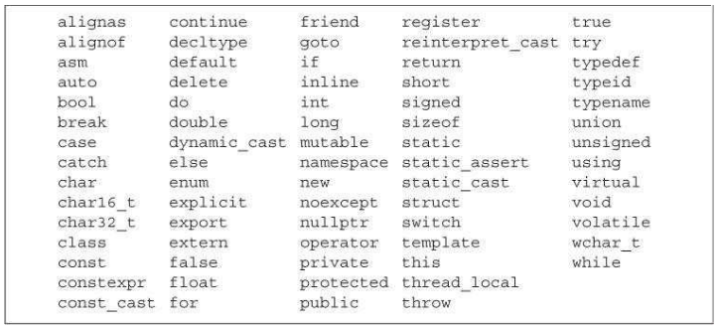

references overview:
- When we define a reference, instead of copying the initializer’s value, we bind the reference to its initializer. Once initialized, a reference remains bound to its initial object.
- There is no way to rebind a reference to refer to a different object and therefore references must be initialized.
- A reference is not an object. Instead, a reference is just another name for an already existing object. Because references are not objects, we may not define a reference to a reference.

Example:
int a = 5;
int &b = a;

pointer overview:
- A pointer is a compound type that “points to” another type.
- Like references, pointers are used for indirect access to other objects.
- Unlike a reference, a pointer is an object in its own right.
- Pointers can be assigned and copied; a single pointer can point to several different objects over its lifetime.
- Unlike a reference, a pointer need not be initialized at the time it is defined.
- Like other built-in types, pointers defined at block scope have undefined value if they are not initialized.

The value (i.e., the address) stored in a pointer can be in one of four states:
1. It can point to an object.
2. It can point to the location just immediately past the end of an object.
3. It can be a null pointer, indicating that it is not bound to any object.
4. It can be invalid; values other than the preceding three are invalid.

Key Concept: Some Symbols Have Multiple Meanings
Some symbols, such as & and *, are used as both an operator in an
expression and as part of a declaration. The context in which a symbol is used determines what the symbol means:

Examples:
int i = 42;
int &r = i; // & follows a type and is part of a declaration;
r is a reference
int *p; // * follows a type and is part of a declaration;
p is a pointer
p = &i; // & is used in an expression as the address-of operator
*p = i; // * is used in an expression as the dereference operator
int &r2 = *p; // & is part of the declaration; * is the dereference operator

In declarations, & and * are used to form compound types. In expressions, these same symbols are used to denote an operator. Because the same symbol is used with very different meanings, it can be helpful to ignore appearances and think of them as if they were different symbols.

null pointer - a null pointer does not point to any object.

Example:
int *p1 = nullptr; // equivalent to int *p1 = 0;

Examples of more complex references and pointers:
int ival = 1024;
int *pi = &ival; // pi points to an int
int **ppi = &pi; // ppi points to a pointer to an int
int *&r = p; // r is a reference to the pointer p

Note!
To share a const object among multiple files, you must define the variable as extern.

Example:
extern const int bufSize = fcn();
constexpr:
- A constant expression is an expression whose value cannot change and that can be evaluated at compile time. A literal is a constant expression.
- Variables declared as constexpr are implicitly const and must be initialized by constant expressions.

Examples:
constexpr int mf = 20; // 20 is a constant expression
constexpr int limit = mf + 1; // mf + 1 is a constant expression
constexpr int sz = size(); // ok only if size is a constexpr function

- Best Practices - generally, it is a good idea to use constexpr for variables that you intend to use as constant expressions.
- The types we can use in a constexpr are known as “literal types”.
- We cannot use a constexpr pointer to point to variables defined inside a function.
- It is important to understand that when we define a pointer in a constexpr declaration, the constexpr specifier applies to the pointer, not the type to which the pointer points.

Example:
const int *p = nullptr; // p is a pointer to a const int
constexpr int *q = nullptr; // q is a const pointer to int

type alias - is a name that is a synonym for another type. Type aliases let us simplify complicated type definitions, making those types easier to use.

Defining a type alias:
a) using typedef
typedef double wages; // wages is a synonym for double
typedef wages base, *p; // base is a synonym for double, p for double*

Another example:
typedef int liczby_calkowite;
liczby_calkowite x = 10;
x += 10.6;
cout << x; // out: 20

b) using alias declaration (keyword ‘using’):
using liczby_calkowite = int; // liczby_calkowite is a synonym for int

auto:
- auto tells the compiler to deduce the type from the initializer
auto item = v1 + v2; // item initialized to the result of v1 + v2

decltype - to define a variable with a type that the compiler deduces from an expression but do not want to use that expression to initialize the variable.

Example:
decltype(f()) sum = x; // sum has whatever type f returns

The way decltype handles top-level const and references differs subtly from the way auto does. When the expression to which we apply decltype is a variable, decltype returns the type of that variable, including top-level const and references.

Example:
const int ci = 0, &cj = ci;
decltype(ci) x = 0; // x has type const int
decltype(cj) y = x; // y has type const int& and is bound to x
decltype(cj) z; // error: z is a reference and must be initialized

Warning!
Remember that decltype(( variable )) (note, double parentheses) is always a reference type, but decltype( variable ) is a reference type only if variable is a reference.

Example:
// decltype of a parenthesized variable is always a reference
decltype((i)) d; // error: d is int& and must be initialized
decltype(i) e; // ok: e is an (uninitialized) int

header guards – preprocessor directives to prevent multi including of header files.

Example:
#ifndef SALES_DATA_H
#define SALES_DATA_H
#include <string>
struct Sales_data {
std::string bookNo;
unsigned units_sold = 0;
double revenue = 0.0;
};
#endif

ways to initialize a string:

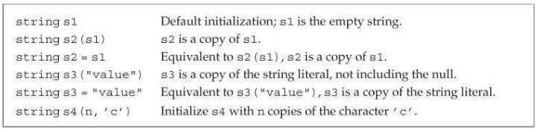
The string::size_type
Although we don’t know the precise type of string::size_type, we do know that it is an unsigned type big enough to hold the size of any string. Any variable used to store the result from the string size operation should be of type string::size_type. Because size returns an unsigned type, it is essential to remember that expressions that mix signed and unsigned data can have surprising results.

auto len = line.size(); // len has type string::size_type

To use size_type, we must name the type in which it is defined. A vector type always includes its element type.

vector<int>::size_type // ok
vector::size_type // error

Advice: Use the C++ Versions of C Library Headers
In addition to facilities defined specifically for C++, the C++ library incorporates the C library. Headers in C have names of the form name .h. The C++ versions of these headers are named c name—they remove the .h suffix and precede the name with the letter c. The c indicates that the header is part of the C library.

Example:
#include <math.h> # C style
#include <cmath> # C++ style

buffer overflow errors - attempting to subscript elements that do not exist. Such bugs are the most common cause of security problems in PC and other applications. A good way to ensure that subscripts are in range is to avoid subscripting altogether by using a range for whenever possible.

Example:
vector<int> v {0, 1, 2};
v[3] = 3 # error – buffer overflow

Note
If the container is empty, the iterators returned by begin and end are equal —they are both off-the-end iterators.

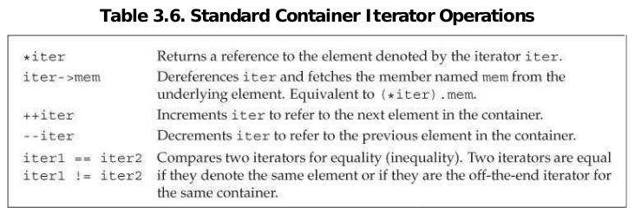
We may dereference only a valid iterator that denotes an element. Dereferencing an invalid iterator or an off-the-end iterator has undefined behavior.

Example:
string s("some string");
if (s.begin() != s.end()) { // make sure s is not empty
auto it = s.begin(); // it denotes the first character in s
*it = toupper(*it); // make that character uppercase
}

Key Concept: Generic Programming
Only a few library types, vector and string being among them, have the subscript operator. Similarly, all of the library containers have iterators that define the == and != operators. Most of those iterators do not have the < operator. By routinely using iterators and !=, we don’t have to worry about the precise type of container we’re processing.

A const_iterator behaves like a const pointer. Like a const pointer, a const_iterator may read but not write the element it denotes; an object of type iterator can both read and write. If a vector or string is const, we may use only its const_iterator type. With a nonconst vector or string, we can use either iterator or const_iterator.

Example:
vector<int>::iterator it; // it can read and write vector<int> elements
string::iterator it2; // it2 can read and write characters in a string
vector<int>::const_iterator it3; // it3 can read but not write elements
string::const_iterator it4; // it4 can read but not write
characters

The begin and end iterators
The type returned by begin and end depends on whether the object on which they operator is const. If the object is const, then begin and end return a const_iterator; if the object is not const, they return iterator:

Example:
vector<int> v;
const vector<int> cv;
auto it1 = v.begin(); // it1 has type vector<int>::iterator
auto it2 = cv.begin(); // it2 has type vector<int>::const_iterator
auto it3 = v.cbegin(); // it3 has type vector<int>::const_iterator

Warning!
It is important to realize that loops that use iterators should not add elements to the container to which the iterators refer.

Character Arrays Are Special
Character arrays have an additional form of initialization: We can initialize such arrays from a string literal . When we use this form of initialization, it is important to remember that string literals end with a null character. That null character is copied into the array along with the characters in the literal:

Example:
char a1[] = {'C', '+', '+'}; // list initialization, no null
char a2[] = {'C', '+', '+', '\0'}; // list initialization, explicit null
char a3[] = "C++"; // null terminator added
automatically
const char a4[6] = "Daniel"; // error: no space for the null!
char arr[] = "adam";
for (const auto &c: arr){
if (c != '\0') // null-terminated character
cout << c << endl;
}

The dimension of a1 is 3; the dimensions of a2 and a3 are both 4. The definition of a4 is in error. Although the literal contains only six explicit characters, the array size must be at least seven—six to hold the literal and one for the null.

No Copy or Assignment of c-style arrays
We cannot initialize an array as a copy of another array, nor is it legal to assign one array to another:

Example:
int a[] = {0, 1, 2}; // array of three ints
int a2[] = a; // error: cannot initialize one array with another
a2 = a; // error: cannot assign one array to another
begin and end function
int ia[] = {0,1,2,3,4,5,6,7,8,9}; // ia is an array of ten ints
int *beg = begin(ia); // pointer to the first element in ia
int *last = end(ia); // pointer one past the last element in ia

// pbeg points to the first and pend points just past the last element in arr
int *pbeg = begin(arr), *pend = end(arr);
// find the first negative element, stopping if we've seen all the elements
while (pbeg != pend && *pbeg >= 0)
++pbeg;

Note
A pointer “one past” the end of a built-in array behaves the same way as the iterator returned by the end operation of a vector. In particular, we may not dereference or increment an off-the-end pointer.

As with iterators, subtracting two pointers gives us the distance between those pointers. The pointers must point to elements in the same array. The result of subtracting two pointers is a library type named ptrdiff_t.
auto n = end(arr) - begin(arr); // n is 5, the number of elements in arr

Warning!
Unlike subscripts for vector and string, the index of the built-in subscript operator is not an unsigned type.

Conversion of c++ string to c-style string:
char *str = s; // error: can't initialize a char* from a string
const char *str = s.c_str(); // ok

The name c_str indicates that the function returns a C-style character string. That is, it returns a pointer to the beginning of a null-terminated character array that holds the same data as the characters in the string. The type of the pointer is const
char*, which prevents us from changing the contents of the array.

Note
To use a multidimensional array in a range for, the loop control variable for all but the innermost array must be references.

for (auto &row : ia)
for (auto col : row)

The unary minus operator returns the result of negating a (possibly promoted) copy
of the value of its operand:

Example:
int i = 1024;
int k = -i; // i is -1024
bool b = true;
bool b2 = -b; // b2 is true!

For most operators, operands of type bool are promoted to int. In this case, the value of b is true, which promotes to the int value 1. That (promoted) value is negated, yielding -1. The value -1 is converted back to bool and used to initialize b2. This initializer is a nonzero value, which when converted to bool is true. Thus, the value of b2 is true!

The sizeof operator
The sizeof operator returns the size, in bytes, of an expression or a type name.

sizeof (type)
sizeof expr

Example:
Sales_data data, *p;
sizeof(Sales_data); // size required to hold an object of type Sales_data
sizeof data; // size of data's type, i.e., sizeof(Sales_data)
sizeof p; // size of a pointer
sizeof *p; // size of the type to which p points, i.e., sizeof(Sales_data)
sizeof data.revenue; // size of the type of Sales_data's revenue member
sizeof Sales_data::revenue; // alternative way to get the size of revenue

The result of applying sizeof depends in part on the type involved:
• sizeof char or an expression of type char is guaranteed to be 1.
• sizeof a reference type returns the size of an object of the referenced type.
• sizeof a pointer returns the size needed hold a pointer.
• sizeof a dereferenced pointer returns the size of an object of the type to which the pointer points; the pointer need not be valid.
• sizeof an array is the size of the entire array. It is equivalent to taking the sizeof the element type times the number of elements in the array. Note that sizeof does not convert the array to a pointer.
• sizeof a string or a vector returns only the size of the fixed part of these types; it does not return the size used by the object’s elements.

Example:
// sizeof(ia)/sizeof(*ia) returns the number of elements in ia
constexpr size_t sz = sizeof(ia)/sizeof(*ia);
int arr2[sz]; // ok sizeof returns a constant expression

The comma operator takes two operands, which it evaluates from left to right. Like the logical AND and logical OR and the conditional operator, the comma operator guarantees the order in which its operands are evaluated.

Arithmetic conversions examples:
bool flag; char cval;
short sval; unsigned short usval;
int ival; unsigned int uival;
long lval; unsigned long ulval;
float fval; double dval;
3.14159L + 'a'; // 'a' promoted to int, then that int converted to long double
dval + ival; // ival converted to double
dval + fval; // fval converted to double
ival = dval; // dval converted (by truncation) to int
flag = dval; // if dval is 0, then flag is false, otherwise true
cval + fval; // cval promoted to int, then that int converted to float
sval + cval; // sval and cval promoted to int
cval + lval; // cval converted to long
ival + ulval; // ival converted to unsigned long
usval + ival; // promotion depends on the size of unsigned short and int
uival + lval; // conversion depends on the size of unsigned int and long

Explicit conversion
cast-name<type>(expression);
where type is the target type of the conversion, and expression is the value to be cast. If type is a reference, then the result is an lvalue. The cast-name may be one of static_cast, dynamic_cast, const_cast, and reinterpret_cast.

A static_cast is often useful when a larger arithmetic type is assigned to a smaller type.

Example:
// cast used to force floating-point division
double slope = static_cast<double>(j) / i;

A static_cast is also useful to perform a conversion that the compiler will not generate automatically. For example, we can use a static_cast to retrieve a pointer value that was stored in a void* pointer.

void* p = &d; // ok: address of any nonconst object can be stored in a void*
// ok: converts void* back to the original pointer type
double *dp = static_cast<double*>(p);

A const_cast changes only a low-level const in its operand:

Example:
const char *pc;
char *p = const_cast<char*>(pc); // ok: but writing through p is
undefined

Conventionally we say that a cast that converts a const object to a nonconst type “casts away the const.” Once we have cast away the const of an object, the compiler will no longer prevent us from writing to that object. If the object was originally not a const, using a cast to obtain write access is legal. However, using a
const_cast in order to write to a const object is undefined.

A reinterpret_cast generally performs a low-level reinterpretation of the bit pattern of its operands.

Example:
int *ip;
char *pc = reinterpret_cast<char*>(ip);

Warning!
A reinterpret_cast is inherently machine dependent. Safely using
reinterpret_cast requires completely understanding the types involved as well as the details of how the compiler implements the cast.

Operation precedence

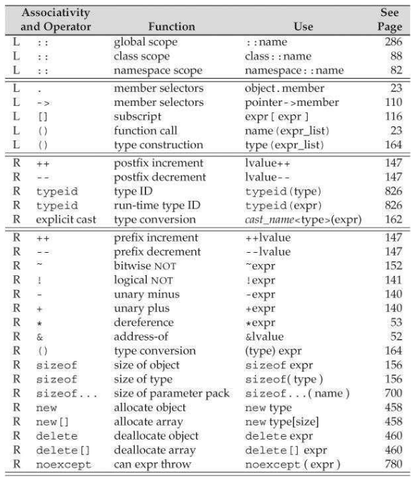
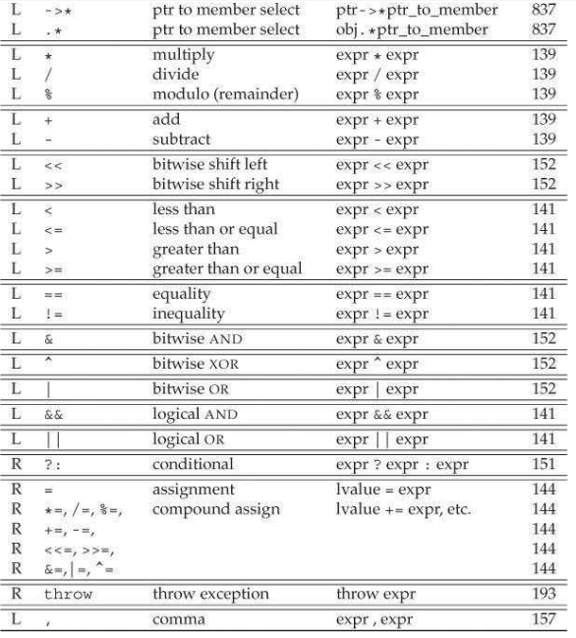
Null Statement
A null statement is useful where the language requires a statement but the program’s logic does not.

Example:
// read until we hit end-of-file or find an input equal to sought
while (cin >> s && s != sought)
; // null statement

Best Practices!
Null statements should be commented. That way anyone reading the code can see that the statement was omitted intentionally.

Note!
A block {…} is not terminated by a semicolon.

We also can define an empty block by writing a pair of curlies with no statements. An empty block is equivalent to a null statement.

Example:
while (cin >> s && s != sought)
{ } // empty block

Exceptions

Example:
// first check that the data are for the same item
if (item1.isbn() != item2.isbn())
throw runtime_error("Data must refer to same ISBN");
// if we're still here, the ISBNs are the same
cout << item1 + item2 << endl;

In this code, if the ISBN s differ, we throw an expression that is an object of type runtime_error. Throwing an exception terminates the current function and transfers control to a handler that will know how to handle this error. The type runtime_error is one of the standard library exception types and is defined in the stdexcept header.

The general form of a try block is:
try {
program-statements
} catch (exception-declaration) {
handler-statements
} catch (exception-declaration) {
handler-statements
} // . . .

Example:
while (cin >> item1 >> item2) {
try {
// execute code that will add the two Sales_items
// if the addition fails, the code throws a runtime_error exception
} catch (runtime_error err) {
// remind the user that the ISBNs must match and prompt for another pair
cout << err.what()
<< "\nTry Again? Enter y or n" << endl;
char c;
cin >> c;
if (!cin || c == 'n')
break; // break out of the while loop
}
}

The prompt to the user prints the return from err.what(). We know that err has type runtime_error, so we can infer that what is a member function of the runtime_error class. Each of the library exception classes defines a member function named what. These functions take no arguments and return a C-style character string (i.e., a const char*).

The C++ library defines several classes that it uses to report problems encountered in the functions in the standard library:
• The exception header defines the most general kind of exception class named exception. It communicates only that an exception occurred but provides no additional information.
• The stdexcept header defines several general-purpose exception classes
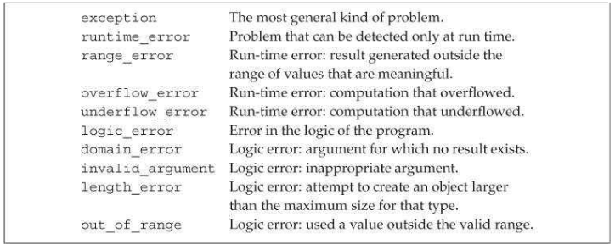
• The new header defines the bad_alloc exception type.
• The type_info header defines the bad_cast exception type.

The exception types define only a single operation named what. That function takes no arguments and returns a const char* that points to a C-style character string. The purpose of this C-style character string is to provide some sort of textual description of the exception thrown.

