Arduino Notes

1. Set up Arduino IDE

a) install drivers
b) install Arduino IDE
c) select your board (Tools/Board)
d) select USB port to which the board is connected (Tools/Port)

2. Code structure

setup() - the setup() function is called when a sketch starts. Use it to:
- initialize variables
- initialize pin modes
- start using libraries
The setup() function will only run once, after each power-up or reset of the Arduino board.

loop() - executed right after setup code, the loop() loops consecutively, allowing program to change and respond. It is the main function.

void setup() {
// put your setup code here, to executed once:
Serial.begin(9600);
Serial.println("This is setup code");
}

void loop() {
// put your main code here, to run repeatedly:
Serial.println("This is loop code");
delay(1000);
}

2. Serial monitor / plotter

Serial monitor - it is used for two purposes:
a) Arduino → PC: receives data from Arduino and display data on screen. This is usually used for debugging and monitoring.
b) PC → Arduino: sends data (command) from PC to Arduino.

Data is exchanged between Serial Monitor and Arduino via USB cable, which is also used to upload the code to Arduino.

Arduino to PC

To send data from Arduino to PC, we need to use the following Arduino code:
Serial.begin(speed)) - Prepares Arduino to begin sending and receiving serial data. You’ll generally use 9600 baud (bits per second) with the
Arduino IDE serial monitor
Serial.begin(9600);

Serial.print(data, encoding) - Sends some data to the serial port. The encoding is optional; if not supplied, the data is treated as much like plain text as possible.
Serial.print(75, HEX); // "4B" (75 in hexadecimal)
Serial.print(75, BIN); // "1001011" (75 in binary)
Serial.println(data, encoding) - Same as Serial.print(), except that it adds a carriage return and linefeed (\r\n) (only linefeed in case of linux)
Serial.println(75); // Prints "75\n"

PC to Arduino
Type text on Serial Monitor and click Send button. Arduino reads data and process it:

Serial.available() - Returns how many unread bytes are available on the serial port for reading via the read() function. After you have read() everything available, Serial.available() returns 0 until new data arrives on the serial port.
int count = Serial.available();

int Serial.read() - Fetches 1 byte of incoming serial data.
int data = Serial.read();

3. Common data types

- char – holds ASCII characters or ints <-128, 127>, 1 byte
- byte – hold number <0, 255>, like uint8_t in c++
- int – hold number <-32’768, 32’767>, 2 bytes
- unsigned int - hold number <0, 65’535>, 2 bytes
- long – hold <–2’147’483’648, 2’147’483’647>, 4 bytes
- float – 4 bytes
- double – double precision floating-point number
- string – same as in c language, ending with ‘null’ character
- array – same as in c language

4. Useful basic functions

Common Input and Output functions:

pinMode(pin, mode) - (Re)configure a digital pin to behave either as an input or an output.
pinMode(7, INPUT); // turns pin 7 into an input

digitalWrite(pin, value) - Turns a digital pin either HIGH or LOW. Pins must be explicitly made into an output using pinMode() before digitalWrite() will have the expected effect.
digitalWrite(8, HIGH); // sets digital pin 8 to 5 V

int digitalRead(pin) - Reads the state of an input pin, and returns HIGH if the pin senses some voltage or LOW if there is no voltage applied.
val = digitalRead(7); // reads pin 7 into val

int analogRead(pin) - Reads the voltage applied to an analogue input pin and
returns a number between 0 and 1023 that represents the voltages between 0 and 5 V.
val = analogRead(0); // reads analog input 0 into val

analogWrite(pin, value) - Changes the PWM rate on one of the PWM pins. pin can only be a pin that supports PWM, that is, pins 3, 5, 6, 9, 10, or 11 on the Uno. Value must be a number between 0 and 255. You can think
of value to represent the average amount of power Arduino will deliver, where a value of zero corresponds to fully off, while a value of 255 corresponds to fully on. A value of 0 sets the output fully LOW, while a value of 255 sets an output fully HIGH.
analogWrite(9,128); // Dim an LED on pin 9 to 50%

shiftOut(dataPin, clockPin, bitOrder, value) - Sends data to a shift register, devices that are used to expand the number of digital outputs. This protocol uses one pin for data and one for clock. bitOrder indicates the ordering of bits (least significant or most significant) and value is the actual data to be sent out.
shiftOut(dataPin, clockPin, LSBFIRST, 255);

unsigned long pulseIn(pin, value) - Measures the duration of a pulse coming in on one of the digital inputs. This is useful, for example, to read some infrared sensors or accelerometers that output their value as pulses of changing duration.
time = pulsein(7,HIGH); // measures the time the next pulse stays high

Common Time functions:

unsigned long millis() - Returns the number of milliseconds that have passed since the sketch started.
duration = millis()-lastTime; // computes time elapsed since "lastTime"

delay(ms) - Pauses the program for the amount of milliseconds specified.
delay(500); // stops the program for half a second

Other useful functions:

map(value, fromLow, fromHigh, toLow, toHigh) - Maps a value in the range fromLow and maxLow to the range toLow and toHigh. Very useful to process values from analogue sensors.
val = map(analogRead(0),0,1023,100, 200); // maps the value of analog 0 // to a value between 100 and 200

randomSeed(seed) - Resets Arduino’s pseudorandom number generator.
randomSeed(analogRead(5)); // randomize using noise from pin 5

long random(min, max) - Returns a pseudorandom long integer value between min and max – 1. If min is not specified, the lower bound is 0.
long randnum = random(0, 100); // a number between 0 and 99
long randnum = random(11); // a number between 0 and 10
BREADBOARD

Breadboard (das Steckbrett / plytka stykowa) is a construction base used to build semi-permanent prototypes of electronic circuits, which does not require soldering.

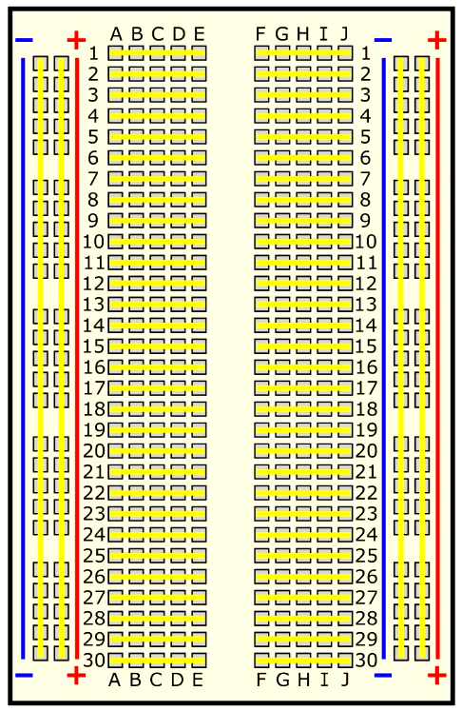

yellow lines - show connected terminal strips
red ‘+’ - positive side of battery (i.e. 1.5V or 5V) should be connected to power rail. By convention red jumpers/cables are used
blue ‘-’ - negative side of battery/ground (GND) should be connected to bus strip. By convention black jumpers/cables are used.

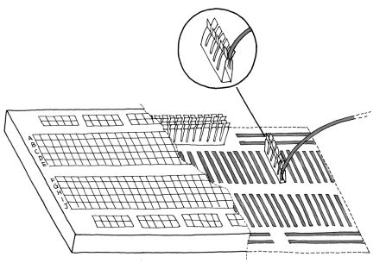

The solderless breadboard with spring loaded contacts.
READING RESISTORS

There are four stripes, and each colour represents a number. One of rings is usually gold-coloured; this one represents the tolerance of that resistor.
To read the stripes in order, hold the resistor so the gold (or silver in some cases) stripe is to the right. Then, read the colours and map them to the corresponding numbers. In the following table, you’ll find a translation between the colours and their numeric values.

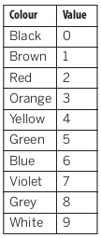

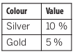

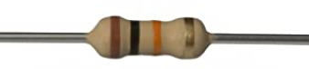

For example, brown, black, orange, and gold markings mean 1 0 3 ±5 %. Easy, right? Not quite, because there is a twist: the third ring actually represents the number of zeros in the value. Therefore 1 0 3 is actually 1 0 followed by three zeros, so the end result is 10,000 ohms ±5 %.

SCHEMATIC DIAGRAMS

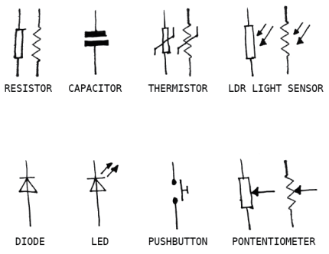

Pic. Common schematic symbols

LED
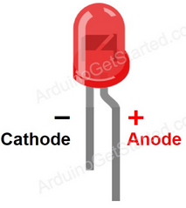
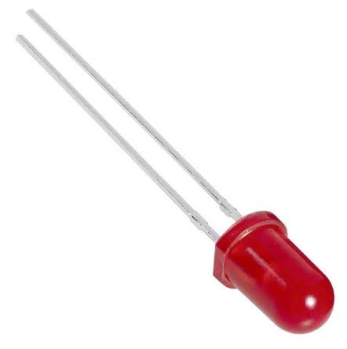

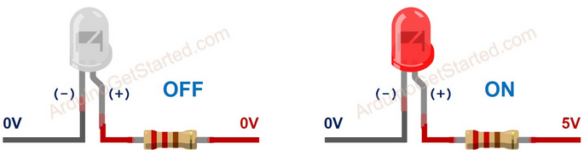

- short lead, cathode, most LED have flattened edge on this side. It should be connected to ground
- long lead, anode, should be connected to I/O pin (positive side)

LED is polarized and requires a resistor to be connected in series to prevent it from burning.
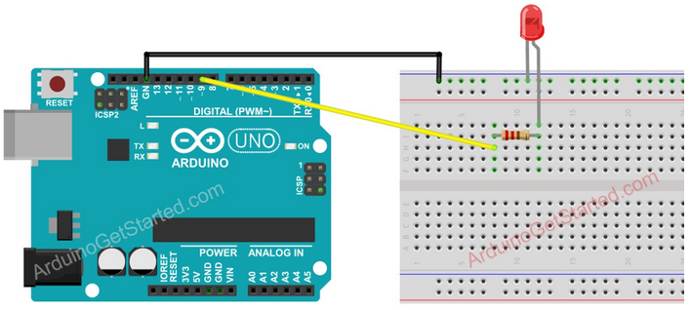

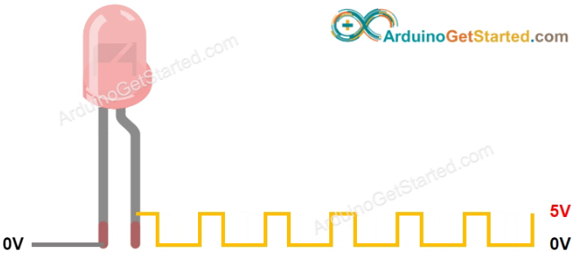
Some of Arduino pins (marked with ~) can be programmed to generate PWM (pulse width modulated) signal.

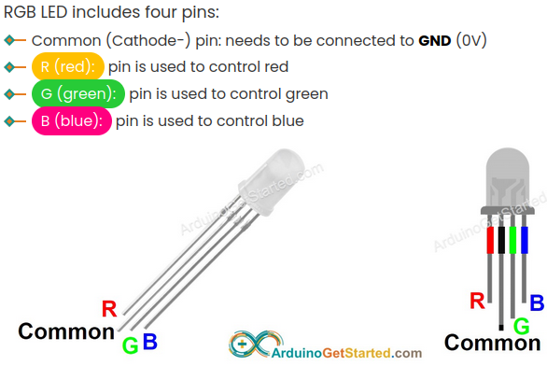
The common pin can be cathode or anode, depending of the RGB LED type.
For RGB LED with common Anode, you need to connect the common pin to 3.3V of Arduino.
Avoid using a single resistor in the common pin of RGB LED instead of three resistors in the other pins.

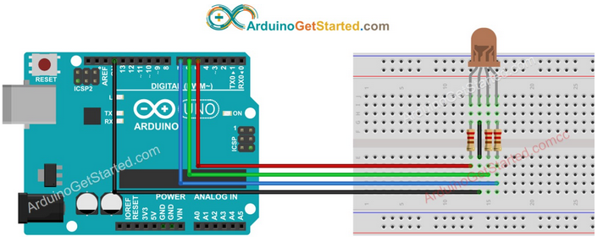

MOSFET

A MOSFET (metal–oxide–semiconductor field-effect transistor) is a four-terminal device having source(S), gate (G), drain (D) and body (B) terminals. In general, The body of the MOSFET is in connection with the source terminal thus forming a three-terminal device such as a field-effect transistor. MOSFET is generally considered as a transistor and employed in both the analog and digital circuits.
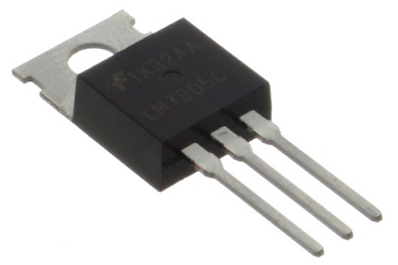
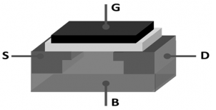

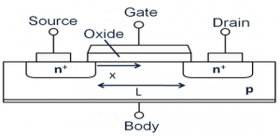

A MOSFET can function in two ways
- Depletion Mode - When there is no voltage across the gate terminal, the channel shows its maximum conductance. Whereas when the voltage across the gate terminal is either positive or negative, then the channel conductivity decreases.
- Enhancement Mode - When there is no voltage across the gate terminal, then the device does not conduct. When there is the maximum voltage across the gate terminal, then the device shows enhanced conductivity.

Working Principle of MOSFET
The main principle of the MOSFET device is to be able to control the voltage and current flow between the source and drain terminals. It works almost like a switch and the functionality of the device is based on the MOS capacitor. The MOS capacitor is the main part of MOSFET.
The semiconductor surface at the below oxide layer which is located between the source and drain terminal can be inverted from p-type to n-type by the application of either a positive or negative gate voltages respectively. When we apply a repulsive force for the positive gate voltage, then the holes present beneath the oxide layer are pushed downward with the substrate.
The depletion region populated by the bound negative charges which are associated with the acceptor atoms. When electrons are reached, a channel is developed. The positive voltage also attracts electrons from the n+ source and drain regions into the channel. Now, if a voltage is applied between the drain and source, the current flows freely between the source and drain and the gate voltage controls the electrons in the channel. Instead of the positive voltage, if we apply a negative voltage, a hole channel will be formed under the oxide layer.

Advantages
Few of the advantages are :
- It generates enhanced efficiency even when functioning at minimal voltage levels
- There is no presence of gate current this creates more input impedance which further provides increased switching speed for the device
- These devices can function at minimal power levels and uses minimal current

Disadvantages
Few of the disadvantages are :
- When these devices are functioned at overload voltage levels, it creates instability of the device
- As because the devices have a thin oxide layer, this may create damage to the device when stimulated by the electrostatic charges

Applications
The applications of MOSFET are
- Amplifiers made of MOSFET are extremely employed in extensive frequency applications
- The regulation for DC motors are provided by these devices
- As because these have enhanced switching speeds, it acts as perfect for the construction of chopper amplifiers
- Functions as a passive component for various electronic elements.

MULTIMETER

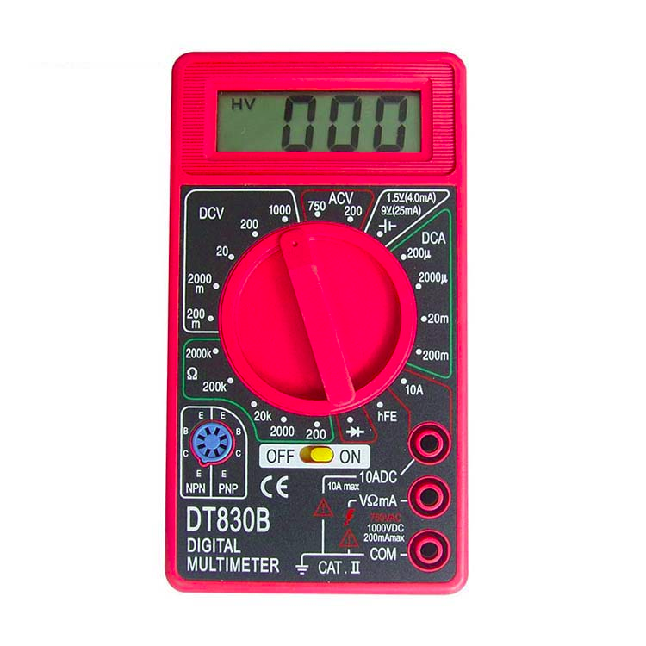
Electrical symbols

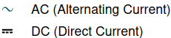

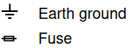

COM jack - plug in connector for black (negative) test lead

VωmA jack- plug in connector for red (positive) test lead for all voltage, resistance and current ( up to 200mA ) measurements.

10ADC jack - plug in connector for red (Positive) test lead for current ( between 200mA and 10A ) measurement. There is no fuse for "10A" jack. To use safely, each measurement can not last for more than 10
seconds, and the interval between each measurement must be
more than 15 minutes

diode (continuity) – enables to verify if elements are connected (or if element is conductive)

Warning!

Be careful when measuring current. It is safer always to start with maximum range (in the example case 10ADC jack) to prevent internal fuse to be blown. This happens if the current is over 200mA and VωmA jack is used.

How to measure:
1) resistance - simply connect to two ends of resistor (not in the circuit, measurement for separate part)

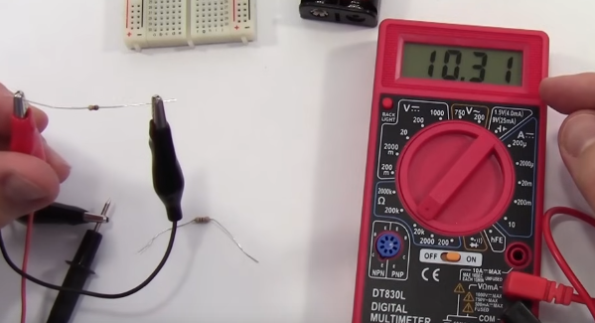

2) voltage of battery – connect to cables to positive and negative terminal, be aware that it creates short circuit, so in case of battery with higher current due it for just a second

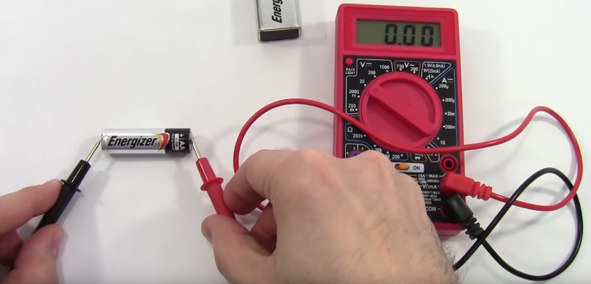
3) voltage – multimeter should be connected in parallel

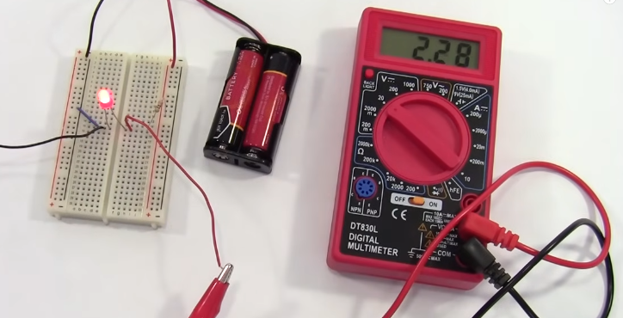

4) current - multimeter should be connected in series

