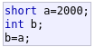
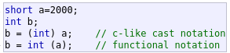
TYPE CASTING

Implicit conversion (‘suggested’ conversion) - do not require any operator. They are automatically performed when a value is copied to a compatible type

Explicit conversion
(new_type) expression
new_type (expression)

Pointer conversion
CDummy d;
CAddition* padd;
padd = (CAddition*) &d;

Traditional explicit type-casting allows to convert any pointer into any other pointer type, independently of the types they point to. The subsequent call to member result will produce either a run-time error or a unexpected result.

To control conversions between classes, we have four specific casting operators:
dynamic_cast <new_type> (expression)
reinterpret_cast <new_type> (expression)
static_cast <new_type> (expression)
const_cast <new_type> (expression)

1. dynamic_cast
- can be used only with pointers and references to objects
- purpose: to ensure that the result of the type conversion is a valid complete object of the requested class
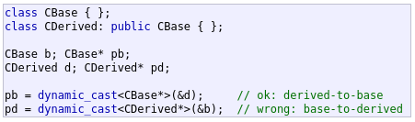
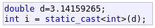
- performs a special checking during runtime to ensure that the expression yields a valid complete object of the requested class
- always successful when we cast a class to one of its base classes
- base-to-derived conversions are not allowed with dynamic_cast unless the base class is polymorphic and it provides a complete object of class derived.
- when dynamic_cast cannot cast a pointer because it is not a complete object of the required class it returns a null pointer to indicate the failure.
- if used to convert to a reference type and the conversion is not possible, an exception of type bad_cast is thrown instead.

Compatibility note: dynamic_cast requires the Run-Time Type Information (RTTI) to keep track of dynamic types. Some compilers support this feature as an option which is disabled by default. This must be enabled for runtime type checking using dynamic_cast to work properly.

2. static_cast
- can perform conversions between pointers to related classes in both directions (from the derived class to its base and also from a base class to its derived)
- ensures that at least the classes are compatible if the proper object is converted, but no safety check is performed during runtime to check if the object being converted is in fact a full object of the destination type.
- it is up to the programmer to ensure that the conversion is safe
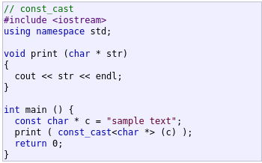
- the overhead of the type-safety checks of dynamic_cast is avoided.
- can also be used to perform any other non-pointer conversion that could also be performed implicitly
- can also be used to any conversion between classes with explicit constructors or operator functions
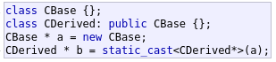

3. reinterpret_cast
- converts any pointer type to any other pointer type, even of unrelated classes. The operation result is a simple binary copy of the value from one pointer to the other.
- all pointer conversions are allowed: neither the content pointed nor the pointer type itself is checked
- it can also cast pointers to or from integer types
- the conversions that can be performed by reinterpret_cast but not by static_cast are low-level operations, whose interpretation results in code which is generally system-specific, and thus non-portable.
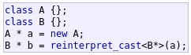

This is valid C++ code, although it does not make much sense, since now we have a pointer that points to an object of an incompatible class, and thus dereferencing it is unsafe.

4. const_cast
- manipulates the constness of an object, either to be set or to be removed
- example: to pass a const argument to a function that expects a non-constant parameter (normally const argument needs const function):

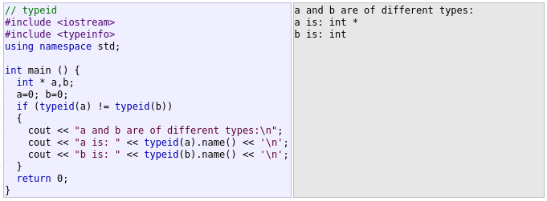

5. typeid
- allows to check the type of an expression
- typeid (expression)
- typeid(element).name() - returns a null-terminated character sequence representing the data type or class name

- when typeid is applied to classes typeid uses the RTTI to keep track of the type of dynamic objects.
- when typeid is applied to an expression whose type is a polymorphic class, the result is the type of the most derived complete object:

Notice how the type that typeid considers for pointers is the pointer type itself (both a and b are of type class CBase *).

However, when typeid is applied to objects (like *a and *b) typeid yields their dynamic type (i.e. the type of their most derived complete object).

SOURCE
http://www.cplusplus.com/doc/oldtustorial/typecasting/

