FUNDAMENTAL TYPES

Data models

The choices made by each implementation about the sizes of the fundamental types are collectively known as data model. Four data models found wide acceptance:

32 bit systems:
LP32 or 2/4/4 (int is 16-bit, long and pointer are 32-bit)
Win16 API
ILP32 or 4/4/4 (int, long, and pointer are 32-bit);
Win32 API
Unix and Unix-like systems (Linux, Mac OS X)
64 bit systems:
LLP64 or 4/4/8 (int and long are 32-bit, pointer is 64-bit)
Win64 API
LP64 or 4/8/8 (int is 32-bit, long and pointer are 64-bit) // my data model
Unix and Unix-like systems (Linux, Mac OS X)

Modifiers
Modifies the integer type. Can be mixed in any order. Only one of each group can be present in type name.

Signedness
signed - target type will have signed representation (this is the default if omitted)
unsigned - target type will have unsigned representation

Size
short - target type will be optimized for space and will have width of at least 16 bits.
long - target type will have width of at least 32 bits.
long long - target type will have width of at least 64 bits. (since C++11)

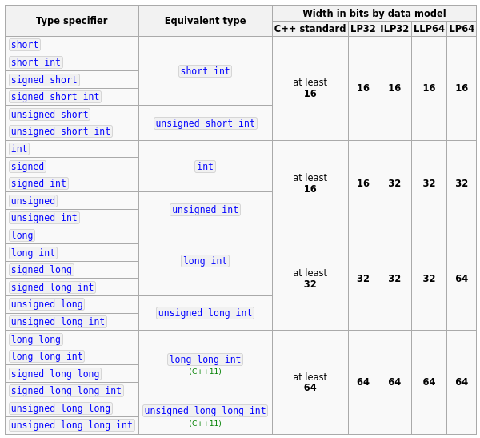

Floating point types
float - single precision floating point type. Usually IEEE-754 32 bit floating point type
double - double precision floating point type. Usually IEEE-754 64 bit floating point type
long double - extended precision floating point type. Does not necessarily map to types mandated by IEEE-754. Usually 80-bit x87 floating point type on x86 and x86-64 architectures.

