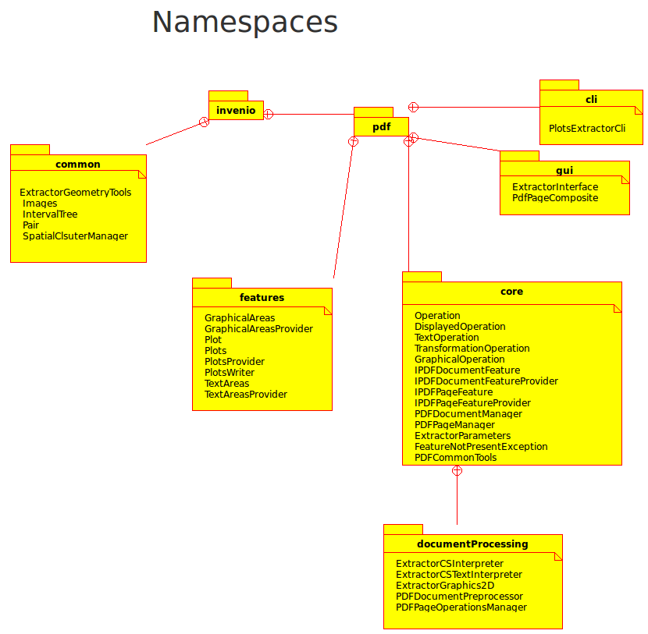

The core namespace (main logic exposed to modules)

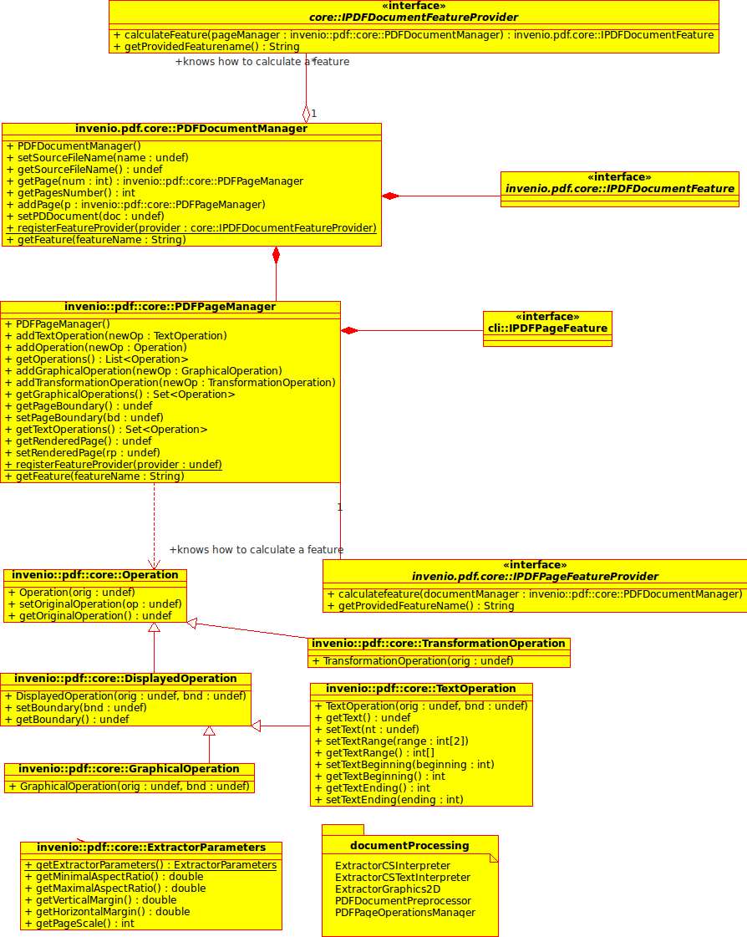
Internals (Extraction of useful metadata from the PDF file) invenio.pdf.core.documentProcessing

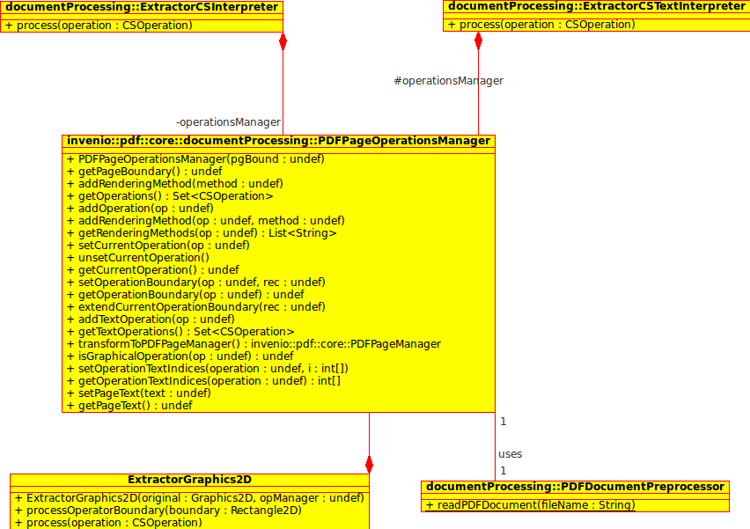

Features allowing to perform some useful work:

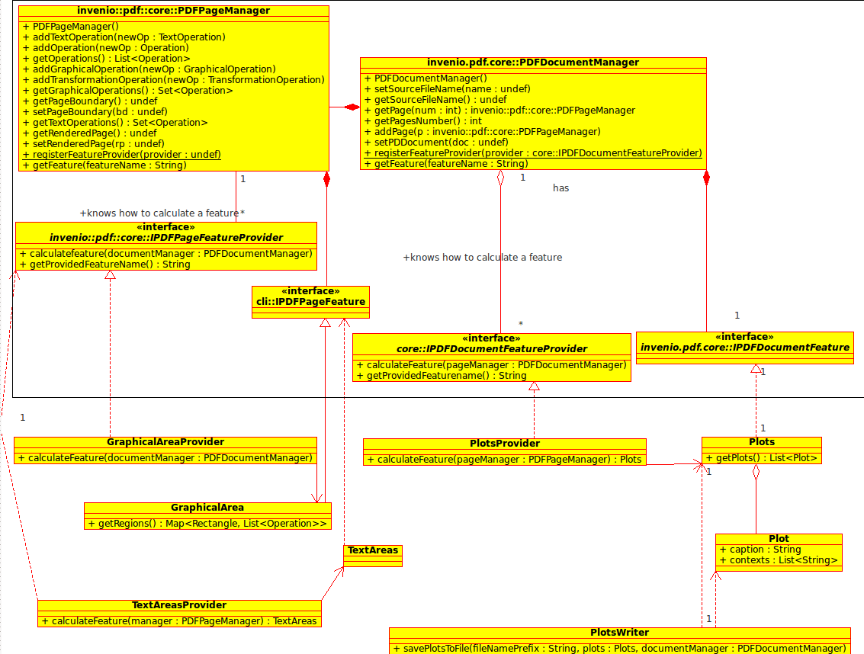
utility classes

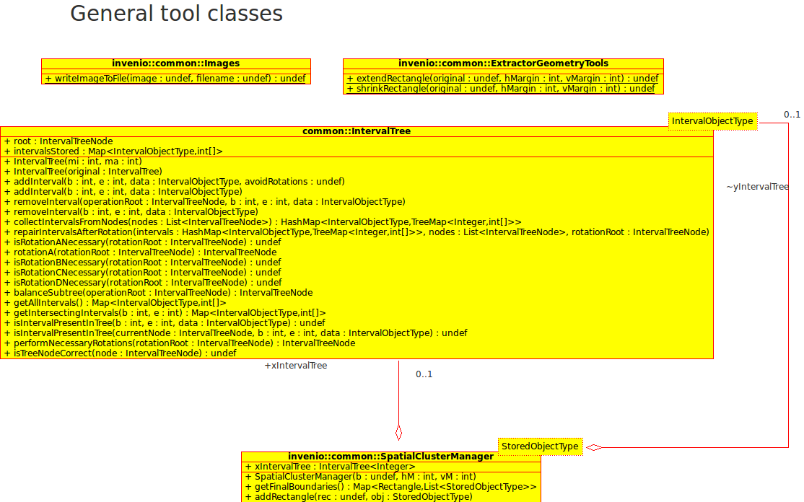

Classes providing user interface

