JLCF User’s and Developer’s manual

Version: 1.0.1  
Date: 03.06.2015  
Author: Petros Pissias , <http://jlcf.sourceforge.net>

**Table Of Contents**

1 Introduction 4

1.1 What is JLCF 4

1.2 JLCF Component Model 4

1.2.1 Component 4

1.2.2 Interceptor 5

1.2.3 Callback 5

1.2.4 Application Description 5

1.2.5 Distribution 6

1.3 Dynamic reconfiguration 6

2 User’s Guide 7

2.1 General usage of the framework 7

2.1.1 Application Description Files – Simple Example 7

2.1.2 Component initialization 8

2.1.3 Properties and Receptacles 9

2.1.4 Interceptors 10

2.1.5 Callbacks 11

2.1.6 Dynamic Reconfiguration 12

2.1.7 Framework API 14

2.2 Examples 16

2.2.1 Simple Calculator 17

2.2.2 Callback 22

2.2.3 Interceptor 26

2.2.4 Calling remote service with Interceptor 28

2.2.5 Calling Remote Service with proxy component 31

2.2.6 Dynamic Reconfiguration 33

2.2.7 Guidelines for implementing components 41

3 Developer’s Guide 42

3.1 System design 42

3.2 Dynamic reconfiguration internals 45

3.2.1 Extending dynamic reconfiguration 48

APPENDIX 1. Application Description Schema 50

# Introduction

## What is JLCF

The Java Light Component Framework (JLCF) is a framework for developing modular applications for the java language. It allows designing an application using building blocks with well-defined inputs and outputs (aka software components). Using this well-defined modular approach, the application has a clear and explicit design which facilitates the development and maintenance of a software system.

JLCF focuses on usability, on a simple programming model and also provides advanced features such as interceptors, callbacks and the ability to replace components while the system is running (dynamic component replacement) in a way that tries to minimise the disturbance to the rest of the application.

## JLCF Component Model

The following sections define the basic elements of JLCF.

### Component

Components are the elementary building blocks of an application. Each component implements part of the application and formalizes the functionality it provides through offered Interfaces and the functionality it requires through required interfaces which are called Receptacles.

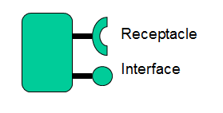

All component-to-component communication must be done via their Receptacles and Interfaces.

#### Interface

Components offer functionality through one or more Interfaces. This functionality can be used by another component or by a user of the framework. A JLCF Interface is a plain Java interface.

#### Receptacle

A Receptacle is an interface requirement. Components require functionality through receptacles. During the instantiation of a component composition, Receptacles are connected by the framework to Interfaces in order to specify the provider of the functionality a component requires.

#### Properties

Each component can have one or more properties. These are name / value pairs that are specified externally and are passed to the component by the framework during its instantiation.

#### Component Interaction patterns

Components interact through their Interfaces and Receptacles using normal request / response synchronous method calls. Asynchronous interactions between components may be implemented as 2 calls between components, for example, ComponentA may call ComponentB, which will immediately return, will process the request and will later reply at an interface provided by ComponentA.

In addition, JLCF provides the ability for one component to provide a callback reference when calling another component. The callback can be obtained on the target component and used to provide asynchronously one or more replies. Callbacks are further explained in the next sections.

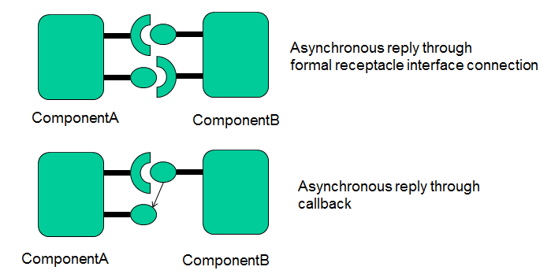

### Interceptor

An interceptor is a construct that is placed in receptacles and can intercept calls between components. An Interceptor can be used in order to intercept and change the target interface arguments or return data. Each receptacle may contain a chain of interceptors, which intercept the call one after the other.

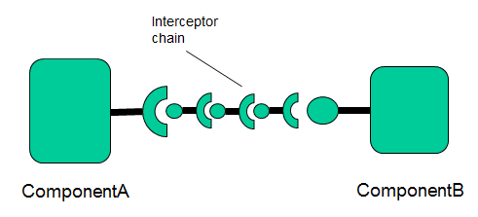

### Callback

A callback is an interaction pattern provided by the framework where a component may provide a callback address when calling another component. The Callback, which is a reference to a component interface, can be obtained from the target component and used to asynchronously provide one or more replies to the caller component.

### Application Description

The application description is the configuration of the application in terms of a component composition, expressed in an xml document. This is a central concept of JLCF, all components and their interconnection are specified centrally in a configuration file. The framework is able to instantiate an application through an application description file which is provided by the framework user.

### Distribution

The JLCF component model is not a distributed component model. That is, it does not natively provide any mechanism interact with external services or a JLCF Component based application running at another JVM locally or remotely. This part is intentionally left out and delegated to the application as there are many other frameworks and middleware that perform this task very well.

If there is a need to have communication between 2 remote JLCF applications, the communication between the boundary components of the 2 applications is done outside of the framework using any normal middleware or framework that is capable of doing this. This can be done either with interceptors or by having a proxy component that communicates with the remote service. These patterns are explained in more detail in the examples section.

## Dynamic reconfiguration

While the application is running as a composition of components described in an application description, it is possible to instruct the framework to replace a component implementation with an alternative one. The application will continue to run and the framework will try to perform this reconfiguration transparently to the rest of the application.

At the current version, the framework only supports replacing one component at a time. If several components need to be replaced at runtime, several requests must be made to the framework sequentially.

# User’s Guide

## General usage of the framework

The definition and composition of the components that form an application is done in the *Application Description* file. This is an xml file which defines all components and their interconnections.

Typically a user of the framework will define an Application Description file, implement the components and will then instantiate and interact with the component composition through the API that the framework provides.

### Application Description Files – Simple Example

A simple example of an Application Description below:

<?xml version=*"1.0"* encoding=*"UTF-8"*?>

<Application applicationName=*"Hello World Example"* xmlns=*"http://jlcf.sourceforge.net/JLCFApplication"* xmlns:xsi=*"http://www.w3.org/2001/XMLSchema-instance"*>

<component implementationClass=*"ComponentA"* name=*"compA"*>

<interface name=*"userinterface"* type=*"IComponentA"* />

<receptacle name=*"to_comp_B"* >

<Reference path=*"compB/compbintf"* />

</receptacle>

<property name=*"version"* value=*"1.01"*/>

</component>

<component implementationClass=*"ComponentB"* name=*"compB"*>

<interface name=*"compbintf"* type=*"IComponentB"*/>

</component>

</Application>

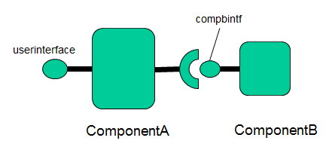

This application would then be instantiated and used by the JLCF framework with the following API calls:

IJLCFContainer runtime = JLCFContainer.*getInstance*();

runtime.loadApplication("HelloWorldExample.xml");

and with the following API call, a user of the framework may obtain a reference to an a component interface and start using it.

//get reference to component provided interface

IComponentA compA = runtime.getComponentReference("compA/userinterface");

Regarding the component definition, this example file defines an application which has 2 components, starting with the simplest definition, compB is defined as follows:

<component implementationClass=*"ComponentB"* name=*"compB"*>

<interface name=*"compbintf"* type=*"IComponentB"*/>

</component>

In the component description we need to specify the implementation class that implements the component. This component offers a formal interface to other components or users of the framework. This is specified in the <interface> element. The interface has a name and type, which defines the Java Interface type. As with all formal interfaces of a component, the implementing class of a component needs to implement the corresponding Java interface.

The interface definition is

**public** **interface** IComponentB {

**public** String someMethod(String input);

}

which is a plain old Java interface with no extra annotations.

The Component implementation class is listed below

**public** **class** ComponentB **implements** IComponentB {

**private** **final** Logger logger = Logger.*getLogger*(getClass());

**public** ComponentB() {

}

@InitMethod

**public** **void** init() {

logger.info("Init method called");

}

@Override

**public** String someMethod(String input) {

logger.info("method called, with input :"+input);

**return** input.toUpperCase();

}

}

Besides the @InitMethod annotation, the component implementation has nothing special, except that it implements the formal interface *IComponentB* that the component offers. The framework follows a POJO approach and tries to minimize the overhead for the component developer.

### Component initialization

The component developer can indicate a method that the framework will call as soon as the component is instantiated. This method is marked with the @InitMethod annotation. Such a method is typically used to initialize the component and may call other components. Components are initialized in the order that they are defined in the Application Description file so if a component calls another component during its initialization phase, the other component must be defined previously.  
The method marked with @InitMethod shall not have any arguments.

### Properties and Receptacles

The other component definition, compA is shown below:

<component implementationClass=*"ComponentA"* name=*"compA"*>

<interface name=*"userinterface"* type=*"IComponentA"* />

<receptacle name=*"compoB"* >

<Reference path=*"compB/compbintf"* />

</receptacle>

<property name=*"version"* value=*"1.01"*/>

</component>

In addition to an interface that the component offers, *IComponentA*, it defines a Receptacle which is an interface requirement.

<receptacle name=*"compoB"* >

<Reference path=*"compB/compbintf"* />

</receptacle>

The receptacle is named “compoB” and has a reference element which points to a target interface offered by another component.

The reference has a target path, which follows the format <component_name / component_interface_name>, which in the example above, the receptacle is pointing to interface compbintf of compB.

The component compB also defines a value for a property :

<property name=*"version"* value=*"1.01"*/>

The Receptacles and properties of a component are injected through the constructor of the class  
that implements the component, when the framework instantiates the component.   
Each Receptacle and Property must be annotated using the @Property and @Receptacle annotations in order for the framework to be able to correctly identify each one and inject the correct references.

The property types on the constructor can be: String, Integer, Float, Double or Boolean. The framework will automatically cast the value to the appropriate type.

**public** **interface** IComponentA {

**public** String doTask(String task);

}

**public** **class** ComponentA **implements** IComponentA{

**private** **final** IComponentB compB;

**private** **final** String version;

**private** **final** Logger logger = Logger.*getLogger*(getClass());

**public** ComponentA(@Receptacle(name="compoB") IComponentB compB,

@Property(name="version") String version) {

**this**.compB = compB;

**this**.version = version;

}

@InitMethod

**public** **void** callme() {

logger.info("component "+getClass().getName()+" version:"+version+" initialized");

}

@Override

**public** String doTask(String input) {

String compBInput = input;

logger.info("doTask called. Calling component B with input="+compBInput);

String ret = compB.someMethod(compBInput);

logger.info("received reply from component B :"+ret);

**return** ret;

}

}

The implementation of Component compA is shown above.

The constructor

**public** ComponentA(@Receptacle(name="compoB") IComponentB compB,

@Property(name="version") String version

must define which fields are of type Property and a Receptacle and their respective names.

### Interceptors

The framework allows placing user defined interceptors between component connections.

Interceptors are specified at the receptacle definition of a component in the application description.

<component implementationClass=*"ComponentA"* name=*"compA"*>

<interface name=*"userinterface"* type=*"IComponentA"* />

<receptacle name=*"compoB"* >

<Reference path=*"compB/compbintf"* />

**<Interceptor name=*"compbinterceptor"* type=*"StringCaseInterceptor"* />**

</receptacle>

</component>

<component implementationClass=*”ComponentB"* name=*"compB"*>

<interface name=*"compbintf"* type=*"IComponentB"*/>

</component>

The definition above specifies that an interceptor, implemented by the user provided class StringCaseInterceptor, will intercept all calls done from this component’s receptacle.

Interceptors must extend the Interceptor class and implement the target interface of the receptacle, which in this case is IComponentB. The example below shows an interceptor that manipulates the String argument and return of a target method.

**public** **class** StringCaseInterceptor **extends** Interceptor **implements** IComponentB {

@Override

**public** String someMethod(String input) {

IComponentB targetInterface = **getTarget();**

String ret = targetInterface.someMethod(input.toUpperCase());

**return** ret.toLowerCase();

}

}

The programming model for interceptors is done by directly re-implementing the target interface and changing the arguments / return of the call. Access to the target interface is provided by the generic getTarget method which is provided by the Interceptor base class.

Interceptors have full freedom to do whatever they want with the input arguments of the method. It is even possible not to call the target interface and return something arbitrary.

### Callbacks

When a component calls another component, via a receptacle – interface connection, it is possible to specify a callback interface that the target component may use. Callbacks are defined at the receptacle definition of a component, for example:

<receptacle name=*"compoB"* >

<Reference path=*"compB/compbintf"* **callbackReference=*"compA/callback"***/>

</receptacle>

The definition above, will pass a callable reference to the target component that may be used to asynchronously reply one or more times or for whatever reason the application developer will decide. The callback reference can be obtained from the target component implementation via the generic methd getCallback provided by the framework.

ITestCallback cb = container.getCallback();

For example, below is an Interface method implementation that utilizes callbacks.

@Override

**public** **void** register() {

ITestCallback cb = **null**;

**try** {

//obtain the callback, the framework provides the correct callback for this call transparently

cb = container.getCallback();

} **catch** (ComponentReferenceException e) {

logger.log(Level.*ERROR*, e.getMessage(), e);

**return**;

}

**if** (cb != **null**) { //add the callback to this list of registered users

registeredComponents.add(cb);

}

}

The container reference is injected by the framework on instantiating the component using the @ConteinerRef annotation (see the examples section for more details).

The callback target interface (ITestCallback in this case) must be known in advance. Typically the target component will specify if it expects callbacks at an Interface and of which type. Then, calling components may specify which callbacks they will provide.

### Dynamic Reconfiguration

The dynamic reconfiguration features of the framework allow to replace a component while the application is running. The framework follows a strategy in order to make the component reach a quiescent state. In such a state, the component is isolated from its surroundings and no calls will be made in its interfaces. In order to reach a quiescent state, the component must stop its internal processing (if any) in order to maintain a consistent internal state.

The algorithms trying to assist a component to reach a quiescent state apply when the component is processing calls and at the same time there is a need to perform a reconfiguration. If the component is dormant (not serving and calls) and a reconfiguration is requested, it reaches a quiescent state immediately.

The API call in order to instruct the framework to perform a dynamic reconfiguration is

Pair<Boolean, String> singleComponentReconfguration(String component, String replacement, **long** millis)

The call will block until the reconfiguration succeeds or times out. The method expects the component name of the component to be replaced (compB for example), the new implementation class of the component and the timeout in milliseconds.

The call returns a pair containing a Boolean in order to indicate if the reconfiguration was successful and a String which contains additional information in case the reconfiguration fails.

A Component may optionally implement the *IReconfigurableComponent* interface

**public** **interface** IReconfigurableComponent {

/**

* Method called by the framework in order to inform a component to stop its internal processing

* that may disrupt its quiscent state.

* implementer should stop all threads that are able to make calls through receptacles.

*/

**public** **void** stopAliveThreads();

/**

* Method called by the runtime in order to inform the component to proceed

* its normal processing. This done when a reconfiguration cannot be reached within the desired timeframe

*/

**public** **void** proceed();

/**

* Method called by the framework when a quiescent state has been reached.

* The components state is extracted in order to be passed to the new component.

* **@return** the state of the component that should be passed on

*/

**public** Object extractState();

/**

* Method called by the framework when a component is being replaced.

* The old components state is inserted into the new component.

* **@param** state the internal state

*/

**public** **void** insertState(Object state);

}

in order to get notified when the runtime tries to bring the component in a quiescent state. The runtime will call the method stopAliveThreads when the reconfiguration process begins, in order to notify the developer that any internal processing must stop. Under this context, the developer must prevent any component-internal threads to make calls through the component receptacles. There is one exceptions to this rule, it is allowed to call another component via another thread as long as it is a direct consequence of handling a call to one of the component interfaces and as long as the originating thread will return after the other thread completes the interactions with other components. Finaly, if the reconfiguration attempt is unsuccessful, the framework will call the proceed method in order to continue the normal component processing.

The interface also allows to transfer the old coponent's internal state to the new component, if it also implements the IReconfigurableComponent interface. If the component reaches a quiescent state, the framework will call the extractState method in order to get the internal state of the component. On handling this call the developer must completely stop any component-internal processing. If the new component implements the interface, the framework will pass the data to the new component through the insertState method after it is instantiated. It is the responsibility of the new component to know the actual type of the data that is being passed.

The framework currently implements a heuristic mechanism on order to assist a component reaching a quiescent state. Besides keeping track all calls to the component interfaces in order to know if the component is currently serving calls, it keeps track of how long methods take to complete an selectively blocks calls directed to the component depending if the framework judges that they will complete in time. For example, if at a given time during the reconfiguration, the reconfiguration process will time out in 1500 milliseconds and the framework detects a method call that is expected to take 900 milliseconds to complete, it will allow the call to be made to the component.

There are other approaches for driving a component to a quiescent state but it is ultimately depending in the nature of the application and the current state of the application. If a component is serving a call that is blocked waiting for data that will never arrive, it will obviously not reach a quiescent state no matter what strategy the framework follows. The selected algorithm is optimistic, by allowing calls to be made to the component as much as possible. The idea is that these calls might help the component reach  quiescent state. If a call is expected to take longer than the remaining time for the reconfiguration it is not allowed to proceed and is selectively blocked.

The framework is designed in order to allow other reconfiguration algorithms to be implemented. Please refer to the developer's manual section for more details.

### Framework API

The IJLCFContainer interface that is used to interact with the framework is the following:

**public** **interface** IJLCFContainer {

/**

* Creates a complete application based on the application input file.

* **@param** applicationFile applicationFile The input file describing the component composition

* **@throws** ApplicationInstantiationException

*/

**public** **void** loadApplication(String applicationFile) **throws** ApplicationInstantiationException;

/**

* Returns the callback associated with this call. The caller should

* use the same thread that initiated the call and not call this method

* from a new thread.

*

* **@return** the callback implementation

* **@throws** ComponentReferenceException

*/

**public** <T> T getCallback() **throws** ComponentReferenceException;

/**

* Generic method that returns a component interface to the requestor.

* The requestors are: Component POJOs that want to get a callback address and Users of the framework.

* They are handled the same way.

*

* **@param** targetPath the target path, for example componentA/interfaceA

* **@return** a component interface implementation that the user can call. This is actually a {@link ReceptacleContextManager} with the target address. On the first call it will resolve the target address to an actual component.

* **@throws** ComponentReferenceException

*/

**public** <T> T getComponentReference(String targetPath) **throws** ComponentReferenceException;

/**

* called by the user when a reconfiguration is needed

* **@param** component the target component

* **@param** millis the timeframe fo the reconfiguration

* **@return**

*/

/**

* Starts a reconfiguration process.

*

* **@param** component the component name of the component to be replaced

* **@param** replacement the class of the new component that will replace the old comopnent

* **@param** millis the time-frame that the reconfiguration should be performed. If the time frame elapses and the framework does not manage to replace the component the reconfiguration will fail.

* **@return** pair of boolean indicating of the reconfiguration was successful and a String message

* **@throws** Exception in case: The new component does not implement the formal interfaces of the old component, in case the old component name cannot be found and in case the new component class cannot be found.

*/

**public** Pair<Boolean, String> singleComponentReconfguration(String component, String replacement, **long** millis) **throws** Exception;

}

The framework provides methods in order to :

* Load an application (loadApplication)
* Get a component reference from a running application (getComponentReference)
* Get a callback reference – this method is used from within a component implementation (getCallback)
* Perform a component replacement (singleComponentReconfiguration)

## Examples

The following examples are also available with the JLCF 1.0.0 download.

### Simple Calculator

In this example, an application implementing a calculator will be created.

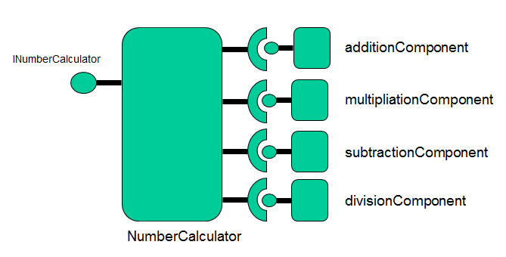

There are four components, implementing each operation (addition, multiplication, subtraction, division) and a central component that uses all of them and provides an interface to a user of the framework in order to do calculations.

The application description is the following:

<?xml version=*"1.0"* encoding=*"UTF-8"*?>

<Application applicationName=*"CalculatorExample"* xmlns=*"http://jlcf.sourceforge.net/JLCFApplication"* xmlns:xsi=*"http://www.w3.org/2001/XMLSchema-instance"*>

<component implementationClass=*"org.jlcf.example.simplecalculator.NumberCalculator"* name=*"NumberCalculator"*>

<interface name=*"INumberCalculator"* type=*"org.jlcf.example.simplecalculator.INumberCalculator"* />

<receptacle name=*"addition"*>

<Reference path=*"additionComponent/addition"* />

</receptacle>

<receptacle name=*"multiplication"*>

<Reference path=*"multiplicationComponent/multiplication"* />

</receptacle>

<receptacle name=*"subtraction"*>

<Reference path=*"subtractionComponent/subtraction"* />

</receptacle>

<receptacle name=*"division"*>

<Reference path=*"divisionComponent/division"* />

</receptacle>

<property name=*"version"* value=*"1.01"*/>

</component>

<component implementationClass=*"org.jlcf.example.simplecalculator.AdditionComponent"* name=*"additionComponent"*>

<interface name=*"addition"* type=*"org.jlcf.example.simplecalculator.IAddition"* />

</component>

<component implementationClass=*"org.jlcf.example.simplecalculator.SubtractionComponent"* name=*"subtractionComponent"*>

<interface name=*"subtraction"* type=*"org.jlcf.example.simplecalculator.ISubtraction"* />

</component>

<component implementationClass=*"org.jlcf.example.simplecalculator.AdditionComponent"* name=*"multiplicationComponent"*>

<interface name=*"multiplication"* type=*"org.jlcf.example.simplecalculator.IMultiplication"* />

</component>

<component implementationClass=*"org.jlcf.example.simplecalculator.DivisionComponent"* name=*"divisionComponent"*>

<interface name=*"division"* type=*"org.jlcf.example.simplecalculator.IDivision"* />

</component>

</Application>

Each of the components that implement the operations offer a formal interface such as the one below,

**public** **interface** IAddition {

**public** Double add(Double a, Double b);

}

Offered by the additionComponent, which has the following implementation;

**public** **class** AdditionComponent **implements** IAddition {

@Override

**public** Double add(Double a, Double b) {

**return** a+b;

}

}

As you can see from the implementation, the component is a POJO.

The NumberCalculator component, has four receptacles connected to the interfaces of each operation and offers the INumberCalculator interface for performing calculations.

**public** **interface** INumberCalculator {

**public** Double doCalculation(String expression) **throws** Exception;

}

The NumberCalculator implementation is the following

**public** **class** NumberCalculator **implements** INumberCalculator{

**private** **final** IMultiplication multComponent;

**private** **final** IAddition addComponent;

**private** **final** IDivision divComponent;

**private** **final** ISubtraction subComponent;

**private** **final** String version;

**private** **final** Logger logger = Logger.*getLogger*(getClass());

**public** NumberCalculator(

@Receptacle(name="multiplication") IMultiplication multComponent,

@Receptacle(name="addition") IAddition addComponent,

@Receptacle(name="division") IDivision divComponent,

@Receptacle(name="subtraction") ISubtraction subComponent,

@Property(name="version") String version)

{

**this**.multComponent = multComponent;

**this**.addComponent = addComponent;

**this**.divComponent = divComponent;

**this**.subComponent = subComponent;

**this**.version = version;

}

@Override

**public** Double doCalculation(String expression) **throws** Exception{

//it is assumed that the expression string contains something in the form of X<operator>Y

Double a,b;

**if** (expression.contains("+")) { //get numbers and call addition component

//parse expression and get a and b values

…

//get the receptacle and call the method on the other component

**return** addComponent.add(a, b);

}**else** **if**(expression.contains("-")) { //get numbers and call subtraction component

//parse expression and get a and b values

…

//get the receptacle and call the method on the other component

**return** subComponent.subtract(a, b);

//parse expression and get a and b values

…

//get the receptacle and call the method on the other component

**return** multComponent.multiply(a, b);

}**else** **if**(expression.contains("/")) {

//parse expression and get a and b values

…

//get the receptacle and call the method on the other component

**return** divComponent.divide(a, b);

}**else** {

**throw** **new** Exception("Cannot parse exception");

}

}

@InitMethod

**public** **void** init() {

logger.info("Init method called");

}

}

The NumberCalculator constructor specifies the receptacles using the @Receptacle annotation and the component properties using the @Property annotation. Receptacles are identified by their name which must match the name of the Receptacle at the Application description. The framework will inject the receptacles when instantiating the component.

The component also implements a method that is annotated as an @InitMethod. The framework will call this method after instantiating the component. Typically init methods perform initializing actions on the component but in this case the method does not do anything.

The application is started as follows

//get instance of the JLCF runtime container

IJLCFContainer runtime = JLCFContainer.*getInstance*();

//load the application

runtime.loadApplication("resources/SimpleCalculatorExample.xml");

//obtain component interface reference

INumberCalculator numberCalcInterface = runtime.getComponentReference("NumberCalculator/INumberCalculator");

//loop forever doing calculations

**int** i = 0, j = 4;

Double res;

**while** (**true**) {

**try** {

Thread.*sleep*(5000);

}**catch** (InterruptedException yy) {

}

res = numberCalcInterface.doCalculation(i+"+"+j);

logger.info(i+"+"+j+"="+res);

i++;j++;

}

The first command, JLCFContainer.*getInstance*(), instantiates the framework and provides an interface that we can use to interact with the framework.

Next, the call runtime.loadApplication("resources/SimpleCalculatorExample.xml"); will load the calculator application which is described as a component composition in the specified file.

Finally, the call runtime.getComponentReference("NumberCalculator/INumberCalculator"); will return a reference to the Interface named “*INumberCalculator*” of the component named “NumberCalculator”. This reference implements the formal component interface.

From then on, the example starts doing some calculations using the NumberCalculator component interface. The output of the example is:

2013-03-08 11:36:41,631 [main] INFO org.jlcf.core.JLCFContainer - JLCF container instance initialized

2013-03-08 11:36:41,631 [AbstractQueueProcessorThread :JLCFContainerProcessor] INFO org.jlcf.core.util.AbstractQueueProcessorThread - org.jlcf.core.util.AbstractQueueProcessorThread thread started.

2013-03-08 11:36:41,756 [AbstractQueueProcessorThread :JLCFContainerProcessor] INFO org.jlcf.core.JLCFFrameworkUtilities - component:NumberCalculator instantiated

2013-03-08 11:36:41,756 [AbstractQueueProcessorThread :JLCFContainerProcessor] INFO org.jlcf.core.JLCFFrameworkUtilities - component:additionComponent instantiated

2013-03-08 11:36:41,756 [AbstractQueueProcessorThread :JLCFContainerProcessor] INFO org.jlcf.core.JLCFFrameworkUtilities - component:subtractionComponent instantiated

2013-03-08 11:36:41,756 [AbstractQueueProcessorThread :JLCFContainerProcessor] INFO org.jlcf.core.JLCFFrameworkUtilities - component:multiplicationComponent instantiated

2013-03-08 11:36:41,756 [AbstractQueueProcessorThread :JLCFContainerProcessor] INFO org.jlcf.core.JLCFFrameworkUtilities - component:divisionComponent instantiated

2013-03-08 11:36:41,756 [AbstractQueueProcessorThread :JLCFContainerProcessor] INFO org.jlcf.core.JLCFContainerProcessor - connecting NumberCalculator / addition -> additionComponent/addition

2013-03-08 11:36:41,756 [AbstractQueueProcessorThread :JLCFContainerProcessor] INFO org.jlcf.core.JLCFContainerProcessor - connecting NumberCalculator / multiplication -> multiplicationComponent/multiplication

2013-03-08 11:36:41,756 [AbstractQueueProcessorThread :JLCFContainerProcessor] INFO org.jlcf.core.JLCFContainerProcessor - connecting NumberCalculator / subtraction -> subtractionComponent/subtraction

2013-03-08 11:36:41,756 [AbstractQueueProcessorThread :JLCFContainerProcessor] INFO org.jlcf.core.JLCFContainerProcessor - connecting NumberCalculator / division -> divisionComponent/division

**2013-03-08 11:36:41,756 [AbstractQueueProcessorThread :JLCFContainerProcessor] INFO org.jlcf.example.simplecalculator.NumberCalculator - Init method called**

**2013-03-08 11:36:46,764 [main] INFO org.jlcf.example.simplecalculator.SimpleCalculatorExample - 0+4=4.0**

**2013-03-08 11:36:51,788 [main] INFO org.jlcf.example.simplecalculator.SimpleCalculatorExample - 1+5=6.0**

**2013-03-08 11:36:56,797 [main] INFO org.jlcf.example.simplecalculator.SimpleCalculatorExample - 2+6=8.0**

…

### Callback

This example utilizes the callback interaction pattern provided by the framework

<?xml version=*"1.0"* encoding=*"UTF-8"*?>

<Application applicationName=*"Callback Example"* xmlns=*"http://jlcf.sourceforge.net/JLCFApplication"* xmlns:xsi=*"http://www.w3.org/2001/XMLSchema-instance"*>

<component implementationClass=*"org.jlcf.example.callbacks.ComponentA"* name=*"compA"*>

<interface name=*"callback"* type=*"org.jlcf.example.callbacks.ITestCallback"* />

<interface name=*"userinterface"* type=*"org.jlcf.example.callbacks.IComponentA"* />

<receptacle name=*"compoB"* >

<Reference path=*"compB/compbintf"* **callbackReference=*"compA/callback"***/>

</receptacle>

<property name=*"version"* value=*"1.01"*/>

</component>

<component implementationClass=*"org.jlcf.example.callbacks.ComponentB"* name=*"compB"*>

<interface name=*"compbintf"* type=*"org.jlcf.example.callbacks.IComponentB"*/>

</component>

</Application>

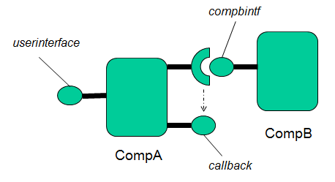

The receptacle of compA specifies a callback reference, **callbackReference=*"compA/callback"***. At runtime, the framework will associate the callback address with the call context. On handling the call on compB, a reference to the callback interface can be obtained.

In order for the implementation of compB to obtain the callback reference, it needs to communicate with the JLCF framework. For that reason it utilizes an annotation (the @ContainerRef annotation) on its constructor that instructs the runtime to insert a reference when instantiating the component.

//container reference

**private** **final** IJLCFContainer container;

**public** ComponentB(@ContainerRef IJLCFContainer container) {

//initialize the list of clients

registeredComponents = Collections.*synchronizedList*(**new** ArrayList<ITestCallback>());

**this**.container = container;

}

The callback can be obtained as follows on handling a call of the component’s formal interface

@Override

//functional interface of the component. Used by other components that want to register for receiving asynchronously information

**public** **void** register() {

ITestCallback cb = **null**;

**try** {

//obtain the callback,

**cb = container.getCallback();**

} **catch** (ComponentReferenceException e) {

logger.log(Level.*ERROR*, e.getMessage(), e);

**return**;

}

**if** (cb != **null**) { //add the callback to this list of registered users

registeredComponents.add(cb);

}

}

In this example, compA registers for receiving information from compB. CompB stores the callback reference and periodically sends back information to compA. The full source code of the example is included in the JLCF distribution.

The output of the example is:

2013-03-09 09:24:46,157 [Thread-2] INFO org.jlcf.example.callbacks.ComponentB - reply thread started

2013-03-09 09:24:46,172 [main] INFO org.jlcf.example.callbacks.ComponentA - version of component=1.01 doTask called. Registering to component B for receiving updates.

2013-03-09 09:24:48,169 [Thread-2] INFO org.jlcf.example.callbacks.ComponentB - sending information to all registered client callbacks

2013-03-09 09:24:48,169 [Thread-2] INFO org.jlcf.example.callbacks.ComponentA - version of component=1.01 received callback with information:100.0

2013-03-09 09:24:50,182 [Thread-2] INFO org.jlcf.example.callbacks.ComponentB - sending information to all registered client callbacks

2013-03-09 09:24:50,182 [Thread-2] INFO org.jlcf.example.callbacks.ComponentA - version of component=1.01 received callback with information:99.0

2013-03-09 09:24:52,196 [Thread-2] INFO org.jlcf.example.callbacks.ComponentB - sending information to all registered client callbacks

2013-03-09 09:24:52,196 [Thread-2] INFO org.jlcf.example.callbacks.ComponentA - version of component=1.01 received callback with information:98.0

2013-03-09 09:24:54,209 [Thread-2] INFO org.jlcf.example.callbacks.ComponentB - sending information to all registered client callbacks

2013-03-09 09:24:54,209 [Thread-2] INFO org.jlcf.example.callbacks.ComponentA - version of component=1.01 received callback with information:97.0

2013-03-09 09:24:56,223 [Thread-2] INFO org.jlcf.example.callbacks.ComponentB - sending information to all registered client callbacks

2013-03-09 09:24:56,223 [Thread-2] INFO org.jlcf.example.callbacks.ComponentA - version of component=1.01 received callback with information:96.0

2013-03-09 09:24:58,236 [Thread-2] INFO org.jlcf.example.callbacks.ComponentB - sending information to all registered client callbacks

2013-03-09 09:24:58,236 [Thread-2] INFO org.jlcf.example.callbacks.ComponentA - version of component=1.01 received callback with information:95.0

By a simple configuration change in the application description, we can add more components that register with compB. For example:

<?xml version=*"1.0"* encoding=*"UTF-8"*?>

<Application applicationName=*"Callback Example"* xmlns=*"http://jlcf.sourceforge.net/JLCFApplication"* xmlns:xsi=*"http://www.w3.org/2001/XMLSchema-instance"*>

<component implementationClass=*"org.jlcf.example.callbacks.ComponentA"* name=*"compA"*>

<interface name=*"callback"* type=*"org.jlcf.example.callbacks.ITestCallback"* />

<interface name=*"userinterface"* type=*"org.jlcf.example.callbacks.IComponentA"* />

<receptacle name=*"compoB"* >

<Reference path=*"compB/compbintf"*

callbackReference=*"compA/callback"*/>

</receptacle>

<property name=*"version"* value=*"flavour 1"*/>

</component>

<component implementationClass=*"org.jlcf.example.callbacks.ComponentA"* name=*"compA2"*>

<interface name=*"callback"* type=*"org.jlcf.example.callbacks.ITestCallback"* />

<interface name=*"userinterface"* type=*"org.jlcf.example.callbacks.IComponentA"* />

<receptacle name=*"compoB"* >

<Reference path=*"compB/compbintf"*

callbackReference=*"compA2/callback"*/>

</receptacle>

<property name=*"version"* value=*"flavour 2"*/>

</component>

<component implementationClass=*"org.jlcf.example.callbacks.ComponentA"* name=*"compA3"*>

<interface name=*"userinterface"* type=*"org.jlcf.example.callbacks.IComponentA"* />

<receptacle name=*"compoB"* >

<Reference path=*"compB/compbintf"*

callbackReference=*"compA2/callback"*/> <!-- notice the callback address, it is another component -->

</receptacle>

<property name=*"version"* value=*"flavour 3"*/>

</component>

<component implementationClass=*"org.jlcf.example.callbacks.ComponentB"* name=*"compB"*>

<interface name=*"compbintf"* type=*"org.jlcf.example.callbacks.IComponentB"*/>

</component>

</Application>

In this example, we use 3 components that are connected to compB and provide difference callback references. The callback references do not have to be at an interface of the calling component itself, for example compA3 specifies a callback on compA2.

The output of this example is:

2013-03-09 09:29:11,069 [main] INFO org.jlcf.example.callbacks.ComponentA - version of component=flavour 1 doTask called. Registering to component B for receiving updates.

2013-03-09 09:29:11,069 [main] INFO org.jlcf.example.callbacks.ComponentA - version of component=flavour 2 doTask called. Registering to component B for receiving updates.

2013-03-09 09:29:11,069 [main] INFO org.jlcf.example.callbacks.ComponentA - version of component=flavour 3 doTask called. Registering to component B for receiving updates.

2013-03-09 09:29:13,066 [Thread-2] INFO org.jlcf.example.callbacks.ComponentB - sending information to all registered client callbacks

2013-03-09 09:29:13,066 [Thread-2] INFO org.jlcf.example.callbacks.ComponentA - version of component=flavour 1 received callback with information:100.0

2013-03-09 09:29:13,066 [Thread-2] INFO org.jlcf.example.callbacks.ComponentA - version of component=flavour 2 received callback with information:99.0

2013-03-09 09:29:13,066 [Thread-2] INFO org.jlcf.example.callbacks.ComponentA - version of component=flavour 2 received callback with information:98.0

2013-03-09 09:29:15,079 [Thread-2] INFO org.jlcf.example.callbacks.ComponentB - sending information to all registered client callbacks

2013-03-09 09:29:15,079 [Thread-2] INFO org.jlcf.example.callbacks.ComponentA - version of component=flavour 1 received callback with information:97.0

2013-03-09 09:29:15,079 [Thread-2] INFO org.jlcf.example.callbacks.ComponentA - version of component=flavour 2 received callback with information:96.0

2013-03-09 09:29:15,079 [Thread-2] INFO org.jlcf.example.callbacks.ComponentA - version of component=flavour 2 received callback with information:95.0

2013-03-09 09:29:17,093 [Thread-2] INFO org.jlcf.example.callbacks.ComponentB - sending information to all registered client callbacks

2013-03-09 09:29:17,093 [Thread-2] INFO org.jlcf.example.callbacks.ComponentA - version of component=flavour 1 received callback with information:94.0

2013-03-09 09:29:17,093 [Thread-2] INFO org.jlcf.example.callbacks.ComponentA - version of component=flavour 2 received callback with information:93.0

2013-03-09 09:29:17,093 [Thread-2] INFO org.jlcf.example.callbacks.ComponentA - version of component=flavour 2 received callback with information:92.0

2013-03-09 09:29:19,106 [Thread-2] INFO org.jlcf.example.callbacks.ComponentB - sending information to all registered client callbacks

2013-03-09 09:29:19,106 [Thread-2] INFO org.jlcf.example.callbacks.ComponentA - version of component=flavour 1 received callback with information:91.0

2013-03-09 09:29:19,106 [Thread-2] INFO org.jlcf.example.callbacks.ComponentA - version of component=flavour 2 received callback with information:90.0

2013-03-09 09:29:19,106 [Thread-2] INFO org.jlcf.example.callbacks.ComponentA - version of component=flavour 2 received callback with information:89.0

### Interceptor

This example uses an interceptor between components.

<?xml version=*"1.0"* encoding=*"UTF-8"*?>

<Application applicationName=*"Interceptor Example"*

xmlns=*"http://jlcf.sourceforge.net/JLCFApplication"* xmlns:xsi=*"http://www.w3.org/2001/XMLSchema-instance"*>

<component implementationClass=*"org.jlcf.example.interceptors.ComponentA"*

name=*"compA"*>

<interface name=*"userinterface"* type=*"org.jlcf.example.interceptors.IComponentA"* />

<receptacle name=*"compoB"*>

<Reference path=*"compB/compbintf"* />

**<Interceptor name=*"compbinterc"***

**type=*"org.jlcf.example.interceptors.StringCaseInterceptor"* />**

</receptacle>

<property name=*"version"* value=*"1.01"* />

</component>

<component implementationClass=*"org.jlcf.example.interceptors.ComponentB"*

name=*"compB"*>

<interface name=*"compbintf"* type=*"org.jlcf.example.interceptors.IComponentB"* />

</component>

</Application>

Interceptors are defined at Receptacles and have full access to the inputs and outputs of method calls that belong to the interface of the target component. Interceptors must implement the target interface (*IComponentB* in this case) and extend a generic Interceptor class.

The interface of compB, IComponentB is the following

**public** **interface** IComponentB {

**public** String someMethod(String input);

}

And the implementation is

@Override

**public** String someMethod(String input) {

logger.info("method called, with input :"+input);

**return** input+" My status is "+(status++);

}

The interceptor StringCaseInterceptor implementation is

**public** **class** StringCaseInterceptor **extends** Interceptor **implements** IComponentB {

**private** **final** Logger logger = Logger.*getLogger*(getClass().getName());

@Override

**public** String someMethod(String input) {

logger.info("Intercepting call to someMethod, changing "+input+" to upper case");

IComponentB targetInterface = getTarget();

String ret = targetInterface.someMethod(input.toUpperCase());

logger.info("Intercepting reply ("+ret+"), switching to lower case");

**return** ret.toLowerCase();

}

}

The interceptor accesses the target interface by calling the getTarget method that is provided by the Interceptor class. Then it has full access to the inputs and outputs of the target methods. In this example the interceptor simply changes the input string to upper case and the reply to lower case.

The output of the example is the following

IJLCFContainer runtime = JLCFContainer.*getInstance*();

runtime.loadApplication("resources/InterceptorExample.xml");

IComponentA compA = runtime.getComponentReference("compA/userinterface");

**while** (**true**) {

Thread.*sleep*(5000);

compA.doTask("HellO");

}

2013-03-09 10:00:48,637 [main] INFO org.jlcf.example.interceptors.ComponentA - doTask called. Calling component B with input=HellO

2013-03-09 10:00:48,637 [main] INFO org.jlcf.example.interceptors.StringCaseInterceptor - Intercepting call to someMethod, changing HellO to upper case

2013-03-09 10:00:48,637 [main] INFO org.jlcf.example.interceptors.ComponentB - method called, with input :HELLO

2013-03-09 10:00:48,637 [main] INFO org.jlcf.example.interceptors.StringCaseInterceptor - Intercepting reply (HELLO My status is 100.0), switching to lower case

2013-03-09 10:00:48,637 [main] INFO org.jlcf.example.interceptors.ComponentA - received reply from component B :hello my status is 100.0

2013-03-09 10:00:53,661 [main] INFO org.jlcf.example.interceptors.ComponentA - doTask called. Calling component B with input=HellO

2013-03-09 10:00:53,661 [main] INFO org.jlcf.example.interceptors.StringCaseInterceptor - Intercepting call to someMethod, changing HellO to upper case

2013-03-09 10:00:53,661 [main] INFO org.jlcf.example.interceptors.ComponentB - method called, with input :HELLO

2013-03-09 10:00:53,661 [main] INFO org.jlcf.example.interceptors.StringCaseInterceptor - Intercepting reply (HELLO My status is 101.0), switching to lower case

2013-03-09 10:00:53,661 [main] INFO org.jlcf.example.interceptors.ComponentA - received reply from component B :hello my status is 101.0

2013-03-09 10:00:58,686 [main] INFO org.jlcf.example.interceptors.ComponentA - doTask called. Calling component B with input=HellO

2013-03-09 10:00:58,686 [main] INFO org.jlcf.example.interceptors.StringCaseInterceptor - Intercepting call to someMethod, changing HellO to upper case

2013-03-09 10:00:58,686 [main] INFO org.jlcf.example.interceptors.ComponentB - method called, with input :HELLO

2013-03-09 10:00:58,686 [main] INFO org.jlcf.example.interceptors.StringCaseInterceptor - Intercepting reply (HELLO My status is 102.0), switching to lower case

2013-03-09 10:00:58,686 [main] INFO org.jlcf.example.interceptors.ComponentA - received reply from component B :hello my status is 102.0

### Calling remote service with Interceptor

This example uses an interceptor to call a remote web service.

<?xml version=*"1.0"* encoding=*"UTF-8"*?>

<Application applicationName=*"Interceptor Example"*

xmlns=*"http://jlcf.sourceforge.net/JLCFApplication"* xmlns:xsi=*"http://www.w3.org/2001/XMLSchema-instance"*>

<component implementationClass=*"org.jlcf.example.interceptors.remoting.ComponentA"*

name=*"compA"*>

<interface name=*"userinterface"*

type=*"org.jlcf.example.interceptors.remoting.IComponentA"* />

**<receptacle name=*"remote"*>**

**<Reference path=*""***

**type=*"org.jlcf.example.interceptors.remoting.IExternalInterface"* />**

**<Interceptor name=*"compbinterc"***

**type=*"org.jlcf.example.interceptors.remoting.RemotingInterceptor"* />**

**</receptacle>**

<property name=*"version"* value=*"1.01"* />

</component>

</Application>

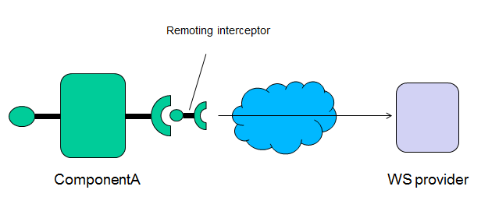

The application description defines a component with a receptacle of type *IExternalInterface* which has an empty path. Receptacles normally have a path which is a target interface of a component, however in this special case the path is omitted as there is no target component. The interface type of the receptacle, *IExternalInterface*, is an arbitrary interface that we use to model the external service. It is up to the developer to define this interface. Depending on the middleware / remote service the remote service interface might have already been defined and thus could be re-used here. In any case, this interface is the way we see the external service in the application.

The implementation class of the interceptor is RemotingInterceptor.

In this example, the remote web-service is a simple web-service service exposed by java

@WebService

**public** **interface** RemoteWSInterface {

@WebMethod String sayHello(String name);

}

The specific remote interface / transport / technology is not important in this example. The same pattern can be used to access any remote service, as long as it is accessible by your Java code.

The implementation of compA is the following:

**public** **class** ComponentA **implements** IComponentA{

**private** **final** IExternalInterface remotingGateway;

**private** **final** String version;

**private** **final** Logger logger = Logger.*getLogger*(getClass());

**public** ComponentA(

@Receptacle(name="remote") IExternalInterface remotingGateway,

@Property(name="version") String version)

{

**this**.remotingGateway = remotingGateway;

**this**.version = version;

}

@InitMethod

**public** **void** callme() {

logger.info("component "+getClass().getName()+" version:"+version+" initialized");

}

@Override

**public** String doTask(String input) {

String compBInput = input;

logger.info("doTask called. Calling receptacle with input="+compBInput);

**String ret = remotingGateway.externalMethod(compBInput);**

logger.info("received reply :"+ret);

**return** ret;

}

}

And the implementation of IExternalInterface (which we use as a façade to the external service) is

**public** **interface** IExternalInterface {

**public** String externalMethod(String argument);

}

The interceptor implementation is shown below

**public** **class** RemotingInterceptor **extends** Interceptor **implements** IExternalInterface {

**private** **final** Logger logger = Logger.*getLogger*(getClass().getName());

**private** **final** RemoteWSInterface remoteService = **new** RemoteWSImplementationService().getRemoteWSImplementationPort();

@Override

**public** String externalMethod(String argument) {

logger.info("Intercepting call to externalMethod, with input "+argument+" and forwarding to web service");

String ret = remoteService.sayHello("Hello");

//proceess return if needed

//return

**return** ret;

}

}

The interceptor calls the external web service and returns the data.

As noted before, in the general case, the interceptor would implement the logic in order to communicate with an external service using any kind of middleware.

### Calling Remote Service with proxy component

Same as with interceptors, another way to interact with the external world is to use a proxy component.

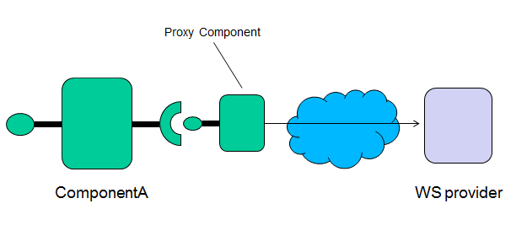

The application description for this example is

<?xml version=*"1.0"* encoding=*"UTF-8"*?>

<Application applicationName=*"Interceptor Example"*

xmlns=*"http://jlcf.sourceforge.net/JLCFApplication"* xmlns:xsi=*"http://www.w3.org/2001/XMLSchema-instance"*>

<component implementationClass=*"org.jlcf.example.remoting.ComponentA"*

name=*"compA"*>

<interface name=*"userinterface"* type=*"org.jlcf.example.remoting.IComponentA"* />

<receptacle name=*"remoteCompProxy"*>

<Reference path=*"remoteProxy/remoteinterface"* />

</receptacle>

<property name=*"version"* value=*"1.01"* />

</component>

<component implementationClass=*"org.jlcf.example.remoting.RemoteProxyComponent"*

name=*"remoteProxy"*>

<interface name=*"remoteinterface"*

type=*"org.jlcf.example.remoting.IRemoteProxyComponent"* />

</component>

</Application>

In this scenario component remoteProxy is a boundary component that calls an external service.

Its implementation is very similar to the logic of the interceptor.

**public** **class** ComponentA **implements** IComponentA{

**private** **final** IRemoteProxyComponent remProxyCpmp;

**private** **final** Logger logger = Logger.*getLogger*(getClass());

**public** ComponentA(@Receptacle(name="remoteCompProxy") IRemoteProxyComponent remProxyCpmp) {

**this**.remProxyCpmp = remProxyCpmp;

}

@Override

**public** String doTask(String input) {

String remProxyCpmpInput = input;

logger.info("doTask called. Calling RemoteProxyComponent with input="+remProxyCpmpInput);

String ret = remProxyCpmp.remoteCall(remProxyCpmpInput);

logger.info("received reply from RemoteProxyComponent :"+ret);

**return** ret;

}

}

The output of the example is

//create the runtime container and get the single instance

IJLCFContainer runtime = JLCFContainer.*getInstance*();

//load the application

runtime.loadApplication("resources/RemotingExample.xml");

//get reference to ComponentA's "userinterface" interface

IComponentA compA = runtime.getComponentReference("compA/userinterface");

compA.doTask("HellO");

2013-03-09 10:46:32,403 [main] INFO org.jlcf.example.remoting.ComponentA - doTask called. Calling RemoteProxyComponent with input=HellO

2013-03-09 10:46:32,403 [main] INFO org.jlcf.example.remoting.RemoteProxyComponent - doTask called. Calling remote WS with input=HellO

2013-03-09 10:46:32,514 [main] INFO org.jlcf.example.remoting.RemoteProxyComponent - received reply from remote WS :Hello from WS

2013-03-09 10:46:32,514 [main] INFO org.jlcf.example.remoting.ComponentA - received reply from RemoteProxyComponent :Hello from WS

### Dynamic Reconfiguration

In this example, an application is started and then a component is dynamically replaced with another implementation at runtime.

<?xml version=*"1.0"* encoding=*"UTF-8"*?>

<Application applicationName=*"Test"*

xmlns=*"http://jlcf.sourceforge.net/JLCFApplication"* xmlns:xsi=*"http://www.w3.org/2001/XMLSchema-instance"*>

<component implementationClass=*"org.jlcf.example.reconfiguration.ComponentA"*

name=*"compA"*>

<interface name=*"callback"*

type=*"org.jlcf.example.reconfiguration.ITestCallback"* />

<interface name=*"userinterface"*

type=*"org.jlcf.example.reconfiguration.IComponentA"* />

<receptacle name=*"compoB"*>

<Reference path=*"compB/compbintf"* callbackReference=*"compA/callback"* />

</receptacle>

<property name=*"version"* value=*"1.01"* />

</component>

<component implementationClass=*"org.jlcf.example.reconfiguration.ComponentB"*

name=*"compB"*>

<interface name=*"compbintf"*

type=*"org.jlcf.example.reconfiguration.IComponentB"* />

</component>

</Application>

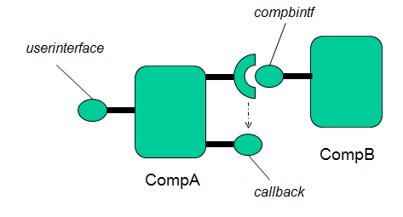

The implementation of compA is ComponentA. At some point, the framework is asked to try and perform a reconfiguration, by changing the implementation class with a new one, NewComponentA

The application the very similar as the callback example. CompA registers with CompB and starts receiving callbacks.

The *userinterface* interface offered by CompA is

**public** **interface** IComponentA {

**public** **void** register();

**public** String doSomething(String input);

}

And the callback Interface

**public** **interface** ITestCallback {

**public** String receiveCallback(String info);

}

The implementation of the interfaces on ComponentA is

@Override

**public** String receiveCallback(String info) {

logger.info("component "+getClass().getName()+" received callback with information:"+info);

**return** "callback processed";

}

@Override

**public** **void** register() {

logger.info("register called. Registering to component B for receiving updates.");

compB.register();

}

@Override

**public** String doSomething(String input) {

logger.info("received call to doSomething. Input:"+input);

//simulate doing something that takes some time

**try** {

Thread.*sleep*(5000);

} **catch** (InterruptedException e) {

}

logger.info("finished processing request for input:"+input);

**return** "done";

}

Method doSomething, simulates executing a time consuming task by sleeping and returning after 5 seconds.

The example scenario is the following:

Initially we call the register method, causing compA to register with compB and to start receiving callbacks from compB. Then we start a new thread every 0.5 seconds, which calls the doSomething method of compA. This causes compA to be active all the time. After 5 seconds we start a reconfiguration process asking the framework to replace the implementation class ComponentA with NewComponentA.

At the point the reconfiguration starts, ComponentA is serving 10 calls, with a new call coming every 0.5 seconds. The output of the example is the following

**final** IJLCFContainer runtime = JLCFContainer.*getInstance*();

runtime.loadApplication("resources/SimpleReconfigrationExample.xml");

IComponentA compA = runtime.getComponentReference("compA/userinterface");

compA.register();

**new** Thread () {

**public** **void** run () {

//sleep for 5 seconds

**try** {

Thread.*sleep*(5000);

} **catch** (InterruptedException e1) {

}

//by now the component is servicing at least 10 calls (see code at the end)

//do a reconfiguration

**try** {

logger.info("starting reconfiguration");

//replace component compA with new implementation class org.jlcf.example.reconfiguration.NewComponentA

//set a timeout for the reconfiguration of 10 seconds

runtime.singleComponentReconfguration("compA", "org.jlcf.example.reconfiguration.NewComponentA", 10000);

} **catch** (Exception e) {

logger.log(Level.*ERROR*, "exception during recofiguration", e);

}

}

}.start();

//do something on component A

//every 500 millisecs we will call a method that needs 5000 millisecs to complete

//this ensures that the component is fully busy while we do the reconfiguration

**while** (**true**) {

//create new thread that calls component

Thread.*sleep*(500);

**new** ComponentCallerThread(compA).start();

}

2013-03-09 11:32:20,773 [Thread-2] INFO org.jlcf.example.reconfiguration.ComponentB - thread started

2013-03-09 11:32:20,773 [main] INFO org.jlcf.example.reconfiguration.ComponentA - register called. Registering to component B for receiving updates.

2013-03-09 11:32:21,288 [Thread-2] INFO org.jlcf.example.reconfiguration.ComponentB - sending data to registered clients

2013-03-09 11:32:21,288 [Thread-4] INFO org.jlcf.example.reconfiguration.ComponentCallerThread - calling component method doSomething with input: INPUT1

2013-03-09 11:32:21,288 [Thread-4] INFO org.jlcf.example.reconfiguration.ComponentA - received call to doSomething. Input:INPUT1

2013-03-09 11:32:21,288 [Thread-2] INFO org.jlcf.example.reconfiguration.ComponentA - component org.jlcf.example.reconfiguration.ComponentA received callback with information:100.0

2013-03-09 11:32:21,803 [Thread-2] INFO org.jlcf.example.reconfiguration.ComponentB - sending data to registered clients

2013-03-09 11:32:21,803 [Thread-2] INFO org.jlcf.example.reconfiguration.ComponentA - component org.jlcf.example.reconfiguration.ComponentA received callback with information:99.0

2013-03-09 11:32:21,803 [Thread-5] INFO org.jlcf.example.reconfiguration.ComponentCallerThread - calling component method doSomething with input: INPUT2

2013-03-09 11:32:21,803 [Thread-5] INFO org.jlcf.example.reconfiguration.ComponentA - received call to doSomething. Input:INPUT2

2013-03-09 11:32:22,303 [Thread-2] INFO org.jlcf.example.reconfiguration.ComponentB - sending data to registered clients

2013-03-09 11:32:22,303 [Thread-6] INFO org.jlcf.example.reconfiguration.ComponentCallerThread - calling component method doSomething with input: INPUT3

2013-03-09 11:32:22,303 [Thread-2] INFO org.jlcf.example.reconfiguration.ComponentA - component org.jlcf.example.reconfiguration.ComponentA received callback with information:98.0

2013-03-09 11:32:22,303 [Thread-6] INFO org.jlcf.example.reconfiguration.ComponentA - received call to doSomething. Input:INPUT3

2013-03-09 11:32:22,818 [Thread-2] INFO org.jlcf.example.reconfiguration.ComponentB - sending data to registered clients

2013-03-09 11:32:22,818 [Thread-7] INFO org.jlcf.example.reconfiguration.ComponentCallerThread - calling component method doSomething with input: INPUT4

2013-03-09 11:32:22,818 [Thread-2] INFO org.jlcf.example.reconfiguration.ComponentA - component org.jlcf.example.reconfiguration.ComponentA received callback with information:97.0

2013-03-09 11:32:22,818 [Thread-7] INFO org.jlcf.example.reconfiguration.ComponentA - received call to doSomething. Input:INPUT4

2013-03-09 11:32:23,318 [Thread-2] INFO org.jlcf.example.reconfiguration.ComponentB - sending data to registered clients

2013-03-09 11:32:23,318 [Thread-8] INFO org.jlcf.example.reconfiguration.ComponentCallerThread - calling component method doSomething with input: INPUT5

2013-03-09 11:32:23,318 [Thread-8] INFO org.jlcf.example.reconfiguration.ComponentA - received call to doSomething. Input:INPUT5

2013-03-09 11:32:23,318 [Thread-2] INFO org.jlcf.example.reconfiguration.ComponentA - component org.jlcf.example.reconfiguration.ComponentA received callback with information:96.0

….  
….  
….

At this point the reconfiguration request is processed by the framework

2013-03-09 11:32:25,785 [AbstractQueueProcessorThread :JLCFContainerProcessor] INFO org.jlcf.core.dynrec.ConnectorTimingBasedReconfigurationManager - connector received reconfiguration message. reconfiguring:true

2013-03-09 11:32:25,785 [AbstractQueueProcessorThread :JLCFContainerProcessor] INFO org.jlcf.core.dynrec.ConnectorTimingBasedReconfigurationManager - connector received reconfiguration message. reconfiguring:true

The framework at any given time monitors how many calls each component processes. When the reconfiguration process starts, an algorithm evaluates if a call should be made on a component or be temporarily blocked until the reconfiguration process terminates.

The current algorithm keeps track of how long methods take to complete and selectively blocks them if they are not likely to complete within the remaining time for the reconfiguration process.

All calls to method receiveCallback are allowed because they complete very fast. At some point the framework starts blocking calls to method doSomething because the remaining time for the reconfiguration is less than the expected time the call will take. Finally, as soon as the component processes all of its pending calls, it reaches a quiescent state and is replaced with the new implementation.

All the calls that were blocked during the reconfiguration are unblocked and reach the new component.

Below is the remaining output of the example

2013-03-09 11:32:25,863 [Thread-2] INFO org.jlcf.example.reconfiguration.ComponentB - sending data to registered clients

2013-03-09 11:32:25,863 [Thread-15] INFO org.jlcf.example.reconfiguration.ComponentCallerThread - calling component method doSomething with input: INPUT10

2013-03-09 11:32:25,863 [Thread-15] INFO org.jlcf.example.reconfiguration.ComponentA - received call to doSomething. Input:INPUT10

2013-03-09 11:32:25,863 [Thread-2] INFO org.jlcf.example.reconfiguration.ComponentA - component org.jlcf.example.reconfiguration.ComponentA received callback with information:91.0

2013-03-09 11:32:26,301 [Thread-4] INFO org.jlcf.example.reconfiguration.ComponentA - finished processing request for input:INPUT1

2013-03-09 11:32:26,363 [Thread-2] INFO org.jlcf.example.reconfiguration.ComponentB - sending data to registered clients

2013-03-09 11:32:26,363 [Thread-2] INFO org.jlcf.example.reconfiguration.ComponentA - component org.jlcf.example.reconfiguration.ComponentA received callback with information:90.0

2013-03-09 11:32:26,363 [Thread-16] INFO org.jlcf.example.reconfiguration.ComponentCallerThread - calling component method doSomething with input: INPUT11

2013-03-09 11:32:26,363 [Thread-16] INFO org.jlcf.example.reconfiguration.ComponentA - received call to doSomething. Input:INPUT11

2013-03-09 11:32:26,816 [Thread-5] INFO org.jlcf.example.reconfiguration.ComponentA - finished processing request for input:INPUT2

2013-03-09 11:32:26,878 [Thread-2] INFO org.jlcf.example.reconfiguration.ComponentB - sending data to registered clients

2013-03-09 11:32:26,878 [Thread-2] INFO org.jlcf.example.reconfiguration.ComponentA - component org.jlcf.example.reconfiguration.ComponentA received callback with information:89.0

2013-03-09 11:32:26,878 [Thread-17] INFO org.jlcf.example.reconfiguration.ComponentCallerThread - calling component method doSomething with input: INPUT12

2013-03-09 11:32:26,878 [Thread-17] INFO org.jlcf.example.reconfiguration.ComponentA - received call to doSomething. Input:INPUT12

2013-03-09 11:32:27,316 [Thread-6] INFO org.jlcf.example.reconfiguration.ComponentA - finished processing request for input:INPUT3

2013-03-09 11:32:27,378 [Thread-2] INFO org.jlcf.example.reconfiguration.ComponentB - sending data to registered clients

2013-03-09 11:32:27,378 [Thread-2] INFO org.jlcf.example.reconfiguration.ComponentA - component org.jlcf.example.reconfiguration.ComponentA received callback with information:88.0

2013-03-09 11:32:27,378 [Thread-18] INFO org.jlcf.example.reconfiguration.ComponentCallerThread - calling component method doSomething with input: INPUT13

2013-03-09 11:32:27,378 [Thread-18] INFO org.jlcf.example.reconfiguration.ComponentA - received call to doSomething. Input:INPUT13

2013-03-09 11:32:27,831 [Thread-7] INFO org.jlcf.example.reconfiguration.ComponentA - finished processing request for input:INPUT4

2013-03-09 11:32:27,893 [Thread-2] INFO org.jlcf.example.reconfiguration.ComponentB - sending data to registered clients

2013-03-09 11:32:27,893 [Thread-2] INFO org.jlcf.example.reconfiguration.ComponentA - component org.jlcf.example.reconfiguration.ComponentA received callback with information:87.0

2013-03-09 11:32:27,893 [Thread-19] INFO org.jlcf.example.reconfiguration.ComponentCallerThread - calling component method doSomething with input: INPUT14

2013-03-09 11:32:27,893 [Thread-19] INFO org.jlcf.example.reconfiguration.ComponentA - received call to doSomething. Input:INPUT14

2013-03-09 11:32:28,331 [Thread-8] INFO org.jlcf.example.reconfiguration.ComponentA - finished processing request for input:INPUT5

2013-03-09 11:32:28,393 [Thread-2] INFO org.jlcf.example.reconfiguration.ComponentB - sending data to registered clients

2013-03-09 11:32:28,393 [Thread-2] INFO org.jlcf.example.reconfiguration.ComponentA - component org.jlcf.example.reconfiguration.ComponentA received callback with information:86.0

2013-03-09 11:32:28,393 [Thread-20] INFO org.jlcf.example.reconfiguration.ComponentCallerThread - calling component method doSomething with input: INPUT15

2013-03-09 11:32:28,393 [Thread-20] INFO org.jlcf.example.reconfiguration.ComponentA - received call to doSomething. Input:INPUT15

2013-03-09 11:32:28,846 [Thread-9] INFO org.jlcf.example.reconfiguration.ComponentA - finished processing request for input:INPUT6

2013-03-09 11:32:28,908 [Thread-2] INFO org.jlcf.example.reconfiguration.ComponentB - sending data to registered clients

2013-03-09 11:32:28,908 [Thread-2] INFO org.jlcf.example.reconfiguration.ComponentA - component org.jlcf.example.reconfiguration.ComponentA received callback with information:85.0

2013-03-09 11:32:28,908 [Thread-21] INFO org.jlcf.example.reconfiguration.ComponentCallerThread - calling component method doSomething with input: INPUT16

2013-03-09 11:32:28,908 [Thread-21] INFO org.jlcf.example.reconfiguration.ComponentA - received call to doSomething. Input:INPUT16

2013-03-09 11:32:29,346 [Thread-10] INFO org.jlcf.example.reconfiguration.ComponentA - finished processing request for input:INPUT7

2013-03-09 11:32:29,408 [Thread-2] INFO org.jlcf.example.reconfiguration.ComponentB - sending data to registered clients

2013-03-09 11:32:29,408 [Thread-2] INFO org.jlcf.example.reconfiguration.ComponentA - component org.jlcf.example.reconfiguration.ComponentA received callback with information:84.0

2013-03-09 11:32:29,408 [Thread-22] INFO org.jlcf.example.reconfiguration.ComponentCallerThread - calling component method doSomething with input: INPUT17

2013-03-09 11:32:29,408 [Thread-22] INFO org.jlcf.example.reconfiguration.ComponentA - received call to doSomething. Input:INPUT17

2013-03-09 11:32:29,861 [Thread-11] INFO org.jlcf.example.reconfiguration.ComponentA - finished processing request for input:INPUT8

2013-03-09 11:32:29,923 [Thread-2] INFO org.jlcf.example.reconfiguration.ComponentB - sending data to registered clients

2013-03-09 11:32:29,923 [Thread-2] INFO org.jlcf.example.reconfiguration.ComponentA - component org.jlcf.example.reconfiguration.ComponentA received callback with information:83.0

2013-03-09 11:32:29,923 [Thread-23] INFO org.jlcf.example.reconfiguration.ComponentCallerThread - calling component method doSomething with input: INPUT18

2013-03-09 11:32:29,923 [Thread-23] INFO org.jlcf.example.reconfiguration.ComponentA - received call to doSomething. Input:INPUT18

From this point the framework blocks calls to doSomething, as it estimates that they will not finish until the reconfiguration process completes.

2013-03-09 11:32:30,361 [Thread-12] INFO org.jlcf.example.reconfiguration.ComponentA - finished processing request for input:INPUT9

2013-03-09 11:32:30,423 [Thread-2] INFO org.jlcf.example.reconfiguration.ComponentB - sending data to registered clients

2013-03-09 11:32:30,423 [Thread-2] INFO org.jlcf.example.reconfiguration.ComponentA - component org.jlcf.example.reconfiguration.ComponentA received callback with information:82.0

2013-03-09 11:32:30,423 [Thread-24] INFO org.jlcf.example.reconfiguration.ComponentCallerThread - calling component method doSomething with input: INPUT19

2013-03-09 11:32:30,423 [Thread-24] INFO org.jlcf.example.reconfiguration.ComponentA - received call to doSomething. Input:INPUT19

2013-03-09 11:32:30,876 [Thread-15] INFO org.jlcf.example.reconfiguration.ComponentA - finished processing request for input:INPUT10

2013-03-09 11:32:30,938 [Thread-2] INFO org.jlcf.example.reconfiguration.ComponentB - sending data to registered clients

2013-03-09 11:32:30,938 [Thread-2] INFO org.jlcf.example.reconfiguration.ComponentA - component org.jlcf.example.reconfiguration.ComponentA received callback with information:81.0

2013-03-09 11:32:30,938 [Thread-25] INFO org.jlcf.example.reconfiguration.ComponentCallerThread - calling component method doSomething with input: INPUT20

2013-03-09 11:32:31,376 [Thread-16] INFO org.jlcf.example.reconfiguration.ComponentA - finished processing request for input:INPUT11

2013-03-09 11:32:31,438 [Thread-2] INFO org.jlcf.example.reconfiguration.ComponentB - sending data to registered clients

2013-03-09 11:32:31,438 [Thread-2] INFO org.jlcf.example.reconfiguration.ComponentA - component org.jlcf.example.reconfiguration.ComponentA received callback with information:80.0

2013-03-09 11:32:31,438 [Thread-26] INFO org.jlcf.example.reconfiguration.ComponentCallerThread - calling component method doSomething with input: INPUT21

2013-03-09 11:32:31,891 [Thread-17] INFO org.jlcf.example.reconfiguration.ComponentA - finished processing request for input:INPUT12

2013-03-09 11:32:31,953 [Thread-2] INFO org.jlcf.example.reconfiguration.ComponentB - sending data to registered clients

2013-03-09 11:32:31,953 [Thread-2] INFO org.jlcf.example.reconfiguration.ComponentA - component org.jlcf.example.reconfiguration.ComponentA received callback with information:79.0

2013-03-09 11:32:31,953 [Thread-27] INFO org.jlcf.example.reconfiguration.ComponentCallerThread - calling component method doSomething with input: INPUT22

2013-03-09 11:32:32,391 [Thread-18] INFO org.jlcf.example.reconfiguration.ComponentA - finished processing request for input:INPUT13

2013-03-09 11:32:32,453 [Thread-2] INFO org.jlcf.example.reconfiguration.ComponentB - sending data to registered clients

2013-03-09 11:32:32,453 [Thread-2] INFO org.jlcf.example.reconfiguration.ComponentA - component org.jlcf.example.reconfiguration.ComponentA received callback with information:78.0

2013-03-09 11:32:32,453 [Thread-28] INFO org.jlcf.example.reconfiguration.ComponentCallerThread - calling component method doSomething with input: INPUT23

2013-03-09 11:32:32,906 [Thread-19] INFO org.jlcf.example.reconfiguration.ComponentA - finished processing request for input:INPUT14

2013-03-09 11:32:32,968 [Thread-2] INFO org.jlcf.example.reconfiguration.ComponentB - sending data to registered clients

2013-03-09 11:32:32,968 [Thread-2] INFO org.jlcf.example.reconfiguration.ComponentA - component org.jlcf.example.reconfiguration.ComponentA received callback with information:77.0

2013-03-09 11:32:32,968 [Thread-29] INFO org.jlcf.example.reconfiguration.ComponentCallerThread - calling component method doSomething with input: INPUT24

2013-03-09 11:32:33,406 [Thread-20] INFO org.jlcf.example.reconfiguration.ComponentA - finished processing request for input:INPUT15

2013-03-09 11:32:33,468 [Thread-2] INFO org.jlcf.example.reconfiguration.ComponentB - sending data to registered clients

2013-03-09 11:32:33,468 [Thread-2] INFO org.jlcf.example.reconfiguration.ComponentA - component org.jlcf.example.reconfiguration.ComponentA received callback with information:76.0

2013-03-09 11:32:33,468 [Thread-30] INFO org.jlcf.example.reconfiguration.ComponentCallerThread - calling component method doSomething with input: INPUT25

2013-03-09 11:32:33,921 [Thread-21] INFO org.jlcf.example.reconfiguration.ComponentA - finished processing request for input:INPUT16

2013-03-09 11:32:33,983 [Thread-2] INFO org.jlcf.example.reconfiguration.ComponentB - sending data to registered clients

2013-03-09 11:32:33,983 [Thread-2] INFO org.jlcf.example.reconfiguration.ComponentA - component org.jlcf.example.reconfiguration.ComponentA received callback with information:75.0

2013-03-09 11:32:33,983 [Thread-31] INFO org.jlcf.example.reconfiguration.ComponentCallerThread - calling component method doSomething with input: INPUT26

2013-03-09 11:32:34,421 [Thread-22] INFO org.jlcf.example.reconfiguration.ComponentA - finished processing request for input:INPUT17

2013-03-09 11:32:34,483 [Thread-2] INFO org.jlcf.example.reconfiguration.ComponentB - sending data to registered clients

2013-03-09 11:32:34,483 [Thread-2] INFO org.jlcf.example.reconfiguration.ComponentA - component org.jlcf.example.reconfiguration.ComponentA received callback with information:74.0

2013-03-09 11:32:34,483 [Thread-32] INFO org.jlcf.example.reconfiguration.ComponentCallerThread - calling component method doSomething with input: INPUT27

2013-03-09 11:32:34,936 [Thread-23] INFO org.jlcf.example.reconfiguration.ComponentA - finished processing request for input:INPUT18

2013-03-09 11:32:34,998 [Thread-2] INFO org.jlcf.example.reconfiguration.ComponentB - sending data to registered clients

2013-03-09 11:32:34,998 [Thread-2] INFO org.jlcf.example.reconfiguration.ComponentA - component org.jlcf.example.reconfiguration.ComponentA received callback with information:73.0

2013-03-09 11:32:34,998 [Thread-33] INFO org.jlcf.example.reconfiguration.ComponentCallerThread - calling component method doSomething with input: INPUT28

2013-03-09 11:32:35,436 [Thread-24] INFO org.jlcf.example.reconfiguration.ComponentA - finished processing request for input:INPUT19

As soon as this call finishes, the component reaches a quiescent state.

2013-03-09 11:32:35,436 [Thread-24] INFO org.jlcf.core.dynrec.SingleComponentReconfigurationManager - component reached quiescent state

2013-03-09 11:32:35,436 [AbstractQueueProcessorThread :JLCFContainerProcessor] INFO org.jlcf.core.dynrec.SingleComponentReconfigurationManager - got reply for the outcome of the reconfiguration:true component reached quiescent state

2013-03-09 11:32:35,436 [AbstractQueueProcessorThread :JLCFContainerProcessor] INFO org.jlcf.core.JLCFContainerProcessor - reconfiguration response:true component reached quiescent state

2013-03-09 11:32:35,436 [AbstractQueueProcessorThread :JLCFContainerProcessor] INFO org.jlcf.core.JLCFContainerProcessor - reconfiguration was succesful, component reached quiescent state

2013-03-09 11:32:35,436 [AbstractQueueProcessorThread :JLCFContainerProcessor] INFO org.jlcf.core.JLCFFrameworkUtilities - component:compA instantiated with new implementation class:org.jlcf.example.reconfiguration.NewComponentA

2013-03-09 11:32:35,436 [AbstractQueueProcessorThread :JLCFContainerProcessor] INFO org.jlcf.core.JLCFContainerProcessor - connecting compA / compoB -> compB/compbintf

2013-03-09 11:32:35,436 [AbstractQueueProcessorThread :JLCFContainerProcessor] INFO org.jlcf.example.reconfiguration.NewComponentA - component org.jlcf.example.reconfiguration.NewComponentA version:1.01 initialized

2013-03-09 11:32:35,436 [AbstractQueueProcessorThread :JLCFContainerProcessor] INFO org.jlcf.core.JLCFContainerProcessor - calling setReconfiguring to false on connectors

2013-03-09 11:32:35,436 [AbstractQueueProcessorThread :JLCFContainerProcessor] INFO org.jlcf.core.dynrec.ConnectorTimingBasedReconfigurationManager - connector received reconfiguration message. reconfiguring:false

2013-03-09 11:32:35,436 [AbstractQueueProcessorThread :JLCFContainerProcessor] INFO org.jlcf.core.JLCFContainerProcessor - calling setReconfiguring to false on connectors

2013-03-09 11:32:35,436 [AbstractQueueProcessorThread :JLCFContainerProcessor] INFO org.jlcf.core.dynrec.ConnectorTimingBasedReconfigurationManager - connector received reconfiguration message. reconfiguring:false

The reconfiguration process finished successfully. Now all previously blocked calls are unblocked and reach the new component.

2013-03-09 11:32:35,452 [Thread-33] INFO org.jlcf.example.reconfiguration.NewComponentA - received call to doSomething. Input:INPUT28

2013-03-09 11:32:35,452 [Thread-32] INFO org.jlcf.example.reconfiguration.NewComponentA - received call to doSomething. Input:INPUT27

2013-03-09 11:32:35,452 [Thread-26] INFO org.jlcf.example.reconfiguration.NewComponentA - received call to doSomething. Input:INPUT21

2013-03-09 11:32:35,452 [Thread-29] INFO org.jlcf.example.reconfiguration.NewComponentA - received call to doSomething. Input:INPUT24

2013-03-09 11:32:35,452 [Thread-30] INFO org.jlcf.example.reconfiguration.NewComponentA - received call to doSomething. Input:INPUT25

2013-03-09 11:32:35,452 [Thread-28] INFO org.jlcf.example.reconfiguration.NewComponentA - received call to doSomething. Input:INPUT23

2013-03-09 11:32:35,452 [Thread-25] INFO org.jlcf.example.reconfiguration.NewComponentA - received call to doSomething. Input:INPUT20

2013-03-09 11:32:35,452 [Thread-31] INFO org.jlcf.example.reconfiguration.NewComponentA - received call to doSomething. Input:INPUT26

2013-03-09 11:32:35,452 [Thread-27] INFO org.jlcf.example.reconfiguration.NewComponentA - received call to doSomething. Input:INPUT22

2013-03-09 11:32:35,498 [Thread-2] INFO org.jlcf.example.reconfiguration.ComponentB - sending data to registered clients

2013-03-09 11:32:35,498 [Thread-2] INFO org.jlcf.example.reconfiguration.NewComponentA - component org.jlcf.example.reconfiguration.NewComponentA received callback with information:72.0

2013-03-09 11:32:35,498 [Thread-34] INFO org.jlcf.example.reconfiguration.ComponentCallerThread - calling component method doSomething with input: INPUT29

2013-03-09 11:32:35,498 [Thread-34] INFO org.jlcf.example.reconfiguration.NewComponentA - received call to doSomething. Input:INPUT29

2013-03-09 11:32:36,013 [Thread-2] INFO org.jlcf.example.reconfiguration.ComponentB - sending data to registered clients

2013-03-09 11:32:36,013 [Thread-35] INFO org.jlcf.example.reconfiguration.ComponentCallerThread - calling component method doSomething with input: INPUT30

2013-03-09 11:32:36,013 [Thread-35] INFO org.jlcf.example.reconfiguration.NewComponentA - received call to doSomething. Input:INPUT30

2013-03-09 11:32:36,013 [Thread-2] INFO org.jlcf.example.reconfiguration.NewComponentA - component org.jlcf.example.reconfiguration.NewComponentA received callback with information:71.0

2013-03-09 11:32:36,467 [Thread-32] INFO org.jlcf.example.reconfiguration.NewComponentA - finished processing request for input:INPUT27

2013-03-09 11:32:36,467 [Thread-26] INFO org.jlcf.example.reconfiguration.NewComponentA - finished processing request for input:INPUT21

2013-03-09 11:32:36,467 [Thread-27] INFO org.jlcf.example.reconfiguration.NewComponentA - finished processing request for input:INPUT22

2013-03-09 11:32:36,467 [Thread-25] INFO org.jlcf.example.reconfiguration.NewComponentA - finished processing request for input:INPUT20

2013-03-09 11:32:36,467 [Thread-31] INFO org.jlcf.example.reconfiguration.NewComponentA - finished processing request for input:INPUT26

2013-03-09 11:32:36,467 [Thread-29] INFO org.jlcf.example.reconfiguration.NewComponentA - finished processing request for input:INPUT24

2013-03-09 11:32:36,467 [Thread-33] INFO org.jlcf.example.reconfiguration.NewComponentA - finished processing request for input:INPUT28

2013-03-09 11:32:36,467 [Thread-28] INFO org.jlcf.example.reconfiguration.NewComponentA - finished processing request for input:INPUT23

2013-03-09 11:32:36,467 [Thread-30] INFO org.jlcf.example.reconfiguration.NewComponentA - finished processing request for input:INPUT25

2013-03-09 11:32:36,513 [Thread-2] INFO org.jlcf.example.reconfiguration.ComponentB - sending data to registered clients

2013-03-09 11:32:36,513 [Thread-34] INFO org.jlcf.example.reconfiguration.NewComponentA - finished processing request for input:INPUT29

2013-03-09 11:32:36,513 [Thread-2] INFO org.jlcf.example.reconfiguration.NewComponentA - component org.jlcf.example.reconfiguration.NewComponentA received callback with information:70.0

2013-03-09 11:32:36,513 [Thread-36] INFO org.jlcf.example.reconfiguration.ComponentCallerThread - calling component method doSomething with input: INPUT31

2013-03-09 11:32:36,513 [Thread-36] INFO org.jlcf.example.reconfiguration.NewComponentA - received call to doSomething. Input:INPUT31

2013-03-09 11:32:37,028 [Thread-2] INFO org.jlcf.example.reconfiguration.ComponentB - sending data to registered clients

2013-03-09 11:32:37,028 [Thread-37] INFO org.jlcf.example.reconfiguration.ComponentCallerThread - calling component method doSomething with input: INPUT32

2013-03-09 11:32:37,028 [Thread-35] INFO org.jlcf.example.reconfiguration.NewComponentA - finished processing request for input:INPUT30

2013-03-09 11:32:37,028 [Thread-37] INFO org.jlcf.example.reconfiguration.NewComponentA - received call to doSomething. Input:INPUT32

2013-03-09 11:32:37,028 [Thread-2] INFO org.jlcf.example.reconfiguration.NewComponentA - component org.jlcf.example.reconfiguration.NewComponentA received callback with information:69.0

2013-03-09 11:32:37,528 [Thread-36] INFO org.jlcf.example.reconfiguration.NewComponentA - finished processing request for input:INPUT31

2013-03-09 11:32:37,528 [Thread-38] INFO org.jlcf.example.reconfiguration.ComponentCallerThread - calling component method doSomething with input: INPUT33

2013-03-09 11:32:37,528 [Thread-38] INFO org.jlcf.example.reconfiguration.NewComponentA - received call to doSomething. Input:INPUT33

2013-03-09 11:32:37,544 [Thread-2] INFO org.jlcf.example.reconfiguration.ComponentB - sending data to registered clients

2013-03-09 11:32:37,544 [Thread-2] INFO org.jlcf.example.reconfiguration.NewComponentA - component org.jlcf.example.reconfiguration.NewComponentA received callback with information:68.0

### Guidelines for implementing components

Although it is up to the component developer to choose how he will implement a component, this section aims at providing some guidelines for implementing complex systems with a component framework.

#### The Abstract Queue processor

The following pattern is used internally in the implementation of the framework and follows a principle where data is handled and processed by dedicated threads in order to avoid handling shared mutability, thread visibility and synchronization.

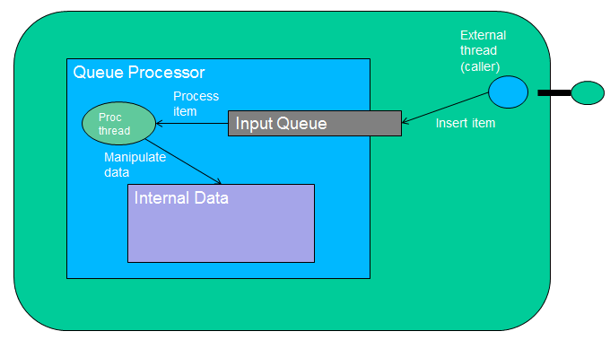

The principle is that the main logic and processing of the component is done in one or more Queue Processors. Calls arriving through the component interfaces insert requests to the input queue of the processor and are asynchronously processed. In case the caller needs to synchronously wait for a reply, the request itself may contain a reply queue that the caller will wait on.

This has the advantage that the internal data of the component are processed by a single thread, which does not need to care for synchronization and data visibility with other threads.

See the “advanced hello world” example that is included with JLCF for a concrete implementation of this pattern.

# Developer’s Guide

Besides this developer’s guide, the source code is extensively documented.

## System design

The central class of the system is JLCFContainer, which implements the formal interface of the framework and returns container instances that are able to load component applications.

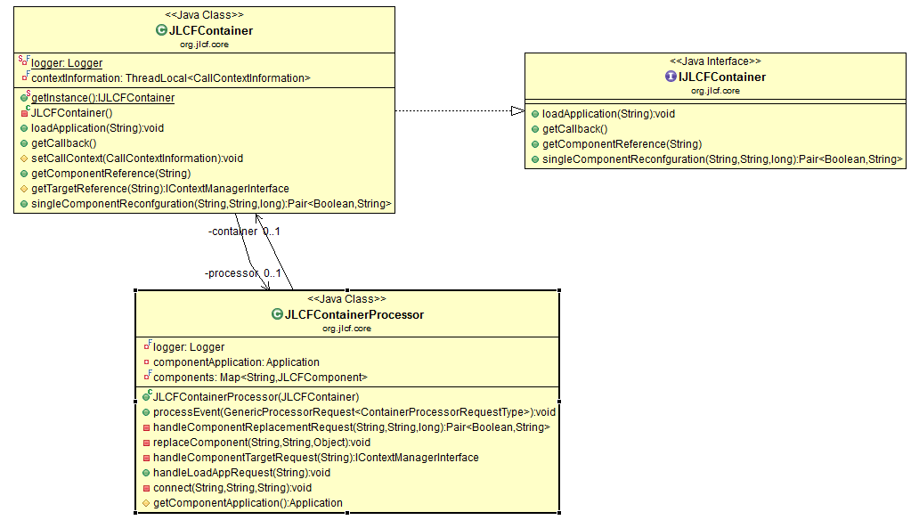

The main logic of the framework is implemented in JLCFContainerProcessor which extends the Abstract Queue Procesor pattern, explained in the examples section, and handles most user requests to the framework.

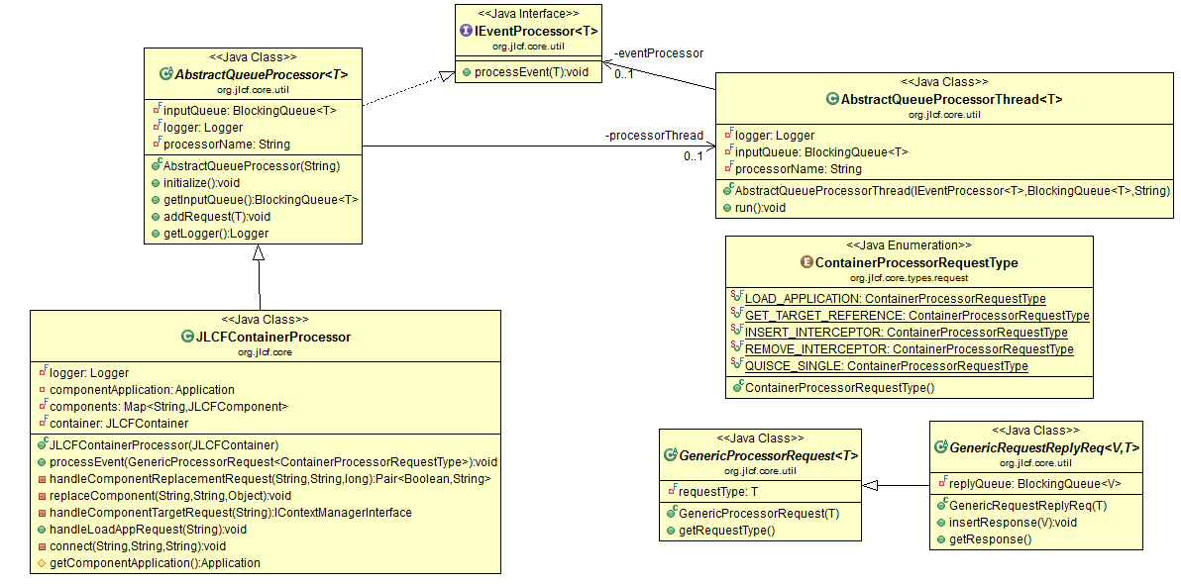

The Abstract Queue Processor is a generic class that is able to process a specific type of requests.

All requests that the JLCFContainreProcessor is able to process extend the GenericRequestReplyReq and can be found in package org.jlcf.core.types.request

JLCFContainerProcessor, on handling a “load application” request, which creates an application from an application description xml file, instantiates all components of the system and stores then on a map. The main class that holds all component information is JLCFComponent.

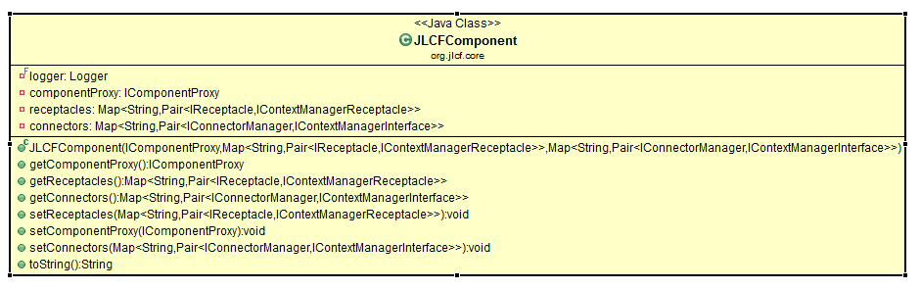

This class holds all data structures that are created by the framework and are related to a component.

When the framework creates a component, it creates the following data structures

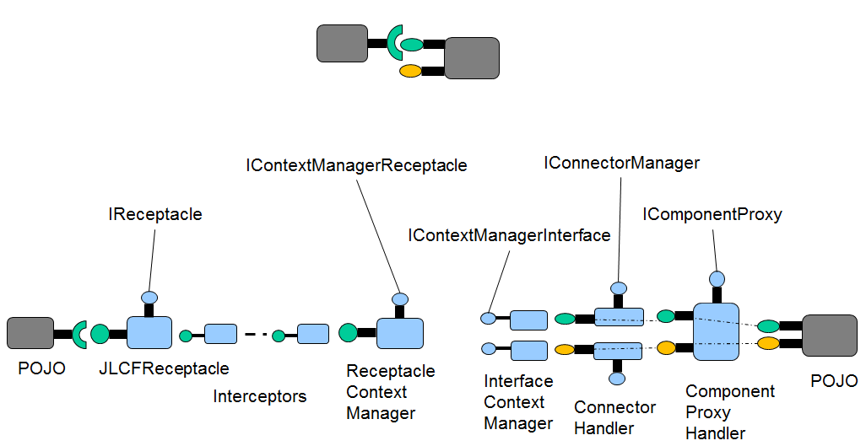

So a simple receptacle – interface call passes through all the objects above. The functionality of each object is the following:

* JLCFReceptacle
  + This is an invocation handler that implements the target interface. The Proxy Object that is created is the object that is passed to the component POJO constructor. This holds the chain of (any) interceptors
* ReceptacleContextManager
  + The last interceptor (or the JLCFReceptacle directly if there are no interceptors) forwards the call to this object. This is an invocation handler that implements the target interface and manages the context of the call. The call context is extra information that is passed and it currently only contains the callback address (if any). Also, when a user of the framework calls the getComponentReference method, the framework returns an object of this type. The receptacle context manager resolves the reference to the target component interface and calls the Interface Context Manager of the target component interface.
* InterfaceContextManager
  + This object receives the call from the ReceptacleContextManager, extracts the callback path (if any) and forwards the call to the ConnectorHandler.
* ConnectorHandler
  + The ConnectorHandler is an invocation handler that is used in a proxy object that implements the target interface. There is one connector handler per formal component interface. The main purpose of the connector handler is to selectively block calls to the component during dynamic reconfiguration (when the component is being replaced). The connector handler forwards the call to the Componetn Proxy Handler.
* ComponentProxyHandler
  + The ComponentProxyHandler is an invocation handler that is used in a proxy object that implements all the component formal interfaces. It keeps track the number of active calls through the component interfaces and uses this information during dynamic reconfiguration (when the component is being replaced). It is also responsible of invoking the @InitMethod method on the component POJO.

Finally the call reaches the component POJO which is implemented by a user of the framework.

Most of the logic of creating these object during a component instantiation is contained at theJLCFFrameworkUtilities helper class.

## Dynamic reconfiguration internals

The current implementation of the dynamic reconfiguration features of the framework is simple and only supports a request to replace a single component dynamically.

The dynamic reconfiguration logic is implemented in the ***org.jlcf.core.dynrec*** package and the ConnectorHandler and the ComponentProxyHandler classes.

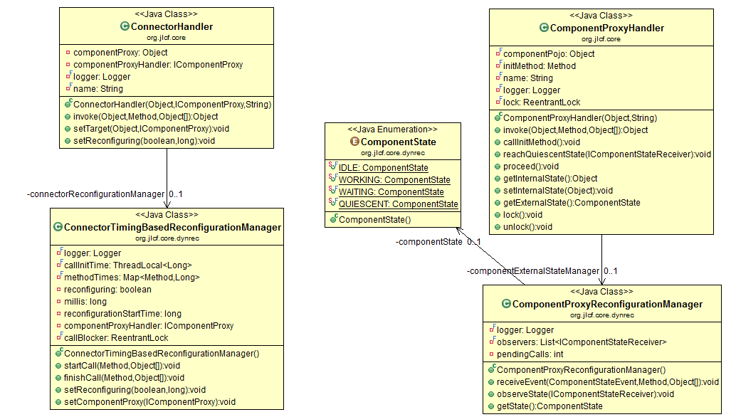

On each call on a component interface, regardless of whether a reconfiguration takes place or not, the following processing occurs:



The “Client Component” timeline, represents the rest of the object chain from the initiating POJO to the InterfaceContextManager object. On receiving a call, the connector proxy handler informs its reconfiguration manager, which acquires a lock on the component proxy handler. This lock ensures that the appropriate objects receive the start call notifications in a consistent way and at the same time does not limit concurrency on the target POJO, as it is unlocked at the Component Proxy Handler before the call is forwarded to the POJO. The connector implements logic in order to selectively block a call if reconfiguration is currently taking place. The call is then forwarded to the component proxy handler, which informs its own reconfiguration manager (which manages the state of the component and keeps track how many calls the component currently serves). It then unlocks the lock, allowing other calls to arrive at the component proxy handler and forwards the call to the POJO.

Once the method is executed at the POJO (which is the component implemented by a user of the framework) is aquires the lock, informs its reconfiguration manager and unlocks the lock. This locking mechanism is also needed in order to ensure consistent state transitions of the components external state as the component proxy reconfiguration manager is queried by connectors if a reconfiguration is currently taking place.

When a user sends a request to do a reconfiguration, it is handled by the JLCFContainerProcessor. The processor locates the target component and gets references to the component proxy handler and all the component connectors starts thread, the SingleComponentRecofigurationManager that is responsible of orchestrating the reconfiguration. It then blocks waiting for a reply indicating a successful or unsuccessful reconfiguration and informs the user.

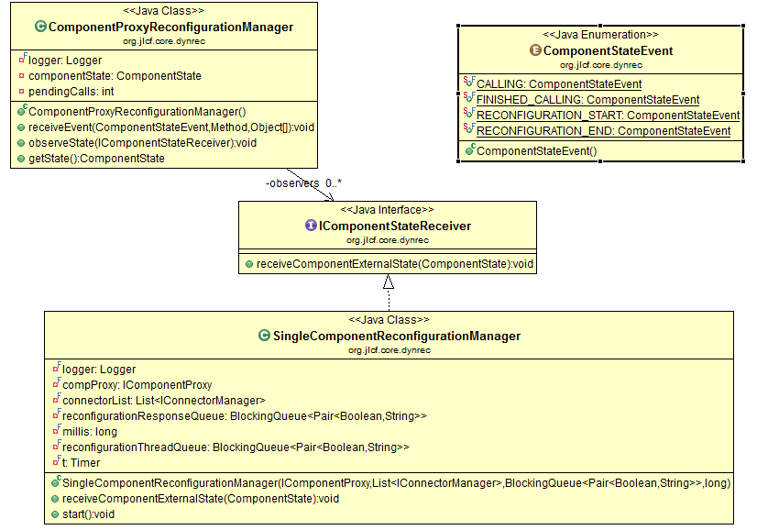

The logic of the SingleComponentRecofigurationManager is the following:

It informs all connectors of the target component that a reconfiguration is about to start, it starts a timer that will expire after the user provided reconfiguration timeout and then instructs the component proxy handler to reach a quiescent state, by registering itself as a listener of the changes in the state of the component. Then, either the component reaches a quiescent state, in which case the reconfiguration process stops successfully, or the timer expires in which case the reconfiguration stops unsuccessfully.

The SingleComponentReconfigurationManager, registers for receiving state changes on the component proxy handler (which is driven by the receive_event calls made to the component proxy reconfiguration manager).



Following a successful reconfiguration, the JLCFContainerProcessor instantiates the new component POJO, transfers the state of the old component (if the POJO implements the optional IReconfiogurableComponent interface) and updates the reference of the component proxy handler in order to forward calls to the new component POJO implementation.

Then it informs all connectors and the component proxy handler that the reconfiguration has finished in order to proceed with the normal processing.

### Extending dynamic reconfiguration

In order to change the algorithm for dynamic reconfiguration, or to implement additional primitives such as also allowing structural changes in a reconfiguration (replace a set of component with a different set of components) the main classes that will need modification are the ConnectorHandler and the ComponentProxyHandler.

In order to change the algorithm for driving a component reaching a quiescent state, the class ConnectorTimingBasedReconfiurationManager will need to be modified or a new class will need to be provided to the ConnectorHandler.

In order to add new dynamic reconfiguration primitives, a new framework request will need to be defined and then the rest of the current logic will need to be revised, as it is likely that new external component states will need to be defined and the blocking algorithm at connectors will need to be revised, in order to take into account the states of the other components reconfiguring and not only the current component that the connector is pointing to.

# APPENDIX 1. Application Description Schema

The schema of the application description is the following

<?xml version=*"1.0"* encoding=*"UTF-8"*?>

<schema xmlns=*"http://www.w3.org/2001/XMLSchema"* targetNamespace=*"http://jlcf.sourceforge.net/JLCFApplication"* xmlns:tns=*"http://jlcf.sourceforge.net/JLCFApplication"* elementFormDefault=*"qualified"*>

<element name=*"Application"*>

<complexType>

<sequence>

<element name=*"component"* type=*"tns:Component"* maxOccurs=*"unbounded"* minOccurs=*"1"*></element>

</sequence>

<attribute name=*"applicationName"* type=*"string"*></attribute>

</complexType>

</element>

<complexType name=*"Component"*>

<sequence>

<element name=*"interface"* type=*"tns:Interface"* maxOccurs=*"unbounded"* minOccurs=*"0"*></element>

<element name=*"receptacle"* type=*"tns:Receptacle"* maxOccurs=*"unbounded"* minOccurs=*"0"*></element>

<element name=*"property"* type=*"tns:Property"* maxOccurs=*"unbounded"* minOccurs=*"0"*></element>

</sequence>

<attribute name=*"name"* type=*"string"*></attribute>

<attribute name=*"implementationClass"* type=*"string"*></attribute>

</complexType>

<complexType name=*"Reference"*>

<attribute name=*"path"* type=*"string"*></attribute>

<attribute name=*"type"* type=*"string"*></attribute>

<attribute name=*"callbackReference"* type=*"string"*></attribute>

</complexType>

<complexType name=*"Receptacle"*>

<sequence>

<element name=*"Reference"* type=*"tns:Reference"* maxOccurs=*"1"* minOccurs=*"1"*/>

<element name=*"Interceptor"* type=*"tns:Interceptor"* maxOccurs=*"unbounded"* minOccurs=*"0"*/>

</sequence>

<attribute name=*"name"* type=*"string"*></attribute>

</complexType>

<complexType name=*"Interceptor"*>

<attribute name=*"name"* type=*"string"*></attribute>

<attribute name=*"type"* type=*"string"*></attribute>

</complexType>

<complexType name=*"Interface"*>

<attribute name=*"name"* type=*"string"*></attribute>

<attribute name=*"type"* type=*"string"*></attribute>

</complexType>

<complexType name=*"Property"*>

<attribute name=*"name"* type=*"string"*></attribute>

<attribute name=*"value"* type=*"string"*></attribute>

</complexType>

</schema>

