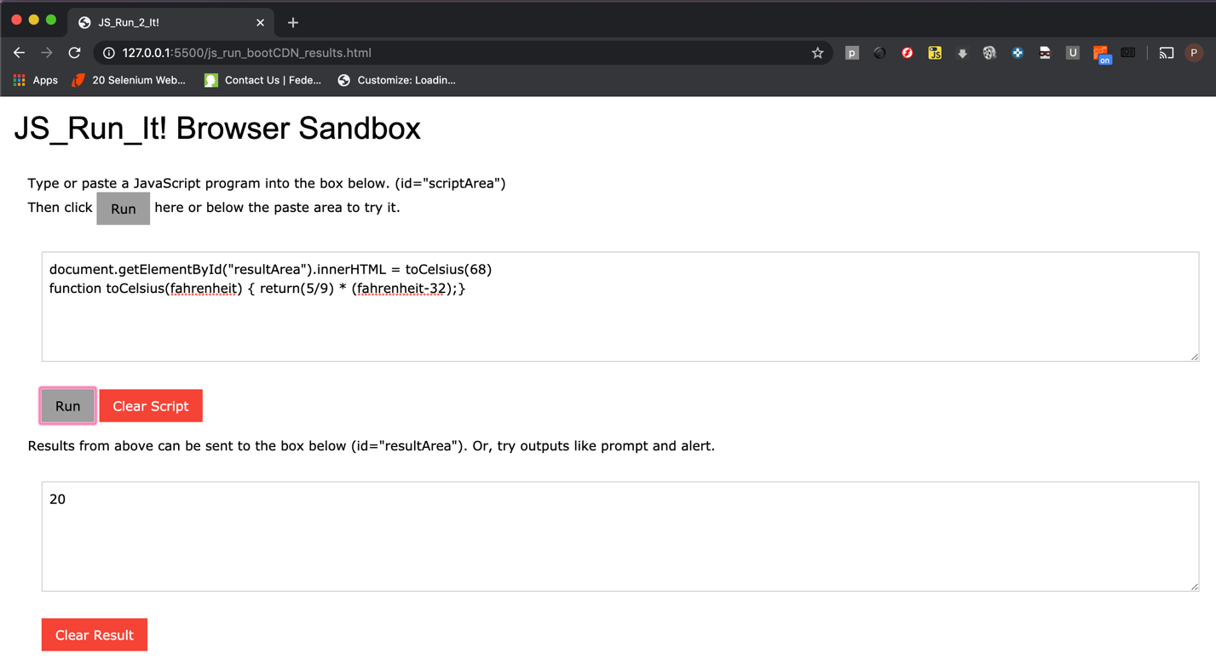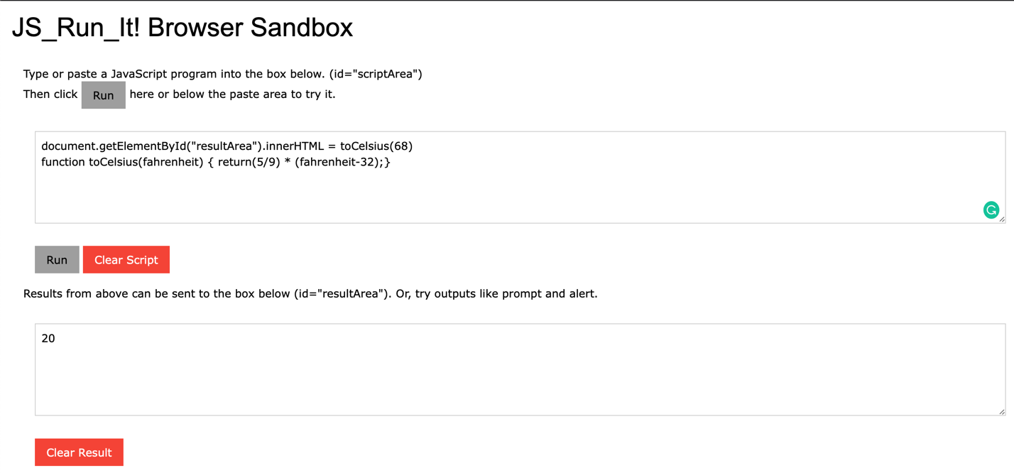Chrome:

Safari:

Conclusion: Performance and order of execution seems to be the same